Daniel Androussenko
Professor Charles Costarella
03/13/2021
L7mvc
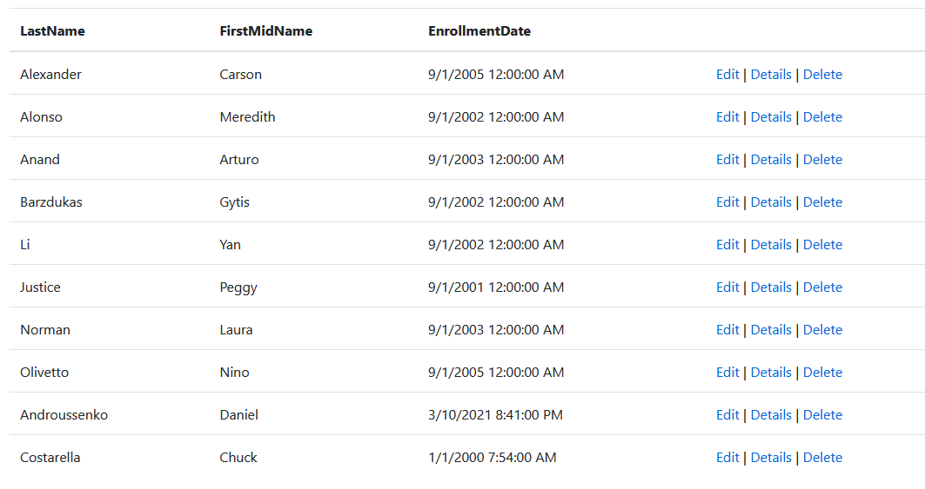

/Views/Students/Index.cshtml

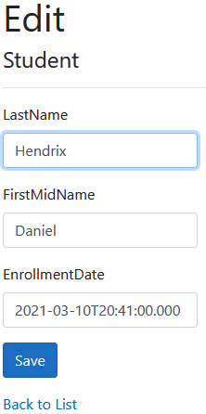
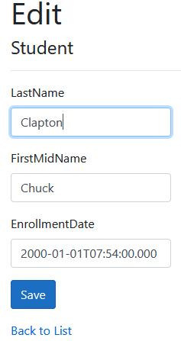

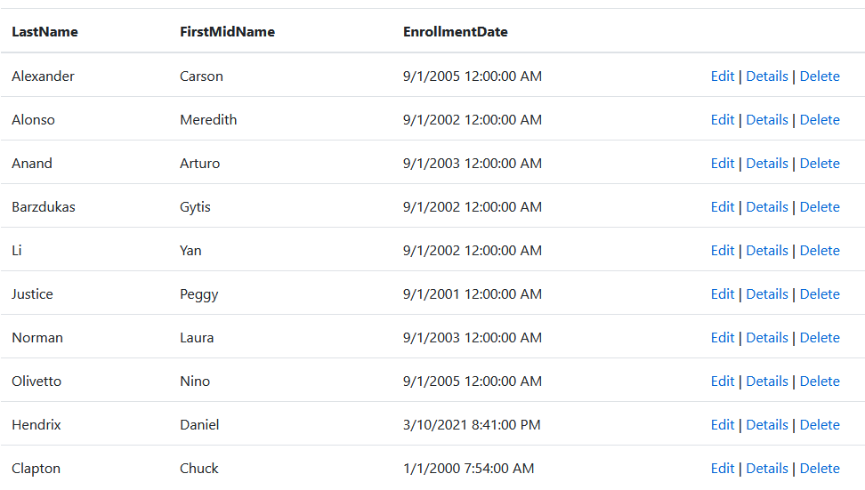
/Views/Students/Edit.cshtml

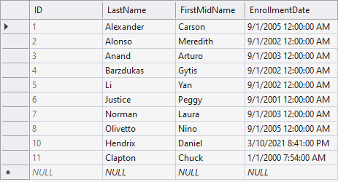
SQL Server Object Explorer (SSOX)

