 | Course | Control System Simulation and CAD
 | Lecturer | Zhen******
Research Report
On Non-linear ADRC
Student ID | Student Name | Score
****** | KONG ******
****** | LIAO ******
****** | HE******
****** | XIA******
****** | ZHAO ******

NUAA College of Automation Engineering
11/2018

Catalogue

Catalogue 3
1 Introduction (10 point) 1
2 Problem Description (15 point) 3
3 Design Process (40 point) 4
4 Simulation Study (30 point) 14
4.1 performance analysis of tracking differentiator 16
4.2 performance simulation of the extended observer 18
4.3 step response of nonlinear adrc 19
4.4 step response for the third-order system 22
4.5 simulation of cross-order control performance 24
4.7 frequency domain response simulation 26
4.8 simulation of suppression of sinusoidal disturbance 29
5 Conclusion (5 point) 30
References 33
Appendix 36

1 Introduction (10 point)
Active disturbance rejection control (adrc) is a new control technology formally proposed in 1998 by jingqing han who integrates the research results of tracking differentiator (TD), nonlinear state error feedback link (NLSEF) and extended observer (ESO). Adrc technology embodies the unique views of hanjing qing researchers on linear and nonlinear feedback, model theory and cybernetics. Developed and enriched the advantages of PID controller, in the control of a variety of linear and nonlinear models show significant advantages, is expected to replace the actual use of PID control is still in use today. However, the traditional Han’s adrc has 12 parameters to be set, among which many parameters have a strong coupling relationship, which has a great impact on the control performance and even stability of the system. Therefore, there is still great room for improvement and research of adrc.
In recent years, active disturbance rejection control has been paid more and more attention. Up to now, many literatures have discussed the theory, application and thought of adrc. Article [1] expounds the control idea contained in adrc; Article [2] introduces the common design method of adrc in solving time-delay systems, and article [3] introduces the method of parameter setting of nonlinear adrc. Article [4] summarizes the research results of adrc in flight control, robot control and motor control. Article [5] analyzes the performance and characteristics of adrc from the perspective of disturbance observer.
With the development of research, there have been many researches on improving the adrc technology in recent years. Zhang Rong and Han Jingqing [6] proposed an auto-disturbance rejection controller based on neural network, which integrated the neural network technology into ADRC, and used the ANN identified to compensate for part of the object, so as to reduce the change range of the original object and improve the control performance of ADRC. Xia yuanqing et al. [4] of the Beijing institute of technology used ADRC and sliding mode control for compound control to overcome chattering problem of sliding mode control and limited estimation ability of ADRC and sliding mode control. Shen Zhao[7] of Lanzhou State University in Cleveland proposed the method of combining predictive control with ADRC to solve the control problem of time-delay objects. However, there are still few studies combining ADRC with adaptive control and model-free control.
In this project, on the basis of learning and understanding the current research literature on ADRC, the modeling and independent simulation of the classical nonlinear ADRC controller are carried out. All the simulation modules are independently built by the team members on the basis of the literature, and the controller parts are all discrete systems to ensure its realization on the single-chip microcomputer system. At the same time, the control object including the second-order oscillation system, and the third order system and instability of the second order system, and performance research direction includes the step response, cross order control, frequency response and disturbance rejection performance and basic includes the various aspects of the control system of immunity control performance, the ADRC theory have a more comprehensive understanding. At the same time, we also found many problems of ADRC control system in the simulation, such as the difficulty in setting too many parameters and the unsatisfactory suppression of sinusoidal noise. Through literature review, we proposed two solutions based on the current mainstream research progress, combining ADRC with neural network algorithm to reduce the difficulty of its implementation. The extended observer is improved to improve its suppression of sinusoidal disturbance. Due to limited research time, we have not realized these two ideas. We plan to further study this problem in future graduation projects and studies, and further extend the research objects to nonlinear systems and MIMO systems.

2 Problem Description (15 point)
The research of this project is the major assignment of the course control theory simulation and CAD. After completing the theoretical research of the basic nonlinear ADRC controller, the project team attempts to simulate the performance of ADRC by Simulink. The control performance of ADRC includes the overall control performance and the performance of each module. The relationship between the whole and the local is complementary. Therefore, we will firstly conduct simulation analysis on the performance of each module.
At the same time, through literature review, we choose a variety of control systems, including the second order oscillation system, the second order system series inertial link of the third order system and unstable system. Unstable system can be used to test the stabilization performance of ADRC for unstable system.
Finally, the anti-perturbation performance of ADRC controller is tested by superimposing various types of noise. At present, the main disturbance is periodic square wave disturbance, periodic sine disturbance and white noise disturbance. Square wave perturbation has become a common perturbation in simulation due to its periodicity. However, periodic square wave perturbation is equivalent to superimposed periodic step response when the system response speed is relatively fast, and anti-perturbation is relatively easy. Due to its uncertainty, white noise becomes a kind of noise that is difficult to suppress. Meanwhile, white noise may have a large differential value, and the disturbance of white noise with excessive energy may threaten the stability of the system. Sinusoidal perturbation is also a kind of noise that is not easy to suppress because sine waves are always different and have high requirements for the response speed and predictability of the system.
Research idea: we propose two solutions based on the current mainstream research progress, combining ADRC with neural network algorithm to reduce the difficulty of its implementation; The extended observer is improved to improve its suppression of sinusoidal disturbance. Due to limited research time, we have not realized these two ideas. We plan to further study this problem in future graduation projects and studies, and further extend the research objects to nonlinear systems and MIMO systems.

3 Design Process (40 point)
3.1 PID to auto-disturbance rejection control
Classical PID control is to determine the feedback control law to eliminate errors based on the error information between the system output and the reference input, that is, to generate control signals with the weighted sum of errors and their derivatives and integrals.
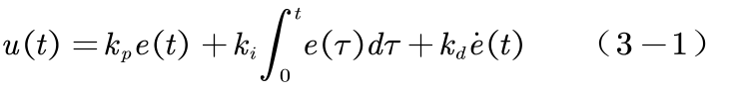
Formula 3-1 is the output expression of the classical PID controller, where is the proportional gain, is the integral gain, is the differential gain, and is the difference between system input and output. The block diagram of classical PID is shown in figure 3-1.
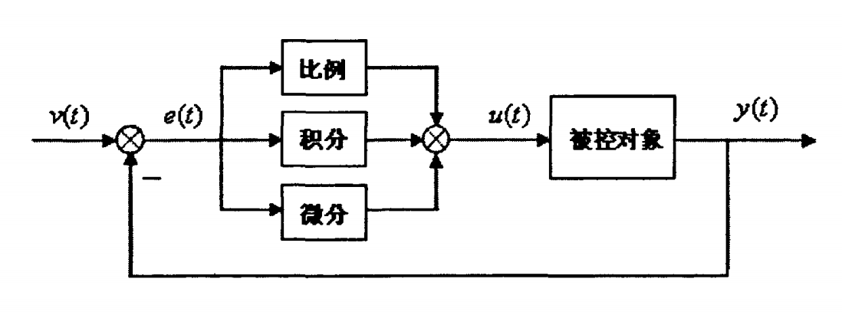
Figure 3-1 classical PID control structure block diagram
At present, PID controller can control most linear systems or even some non-linear systems, but the three gain parameters in PID have a great impact on the dynamic performance of the control system, which leads to frequent changes of PID parameters in the case of strong disturbance, which is also a part of adaptive control. PID controller, with its simple structure and relatively easy parameter setting, has been widely used in the industrial field. However, in some cases, the classical PID controller is difficult to obtain satisfactory control effect, such as: large range fluctuation of object parameters or control object with strong nonlinear characteristics. This exposes some problems of PID controller itself. According to professor Han Jingqing's paper "from PID to auto-disturbance rejection control" [28], these problems mainly include:
(1) the selection method of error e(t)=y(t) and u(t) is not complete, which makes the error at the initial moment large and easy to cause the contradiction between the rapidity and overshoot of the control system.
(2) in practical problems, the reference input y(t) is generally non-differentiable, or even discontinuous, and noise pollution often exists in y(t), so e(t)=y(t)-u(t) is usually non-differentiable, and its differential signal information quality is not good, which limits the scope of application of PID controller.
(3) the "weighted sum" strategy is not necessarily the best. The linear combination method is easy to cause the contradiction between system rapidity and overshoot.
(4) integral feedback has many negative effects. PID controller integral essence is to eliminate the system static difference, but it also affects the stability of the system, at the same time may cause integration saturation phenomenon.
Many scholars predicted in the 1960s and 1970s that one day the new concept controller of "modern control theory" would replace the classical PID controller. To this day, however, engineering applications have failed to fulfill this prediction. PID controller is still stubbornly holding its own position, but the controller provided by modern control theory is in a weak position in the control engineering due to the difficult problems such as "adaptability" and "robustness" that are difficult to overcome. Therefore, people have to re-evaluate and re-recognize "modern control theory" and "classical control theory". In a sense, "modern control theory" is successful in analyzing the structural properties of control systems and is a good analytical tool. However, the controller design method provided by "modern control theory" completely relies on the mathematical model of the object, and because the differential signal cannot be obtained simply, it has to rely on the "mathematical model" to extract the state variable information. In this way, "modern control theory" has to rely on the assumed mathematical model to a large extent, and the approximation and uncertainty of the mathematical model also cause problems of the control system. As a result, problems such as "adaptability" and "robustness" were encountered, which limited the scope of application. But the "classical adjustment theory" does not start from the mathematical model of the system, but to eliminate errors and external disturbances for the purpose, with the combination of reducing errors and eliminating external disturbances to form a controller like PID. In addition, "differentiators" can be used in classical controllers, which do not need to rely too much on mathematical models to extract the required information. Therefore, it "basically gets rid of the constraint of mathematical model" and has strong practicability. However, in the traditional PID controller design, the way of extracting differential signals is relatively simple, and the obtained differential signals are of poor quality, which limits the range of use.
In order to solve the above problems, Han Jingqing proposed an ADRC, which is now known as the nonlinear ADRC or Han's ADRC, on the theoretical basis of tracking differentiator, extended observer and nonlinear PID in 1998.
Control theory and control engineering are actually studying different problems. The research of control theory is mainly about feasibility issues, such as the controllability, decoupling and controllability of the system, etc., while control engineering is to solve practical problems. The control theory needs to draw impeccable general conclusions, and the control engineering pays more attention to solving the problems in practical application, but the requirements for accurate theoretical derivation and feasibility analysis are not particularly strict. Therefore, the feasibility proof in the control theory can only provide guidance for the practical application of control engineering rather than the full sense of feasibility, while the practical application in the control engineering can provide hints for the feasibility analysis in the control theory instead of the feasibility proof. ADRC has grown up in the fierce conflict between control theory and control engineering. Control theory provides a theoretical basis for the analysis and design of ADRC, and control engineering provides a platform for the use of ADRC. With the wide application of ADRC in control engineering, it will undoubtedly enrich the research content of control theory.
The ADRC consists of four parts, as shown in the figure below. The following paper will analyze the theory of each part and make some design.
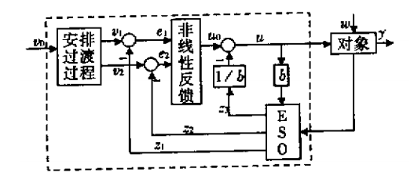
Figure 3-2 ADRC structure diagram
3.2 tracking differentiator (TD)
In the classical control theory, the method of obtaining the differential link of a given signal is described in equation 3-2:
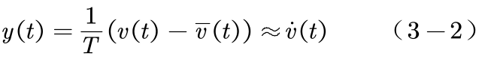
Where T is a relatively small time constant. So the smaller T is, the closer the output y is to differentiating. However, when the input signal is polluted by high-frequency noise with an average value of 0, formula 3-3 can be obtained:
Where n (t) is the noise expression. Therefore, the smaller the time constant T is, the more serious the noise interference will be. This is the noise amplification effect of the classical differential link, and a major disadvantage of the classical differentiator. Therefore, the fastest tracking differentiator derived from optimal control theory can be used to replace the traditional differentiator.
For a second order series system:
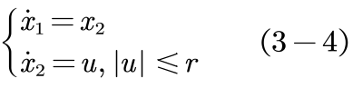
When we select the origin as the end point, then the fast optimal control function is:
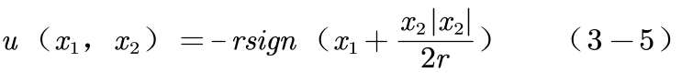
If equations 3-4 and 3-5 are combined, system 3-6 can be obtained:
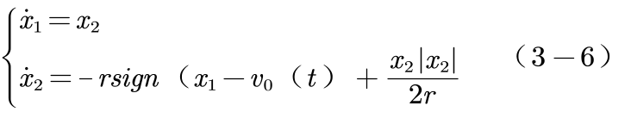
System 3-6 is the tracking differentiator based on optimal control. When the acceleration is limited to, it will be able to track the input signal fastest, and the larger r is, the faster it will track. Therefore, when, the state variable x2(t) can be approximated as the differential of the input signal Vo(t).
3-6 is the nonlinear tracking differentiator proposed by researcher Han Jingqing. According to the theory of solving the minimum time problem by applying the minimum principle in the optimal control, the tracking time of the nonlinear tracking differentiator is shorter, but it is more complicated than other algorithms.
According to the discretization theory, if we directly discretize the system 3-6, we can obtain the discrete system 3-7
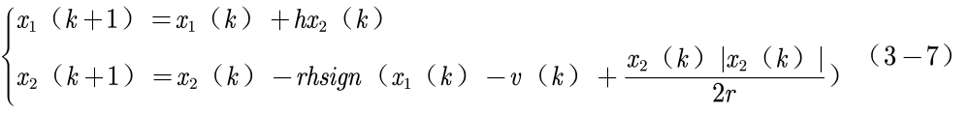
However, this system will show unsatisfactory high-frequency tremor in real numerical calculation [28], which is given to continuous system discretization. For this reason, Hanjing Qing researcher defined the fhan (x1, x2, r, h), the fastest control function of the discrete system, and its expression is as follows:
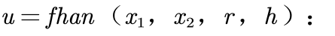
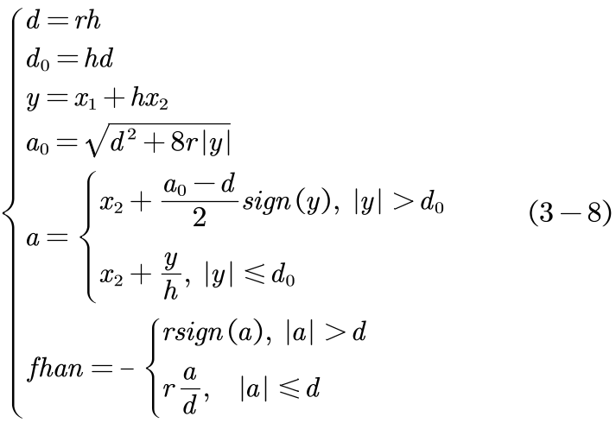
Substituting the function u=fhan (x1, x2, r, h) into the system, we can get:
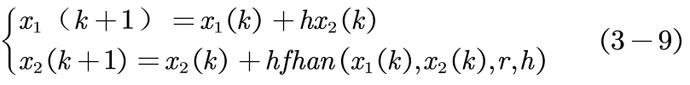
For the discrete system, starting from the non-zero value and following the recurrence of the difference equation of equation 3-9, the origin can be reached in a finite step and the system is stable. If used, the discretized nonlinear differential tracker (3-10) can be obtained:
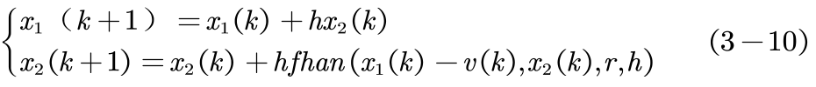
However, when the input signal superposition of the high frequency noise, speed curve into steady state occurs overshoot, the overshoot phenomenon also can aggravate the differential noise amplification effect, in order to eliminate the overshoot phenomenon, han jing qing, a researcher at the function u = fhan (x1, x2, r, h) and variable h instead of independent new variable step size h h0, generally h0 off for appropriate constant is greater than the step size h, so can eliminate the overshoot of speed curve, thus inhibiting differential signal to noise amplification. Thus, a new discrete differential tracker (3-11) can be obtained:
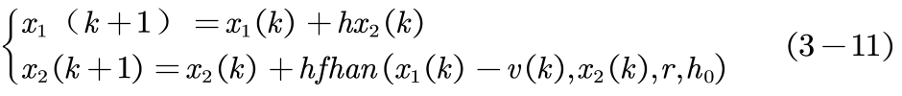
This is the discrete form of the fastest differential tracker, which is the tracking differentiator widely used in adrc to arrange the transition process and extract differential signals. In the theoretical derivation of this section, a large number of optimal control theories are used, which are of certain theoretical difficulty. At the same time, it is also very difficult to prove the stability and convergence of the tracking differentiator, as detailed in a series of papers by professor guo baozhu [14].
The theory and numerical simulation of using discrete tracking differentiators to construct the transition arrangement process will be described in detail in section 4.1.
3.3 extended observer (ESO)
(1) state observer
In the running process of the system, people often grasp the running state of the control system through the output of the controlled object (part of state variables), that is, all internal state information of the controlled object is determined according to the input of the controlled object (control quantity) and the output of the controlled object. At this time, state observer is needed. So let's think about linear control systems
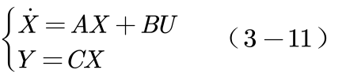
Where X is the state variable, U is the control vector, and Y is the output vector. Observation system L can be constructed:
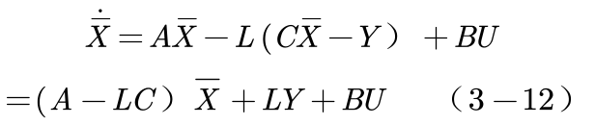
For equation 3-12, as long as the matrix a-lc is stable, z (t) can estimate the state variable x (t) incrementally. In addition, if L is designed according to the law of minimum variance of noise, then the observer is a kalman filter.
For nonlinear systems, such as the following second-order systems
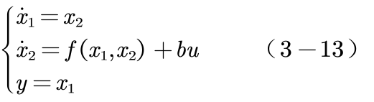
When the functions f and b are known, the following state observer can be established
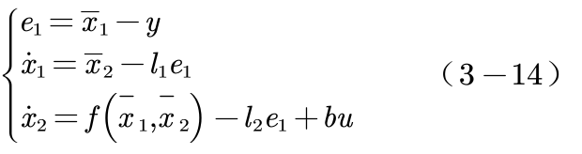
(2) expansion observer
According to the optimal control theory, a special nonlinear state observer can be obtained
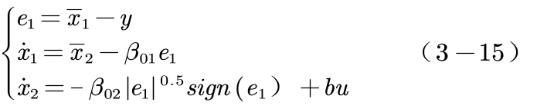
It does a good job of tracking the sum of the state variables in system 3-13, and if I rewrite the nonlinear function f as a new state variable, like system 3-16,
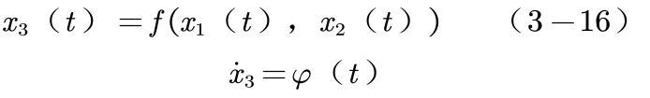
Therefore, the nonlinear state observer established by the extended system is:
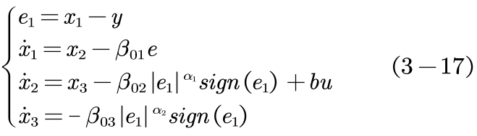
In equation (3-17), the parameters are often 0.5 and 0.25, and the parameter,, play an important role in the estimated performance of the whole state observer and the stability of the system. Therefore, the setting of these three parameters is also the key point of the configuration of the extended observer and even the whole ADRC.
(3) inhibition principle of ESO on disturbance
For system 3-17, the expanded state X3 is able to make a good estimate of the real-time action of unknown disturbance [].If we assume that the sum of the internal and external disturbances of the system is f, that is the total disturbance. When the control quantity u satisfies equation 3-18,
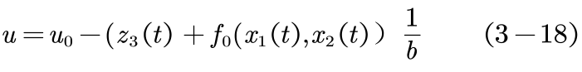
The object can be approximated as the linearized integral series system shown in system 3-19.This is the real-time dynamic linearization of uncertain systems. Therefore, the design problem of the system can be simplified to the design of "linear integral series system".
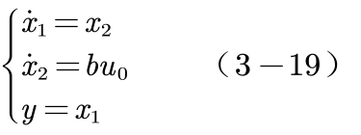
3.4 nonlinear PID
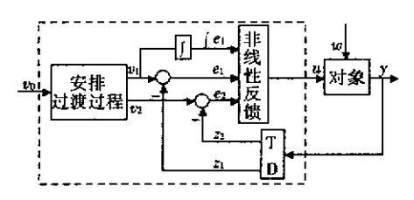
Figure 3-3 nonlinear PID structure diagram
As shown in the structure diagram in figure 3-3, the three signals in the input nonlinear feedback part are error quantity e1, differential error quantity e2 and integral error quantity respectively. For this reason, we change the "weighted sum" method in the traditional PID control to the nonlinear combination method. According to the research of researcher han jingqing, he gives a non-linear combination form that can be used:
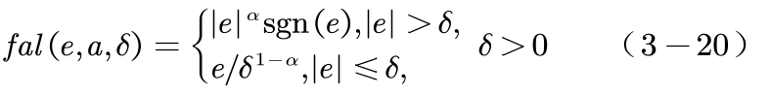
When, fal function has a small error and a large gain; The advantage of small gain with large error. Thus, the discrete form of nonlinear PID control law can be expressed as:
Where, there are multiple parameters, and the basic parameter setting range is:
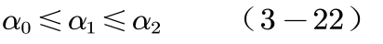
Sometimes you can take:
3.5 summary
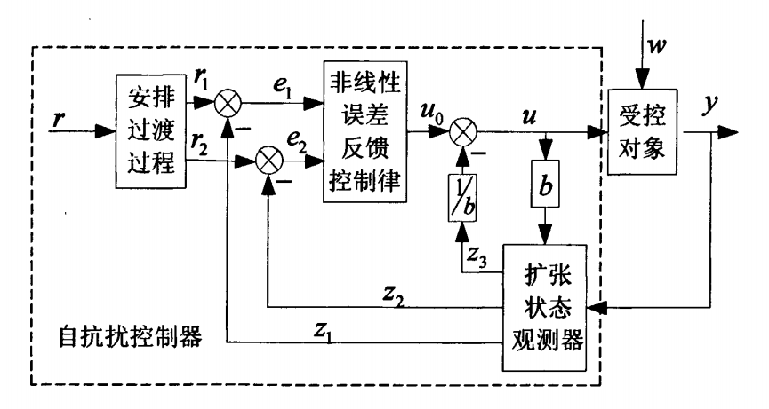
Figure 3-4 ADRC structure diagram
The discrete algorithm of adrc is as follows:
Controlled object: 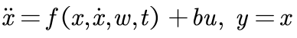
1) arrange the transition process:
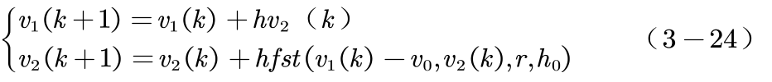
2) ESO equation
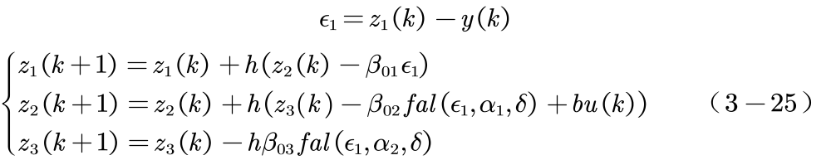
3) control quantity formation
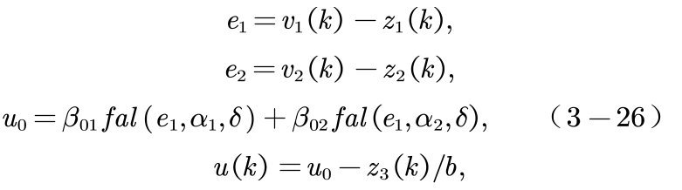
4) common functions
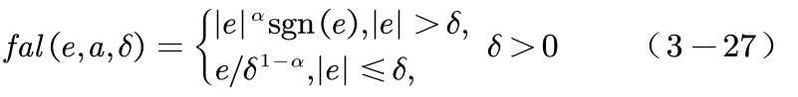

4 Simulation Study (30 point)
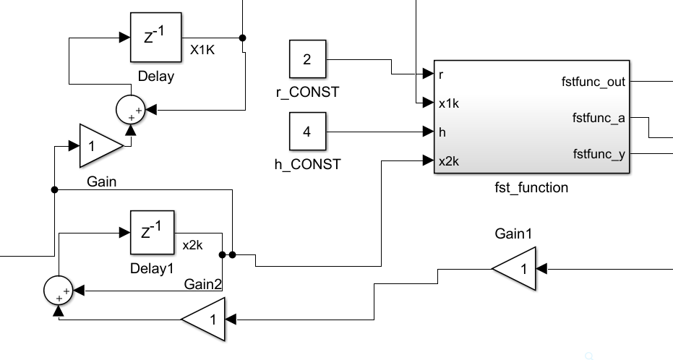
Figure 4-1 Simulink structure diagram of tracking differentiator
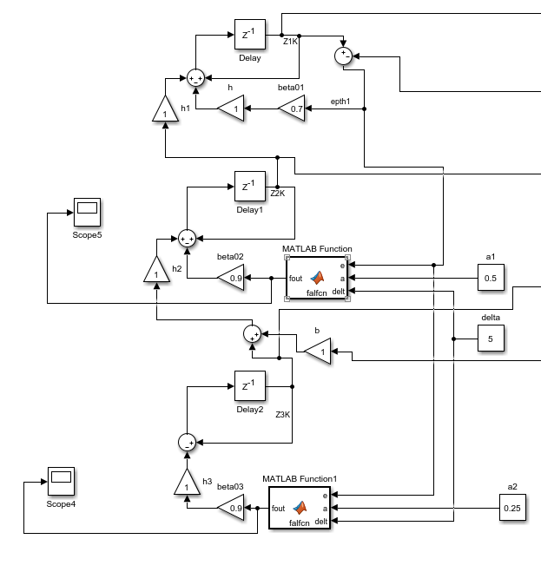
Figure 4-2 Simulink structure diagram of the extended observer
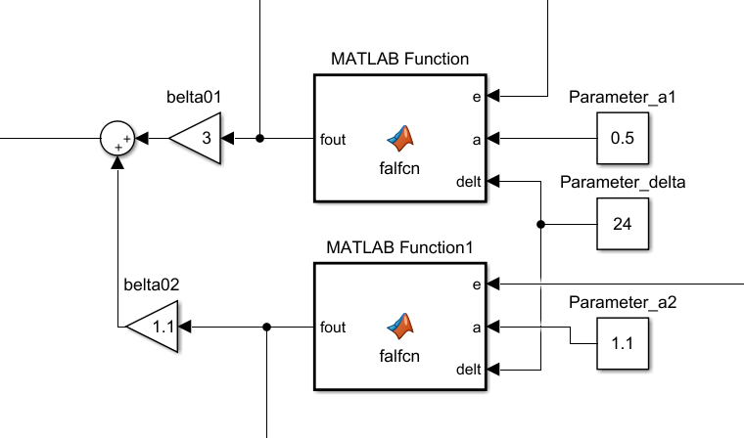
Figure 4-3 Simulink structure diagram of nonlinear PID part
Figure 4-1, 4-2 and 4-3 show the structure diagram of SIMULINK subsystem we used in the simulation. According to the structure in figure 3-4, they are connected to each other to form the entire ADRC control system. Next, we will conduct numerical simulation from part to whole and analyze its control performance.

4.1 performance analysis of tracking differentiator

4.1.1 purpose and conditions of simulation
This simulation aims at analyzing the performance of the tracking differentiator and whether it can realize the advantages of combining the rapidity shown in theory with no overshoot under the excitation of step response.
The specific simulation structure diagram of the tracking differentiator is shown in figure 4-1. The specific parameters are selected as follows:
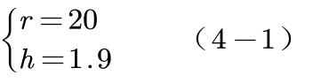
Where, the parameter h represents the step size of the system and r represents the tracking speed. Under this combination of parameters, the system has good stability and rapidity.

4.1.2 simulation environment
Software environment: Windows 10, MATLAB 2014b
Hardware environment: processor Intel core i5-5200u;Graphics NIVIDA GTX940M

4.1.3 simulation results
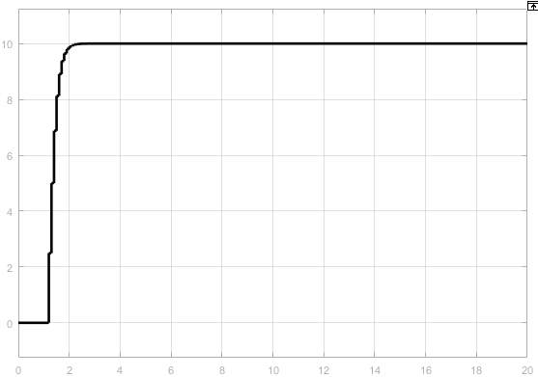
Figure 4-4 step response of the trace differentiator: trace output
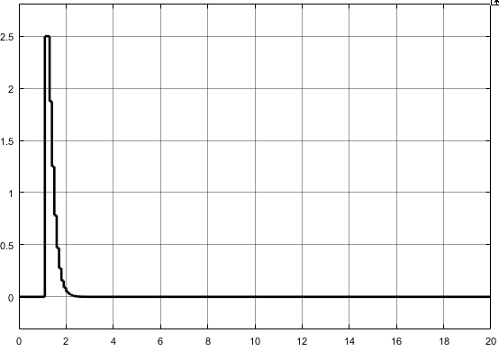
Figure 4-5 tracks the step response of the differentiator: differential output

4.1.4 simulation analysis
Figure 4-4 and 4-5 respectively show TD's tracking output and differential output in the step response.As can be seen from figure 4-4, the system has a good rapidity, the adjustment time is less than 1ms, and there is no overshoot. It can be seen that the system successfully solves the contradiction between overshoot and rapidity, and has a good tracking effect for the given signal.As can be seen from figure 4-5, the system does not derive a large differential signal for the step signal, which not only ensures the stability and accuracy of the system, but also effectively improves the quality of the differential signal. Compared with the differential signal of the traditional PID controller, the system has made significant progress.
Through this numerical simulation, the theory and design method introduced in section 3.2 are verified.

4.2 performance simulation of the extended observer

4.2.1 purpose and conditions of simulation
The purpose of this simulation is to analyze the performance of the extended observer (ESO) and whether it can achieve the good observation performance of the total disturbance shown by the theory under the action of step response and sinusoidal noise.
The SIMULINK subsystem of the extended observer used in simulation is shown in figure 4-2.Where, the parameters are selected as shown in equation 4-2.
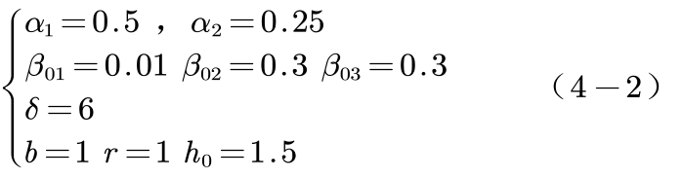

4.2.2 simulation environment
Software environment: Windows 10, MATLAB 2014b
Hardware environment: processor Intel core i5-5200u;Graphics NIVIDA GTX940M

4.2.3 simulation results
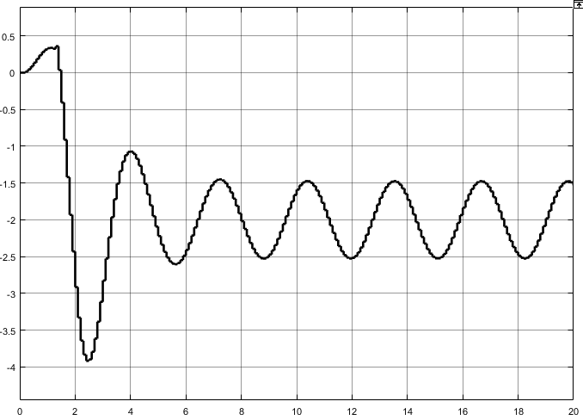
Figure 4-6 disturbance observation output of the extended observer

4.2.4 simulation analysis

4.3 step response of nonlinear adrc

4.3.1 purpose and conditions of simulation
The simulation aims at analyzing the control performance of the designed adrc, that is, the control effect of a second order oscillation system under the excitation of step response.The controlled object is selected as the second-order oscillation link as follows, and the controller parameters are selected as 4-7:
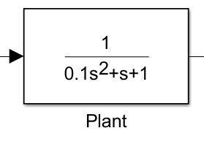
4-7 controlled object 1
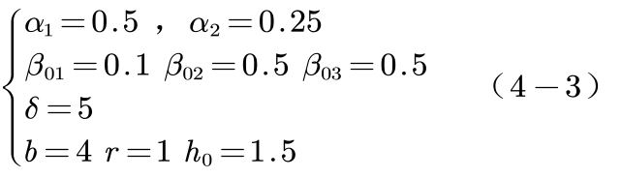

4.3.2 simulation environment
Software environment: Windows 10, MATLAB 2014b
Hardware environment: processor Intel core i5-5200u;Graphics NIVIDA GTX940M

4.3.3 simulation results
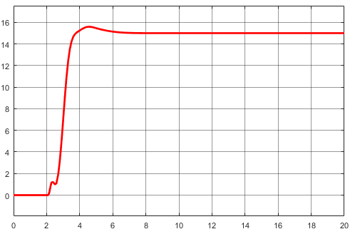
Figure 4-8 simulation results without superimposed noise interference
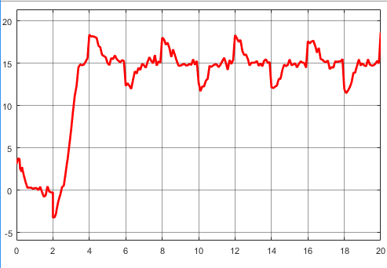
Figure 4-9 shows the simulation results of noise superimposed
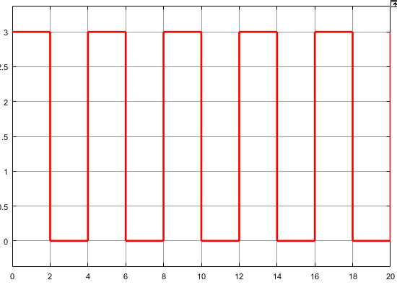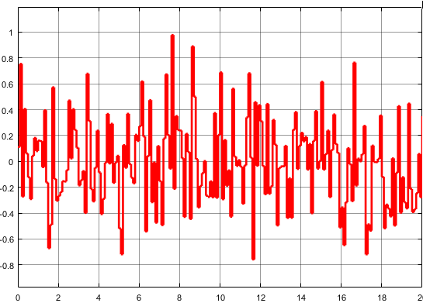
FIG. 4-10 schematic diagram of square wave disturbance FIG. 4-11 schematic diagram of white noise disturbance

4.3.4 simulation analysis
FIG. 4-8 shows the response curve when the disturbance is superimposed. We can find that the control system has good rapidity and a small overshoot.
FIG. 4-9 is the response curve after the disturbance is superimposed. From the response curve, we can clearly see the periodicity. For the white noise whose amplitude is within 8% of the target value, it has a good inhibitory effect and can maintain a good stability. Therefore, we believe that this system can perform the control task under the environment of white noise and periodic square wave disturbance.

4.4 step response for the third-order system

4.4.1 purpose of simulation
This simulation aims to study whether the adrc designed in this study has a good control effect on the third-order system, for which we use the controlled object as shown in figure 4-12.At the same time, we will compare the differences and similarities of the control difficulty and parameter setting between the first section and the second order system.
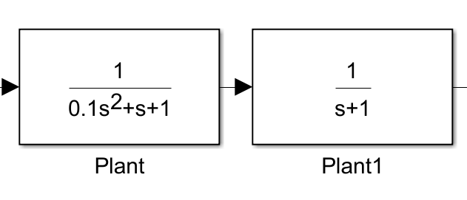
Figure 4-12 controlled object 2

4.4.2 simulation environment
Software environment: Windows 10, MATLAB 2014b
Hardware environment: processor Intel core i5-5200u;Graphics NIVIDA GTX940M

4.4.3 simulation results
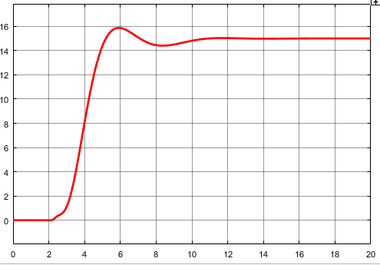
Figure 4-13
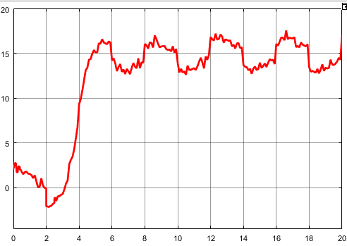
Figure 4-14

4.4.4 simulation analysis
Figure 4-13 is the response curve of the third-order system without noise superposition, which has the advantage of small overshoot while being fast.
Compared with the second-order system in figure 4-8, we can see that the control difficulty of the system is significantly increased, the overshoot is significantly increased, and even an oscillation occurs. At the same time, the difficulty of setting parameters of the third-order system is also significantly increased. Since the parameters in ESO have a strong impact on the control performance and stability, it is very difficult to guarantee the stability and control performance at the same time. This shows that the parameter setting of high order adrc is more difficult than that of low order adrc.

4.5 simulation of cross-order control performance

4.5.1 purpose of simulation
This simulation aims at studying the performance of the adrc designed in the cross-order control, that is, using the controller of the low-order system to control the high-order system or using the controller of the high-order system to control the low-order system.In the simulation, the first order system controller is used to control the second order system, and the second order system controller is used to control the first order system.

4.6.2 simulation environment
Software environment: Windows 10, MATLAB 2014b
Hardware environment: processor Intel core i5-5200u;Graphics NIVIDA GTX940M

4.6.3 simulation results
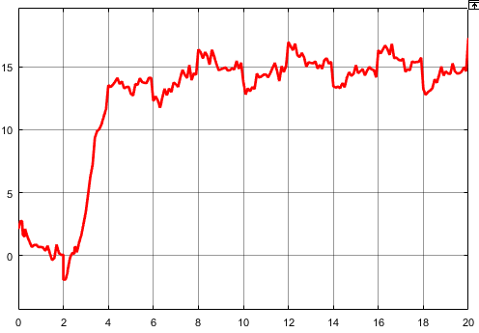
Figure 4-15 USES a high order controller to control a second order system
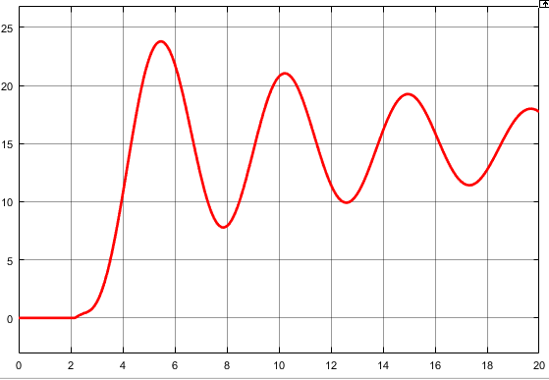
Figure 4-16 USES a second-order controller to control a third-order system

4.6.4 simulation analysis
Figure 4-17 shows the Byrd diagram of the ADRC control system. It is found from the amplification-frequency characteristics that the resonance peak is greater than 1, so the damping is relatively small, less than 0.707;The slope decreases at the second transition frequency, indicating that there is a first-order differential link.
Figure 4-18 is the Nyquist diagram of the control system, and figure 4-19 is the zero-pole diagram of the open loop system. According to the zero-pole diagram, the open-loop system has four zeros located in the right half plane. It can be seen from the figure that two negative traverses, p=5 and n=-2, are unstable from the classical theory. Due to the limited research time and ability, the possible reasons for our analysis are as follows: MATLAB linearized the frequency characteristic curve in drawing, resulting in distortion of the results; Nonlinearization of feedback is inconsistent with linear control theory.According to references [25] and [26], the frequency response of ADRC still needs to be further studied.
According to the reference [8], the advantages of frequency-domain analysis method make it particularly popular in engineering applications. Frequency-domain analysis of adrc systems needs to be further deepened, especially for discrete systems, multi-in, multi-out systems and nonlinear systems.

4.7 frequency domain response simulation

4.7.1 purpose of simulation
This simulation aims at exploring the frequency domain characteristics of the designed adrc.Frequency domain characteristics analysis method is the most commonly used methods in classical control theory, the physical meaning and bright, is to facilitate the analysis of the effect of parameters on the performance of the system, the available experimental method and frequency domain properties of system, can be directly according to the open loop frequency response linear the absolute stability of the closed-loop system and the relative stability, can clearly understand how to change the system open-loop transfer function to the effective ways to improve system control performance, etc.4.7.2 simulation environment
Software environment: Windows 10, MATLAB 2014b
Hardware environment: processor Intel core i5-4210 graphics card NIVIDA GTX960M

4.7.3 simulation results
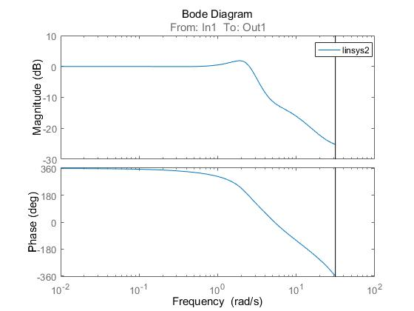
Figure 4-17 bode diagram
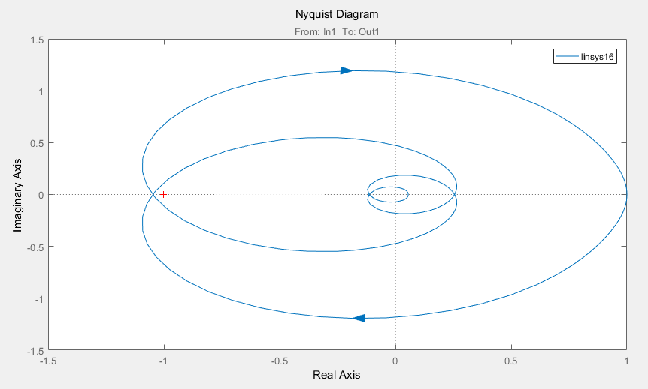
Figure 4-18 Nyquist diagram
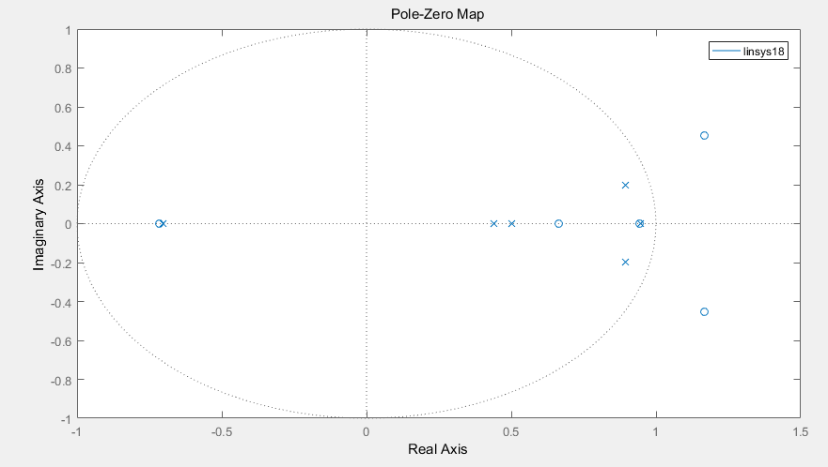
FIG. 4-19 open-loop zero-pole diagram

4.7.4 simulation analysis
Figure 4-17 shows the Byrd diagram of the ADRC control system. It is found from the amplification-frequency characteristics that the resonance peak is greater than 1, so the damping is relatively small, less than 0.707;The slope decreases at the second transition frequency, indicating that there is a first-order differential link.
Figure 4-18 is the Nyquist diagram of the control system, and figure 4-19 is the zero-pole diagram of the open loop system. According to the zero-pole diagram, the open-loop system has four zeros located in the right half plane. It can be seen from the figure that two negative traverses, p=5 and n=-2, are unstable from the classical theory.Due to the limited research time and ability, the possible reasons for our analysis are as follows: MATLAB linearized the frequency characteristic curve in drawing, resulting in distortion of the results;Nonlinearization of feedback is inconsistent with linear control theory.According to references [25] and [26], the frequency response of ADRC still needs to be further studied.
According to the reference [8], the advantages of frequency-domain analysis method make it particularly popular in engineering applications. Frequency-domain analysis of adrc systems needs to be further deepened, especially for discrete systems, multi-in, multi-out systems and nonlinear systems.

4.8 simulation of suppression of sinusoidal disturbance

4.8.1 purpose of simulation
The purpose of this project is to study the suppression of sinusoidal disturbance by the designed adrc system.

4.8.2 simulation environment
Software environment: Windows 10, MATLAB 2014b
Hardware environment: processor Intel core i5-4210 graphics card NIVIDA GTX960M

4.8.3 simulation results
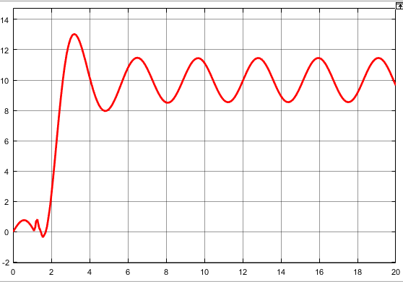
Figure 4-20 control effect of superimposed sinusoidal disturbance

4.8.4 simulation analysis
Figure 4-20 experimental results show that the designed system of sinusoidal disturbance suppression effect is not satisfactory, to this, we turn to the literature, the commonly used methods for the use of sliding mode control to suppress sinusoidal disturbances, there are few research try to expand synovial control and observer combined to study the inhibition of sinusoidal disturbances, we will set in the course of the future and to do further research on this question in the study.

5 Conclusion (5 point)

5.1 project summary
Based on the existing theories, this project learned to digest and absorb, independently built a discrete adr control system, tried to set the parameters of the controller, and studied its performance through numerical simulation. At the same time, some problems were found: the suppression effect of periodic disturbance was poor; Parameter setting is still difficult; Theoretical analysis of frequency response is still inadequate. We will do further research on this issue in future courses and researches.

5.2******'s experience:
In this course, I was responsible for leading a team of five people to conduct research on the whole topic. Among them, I was responsible for modeling, simulation and analysis, and familiar with all the details. Difficulty relatively large due to the study of theory, we during the undergraduate course of study is mainly confined to the linear SISO system, is not very familiar with this kind of control theory, introduction is difficult, therefore, spent more time, through our mutual cooperation and encourage each other, will target down into pieces, finally completed the basic research of target smoothly. Active disturbance rejection control is a new type of controller originated from nonlinear PID controller, including the idea that the modern control theory emphasizes the opposite of mathematical model, which is of great significance to replace the PID control still in use at present. Therefore, we plan to further study this problem in the later course design.
This research has improved my skills in MATLAB and the theoretical level of control science, which is of great significance for the in-depth research of the follow-up postgraduate stage.

5.3******'s experience
In this project, I was responsible for tracking the differentiator.Due to some characteristics of the system, it is difficult to balance overshoot and adjustment time.The tracking differentiator introduced this time can solve this contradiction. While accelerating the response speed of the system and entering a stable state quickly, it will not produce too much overshoot. It can be said that it can have it both ways.
At the same time of constructing the system, we also find the connection and gap between theory and practice. Although the knowledge on the book is very complete, but when solving specific problems, or need to change the train of thought, from different angles to analyze, consider, in order to get the best results.
Especially in the process of simulation, some problems that are easy to be ignored can be found more easily. Combined with the specific simulation results, some difficult diseases can be more easily solved.
Through this simulation project, I have achieved a leap from book knowledge, theory to practical problems, which enables me to have a deeper understanding of the previous knowledge and get new experience and progress at the same time.

5.4 ******'s experience
So what we did was we did adrc, and I was responsible for the design of the extended observer. At first, I wanted to do uav, but considering the actual situation, I chose auto-disturbance rejection. We are a group of five, including three parts: system planning, system analysis and system design. Two are responsible for planning, one for analysis, and two for design. I was responsible for the design with a group of members, and I was responsible for the content of the previous part, expansion observer, system functional structure design and so on. It took two weeks, in fact, the actual working time is only a few days, early topic selection and data search with a lot of time, for the adr system, I looked up a lot of information on the Internet including journal papers, some advanced thinking and technology. Because it was the first time to complete an independent and complete system, the communication with teammates was not very perfect at the beginning. For example, the implementation in the later stage could not be consistent with the requirements in the early stage, which led to a great difference between the test function at the beginning and the final implementation.

5.5 ******'s experience
Nonlinear PID is based on the traditional PID introduced nonlinear factors to improve, the basic elements of the control quantity is not directly from the input-output error, but after the nonlinear change of the error proportion, integration and differentiation.
Through practical operation, it is found that the setting of nonlinear PID is not easy, and it is likely to cause the distortion of self-excited oscillation or transient intermodulation of the control loop and damage to the controlled object.If the dynamic characteristics of the system are simply pursued, the obtained parameters are likely to make the control signal too large. Such parameters may lead to the instability of the system due to the inherent saturation characteristics of the actual system and other unknown factors in the application, so the dynamic characteristics of the system and the control input energy should be comprehensively considered.
Through different methods of testing and debugging, such as close test method, critical comparison method and attenuation curve, PID performance was improved. In the process of continuous improvement, I had a deeper understanding of nonlinear PID.

5.6 ******'s experience
After a few weeks of designing an ADRC course, we have only just scratched the surface of the surface in this respect, and the profound knowledge of the true essence is still to be explored, but we still learn a lot.
Everything is difficult at the beginning. As a subject rarely touched before, I really felt I had no way to start at the beginning, so I could only study the existing papers slowly and gradually, and then try to explore step by step. In addition, in the process of matlab simulation, good results are not expected for many times, then, after many times of trying, to get a relatively satisfactory result, however, the effect of adjusted many times, many unstable factors still exist, in the study, we will continue to explore.
Through this course design, we have exercised our ability to analyze and solve problems, cultivated better team spirit, communication ability and practical ability, cultivated the style of combining theory with practice, and accumulated experience for future development practice.

References
- han jingqing, wang wei. Nonlinear tracking -- differentiator [J]. Systems science and mathematics, 1994,14(3): 177-183.
- Han jingqing. Nonlinear state error feedback control law -- NLSEF [J]. Control and decision-making,1995, 10(3): 221-226
- Han jingqing. Adrc and its application [J]. Control and decision-making, 1998, 13(1): 19 -- 23.
- han jingqing. Control theory -- model theory or cybernetics [J]. Systems science and mathematics, 1989,9(4): 328 -- 335.
- Han jingqing. Auto-disturbance rejection control of time-delay objects [J]. Control engineering, 2008, 15(add): 7-11.
- han jingqing. Adrc control technology -- control technology for estimating compensating uncertain factors [M]. Beijing: national defense industry press, 2008
- Wang l J, li q, tong z s, et al. Review of adrc for time-delay systems [J]. Control theory and application, 2013, 30(12): 1521-1533. (in Chinese)
- Xia y q, fu m y, deng z h, et al. Research progress of sliding mode control and adrc [J]. Control theory and application, 2013, 30(2): 137-147. (in Chinese)
- GUO B, ZHAO z. On convergence of differentiators [J]. International Journal of Control, 2011, 84(4): 693-701.
- Zhao zhiliang, guo baozhu. Stabilization of self-disturbance rejection control on wave equation with boundary disturbance and anti-damping in interval [J]. Control theory and application, 2013, 30(12): 1553-1563
- XU Zhicai, WANG Yongji. Optimal control of nonlinear system-based onlinear extended state observer [C] //Proceedings of the 30th Chinese control Conference. Yantai: IEEE, 2011: 97 -- 101.
- Yang ruiguang, sun mingwei, Chen zhengqiang. Optimization and simulation of aircraft adrc attitude control [J]. Journal of system simulation, 2010, 22(11): 2689-2693.
- Wang haiqiang, huang hai. Performance and application of extended state observer [J]. Control and decision-making,2013, 28(7): 1078-1082.
- Shi chenxi. Research on adrc and parameter setting method of controller [D]. Jiangnan university, 2008.
- Chen xing. Parameter setting method of adrc and its application in thermal process [D]. Beijing: tsinghua university, 2008.
- Yang yao. Research on a nonlinear PID control algorithm for digital electric steering gear [J]. Journal of northwest polytechnic university, 2010, 28(3).
- Wan hui. Stability analysis and application of adrc [D]. Beijing: institute of mathematics and systems science, Chinese academy of sciences, 2001
- Zhang r, han J q. adrc based on neural network [J]. Journal of system simulation,2000, 12(2): 149-151. (in Chinese)
- Hou l m, zhang h g, liu x c. SPMSM auto-disturbance rejection -- passive control with ESO adaptive sliding mode adjustment [J]. Control & decision, 2010, 25(11): 1651 -- 1656. (in Chinese)
- Wang yuhang, yao yu, mark MAO. Analysis and application of Fal function filter [J]. Journal of motor and control, 2010, 14(11): 88-92.
- Lin f, sun h, zheng q l, et al. A novel extended state observer with measurement noise system [J]. Control theory and application, 2005, 22(6): 995-998. (in Chinese
- HERBST g. Practical active disturbance rejection control: bump less transfer, rate limitation and incremental algorithm [J]. IEEE the Transactions on Industrial Electronics, 2016, 63 (3) : 1754-1762.
- Zhang ting. Design of four-rotor flight controller based on ADRC [D]. Northeast university, 2013.
- Meng fandong. Design and research of adrc [D]. Harbin university of science and technology, 2009.

Appendix

