To run the system, in a terminal first run roscore
then In another terminal, cd into the turtledamola workspace then run " roslaunch turtledamola3 teleoperation.launch"
turtledamola3 is the package (name) containing all the scripts and teleoperation.launch represents one of the launch files.
There are four launch files for five different scripts.
The launch files are called:
- autonavigation.launch
- teleoperation.launch
- wallAvoidance.launch
- multipleturtles.launch

I initialize the turtlesim in every launch file so that I don’t have to run it in the terminal. I will briefly be explaining what each launch file does and what script they launch.

1. "autonavigation.launch" launches the python script called "autoNavigation3.py" that allows the turtle go to a specific set goal.(the goal is specified in the code and can be changed easily) The code sets up the publisher to send velocity commands, subscribes to the turtle's pose to get its position then defines parameters that sets the goal position. The code also calculates the angle between the turtle and the goal and checks if the turtle has reached its goal. If it has, the terminal will print out "turtle has reached the goal"
The script starts by setting up a publisher for sending velocity commands to the turtle, and initializing a ROS node called "navigate". The script sets the desired rate of velocity commands at 10 Hz, and subscribes to the "/turtle1/pose" topic to get the position of the turtle.
Then, the script sets the goal position for the turtle to (4,6) [this is what I change when I want to change the goal] and enters a control loop to move the turtle towards the goal. In each iteration of the loop, it calculates the angle between the turtle's current position and the goal. If the turtle has reached the goal, the loop breaks and the script logs a message indicating the turtle has reached the goal.
If the turtle has not reached the goal, the script sets the linear velocity to 5 units per second and the angular velocity to 20 * (angle - turtle_pose.theta), which causes the turtle to move towards the goal while adjusting its orientation to face the goal. The velocity commands are published and the script waits for the desired rate of 10 Hz before the next iteration.
Finally, the script uses a try-except block to handle the case when the ROSInterruptException is raised, allowing the script to gracefully shut down.

2. "teleoperation.launch" launches the python script called "teleoperation2.py" that allows you use keyboard inputs to move the turtle. different keys have been set and you will be informed which one does what when you launch.
The script controls the movement of the turtle in the turtlesim environment. The turtle can be moved in different directions (up, down, left, right, clockwise, counter-clockwise) and stopped based on user inputs through the keyboard. The script sets up a node "teleoperation_node" in the ROS (Robot Operating System) network and creates a publisher to send velocity commands to the turtle. It changes the terminal settings and waits for the user to press a key to control the movement of the turtle. Based on the user input, the script sets the velocity of the turtle and publishes the velocity through the publisher. The script continuously listens for user input and updates the turtle's velocity accordingly.
The programs defines a function to allow keyboard input. it defines the keys that can be inputed and prints out instructions on what each key does. it sets the velocity based on the key clicked and publishes the velocity. it also initializes the node, creates a publisher for the velocity and continuously receives keyboard input. If the wrong key is inputted, the node closes.

3. "wallAvoidance.launch" launches the “avoidwall3.py” python script where the turtle goes in random in the window while trying to avoid the wall.
The turtle moves towards a set goal position while avoiding wall collisions. The goal position is periodically changed to a random position within the simulation environment. The turtle's movement is controlled by sending velocity commands to the simulation environment via a ROS publisher. The turtle's current position and orientation are obtained through a ROS subscriber that listens to the turtle's pose information.
The control loop operates at 10 Hz and consists of the following steps:
- Calculate the angle between the turtle and the goal position.
- Check if the turtle is about to hit a wall. If so, move the turtle away from the wall by setting the linear velocity to -0.5 and the angular velocity based on the angle between the turtle and the wall.
- If the turtle is not about to hit a wall, check if it has reached the goal. If so, choose a new random goal. If not, move the turtle towards the goal by setting the linear velocity to 5 and the angular velocity based on the angle between the turtle and the goal.
- Publish the velocity command and sleep for the desired loop rate.
The code continuously checks the turtle's position to see if it's about to hit a wall. If it is, the turtle's movement is overridden to move away from the wall to a random position. The image below shows the turtle moving in random while avoiding hitting the wall.
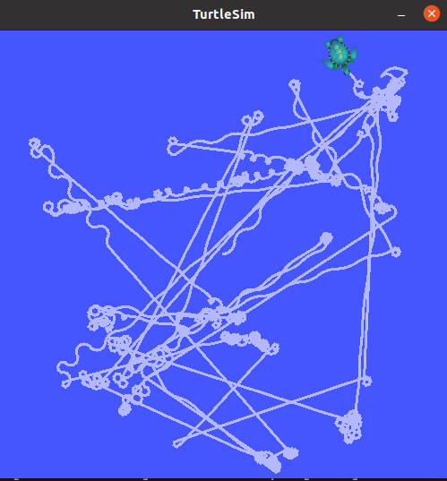

4. "multipleturtles.launch" launches the "multipleVacuum4.py" and “spawn.py” script. The “multipleVacuum4” script creates two instances of the "Turtle" class, which is used to control the movement of two TurtleBot robots in the ROS simulation environment. The Turtle class has the following attributes and methods:
- pubOne and pubTwo: Publishers that publish Twist messages to control the linear and angular velocities of the two robots.
- twistOner and twistTwoer: Twist messages that store the initial linear and angular velocities of the two robots. These velocities are randomly generated using the uniform method from the random module.
- moveOne and moveTwo: Methods that publish Twist messages to the robots to make them move. The linear and angular velocities are randomly generated each time the methods are called.
In the main section of the script, the rospy.init_node function initializes a ROS node named turtle_random_movement. Then, an instance of the Turtle class is created and stored in the turtle1 variable. A loop is run at a rate of 10 Hz, calling the moveOne and moveTwo methods to make the robots move randomly.
The “spawn.py” script creates a service proxy to call the 'spawn' service and then calls the 'spawn' service using the 'spawn_turtle' proxy to spawn a turtle in the ROS environment. The parameters passed to the 'spawn' service are:
- 2.0: X coordinate for the initial position of the turtle in the environment
- 3: Y coordinate for the initial position of the turtle in the environment
- 1.7: initial orientation of the turtle in radians
- "turtle2": name of the turtle
This creates another turtle when launched. The output when the "multipleturtles.launch" file is launched is shown in the image below.

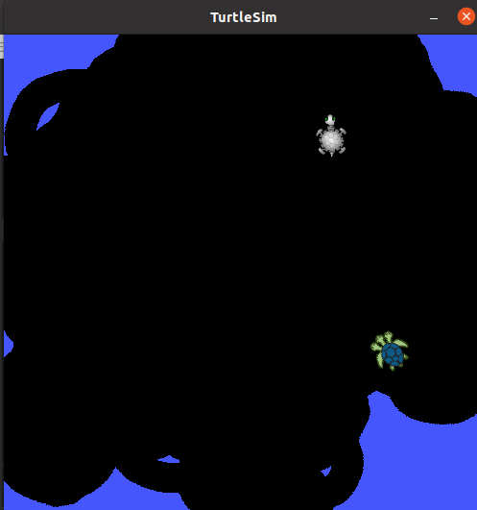
The image below shows the window after the script has been running for a while. The screen is almost completely covered.

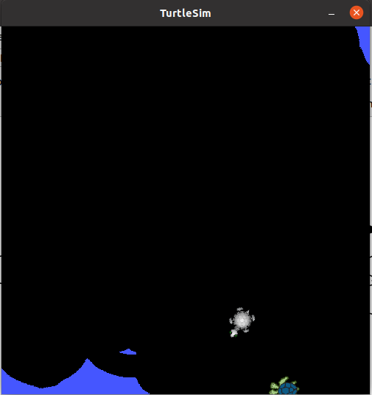
The image below shows how the topics and nodes in my system interact with each other. I got it using rqt_graph.
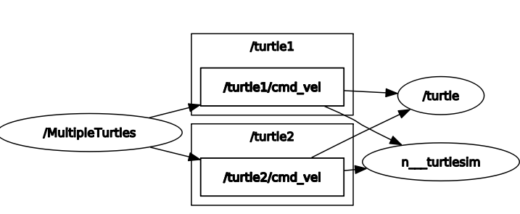

The main python libraries imported for all the scripts were "rospy", "math", "geometry_msgs.msg", "turtlesim.msg" and "random"
The terminal is case sensitive to the script and launch file names.

