Name: Daanish Muzaffar  Student ID: 7259472  Course: M.Sc. Economics and Finance | Structured Product Pricing and Risk Analysis on Rheinmetall AG  Eberhard Karls Universität Tübingen · B401: Continuous-Time Derivatives Pricing · Summer Term 2026 | 

PART 1: DESIGNING THE PRODUCT
Task I: Investor Profile
Dimension | Description
Investor | German retail saver, age 40–60
Perspective | 3–5 years. Expects +15–30% from the defence re-rating (€100bn programme).
Risk tolerance | Low. Needs full capital protection. RHM's ~40% vol is too high.
Alternatives | Beats direct stock, defence ETF, bank deposits, reverse convertibles
Task II: Product Design
Product: Capped Capital Protected Participation Note on RHM.DE
Structure: ZCB + 85.2% × [Call(1,207) − Call(1,569)]
S₀=EUR 1,207 | T=3 y | σ=39.88% (full-sample hist.) | r(3y)=2.62% (Svensson, ECB AAA) | q=0.95%
Component | EUR
ZCB present value | 1,115.79
ATM call (K=1,207) | 338.64
Cap call (K=1,569, short) | 231.59
Net spread | 107.04
Participation α | 85.2%
Max gain at cap | +25.6% (1,515.53)
The zero bond guarantees the EUR 1,207 nominal. The short 130% call pays for the 85.2% participation. The participation rate is stable across vol levels.
Task III: Payoff Profile
The note beats the stock below S₀=1,207 and beats the risk-free bond above roughly EUR 1,323. Above the cap at 1,569 the payoff is fixed at EUR 1,516 and the stock pulls ahead.
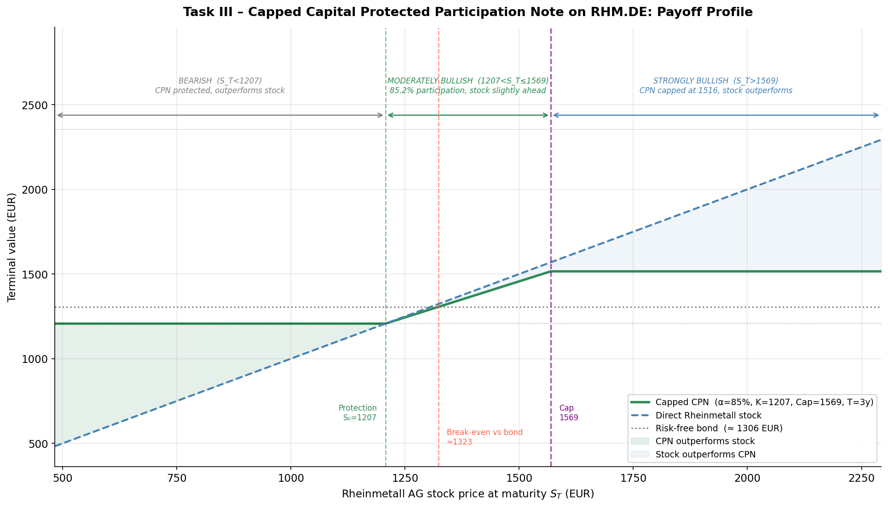
Fig. 1: Certificate vs stock payoff at maturity.
S_T | CPN | Stock | Region
844.9 | 1,207.00 | 844.9 | Protected
1,207.0 | 1,207.00 | 1,207.0 | Floor (ATM)
1,322.8 | 1,305.67 | 1,322.8 | Break-even vs bond
1,569.1 | 1,515.53 | 1,569.1 | At cap
2,051.9 | 1,515.53 | 2,051.9 | Capped
Task IV: Market Size
Segment | EUR | Share
Total structured products | 112 bn | 100%
Capital protection (BSW 2023) | 4,254 mn | 3.80%
Participation notes (own est.) | ~2.3 bn | ~55%
Demand comes from capital-preserving savers with sector convictions, falling deposit rates and MiFID II suitability rules.
PART 2: VALUATION OF OUR CERTIFICATE
DU2076 Bonus Certificate with Cap on RHM.DE (DZ BANK)
Decomposition: Down-and-Out Put (K=2,000, B=1,050) + Capped Forward min(S_T, 2,000)
B=EUR 1,050 (continuous) | Bonus/Cap K=EUR 2,000 | S at issue = EUR 1,707.93 | barrier intact
Issued 04 Sep 2025, final valuation 18 Jun 2027 | Window: 04 Sep 2025 – 01 Jun 2026 (183 trading days, comfortably above the 100-day minimum)
Task V: Valuation with a Binomial Tree (N=500)
Daily inputs: maturity-matched ECB AAA Svensson rate (mean 2.14%, range 1.87–2.59%), 30-day rolling historical vol (mean 44.4%, range 26.3–58.6%), q=0.95%. The tree checks the barrier at every node. Black-Scholes cannot price the path-dependent knock-out.
Metric | Value
Mean Error (ME) | −94.25 EUR
MAE | 110.89 EUR
RMSE | 123.31 EUR
MAPE | 7.11%
Quartiles q25/q50/q75 | −153.59 / −95.02 / −56.44
The model underprices the market throughout the window. The market prices DU2076 at an implied vol of 37.0% on average while the model uses realized vol (mean 44.4%). Vega is negative, so the higher vol input pushes the model price below the market. The remaining gap is DZ BANK's issuer margin.
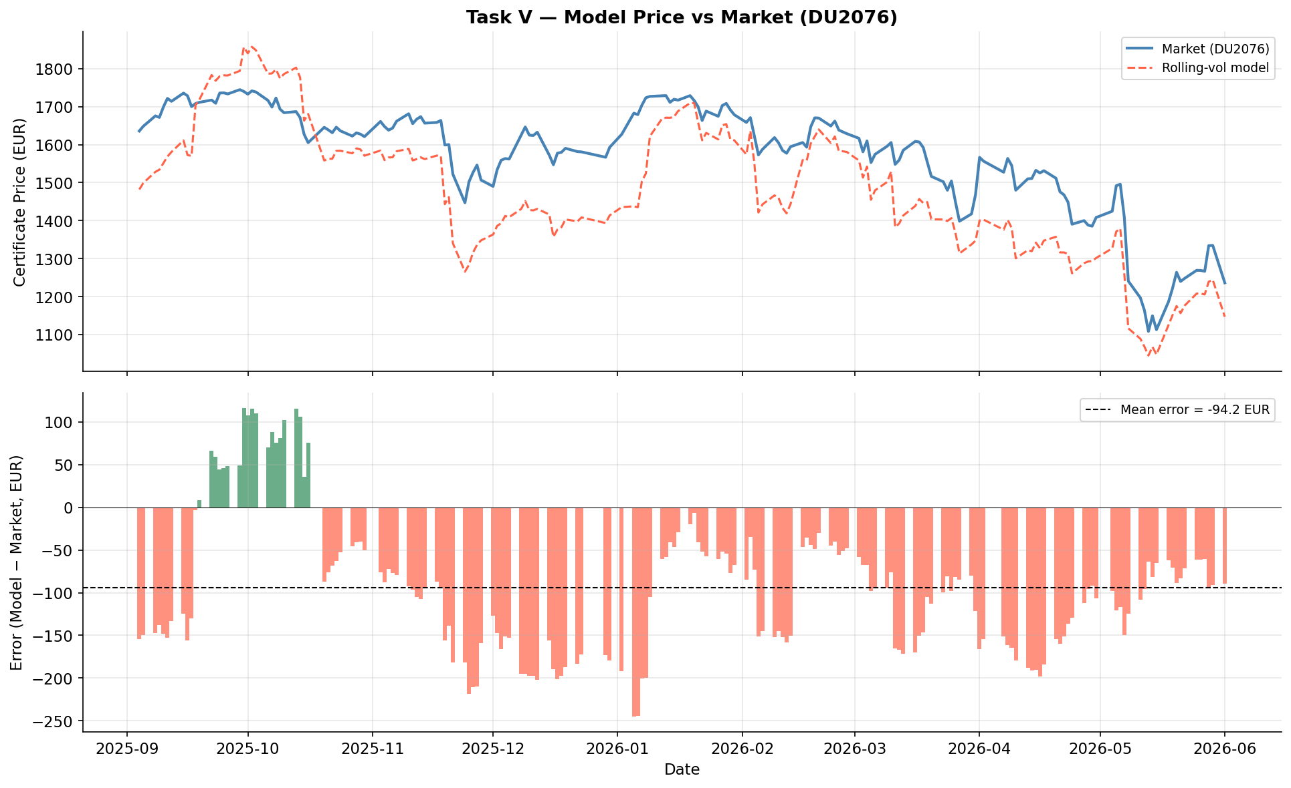
Fig. 2: Our model price vs DU2076 market price
Task VI: Sensitivity Analysis (Greeks)
Greeks evaluated at S=EUR 1,708, T=1.79 y, σ=44.7% (median rolling vol). Certificate value EUR 1,443.73.
Greek | Value | Key insight
Delta | 0.515 | Rises above 1 as S nears the barrier, falls near the cap
Gamma | −0.0006 | Negative at the cap, spikes at the barrier
Vega | −13.12 | Negative: higher vol raises knock-out risk and the value of the short cap call
Theta +0.52 EUR/day: passing time reduces barrier risk. Rho −12.1 EUR per +1pp: the bonus payment is discounted like a bond.
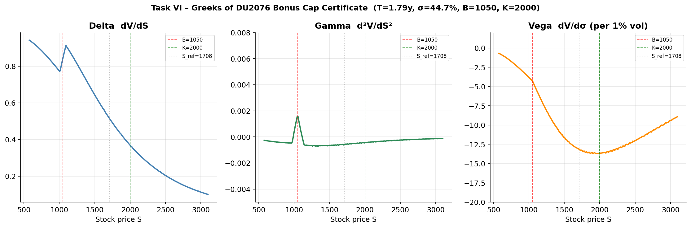
Fig. 3: Delta, Gamma and Vega
Task VII: Replicating Portfolio
Daily replication from the tree: V(t)=Δ(t)·S(t)+B(t). Delta ran from 0.20 to 1.06. The equity fraction Δ·S/V ran from 22% to 110% and was above 50% on 152 of 183 days. As RHM fell toward the barrier, Delta rose to 1 and the bond leg turned negative. The certificate concentrates stock exposure exactly when the market falls, the opposite of a capital-protected note. Below the barrier the payoff becomes a capped forward and the equity fraction sits near 81%, rising toward 98%.
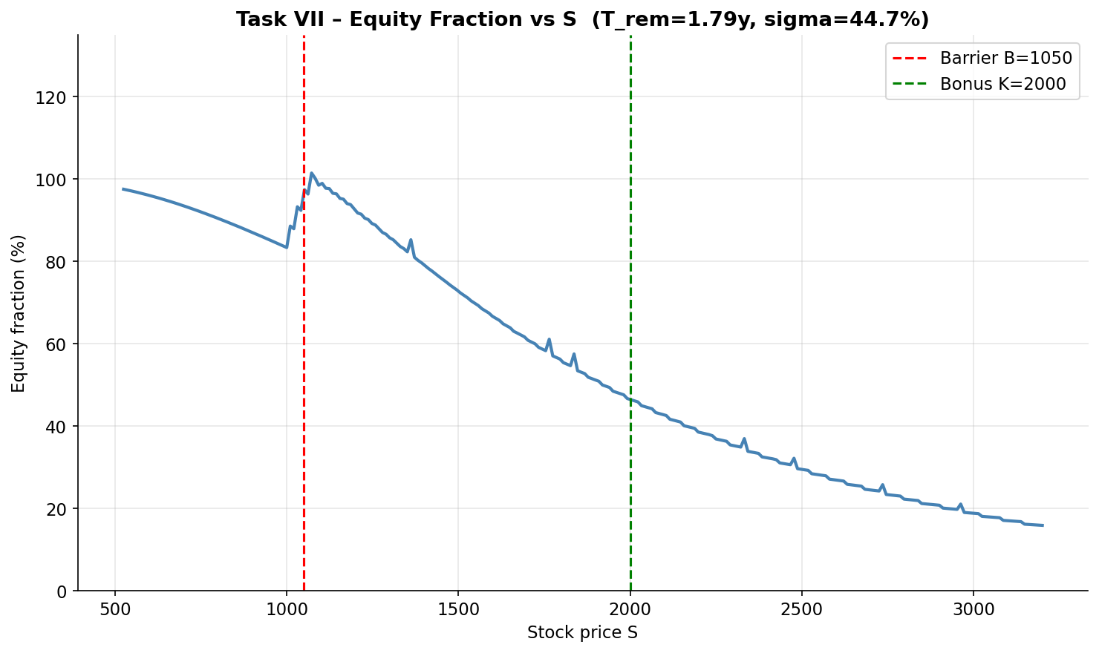
Fig. 4: Equity fraction (Δ×S / Value) vs stock price S.
PART 3: PORTFOLIO INSURANCE STRATEGY
EUR 10,000 | T*=1 y | S₀=EUR 1,207 | Risk-neutral log-drift r−q−½σ² = −8.27% p.a. (historical drift 54.05% for reference only) | σ=45.57% (252-day) | r=3.07% (10y Svensson) | q=0.95% (EUR 11.50/1,207 spot)
50,000 GBM paths × 252 steps | seed 2026 | SE(mean)=0.221% | simple wealth returns | terminal range EUR 136–7,666
Task VIII: Without Risk Management
Mean=2.16% | Std=49.34% | Skew=1.60 | VaR₉₅=56.38% | CVaR₉₅=63.60%
The simulated mean of +2.16% matches the risk-neutral benchmark e^(r−q)−1 = 2.14%. The negative log-drift is volatility drag, not a forecast of a falling stock. The distribution is strongly right-skewed with a heavy left tail. The unhedged 95% VaR of 56.38% is far above the 15% limit from Task XI, so the position must be hedged.
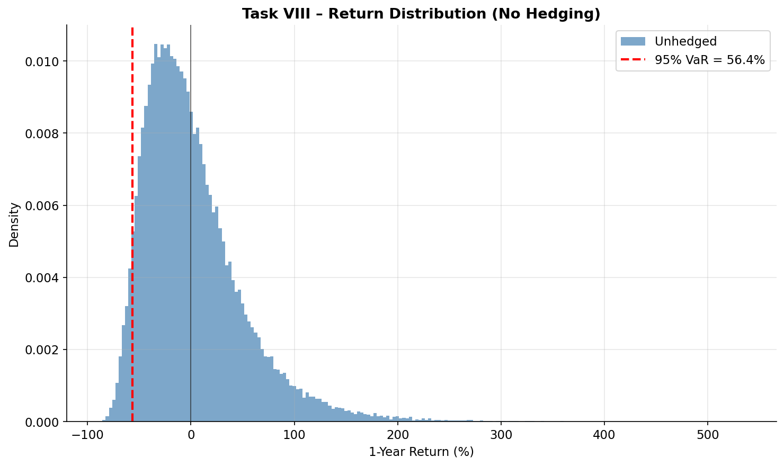
Fig. 5: 1-year return distribution, unhedged.
Task IX: Portfolio Insurance (α × K grid)
The portfolio holds (1−α) in stock and α in puts priced at σ=45.57%. α runs from 5% to 20%, strikes from 90% to 105% of S₀. VaR falls steeply up to α=10%, then turns U-shaped for strikes at or below 100%. Only K=105% keeps improving out to α=20%. The cheap 90% strike is best at α=10% (VaR 20.54%), near-the-money strikes win from α=15%. The grid minimum is α=15%, K=100% with VaR 14.73%. Larger put positions raise skew and barely change the mean. The table shows the K=105% strike used in Task XI.
α | Mean | Std | Skew | VaR₉₅ | CVaR₉₅
5% | 2.20% | 42.72% | 2.01 | 42.84% | 47.85%
10% | 2.25% | 36.51% | 2.54 | 29.30% | 32.10%
15% | 2.29% | 30.98% | 3.13 | 15.77% | 16.36%
20% | 2.33% | 26.53% | 3.55 | 14.92% | 15.45%
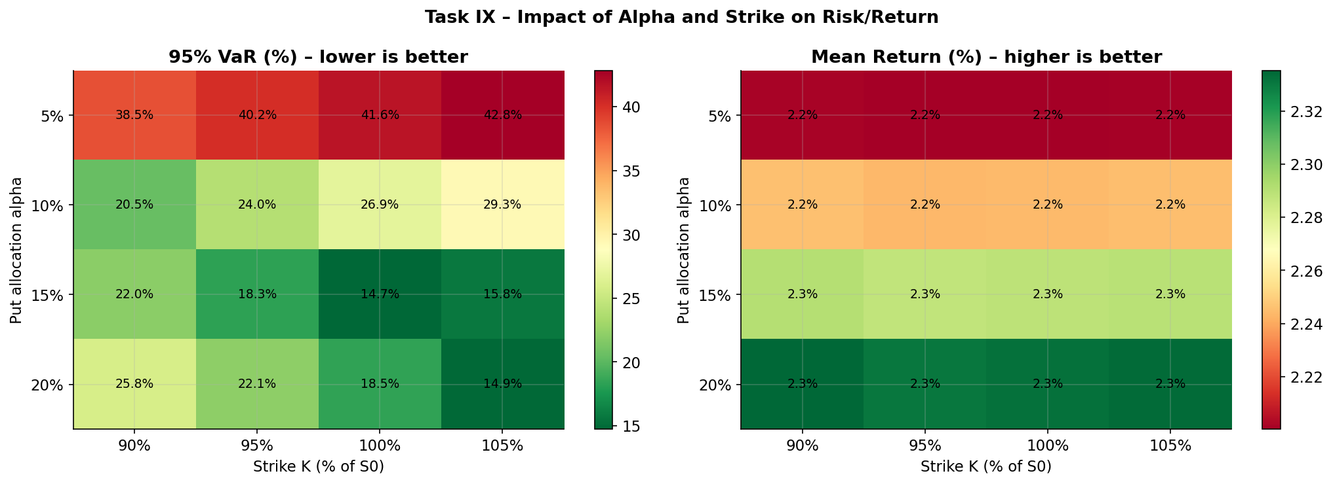
Fig. 6: 95% VaR (left) and mean return (right) across α and K.
Task X: Stress Scenarios (α=10%, K=95%S₀)
A ±5pp vol shock only changes the put purchase price. Costlier puts buy fewer contracts and VaR rises to 28.25%. Cheaper puts cut it to 18.44%. A −20% crash at mid-year turns the mean negative (−9.70%). Crash with vol +5pp is the worst case (VaR 30.58%, mean −11.64%). Crash with vol −5pp even beats the baseline VaR (19.11% vs 23.99%) because the cheap, larger put position ends up deep in the money. All six scenarios breach the 15% limit.
Scenario | Mean | Std | Skew | VaR₉₅ | CVaR₉₅
Baseline | 2.24% | 36.21% | 2.63 | 23.99% | 25.33%
Vol +5pp | 1.05% | 37.02% | 2.51 | 28.25% | 30.18%
Vol −5pp | 3.80% | 35.24% | 2.77 | 18.44% | 19.00%
−20% shock T/2 | −9.70% | 24.61% | 3.41 | 25.61% | 26.67%
Shock & vol +5pp | −11.64% | 25.65% | 3.16 | 30.58% | 32.13%
Shock & vol −5pp | −7.17% | 23.38% | 3.72 | 19.11% | 19.55%
Task XI: Optimal VaR-Constrained Allocation
The 95% one-year VaR may not exceed 15%. The unhedged VaR of 56.38% forces a hedge. Searching α from 0% to 50% for every strike shows the 90% and 95% strikes never reach the limit (best VaR 19.33% and 16.67%). Only the 100% and 105% strikes can meet it.
The constraint binds at α=15.30% with K*=105% (VaR 14.99%). Recommended allocation: α*=15.50%, VaR 14.41%, E[r]=2.29%. The 100% strike is a close runner-up (α=14.20%, VaR 14.49%).
That allocation puts EUR 8,450 in the stock and EUR 1,550 in one-year puts struck at EUR 1,267, for a VaR of 14.41%, 0.59pp under the ceiling. A risk manager sizes below a VaR limit rather than exactly on it, and here the buffer costs nothing in expected return.
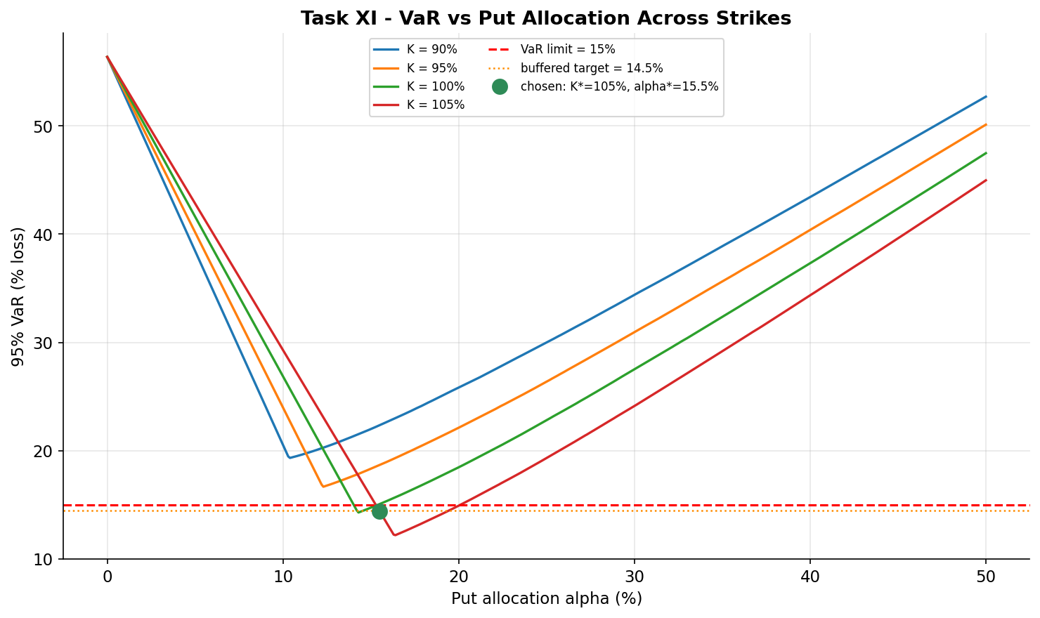
Fig. 7: 95% VaR vs α for all four strikes, with the 15% limit, binding point and α*=15.50% marked.

