Name: Daanish Muzaffar  Matriculation: 7259472 | Portfolio Insurance and Structured Product Pricing on Rheinmetall AG  Eberhard Karls Universität Tübingen · B401: Continuous-Time Derivatives Pricing · Summer Term 2026

PART 1 — DESIGNING CERTIFICATES
Task I: Investor Profile
Target: German retail saver aged 40–60, approaching retirement, holding pension-fund and real-estate savings. Seeks satellite equity exposure to European defence (NATO budget commitments, Germany's €100bn Sondervermögen) but cannot tolerate direct RHM.DE single-stock risk — σ=54.2% annualised far exceeds a conservative retail risk ceiling. A capped capital-protected participation note provides structured upside with a nominal floor at maturity. Investment horizon: 3 years, matching the product tenor and the investor's pre-retirement planning window.
RHM.DE σ: EWMA λ=0.94 → 54.17%; HV-30/60/90/252d: 54.41/54.09/50.38/45.57%

Task II: Product Design
Product: Capped Capital Protected Participation Note — RHM.DE
Structure: ZCB + 93.4% × [Call(1,207) − Call(1,569)]
S₀=EUR 1,207 | T=3 y | σ=54.17% | r(3y)=2.62% | q=0.60%
Component | EUR
ZCB present value | 1,115.79
ATM call (K=1,207) | 451.04
Cap call (K=1,569) | 353.43
Net spread | 97.61
Participation α | 93.4%
Max gain at cap | +28.0%

ZCB guarantees EUR 1,207 at maturity. The bull call spread delivers 93.4% participation up to the 30% cap; the short cap call finances the higher participation rate by monetising extreme upside.
Task III: Payoff Profile
Outperforms direct stock in falling / flat markets; underperforms above EUR 1,384 where the cap binds.
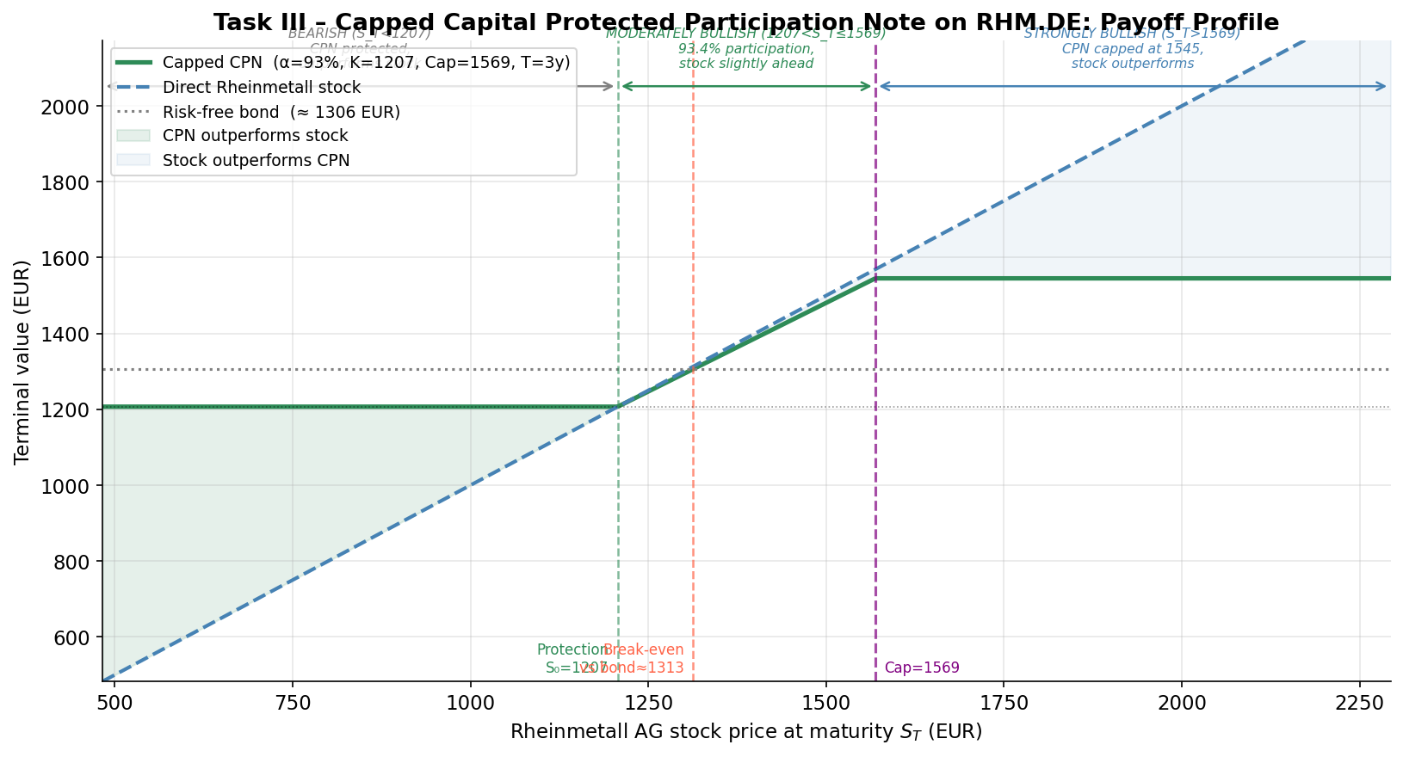
Fig. 1 — Certificate vs stock payoff at maturity.
S_T | CPN | Stock | Region
844.9 | 1,207 | 844.9 | Protected
1,207 | 1,207 | 1,207 | Floor
1,312 | 1,305 | 1,312 | Participating
1,569 | 1,545 | 1,569 | At cap
2,050 | 1,545 | 2,050 | Capped

Task IV: Market Size
Segment | EUR bn | Share
Total structured products | 112 | 100%
Kapitalschutz (BSW 2023) | 4.26 | 3.8%
Participation notes | 2.34 | ~55%
Avg. issue size | 0.033 | ~130 issues

Addressable market for a single-name RHM.DE capital-protected note: EUR 200–300 mn on EUWAX, based on comparable DDV-member issuances.
PART 2 — VALUATION OF CERTIFICATES
DU2076 Bonus Certificate with Cap on RHM.DE (DZ BANK)
Decomposition: Down-and-Out Put + Capped Forward
B=EUR 1,050 | K=EUR 2,000 | T≈1.80 y | S₀=EUR 1,707.93
Observation: 4 Sep 2025 – 18 Jun 2027 | Market prices: 1,236–1,636 EUR
Task V: Valuation — CRR Binomial Tree (N=200)
183 trading days (4 Sep 2025 – 1 Jun 2026); daily ECB Svensson rate matched to remaining maturity (mean r=2.14%, range 1.87–2.59%). Tree root on day 1: V_cert=EUR 1,558.89 vs market EUR 1,635.75. EWMA σ=44.27% (λ=0.94) vs back-solved implied vol σ_IV=37.77%.
Metric | EWMA | Implied Vol
Mean Error | −85.54 | −8.89
MAE (EUR) | 94.49 | 9.82
RMSE (EUR) | 108.92 | 12.37
MAPE | 6.11% | 0.64%
Mean vol | 44.27% | 37.77%

EWMA overestimates volatility relative to the option-implied level (44.27% vs 37.77%), causing systematic underpricing of EUR 85.54 per cert (6.1%). Implied vol reduces the error to EUR 8.89 (0.64%), confirming the CRR model structure is correct.

Worst error: 01 Jun 2026 (barrier proximity + vol spike). Best fit: 17 Nov 2025.
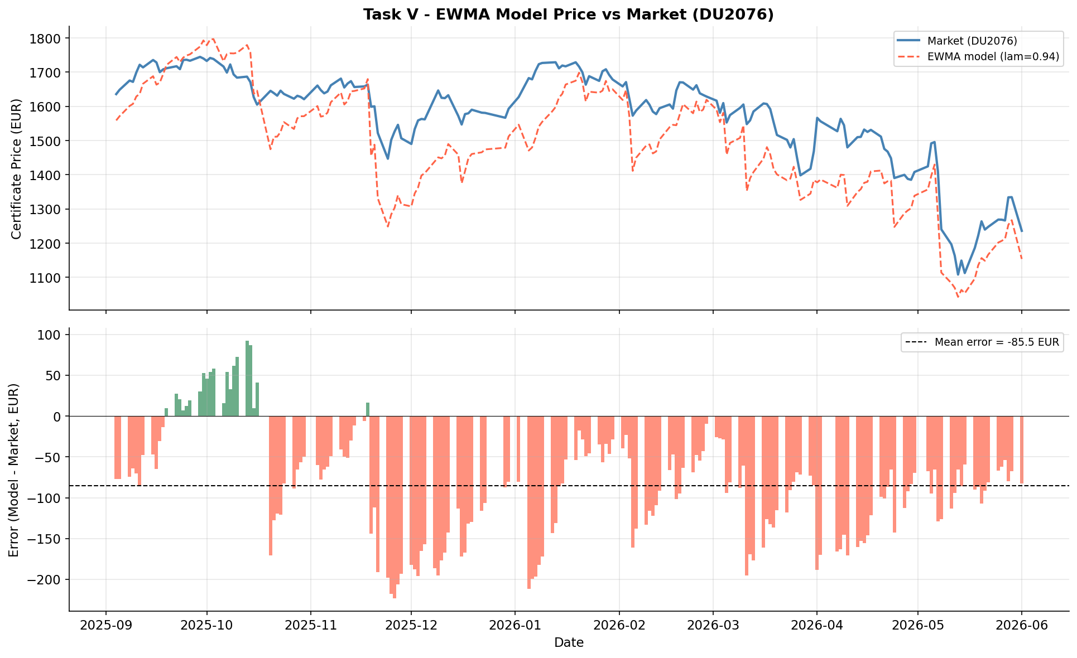
Fig. 2 — EWMA model price vs DU2076 market price, Sep 2025 – Jun 2026.
Task VI: Sensitivity — Greeks
Central finite differences at S=EUR 1,708, T=1.79 y, σ=44.6%, r=2.14%. Cert value at reference: EUR 1,457.77.
Greek | Value | Key insight
Delta | 0.245 | Near capped-forward; low directional exposure
Gamma | ≈ 0.000 | Negligible here; spikes negative near barrier
Vega | −13.55/pp | Negative — vol raises knock-out probability
Theta | +0.36/day | Positive — time reduces knock-out risk
Rho | −1.82/pp | Higher rates reduce PV of capped forward

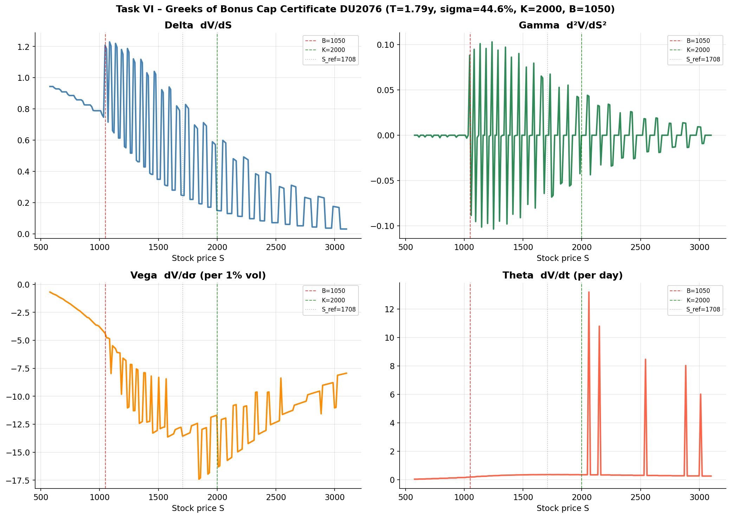
Fig. 3 — Delta, Gamma, Vega, Theta vs stock price S.
Task VII: Replicating Portfolio
Dynamic delta-hedging: Δ×S in RHM.DE stock + bond. Equity fraction = Δ×S / Value. As S fell toward B=EUR 1,050 over Sep 2025–Jun 2026, Delta rose toward 1.0 — the cert behaved like a leveraged stock position near the barrier. Near B, fraction exceeds 130%: portfolio goes short bonds, leveraged long stock to hedge the down-and-out put. Above B the fraction falls to near zero (capped forward mode). Barrier breach eliminates the put — no capital floor remains.
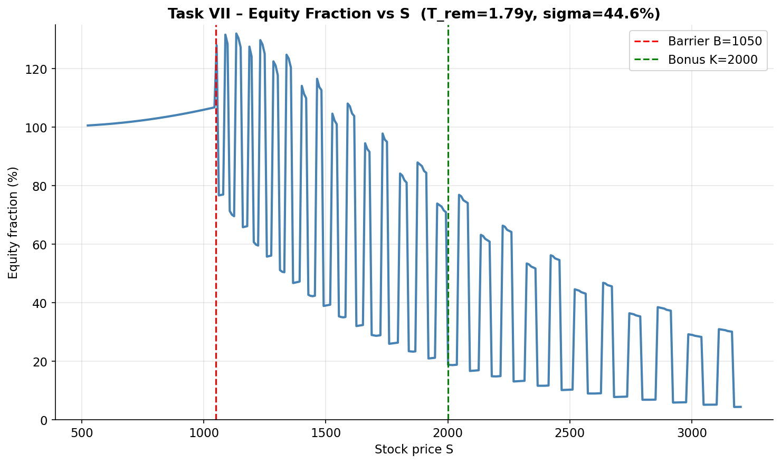
Fig. 4 — Equity fraction (Δ×S / Value) vs stock price S.
PART 3 — PORTFOLIO INSURANCE STRATEGY
EUR 10,000 | T*=1 yr | S₀=EUR 1,207 | μ=54.05% | σ=39.88% | r=3.07%
50,000 GBM paths × 252 steps | seed 2026 | Terminal range: EUR 330–11,233
Task VIII: Without Risk Management
Mean=54.03% | σ=39.92% | Sharpe=1.277 | VaRₕ=11.32% | CVaRₕ=28.38% | P(loss)=8.7%

Log-returns nearly symmetric (skewness=0.007), consistent with GBM. 91.3% of paths finish above S₀. The unhedged 95% VaR=11.32% is the baseline — counter-intuitively, adding insurance raises this metric (see Task IX).
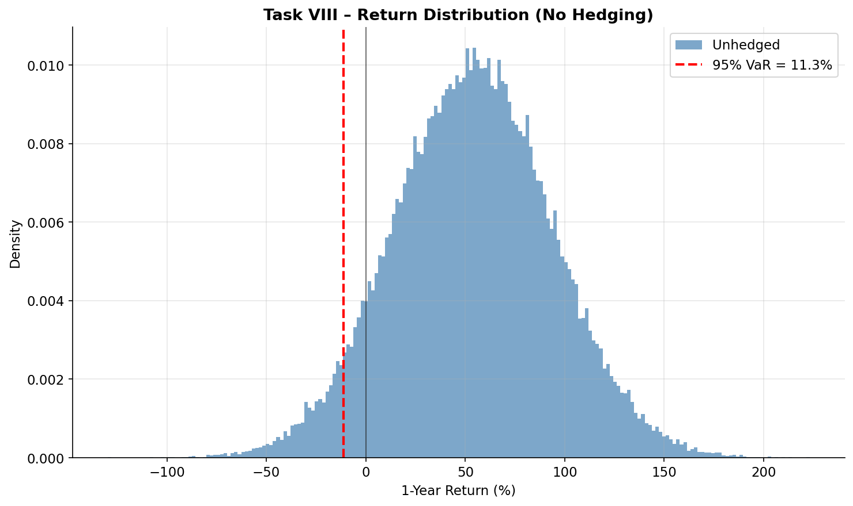
Fig. 5 — Terminal wealth distribution, unhedged (50,000 GBM paths).
Task IX: Portfolio Insurance — Full Grid
(1−α)×stock + α×BS puts (σ=39.88%). In this high-drift regime VaR rises with α: puts expire worthless at the 5th-percentile tail, so premium drag dominates. Higher K (ATM puts) reduces VaR at a given α by paying off in more downside paths.
α | K | Mean | Sharpe | VaR | CVaR | P(loss)
5% | 95%S₀ | 49.50% | 1.201 | 13.63% | 22.15% | 10.9%
10% | 95%S₀ | 44.66% | 1.105 | 16.00% | 16.79% | 13.7%
15% | 95%S₀ | 39.49% | 0.990 | 16.07% | 18.77% | 17.1%
20% | 95%S₀ | 34.32% | 0.851 | 16.07% | 19.02% | 20.1%

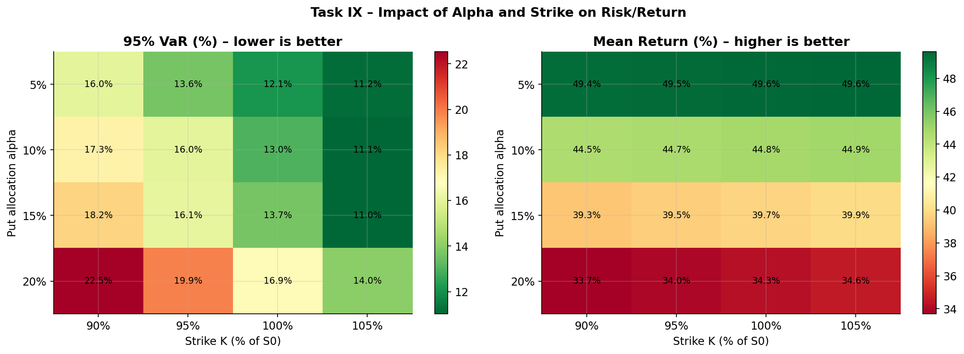
Fig. 6 — 95% VaR (left) and mean return (right) across α and K.
Task X: Stress Scenarios (α=10%, K=95%S₀)
Only Vol −5pp is VaR-compliant (13.62% < 15%). The −20% mid-horizon shock is the dominant stress driver — it triples P(loss) to 29.8% and collapses mean return to 24.82%, far beyond pure volatility perturbations. This confirms path dependency (entry-point timing) matters more than vol estimation error.
Scenario | Mean | VaR 95% | CVaR 95% | P(loss)
Baseline | 44.66% | 16.00% | 16.79% | 13.7%
Vol +5 pp | 44.52% | 16.77% | 19.40% | 13.7%
Vol −5 pp | 44.84% | 13.62% | 14.73% | 13.7%
−20% shock T/2 | 24.82% | 17.07% | 17.70% | 29.8%

Task XI: Optimal VaR-Constrained Allocation
Constraint: 95% one-year VaR ≤ 15% at K=95%S₀. Brentq root-finding on VaR(α)=15% (monotone confirmed over α∈[0.1%,40%]).
α* = 7.90% | VaR = 15.00% | E[r] = 46.73% | Sharpe = 1.148
VaR is monotone increasing in α: at the 5th percentile the stock has risen modestly (μ dominates), so the put expires worthless and only the premium drag remains — making more insurance costlier at the VaR quantile. α*=7.90% is the regulatory ceiling; above it the constraint is violated.
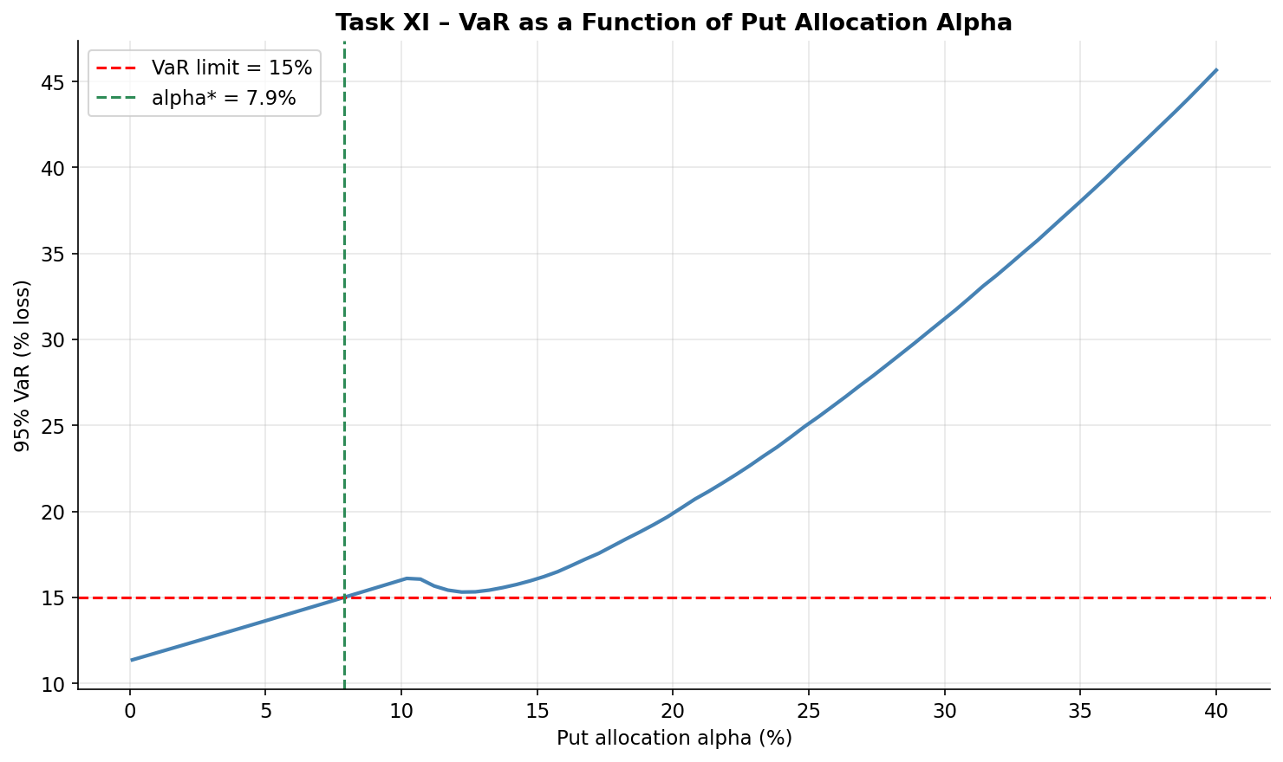
Fig. 7 — 95% VaR vs α (K=95%S₀); 15% limit and α*=7.90% marked.

