Name: Daanish Muzaffar  Student ID: 7259472 | Structured Product Pricing and Risk Analysis on Rheinmetall AG  Eberhard Karls Universität Tübingen · B401: Continuous-Time Derivatives Pricing · Summer Term 2026 | 

PART 1: DESIGNING CERTIFICATES
Task I: Investor Profile
Dimension | Description
Investor | German retail saver, age 40–60
Perspective | 3–5 years. Expects +15–30% from the defence re-rating (€100bn programme).
Risk tolerance | Low. Needs full capital protection. RHM's ~40% vol is too high.
Alternatives | Beats direct stock, defence ETF, bank deposits, reverse convertibles
Task II: Product Design
Product: Capped Capital Protected Participation Note on RHM.DE
Structure: ZCB + 85.2% × [Call(1,207) − Call(1,569)]
S₀=EUR 1,207 | T=3 y | σ=39.88% (full-sample hist.) | r(3y)=2.62% (Svensson, ECB AAA) | q=0.95%
Component | EUR
ZCB present value | 1,115.79
ATM call (K=1,207) | 338.64
Cap call (K=1,569, short) | 231.59
Net spread | 107.04
Participation α | 85.2%
Max gain at cap | +25.6% (1,515.53)
The zero bond guarantees the EUR 1,207 nominal at maturity. Selling the 130% call funds the 85.2% participation. Both calls gain from higher volatility, so the participation rate stays stable when volatility moves.
Task III: Payoff Profile
Below EUR 1,207 the note repays the full nominal and beats holding the stock. From roughly EUR 1,323 it also beats the risk-free bond. Above the cap at EUR 1,569 the payoff is fixed at EUR 1,516, and only there does the stock pull ahead.
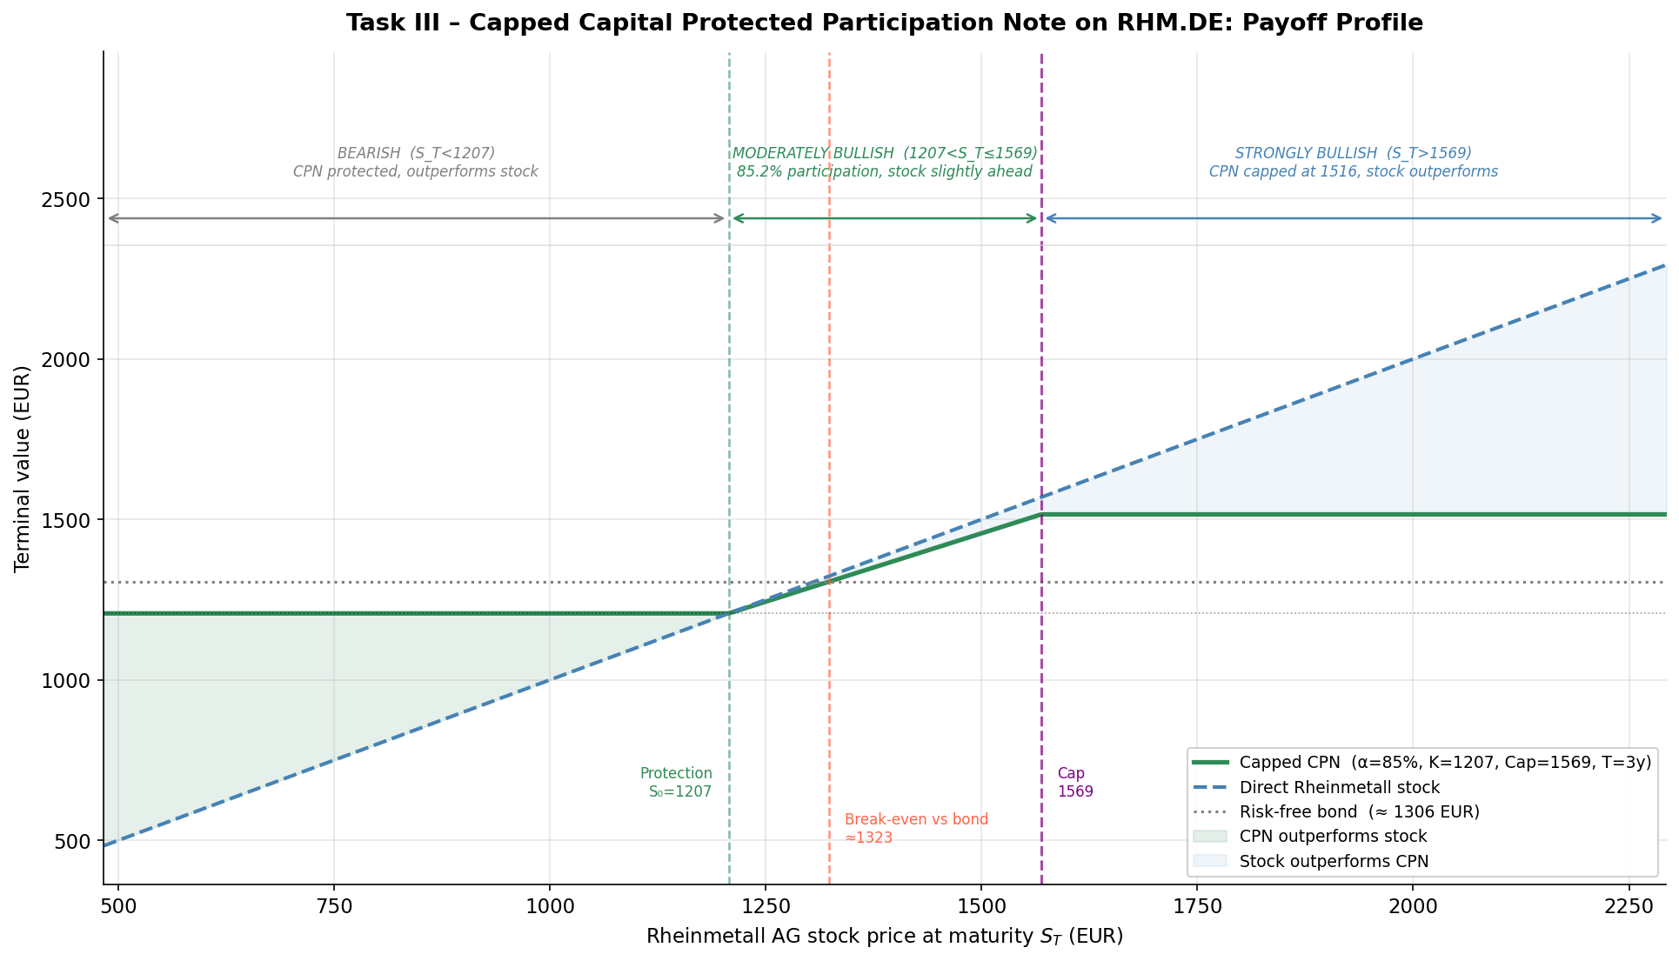
Fig. 1: Certificate vs stock payoff at maturity.
S_T | CPN | Stock | Region
844.9 | 1,207.00 | 844.9 | Protected
1,207.0 | 1,207.00 | 1,207.0 | Floor (ATM)
1,322.8 | 1,305.67 | 1,322.8 | Break-even vs bond
1,569.1 | 1,515.53 | 1,569.1 | At cap
2,051.9 | 1,515.53 | 2,051.9 | Capped
Task IV: Market Size
Segment | EUR | Share
Total structured products | 112 bn | 100%
Capital protection (BSW 2023) | 4,254 mn | 3.80%
Participation notes (own est.) | ~2.3 bn | ~55%
Demand comes from capital-preserving savers with sector convictions, falling deposit rates and MiFID II suitability rules.
PART 2: VALUATION OF CERTIFICATES
DU2076 Bonus Certificate with Cap on RHM.DE (DZ BANK)
Decomposition: Down-and-Out Put (K=2,000, B=1,050) + Capped Forward min(S_T, 2,000)
B=EUR 1,050 (continuous) | Bonus/Cap K=EUR 2,000 | S at issue = EUR 1,707.93 | barrier intact
Issued 04 Sep 2025, final valuation 18 Jun 2027 | Window: 04 Sep 2025 – 01 Jun 2026 (183 trading days, comfortably above the 100-day minimum)
Task V: Valuation with a Binomial Tree (N=500)
Each day is priced with its own maturity-matched ECB Svensson rate, which averaged 2.14%, and the 30-day rolling historical volatility, which averaged 44.4%. The tree checks the barrier at every node. Black-Scholes cannot price this path-dependent knock-out.
Metric | Value
Mean Error (ME) | −94.25 EUR
MAE | 110.89 EUR
RMSE | 123.31 EUR
MAPE | 7.11%
Quartiles q25/q50/q75 | −153.59 / −95.02 / −56.44
The model underprices the market throughout the window. The market prices DU2076 at an implied volatility of 37.0% on average, while the model uses realized volatility averaging 44.4%. Vega is negative, so the higher vol input pushes the model price below the market. The remaining gap is DZ BANK's issuer margin.
The best fit is 18 Sep 2025 with an error of EUR 3. The worst is 05 Jan 2026 with EUR 245, when realized vol ran at 53.6% against an implied 35.3%.
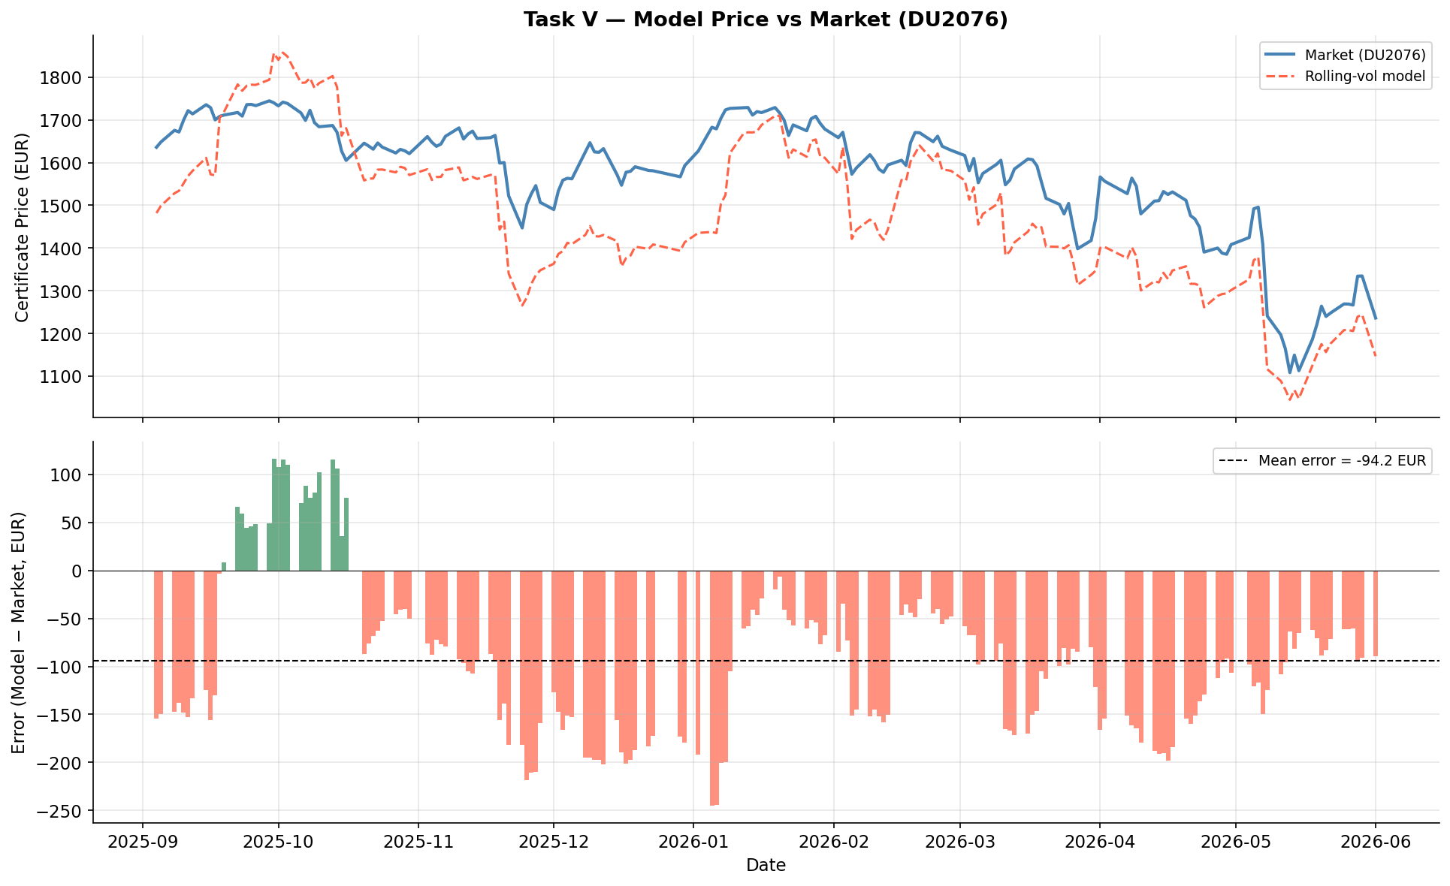
Fig. 2: Our model price vs DU2076 market price
Task VI: Sensitivity Analysis (Greeks)
Greeks evaluated at S=EUR 1,708, T=1.79 y, σ=44.7% (median rolling vol). Certificate value EUR 1,452.87.
Greek | Value | Key insight
Delta | 0.602 | Rises above 1 as S nears the barrier, falls near the cap
Gamma | −0.0004 | Negative at the cap, spikes at the barrier
Vega | −14.37 | Negative: higher vol raises knock-out risk and the value of the short cap call
Theta is +0.36 EUR per day, because passing time reduces the barrier risk. Rho is −12.4 EUR per +1pp, because the bonus payment is discounted like a bond.
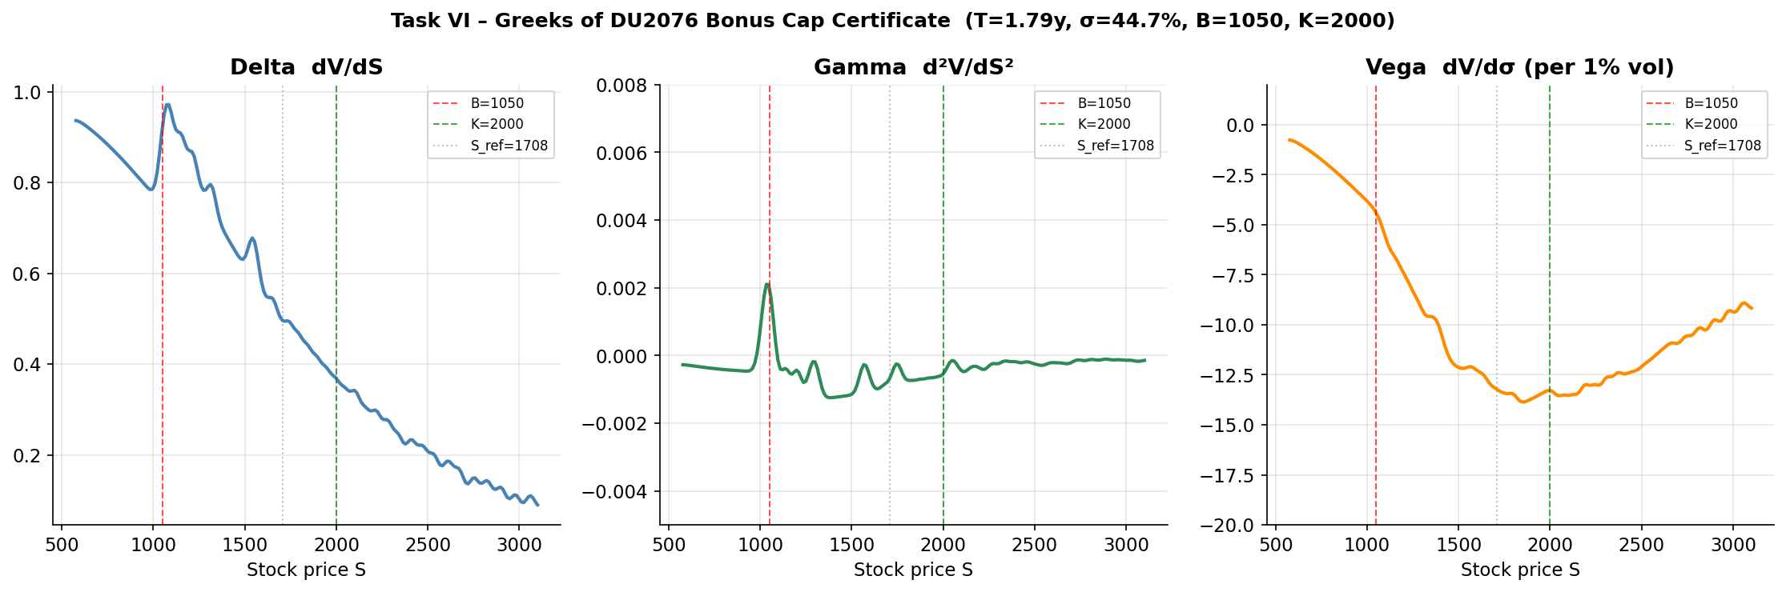
Fig. 3: Delta, Gamma and Vega
Task VII: Replicating Portfolio
The tree rebuilds the certificate each day as Delta shares of stock plus a bond position, V(t)=Δ(t)·S(t)+B(t). Delta ran from 0.14 during the autumn rally to 1.07 near the barrier. The equity fraction was above 50% on 143 of 183 days and peaked at 112%, where the bond leg turned negative. The certificate concentrates stock exposure exactly when the market falls, the opposite of a capital-protected note. Below the barrier the payoff becomes a capped forward and the equity fraction sits near 81%, rising toward 98%.
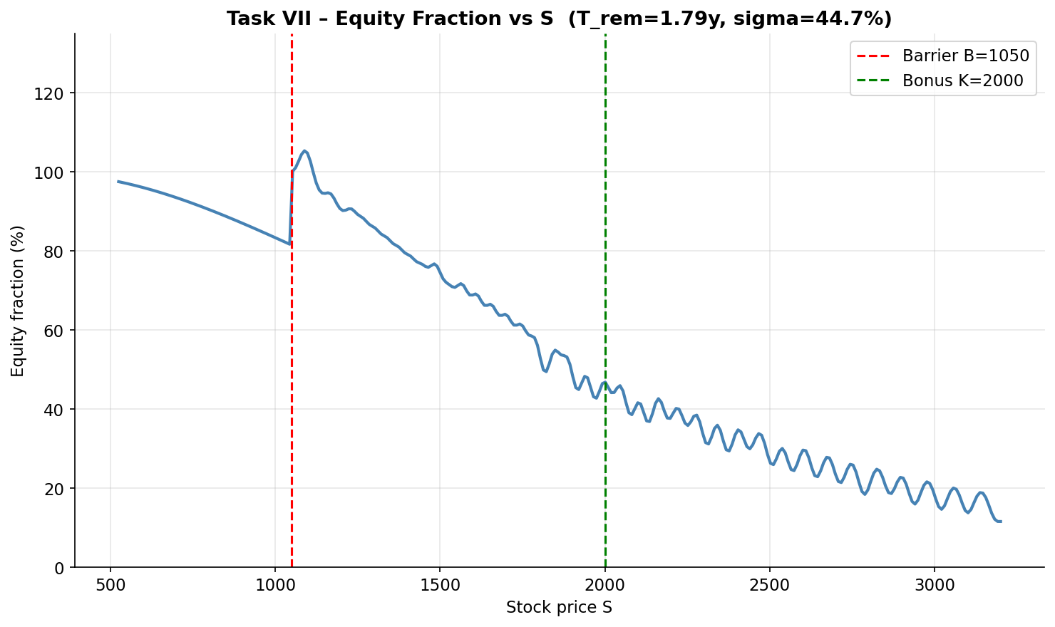
Fig. 4: Equity fraction (Δ×S / Value) vs stock price S.
PART 3: PORTFOLIO INSURANCE STRATEGY
EUR 10,000 | T*=1 y | S₀=EUR 1,207 | Risk-neutral log-drift r−q−½σ² = −8.27% p.a. (historical drift 54.05% for reference only) | σ=45.57% (252-day) | r=3.07% (10y Svensson) | q=0.95%
50,000 GBM paths × 252 steps | seed 2026 | SE(mean)=0.221% | simple wealth returns | terminal range EUR 136–7,666
Task VIII: Without Risk Management
Mean=2.16% | Std=49.34% | Skew=1.60 | VaR₉₅=56.38% | CVaR₉₅=63.60%
The simulated mean of +2.16% matches the risk-neutral benchmark e^(r−q)−1 = 2.14%. The negative log-drift is volatility drag, not a forecast of a falling stock. The distribution is strongly right-skewed with a heavy left tail. The unhedged 95% VaR of 56.38% is far above the 15% limit from Task XI, so the position must be hedged.
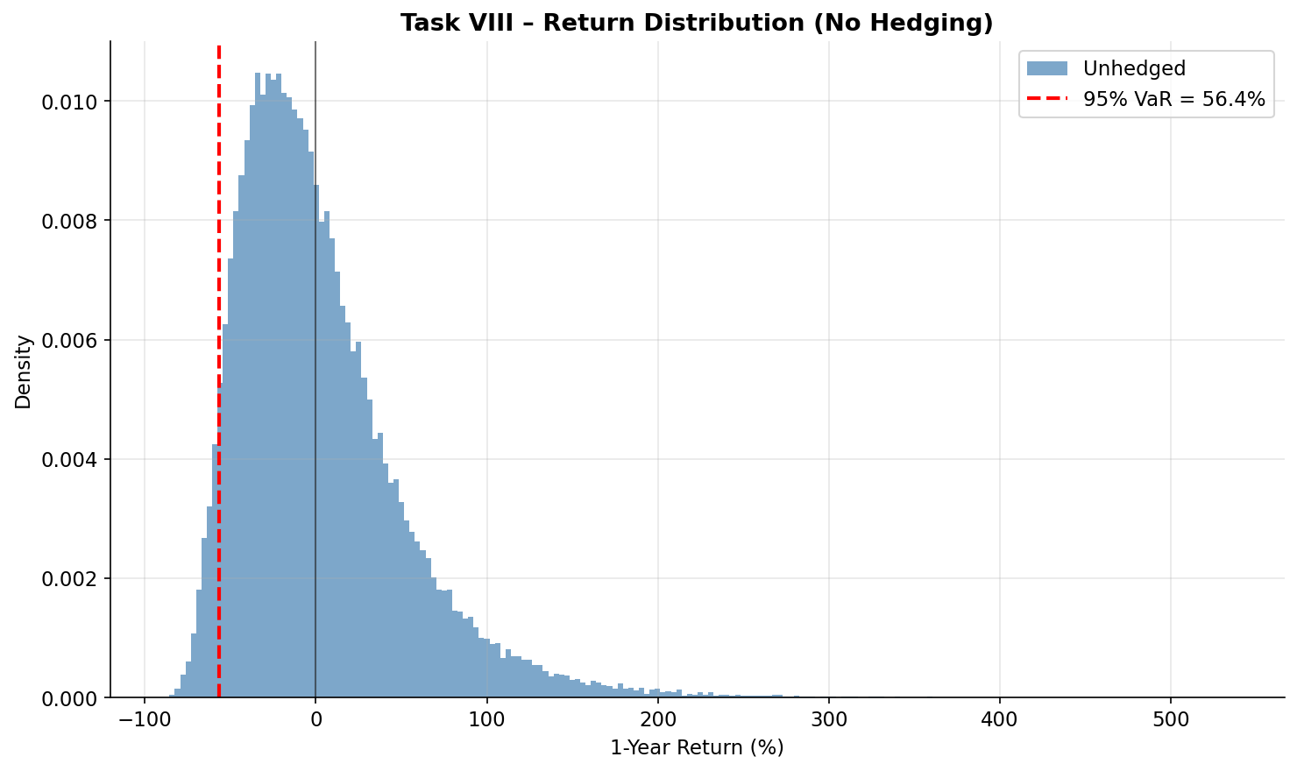
Fig. 5: 1-year return distribution, unhedged.
Task IX: Portfolio Insurance (α × K grid)
The portfolio holds (1−α) in the stock and α in one-year puts. VaR falls steeply up to α=10% at every strike. Beyond that the strikes at or below 100% turn U-shaped, and only K=105% keeps improving out to α=20%. The cheap 90% strike is best at small budgets, while the near-the-money strikes win from α=15%. The grid minimum is α=15% with K=100% at a VaR of 14.73%. Larger put positions raise skewness but barely change the mean. The table shows the 105% strike used in Task XI.
α | Mean | Std | Skew | VaR₉₅ | CVaR₉₅
5% | 2.20% | 42.72% | 2.01 | 42.84% | 47.85%
10% | 2.25% | 36.51% | 2.54 | 29.30% | 32.10%
15% | 2.29% | 30.98% | 3.13 | 15.77% | 16.36%
20% | 2.33% | 26.53% | 3.55 | 14.92% | 15.45%
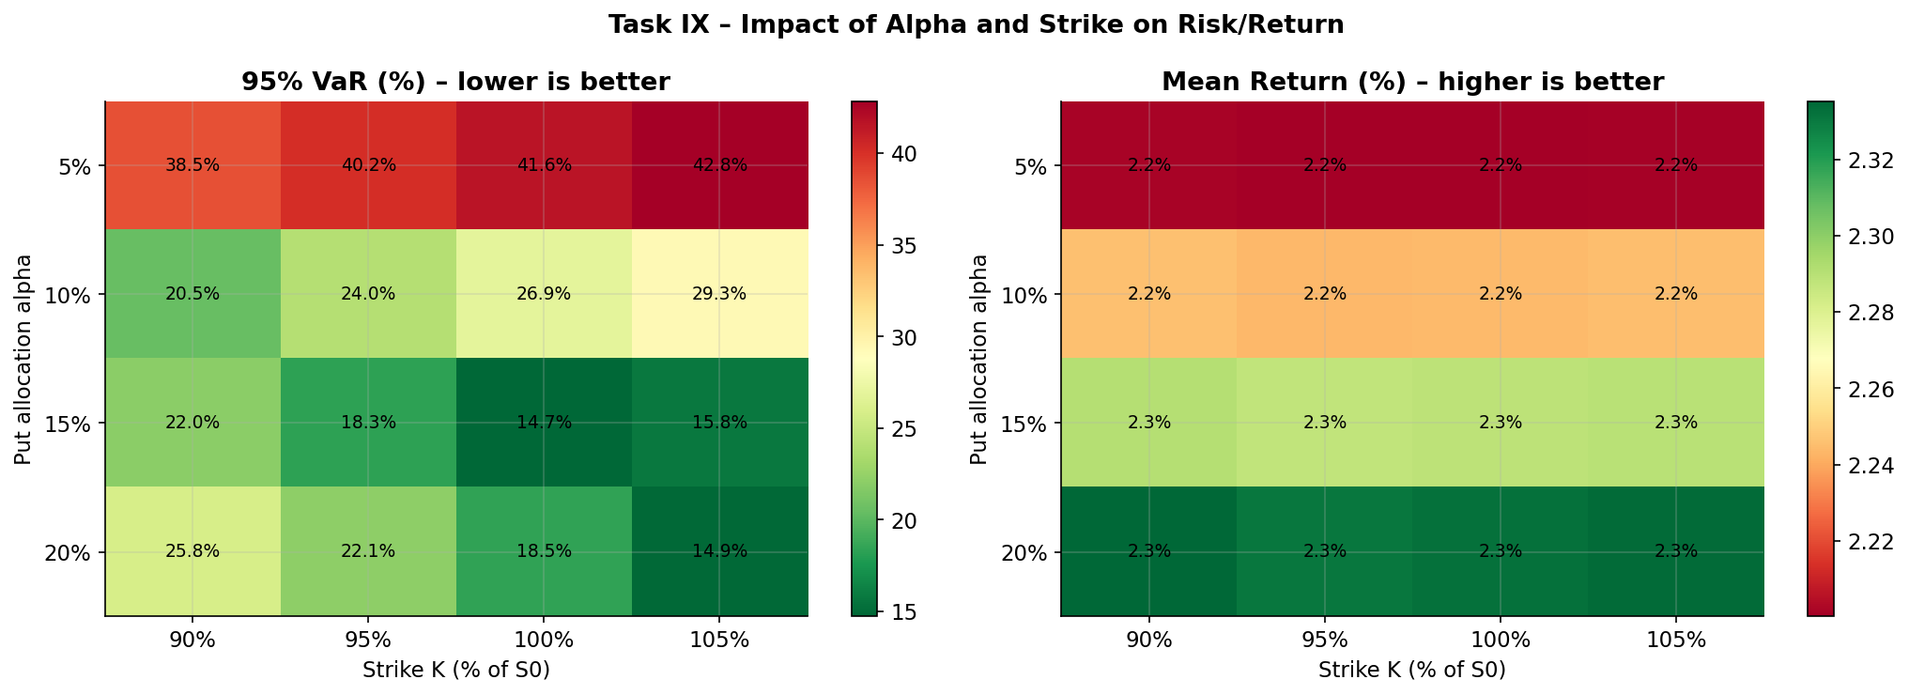
Fig. 6: 95% VaR (left) and mean return (right) across α and K.
Task X: Stress Scenarios (α=10%, K=95%S₀)
A volatility shock changes only the purchase price of the puts. With vol +5pp the budget buys fewer contracts and the VaR rises to 28.25%; with vol −5pp it drops to 18.44%. A −20% crash at mid-year pushes the mean return to −9.70%. The worst case combines the crash with expensive puts, where the VaR reaches 30.58%. Combined with cheap puts, the crash even beats the baseline VaR, because the larger put position ends up deep in the money. All six scenarios breach the 15% limit.
Scenario | Mean | Std | Skew | VaR₉₅ | CVaR₉₅
Baseline | 2.24% | 36.21% | 2.63 | 23.99% | 25.33%
Vol +5pp | 1.05% | 37.02% | 2.51 | 28.25% | 30.18%
Vol −5pp | 3.80% | 35.24% | 2.77 | 18.44% | 19.00%
−20% shock T/2 | −9.70% | 24.61% | 3.41 | 25.61% | 26.67%
Shock & vol +5pp | −11.64% | 25.65% | 3.16 | 30.58% | 32.13%
Shock & vol −5pp | −7.17% | 23.38% | 3.72 | 19.11% | 19.55%
Task XI: Optimal VaR-Constrained Allocation
The 95% one-year VaR may not exceed 15%, and the unhedged VaR of 56.38% forces a hedge. Searching α from 0% to 50% for every strike shows the 90% and 95% strikes never reach the limit; their best VaRs are 19.33% and 16.67%, no matter how large the position gets. Only the 100% and 105% strikes can meet the constraint.
The optimal portfolio allocates 15.50% to put options and 84.50% to the stock, with the strike at 105% of S₀. This brings the 95% VaR to 14.41% at an expected return of 2.29%, just under the required 15%. The constraint binds exactly at α=15.30%, and the 100% strike is a close runner-up.
In euro terms that is EUR 8,450 in the stock and EUR 1,550 in one-year puts struck at EUR 1,267, leaving 0.59pp of buffer under the ceiling. A risk manager sizes below a VaR limit rather than exactly on it, and here the buffer costs nothing in expected return.
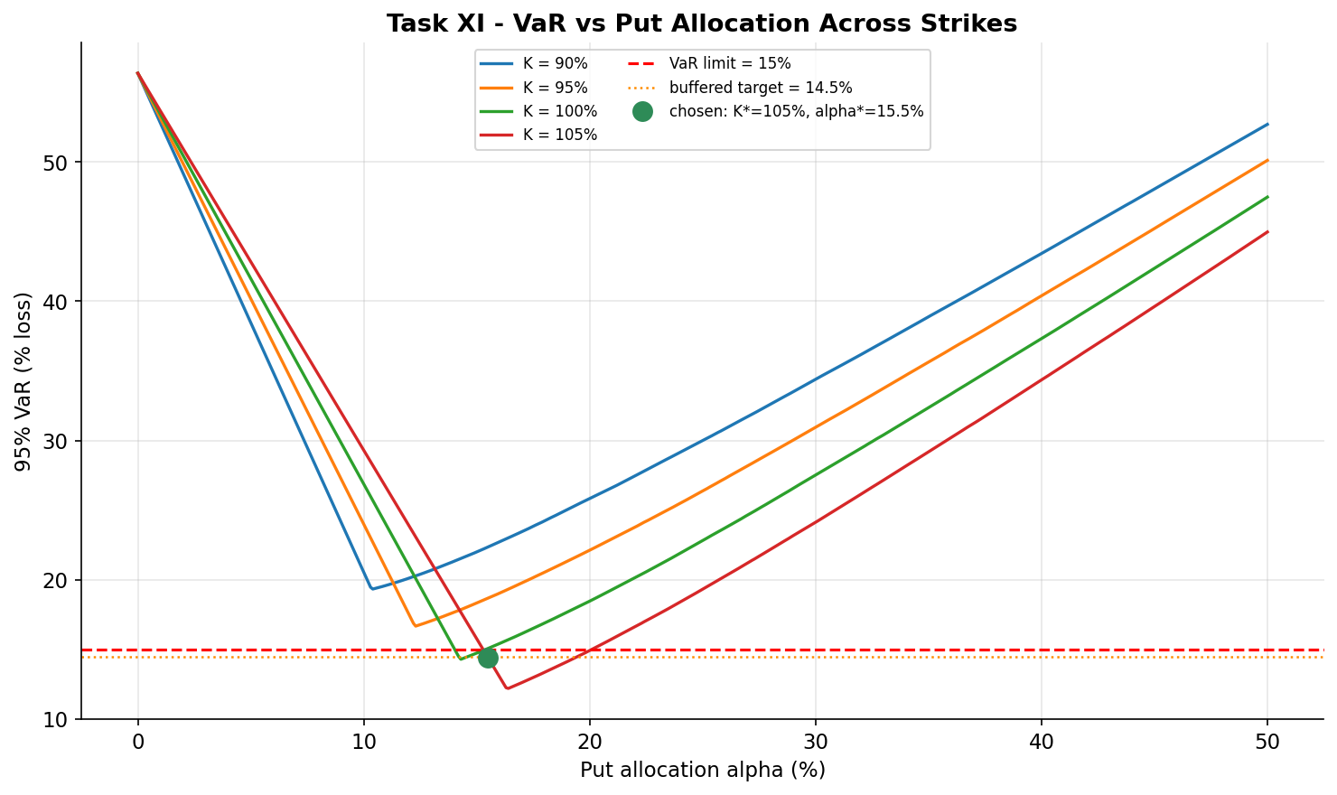
Fig. 7: 95% VaR vs α for all four strikes, with the 15% limit, binding point and α*=15.50% marked.

