

Java project

Jan Martin Jurie Daniel de Waard



Neptun: ap7n11

TOC

1. Introduction 2

2. XML structure 3

3. What the application looks like 4

3.1 Showing student information 4

3.2 Editing/removing a student 4

3.3 Adding grades 5

3.4 Adding a new student 6

# Introduction

For the Methodology of Programming I project, I’ve made an application with education as the topic. The application can manage students and their grades.

There are 3 parts in this document: the explanation of the XML-structure, a manual of how the application works/what it can do, and finally technical information about the actual code.

# XML structure

Below is an example of what the XML file looks like.

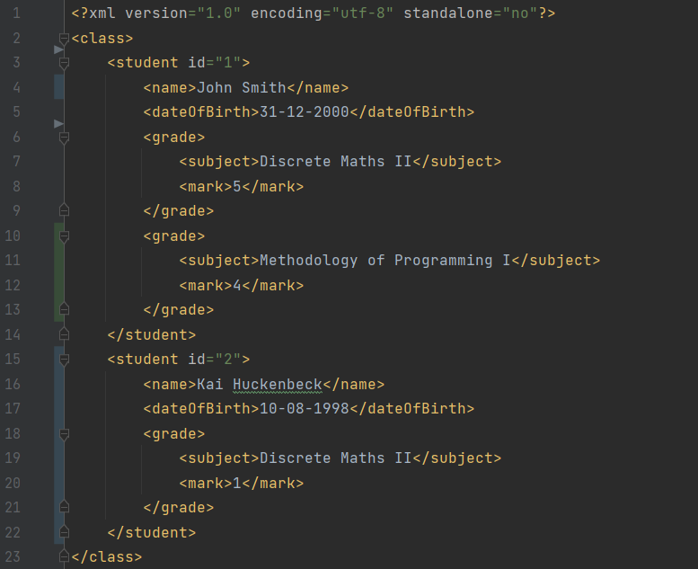

The root element is “class” (as in a school class). The “class” element contains a number of “student” child elements, which all have an id property. This id is used to find the correct student when doing things like editing a student, or adding a grade to a particular student.

Each student has exactly 1 “name” and “date of birth” child element, and furthermore the student can have a finite number of ‘grade” elements. These “grade” elements have exactly 2 child elements: “subject” and “mark”.

# What the application looks like

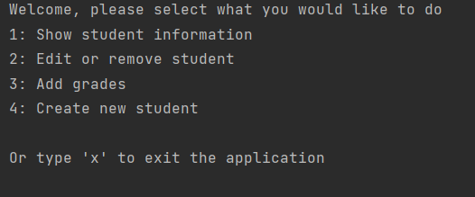

When started up, the user will first see the main menu. From here there are 4 different options, with another option ‘x’ to leave the application.

## Showing student information

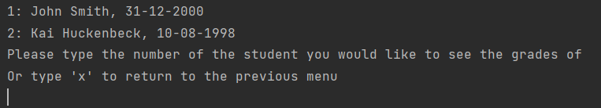

This option will display all the students in the database. We can select one of these students to see their grades.

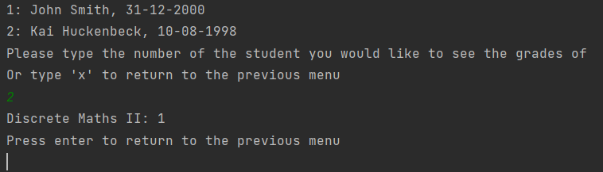

## Editing/removing a student

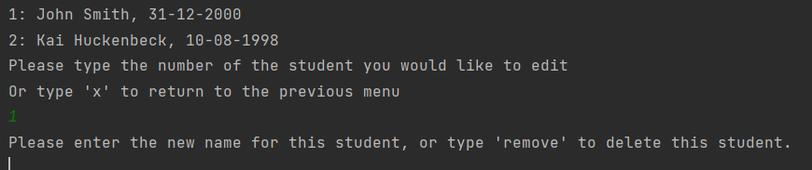

Once again we see the list of students, but now we can either enter a new name for the student, or we can type “remove” to delete the student.

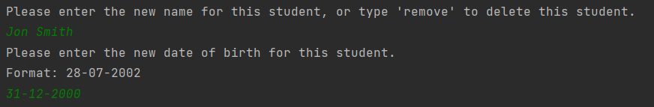

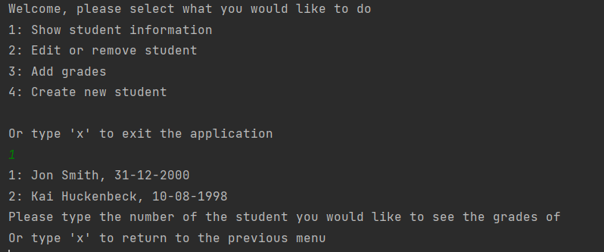

## Adding grades

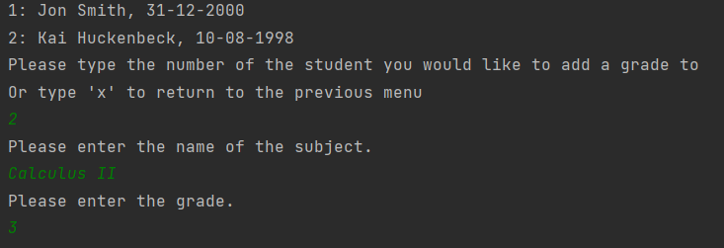

We are shown the list of students, and after selecting a student we can enter the name of the subject, as well as the grade that the student received.

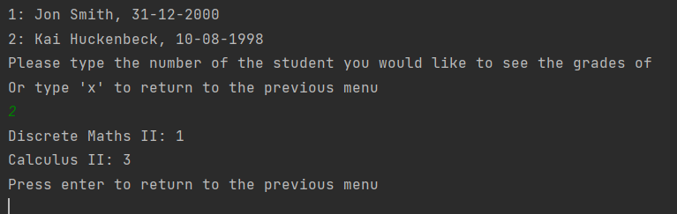

## Adding a new student

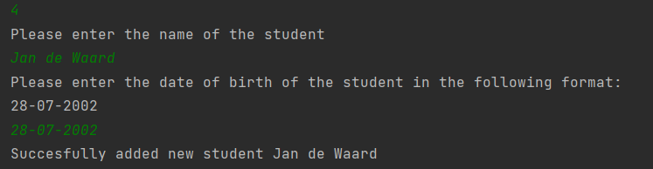

When selecting this option, the user gets asked to enter the name and date of birth of the student. This student will then be added to the xml file.

