**HOUSE**

**ITALO**

**DISCO**

**MICRO**

**HOUSE**

**TECH**

**HOUSE**

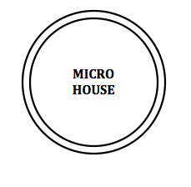

***BACK TO HOUSE***

***ARTISTS***

***Microhouse is a stripped down, minimal form of***[***House***](http://rateyourmusic.com/genre/House/)***music, originating in the late 90s, which takes influence from*** [***Minimal Techno***](http://rateyourmusic.com/genre/Minimal+Techno/)***,***[***Glitch***](http://rateyourmusic.com/genre/Glitch/)***and***[***IDM***](http://rateyourmusic.com/genre/IDM/)***. Although often built around a steady 4/4 time signature, it differs from traditional House music with regard to its use of samples: short clips of static, glitches and sometimes even human voices are often included, as opposed to House's common use of drum machine samples, such as hi-hats and kick drums. The genre has increased in popularity over the years, especially within Europe, with artists such as***[***Ricardo Villalobos***](http://rateyourmusic.com/artist/ricardo_villalobos)***and***[***Luomo***](http://rateyourmusic.com/artist/luomo)***enjoying a strong underground following and critical success.***

***Microhouse is a stripped down, minimal form of***[***House***](http://rateyourmusic.com/genre/House/)***music, originating in the late 90s, which takes influence from***[***Minimal Techno***](http://rateyourmusic.com/genre/Minimal+Techno/)***,***[***Glitch***](http://rateyourmusic.com/genre/Glitch/)***and***[***IDM***](http://rateyourmusic.com/genre/IDM/)***. Although often built around a steady 4/4 time signature, it differs from traditional House music with regard to its use of samples: short clips of static, glitches and sometimes even human voices are often included, as opposed to House's common use of drum machine samples, such as hi-hats and kick drums. The genre has increased in popularity over the years, especially within Europe, with artists such as***[***Ricardo Villalobos***](http://rateyourmusic.com/artist/ricardo_villalobos)***and***[***Luomo***](http://rateyourmusic.com/artist/luomo)***enjoying a strong underground following and critical success.***

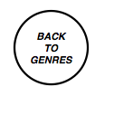

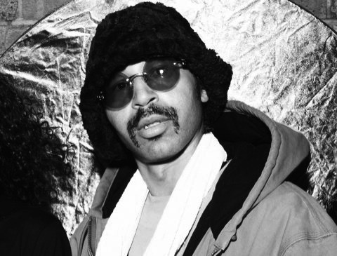

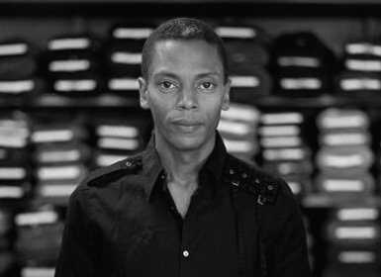

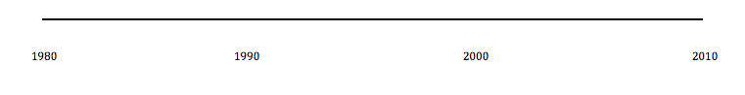



***BACK TO ARTISTS***



***Kenny Dixon Jr., better known by his stage name Moodymann, is an American*** [***techno***](http://en.wikipedia.org/wiki/Techno)***/***[***house***](http://en.wikipedia.org/wiki/House_music) ***musician based in*** [***Detroit***](http://en.wikipedia.org/wiki/Detroit)***,*** [***Michigan***](http://en.wikipedia.org/wiki/Michigan)***. He is an owner of KDJ Records. He is a member of 3 Chairs along with*** [***Theo Parrish***](http://en.wikipedia.org/wiki/Theo_Parrish)***, Rick Wilhite and Marcellus Pittman.***

***In 1997, Moodymann released Silentintroduction, the debut album which compiled previously released tracks, on*** [***Planet E Communications***](http://en.wikipedia.org/wiki/Planet_E_Communications)***. It was followed by Mahogany Brown in 1998.Forevernevermore was released in 2000.***

***Moodymann released Silence in the Secret Garden on*** [***Peacefrog Records***](http://en.wikipedia.org/wiki/Peacefrog_Records) ***in 2003.It was followed by Black Mahogani on the label in 2004.His free EP, Picture This, was released in 2012.He released the seven-track ABCD in 2013.Moodymann, the self-titled album featuring contributions from*** [***Amp Fiddler***](http://en.wikipedia.org/wiki/Amp_Fiddler)***, Andres, and*** [***José James***](http://en.wikipedia.org/wiki/Jos%C3%A9_James)***, followed in 2014.***