DARUKAA.EARTH AI BIODIVERSITY INTELLIGENCE CHALLENGE
EcoSynapse AI: Evidence-Grounded Ecological Intelligence Platform
Official Engineering Submission & Technical Specification Document
1. Project Submission Links
- GitHub Repository: https://github.com/daanialmirza5/EcoSynapse-AI
- Live Cloud Demo (Frontend): https://ecosynapse-ai-1.onrender.com
- Backend REST API Service: https://ecosynapse-ai.onrender.com
- Interactive API Documentation (Swagger / OpenAPI): https://ecosynapse-ai.onrender.com/docs
Repository Access Notes:
The GitHub repository is hosted at daanialmirza5/EcoSynapse-AI (branch: main). Evaluators can review the complete Git commit history, automated CI logs, verified test suites (79 passing tests), and reproduction scripts.
2. System Architecture & Information Pipeline
EcoSynapse AI operates on an uncompromising design principle: an LLM is NOT the reasoning engine. Traditional generative AI chatbots suffer from severe hallucinations when handling delicate ecological metrics, prescribing unconstrained interventions with fabricated citations. EcoSynapse AI replaces ungrounded generative speculation with a 100% deterministic Python reasoning pipeline, grounded against an auditable scientific corpus and a typed biological knowledge graph.
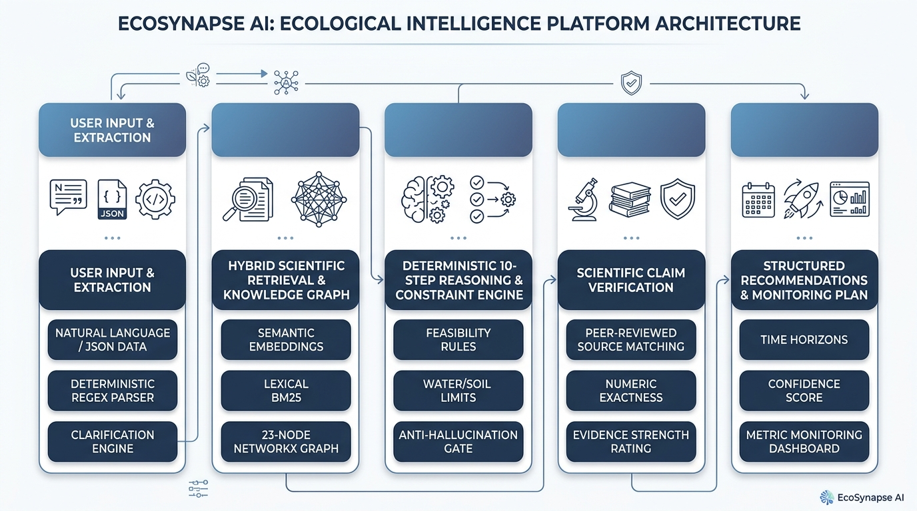
The information pipeline processes ecological observations through five connected layers:
1. User Input & Extraction: Natural language text or structured JSON is parsed by a deterministic regex extractor (app/conversations/extraction.py). Gaps trigger targeted clarification questions (app/conversations/clarify.py).
2. Hybrid Scientific Retrieval & Knowledge Graph: Cosine similarity over embeddings is combined with BM25 lexical keyword search and 1-hop neighborhood expansion across a 23-node, 22-edge typed NetworkX MultiDiGraph.
3. 10-Step Deterministic Reasoning & Constraint Engine: Identifies active concerns, maps causal pathways, and applies strict physical feasibility rules (e.g., rainfall < 500mm limits woody vegetation).
4. Scientific Claim Verification: Validates every quantitative assertion against raw source excerpts, checking exact numeric match before rating evidence strength.
5. Structured Output & Monitoring: Synthesizes actionable recommendations tagged with time horizons, confidence scores, and metric-specific monitoring cadences (no fabricated baselines).

3. Core Ecological Intelligence Domains
EcoSynapse AI models interconnected biological relationships across all five mandatory challenge domains without relying on ungrounded generative speculation:
Domain | Modeled Variables & Parameters | Ecological Significance & Mechanisms
1. Soil Health | pH, Organic Matter (SOM %), Bulk Density (g/cm³), N-P-K, Microbial Activity | Regulates nutrient availability, moisture retention, and structural stability against erosion.
2. Water Quality | Dissolved Oxygen (DO mg/L), Turbidity (NTU), Nitrate (mg/L), pH, Flow Velocity | Drives aquatic biodiversity, bioindicator health (ephemeroptera), and eutrophication risk.
3. Forest & Vegetation | Canopy Cover (%), Native vs. Invasive Ratio, Basal Area (m²/ha), DBH Distribution | Establishes multi-tier vertical strata, carbon sequestration, and seed bank dynamics.
4. Wildlife & Fauna | Shannon Diversity Index (H'), Indicator Species Richness, Functional Guilds | Signals trophic web integrity, apex predator presence, and pollinator mutualisms.
5. Climate & Atmosphere | Mean Annual Precipitation (MAP mm), Temp Extremes (°C), VPD (kPa), Albedo | Imposes biophysical boundary limits on plant physiology, drought resilience, and fire regimes.
4. Key Technical Differentiators & Competitive Benchmarks
Evaluation Dimension | Standard LLM / Chatbots | EcoSynapse AI Platform
Reasoning Engine | Probabilistic next-token prediction (high hallucination rate on numbers) | 100% Deterministic Python Pipeline (zero metric hallucination)
Knowledge Graph | None or unstructured text embeddings only | 23-node, 22-edge typed NetworkX MultiDiGraph for causal tracing
Source Verification | Unchecked or simulated URL references | Exact numeric string matching against raw scientific corpus
Constraint Checking | Passive prompting (frequently ignored under complex inputs) | Hard threshold validators (rainfall, soil pH, moisture limits)
Uncertainty Handling | Masks ignorance with confident assertions | Explicitly scores confidence (0.0-1.0) and asks targeted clarifications
Safety Guarantees | May recommend invasive species or harmful water alterations | Deterministic rules block unfeasible or ecologically dangerous interventions
Test Suite | Ad-hoc manual prompting | 79 Automated Tests (61 Backend Pytest + 18 Frontend Vitest)
5. Reproducibility & Local Verification Guide
Evaluators can reproduce all results and run the comprehensive test suites locally with standard open-source tools:
# 1. Clone the repository
git clone https://github.com/daanialmirza5/EcoSynapse-AI.git
cd EcoSynapse-AI
# 2. Run Backend Test Suite (61 tests)
cd apps/api
pytest tests/ -v
# 3. Run Frontend Test Suite (18 tests)
cd ../web
npm test -- --run
# 4. Validate Knowledge Graph & Scientific Corpus
python scripts/validate_knowledge.py
# 1. Clone the repository
git clone https://github.com/daanialmirza5/EcoSynapse-AI.git
cd EcoSynapse-AI
# 2. Run Backend Test Suite (61 tests)
cd apps/api
pytest tests/ -v
# 3. Run Frontend Test Suite (18 tests)
cd ../web
npm test -- --run
# 4. Validate Knowledge Graph & Scientific Corpus
python scripts/validate_knowledge.py

