**Escuela Superior Politécnica del Litoral**

**Robot Móviles y Articulados**

**Final Project Groups**

Member:

* Bryan Cali
* Daniel Alvarado
* Kevin Lopez
* Marcelo Mendoza

**Abstract**

This report aims to determine the most efficient way that can be obtained through a comparison between different algorithms that allow controlling a robotic arm of 6 degrees of freedom PUMA 560, through simulations and graphs that represent the time and load necessary to make the movements. This to obtain the best means to carry out a redistribution of products in a food industry that allows the relocation of products. These simulations and trajectories will be performed by means of Jupiter by means of Python 3 programming, using functions that express spatial values, kinematic and dynamic trajectories, the two means to trace these trajectories will be the 5th order polynomial interpolation and the other one is the Dual Quaternions.

*Imagen. Robot Articulado de 6 juntas PUMA 560.*

**Problem Statement**

In any food industry, the product must be treated with either packaging, elaboration, or creation processes, in the end these always end up being shipped to a half truck to be transported from one place to another in order to market the product, it is because of this that a company that is dedicated to the elaboration of different products at the same time require a robotic arm to place the final product of one conveyor belt to another in an organized and safe way, so a PUMA 560 with 6 degrees of freedom is used to be able to reorganize these products in the best way.

And it’s in this point where our group proposes to implement a PUMA 560 manipulator robot for the classification of boxes for storage in a company dedicated to the food industry, so that the robot will sequentially fulfill trajectories in different positions to rearrange the company's products from a from a storage center to conveyor belts, but first we will understand what will be the best way to configurate those trajectories, to obtain the movement that will not affect the product or harm the robot arm.

**Methodology**

First of all, it is important to know in detail what are the qualities present in the robotic arm that is going to be used, this being the PUMA 560, then a data table will be shown that presents the parameters of the Denavit-Hatenberg table and with this show the number of links, the distances they have, the respective possible spin that each of these can reach, as well as the Joint Offset and the values of -q and +q:

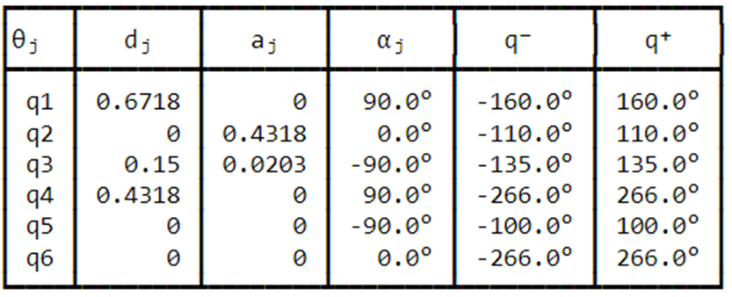

Polynomial interpolation is a method of estimating values between known data points. In robots it is used when it is necessary to achieve a continuous acceleration, and a smooth position and speed both in the initial and final conditions.

Screw Linear interpolation extends dual quaternion interpolation, it involves interpolating around a screw motion. A screw involves a rotation around an axis, and a translation along that same axis. Sclerp then is a linear interpolation on the amount of translation on the screw axis, and the angle of the screw axis. Screw Linear interpolation is coordinate invariant and thus do not have the same issues with changes in centre of rotation. It is important to note, that like quaternions, there are two dual quaternions representing each rotation.

**Validation, Results, Comparison**

Regarding the simulation of the trajectory to be followed by our robotic arm, it will be shown first using the fifth-degree polynomial method, of which it is necessary to initially configure the points that are going to be used as the base point and that point that should reach the arm as an end point of the trajectory, this also represents the robotic arm within the plane to determine its initial position.

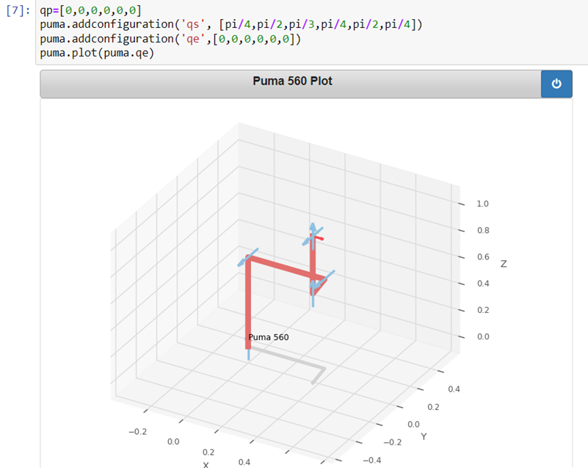

With the next step the movement of the robotic arm is obtained, with which the trajectory is traced and the first movement of the PUMA 560 is made, showing this position as the end of the trajectory, it is important to emphasize that the movement of said trajectory took exactly 2.95 seconds:

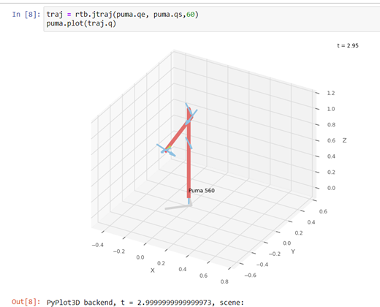

Other way to view the robot puma 560 of way more representative is used the swift. Swift is into of the library robotic toolbox. In this case we show the final position of this robot.

After this, the graph of the times taken by the joints to make their respective movements is shown, because some joints perform in the same movement these are superimposed within the graph, which is why in this only 3 joints can be detailed.

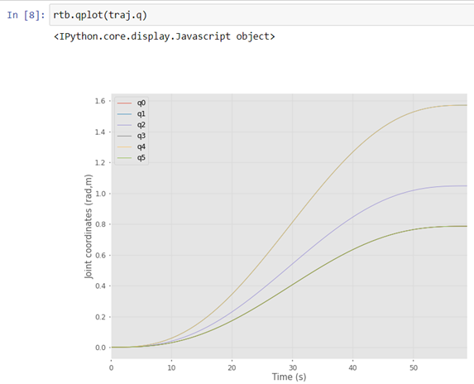

For the next three lines of programming, the obtaining of the trajectories by means of the inverse kinematics, both of the initial point and the end point, in addition to programming issues the second matrix of the end point of the trajectory is converted into an array to be able to use it in the subsequent codes:

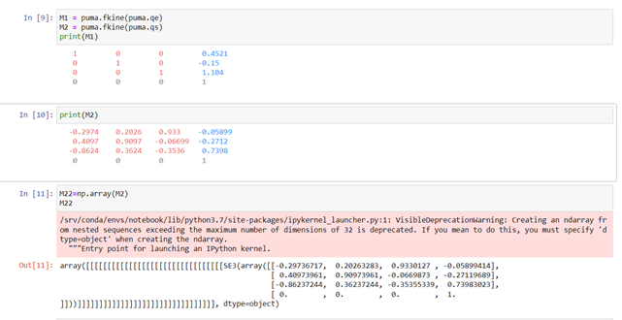

After obtaining the matrices of the values of the trajectory to follow, the fifth-order polynomial interpolation is used again, which obtains the following result and the following trajectory:

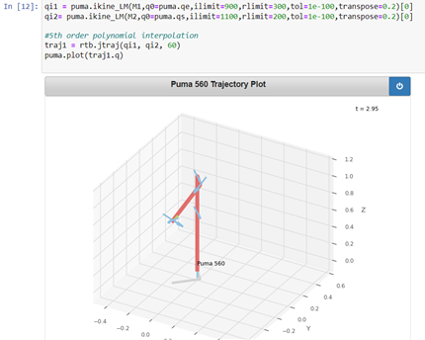

After having obtained the results from the fifth-order polynomial interpolation method as an alternative method, the original method will be used to trace trajectories with which the Dual Quaternion method will be implemented to make the corresponding configurations:

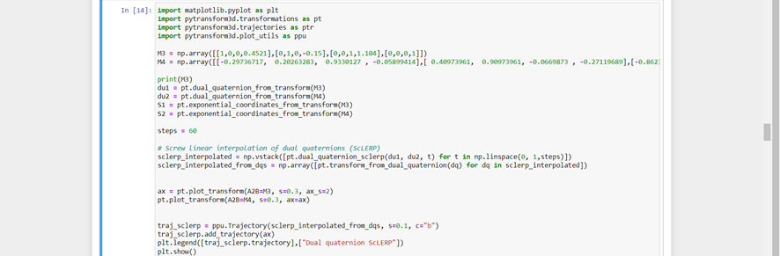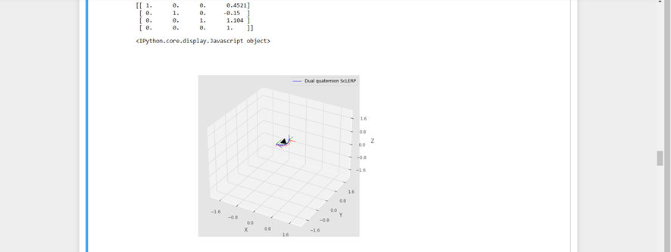

These configurations will be able to show as a result the matrix of the trajectory together with the graph of the trajectory obtained by means of the linear interpolation method of the dual quaternions, in addition to this it was possible to obtain a series of array matrices with which to show the robotic arm of PUMA 560 in the final position.

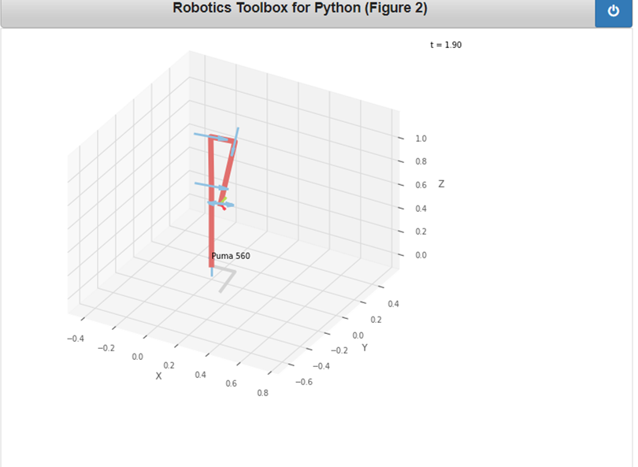

With this, as was done in the previous method, a comparative graph of each joint is made where the movement that each of these makes is determined in relation to the time it takes and as can be seen in this, each quaternion makes a sudden movement in relation to time, so that the movements generated by the use of the linear interpolation method produce large movements in short periods of time which are reflected in the following graph:

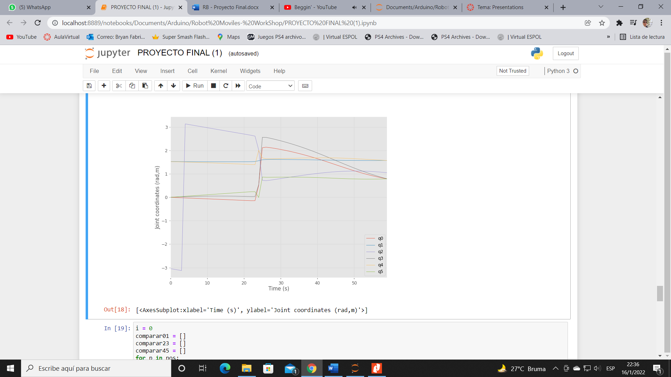

With both graphs of projected trajectories, it is possible to make comparisons with regard to each joint, for this the joints of each method were divided into three groups with which a total of three graphs will be obtained to show the displacement of the joints, in relation to the time it takes to each of these:

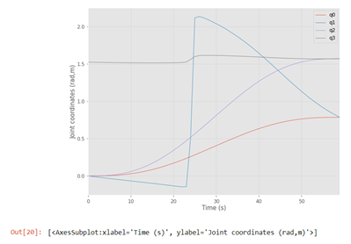

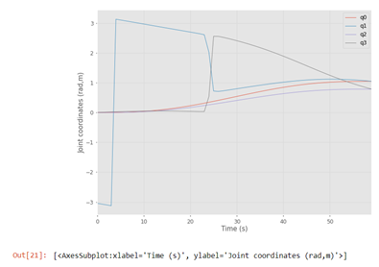

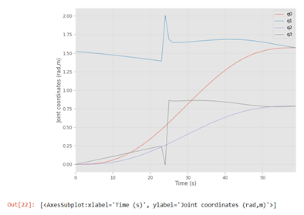

When comparing the two interpolations starting with the simulation of their displacement from the initial point to the final point, it can be seen that their movements are not the same, and while the polynomial method has a smooth movement at what would appear to be a controlled speed and acceleration, the method of the screw linear interpolation in some moments performs certain abrupt movements in addition to following another trajectory, it is possible to confirm this in the pairwise comparison graphs, where it can be clearly observed how for the polynomial method the movement of the joints is totally smooth, on the other hand, the screw linear interpolation method presents in all its joints peaks which would be the abrupt movements, physically that would put the PUMA 560 joints in great tension due to the speed and acceleration to which it is forced to work and possibly it would be unable to achieve. For the problem it is convenient that the robot performs moderate and controlled movements, so the implementation of the polynomial interpolation of 5th order method is better, besides its implementation is easier.

Conclusions

* The trajectory of a Puma560 robotic arm was made by means of the 5th order polynomial method and through the use of the dual quaternion and the comparison between the two was made, being able to verify that the trajectory has notable differences between both
* In addition, it is determined that the use of the linear interpolation method by means of the Dual Quaternion makes much more abrupt trajectories, which translates into rapid movements in short periods of time, which could conclude in future damage to the articulated robot by these sudden changes in its position, in addition to remembering that the material used could be affected by these unorthodox movements.
* Compared to the process or alternative method used of interpolation by fifth degree polynomial order, which presented trajectories that made their movements in a much smoother way with less abrupt changes so that the robot does not have problems to exercise these trajectories.