Week 5 ANA 515

Daniel Appadurai

2023-06-24

# Heavy Drinking Among Adults In the US Aged 18 and Above

## Overview:

The chronic disease indicators data set is a comprehensive data set collected on an annual basis since 2001 by the CDC’s Division of Population Health across all 50 US states. The dataset has a total of 34 columns and 1185676 rows as of 2021 and contains 124 indicators for a total of 17 chronic diseases.

## Heavy Alcohol Consumption Among Adults Aged 18 And Above:

One of the chronic disease data collected is on heavy alcohol consumption among adults across 50 US states. This data analysis is done on heavy alcohol consumption among different race/ethnic groups for the year 2021. The table below shows the mean, min and max age-adjusted prevalence for the various race/ethnic groups.

| Race_Ethnicity | Mean_Prevalence | Min_Prevelence | Max_Prevelance |
| --- | --- | --- | --- |
| Black, non-Hispanic | 5.617391 | 3.3 | 10.1 |
| Hispanic | 4.582759 | 2.2 | 8.2 |
| Multiracial, non-Hispanic | 8.571429 | 2.8 | 13.6 |
| Other, non-Hispanic | 4.500000 | 1.8 | 6.9 |
| White, non-Hispanic | 7.513725 | 4.0 | 17.3 |

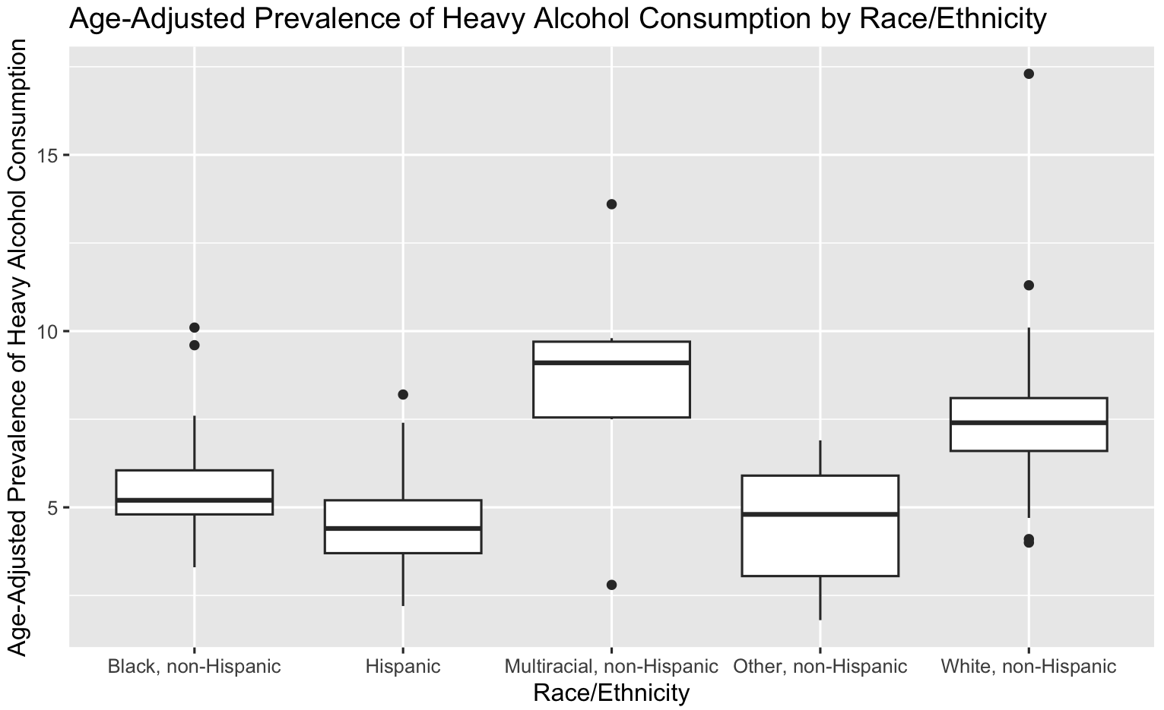

A box plot showing the age-adjusted prevalence of heavy alcohol consumption among different ethnic groups. The multiracial, non-Hispanic group showed the highest prevalence (8.48 %). Based on the median position in the box plot, the multiracial, non-hispanic group shows skewness. A log transformation may be required to normalize the data. Age-adjusted prevalence represents the percentage state adult population aged 18 and above.

Disclaimer: The above conclusions are highly contingent on the available data and is subject to change anytime with new available data. This is solely meant as academic exercise only and in no way represents the personal view of the author nor it is intended to be discriminatory or maliciously targeted towards any particular race/ethnicity, group or gender.

The histogram shows the frequency distribution of states based on age-adjusted prevalence of heavy alcohol consumption. The distribution if fairly normally distributed with most states centering around the mean of (6.4388889 %).