System Architecture
This document explains how the Gemini-Hybrid-RAG code works. It is designed as an agent loop rather than a simple chatbot.

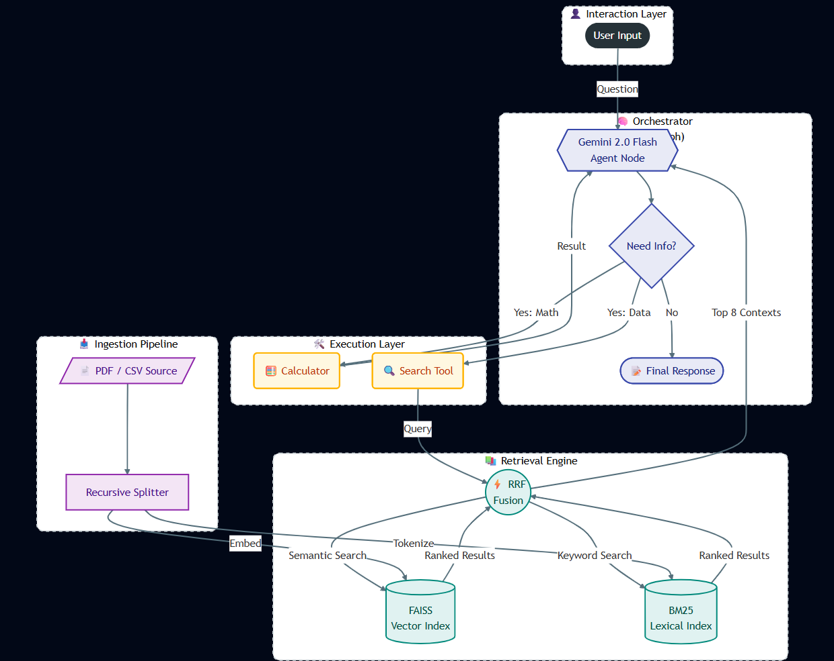

1. The Agent (LangGraph)
The main logic is handled by LangGraph. This acts as the "brain" of the system.
- When you ask a question, the Agent checks if it needs more information.
- It decides whether to use a Search Tool, a Calculator, or just answer you directly.
- If the first search doesn't give a good answer, it can decide to search again with a better query.
2. The Tools
The Agent has access to two specific tools to help it answer correctly:
- Search Tool: This connects to the document index. The agent uses this to find facts.
- Calculator: A Python-based calculator. If you ask a math question based on the document (like adding up columns in a table), the AI extracts the numbers but sends them here to be calculated accurately.
3. The Search Engine (Hybrid Search)
To find the right text in your documents, the system uses two methods simultaneously:
- Vector Search (FAISS): This converts text into numbers (embeddings) using Google's models. It finds text that means the same thing as your question, even if the words are different.
- Keyword Search (BM25): This looks for exact word matches. This is important for finding specific names, dates, or ID numbers.
Rank Fusion: The system takes the top results from both search methods and combines them using an algorithm called Reciprocal Rank Fusion (RRF). This ensures the final information given to the AI is highly relevant.
4. Ingestion (Loading Files)
When you provide a file, the system goes through these steps:
- Read: It extracts raw text from the PDF or CSV.
- Split: It breaks the text into chunks of 1500 characters. We use large chunks to make sure tables and full paragraphs stay together.
- Index: It saves these chunks into the FAISS and BM25 indexes so they can be searched instantly.

