TECHNICAL REPORT
The Order Journey
A Visual Study of E-Commerce Orders, Delivery & Customer Satisfaction
Data Visualization Design Project — May 2026 Term
Indian Institute of Technology Madras
Prepared for: Marketplace Leadership Team
Dataset: Brazilian E-Commerce Marketplace Dataset + Marketing Funnel Dataset
Team: Group 7
Date: 11/09/2026
I

Table of Contents
Table of Contents 1
1. Executive Summary 1
2. Business Context & Problem Statement 1
3. Translating the Business Goal into Analysis Questions 1
4. Data Sources & Methodology 1
4.1 Dataset overview 1
4.2 Data quality checks and how they shape the analysis 1
4.3 Tools and chart-selection approach 1
5. Exploratory & Explanatory Analysis 1
5.1 Fulfillment & Satisfaction (orders · order_reviews) 1
5.2 Customers & Geography (customers · geolocation) 1
5.3 Catalog & Sellers (products · sellers · category_translation) 1
5.4 Purchases & Payments (order_items · order_payments) 1
5.5 Seller Acquisition Funnel (marketing_qualified_leads · closed_deals) 1
5.6 Risk Landscape (all tables, combined) 1
6. Cross-Cutting Insights 1
7. Interactive Dashboard & Presentation 1
8. Recommendations for Leadership 1
8.1 Protect satisfaction without slowing growth 1
8.2 Grow the marketplace without adding risk 1
8.3 Untapped, lower-risk growth levers 1
9. Scope, Limitations & Suggested Extensions 1
9.1 Scope and limitations 1
9.2 Suggested extensions 1
10. Team Contributions & Work Log 1
Work log 1
Appendix A: Data Dictionary Reference 1

1. Executive Summary
Leadership's growth objective creates a direct trade-off: aggressive seller onboarding raises gross sales but can raise late deliveries, poor product ratings, and churn; strict quality enforcement protects satisfaction but shrinks the catalogue and slows growth. This report studies the complete lifecycle of a marketplace order — acquisition of the seller, catalog listing, purchase, fulfillment, and the review the customer ultimately leaves — to replace gut-feel trade-off decisions with an evidence-based view of what actually drives customer satisfaction and where the marketplace is quietly at risk.
The analysis draws on nine relational tables covering 99,441 orders, 96,096 unique customers, 3,095 active sellers, 32,951 products, and 8,842 acquisition leads, joined on shared keys (order_id, customer_id, product_id, seller_id, mql_id).
Three findings dominate the results:
- Delivery timing is the single strongest predictor of satisfaction in the entire dataset. The average review score falls from 4.29 to 2.57 the moment a delivery becomes late, and most of that drop happens in the first few days late rather than accumulating gradually.
- A small, geographically clustered core carries a disproportionate share of the marketplace. The top 10% of sellers generate about 67.5% of revenue, the Southeast region holds more than two-thirds of customers, and São Paulo alone accounts for roughly 42% of customer records — meaning the same core is simultaneously the primary growth engine and the primary point of operational risk.
- Retention and basket size are largely untapped growth levers that do not depend on fixing logistics or acquiring new supply. Only 3.1% of unique customers are repeat buyers, and 90.1% of orders contain a single line item.
Section 8 translates these findings into a prioritized set of actions for leadership, organized around the growth-versus-satisfaction trade-off named in the project brief.

2. Business Context & Problem Statement
The organization operates an online marketplace connecting thousands of small and medium-sized sellers to customers across a large, geographically dispersed country (Brazil). Leadership's stated goal is to grow the marketplace without breaking the customer experience.
This is a genuine trade-off, not a solvable-once problem:
- Onboarding sellers aggressively raises gross sales, but late deliveries, poorly rated products, and negative reviews begin driving customers away.
- Cracking down on every slow seller improves quality, but shrinks the catalogue and stalls growth.
These decisions are currently made on gut feel. The purpose of this project is to study the full order journey — placement, payment, seller handling, freight and delivery, and the resulting review — and turn it into a clear, visual account of what predicts a happy customer versus a one-star review, and where the company should invest or intervene.

3. Translating the Business Goal into Analysis Questions
The business objective was decomposed into the following answerable questions, each of which maps to one or more sections of the exploratory and explanatory analysis:
# | Analysis question | Addressed in
1 | How far do orders get, and how are they ultimately rated? | Section 5.1
2 | Does delivery timing predict review score, and if so, how strongly and at what threshold? | Section 5.1
3 | Who are our customers, where are they, and how often do they come back? | Section 5.2
4 | What does the catalog contain, which categories drive revenue vs. volume, and does listing quality matter? | Section 5.3
5 | Who supplies the catalog, and how concentrated is seller revenue? | Section 5.3
6 | What do checkout and payment behavior look like, and where is untapped commercial opportunity? | Section 5.4
7 | How efficiently does the marketing funnel convert leads into sellers, and which channels/segments matter? | Section 5.5
8 | Which categories, regions, and sellers combine high scale with high risk, once delay, satisfaction, and volume are viewed together? | Section 5.6

4. Data Sources & Methodology

4.1 Dataset overview
The study combines the E-Commerce Dataset (order, payment, product, seller, customer, shipping, and review data for a Brazilian online marketplace) with the Marketing Funnel dataset (seller acquisition leads and closed deals), joined into nine relational tables:
Table | Grain | Rows | Role in the analysis
orders | One row per order | 99,441 | Order lifecycle timestamps and status
order_reviews | One row per review | 99,224 | Star rating and free-text feedback
customers | One row per order's customer | 99,441 | Location and repeat-purchase identity
geolocation | One row per address ping | 1,000,163 | ZIP-prefix to latitude/longitude lookup
order_items | One row per line item | 112,650 | Product, seller, price, freight per item
order_payments | One row per payment method used | 103,886 | How each order was paid for
products | One row per product | 32,951 | Category, weight, dimensions, listing quality
sellers | One row per seller | 3,095 | Seller location
marketing_qualified_leads + closed_deals | One row per lead / per won deal | 8,000 + 842 | How new sellers are acquired

4.2 Data quality checks and how they shape the analysis
Before any chart was built, each table was profiled for completeness, duplication, and referential integrity. Four findings materially shape how the results in this report should be read:
- Missing delivery timestamps (~3% of orders) are structural — they line up with orders that were canceled, lost, or still in transit — not random. All delivery-time metrics are therefore computed only on orders with status “delivered,” rather than averaging silently over missing dates.
- The geolocation table has far more rows than distinct ZIP prefixes, and a small share of prefixes carry more than one spelling of the same city. All geography in this study is computed on a ZIP-prefix aggregate (mean latitude/longitude, most common city spelling), not on raw address pings.
- A handful of product category names have no counterpart in the category-translation lookup; these are kept under their original name rather than dropped, so no products silently disappear from category-level charts. About 2% of products are missing category, listing-length, and photo-count fields together, consistent with incomplete listings rather than random gaps.
- In the acquisition funnel, fields a seller only completes later during onboarding (company registration, product barcode, stock levels, catalog size) are missing for roughly 90% of won deals. This is expected — most sellers have not yet reached that onboarding step — and is treated as “not yet provided,” never as a false or zero value.
Every metric in this report states, implicitly or explicitly, which subset of rows it is computed on. Where a metric could be misread — repeat customers vs. repeat orders, catalog size vs. revenue concentration — the surrounding text calls out the distinction explicitly.

4.3 Tools and chart-selection approach
Chart types were chosen deliberately for the shape of each question rather than defaulted to a single style throughout: ranked horizontal bars for long-tail categorical breakdowns (status, category, geography); combination bar-and-line charts where a volume and a rate need to be read together (delay buckets, acquisition channels); heatmaps for two-dimensional density questions that would otherwise need too many bars to stay readable (order timing, state-by-month growth, channel-by-segment); a Lorenz curve for revenue concentration; box-and-whisker plots for distributions that need spread, not just an average (product weight, sales-cycle length); a correlation heatmap for many pairwise numeric relationships at once; and 3D scatter plots only where a fourth continuous or size-encoded variable carried genuine analytical information (Section 5.6). Donut charts are used sparingly, reserved for genuine part-to-whole splits with a small number of categories.

5. Exploratory & Explanatory Analysis

5.1 Fulfillment & Satisfaction (orders · order_reviews)
This is where the central relationship in the dataset lives: does how an order was fulfilled predict how it was reviewed?
Of 99,441 orders placed, 97.0% reach “delivered.” The remainder splits across in-transit, canceled (0.63%), and unavailable (0.61%) — together about 1.24% of demand that never reaches a customer, plus a thin tail stuck earlier in processing.
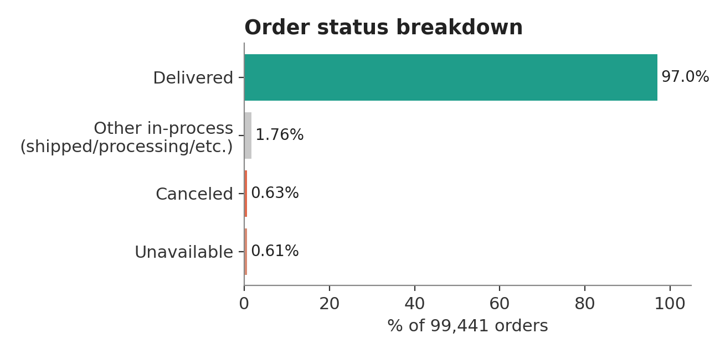
Figure 1. Order status breakdown (n = 99,441).
Review scores average 4.09 / 5, and 57.8% of reviews are a full 5 stars. But the distribution is not simply “mostly happy, a little unhappy”: 11.5% of all reviews are the lowest possible score — more than three times the share giving a 2-star review. That imbalance is a signature of acute-failure dissatisfaction (a single bad event, such as a non-arrival or damaged item, driving a customer straight to the floor) rather than a gradual drift from good to mediocre.

Does delivery timing explain the gap?
Every delivered order was bucketed by how many days early or late it arrived relative to the promised estimate, then average review score was computed per bucket. The relationship is sharply non-linear: score barely moves across the “early” buckets, then drops hard the moment an order crosses into “late” at all, with only marginal further damage beyond about two weeks late. The business does not need to eliminate all delay risk equally — the highest-leverage target is preventing an order from becoming late in the first place, even by a single day.
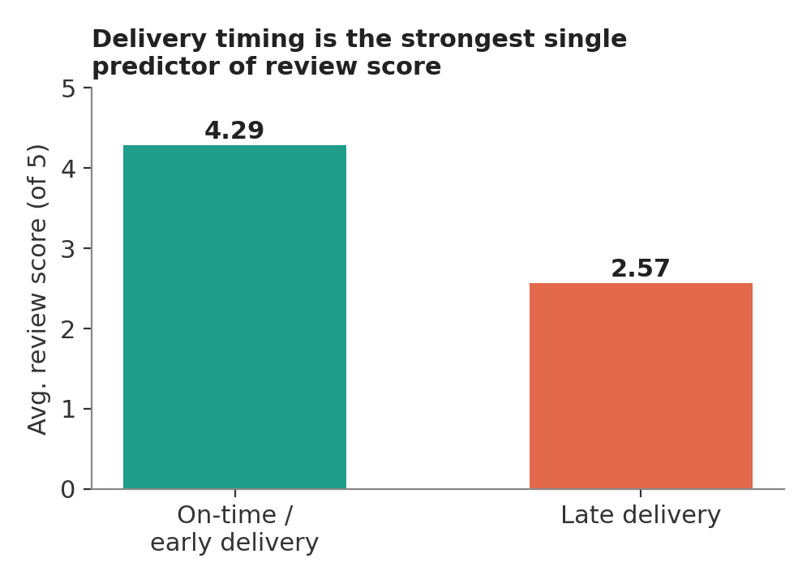
Figure 2. Average review score collapses from 4.29 to 2.57 once a delivery becomes late.
Reversing the cut confirms the same story from the customer's side: orders behind a 5-star review were delivered on time 96.2% of the time and took 10.2 days on average; orders behind a 1-star review were on time only 65.1% of the time and took over 20 days on average. A scatter of order value against delivery delay, colored by review score, shows the low-score points concentrated on the “late” side of the axis across essentially every price band — this is not a phenomenon confined to cheap or expensive orders alone.
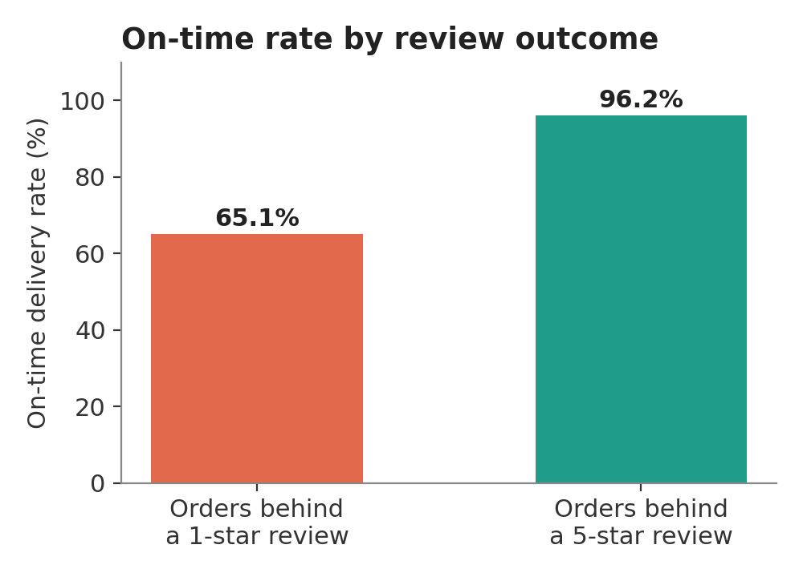
Figure 3. On-time delivery rate for orders behind a 1-star vs. a 5-star review.

Demand timing and written feedback
A day-by-hour heatmap of order placement shows weekday volume fairly even with a dip on weekends, climbing steadily from mid-morning, peaking in the early evening, and falling off sharply after 10pm — information directly relevant to staffing customer support and scheduling promotional pushes.
Most reviews (58.7%) leave the comment box empty, but the rate of writing something is far from uniform: 76.5% of 1-star reviews carry a written comment, versus only 35.9% of 5-star reviews. The free-text field behaves less like general feedback and more like a complaints channel, making it a strong candidate for text-mining in follow-on work aimed at identifying why an order failed, beyond delay alone (wrong item, damaged goods, poor seller communication).
KEY FINDING
Average review score falls from 4.29 to 2.57 the moment a delivery becomes late, and most of that drop happens in the first few days late rather than accumulating gradually — the single strongest relationship found anywhere in this study.

5.2 Customers & Geography (customers · geolocation)
The customer table distinguishes customer_id (unique per order's customer record) from customer_unique_id (the actual person); every customer-level statistic in this section uses the latter.
Customer records are heavily concentrated in Brazil's Southeast: São Paulo alone accounts for roughly 42% of all customer records, the top five states together hold about 77%, and the Southeast macro-region holds roughly 65,900 of the 96,096 unique customers — more than two-thirds of the entire customer base. Repeat-purchase rate is fairly flat across regions (roughly 2.5%–3.2%), meaning the retention problem is marketplace-wide rather than isolated to one geography.
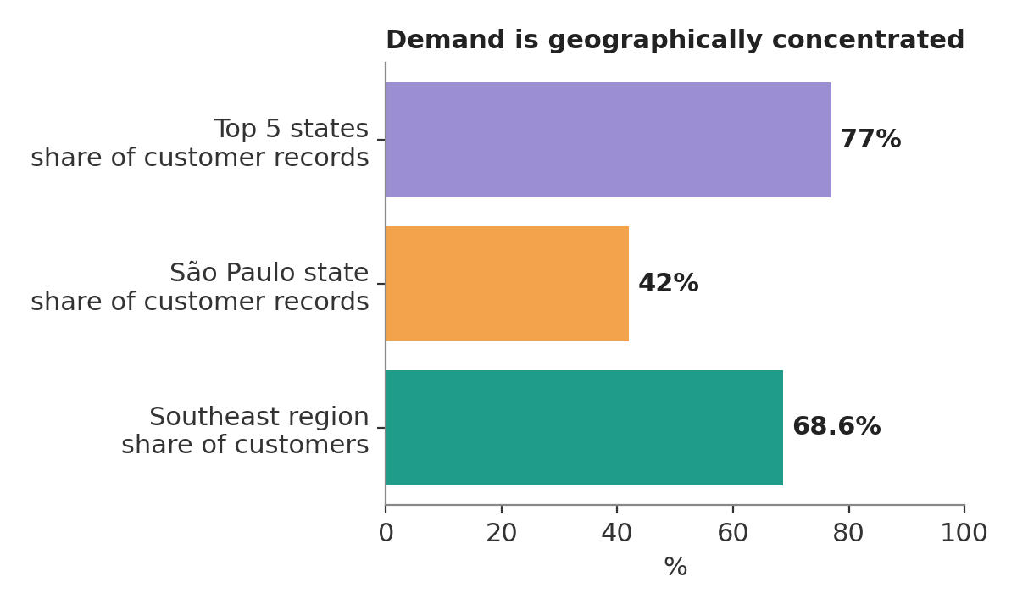
Figure 4. Customer demand is concentrated in a small geographic core.
Grouping unique customers by how many order records they generated produces four segments. The result is stark: 96.9% of unique customers appear only once. Only 3.1% are repeat customers by this definition, and the maximum observed frequency for any single customer is 17 records.
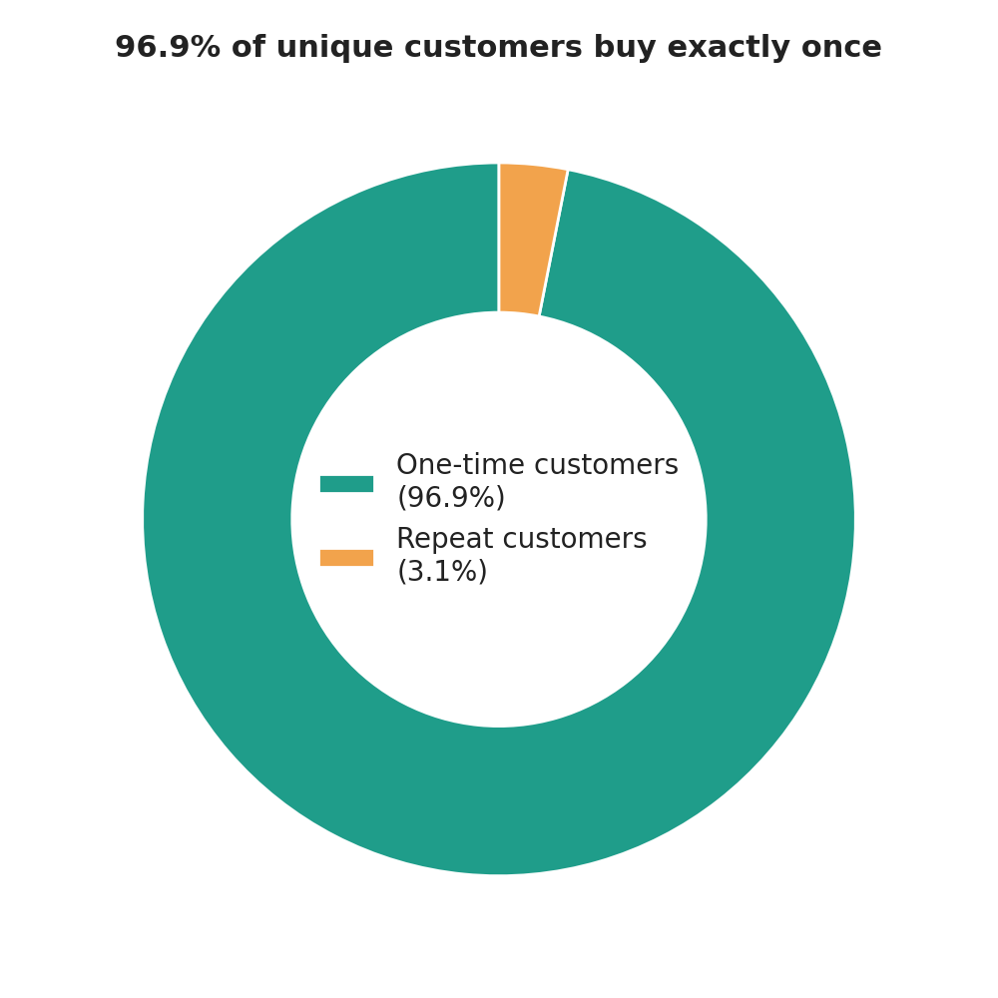
Figure 5. Customer segmentation by purchase frequency.
A ZIP-prefix join (aggregated to mean coordinate per prefix, since a single prefix can carry many raw address pings) succeeds for 99.72% of customer records, and a plain longitude/latitude scatter colored by state reconstructs a recognizable silhouette of the country directly from the data, making the Southeast concentration visible spatially. Order volume climbs for every major state over the trailing 12 months, with São Paulo's growth visibly steeper than the rest — the marketplace's overall growth curve is disproportionately a São Paulo growth curve.
KEY FINDING
Only 3.1% of unique customers are repeat buyers — growth to date has been almost entirely acquisition-driven. Given the delivery-satisfaction finding above, it is plausible that late deliveries are directly suppressing an already-thin retention base.

5.3 Catalog & Sellers (products · sellers · category_translation)
32,951 products span 71 categories. Sorted by product count, bed_bath_table, sports_leisure, and furniture_decor lead the catalog; sorted by delivered-order revenue, the ranking shifts (health_beauty, watches_gifts, and bed_bath_table lead), and each category's average review score can be read alongside its revenue rank to see how big a category is and how well it is performing at the same time.
A box-and-whisker comparison of product weight by category shows furniture and housewares carry both a higher median weight and a far wider spread than categories like toys — a detail that matters directly for the delivery-delay findings above, since bulkier, heavier items are plausible contributors to the long tail of very slow deliveries.
A correlation heatmap across seven listing attributes shows physical-size fields (weight, length, height, width) correlate strongly with each other, unsurprisingly. More interesting: photo count, title length, and description length — three signals of listing effort — correlate only weakly with each other and barely at all with a product's physical attributes. Listing quality is a largely independent axis from what is being sold, and a separate lever the marketplace could act on marketplace-wide rather than category by category.
Sellers mirror the same geographic pattern seen on the customer side: seller state and city rankings show heavy concentration in São Paulo and its neighboring states, meaning supply and demand cluster in the same places rather than supply reaching evenly into regions with fewer local sellers.
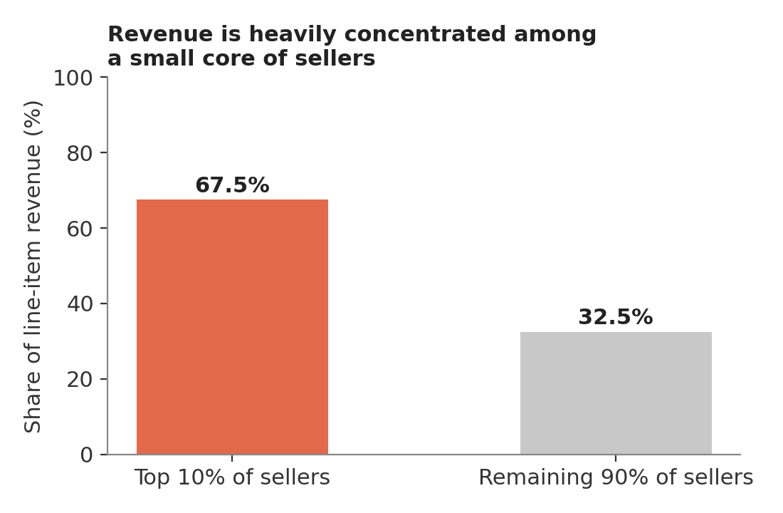
Figure 6. A Lorenz-curve analysis shows the top 10% of sellers generate about 67.5% of total line-item revenue.
KEY FINDING
Revenue concentration among sellers (top 10% → 67.5% of GMV) mirrors the geographic concentration of both sellers and customers — the marketplace currently depends heavily on a small, geographically clustered core on both the supply and demand side.

5.4 Purchases & Payments (order_items · order_payments)
112,650 line items and 103,886 payments describe a checkout habit that is simple, single-item, and paid for over time. 90.1% of orders contain exactly one line item — cross-sell essentially is not happening today. 73.9% of payments are by credit card, with most cardholders opting to split the cost across several months rather than pay in a single instalment.
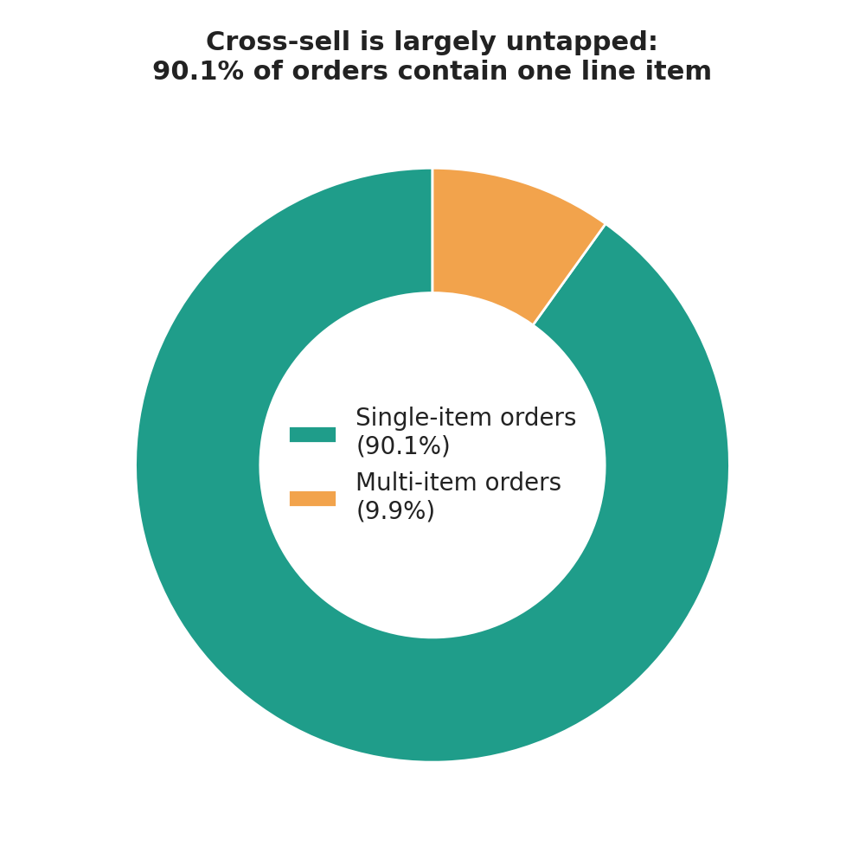
Figure 7. Basket composition — the overwhelming majority of orders are single-item.
Both patterns are growth levers the company can act on independently of anything related to delivery or catalog composition: basket-building (bundles, “frequently bought together” prompts) and payment-plan design each stand on their own, and instalment credit should be treated as the payment norm, not the exception, when framing any future pricing, discounting, or promotional strategy.

5.5 Seller Acquisition Funnel (marketing_qualified_leads · closed_deals)
This section runs in the opposite direction from the rest of the study — instead of following a customer's order, it follows a prospective seller from first contact through to becoming part of the marketplace, which is how the supply seen in Sections 5.3–5.4 is ultimately created.
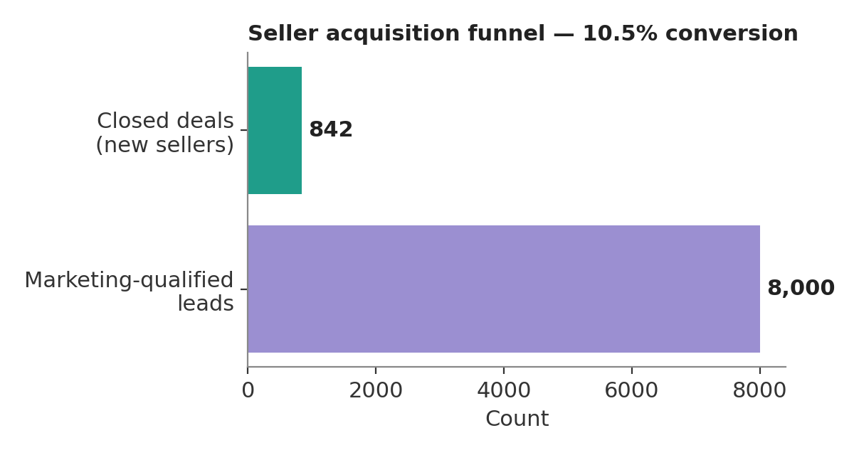
Figure 8. Only 10.5% of marketing-qualified leads ultimately become a seller.
Among named channels, paid search converts best (12.3%); traffic of unknown origin shows an even higher raw conversion rate, but that almost certainly reflects an attribution gap (leads whose real source went untracked) rather than a channel actually worth extra spend, and should be investigated at the tracking level before being treated as a growth lever.
Newly won sellers skew heavily toward home and lifestyle categories (home decor, health & beauty, car accessories) and toward resellers rather than manufacturers — most new supply is not coming from the original producer of what is being sold, which is useful context for the category and seller concentration found in Section 5.3. A sales-assigned behavioral archetype (“cat,” “eagle,” “wolf,” etc.) is captured at first contact, and every acquisition channel shows a right-skewed sales-cycle length — most deals close quickly, with a long tail taking much longer.
KEY FINDING
Lead volume and lead quality are genuinely different axes — the highest-volume channels are not automatically the highest-converting ones, so acquisition budget allocated purely on lead count risks under-investing in smaller, higher-converting channels.

5.6 Risk Landscape (all tables, combined)
Every relationship examined earlier in this report looks at two dimensions at a time. To bring delay, satisfaction, and scale together at once, three interactive 3D views were built in the accompanying dashboard: a category risk landscape (delay × review score × order volume, sized by revenue), a regional risk cube (% orders late × review score × customer count), and a seller performance cube (revenue × delay × review score).
Read together, the three views tell a consistent story: in the category landscape, heavier and bulkier categories sit further along the delay axis and lower on the score axis — physical fulfillment difficulty, not category popularity, is what drags a category toward the low-satisfaction corner. In the regional cube, the states with the largest customer bases are not necessarily the ones with the worst late-delivery rates, but the states that combine high volume and elevated lateness are exactly the ones a logistics investment should prioritize first. In the seller cube, the highest-revenue sellers cluster in a tight band of low delay and high score — the marketplace's commercial core is, encouragingly, also its operational core, and risk is concentrated more in the smaller, less consistent sellers surrounding that band.

6. Cross-Cutting Insights
RISK — Delay predicts satisfaction more than any other single variable
Across every cut in this study — category, region, individual order — the delay axis aligns with the satisfaction axis more tightly than price, category, or geography alone.

CONCENTRATION — A small core carries a large share of the marketplace
The same small set of states and top sellers reappears across nearly every chart in this study — they are simultaneously the primary growth engine and the primary point of operational risk.

OPPORTUNITY — Retention and basket size remain largely untouched
A 3.1% repeat-purchase rate and 90% single-item orders point to two growth levers — loyalty and cross-sell — that do not depend on fixing logistics or acquiring new supply first.

7. Interactive Dashboard & Presentation
The findings in this report are supported by an interactive marketplace dashboard that lets a viewer explore satisfaction and risk by category, seller, region, and delivery performance, and drill into why a given segment stands out. The dashboard mirrors the section structure of this report (Data Foundations, Fulfillment & Satisfaction, Customers & Geography, Catalog & Sellers, Purchases & Payments, Acquisition Funnel, Risk Landscape) and is delivered alongside this report and the accompanying notebooks/code repository, per the project's three required deliverables:
- Interactive Marketplace Dashboard — dynamic exploration of satisfaction and risk by category, seller, region, and delivery performance.
- Final Presentation — problem, approach, key insights, and recommended actions for leadership.
- Technical Report and Code Repository (this document) — data preparation, exploratory and explanatory analysis, insights, and recommended actions, with all notebooks/scripts needed to reproduce the work.

8. Recommendations for Leadership
Recommendations are organized around the same growth-vs-satisfaction trade-off named in the project brief, so leadership can see directly which lever moves which side of that trade-off.

8.1 Protect satisfaction without slowing growth
- Treat “becoming late at all” as the key operational threshold to prevent, rather than trying to compress delivery times generally — the score damage is concentrated in the first few days late, so even small reductions in the share of orders that cross that line should have an outsized effect on average review score.
- Prioritize logistics investment in states that combine high order volume with elevated late-delivery rates (identified in the Regional Risk Cube, Section 5.6), rather than spreading logistics spend evenly across all regions.
- Route bulkier/heavier categories (furniture, housewares) through carriers or fulfillment paths built for their size profile, since these categories show both wider delivery-time variance and higher average delay.
- Mine the free-text review field for 1-star and 2-star reviews specifically, since the comment rate more than doubles at the low end of the scale and likely contains failure modes (damaged goods, wrong item, poor communication) beyond delay alone.

8.2 Grow the marketplace without adding risk
- When onboarding new sellers, weight quality signals (on-time track record where available, or proxies such as listing completeness) alongside raw seller volume, given how tightly seller-level delay and revenue concentration are linked in the Seller Performance Cube.
- Reallocate acquisition marketing spend from raw lead volume toward proven-converting channels (paid search converts at 12.3%), and fix attribution tracking before treating “unknown-origin” traffic as a channel worth copying.
- Continue supply growth in underrepresented regions deliberately, since supply currently clusters in the same places as demand (São Paulo and its neighboring states) rather than expanding marketplace reach into under-served regions.

8.3 Untapped, lower-risk growth levers
- Invest in retention: only 3.1% of customers are repeat buyers, and growth to date has been almost entirely acquisition-driven. Even a modest lift in repeat-purchase rate compounds without depending on fixing logistics first.
- Invest in cross-sell: 90.1% of orders are single-item. Bundling and “frequently bought together” prompts are a lever entirely independent of delivery performance or seller quality.
- Design pricing and promotions around instalment credit as the payment norm (73.9% credit card, most split across multiple instalments), not as an edge case.
- Encourage listing-quality improvements (more photos, longer descriptions) marketplace-wide rather than by category, since listing effort is statistically independent of a product's physical category or size.

9. Scope, Limitations & Suggested Extensions

9.1 Scope and limitations
This study covers acquisition, catalog, purchase, fulfillment, and satisfaction data up to the point an order is delivered and reviewed. It does not include cost data, marketing spend, or customer-service contact logs, so statements about profitability, return on acquisition spend, or support-cost impact are outside what these tables can support directly. Findings describe statistical association, not causal proof — the delay–satisfaction relationship is extremely consistent across cuts, but a designed experiment (not just observational data) would be the appropriate next step before treating it as fully causal for planning purposes.

9.2 Suggested extensions
- Text-mine the written review comments to categorize complaint themes beyond delivery delay (damaged goods, wrong item, seller communication).
- Build a customer-level (not order-level) feature set — recency, frequency, monetary value — to support a churn or lifetime-value model on top of the repeat-purchase patterns surfaced in Section 5.2.

10. Team Contributions & Work Log
Per the project's team-structure requirement, each member's individual contribution is documented below for transparency and fair assessment. [To be completed by the team.]
Team member | Primary contribution area(s) | Summary of individual contribution
Ravina(21f20001128) | Marketing Funnel Datasets & Presentation | EDTA & Presentaion Making
Daaris Ameen(21f1001365) | Order_reviews, Orders(Datasets) | EDTA & Dashbord(git-hub , Deployments)
Shubham Tiwari (22f1001934) | Product_catogaries,product, sellers(Datsets) | EDTA & Dashbord
Ayush Vats(22f1001365) | Order_items, Order_payments(Datsets) | EDTA & Report making
Deepak Kumar(21f2000818) | Customer, geolocation(Datsets) | EDTA & Report making

Appendix A: Data Dictionary Reference
Join keys used throughout this study: order_id, customer_id, product_id, seller_id, mql_id.
Table | Key fields used in this study
orders | order_id, customer_id, order_status, order timestamps (purchase, delivered, estimated delivery)
order_reviews | order_id, review_score, review_comment_message
customers | customer_id, customer_unique_id, customer_zip_code_prefix, customer_city, customer_state
geolocation | geolocation_zip_code_prefix, geolocation_lat, geolocation_lng, geolocation_city
order_items | order_id, product_id, seller_id, price, freight_value
order_payments | order_id, payment_type, payment_installments, payment_value
products | product_id, product_category_name, weight_g, length_cm, height_cm, width_cm, photos_qty, name_length, description_length
sellers | seller_id, seller_zip_code_prefix, seller_city, seller_state
marketing_qualified_leads | mql_id, first_contact_date, origin
closed_deals | mql_id, seller_id, won_date, business_segment, business_type, lead_behaviour_profile

Note: all fulfillment and satisfaction metrics in this report are computed on delivered orders unless stated otherwise; all geographic joins use ZIP-prefix aggregated coordinates.

