AlpiGPT
B2B Travel Agent Concierge
Agentic Orchestration Blueprint

AI Lab Initiative — Alpitour World
Prepared for: Alpitour Leadership · Kyndryl Stakeholders · AI Lab Participants
Orchestration Platform: KAF (Kyndryl Agentic Framework)

Evolving AlpiGPT from information retrieval to agentic orchestration
across the full B2B travel agent sales journey

1. Executive Summary
Alpitour World operates at the intersection of tour operating, aviation (Neos), hospitality, and a vast agency network through Welcome Travel Group. With brands including Alpitour, Eden Viaggi, Francorosso, Bravo, and Turisanda, the group serves internal teams, B2B agency partners, and B2C consumers through a multi-brand portfolio.
This blueprint defines how AlpiGPT evolves from an information retrieval assistant into an agentic orchestration layer supporting travel agents across the full sales journey — from initial inquiry through needs capture, personalised recommendation, itinerary creation, proposal preparation, and booking support with next-best-action intelligence.
The orchestration substrate is the Kyndryl Agentic Framework (KAF), which coordinates a specialised agent inventory through MCP toolsets against Alpitour's inventory, CRM, and booking platform services. The result is a single conversational touchpoint that delivers the right solution at the right time, reducing manual effort while increasing conversion and agent productivity.
- Strategic objective: Transform AlpiGPT into the B2B concierge orchestration layer for ~80% of agency bookings via EasyBook
- Scope: Seven-stage sales journey with ten specialised AI agents coordinated through KAF
- Target impact: −50% quote turnaround, +30% agent productivity, +25% proposal acceptance
- Phase 1 pilot: Standard package quote with sold-out alternative handling — highest volume, lowest integration risk

2. Future User Journey
The future user journey structures the travel agent experience as seven sequential stages. Each stage maps to one or more specialised agents orchestrated through KAF, reusing shared inventory, customer, and booking services.
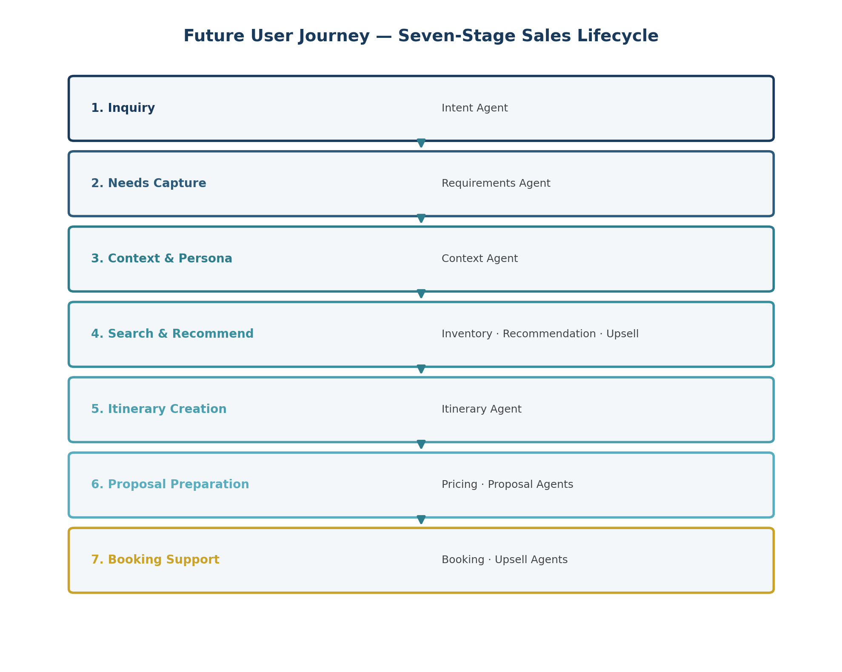
Figure 1: Seven-Stage Future User Journey with Agent Mapping

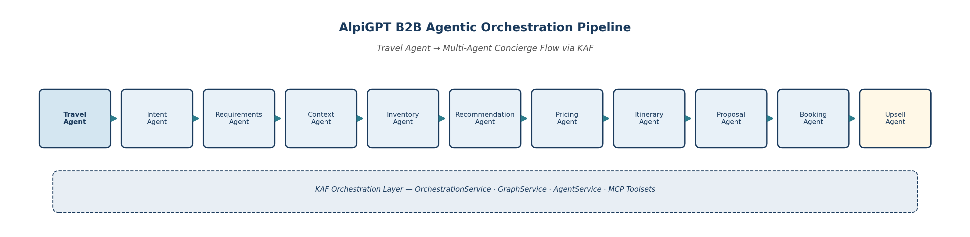
Figure 2: Agentic Orchestration Pipeline — Travel Agent through Upsell Agent

Step | Stage | Primary Agents | Agent Experience
1 | Inquiry | Intent Agent | Customer request arrives; agent opens AlpiGPT
2 | Needs Capture | Requirements Agent | Guided clarifying questions structure the request
3 | Context & Persona Signals | Context Agent | Agency tier, client history, preferences applied
4 | Search & Recommend | Inventory · Recommendation · Upsell | Ranked packages, alternatives, upsell options
5 | Itinerary Creation | Itinerary Agent | Customised multi-segment travel solution composed
6 | Proposal Preparation | Pricing · Proposal Agents | Agency-branded quote ready for review
7 | Booking Support & NBA | Booking · Upsell Agents | Hold, confirm, upsell, next best actions

1. Inquiry
Business Goal: Capture the customer request immediately and initiate an orchestrated work package with zero friction for the travel agent.
User Actions: Travel agent receives client inquiry; opens AlpiGPT within EasyBook; submits natural-language request describing destination, dates, and traveller profile.
AI Agents Involved: Intent Agent
Data Sources Accessed: EasyBook session context; channel authentication; agency credentials
Inputs: Natural-language inquiry; agency ID; session metadata
Outputs: Classified intent; initial work package; conversation thread ID
Business Value: Instant request acceptance eliminates manual triage; every inquiry enters a traceable orchestration pipeline from the first interaction.

2. Needs Capture
Business Goal: Transform ambiguous requests into structured, actionable requirements before any inventory search begins.
User Actions: Agent responds to guided clarifying questions; confirms dates, party size, budget, brand preference, and special requirements.
AI Agents Involved: Requirements Agent (guided by Intent Agent)
Data Sources Accessed: OrchestrationService clarification API; conversation history; agency booking patterns
Inputs: Partial intent; agent clarifications; constraint signals
Outputs: Structured requirements object (destination, dates, pax, budget, brand, constraints)
Business Value: Reduces rework and failed searches; ensures downstream agents operate on complete, validated requirements.

3. Context & Persona Signals
Business Goal: Enrich the request with agency tier, client history, and preference signals to enable personalised orchestration.
User Actions: Agent optionally identifies repeat client or references past bookings; reviews AI-surfaced context summary.
AI Agents Involved: Context Agent
Data Sources Accessed: CRM (agency tier, commission structure); client profiles; booking history API; loyalty data
Inputs: Structured requirements; agency ID; optional client identifier
Outputs: Enriched context profile (tier, commission, preferences, past destinations, spend patterns)
Business Value: Personalisation without manual CRM lookup; agency-tier pricing and recommendations applied automatically.

4. Search & Recommend
Business Goal: Deliver a ranked shortlist of relevant packages, alternatives, and upsell opportunities aligned to agency and client context.
User Actions: Agent reviews ranked options; requests alternatives for sold-out properties; explores upsell suggestions.
AI Agents Involved: Inventory Agent; Recommendation Agent; Upsell Agent
Data Sources Accessed: Inventory API (packages, hotels, Neos flights, allotments); RAG product catalogues; yield status; CRM purchase history
Inputs: Structured requirements; enriched context; search constraints
Outputs: Ranked option shortlist; availability status; alternative proposals; upsell candidates
Business Value: Cuts manual search time by up to 50%; intelligent alternatives prevent lost sales on sold-out inventory.

5. Itinerary Creation
Business Goal: Compose a customised, multi-segment travel solution that satisfies all captured constraints and client preferences.
User Actions: Agent reviews composed itinerary; requests segment adjustments (hotel changes, transfer additions, excursion inclusions).
AI Agents Involved: Itinerary Agent
Data Sources Accessed: Inventory API; itinerary composition rules; destination content (RAG); transfer and excursion catalogues
Inputs: Selected options; structured requirements; context profile
Outputs: Multi-segment itinerary (hotels, flights, transfers, excursions); constraint validation report
Business Value: Enables complex custom trips without call-centre escalation; dynamic KAF workflows handle multi-segment composition.

6. Proposal Preparation
Business Goal: Generate an agency-branded, commercially accurate proposal ready for client presentation.
User Actions: Agent reviews priced proposal; verifies commission visibility; approves or requests revision before client sharing.
AI Agents Involved: Pricing Agent; Proposal Agent
Data Sources Accessed: Pricing engine (B2B markup, commission rules); OPA policy guardrails; brand templates; cancellation and insurance policies (RAG)
Inputs: Composed itinerary; agency tier; commercial rules; brand guidelines
Outputs: Structured quote/proposal (PDF or in-app); commission breakdown; compliance annotations
Business Value: Proposal assembly automated from hours to minutes; consistent commercial accuracy and brand compliance.

7. Booking Support & Next Best Actions
Business Goal: Complete the sale with booking holds or confirmations, contextual upsells, and proactive follow-up actions.
User Actions: Agent confirms booking or places hold; selects upsell options; receives confirmation reference and next-best-action recommendations.
AI Agents Involved: Booking Agent; Upsell Agent
Data Sources Accessed: Booking Platform APIs (EasyBook); hold/reservation services; notification services; CRM for follow-up triggers
Inputs: Approved proposal; agent confirmation; upsell selections
Outputs: Booking reference or hold confirmation; upsell attachments; client notification; next-best-action alerts
Business Value: Accelerates conversion at point of decision; contextual upsells increase average order value; automated follow-up reduces drop-off.

3. Agent Inventory
Ten specialised AI agents form the B2B concierge orchestration inventory. Each agent is invoked by KAF based on journey stage and request complexity, reading from and writing to a shared Travel Work Context object within the work package graph.
Agent | Journey Stage(s) | Primary Responsibility | Key Capabilities
Intent Agent | 1. Inquiry | Request intake and classification | Parse NL requests; classify intent type; initiate KAF work package
Requirements Agent | 2. Needs Capture | Structured requirement extraction | Guided clarification; constraint validation; requirements object assembly
Context Agent | 3. Context & Persona | Identity and preference enrichment | Agency tier resolution; client profile; booking history; persona signals
Inventory Agent | 4. Search & Recommend | Product and availability search | Package/hotel/flight search; allotment checks; sold-out detection
Recommendation Agent | 4. Search & Recommend | Personalised ranking and scoring | Profile-aware ranking; similarity scoring; alternative matching
Pricing Agent | 6. Proposal Preparation | Commercial rule application | Commission, markup, promotions; dynamic yield; OPA guardrails
Itinerary Agent | 5. Itinerary Creation | Multi-segment trip composition | Segment assembly; constraint validation; transfer/excursion integration
Proposal Agent | 6. Proposal Preparation | Branded proposal generation | Structured quote assembly; PDF/HTML output; compliance annotations
Booking Agent | 7. Booking Support | Reservation handoff and confirmation | Hold creation; PNR generation; booking platform API mapping
Upsell Agent | 4, 7 Search & Booking | Revenue enrichment opportunities | Excursions, transfers, insurance, upgrades; contextual NBA suggestions

4. Detailed Orchestration Flow
AlpiGPT sits as the conversational layer above KAF. The orchestration router selects static workflows for standard package quotes or dynamic multi-agent graphs for custom itineraries. All agents access the same Inventory, Customer, and Booking services via MCP toolsets.
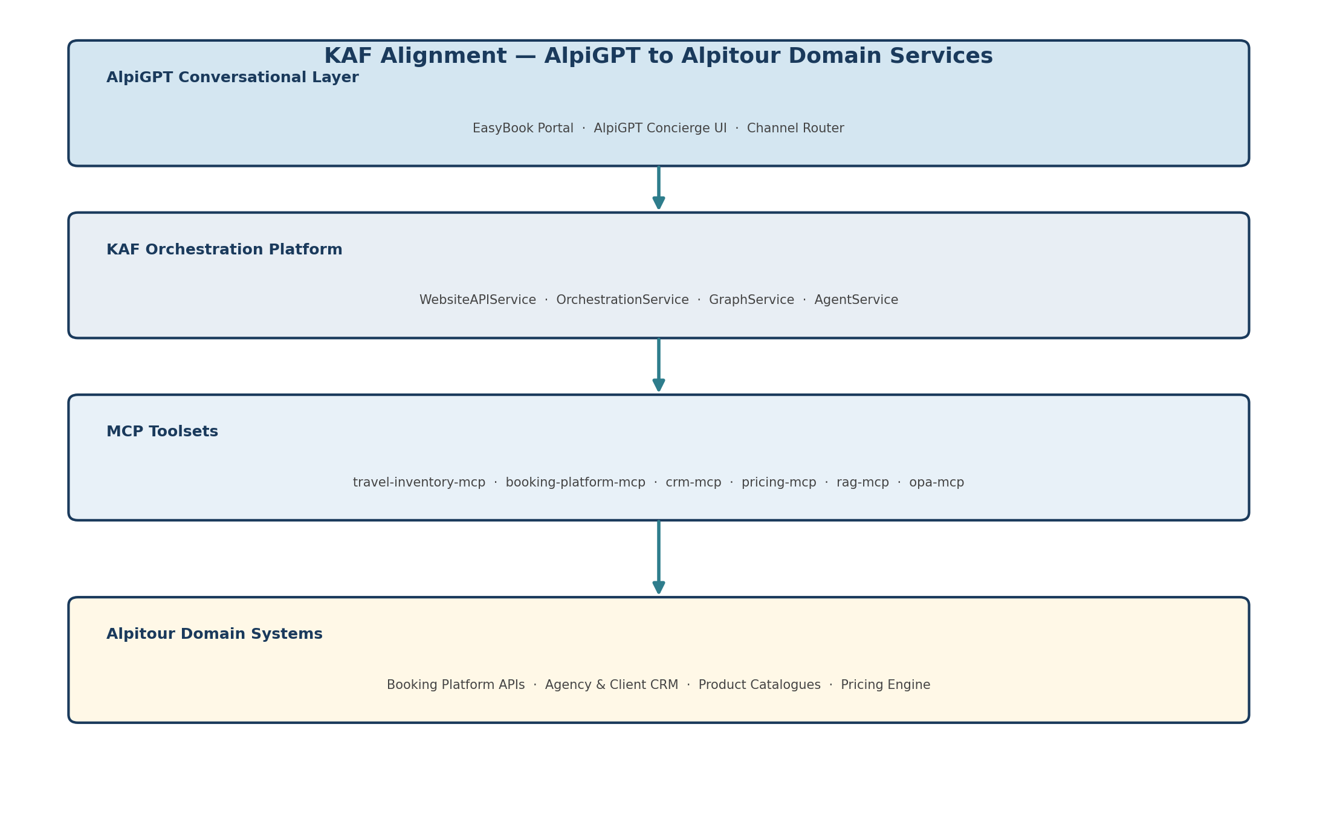
Figure 3: KAF Alignment — Layered Architecture from AlpiGPT to Domain Systems

Orchestration Lifecycle
Phase | Description | Agents Involved | KAF Component
Discover | Parse intent, enrich context, clarify gaps | Intent → Requirements → Context | OrchestrationService
Plan | Search inventory, rank options, compose itinerary | Inventory → Recommendation → Itinerary | GraphService (DAG)
Validate | Apply pricing, compliance, and policy checks | Pricing → Proposal | AgentService + OPA MCP
Commit | Hand off to booking platform; trigger upsells and notifications | Booking → Upsell | booking-platform-mcp

Workflow Selection Logic
Request Type | Workflow Mode | Agent Graph | Typical Duration
Standard package quote | Static workflow | Intent → Requirements → Context → Inventory → Recommendation → Pricing → Proposal → Booking | < 5 minutes
Sold-out alternatives | Static workflow (branch) | Intent → Inventory → Recommendation → Itinerary → Proposal → Booking | < 3 minutes
Custom multi-destination | Dynamic workflow | Full agent graph with Itinerary Agent composition | < 10 minutes
Group / corporate inquiry | Dynamic workflow + escalation | Full graph → internal operator handoff | < 15 minutes

5. Agent Interaction Map
The agent interaction map illustrates how specialised agents coordinate through KAF's orchestration router, sharing context via the Travel Work Context object and accessing common domain services.
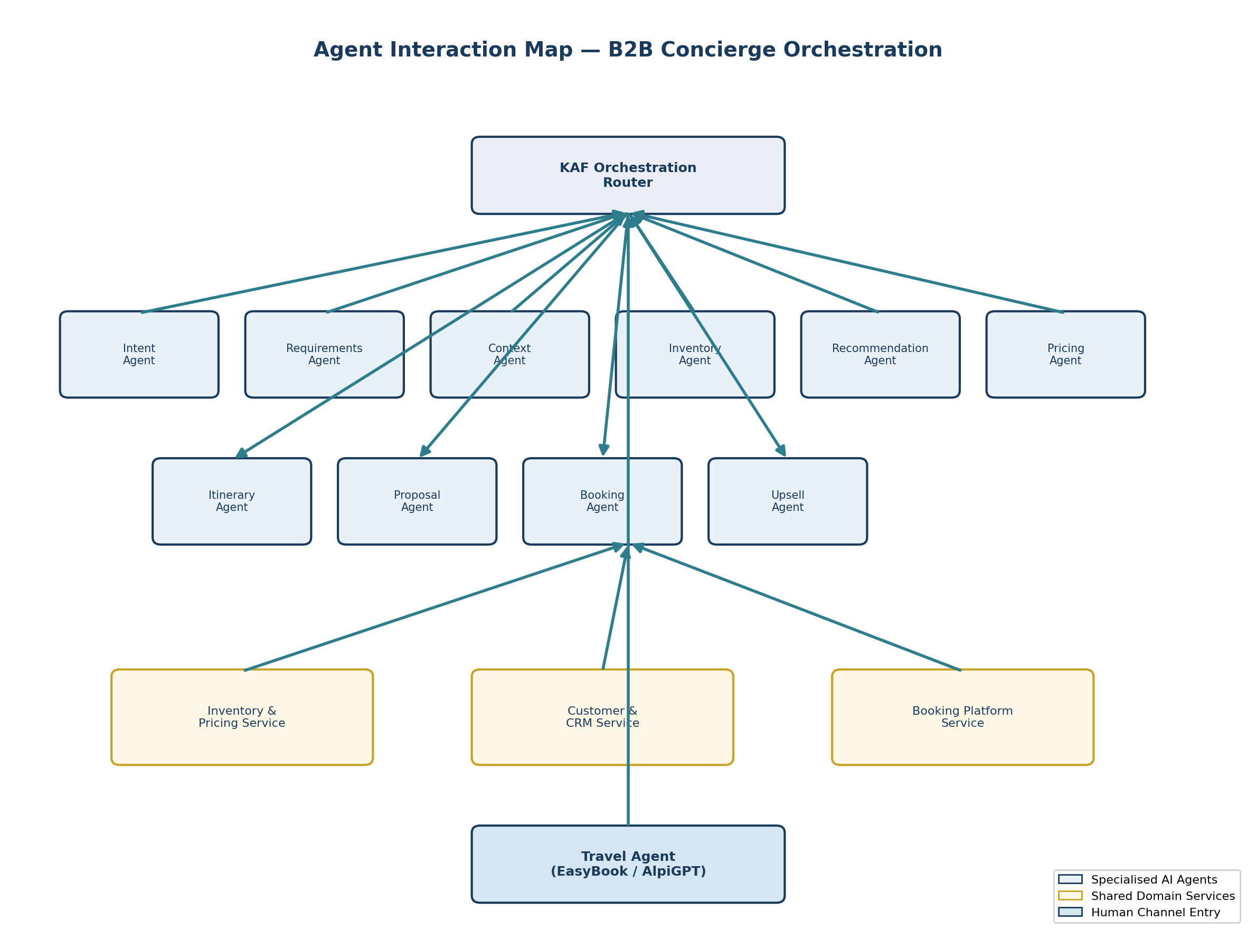
Figure 4: Agent Interaction Map — Coordination via KAF and Shared Services

Inter-Agent Communication Patterns
From Agent | To Agent | Shared Artefact | Purpose
Intent Agent | Requirements Agent | Raw inquiry + classification | Trigger structured needs capture
Requirements Agent | Context Agent | Structured requirements | Enable persona enrichment
Context Agent | Inventory Agent | Enriched context profile | Context-aware search parameters
Inventory Agent | Recommendation Agent | Raw search results | Personalised ranking
Recommendation Agent | Itinerary Agent | Ranked shortlist | Itinerary composition input
Itinerary Agent | Pricing Agent | Composed itinerary | Commercial rule application
Pricing Agent | Proposal Agent | Priced itinerary | Branded proposal generation
Proposal Agent | Booking Agent | Approved proposal | Reservation handoff
Booking Agent | Upsell Agent | Booking confirmation | Post-booking enrichment
Upsell Agent | Recommendation Agent | Upsell signals | Cross-sell in search stage

6. Systems & Data Sources
All agents access Alpitour domain systems through KAF MCP toolsets. This section catalogues the systems, data sources, and integration points required for B2B concierge orchestration.
Data Source / System | Type | Accessed By | Data Provided
EasyBook Portal | Channel / UI | Travel Agent, AlpiGPT | Session context, agency authentication, booking entry point
Agency & Client CRM | Master data | Context Agent, Upsell Agent | Agency tier, commission, client profiles, booking history
Inventory API | Transactional | Inventory Agent, Itinerary Agent | Packages, hotels, Neos flights, allotments, yield status
Pricing Engine | Commercial rules | Pricing Agent | B2B markup, commission rules, promotions, dynamic yield
Product Catalogues (RAG) | Knowledge base | Inventory Agent, Recommendation Agent | Destination guides, brand catalogues, hotel descriptions
Policy Documents (RAG) | Knowledge base | Proposal Agent, Pricing Agent | Cancellation terms, insurance rules, brand guidelines
Booking Platform APIs | Transactional | Booking Agent | Holds, reservations, PNRs, confirmations
Notification Services | Integration | Booking Agent, Upsell Agent | Confirmations, diary links, follow-up alerts
OPA Policy Engine | Guardrails | Pricing Agent, Proposal Agent | Commission limits, pricing floors, compliance rules
Observability Stack | Monitoring | All agents (via KAF) | Conversion metrics, resolution time, agent success rates

Inputs and Outputs by Journey Stage
Stage | Primary Inputs | Primary Outputs | Downstream Consumer
1. Inquiry | NL request, agency ID, session metadata | Classified intent, work package ID | Requirements Agent
2. Needs Capture | Partial intent, agent clarifications | Structured requirements object | Context Agent
3. Context & Persona | Requirements, agency/client identifiers | Enriched context profile | Inventory Agent
4. Search & Recommend | Requirements, context, constraints | Ranked shortlist, alternatives, upsells | Itinerary Agent
5. Itinerary Creation | Shortlist, requirements, context | Multi-segment itinerary | Pricing Agent
6. Proposal Preparation | Itinerary, commercial rules, brand guidelines | Priced proposal (PDF/in-app) | Booking Agent
7. Booking Support | Approved proposal, agent confirmation | Booking ref, upsells, NBA alerts | Travel Agent / Client

7. KAF Alignment
KAF provides the orchestration substrate for AlpiGPT. Agent inquiries become KAF work packages; agents execute via MCP toolsets against Alpitour domain services with OPA guardrails ensuring commercial and policy compliance.
AlpiGPT Concept | KAF Implementation | MCP Toolset / Service
Agent inquiry | WorkPackageCreate via WebsiteAPIService | WebsiteAPIService
Standard package quote | Static workflow — fixed agent DAG | GraphService
Custom itinerary request | Dynamic workflow — OrchestrationService build_steps | OrchestrationService
Inventory search | Inventory Agent tool invocation | travel-inventory-mcp
Booking commit | Booking Agent handoff | booking-platform-mcp → EasyBook / Booking Platform APIs
Agency context | Context Agent enrichment | crm-mcp
Commercial rules | Pricing Agent validation | pricing-mcp + opa-mcp guardrails
Product knowledge | Recommendation Agent grounding | rag-mcp — brand catalogues and destination guides
Observability | Agent execution tracing | Grafana / Loki / Tempo

KAF Component Responsibilities
KAF Component | Role in B2B Concierge | Interaction Pattern
WebsiteAPIService | Channel ingress, authentication, work package creation | AlpiGPT → KAF entry point
OrchestrationService | Complexity analysis, step generation, clarification, SSE streaming | Routes to static or dynamic workflow
GraphService | Agent execution order, dependencies, parallel tasks | Manages agent DAG per work package
AgentService (ReAct + MCP) | Specialised travel agent runtime with tool use | Executes individual agents against MCP toolsets
Custom MCP Servers | Domain-specific tool interfaces | Bridge agents to Alpitour systems
OPA MCP | Policy guardrails and compliance enforcement | Validates pricing, commission, and policy rules

8. Business Value
The agentic orchestration blueprint delivers measurable business value across productivity, conversion, quality, and operational efficiency dimensions.
Value Driver | Description | Mechanism | Target Impact
Faster Time to Offer | Reduce time to prepare and respond to quotes | Automated search, ranking, and proposal assembly | −50% quote turnaround
Reduced Manual Effort | Eliminate repetitive search and comparison tasks | Multi-agent orchestration replaces manual system switching | −40% repetitive tasks
Improved Agent Productivity | More requests handled per agent per day | Right information and actions surfaced at each journey stage | +30% requests per agent
Higher Quality & Relevance | Personalised itineraries aligned to client needs | Context Agent + Recommendation Agent persona signals | +25% proposal acceptance
Increased Conversion | Better recommendations driving more confirmed bookings | Intelligent alternatives and contextual upsells | +25% self-service conversion
Revenue Enrichment | Higher average order value through contextual upsells | Upsell Agent at search and booking stages | +15% AOV on upsell-eligible bookings
Call-Centre Deflection | Complex requests resolved without escalation | Custom itinerary and group workflows with clean handoff paths | −35% B2B support escalations

Business Benefits by Stakeholder
Stakeholder | Primary Benefit | Key Metric
External Travel Agent | Faster quotes, less searching, more selling time | Time-to-offer < 5 minutes
Internal Booking Operator | Clean escalations with full context visibility | Escalation resolution time −40%
Sales & Customer Service | Pipeline visibility and reduced queue pressure | Support ticket volume −35%
Product & Content Teams | Catalogue utilisation insights from agent analytics | Catalogue coverage score +20%
IT & Data Operations | Observable, governable agent platform on KAF | Agent success rate > 95%
Alpitour Leadership | Measurable ROI on AI Lab investment | B2B conversion rate +25%
Kyndryl / KAF Stakeholders | Production-grade agentic reference architecture | End-to-end orchestration demonstrator

9. Future Expansion Opportunities
The B2B concierge orchestration blueprint establishes a foundation for broader agentic capabilities across the Alpitour ecosystem. The following expansion opportunities build on the shared agent inventory and KAF orchestration substrate.
Expansion Opportunity | Description | Prerequisite
B2C Personalised Travel Concierge | Extend the same agent inventory to direct consumers with channel-aware pricing, tone, and guardrails. Personalisation Agent and Recommendation Agent already support profile-aware ranking. | Phase 1 B2B concierge pilot validated
Internal Operational Efficiency | Deploy Intent, Context, Inventory, and Analytics agents for internal sales tracking, customer service resolution, and operational reporting — reusing MCP toolsets without duplication. | Phase 1 B2B concierge pilot validated
Proactive Next-Best-Action Engine | Evolve the Upsell Agent into a continuous NBA engine that monitors booking patterns, seasonal signals, and client lifecycle events to trigger proactive agent outreach. | Phase 1 B2B concierge pilot validated
Multi-Brand Orchestration Profiles | Configure brand-specific orchestration profiles (Alpitour, Francorosso, Eden Viaggi) with tailored RAG knowledge bases, pricing rules, and proposal templates within a single platform. | Phase 1 B2B concierge pilot validated
Group & Corporate Travel Automation | Expand dynamic workflows for group bookings, MICE events, and corporate travel programmes with dedicated compliance and contract management agents. | Phase 1 B2B concierge pilot validated
Cross-Channel Continuity | Enable seamless handoff between B2B agent sessions and B2C client interactions, preserving Travel Work Context across channels for unified customer experience. | Phase 1 B2B concierge pilot validated
Analytics & Learning Loop | Introduce an Analytics & Learning Agent to capture outcome data, power A/B testing of recommendation strategies, and continuously improve agent performance. | Phase 1 B2B concierge pilot validated
Neos Aviation Integration | Deepen Inventory Agent integration with Neos flight operations for real-time seat availability, yield management, and bundled package optimisation. | Phase 1 B2B concierge pilot validated

Recommended Roadmap
Phase | Scope | Timeline | Success Criteria
Phase 1 — Pilot | Standard package quote + sold-out alternatives (Scenarios 1–2) | Q3 2026 | Quote in < 60 seconds; 95% agent success rate
Phase 2 — Expand | Custom itineraries + context enrichment (Scenarios 3–5) | Q4 2026 | Multi-segment composition; repeat-client personalisation
Phase 3 — Scale | Full seven-stage journey for all agency tiers | H1 2027 | −50% quote turnaround; +25% conversion
Phase 4 — Extend | B2C concierge + internal ops + NBA engine | H2 2027 | Unified platform across three channels

Platform Reference: AlpiGPT operates as the conversational front-end to KAF-orchestrated agents. "Alpitour Booking Platform" and EasyBook refer to the group's reservation layer consumed via booking-platform-mcp (~80% of agency bookings through EasyBook). This document is prepared as part of the Alpitour AI Lab initiative.

