Demonstration Guide: Item 8, Slicer and 4th Focus Axis
This guide walks through the project one folder at a time. Each section says what the folder holds, how the work was done and why, how it connects to the assignment, how to test it, what a correct result looks like, and which software you need.
Project root (ROOT): C:\Users\Bombe\Downloads\XYZ-Micromanipulator-GitHub
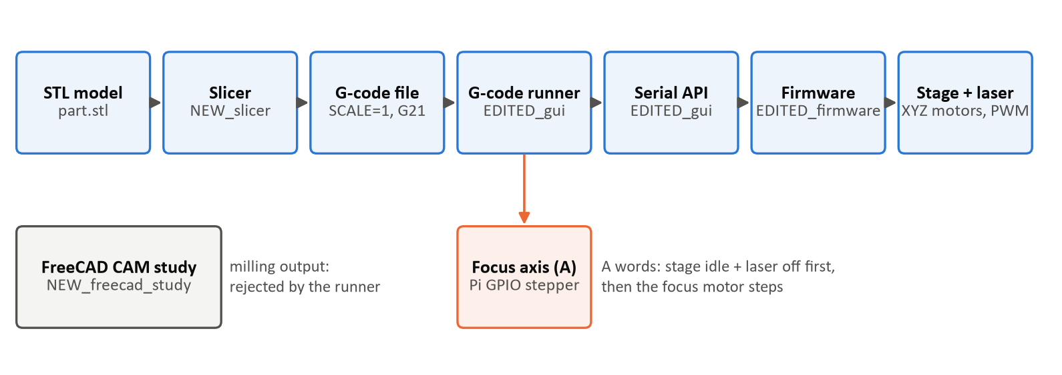
The software chain this guide covers, with the new repo folders

The assignment, in one table
Assigned | Where it is delivered | Sections
Item 8: study how FreeCAD's contour (Profile) and facing (MillFace) toolpaths are made and how they fit the system; one-page summary + first FreeCAD file | FreeCAD study, rerun evidence, Item 8 summary | 7, 2
Item 8: start building the slicer | Corrected slicer, tests, examples | 5, 6
Weekly task: add a 4th (focus) axis to the micromanipulator GUI | GUI code, tests, firmware support | 3, 4, 8
Weekly task: write-up | All write-ups | 2

Software needed overall
Software | Used in sections | Get it from
Python 3.14 | 1, 3, 4, 5, 6 | python.org (installed)
Project Python environment ROOT\EDITED_gui\.venv | 3, 4, 5, 6 | already set up; recreate with setup.bat + requirements-dev.txt
Visual Studio Code + Python extension | 1, 3, 4, 5, 6, 8 | code.visualstudio.com
FreeCAD 1.0.x | 6, 7 | freecad.org
CAMotics (G-code viewer, optional) | 6 | camotics.org
PlatformIO extension for VS Code + Git for Windows (long paths on) | 8 | VS Code Extensions; git-scm.com
Windows Photos, a Markdown viewer (VS Code preview: Ctrl+Shift+V) | 2, 6 | built in

Before running any of the VS Code terminal commands below, select the interpreter ROOT\EDITED_gui\.venv\Scripts\python.exe (Ctrl+Shift+P → "Python: Select Interpreter"). Once that's set, python refers to the project environment.

1. Project root (everything)
Path: C:\Users\Bombe\Downloads\XYZ-Micromanipulator-GitHub
What is there: the whole project, reorganized for GitHub. Folder names say what happened to each part: NEW_ (created in this work), EDITED_ (changed), UNCHANGED_ (kept as it was). EDITED_gui, EDITED_firmware, NEW_slicer, NEW_freecad_study, NEW_docs and UNCHANGED_reference (CAD, electronics, datasheets, original documentation, the PythonAPI scripts and the embossing-machine project). The top-level README.md lists every new and edited file.
How it was done:
- Before anything changed, the GUI, software and firmware folders were copied to C:\Users\Bombe\Downloads\Senior-Design-XYZ-Micro-manipulator-main\_baseline_snapshot_2026-11-11.
- The newer prototype files from the Desktop package (seniordesign git\github upload) were copied in and then corrected here. The Desktop package itself was only read, never edited.
Why: the assignment work has to sit in the real project so the team can upload it. The snapshot holds on to the original for comparison, and there's no git history to fall back on.
Significance: all three deliverables (Item 8 study, slicer, 4th axis) are in one place, together with the write-ups that describe them.
How to test: run every automated test at once from a VS Code terminal opened in ROOT\EDITED_gui:
python -m pytest tests ..\NEW_slicer\tests -v
Expected result: a list of test names, each one marked PASSED, ending with:
136 passed
A few GUI windows flash open briefly during the Qt tests, which is normal. If a line says FAILED, it names the test and the reason.
Software: Python 3.14, the project environment, VS Code.

2. Write-ups
Path: C:\Users\Bombe\Downloads\XYZ-Micromanipulator-GitHub\NEW_docs
File | Content
item8_freecad_summary.md | Item 8 one-pager: FreeCAD job, findings, how it fits, slicer progress
slicer_writeup.md | Slicer inputs/outputs, algorithm, results, tests, limits
fourth_axis_gui_writeup.md | Focus axis controls, flow, failure handling, verification, physical checks
setup_and_verification.md | Install steps, reproduction commands and their results
correction_report.md | Every problem → evidence → fix → how it was verified → remaining limit
firmware_build_2026-11-11.log | Full PlatformIO build output
demonstration_guide.md | This guide

How it was done: every claim comes from the code, a test, a measured file, the FreeCAD rerun, or the firmware build. The label next to each of the claims show the strongest evidence behind it: source, automated test, app launch, firmware build, or hardware.
Why: the assignment asks for a summary and a write-up. The team is also making decisions based on it (Decision 4, SR-01, SR-02, FR-04), so it has to say what was proven and what still isn't.
Significance: these files are the write-up deliverable, and they hold the evidence for Item 8.
How to test: open each .md file in VS Code and press Ctrl+Shift+V for the formatted view. Then check the numbers against sections 5 to 8 of this guide.
Expected result: you should see readable pages with tables, and every result they quote (136 tests, 100 layers, 1,436 lines, build SUCCESS) can be reproduced with the steps below.
Software: VS Code (or any Markdown viewer). Word is only needed if you convert them to .docx.

3. GUI code (focus axis, runner, parser)
Path: C:\Users\Bombe\Downloads\XYZ-Micromanipulator-GitHub\EDITED_gui\source
File | Status | Role
hardware\focus_axis.py | new | Drives the focus stepper (Pi GPIO) or an explicit simulation; rejects out-of-range moves; Stop works mid-move; reports COMPLETED / CANCELLED / REJECTED / FAILED
gcode_program.py | new | Strict G-code reader: handles comments, G1 vs G10, units; rejects unsupported commands with the line number before anything moves
gcode_runner.py | rewritten | Runs a program; checks every controller reply; turns the laser off and waits for the stage before each focus move; reports exactly how it ended
hardware\open_micro_stage_api.py | updated | One serial conversation at a time; late replies discarded; number checks; ensure_stage_idle_and_tool_off()
mainwindow.py | updated | Focus panel, manual moves on a worker thread, program start/stop with status, safe window close, waypoint files with SCALE=1
gui_components\realtime_controller_widget.py | updated | Switching realtime mouse control off now really stops it
main.py | updated | --simulate-focus option
version.py | new | Missing file that stopped the GUI from starting

How it was done:
- The prototype's focus code was rebuilt so that it never reports a success it didn't actually achieve.
- Each reply from the controller is now compared against OK. The old code counted any reply as a success, because in Python the reply type is always "true".
- Reading the firmware turned up the laser-off problem. M3 S0 only changes the value used by the next queued move, and the "done" query didn't look at the move that was currently running. Now the PC sends tool-off, queues a 1 ms pause carrying the off value, and waits for the controller to report idle before the focus motor takes a step.
- Worker threads talk to the window through Qt signals, which means only the GUI thread ever updates the screen.
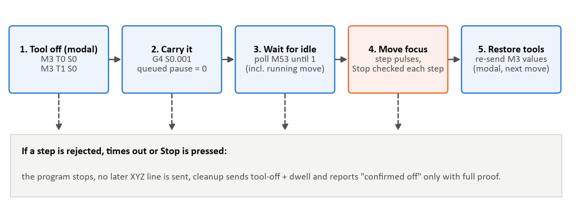
Laser-off sequence the runner follows before every focus (A) move
Why: the weekly task is to add the 4th axis to the GUI. A focus move with the laser still on would write resin in the wrong place, a "done" message after a rejected move would hide a fault.
Significance: this is the 4th-axis deliverable. It's also what makes the slicer's G-code runnable, so it connects the slicer (Item 8) to the machine.
How to test (demo, no hardware): open a VS Code terminal in ROOT\EDITED_gui and run:
python source\main.py --simulate-focus
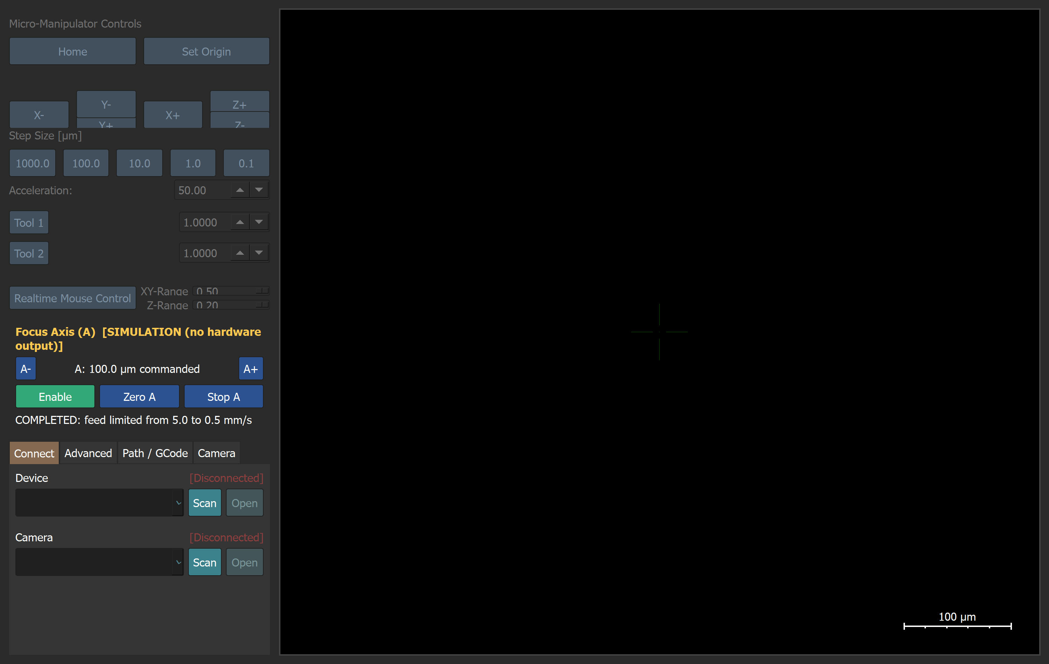
The GUI started with --simulate-focus (no stage or camera connected)
Then:
1. Find the Focus Axis (A) panel. Its label reads SIMULATION (no hardware output) in yellow.
2. Leave the step at the default 0.1 mm and press A+ (or the E key). The readout changes to A: 100.0 µm commanded, and the status line shows COMPLETED: feed limited from 5.0 to 0.5 mm/s because the jog feed is higher than the focus axis's 0.5 mm/s limit.
3. Select the largest step (1 mm). The focus speed limit is 0.5 mm/s, so this move takes about 2 s. Press A+, then hit Stop A while it's still moving. The status shows CANCELLED and the readout stops partway.
4. Close the window and start it again without --simulate-focus. This time the label shows UNAVAILABLE: lgpio is not installed … in red, and the A buttons are disabled. The focus axis no longer pretends to move when there's no hardware.
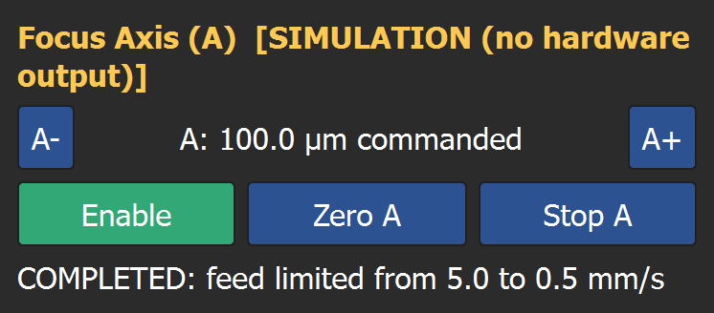
Focus panel in SIMULATION after a 0.1 mm A+ move
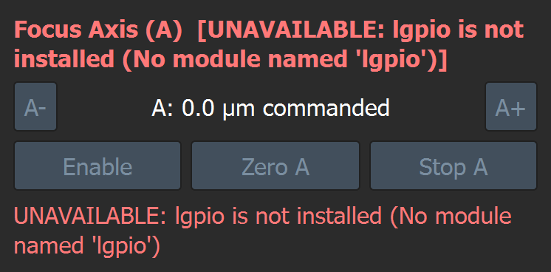
Focus panel when GPIO is not available: controls disabled, no silent simulation
Expected result: each step should behave as described. The XYZ and G-code tabs stay grey because no stage is connected. Running G-code needs the controller, and that's why the tests in section 4 use a simulated one.
Software: Python 3.14, the project environment, VS Code. On the real Pi: Raspberry Pi OS with lgpio.

4. GUI tests
Path: C:\Users\Bombe\Downloads\XYZ-Micromanipulator-GitHub\EDITED_gui\tests
File | Tests | What it proves
test_gcode_program.py | 34 | ; Y99 is ignored; G10 ≠ G1; G01/M05 work; dwell P = ms, S = s; arcs, inches, relative mode, M6, M3 S1000 rejected with line numbers; FreeCAD's file rejected at line 5 (M6)
test_serial_api.py | 21 | Error replies are not treated as success; tiny/invalid feeds refused; 8 threads each get their own reply; a late reply is not given to the next command; M3 S0 alone leaves the laser on, the new sequence turns it off
test_focus_axis.py | 18 | No silent simulation; out-of-range rejected; Stop ends a move in < 0.5 s; GPIO error → FAILED; two moves can't overlap; close disables the driver
test_gcode_runner.py | 16 | Rejected move stops the program at that line; at every focus step the stage is idle and the laser is 0 (0 violations); cancel during a focus move sends no later XYZ; cleanup never claims "off" without proof; STL → slicer → runner → controller end to end
test_gui_qt.py | 13 | Real window: realtime-off stops sending; Stop A cancels; a driver fault shows FAILED; controller errors show in the status line; invalid programs refused before moving; closing with work running; waypoint save/reopen keeps coordinates
fake_controller.py, conftest.py, slicer_shapes.py | – | Helpers: a simulated controller speaking the real text protocol at the USB boundary, plus shared fixtures and test shapes

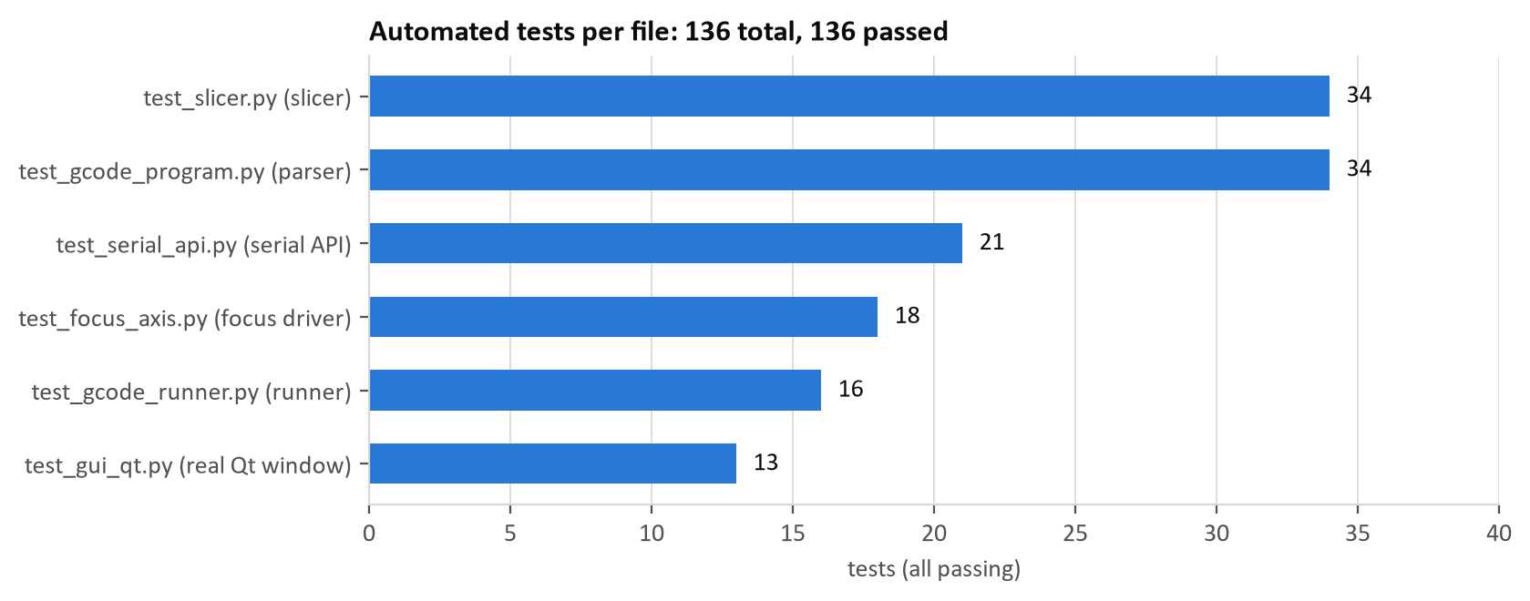
Automated tests per file, all passing
How it was done:
- The tests run the real production code. Only the hardware edges are swapped out: fake_controller.py stands in for the USB serial port, and a recording backend stands in for the GPIO pins.
- The fake controller copies how the real firmware behaves: replies in order, a move queue, modal laser values, and the "done" query.
- The Qt tests use pytest-qt and the real PySide6 window, not the FreeCAD Qt which the earlier prototype relied on.
Why: the hardware isn't available yet, and a window that opens doesn't prove the logic works. Every defect found during the work has its own test, which fails on the old code and passes on the new code.
Significance: these tests are the evidence that the 4th axis and the G-code path work in software. They also give the team a safety net against regressions.
How to test:
- VS Code Testing panel: click the flask icon → Configure → pytest → choose the folder EDITED_gui\tests → Run All.
- Or the terminal, in ROOT\EDITED_gui:
python -m pytest tests -v
Expected result: green ticks in the Testing panel, or a terminal run that ends with:
102 passed
Software: Python 3.14, the project environment (it includes pytest and pytest-qt), VS Code.

5. Slicer
Path: C:\Users\Bombe\Downloads\XYZ-Micromanipulator-GitHub\NEW_slicer
File | Role
pbm_slicer.py | STL → G-code: bottom-up layers, outline + straight hatch, laser on only while writing, feeds capped
verify_gcode.py | Independent checker: counts layers/moves and checks the laser and feeds from the finished file
tests\test_slicer.py | 34 geometry and output tests
README.md, requirements.txt | Usage and dependencies (numpy, matplotlib)

How it was done:
- Cut lines no longer go missing when a triangle corner sits exactly on a slice plane. A corner on the plane always counts as "above", so every edge crossing is clear-cut. For example, the triangle (0,0,0)/(1,0,1)/(0,1,2) cut at z = 1 now gives the line from (1,0) to (0,0.5), which the old code lost.
- Cut pieces are joined into outlines by merging endpoints that nearly touch. If the mesh is broken (not watertight), the slicer now stops and reports the z height and location instead of silently dropping part of the model.
- Fill lines use an inside/outside count, so holes stay empty and separate parts all get filled.
- Each layer is now written at the height it was actually cut. Before, it sat half a layer too high.
- Bad input and settings get clear error messages. That covers empty or broken STLs, NaN coordinates, a zero layer height and power above 1. Units can be mm or µm.
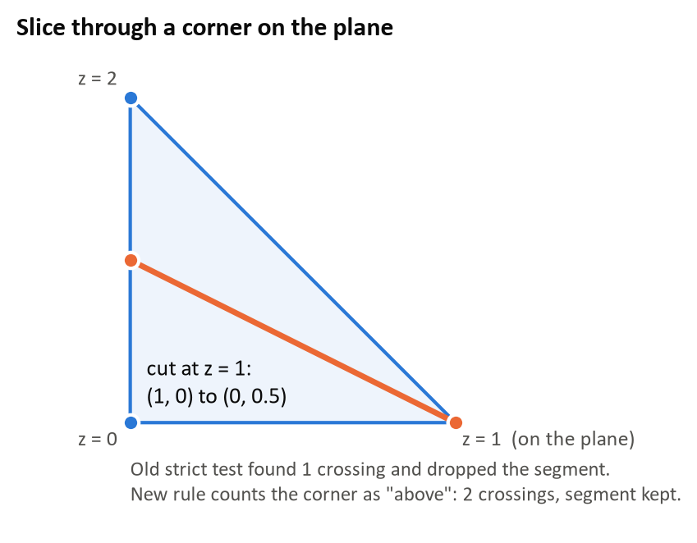
The vertex-on-plane case the slicer now handles
Why: Item 8 says "start building the slicer", and the FreeCAD study showed the CAM toolpaths can't drive the stage directly. A slicer that silently drops geometry, or writes in the wrong place would print the wrong part.
Significance: this folder is the Item 8 slicer deliverable. It's the "convert model to toolpath" block in the system diagram, and it's the first place the SR-01 speed limit gets enforced.
How to test: from a VS Code terminal in ROOT\NEW_slicer:
python pbm_slicer.py examples\block_with_hole.stl --preview
python verify_gcode.py examples\block_with_hole.gcode
python -m pytest tests -v
Expected result:
read 32 triangles (0 degenerate dropped), 101 layers
warning: speeds capped to 60.0 mm/min
wrote examples\block_with_hole.gcode: 562407 lines, 100 layers, 200 contours, 140000 hatch lines
laser-on path 42280.00 mm, travel 8143.92 mm, ~840 min at the programmed feeds ...
preview saved: examples\block_with_hole_preview.png
The checker prints "layers": 100, "laser_on_during_layer_move": 0, "max_feed": 60.0 and "ends_laser_off": true, and the tests end with 34 passed. The "101 layers" figure counts the whole slab grid, and only the 100 layers that contain material get written.
Software: Python 3.14 with numpy and matplotlib (both are in the project environment), VS Code.

6. Slicer examples (STL, G-code, preview PNGs)
Path: C:\Users\Bombe\Downloads\XYZ-Micromanipulator-GitHub\NEW_slicer\examples
File | Content
block_test_v2.stl / .gcode / _preview.png | 0.502 × 0.498 × 0.1 mm block (same STL as the FreeCAD study) and its sliced output
block_with_hole.stl / .gcode / _preview.png | Block with a square hole through it
verification_stats.json | Counts measured from the new files and from the old prototype files

How it was done: both STLs were sliced again with the corrected slicer. The counts below come from reading the finished files with verify_gcode.py, not from earlier claims.
File | Lines | Layers | Moves (write / travel) | Laser on at layer change | Max feed | Ends laser off
block_test_v2.gcode | 401,307 | 100 | 100,800 / 100,100 | 0 | 60 mm/min | yes
block_with_hole.gcode | 562,407 | 100 | 141,600 / 140,200 | 0 | 60 mm/min | yes

Why: these files give reproducible evidence that the slicer works on the Item 8 test part and on a part with a hole.
Significance: they are the first slicer output for Item 8. They also show that the same part FreeCAD milled from the top down now gets built from the bottom up, with an outline plus fill.
How to test:
1. Windows Photos: open block_with_hole_preview.png. It has three panels (first, middle and last layer). The red outlines show an outer and an inner square, and the blue fill lines stop at the hole.
2. FreeCAD: use File → Open on block_with_hole.stl, and the part shows up in 3D.
3. CAMotics, or FreeCAD's CAM workbench → File → Import: load block_with_hole.gcode. These files are big, so they load slowly. For a live demo, slice with a thicker layer to get a smaller file, for example python pbm_slicer.py examples\block_with_hole.stl -o demo.gcode --layer-height 0.01 --hatch-spacing 0.005. That gives 10 layers and 5,847 lines. If the viewer complains about the first lines (SCALE=1, ;), delete them in a copy.
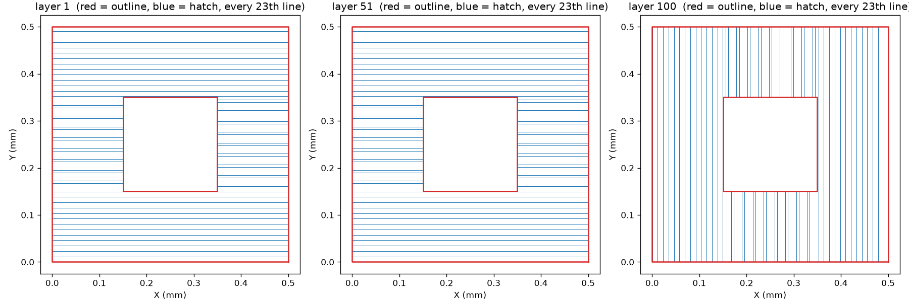
block_with_hole_preview.png: first, middle and last layer (red outline, blue hatch skipping the hole)
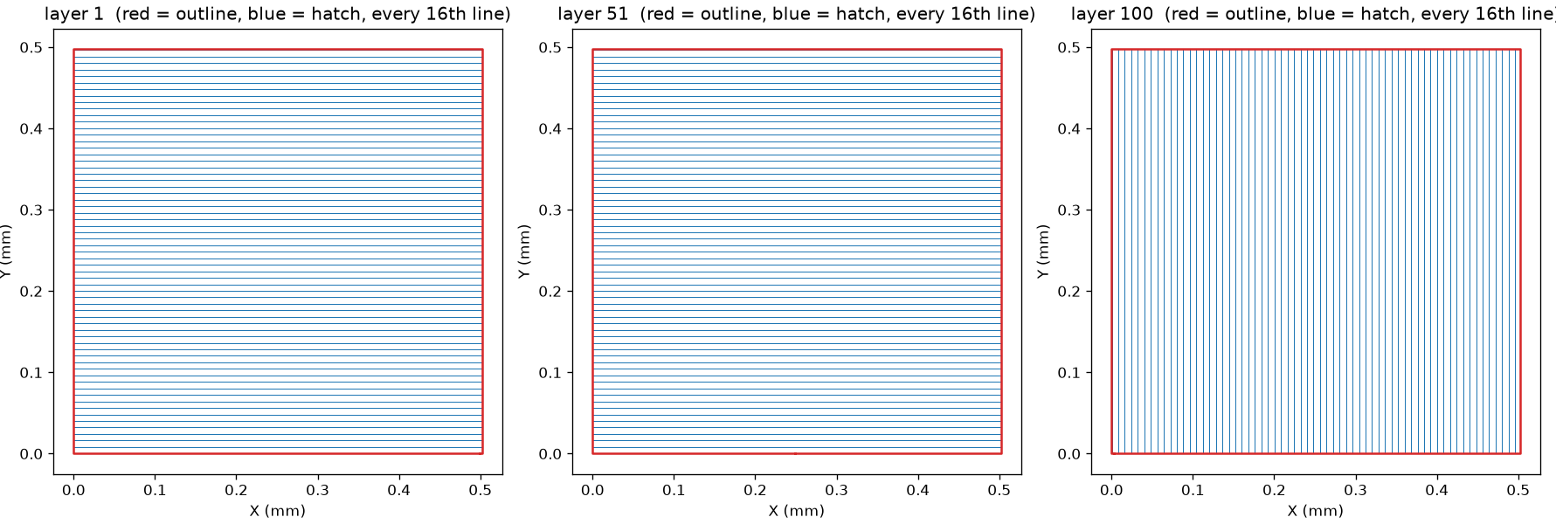
block_test_v2_preview.png: the Item 8 test block, alternating hatch direction
Expected result: a stack of square outlines filled with straight back-and-forth lines, built from the bottom up, with an empty square channel through the middle.
Software: Windows Photos, FreeCAD 1.0.x, CAMotics (optional).

7. FreeCAD study and rerun
Path: C:\Users\Bombe\Downloads\XYZ-Micromanipulator-GitHub\NEW_freecad_study
File | Content
block_test_v2.FCStd | FreeCAD project: Body → Sketch → Pad (0.502 × 0.498 × 0.1 mm); CAM Job with a 0.01 mm "Endmill", MillFace (facing) and Profile (contour); linuxcnc post processor
block_test_v2.stl | The part
block_test_v2.gcode | FreeCAD's milling G-code (1,436 lines)
rerun_2026-11-11\stored_paths.gcode | Fresh export from FreeCAD 1.0.2: identical to the stored file
rerun_2026-11-11\recomputed.gcode | Export after recomputing the toolpaths from the model: same apart from 5 tiny corner arcs
rerun_2026-11-11\diff_vs_stored.txt, rerun_log.txt, fc_rerun.py | Comparison, log and the script used

How it was done:
- First, the saved FreeCAD file was opened and read through: the model, Job, tool, both operations, depths, heights, post processor and settings.
- Then the G-code was measured:
- 190 arcs, and 11 rapids with no speed.
- The spindle (laser) is switched on once at the start and only switched off at the end.
- It works from the top down (Z 0.14 → 0.00) and outside the part, offset by the tool radius.
- After that, the official FreeCAD 1.0.2 was run headlessly. It's the same build that saved the file (rev 39319). It post-processed the job again, and that proved the stored G-code is genuine FreeCAD output.
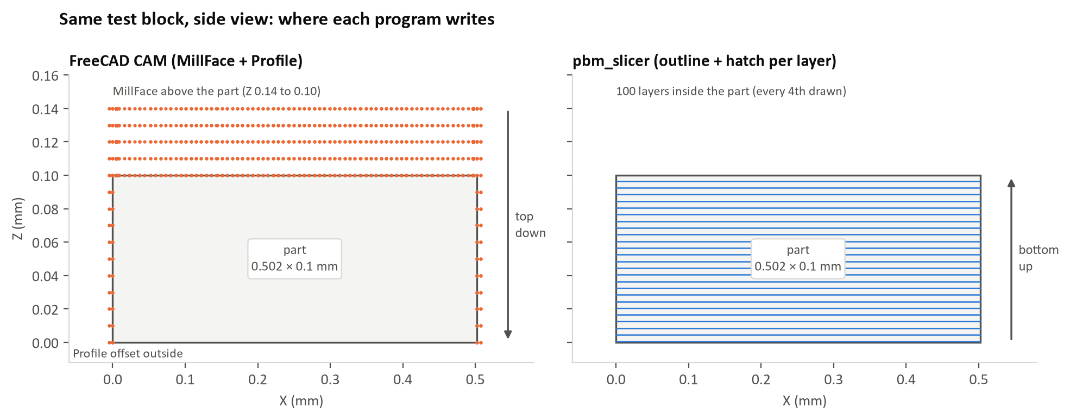
FreeCAD's milling toolpath vs the slicer's layers on the same block
Why:
- Item 8 asks how FreeCAD's contour and facing toolpaths are generated and whether they fit the project.
- Decision 4 assumed they would.
- The reason a rerun was needed is because the history showed the files were partly scripted, and the evidence had to be trustworthy.
Significance: this folder holds the Item 8 "first FreeCAD file" and the evidence behind its conclusion. FreeCAD CAM is good for modelling, but its milling output can't drive this stage as exported, and that's why the slicer exists. The GUI now rejects this file at line 5 (M6 T1) rather than silently running parts of it 1000× too small.
How to test:
1. Open FreeCAD and use File → Open on block_test_v2.FCStd.
2. Switch to the CAM workbench and expand Job → Operations in the tree. You'll see MillFace and Profile. Double-click each one to check the depths and step-down. The toolpaths appear as lines over the part.
3. Select Job, click Post Process in the toolbar, choose linuxcnc and save the result as a new file.
4. Compare that file with block_test_v2.gcode. In VS Code, for example, right-click the file → Select for Compare, then Compare with Selected.
Expected result:
- Step 2 shows the job tree and the toolpath lines.
- Steps 3 and 4 give a 1,436-line file identical to the stored one. The only differences you might see are the 5 corner arcs listed in diff_vs_stored.txt, and only if FreeCAD recomputes the paths first.
- The file starts with G17 G54 G40 G49 G80 G90, G21, G54, M5, M6 T1, G43 H1, M3 S1000 and ends with M05, G17 G54 G90 G80 G40, M2.
Software: FreeCAD 1.0.x (1.0.2 was used), VS Code for the comparison.

8. Firmware code
Path: C:\Users\Bombe\Downloads\XYZ-Micromanipulator-GitHub\EDITED_firmware\src
File | Change
version.h, utilities\math3d.h, math_constants.h, ringbuffer.h, utilities.h, utilities.cpp, waveforms.h, waveforms.cpp | Restored. They were missing, so the firmware could not compile. Taken from the original open-source project at the exact version this copy matches
motion_control\motion_controller.cpp/.h | New is_idle(): is a move still executing?
robot.cpp, robot.h | M53 ("done?") now also waits for the executing move; rejects bad feed/coordinates/laser values and unreachable targets; every command gets a reply; M55 stops after an error; version v1.0.5-sd.1
motion_control\path_segment.cpp | If the arm math fails mid-move, it holds position instead of using garbage angles
servo_control\homing_controller.cpp | Homing ends with an error when the end stop is not found (used to loop forever)
command_parser\command_parser.cpp | Rejects malformed numbers such as X1abc

How it was done:
- The command path was traced from the USB line all the way to the motor and the laser PWM pin and only the problems on that path got fixed.
- Any comments in the firmware are the original author's. No new ones were added.
- The build used the project's own PlatformIO setup (pio run -e pico) with Git long paths turned on. Nothing was flashed.
Why:
- The GUI's laser-off sequence and "done" checks can only be trusted if the firmware's "done" includes the move that's currently running.
- The PC can only match replies to commands if every command gets exactly one reply.
- Firmware that doesn't compile can't be tested at all.
Significance: this is the controller-side support that makes the 4th-axis sequencing safe (laser off and stage stopped before focus moves), which is relevant to SR-02.
How to test:
1. Install Git for Windows with "long paths" enabled, then VS Code with the PlatformIO IDE extension.
2. In VS Code, use File → Open Folder on ROOT\EDITED_firmware.
3. Click the PlatformIO ✓ Build button in the bottom bar (environment pico). The first build downloads the Pico toolchain, and that takes a few minutes.
4. Only after review, and with the laser disconnected, plug in the Pico 2 while holding BOOTSEL and copy firmware.uf2 onto it. You can also use the PlatformIO → Upload button.
Expected result (the full log is in firmware_build_2026-11-11.log):
Linking .pio\build\pico\firmware.elf
RAM: [ ] 4.9% (used 25916 bytes from 524288 bytes)
Flash: [ ] 3.3% (used 121896 bytes from 3665920 bytes)
========================= [SUCCESS] ...
The build produces .pio\build\pico\firmware.uf2. After flashing, the GUI console prints Firmware version: v1.0.5 when it connects. The -sd.1 part gets read internally and turns on the "laser off confirmed" reports.
Software: VS Code + PlatformIO IDE, Git for Windows (long paths on). For flashing you also need the Pico 2 board and a USB cable.

What is still unproven
Everything above has been proven in software through the code, the automated tests, the app launch, the FreeCAD rerun and the firmware build. The items below still need the real machine, so they aren't proven yet:
- Focus axis wiring, direction, steps/mm, limits and step timing on the Pi.
- That the laser PWM pin reads 0 V before every focus step on the flashed firmware.
- Stopping distance (SR-02). Stop can't cancel moves that are already queued in the controller.
- The real values for the speed limit (SR-01), laser power, layer height and hatch spacing.
The step-by-step physical checklist is at the end of fourth_axis_gui_writeup.md.

