3. Methodology

3.1 Sample and sequencing
Genomic DNA from the bacterial isolate (sample ID: Bali_1) was extracted and sequenced by Novogene Co., Ltd. (Contract H208SC26081945, Batch X208SC26081945-Z01-F001) on an Illumina platform, paired-end, with a read length consistent with 2×150 bp. Sequencing yielded 19,111,538 raw reads (2.9 Gb total). The provider's standard quality filtering (removal of reads containing adapter sequence, >10% ambiguous bases, or >50% low-quality [Q≤5] bases) retained 99.88% of the data as clean reads (Q20 = 99.59%, Q30 = 97.72%, error rate = 0.01%, GC content = 46.20%). These clean reads were used directly for downstream analysis; no additional local trimming step was applied.

3.2 General strategy: reference-based genotyping
Given the computational constraints of the project, whole-genome de novo assembly was not performed. A reference-based (mapping) strategy was used throughout: reads were aligned to a reference genome, variants were called relative to that reference, and a consensus genome sequence was derived from the alignment.

3.3 Initial reference mapping and variant calling
Clean reads were mapped against a Bacillus licheniformis reference genome (strain ATCC 14580 / DSM 13) using BWA-MEM (latest version available at the time of analysis). Alignments were sorted and indexed with SAMtools. Variants were called with bcftools mpileup/call (v1.24, htslib 1.24) and filtered to QUAL ≥ 20 and depth (DP) ≥ 10. A consensus sequence was generated with bcftools consensus.

3.4 Species-level verification
BLASTN comparison of this initial consensus against NCBI's nt database returned a flat ~95% nucleotide identity across the full genome length — a value consistent with the boundary between bacterial species rather than intraspecific variation. Whole-genome Average Nucleotide Identity (ANI) was therefore computed with FastANI (latest version available at the time of analysis) against reference genomes of five Bacillus species — B. licheniformis, B. paralicheniformis, B. sonorensis, B. subtilis, and B. haynesii — retrieved via the NCBI Datasets CLI (latest version available at the time of analysis).

3.5 Reference correction and re-mapping
Following species reassignment (§4.1), the workflow in §3.3 was repeated using the RefSeq reference-flagged B. paralicheniformis genome (strain Bac84, NZ_CP023665.1) in place of the B. licheniformis reference, producing a corrected consensus genome (4,376,788 bp; GC content 45.85%) and variant call set.

3.6 Strain-level identification
Complete-genome assemblies of B. paralicheniformis (n = 25) were retrieved from NCBI via the Datasets CLI and compared against the corrected consensus using FastANI, ranking all references by whole-genome ANI.

4. Results

4.1 Species reassignment
Species | ANI (%)
Bacillus paralicheniformis | 98.76
Bacillus licheniformis | 95.36
Bacillus haynesii | 95.13
Bacillus sonorensis | 83.25
Bacillus subtilis | 78.92

Bacillus paralicheniformis was clearly identified as the correct species, superseding the initial working assumption of B. licheniformis.

4.2 Variant calling against the corrected reference
Mapping against the B. paralicheniformis (Bac84) reference yielded a 4,376,788 bp consensus genome (GC 45.85%, consistent with the raw-read GC of 46.20% reported by the sequencing provider) and 27,770 variant records: 27,175 SNPs and 595 indels (32 multiallelic sites). The transition/transversion ratio was 2.24, consistent with genuine biological substitution rather than sequencing noise. Read depth clustered predominantly between 200× and 260× (peak at 249×), and the majority of variant QUAL scores fell at the upper end of the reported range (≥220), indicating high-confidence calls throughout.

4.3 Strain-level ANI ranking
Rank | Strain | Accession | ANI (%) | Fragments matched/total
1 | BL-09 | GCA_000876525.1 | 99.729 | 1398/1458
2 | J25TS1 | GCA_021654715.1 | 99.727 | 1393/1458
3 | DSM 28591 | GCA_029537035.2 | 99.713 | 1398/1458
4 | Bac84 (mapping reference) | GCA_002993925.1 | 99.338 | 1458/1458

The isolate clusters most closely with a statistically indistinguishable trio (BL-09, J25TS1, DSM 28591; ANI spread of 0.016 points). Notably, the genome used as the mapping reference itself (Bac84) ranked only fourth by ANI — the reference choice for mapping was based on being the species' RefSeq-flagged representative, not on being the closest strain, which is appropriate methodologically but worth stating explicitly to avoid the appearance of circular reasoning.

5. Additional bioinformatic validation
Given that ANI could not resolve a single closest strain among BL-09, J25TS1, and DSM 28591 (§4.3), three independent, low-cost bioinformatic methods were applied to corroborate the species assignment and further characterize the isolate's placement: digital DNA-DNA hybridization, read mapping rate, and a bootstrap-supported phylogenetic tree.

5.1 Digital DNA-DNA hybridization (dDDH)
dDDH was computed against the three tied top strains using the DSMZ Genome-to-Genome Distance Calculator (GGDC 3.0). Formula 2 (identities / HSP length), recommended by GGDC when the query is not a fully closed, gap-free assembly, is reported here as the primary value.
Reference | dDDH (Formula 2) | Model C.I. | Prob. dDDH ≥ 70% | G+C difference (%)
BL-09 | 98.60% | [97.9–99.1%] | 97.98% | 0.03
J25TS1 | 98.60% | [97.9–99%] | 97.98% | 0.04
DSM 28591 | 98.60% | [97.9–99%] | 97.97% | 0.04

dDDH values are far above the 70% species-delimitation threshold, with near-certain probability of exceeding it (97.97–97.98%), and G+C content differences are negligible (0.03–0.04%). Both results independently corroborate the species assignment via a method unrelated to ANI's underlying algorithm. As expected, dDDH did not resolve the three-way tie: values are effectively identical across all three reference strains, consistent with dDDH being a species/subspecies-boundary metric rather than a fine-grained strain discriminator.

5.2 Read mapping rate
Alignment statistics for the corrected mapping (§3.5) were assessed with samtools flagstat. Of 19,140,539 total reads (19,111,538 primary), 90.72% mapped overall (90.71% of primary reads), with 89.93% properly paired and 0.32% singletons; no reads had a mate mapped to a different contig.
This mapping rate is supportive of, but lower than ideally expected for, the species assignment: a reference at 99.3% ANI to the isolate (Bac84) would typically be expected to yield a mapping rate above 95%. The most parsimonious explanation is that the Bac84 reference record used for mapping is annotated as chromosome-only (no plasmid sequence), while B. paralicheniformis commonly carries plasmids; isolate reads originating from plasmid DNA absent in this reference would be unable to map, plausibly accounting for a meaningful share of the unmapped ~9%. Low-level sample contamination remains a secondary, untested possibility, as no taxonomic classification (e.g., Kraken2, sourmash) was run directly on the raw reads in this workflow. This is noted here as an explicit, testable limitation rather than treated as resolved.

5.3 Phylogenomic tree
A neighbor-joining tree based on Mash distances was constructed with Mashtree (100 bootstrap replicates) from the corrected consensus genome and the 25 complete B. paralicheniformis assemblies used in the strain-level ANI ranking (§3.6).
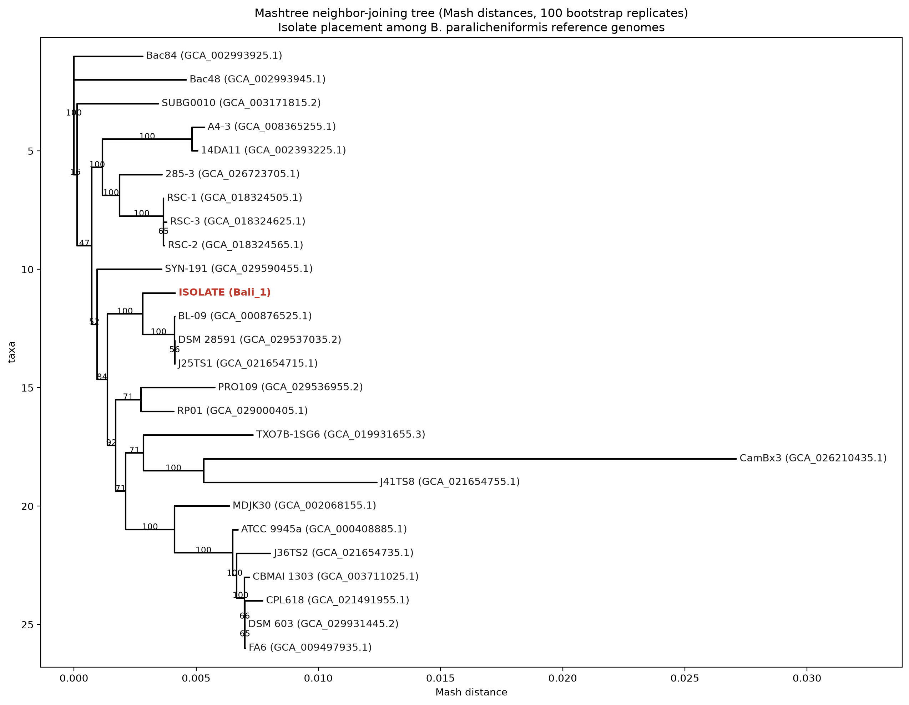
Figure 1. Mashtree neighbor-joining tree (Mash distances, 100 bootstrap replicates). The isolate (red) is highlighted among B. paralicheniformis reference genomes.

The isolate formed a clade with BL-09, J25TS1, and DSM 28591 at 100% bootstrap support — a statistically robust, independent confirmation (via tree topology rather than pairwise identity) that the isolate belongs with exactly the three strains flagged as tied by ANI. Internal resolution within that clade was weak: the branch separating DSM 28591+J25TS1 from BL-09 received only 56% bootstrap support, so the tree — like ANI and dDDH — does not identify a single closest strain. Separately, strain CamBx3 (GCA_026210435.1) showed by far the longest branch in the tree (Mash distance 0.0218, roughly an order of magnitude greater than any other branch), corroborating its identification as a clear outlier in the ANI ranking (96.72%, §4.3) via an independent method.

6. Conclusion
Reference-based genomic analysis, using paired-end Illumina data (19.1 million reads, 2.9 Gb, Q30 = 97.72%) provided by Novogene, identified the isolate as Bacillus paralicheniformis, correcting an initial working assumption of B. licheniformis that a single-reference BLAST comparison alone had failed to distinguish. Within B. paralicheniformis, the isolate's closest relatives among currently deposited genomes form a tight clade of three strains (BL-09, J25TS1, DSM 28591) at ~99.7% ANI, with no single exact match identified. Three independent, low-cost validation methods — digital DNA-DNA hybridization, read mapping rate, and a bootstrap-supported phylogenomic tree — converge on the same conclusion: strong, multi-method support for the species assignment and for this specific three-strain clade, with consistent inability across all three methods to resolve a single closest strain within it. This convergence, including a shared limitation, is itself evidence of a robust rather than coincidental result. One open, explicitly flagged limitation — a lower-than-ideal read mapping rate, plausibly attributable to isolate-specific plasmid content absent from the chromosome-only mapping reference — remains for future work. The entirely reference-based workflow — avoiding de novo assembly — proved sufficient to reach genome-scale species and strain-level resolution within the available computational budget, producing a 4.38 Mb consensus genome with internally consistent quality metrics (GC content, depth, Ts/Tv ratio) at every stage.

