Part B – Discussion of Model Scenarios.
Task 1: Scenario Analysis – Economic Rationale
The DEFINE-SIMPLE-MODIFIED model simulates three scenarios across macroeconomic, financial and environmental dimensions. The baseline represents a business-as-usual trajectory. Scenario 2 (Task 1) raises the carbon tax to 0.08 trillion USD per Gt of CO₂ (80 USD per tonne). Scenario 3 (Task 1) introduces degrowth by reducing the propensity to consume to c₁ = 0.8 and autonomous investment to α₀ = 0.02.
1.1 Environmental Variables: Temperature, Depreciation and Damage Rate.
Figure 1: Atmospheric Temperature (C) Figure 2, Capital Depreciation Rate. Figure 3, Climate Damage Rate
Figure 1 shows that the baseline produces the steepest temperature rise, reaching approximately 3.3°C by 2070 – consistent with the NGFS Current Policies scenario trajectory (NGFS, 2024). The higher carbon tax (Scenario 2, Task 1) moderates warming to around 2.9°C, as rising fossil energy costs raise the total unit cost of production (tucfₜ), inducing a shift towards green investment per equation (11). Scenario 3 (degrowth) achieves the lowest temperature of approximately 2.5°C by 2070 because demand compression directly reduces fossil energy use and cumulative CO₂ emissions, in line with the TCRE framework of Matthews et al. (2021). Figure 2 confirms that the depreciation rate rises non-linearly with temperature in all scenarios. In the baseline, it approaches 0.085 by 2070 as climate damages accumulate, consistent with equation (20), which links depreciation to the damage rate. The carbon tax and degrowth scenarios both suppress depreciation – to approximately 0.070 and 0.062 respectively – by limiting temperature rise. A lower depreciation rate protects productive capital, moderating the damage channel identified by Dafermos et al. (2017). Figure 3 shows the climate damage rate accelerating sharply in the baseline from 2050 onwards, reaching 0.20 by 2070, reflecting the Weitzman (2012) non-linear damage specification embedded in the model. Both interventions significantly suppress damages: the carbon tax reduces the rate to approximately 0.125, and degrowth-plus-carbon-tax to approximately 0.065. This confirms that policies reducing cumulative emissions generate compounding benefits by slowing the damage feedback loop.
1.2 Macroeconomic Variables: Output and Growth .
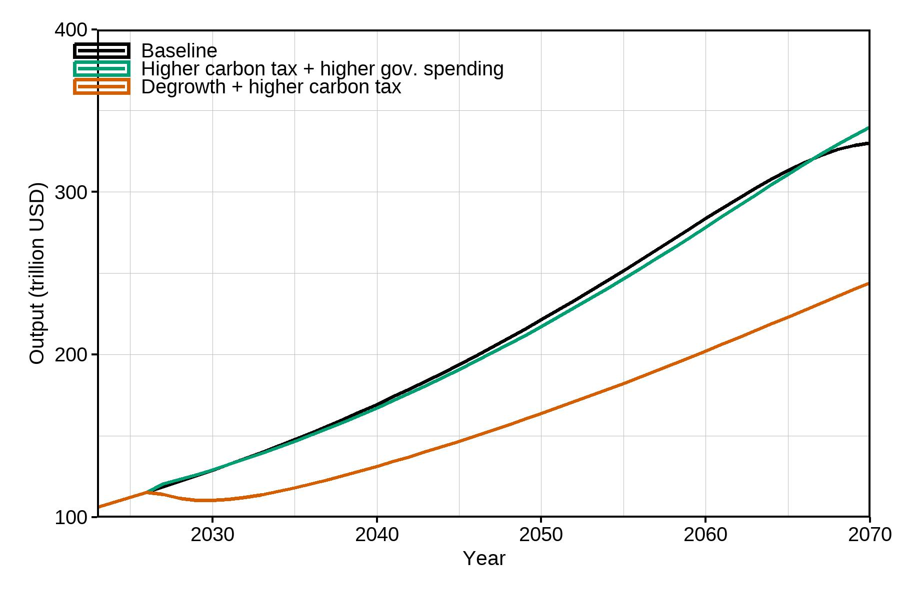
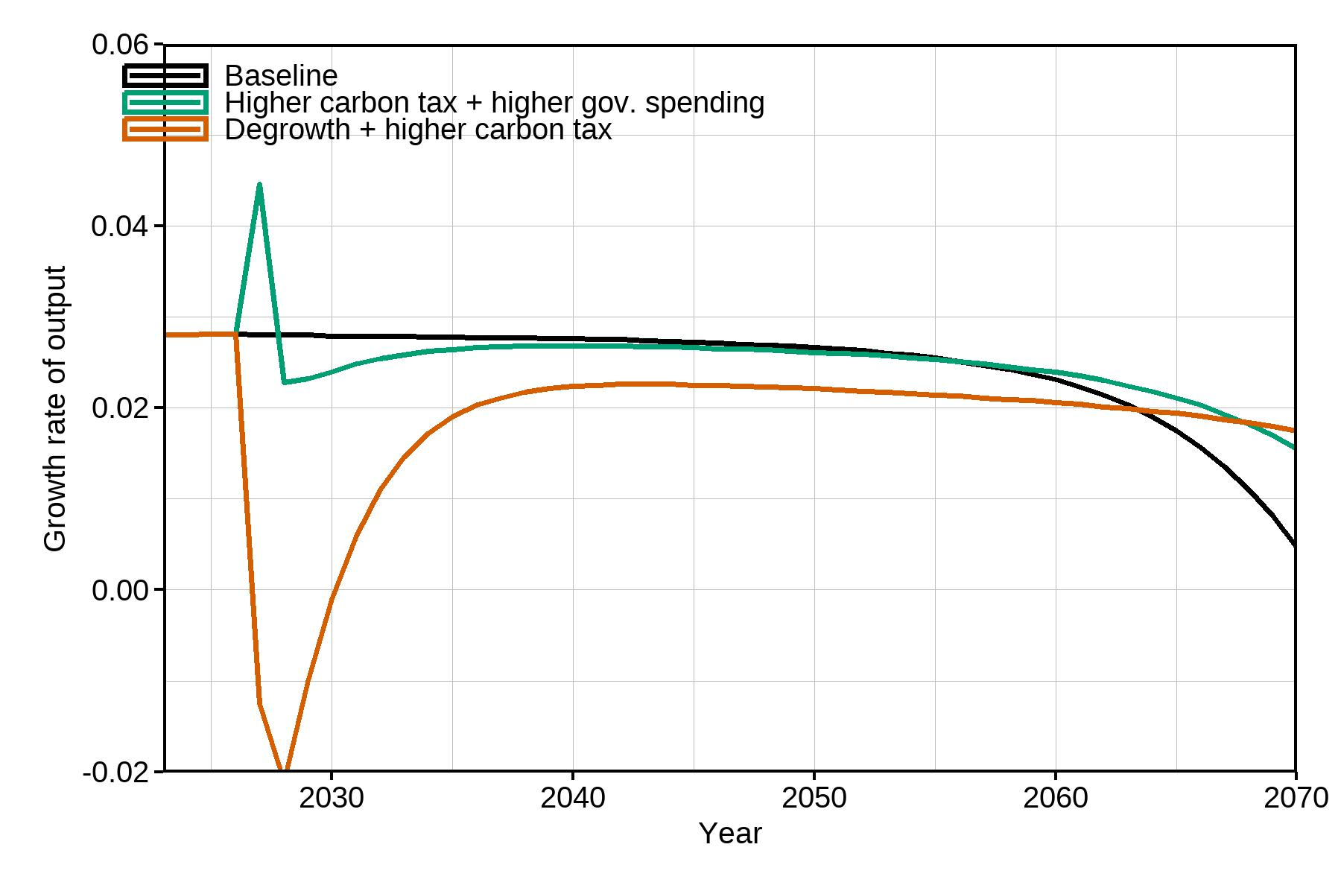Figure 4: Output levels. Figure 5: Growth Rate of Output

Figure 4 shows that the baseline and Scenario 2 (carbon tax) track closely in output levels through to 2070, with Scenario 2 ultimately surpassing the baseline as reduced climate damages protect the capital stock and sustain investment. Scenario 3 (degrowth) produces substantially lower output, approximately 245 trillion USD by 2070 versus 340 trillion in the baseline because reduced autonomous investment (α₀ = 0.02) and lower consumption propensity (c₁ = 0.8) compress aggregate demand. Figure 5 illustrates this starkly: degrowth generates a sharp output contraction of nearly -2% around 2027, before gradually recovering to around 2%. The higher carbon tax scenario initially produces a brief growth spike (teal line, Figure 4) reflecting the investment stimulus from green capital accumulation, before settling slightly below the baseline as carbon tax costs weigh on net profits.
1.3 Financial Variables: Profit Rate and Firm Leverage
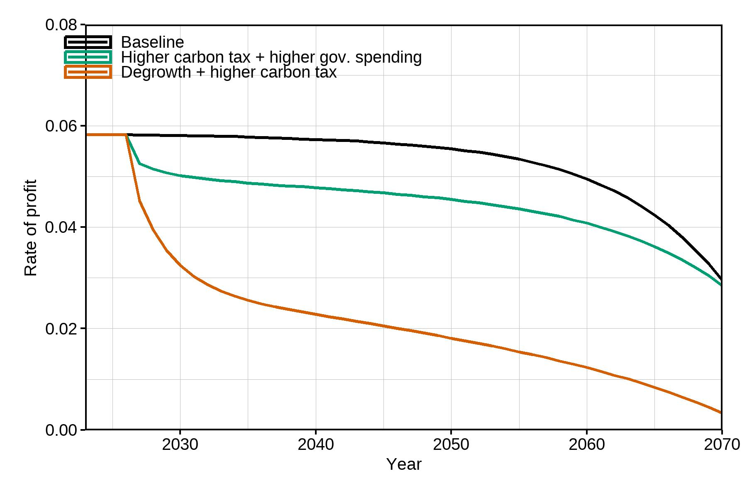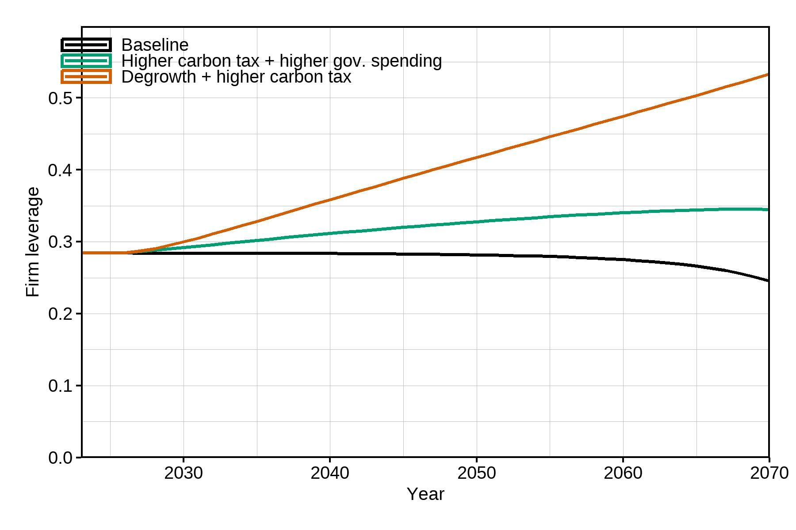
Figure 6: Rate of Profit Figure 7: Firm Leverage

Figure 6 shows that the carbon tax (Scenario 2, Task 1) immediately depresses the profit rate relative to the baseline, as firms face higher costs from carbon taxation, net profits (TPₜ) fall because carbon taxes are deducted from gross profits. Degrowth produces an extreme profit collapse, falling towards zero by 2070, as the double squeeze of reduced revenues (lower output) and higher carbon costs eliminates retained profits, undermining future investment capacity. Figure 7 (firm leverage) shows that the baseline exhibits declining leverage over time, reflecting healthy capital accumulation relative to debt. The carbon tax raises leverage (teal) as firms borrow more relative to their eroding capital base. Degrowth generates the most severe leverage escalation (orange), driven by falling output, collapsing profitability, and continued debt service requirements. This financial fragility echoes the instability channel of Dafermos et al. (2017).
1.4 Green Investment and Emission
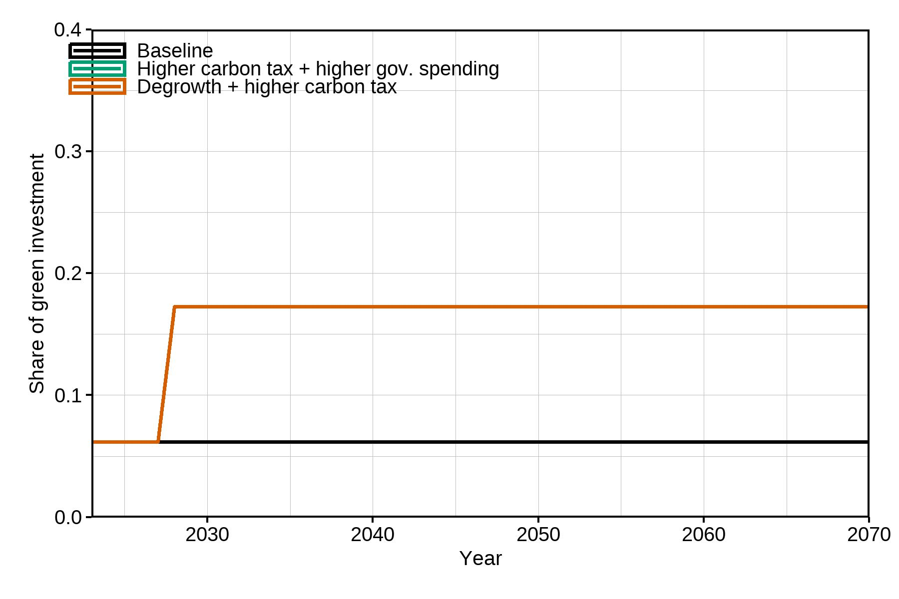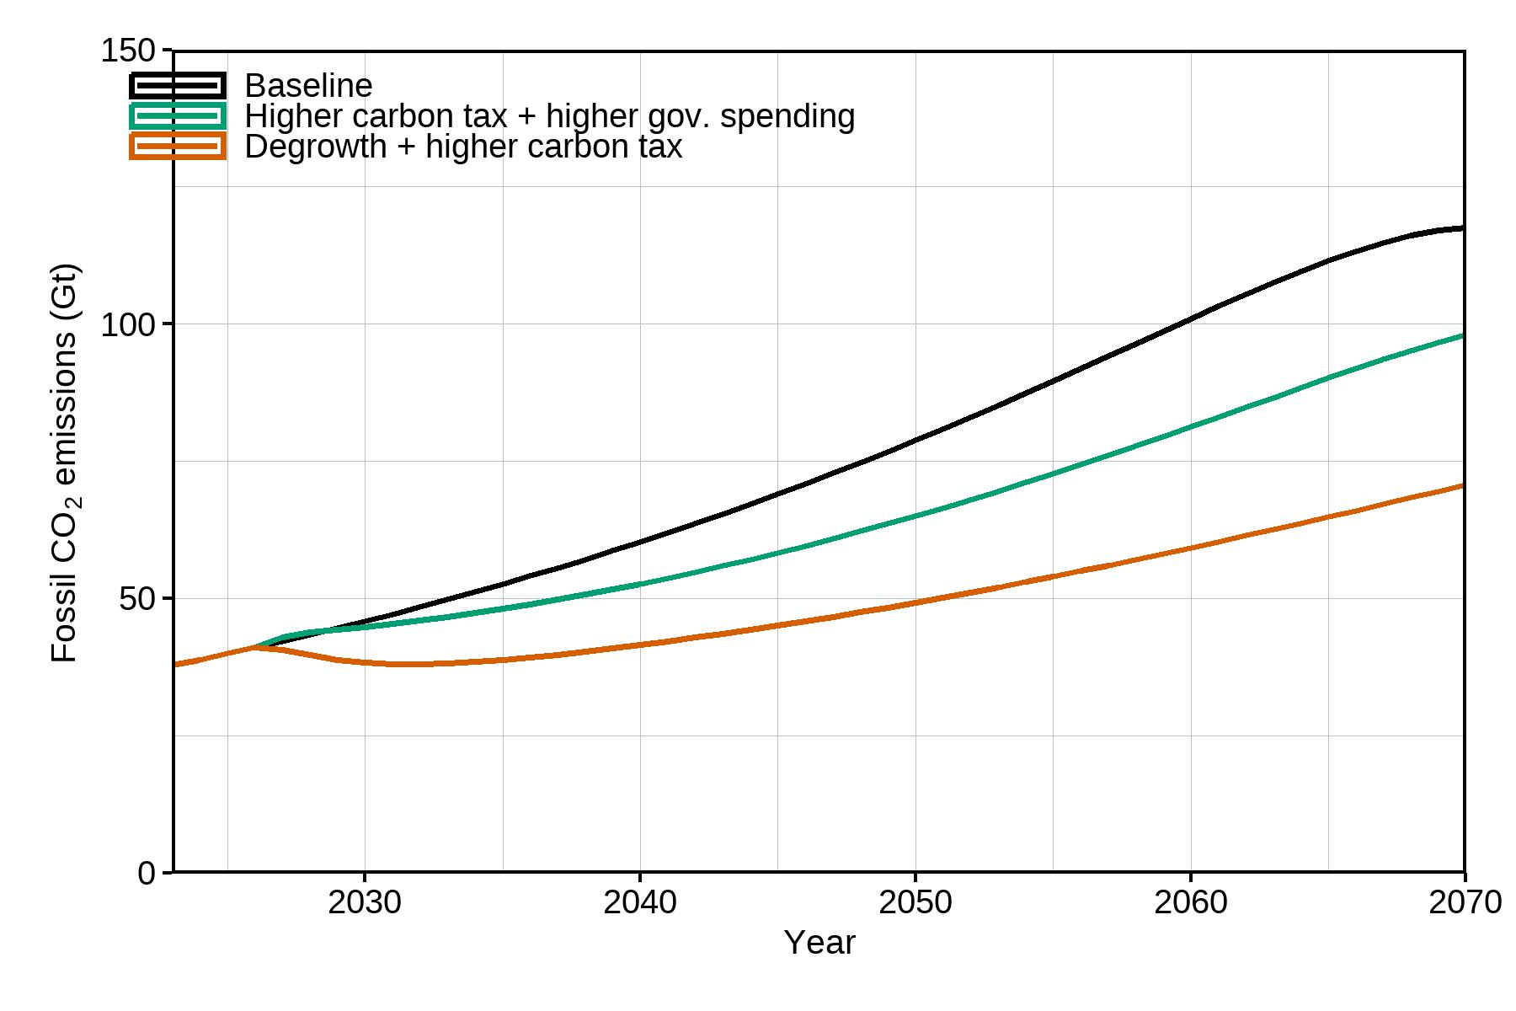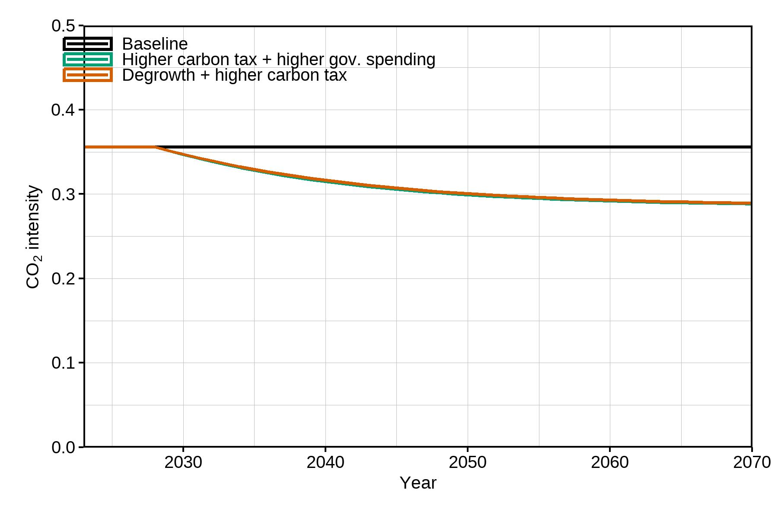Figure 8: Share of Green Investment Figure 9: Fossil CO₂ Emissions (Gt) Figure 10: CO₂ Intensity
Figure 8 reveals a striking result, the share of green investment rises sharply only under degrowth-plus-carbon-tax (Scenario 3, Task 2, orange line), jumping from around 0.06 to 0.17 after 2027. The carbon-tax-plus-spending scenario (Scenario 2, Task 2) does not visibly differentiate from the baseline in green investment share, suggesting that the higher tucfₜ in this model version is insufficient alone to shift the green investment threshold without demand compression. Figure 9 shows that both policy scenarios reduce fossil CO₂ emissions relative to the baseline (approximately 120 Gt by 2070), with degrowth achieving the lowest emissions trajectory (approximately 70 Gt). Figure 10 (CO₂ intensity) shows that policy scenarios generate declining intensity, reflecting the substitution towards greener production methods, while the baseline intensity remains flat.
1.5 Government Debt
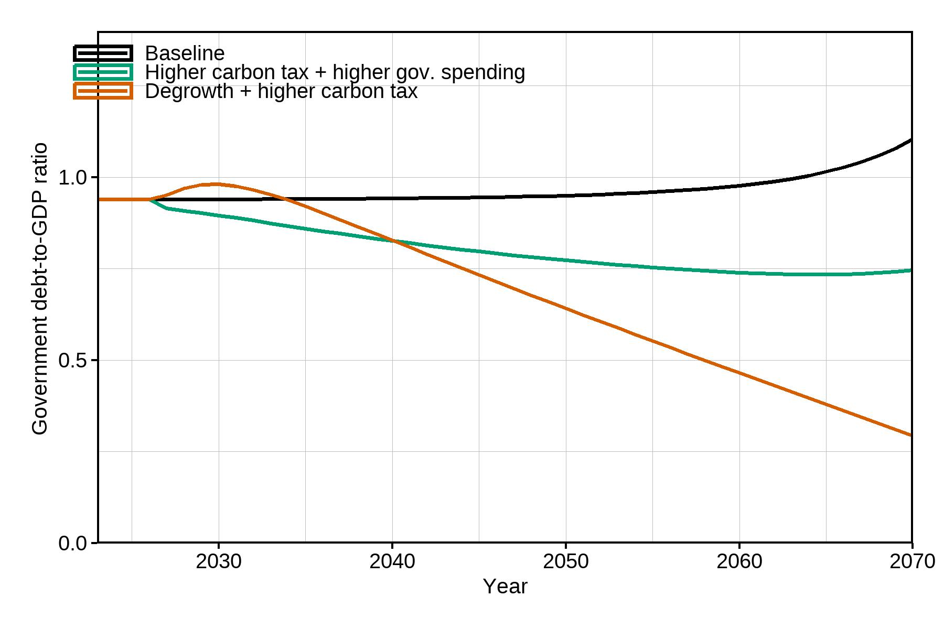
Figure 11: Government Debt-to-GDP Ratio
Figure 8 shows government debt-to-GDP rising continuously in the baseline (reaching 1.1 by 2070), as insufficient carbon tax revenues fail to offset expenditures. The carbon-tax-plus-spending scenario (teal) stabilises debt at approximately 0.75, because carbon tax revenues partially offset higher spending, consistent with the government budget constraint in equation (14). Degrowth with carbon tax (orange) produces a dramatic fall in the debt-to-GDP ratio to 0.28, driven by strong carbon tax revenues relative to the much smaller GDP denominator – though this reflects economic contraction rather than fiscal health.
Task 2: Policy Mix – Comparing Scenario 2 and Scenario 3 with Task 1
2.1 Scenario 2 (Task 2 vs Task 1): Higher Carbon Tax with Government Spending
Adding the government consumption-to-GDP ratio (govC = 0.02) to the carbon tax significantly alters macroeconomic outcomes. In Task 1, the carbon tax alone depresses output slightly below the baseline (Figure 4) and reduces the profit rate (Figure 6), as higher costs reduce net profits without an offsetting demand stimulus. In Task 2, the additional government expenditure (equation 12: COGOVₜ = govC × Yₜ₋₁) injects demand into the economy, lifting output above the baseline from around 2035 onwards (teal line, Figure 4). The growth rate spikes briefly to approximately 4.5% (Figure 5) reflecting the multiplier effect of public spending. Crucially, the environmental gains are preserved: temperature (Figure 1), damage rate (Figure 3) and depreciation (Figure 2) all remain below the baseline. The government debt-to-GDP ratio (Figure 11) falls relative to the baseline due to carbon tax revenues supplementing government finances per equation (14). This demonstrates the capacity of a fiscal-environmental policy mix to achieve both macroeconomic stabilisation and ecological transition simultaneously, a result consistent with Fontana and Sawyer's (2016) post-Keynesian ecological framework.
2.2 Scenario 3 (Task 2 vs Task 1): Degrowth with Higher Carbon Tax
Combining degrowth with a higher carbon tax (Scenario 3, Task 2) reinforces both the environmental and macroeconomic effects relative to degrowth alone (Scenario 3, Task 1). Environmentally, temperature (Figure 1), damage rate (Figure 3) and depreciation (Figure 2) are lower than in degrowth alone, because the carbon tax additionally incentivises green investment (Figure 8 shows a larger jump in green investment share to around 0.17 under this combined scenario). Fossil emissions (Figure 9) are the lowest of all scenarios. However, the financial costs are compounded. The rate of profit (Figure 6) falls more steeply - approaching zero by 2070 because carbon taxes further erode net profits on top of already-compressed revenues from degrowth. Firm leverage (Figure 7) rises dramatically to approximately 0.55, as firms increasingly rely on debt relative to a shrinking capital base. Government debt-to-GDP (Figure 11) falls sharply to 0.28, reflecting large carbon tax revenues relative to depressed GDP. The degrowth-plus-carbon-tax combination therefore achieves the strongest environmental performance across all variables but poses serious financial stability risks, echoing Dafermos et al.'s (2017) financial instability channel.
References
Dafermos, Y., Nikolaidi, M. and Galanis, G. (2017) ‘A stock-flow-fund ecological macroeconomic model’, Ecological Economics, 131, pp. 191–207.
Dietz, S. and Stern, N. (2015) ‘Endogenous growth, convexity of damage and climate risk: how Nordhaus’ framework supports deep cuts in carbon emissions’, Economic Journal, 125(583), pp. 574–620.
Fontana, G. and Sawyer, M. (2016) ‘Towards post-Keynesian ecological macroeconomics’, Ecological Economics, 121, pp. 186–195.
Matthews, H.D., Tokarska, K.B., Rogelj, J., Smith, C.J., MacDougall, A.H., Haustein, K., Mengis, N., Sippel, S., Forster, P.M. and Knutti, R. (2021) ‘An integrated approach to quantifying uncertainties in the remaining carbon budget’, Communications Earth & Environment, 2(1), p. 7.
NGFS (2024) NGFS Scenarios for Central Banks and Supervisors – Phase V. Paris: Network for Greening the Financial System.
Nordhaus, W. and Sztorc, P. (2013) DICE 2013R: Introduction and User’s Manual. Yale University. Available at: http://www.econ.yale.edu/~nordhaus/homepage/documents/DICE_Manual_103113r2.pdf (Accessed: 23 April 2026).
Victor, P.A. (2012) ‘Growth, degrowth and climate change: a scenario analysis’, Ecological Economics, 84, pp. 206–212.
Weitzman, M.L. (2012) ‘GHG targets as insurance against catastrophic climate damages’, Journal of Public Economic Theory, 14(2), pp. 221–244.

