Minor Project 2

SYNOPSIS

FOR

UniForum

Submitted by

|  |  |  |
| --- | --- | --- |
| Specialization | SAP ID | Name |
| B. Tech CSE AIML B5 (NH) | 500082642 | Harshit Sharma |
| B. Tech CSE AIML B3 (H) | 500085018 | Yugal Agarwal |
| B. Tech CSE AIML B5 (NH) | 500082718 | Jayendra Vardhan Singh |
| B. Tech CSE AIML B5 (NH) | 500083993 | Gourav |



# Department of Systemics

# School Of Computer Science

# UNIVERSITY OF PETROLEUM & ENERGY STUDIES,

# DEHRADUN- 248007. Uttarakhand

Dr. Deepika Koundal Dr. Thipendra P Singh

**Project Guide**  **Cluster Head**

# Project Title

Uni-Forum is a platform where people can engage in discussions and exchange ideas and information on specific topics. This forum provides a space for individuals to connect, share information, and collaborate with each other in a community setting.

# Abstract

Universities there are organization (Chapters, events, etc) which failed to connect all users together at single place. We are building a forum where users can discuss and exchange information on a specific topic. It is a space for people to connect, share ideas, and engage in discussions. Forums can be centered around a particular theme, such as a hobby or a community, or they can be dedicated to a particular organization or brand. They provide a space for users to express themselves, ask questions, and learn from others. Forums can be accessed from anywhere with an internet connection and can be moderated to ensure a safe and productive environment for all users.

# Introduction

A forum is a platform where people can engage in discussions and exchange ideas and information on specific topics. The purpose of a forum is to provide a space for individuals to connect, share information, and collaborate with each other in a community setting. Forums can be used for a variety of purposes including sharing opinions, asking questions, providing support, and exchanging knowledge.

Benefits of Forums includes

* Bring people with common interests together and foster a sense of community.
* Members can share their knowledge and experiences with each other and learn from each other.
* Provide a space for members to ask questions and receive answers and solutions to problems.
* Facilitate communication between members, allowing for the exchange of ideas and feedback.

# Literature Review

In recent years, online discussion forums have become increasingly popular as a tool for promoting learning and collaboration in higher education. This literature review seeks to explore the benefits and challenges of discussion forums in the university context, and to identify best practices for facilitating productive online discussions.

Research suggests that online discussion forums have a number of benefits for university students, including increased engagement, enhanced critical thinking and problem-solving skills, and improved communication and collaboration (Ertmer & Newby, 2013; Wang & Chen, 2019). Discussion forums can also provide opportunities for students to share diverse perspectives and engage in peer-to-peer learning (Garrison & Cleveland-Innes, 2005). Additionally, discussion forums can be used to promote active learning, as students are encouraged to engage in reflection, analysis, and synthesis of course material (Garrison & Anderson, 2003).

//here

# Problem Statement

The current forum lacks engagement and user participation, leading to a lack of meaningful discussions and valuable content. Users are not incentivized to contribute and there is a need to improve the overall user experience to increase engagement and build a stronger community.

# Methodology

* Use-Case Diagram

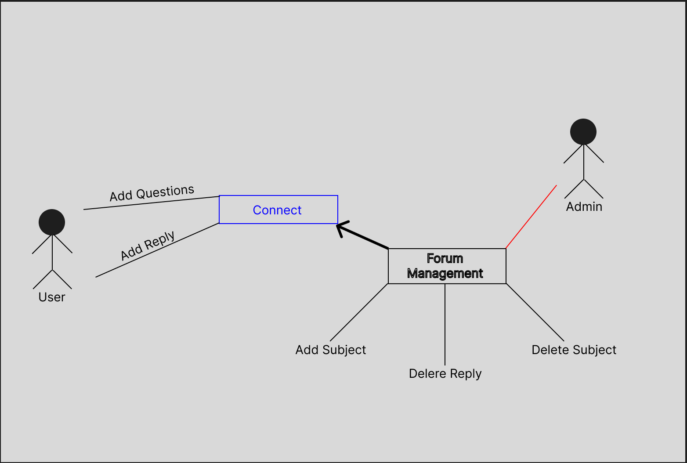  
Fig.1.0 Use Case Diagram

* Pert Chart

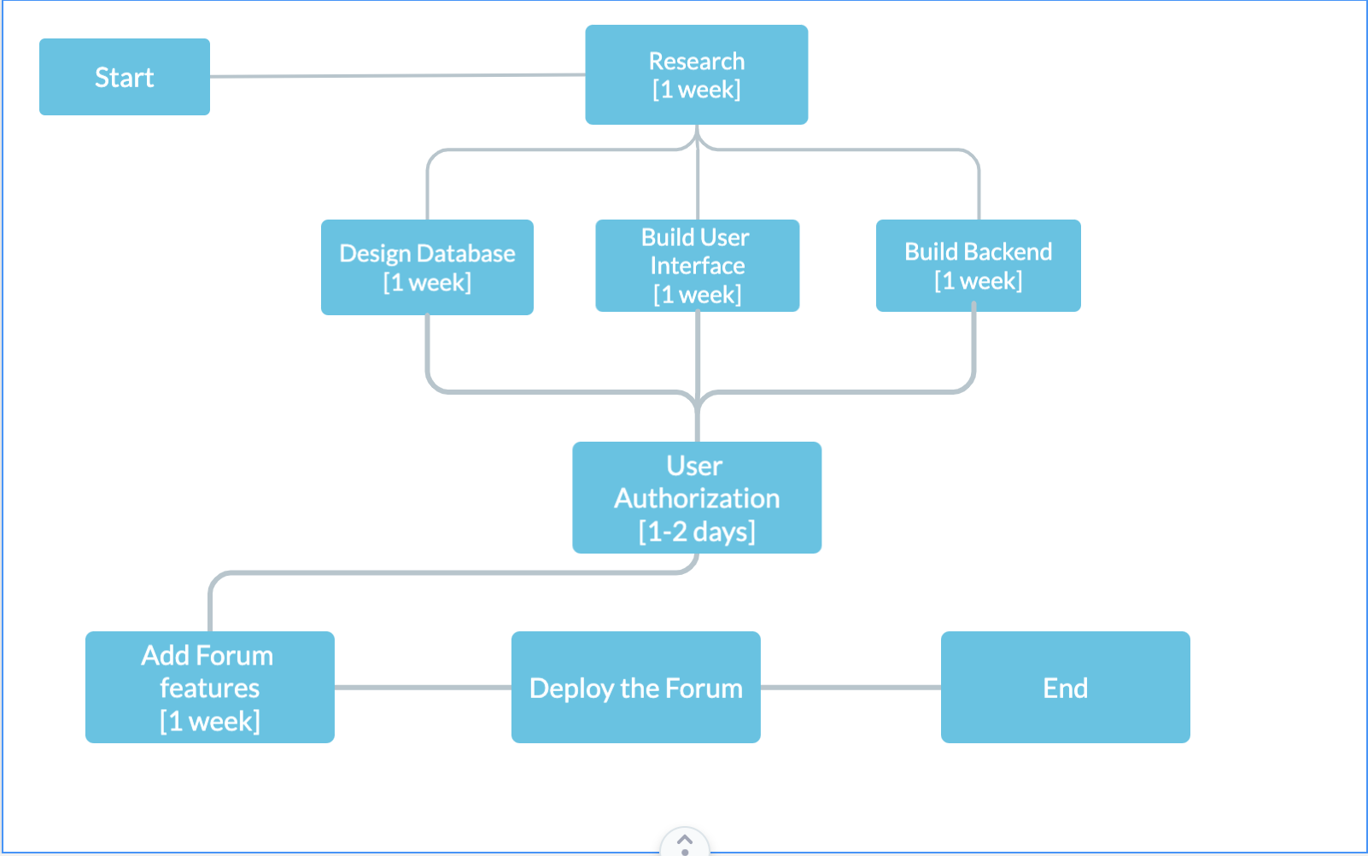

Fig. 1.1 Pert Chat

# Conclusion

Overall, online discussion forums have the potential to be a valuable tool for promoting learning and collaboration in the university context. While there are certainly challenges associated with their use, by following best practices and incorporating strategies to promote engagement and productivity, instructors can create a positive and effective online discussion experience for their students.

# Future Scope

The future scope for discussion forums could include further integration with My UPES platform. The incorporation of more advanced moderation tools to combat misinformation and hate speech, and the use of artificial intelligence and natural language processing to facilitate more productive and meaningful discussions. Providing labels to each discussion through natural language processing. Additionally, discussion forums may continue to evolve to better serve niche communities and professional networks.

# References