|  |  |  |
| --- | --- | --- |
|  | **Rochester Institute of Technology**  **Golisano College of Computing and Information Sciences**  **School of Interactive Games and Media**  **2145 Golisano Hall – (585) 475-7680** |  |

**Data Structures & Algorithms for Games & Simulation II**

**IGME 309**

**Exam 1 Practical**

Please open the example submission under _Binary to get a better idea of how the final solution should look like.

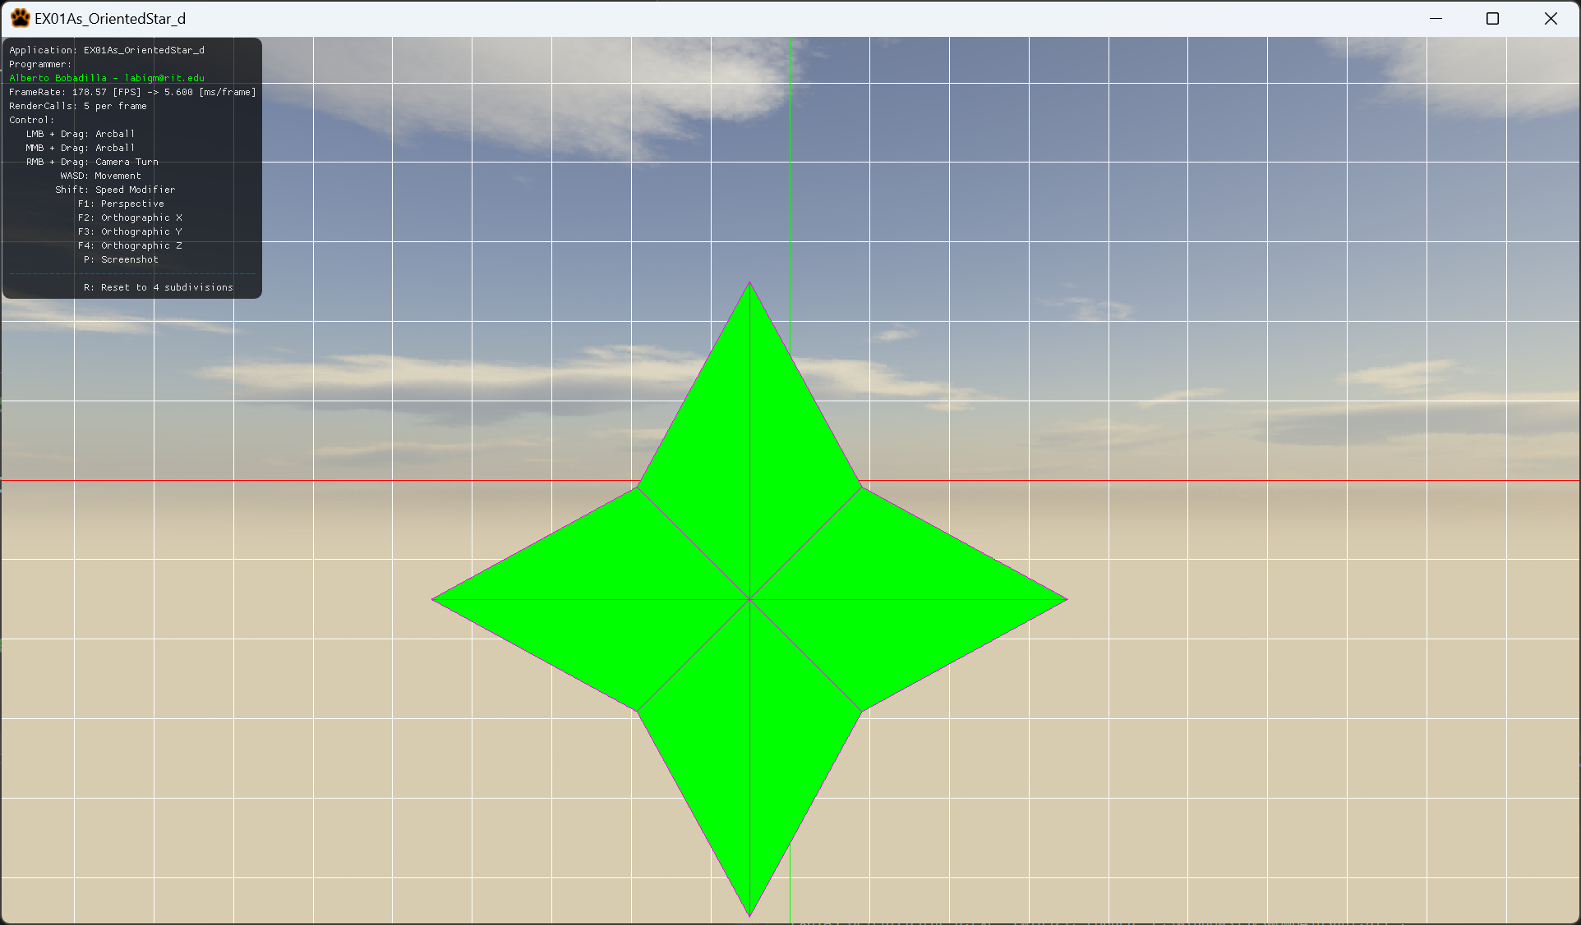

For this exam you are in charge of coding a method that will generate a star shape, the number of rays of this star will increment each 2 seconds. The star is flat and has no back faces. The star has to be symmetrical on its Y axis (its mirrored left to right), this means that a ray will always be pointing up. Assume the radius argument is the length of the ray and the vertices closer to the center are half the radius.

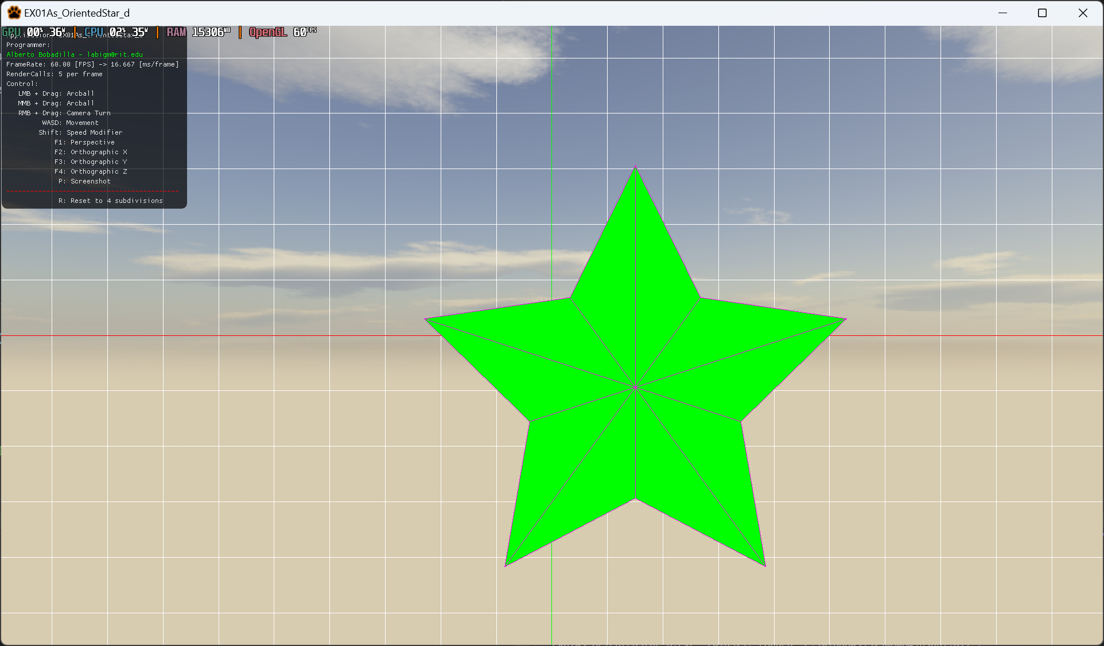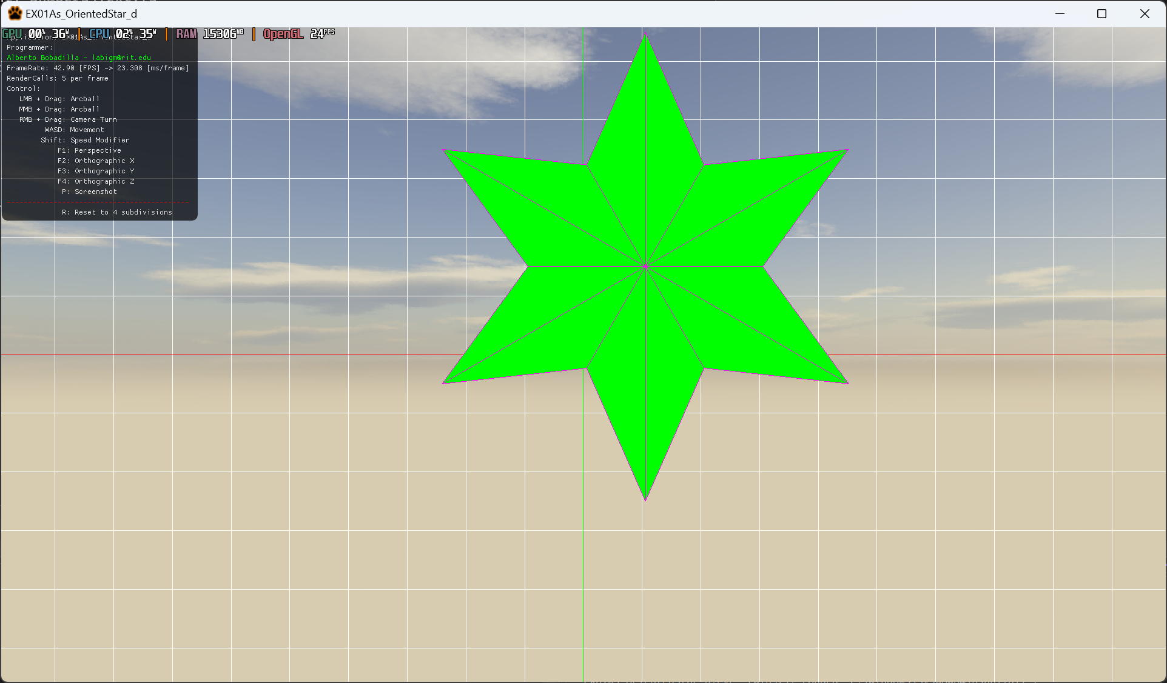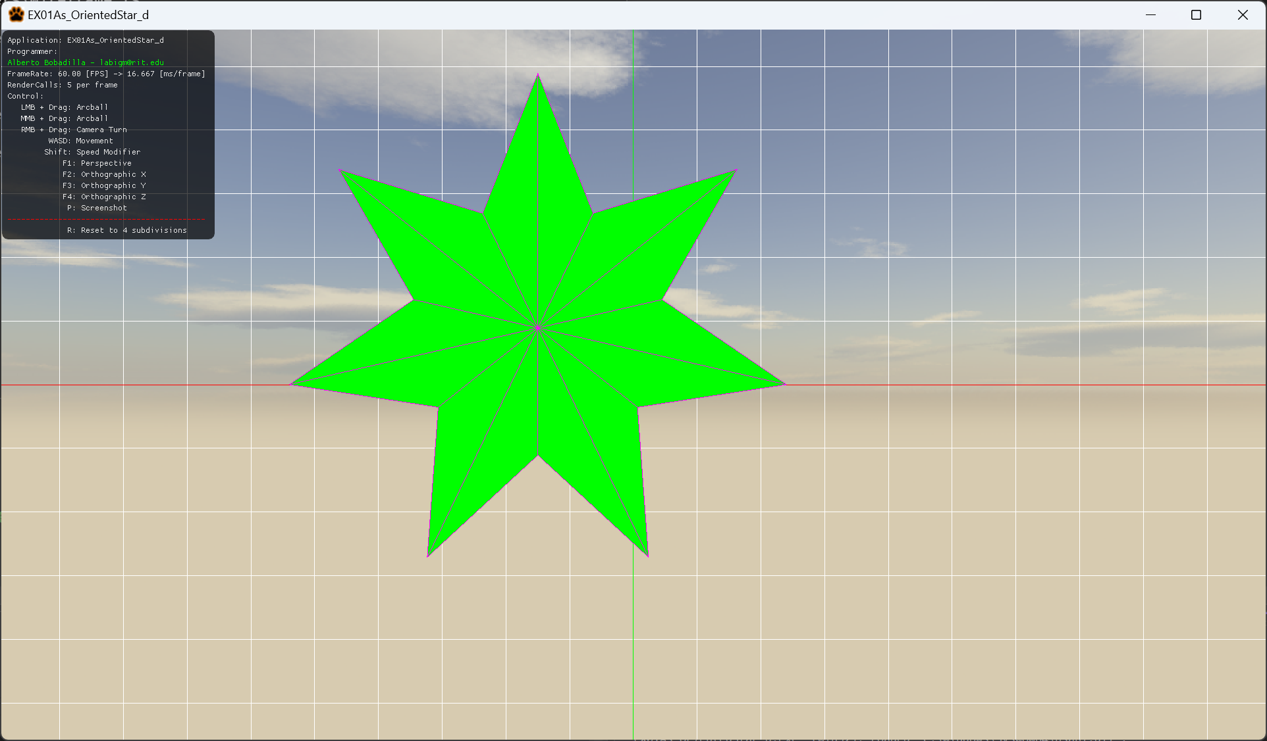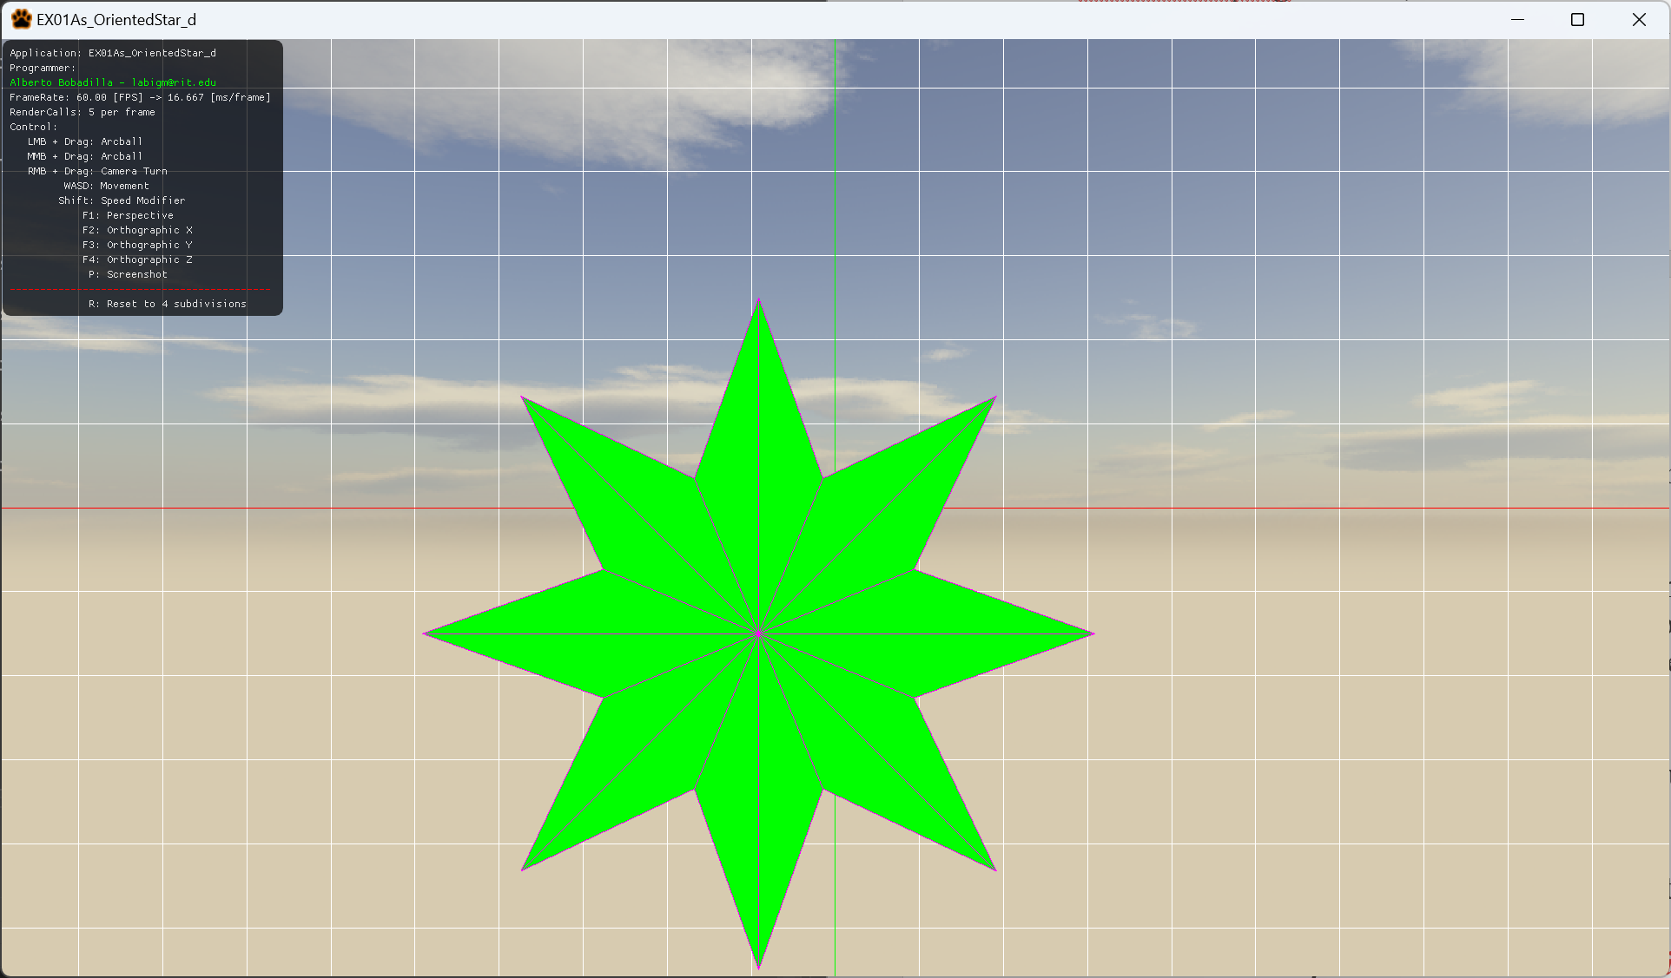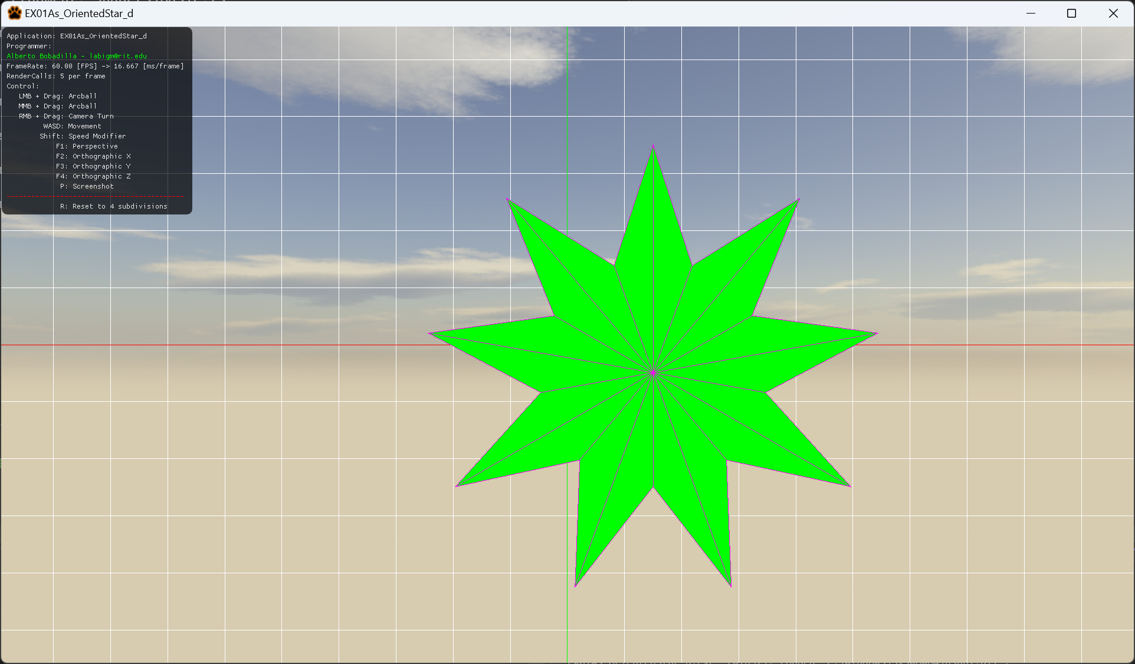

Once the star has been successfully coded, you are also in charge of implementing the PositionLerping method, this method will interpolate by routes in a list of steps, repeating from last to first to start over. This list is hardcoded in the main file but it may be dynamic at the moment of testing, meaning that it may have more steps than those 4, DO NOT HARD CODE this behavior.

Let’s me elaborate more on this last point. Suppose the list of points is V1(0,0); V2(1,0); V3(1,1), this means that the first route will go from V1 to V2, once the position reaches V2 it will move to a new route V2 to V3, once it reaches V3 it will move to a new route V3 to V1 and will loop V1 -> V2; V2 -> V3; V3 -> V1; V1 -> V2 […] forever.

Each time the star reaches the end of the route its coded to increment the number of points.

Your grade will be as follows:

50pts Generating a star with the rays incrementing by the argument.

If you cannot generate a star, do a circle and move on to the rest of the test, your grade for a circle instead of a star will be partial credit to 25pts.

20pts Making sure the shape is symmetrical on the y axis as shown.

This can also be achieved if you did only a circle as well.

15pts Making sure the shape generated lerps from at least the first route (v0 to v1)

10pts Making sure the shape lerps from at least all the points in the list,

no looping required.

5pts Making sure the shape keeps on looping and incrementing the rays forever.

---------

20pts extra credit (If you orient your shape by correct quaternion usage)

You can only submit the file Mesh.cpp, no other files should be modified.

***Submit to the dropbox labeled: EX1 - Practical***