|  |  |  |
| --- | --- | --- |
|  | **Rochester Institute of Technology**  **Golisano College of Computing and Information Sciences**  **School of Interactive Games and Media**  **2145 Golisano Hall – (585) 475-7680** |  |

**Data Structures & Algorithms for Games & Simulation II**

**IGME 309**

**Exam 2 Practical**

Please open the example submission under _Binary to get a better idea of how the final solution should look like.

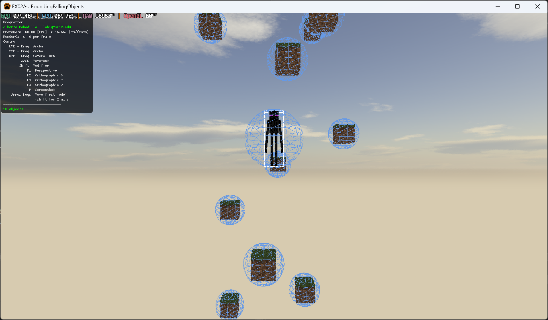

For this exam you are in charge of coding 3 methods that will calculate a collision between objects. In the sample scene there will be a center object not affected by “gravity” and 10 objects that will. You need to calculate the OBB, ARBB and BS of them all in the RigidBody.cpp methods, Constructor and SetModelMatrix as well as calculating if objects are intersecting in IsColliding. For this last one you are only required to give the variable bColliding a true or false value depending on a BS vs BS collision detection, you do not need to worry about the collision list or adding or removing from it, just a value of true or false on bColliding.

Your grade will be as follows:

30pts Generating the BS

This implies calculating the center and the radius of the shape

30pts Generating the OBB

Rember an OBB is an AABB before you modify its transform.

This can also be achieved if you did only a circle as well.

20pts Generate the ARBB

This uses the max and min and center in Global space and the ARBBSize variable, this is NOT the Halfwidth

20pts initializing the bColliding correctly in the IsColliding method

---------

20pts extra credit (If you use the ARBB vs ARBB as a pretest and when that fails use the BSvsBS, make sure you have the regular credit before attempting to do the extra credit)

You can only submit the unzipped file RigidBody.cpp, no other files should be modified.

***Submit to the dropbox labeled: EX2 - Practical***