# Sheet.1916Network Design for Ambo University Main campus

#### Date 21/11/2014

##### *Designed by:-*

***1,Alamu kebebe Ambo university.***

***2,ababae Lammesa Ambo university.***

***3,Bekuma Negese Ambo university.***

***4,Daniel Oda Ambo University.***

***5,Elsa Hailu Ambo university.***

***6,Elsay kumala Hawasa university.***

***7,Getu shashoo Ambo university.***

***8,Mandia Ararsa Hawasa university.***

***9,Sara Amante Ambo university.***

***1 st***

***floor***

**Library**

***Ground floor***

Fiber Optic patch code(sc-sc multi mode).

-Fiber optic patch panel.

-SFP fiber module.

-UTP cable. Huawaei switch. RJ-45 connector.

-UTP fiber patch panel

**Law LIbrary**

**PHD Library**

**Ground floor**

Fiber Optic patch code(sc-sc multi mode).

-Fiber optic patch panel.

-SFP fiber module.

-UTP cable. Huawaei switch. RJ-45 connector.

-UTP fiber patch panel

-Huawai switch. RJ-45 Connector. UTP-cable.

-UTP-patch panel.

### *Ground floor*

Fiber Optic patch code(sc-sc multi mode).

-Fiber optic patch panel.

-SFP fiber module.

-UTP cable. Huawaei switch. RJ-45 connector.

-UTP fiber patch panel

1 st floor

## Pharmacy

**Lab**

***5 th***

### *floor*

***1 st floor***

-Huawai switch. RJ-45 Connector. UTP-cable.

-UTP-patch panel.

### *Ground floor*

Fiber Optic patch code(sc-sc multi mode).

-Fiber optic patch panel.

-SFP fiber module.

## Block -1

1 st floor

**Block -2**

1 st floor

**1 st floor**

-Huawai switch. RJ-45 Connector. UTP-cable.

-UTP-patch panel.

### *Ground floor*

Fiber Optic patch code(sc-sc multi mode).

***1 st***

### *floor*

-Huawai switch. RJ-45 Connector. UTP-cable.

-UTP cable.

Huawaei switch. RJ-45 connector.

-Fiber optic patch panel.

-SFP fiber module.

-UTP cable.

-Huawai switch. RJ-45 Connector. UTP-cable.

1 st floor

-UTP-patch panel.

### *4 th floor*

-UTP fiber patch panel

#### Fiber optic cable

Huawaei switch.

RJ-45 connector.

-UTP fiber patch panel

-UTP-patch panel.

### *Ground floor*

Fiber Optic patch code(sc-sc multi mode).

-Fiber optic patch panel.

-SFP fiber module.

-UTP cable. Huawaei switch. RJ-45 connector.

-UTP fiber patch panel

## Cooperative education

### *Ground floor*

Fiber Optic patch code(sc-sc multi mode).

-Fiber optic patch panel.

# Admin Building

5 th floor

4 th floor

3 rd floor

-Huawai switch. RJ-45 Connector. UTP-cable.

-UTP-patch panel.

### *3 rd floor*

-Huawai switch. RJ-45 Connector. UTP-cable.

-UTP-patch panel.

### *2 nd floor*

-Huawai switch. RJ-45 Connector. UTP-cable.

-UTP-patch panel.

### *1 st floor*

-Huawai switch. RJ-45 Connector. UTP-cable.

Internet is provided by Ethio Telecom

#### Router

**E-Book**

1 st floor

1. ***st***

### *floor*

-SFP fiber module.

-UTP cable. Huawaei switch. RJ-45 connector.

-UTP fiber patch panel

1. nd floor

1 st floor

ground

-UTP-patch panel.

***Ground floor***

Fiber Optic patch code(sc-sc multi mode).

-Fiber optic patch panel.

-SFP fiber module.

-UTP cable. Huawaei switch. RJ-45 connector.

-UTP fiber patch panel

#### Huawai switch

-Huawai switch.

RJ-45 Connector. UTP-cable.

-UTP-patch panel.

### *Ground floor*

Fiber Optic patch code(sc-sc multi mode).

-Fiber optic patch panel.

-SFP fiber module.

-UTP cable. Huawaei switch. RJ-45 connector.

-UTP fiber patch panel

### *Ground floor*

Fiber Optic patch code(sc-sc multi mode).

-Fiber optic patch panel.

-SFP fiber module.

-UTP cable. Huawaei switch. RJ-45 connector.

-UTP fiber patch panel

**Continuous education**

**Medicine Health**

#### Server

3322UU

1. U
2. U

router

switch

1 st floor

2 U

2 U **Patch panel**

***1 st floor***

-Huawai switch.

RJ-45 Connector.

UTP-cable.

-UTP-patch panel.

## Ground floor

Fiber Optic patch code(sc-sc multi mode).

8 U

2 U

server

Power supply

Smart phone

***1 st***

### *floor*

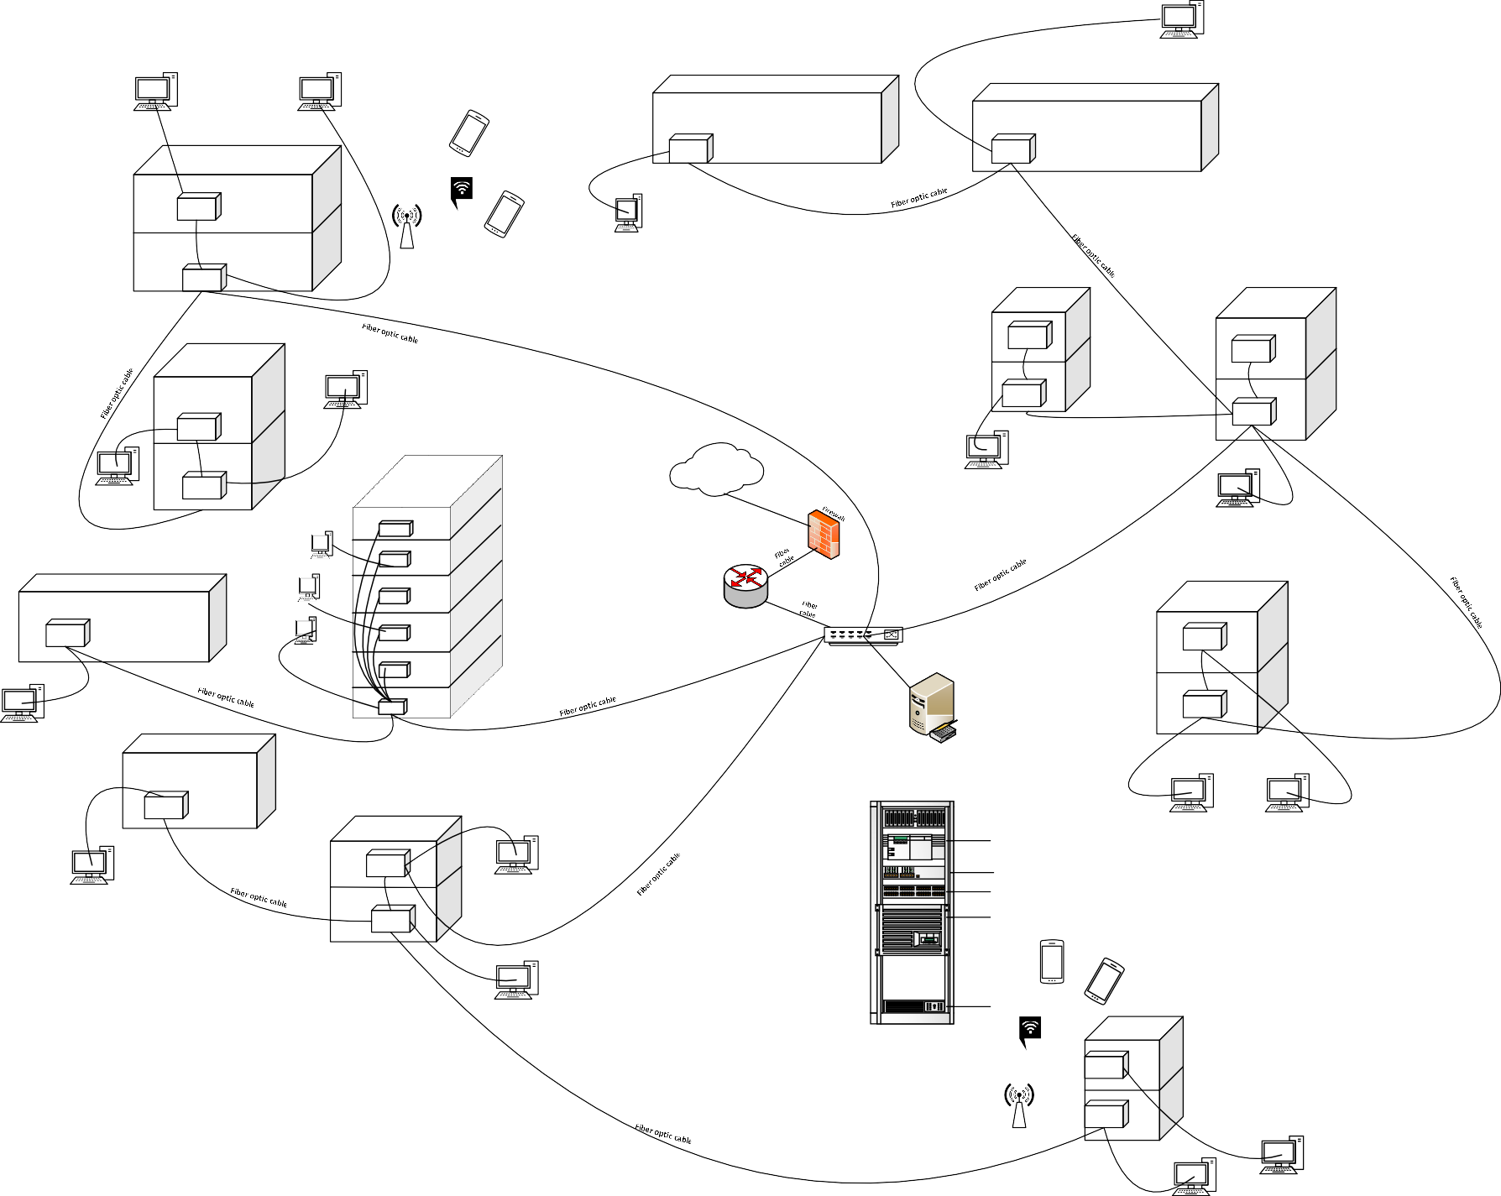-Fiber optic patch panel.

-SFP fiber module.

-UTP cable. Huawaei switch. RJ-45 connector.

-UTP fiber patch panel

Rack

**Finance Office**

1 st floor

-Huawai switch. RJ-45 Connector. UTP-cable.

-UTP-patch panel.

### *Ground floor*

Fiber Optic patch code(sc-sc multi mode).

-Fiber optic patch panel.

-SFP fiber module.

-UTP cable. Huawaei switch. RJ-45 connector.

-UTP fiber patch panel