Overview and Introduction:
Thank you so much for participating in this experiment.

This experiment is built around a notional DoD acquisitions program. It is not intended to represent an actual program, but should provide enough material to permit evaluation of requirement verification techniques. The performance data within is entirely fictional, with little to no analysis completed to determine whether or not the performance is actually feasible.

Please review it with this context.

As part of the review, you have been provided with documents and models to support the analysis, as well as a review tool to present the model data and capture your review data. This review tool will be the only method for officially documenting your review. It will start you on a random requirement and enable you to select whether you consider the requirement ‘met’ or ‘not met.’ You will be required to annotate how long you spent reviewing the requirement, as well as the errors or inconsistencies you found during your review of the requirement.

Some requirements will provide you assistance in your review by presenting data collected from models. You will always have the ability to review documents to help you make your decisions.

Some additional notes:

- Use this documents, data and the tool exclusively to conduct your review. This example exists nowhere outside of this experiment, so searching won’t help.
- To ensure controlled test execution, make your best effort with the data provided… the test team will not be able to answer questions about the test.
- Do not communicate with others regarding the test.
- Please document any errors you believe would affect your review of the requirement. This data will be evaluated even if the review was correct. For example, if you find a single glaring error that caused you to determine that the requirement was not met, keep looking. There may be other errors. In real reviews, this is extremely important, because documenting this information may be the difference between a sustained protest and a successful award.
- Keep track of the time you spend on the review. Each requirement will be evaluated statistically to determine if a particular approach was faster, so accurate information is vital.

Part 1: What is being tested?
- Background
A 2013 Study by the Project Management Institute found that “On average, two in five projects do not meet their original goals and business intent, and one-half of those unsuccessful projects are related to ineffective communications.” Similarly, at the 2017 Australian Systems Engineering Workshop, a panel of industry experts determined that “the root cause of all project failures is a lack of shared understanding between the acquirer and the supplier.” (Hallet 2018) Perhaps the most important concepts to understand are the user’s needs (as specified in requirements) and the system’s ability to meet those needs (as shown through requirement verification).

Currently, most projects attempt to achieve common understanding by creating and sharing a series of documents including reports, checklists, requirements databases and verification matrices. Stakeholders review these documents throughout the program lifecycle to independently evaluate progress towards program goals. However, as Madni notes “[w]ith growing system complexity, document-centric approaches have become increasingly difficult to manage.” (Madni 2018) Multiple researchers, including Madni (2018), Friedenthal (2014), and Bernard (2012) have found that document based approaches increase program risk due inconsistencies in language, differences in assumptions and semantics, and reliance on inconsistent, out-of-date, disconnected documentation. These approaches often lack technical rigor and standardization, resulting in incompatibilities across organizational lines. As a result, it becomes infeasible to check for correctness or ensure unambiguous statement of needs. (Madni 2018) To ensure successful program execution, engineering methods capitalizing on modeling and machine assistance have been developed and are beginning to be adopted.

This experiment aims to test model based approaches to utilize machine assistance to verify that system requirements have been met. You will evaluate requirements for a notional system utilizing four different approaches, ranging from purely document based to utilizing an approach that integrates requirements and systems models. The integrated approach is called Machine Assisted Requirements Verification for Stakeholders (MARVS), which is being developed as part of doctoral research at George Washington University. The remaining two approaches balance a model based approach (for either requirements or implementation) with a legacy document based approach.

- Requirements Model
Requirements modeling is focused on writing requirements in formal language and connecting them together in a manner that explicitly defines their relationships. Often, this takes the form of a mathematical relationship that relates an attribute of the system to a required value, as in the following example:

System::Weight < 50 pounds

Similarly, requirements can reference other requirements. For example:

R1: System::Weight < 50 pounds
R2: System::Cost < $10,000
R3: R1 and R2

In this example, the system must weigh less than 50 pounds AND must also cost less than $10,000. This type of relationship can be expanded using boolean expressions to express all system requirements, enabling rapid evaluation of the requirement model.

- Systems Model
The systems model describe the components of a systems, their attributes, and the explicit links between components. In addition, system models may have the ability to link requirements to components. SysML, a common systems modeling language, utilizes the ‘satisfy’ relationship to connect components to requirements, implying that the linked component has attributes that satisfy the originating requirement. While promising, current versions of SysML only support textual requirement rather than mathematically rigorous language. Discrete expressions of systems models are called implementations. For example:

Model: System::Weight : pounds
Implementation A: System::Weight : 30 pounds
Implementation B: System::Weight : 60 pounds

In this example, the system model identifies an attribute belonging to the “System” component called “Weight” that is expressed in “pounds.” To be conformant to the model, any potential implementation would have a System::Weight attribute expressed in the same data type. The example shows two implementations of the same system model, one that weighs 30 pounds and one that weighs 60 pounds.

- Integrated Requirements – Systems Model (IRSM)
Both the requirements model and the systems model provide important information about the system. However, neither model by itself provides enough information to assert that an implementation of the system meets its requirements. Combining the two models into a single integrated model allows for traceability from a system requirement model all the way to the lowest relevant system attribute. Linking the requirements and systems models is accomplished by ensuring that (1) the requirements are expressed in formal language using system attributes and (2) the system attributes expressed in the requirements are present in the system model.

Another important benefit of integrating the two models is that any parameters required for validation are required to be present in the model implementation, ensuring accurate and complete documentation. In the MARVS approach documented in this research, this capability is used as an integral part of the requirement verification process. As part of the verification artifacts for each requirement, a full implementation is identified that satisfies the requirement. This implementation corresponds with requirement verification event and includes all system parameters that were expressed at the time of the event. In the above examples, Implementation A could represent the flight testing implementation, meaning the Implementation A’s System::Weight attribute would be the ‘as tested’ flight test weight. Implementation B could represent a sensor test, with an associate ‘as tested’ weight.

The MARVS approach has the entire requirement tree evaluated for each requirement by default, rather than only the attributes associated with the single requirement being verified. For the above example, the System::Weight would have caused the requirement tree to fail during the sensor test. This does not mean that the sensor requirement was not met; instead, it informs the user that aspects of the system were out of specification during the test event. The reviewer would be responsible for determining whether this information results in a ‘not-met’ status for the requirement. This approach is intended to be conservative, ensuring that the reviewer must make a strong determination that the requirement was not relevant rather than having that decision made by default.

If done manually, this approach would likely add a significant burden to reviewing requirements. The MARVS approach is designed to utilize machine assistance to automate as much as possible this effort, while still giving the reviewer the last say. One goal of this experiment is to determine whether machine assistance makes this approach feasible.

Part 2: Test Scenario
The system provided for this experiment is designed to meet the requirements of the Organic Tactical Surveillance System – Expeditionary (OTSS-E) program. This notional program is to procure a small unmanned aircraft system (SUAS) for tactical operations in austere deployed environments. OTSS-E will provide imagery capability for small units, including full motion video (FMV) and wide area imagery. The system will be rapidly re-deployable, with a small lightweight ground control station (GCS). For more detailed information, please see the Systems Requirements Document (SRD) found in the same folder as these instructions.

The OTSS-E program completed an initial market study and concluded that no Commercial Off The Shelf (COTS) solution existed that completely satisfied the requirements. However, multiple companies were identified that had solutions deemed ideal for ‘rapid tailoring’ to the military requirements. The OTSS-E program was structured around a two phase approach, with 5 contractors selected for a Phase 1 effort to tailor their COTS solutions under USAF contract followed by a source selection for the Phase 2 production effort. As part of this effort, bidders were encourages to leverage previous analysis, data, testing and certifications to reduce cost and risk.

This experiment is set after the completion of Phase 1. You will review the submission by XYZ Aerospace, one of the 5 competitors. The award is based on a Lowest Price Technically Acceptable (LPTA) evaluation. You are a member of the technical team determining whether the offering is technically acceptable (meets all requirements). The Source Selection Authority has determined that you will not see any price or contracting aspects of the proposal to ensure that your review will not be biased.

XYZ Aerospace has chosen to submit their Nomad SUAS, a quadcopter design based on their commercially successful Wanderer SUAS. Wanderer has been used in multiple industries, including mining, private security, and film. However, it does not meet military requirements for sensor accuracy, communications security, and degraded GPS performance (among others). In addition, multiple Wanderer components are produced in prohibited countries. In Phase 2, XYZ chose to leverage Wanderer flight data and FAA certification to dramatically reduce flight testing. Consequently, Phase 2 was primarily focused on integrating new sensors and software, along with implementing a domestically produced flight computer.

Additional detail can be found in the documents provided with this instruction.

Part 3: Using the Tool
- Tool Overview
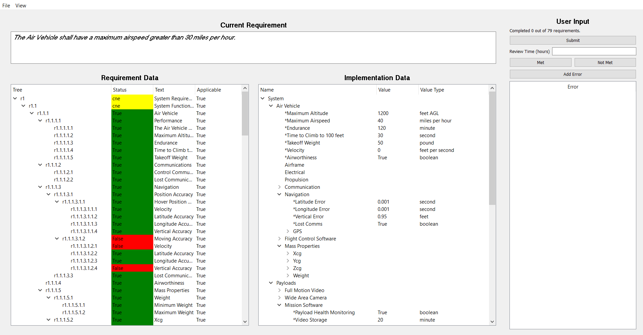
- Submissions

- Reqiurements Pane
  - Model based

- Implementation Pane
  - Document based
  - Model based

