Supplementary Information
TITLE PAGE
Title:
Hydrosheaf: An Integrated Validation Framework for Coupled Groundwater Residence-Time, Flow-Topology and Inverse Hydrogeochemical Modelling in Data-Limited Aquifers

Authors:
Dickson Abdul-Wahab^{a*}, Ebenezer Aquisman Asare^{b}, Dickson Adomakoª, Gibrilla Abass^{c}, Samuel Ganyaglo^{a,d},

Affiliations:

ª Department of Nuclear Science and Applications, School of Nuclear and Allied Sciences, University of Ghana, Atomic-Kwabenya, Accra, Ghana

^{b}Nuclear Chemistry and Environmental Research Centre, National Nuclear Research Institute (NNRI), Ghana Atomic Energy Commission (GAEC), Box LG 80, Legon-Accra, Ghana

^{c}Department of Water Resources and Aquaculture Management, School of Sustainable Development, University of Environment and Sustainable Development, Somanya, Ghana

^{d}Water Resources Research Centre, National Nuclear Research Institute, GAEC, Box LG 80, Kwabenya-Accra, Ghana

*Corresponding Authors:
Dickson Abdul-Wahab;
Email: dabdul_wahab11@yahoo.com
ORCiD: https://orcid.org/0000-0001-7446-5909

Supplementary Table
Table S1

Data type | Required field | Unit | Required/optional | QC rule | Used in module
Location | latitude/longitude or x/y | decimal degrees or projected | required | valid coordinate range | graph
Elevation/head | elevation, head_m | m | recommended | non-missing preferred | topology
Major ions | Ca, Mg, Na, K, HCO3, Cl, SO4, NO3 | mmol/L or mg/L | required | charge-balance screening | chemistry
Conditional ions | F, Fe, PO4, Br | mg/L or ug/L | optional | detection-limit handling | logic gates
Stable isotopes | d18O, d2H | permil | optional/enhanced | tracer range check | transport
Nuclear tracers | tritium, 14C | TU, pmC | optional | tracer range check | age
Field parameters | pH, EC, temperature, DO/Eh | field units | recommended | field range check | geochemistry

Table S2
Process family | Reaction/process term | Chemical signature | PHREEQC/SI rule | Logic gate | Allowed direction
carbonate dissolution | calcite | Ca, HCO3 | SI/forward check when available | reaction dictionary | nonnegative
carbonate dissolution | dolomite | Ca, HCO3, Mg | SI/forward check when available | reaction dictionary | nonnegative
evaporite dissolution | gypsum | Ca, SO4 | SI/forward check when available | reaction dictionary | nonnegative
evaporite dissolution | halite | Cl, Na | SI/forward check when available | reaction dictionary | nonnegative
silicate weathering | albite | HCO3, Na | SI/forward check when available | reaction dictionary | nonnegative
redox process | pyrite_oxidation_aerobic | Fe, SO4 | SI/forward check when available | reaction dictionary | nonnegative
nitrate input | NO3src | NO3 | SI/forward check when available | reaction dictionary | nonnegative
redox process | denit | HCO3, NO3 | SI/forward check when available | reaction dictionary | nonnegative
ion exchange | CaNa_exch | Ca, Na | SI/forward check when available | reaction dictionary | signed
ion exchange | NaCa_exch | Ca, Na | SI/forward check when available | reaction dictionary | nonnegative
ion exchange | MgNa_exch | Mg, Na | SI/forward check when available | reaction dictionary | signed
ion exchange | NaMg_exch | Mg, Na | SI/forward check when available | reaction dictionary | nonnegative

Table S3
Parameter | Value/range | Used in module | Scientific rationale
n_realisations | 100 | benchmark | Monte Carlo recovery ensemble
lambda_l1 (default) | 0.002 | sparse inversion | default sparse-recovery penalty
AICc-selected lambda | 0.0483 | site model selection | selected for Lower Anayari and Talensi only
major_ion_rel_sigma | 0.04 | synthetic data | analytical uncertainty on chemistry
isotope_sigma_permil | 0.50 | isotope validation | stable-isotope measurement noise
transport_models_enabled | evap, mix | edge fitting | minimum transport alternatives for M2
PSI trials | 30 default | field uncertainty | edge stability under perturbation
SI threshold | 0.2 diagnostic band | forward checks | thermodynamic feasibility screening

Table S4
Site | Sample ID | Latitude | Longitude | Elevation (m) | Aquifer setting | Land-use/mining influence | Available tracers | Completeness score
Talensi | TGW1 | 10.71 | 0.82 | 217 | Crystalline basement | Mining/Agri | stable isotopes; no nuclear tracers | 1.00
Talensi | TGW2 | 10.71 | 0.81 | 222 | Crystalline basement | Mining/Agri | stable isotopes; no nuclear tracers | 1.00
Lower Anayari | PUB1 | 10.91 | -1.06 | 217 | Alluvial/Basement | Agriculture | stable isotopes; no nuclear tracers | 1.00
Lower Anayari | PUB2 | 10.91 | -1.06 | 217 | Alluvial/Basement | Agriculture | stable isotopes; no nuclear tracers | 1.00

Table S5
Edge ID | From node | To node | Distance (km) | Elevation/head relation | Edge confidence | Age consistency | Chemical match R2 | Dominant reaction | Status
Talensi_48_61 | TGW49 | THDW10 | 2.52 | downgradient | 1.00 | field tracer absent | 1.00 | carbonate dissolution | screening-level demonstration
Talensi_45_44 | TGW46 | TGW45 | 1.93 | upgradient/flat | 1.00 | field tracer absent | 1.00 | nitrate input | screening-level demonstration
Talensi_48_42 | TGW49 | TGW43 | 2.54 | downgradient | 1.00 | field tracer absent | 1.00 | redox process | screening-level demonstration
Manu_30_28 | GOB38 | GOB36 | 1.31 | downgradient | 1.00 | field tracer absent | 0.99 | evaporite dissolution | screening-level demonstration
Talensi_51_26 | TGW52 | TGW27 | 3.31 | upgradient/flat | 1.00 | field tracer absent | 0.99 | nitrate input | screening-level demonstration
Talensi_28_27 | TGW29 | TGW28 | 1.57 | downgradient | 1.00 | field tracer absent | 0.99 | nitrate input | screening-level demonstration

Supplementary Figures
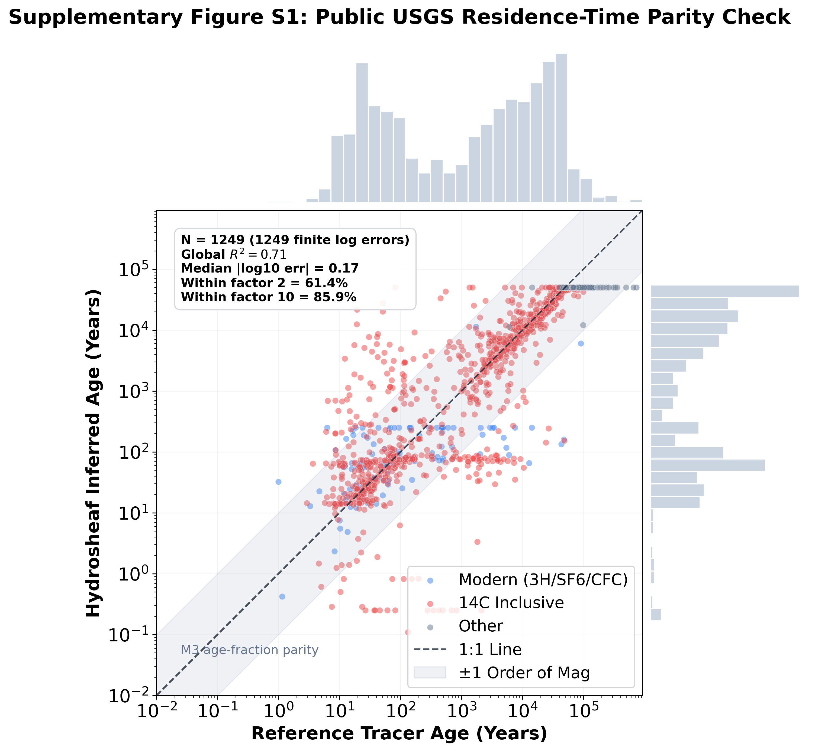
Supplementary Figure S1. Public USGS residence-time parity check using the M3 age-fraction-constrained benchmark. Among 1,272 rows, 1,249 had finite log10 errors; R² = 0.71, median absolute log10 error = 0.17, 61.4% were within a factor of two and 85.9% within a factor of ten. The USGS ages and age fractions are reported model outputs, so this is screening-level parity rather than direct true-age validation or full TracerLPM equivalence.
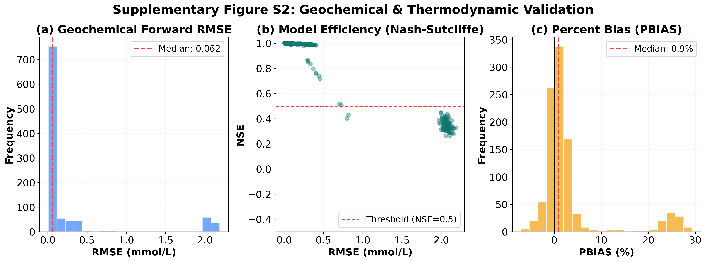
Supplementary Figure S2. PHREEQC-compatible forward-feasibility proxy. Panel (a) shows the RMSE distribution (median = 0.062 mmol/L); panel (b) relates RMSE to Nash–Sutcliffe efficiency (median NSE = 0.999); and panel (c) shows percent bias (median PBIAS = 0.9%). The simulator uses locked PHREEQC-consistent saturation fields; live PHREEQC kinetic execution remains pending.
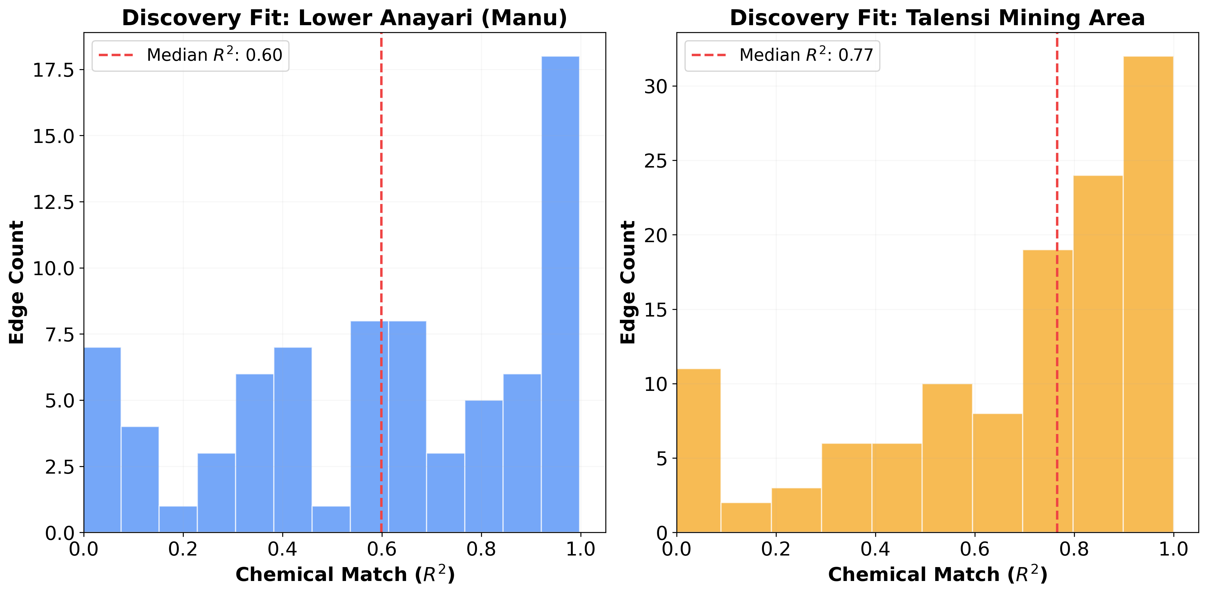
Supplementary Figure S3. Field-scale chemical discovery fit for the Lower Anayari and Talensi groundwater networks. The histograms show edge-level chemistry R² for generated coordinate/head-proxy graphs: median R² = 0.60 for Lower Anayari and 0.77 for Talensi. These fits describe hydrochemical closure of a field demonstration and do not provide independent process-truth validation.

