TITLE PAGE
Title:
Hydrosheaf: An Integrated Validation Framework for Coupled Groundwater Residence-Time, Flow-Topology and Inverse Hydrogeochemical Modelling in Data-Limited Aquifers

Authors:

Dickson Abdul-Wahab^{a*}, Ebenezer Aquisman Asare^{b}, Dickson Adomakoª, Gibrilla Abass^{c}, Samuel Ganyaglo^{a,d},

Affiliations:

ª Department of Nuclear Science and Applications, School of Nuclear and Allied Sciences, University of Ghana, Atomic-Kwabenya, Accra, Ghana

^{b}Nuclear Chemistry and Environmental Research Centre, National Nuclear Research Institute (NNRI), Ghana Atomic Energy Commission (GAEC), Box LG 80, Legon-Accra, Ghana

^{c}Department of Water Resources and Aquaculture Management, School of Sustainable Development, University of Environment and Sustainable Development, Somanya, Ghana

^{d}Water Resources Research Centre, National Nuclear Research Institute, GAEC, Box LG 80, Kwabenya-Accra, Ghana

*Corresponding Authors:
Dickson Abdul-Wahab;
Email: dabdul_wahab11@yahoo.com
ORCiD: https://orcid.org/0000-0001-7446-5909

Title:
Hydrosheaf: An Integrated Validation Framework for Coupled Groundwater Residence-Time, Flow-Topology and Inverse Hydrogeochemical Modelling in Data-Limited Aquifers

Abstract
Groundwater quality in data-limited aquifers is governed by the interplay of residence time, flow-path connectivity, and geochemical reactions, yet existing tools address these dimensions separately. This study introduces Hydrosheaf, a Python-based framework that couples residence-time inversion, directed graph-topology inference and sparse inverse hydrogeochemical modelling in one workflow. Sheaf-style consistency refinement scores candidate edges against hydraulic, isotopic and chemical evidence; network-enhanced Bayesian inference propagates graph constraints into age uncertainty; and L1-regularised reaction fitting uses PHREEQC-compatible logic gates to rank chemically feasible solutions. Across 100 locked synthetic realisations, median transport-parameter absolute error was 0.056 and median reaction-extent error was 0.050 mmol/L; active-reaction recovery in the refreshed figure was R2 = 0.57 (MAE = 0.33 mmol/L), with 32.7% of inactive terms exceeding the 0.05 mmol/L leakage threshold. No-prior topology recovery against MODPATH gave F1 = 0.618 (precision 0.487, recall 0.845), whereas the prior-assisted mode reproduced the reference edges exactly, as expected for a conditioning-prior test. Synthetic network-age recovery gave log-space R2 = 0.98 and MAE = 183.3 years. The independent public-age comparison was screening-level parity with reported USGS model outputs (n = 1,249 finite log errors; R2 = 0.71; median absolute log10 error = 0.17; 61.4% within a factor of two), not true-age validation. A deterministic PHREEQC-compatible mass-balance proxy marked 89.1% of edges thermodynamically feasible; live PHREEQC execution remains pending. The Northern Ghana demonstration generated 208 edges with overall chemistry R2 = 0.711 (Lower Anayari median 0.60; Talensi median 0.77) but no independent process-truth labels. Hydrosheaf therefore provides an auditable, evidence-tiered workflow for process diagnosis where calibrated numerical models are unavailable, while retaining explicit identifiability and transferability limits.

Keywords: Sheaf theory, PHREEQC, Sparse regularisation, Process-stability index, Thermodynamic constraints

1. Introduction
Groundwater quality is not static but evolves continuously as water moves through the subsurface, accumulating dissolved constituents through mineral weathering, ion exchange, redox transformation, and mixing with waters of different ages and origins (Ma et al., 2019; Yang et al., 2018). This evolution is governed by three interacting dimensions: the residence time of water in the aquifer, which determines the duration of water–rock contact; the connectivity structure of the flow system, which determines which minerals and rock surfaces water encounters; and the geochemical reactions that transform initial recharge chemistry into the observed groundwater composition (Casillas-Trasvina et al., 2022; Villegas et al., 2018). These three dimensions are not independent, residence time constrains the feasible extent of mineral dissolution and redox transformation; flow-path connectivity determines whether samples at different points represent an evolutionary sequence or hydraulically isolated compartments; and reaction history is physically meaningful only when anchored to a plausible flow path and a defensible contact time (Caschetto et al., 2016; Díaz-Puga et al., 2016).
Multi-tracer field studies across contrasting settings such as arid-basin alluvial aquifers in northwestern China (Xiao et al., 2018; Yang et al., 2018), confined coastal aquifers in Colombia (Villegas et al., 2018), and carbonate karst systems in Morocco (Roubil et al., 2022), consistently demonstrate that groundwater evolves from fresh, recently recharged waters toward more mineralised, mixed, or palaeorecharge compositions through carbonate and silicate dissolution, evaporite dissolution, cation exchange, redox reactions, evaporation, and anthropogenic inputs (Caschetto et al., 2016). In arid and semi-arid aquifers, groundwater age increases with distance from recharge zones and depth while chemistry shifts toward higher salinity, as documented in loess-basin systems (Ling et al., 2022) and basin-scale confined aquifers (Purtschert et al., 2022). In mining-influenced and urban environments, age tracers combined with redox chemistry have revealed that modern water fractions transport arsenic, nitrate, and sulphate into shallow and deeper aquifer zones via coupled flow and reaction mechanisms (Richards et al., 2022; Cheng et al., 2022; Lapworth et al., 2017). Seasonal pumping-induced recharge further complicates the coupling between surface-water chemistry and groundwater composition (Guo et al., 2018), while semi-arid zoning models confirm that hydrochemical processes change along flow systems from leaching through cation exchange, evaporation, and concentration (Li et al., 2019). Interpreting groundwater chemistry therefore requires the simultaneous consideration of age evidence, spatial connectivity, and geochemical process (Newman et al., 2021).
Conventional groundwater interpretation treats each sampled location as an independent observation whose chemistry is attributed to processes at that point or along a flow path selected by the analyst on the basis of geological intuition, spatial proximity, or hydrochemical similarity (Teeple et al., 2021; Wang et al., 2025). This point-based paradigm has two well-recognised limitations. First, a single groundwater sample typically represents a mixture of waters that have followed different flow paths and carry different ages, such that neither the apparent age nor the chemistry can be unambiguously attributed to a single evolutionary trajectory (Casillas-Trasvina et al., 2022; Newman et al., 2021). Multi-component mixing, between modern shallow recharge and older confined water, for example, can produce intermediate chemistry, yielding an apparent LPM age that reflects neither end-member correctly, as documented in the Belgian Neogene aquifer (Casillas-Trasvina et al., 2022), fault-connected Algerian systems (Ghiglieri et al., 2021), and aquifer complexes with inter-unit leakage (Murgulet et al., 2016). Second, point-based hydrochemical classifications such as Piper diagrams, hydrochemical facies, bivariate ion ratios, identify water types but do not identify the spatial or temporal sequence that generated them (Díaz-Puga et al., 2016; Song et al., 2024). Two samples of the same facies can arise from entirely different evolutionary pathways in contrasting lithological and climatic settings (Wang et al., 2025).
Residence-time estimation by lumped-parameter modelling addresses the temporal dimension but introduces its own interpretive limitations. Single-tracer inversion conflates mean residence time with the shape of the transit-time distribution and tracer input function uncertainty (Ma et al., 2019; Rädle et al., 2022). When multiple tracers disagree, as is common in mixed-age systems, the analyst must choose between competing age models without a formal arbitration framework (Casillas-Trasvina et al., 2022). In heterogeneous hard-rock aquifers, nearby wells can sample entirely different hydraulic domains whose age and chemistry patterns are only interpretable when aquifer architecture is considered (Comte et al., 2018; Cao et al., 2020). Point samples can also miss vertical connectivity and leakage: isotopic differences between shallow and deep alluvial groundwater in Beijing were invisible to point-chemistry classification but clearly interpretable in a depth-connected network context (He et al., 2021; Joshi et al., 2018). River–aquifer exchange further illustrates that isolated well sampling can miss discharge-integrated flow-path signals apparent only when surface-water and groundwater nodes are treated as parts of a connected network (Newman et al., 2021; Smerdon & Gardner, 2022; Binet et al., 2017; Sun et al., 2025). Eastern Dahomey Basin analyses further demonstrated that aquifer heterogeneity and anthropogenic influences obscure the simple spatial trends that point-based interpretation assumes (Aladejana et al., 2020).
Inverse geochemical modelling, as implemented in PHREEQC (Parkhurst & Appelo, 2013) and NETPATH, solves for the set of mineral dissolution, precipitation, ion exchange, and redox reactions explaining the observed chemistry difference between a nominated initial and final water along an assumed flow path. The fundamental non-uniqueness of this problem has been extensively documented: for any given water pair, multiple chemically distinct reaction sets can satisfy mass-balance constraints within analytical uncertainty, particularly when the mineral phase library is large relative to the number of measured ions (Slimani et al., 2017; Manu et al., 2023). The same Ca-HCO₃ water type, for instance, may be produced by carbonate dissolution, silicate weathering with CO₂ uptake, mixing with Ca-rich end-members, ion exchange, or combinations of these processes (Roy et al., 2020; Li et al., 2018). Dissolution, precipitation, and exchange reactions can offset each other, for example, gypsum dissolution adding Ca²⁺ and SO₄²⁻ while calcite precipitation removes Ca²⁺, generating net budgets indistinguishable from alternative reaction combinations (Slimani et al., 2017; Roy et al., 2020). In the Qaidam Basin, Guo et al. (2025) demonstrated that halite and gypsum dissolution, silicate weathering, carbonate precipitation, and cation exchange were all necessary to explain observed hydrochemical evolution, but that numerous phase-extent combinations reproduced the same final water chemistry within analytical precision. In the Hancheng Mining Area, Gibbs and Piper plots indicated rock-weathering control, yet the interpretation still required separate attribution to dolomite, calcite, gypsum, halite, and pyrite oxidation, highlighting the inadequacy of graphical methods alone (Kou et al., 2024). Phase selection strongly controls the solution: Manu et al. (2023) explicitly used combinatorial inverse modelling in the Ghanaian Pra Basin because different mineral assemblages produced chemically valid but geologically contrasting pathway interpretations, and multiple tracers in the Pahute Mesa groundwater study were required to reveal mixing zones and long-term regional flow that no single method could identify (Kwicklis et al., 2021).
The problem is compounded by uncertainty in the flow-path assumption itself. If the analyst incorrectly pairs wells that are not hydraulically connected, the inferred reaction extents are artefacts rather than records of genuine geochemical evolution (Manu et al., 2023; Teeple et al., 2021). Seltzer et al. (2021) further showed that anthropogenic carbonate inputs can distort ¹⁴C-based age estimates by thousands of years, illustrating how geochemical-model uncertainty propagates directly into age estimates and thence into assessments of groundwater renewability. In sparse field campaigns typical of data-limited regions, incomplete monitoring networks, partial ion records, rare tracer data, these problems are amplified, and the risk of producing confident but geologically inadmissible process attributions is substantially elevated (Borzí, 2025).
The limitations outlined above collectively point to the need for a framework that integrates residence-time evidence, spatial flow-path structure, and inverse reaction modelling within a single, physically consistent workflow. Representing groundwater sampling locations as nodes in a directed graph and inferred flow connections as directed edges provides a natural and flexible structure for this integration (Schiavo et al., 2022; Taccari et al., 2024; Borzí, 2025). Empirical evidence for the network character of groundwater systems is strong: in the Gran Sasso karst aquifer, spatial patterns in δ²H, δ¹⁸O, ⁸⁷Sr/⁸⁶Sr and hydrochemistry were used to distinguish groundwater circulation groups and infer recharge areas and flow paths (Barbieri et al., 2005); in the Lez karst system, δ¹⁸O, δ²H, and ⁸⁷Sr/⁸⁶Sr indicated interaction between deep storage and the main Jurassic aquifer through fracture-controlled connections (Bicalho et al., 2017); in the Galilee Basin, hydraulic-head patterns and isotopic evidence jointly supported connected spring discharge from shallow and deep regional flow paths (Keegan-Treloar et al., 2024); in fractured gneiss in Malawi, isotopes and major ions identified the Ntcheu Fault as a conduit linking recharge and discharge zones along a directed flow network (Kambuku et al., 2018); and in the Yuquan Mountain karst system, multiple evidence streams identified distinct recharge zones and fault-controlled pathways undetectable from point chemistry (Sun et al., 2025).
Within a directed graph, each edge is a testable hypothesis scored, tested, and either retained or discarded on the basis of physical and geochemical evidence (Borzí, 2025). Graph constraints improve reaction interpretation in two complementary ways: they restrict the set of node pairs submitted to the inverse solver to those for which connectivity is physically admissible, eliminating reaction solutions that contradict elevation, head, or tracer evidence; and they enable network-level consistency checks (that is, age must increase monotonically along directed edges, chemistry must evolve in the direction of the inferred reaction) impossible to apply when samples are interpreted individually (Roubil et al., 2022; Schiavo et al., 2022). Sheaf-theoretic consistency formalises this: the requirement that local observations on edges must agree globally across the network parallels the requirement in cellular sheaf theory that local sections must be consistent across the covering structure (Robinson, 2020; Hansen & Ghrist, 2019), and while formal sheaf implementations have not previously been demonstrated for groundwater networks (Borzí, 2025), the underlying principle is directly implementable as a scoring mechanism for directed edge plausibility.
The primary objective of this study is to introduce, describe, and systematically validate Hydrosheaf, a Python-based computational framework that couples groundwater residence-time inversion, directed graph topology inference, and sparse inverse hydrogeochemical modelling within a single integrated workflow designed for data-limited aquifers. Hydrosheaf addresses three specific methodological gaps: the absence of tools simultaneously inferring flow-path topology and fitting geochemical reactions along those paths; the lack of formal uncertainty propagation from graph structure through to reaction-extent uncertainty; and the absence of a multi-tier validation protocol testing topology, age, chemistry, and thermodynamic feasibility against independent reference standards (Borzí, 2025; Manu et al., 2023; Casillas-Trasvina et al., 2022).
Four methodological contributions are advanced. First, sheaf-style consistency refinement combines hydraulic, isotopic and chemical evidence to score directed-edge plausibility. Second, network-enhanced Bayesian age inference uses graph structure to narrow posterior uncertainty and evaluate age-order consistency; the resulting uncertainty reduction is a model property and should not be interpreted as a universal improvement in reference-age accuracy. Third, sparse L1-regularised reaction fitting with thermodynamic logic gates and geological-bias penalties ranks parsimonious candidate process classes while retaining non-uniqueness where the ion data are insufficient. Fourth, a process-stability index (PSI) quantifies how often reaction terms recur across Monte Carlo perturbations, distinguishing stable signals from data-contingent attributions.
The evaluation comprises five evidence tiers: locked synthetic recovery with known truth; MODFLOW/MODPATH-referenced directed-topology comparison; synthetic and public residence-time benchmarking; PHREEQC-compatible forward-feasibility proxy testing; and a Northern Ghana field-hydrochemistry demonstration. These tiers are intentionally reported separately because they test different claims and do not constitute a single proof of universal field validity.

2. Materials and Methods
2.1 Hydrosheaf Framework Overview
2.1.1 Software Architecture and Main Workflow
Hydrosheaf is implemented as a modular Python package whose computational architecture integrates six functionally distinct modules that operate sequentially from raw field inputs to validated diagnostic outputs (Table 1; Figure 1). The framework is accessed via a command-line interface, a high-level Python application programming interface (API), or automated workflow scripts, all of which are governed by a central Config dataclass that specifies solver settings, penalty parameters, active minerals, uncertainty modes, and module-level toggles. The modular design permits individual components to be automatically disabled when required input fields are absent, thus accommodating the variable data completeness that characterises data-limited aquifer settings (Table S1).
The principal execution sequence proceeds as follows. Raw hydrogeological data are first ingested and standardised by the data-preprocessing module. The graph-construction module then generates and scores candidate directed edges between sampling nodes using spatial, elevational, and hydraulic-head evidence. Where external physics priors are available, for example, from MODFLOW/MODPATH particle tracking, these are applied to the edge set before network fitting. The residence-time module performs single-node lumped-parameter-model (LPM) inversion and, optionally, network-enhanced Bayesian age inference using the directed graph structure. The inverse hydrogeochemistry module fits transport models and sparse reaction vectors to the observed chemistry difference along each directed edge, subject to thermodynamic constraints from PHREEQC (Parkhurst & Appelo, 2013). An uncertainty and robustness module propagates input errors through bootstrap, Bayesian, or Monte Carlo resampling. All intermediate and final outputs are exported in CSV, JSON, and YAML formats, and a figure-generation pipeline produces publication-ready diagnostics including directed-network plots, regularisation-path curves, and Phase Stability Matrix heatmaps.

2.1.2 Conceptual Model: Nodes, Edges, Tracers, Reactions and Constraints
Within the Hydrosheaf conceptual model, each groundwater sampling location, including boreholes, springs, piezometers, and surface-water sites, is represented as a node characterised by a chemistry vector, optional tracer concentrations, stable isotope ratios, spatial coordinates, elevation, and hydraulic metadata. A directed edge from node u to node v represents a testable hypothesis that groundwater flows from u towards v along an inferred pathway, such that the chemistry observed at v can be understood as the result of applying transport processes (evaporation, dilution, or mixing) and geochemical reactions to the chemistry of u. Edge direction is constrained by elevation, hydraulic-head proxies, and, where available, particle-tracking priors, rather than by geochemical similarity alone, thereby preserving the physical admissibility of the inferred network (Section 4.5).
Tracers supply the temporal dimension of groundwater evolution. Tritium (³H; T½ = 12.32 yr) and radiocarbon (¹⁴C; T½ = 5,730 yr) serve as primary nuclear tracers, and stable isotopes of water (δ¹⁸O and δ²H) provide conservative mixing and recharge-source constraints. Residence-time classes, recharge/young, intermediate/dilute, and deep/old, are assigned to nodes on the basis of posterior age distributions generated by the nuclear inversion module. Reactions are represented by stoichiometric vectors drawn from a configurable process dictionary encompassing carbonate dissolution, silicate weathering, evaporite dissolution, redox transformations, cation exchange, and anthropogenic-source terms (Table S2). Two classes of constraint govern which reactions may appear in the final solution: (i) concentration logic gates, which suppress reactions whose indicator ions fall below geochemically meaningful thresholds; and (ii) thermodynamic logic gates, which eliminate reactions for which the saturation index computed by PHREEQC indicates that dissolution is thermodynamically inhibited (Table S3).

2.2 Data Model and Preprocessing
2.2.1 Required Sample, Chemistry, Isotope, Coordinate and Elevation Fields
The minimum dataset required to execute the Hydrosheaf workflow comprises a unique site identifier, decimal-degree geographic coordinates, and a major-ion chemistry profile including calcium (Ca), magnesium (Mg), sodium (Na), potassium (K), bicarbonate (HCO₃), chloride (Cl), and sulphate (SO₄). Elevation above mean sea level is recommended; a topographic proxy may be substituted when measured values are unavailable. Nitrate (NO₃), fluoride (F), iron (Fe), and phosphate (PO₄) are conditionally required: their inclusion extends the active process dictionary and activates the corresponding logic gates (Table S1). Field parameters, pH, electrical conductivity (EC), temperature, and redox potential (Eh or dissolved oxygen), are recommended to support thermodynamic speciation and EC/TDS consistency scoring. Stable isotopes (δ¹⁸O, δ²H) are optional but strongly recommended for transport model discrimination, while nuclear tracers (³H in tritium units, TU; ¹⁴C in per cent modern carbon, pMC) are optional but required for the residence-time inversion module to generate posterior age distributions. The full field specifications are detailed in Supplementary Table S1.
2.2.2 Unit Harmonisation, Charge-Balance Screening and Ion-Order Configuration
All ion concentrations are converted to a common unit prior to network fitting. The default operational unit is millimoles per litre (mmol/L), with milliequivalents per litre (meq/L) available as an alternative via the unit_mode configuration parameter. Conversions from mg/L are performed using standard ionic molar masses. The ion sequence is fixed to the canonical order Ca, Mg, Na, K, HCO₃, Cl, SO₄, NO₃, F, Fe, PO₄, which governs all chemistry vectors and reaction stoichiometry matrices throughout the framework. Charge-balance error (CBE) is computed for each sample as:
$$\text{CBE}=\frac{\sum{z_{i}C_{i}^{+}}-\sum{\left|z_{j}\right|C_{j}^{-}}}{\sum{z_{i}C_{i}^{+}}+\sum{\left|z_{j}\right|C_{j}^{-}}}×100$$ | (1)
where $z_{i}$ denotes ionic charge and $C_{i}$ molar concentration. Samples with a CBE exceeding the configurable limit (default 10%) are flagged with a QC warning propagated to the edge-result output. Charge-balance exceedance does not automatically exclude samples, enabling the framework to operate with analytically imprecise field data, but flagged samples are retained in the output QC field for user review.
2.2.3 Missing-Value, Detection-Limit and Quality-Control Handling
Missing ion values are handled according to a configurable policy. The default skip policy retains samples with missing ions by setting the absent value to zero and reducing the effective reaction-dictionary dimension to processes whose indicator ions are observed; the impute_zero policy fills all missing values with zero for full-vector consistency. Values reported below the analytical detection limit are processed by a separate four-option policy: substitution at half the detection limit (default), substitution at zero, retention of the reported value, or exclusion. In Hydrosheaf we implemented an auto disable missing modules function that inspects the sample set at run-time and disables modules whose minimum field requirements are unmet, for example, deactivating the nuclear tracer module when neither ³H nor ¹⁴C values are present in any sample. This automatic graceful degradation is essential for African basement and semi-arid aquifer datasets where isotope or tracer records are frequently sparse or absent, and it ensures that partial datasets do not halt execution or produce spurious outputs arising from imputed tracer values.
2.3 Graph Construction and Edge Inference
2.3.1 Spatial, Elevation and Head-Proxy Edge Generation
Candidate directed edges are generated through a probabilistic inference procedure that evaluates the plausibility of groundwater flow from each node to its spatial neighbours within a configurable search radius (default 5.0 km). For each candidate pair (u, v), a composite edge-confidence probability $p_{uv}$ is assembled from three independent evidence streams:
$$p_{uv}=p_{\text{dist}}⋅p_{\text{elev}}⋅p_{\text{head}}$$ | (2)
The distance component decays as a Gaussian with configurable scale $σ_{\text{dist}}$; the elevation component favours downward flow with Gaussian decay $σ_{\text{elev}}$ and an indicator requiring $z_{u}≥z_{v}$; and the head-proxy component is derived from measured hydraulic head, depth-to-water, or topographic-head estimates, using heuristic, Bayesian, or MCMC inference modes. Candidate edges with $p_{uv}$ below a minimum threshold (default 0.75) are discarded. Each node is connected to a maximum of three downstream neighbours. Directional consistency is enforced by requiring a minimum hydraulic gradient of ${10}^{-4}$ along each accepted edge. Scale parameters governing each evidence component are listed in Supplementary Table S3. This probabilistic formulation ensures that all accepted edges carry a quantified confidence score that is propagated through subsequent refinement and validation steps.
2.3.2 Primary, Lateral and 3D Candidate-Edge Structures
Three structural edge classes are distinguished. Primary edges connect nodes in the inferred principal flow direction and are submitted to the inverse solver. Lateral edges connect nodes at approximately similar elevations where hydraulic gradients are weak, representing dispersion-influenced or lateral-connectivity candidates; these are retained in a neighbour-lookup table for mixing-endmember identification but are not directly processed by the reaction-fitting solver. Three-dimensional (3D) edges are generated by the build_network_3d module when screen-depth or elevation metadata permit vertical connectivity to be evaluated; these carry attributes for horizontal distance, vertical distance, and horizontal and vertical gradients, enabling representation of inter-layer leakage and vertical flow paths. Stratigraphic layer membership is assessed against configured layer tops and bottoms; cross-layer edges receive a reduced baseline connectivity probability (default 0.3) unless overridden by physics priors. The distinction between edge classes ensures that the solver operates on physically admissible pathway hypotheses rather than on statistically similar samples whose proximity may reflect spatial clustering rather than hydraulic connection.
2.3.3 Physics Priors from MODFLOW/MODPATH and External Flow Models
When a calibrated regional groundwater-flow model is available, particle-tracking results from MODPATH are incorporated as physics priors to condition graph topology before network fitting. MODPATH endpoints are converted to directed reference edges by mapping particle origins and destinations to the nearest sampling nodes, generating physically simulated flow connections that can either condition the inference or serve as an independent validation reference (Figure 2). Each prior-derived edge is represented as a PhysicsPrior object carrying a travel-time estimate ($τ_{\text{prior}}$, in days) and a prior edge-confidence probability derived from particle-path density. Priors are applied through the “apply_physics_priors” function in either override mode (replacing heuristic probabilities) or blending mode (combining prior and heuristic probabilities). Travel-time estimates from MODPATH, when available, override the Darcy-based approximation:
$$τ=\frac{Lϕ}{K⋅i}$$ | (3)
where $L$ is path length (m), $ϕ$ is effective porosity, $K$ is hydraulic conductivity (m day⁻¹), and $i$ is the hydraulic gradient. The MODFLOW/MODPATH topology simultaneously serves as an independent validation reference by comparing Hydrosheaf-inferred edges against reference edges without physics-prior conditioning (Section 2.6.3), thereby providing a stringent test of topology-recovery capability under physics-naïve conditions (Table 4).
2.3.4 Sheaf-Style Topology Refinement Using Chemical and Age Consistency
Following probabilistic edge generation, the graph topology is subjected to a sheaf-style consistency-refinement procedure inspired by the consistency-checking framework of cellular sheaves, in which local data over edges must agree with global data over nodes (Section 4.4). The refinement evaluates whether the observable variables at nodes u and v are mutually consistent with the directed-flow hypothesis along edge (u, v). Four evidence streams are assessed: (i) hydraulic-head or depth-to-water gradient; (ii) stable-isotope consistency (δ¹⁸O, δ²H); (iii) conservative-tracer (chloride) directionality; and (iv) age-order consistency. Edge-confidence scores are updated iteratively across a maximum of three refinement passes, and edges whose updated confidence falls below the minimum threshold (0.75) are removed from the network. An evaporation logic gate is applied to shallow nodes (screen depth < 30 m) to prevent evaporatively enriched isotope signatures from being misinterpreted as recharge-to-deeper-zone connectivity, and soft selection sharpness is governed by the configurable inverse-temperature parameter $β$ (sheaf_soft_beta). This procedure substantially reduces the number of physically implausible edges submitted to the inverse solver without requiring a fully calibrated flow model.
2.4 Residence-Time and Nuclear-Tracer Modelling
2.4.1 Nuclide Definitions, Tracer Input Functions and Residence-Time Classes
Residence-time modelling is based on the radioactive decay of environmental tracers whose atmospheric input functions are sufficiently well-constrained to permit inversion of measured concentrations to groundwater mean residence time (MRT). Tritium (³H) and radiocarbon (¹⁴C) are the primary supported nuclides, spanning groundwater ages from sub-decadal to several tens of thousands of years and thus encompassing the recharge/young, intermediate/dilute, and deep/old residence-time classes used throughout the manuscript. For each nuclide, the tracer concentration at a node with MRT $τ$ (years) is computed under the piston-flow model assumption as:
$$C\left(τ\right)=C_{0}exp\left(-\frac{\ln{2}}{T_{1/2}}⋅τ\right)$$ | (4)
where $C_{0}$ is the reference initial activity (5 TU for tritium; 100 pMC for radiocarbon) and $T_{1/2}$ is the isotopic half-life. The sample collection date is extracted from sample metadata or estimated as the dataset median collection year to align decay calculations with the measurement epoch. The default tracer is configurable via residence time tracer (default "3H"), with radiocarbon activated through the nuclide registry function.
2.4.2 Lumped Parameter Models: Piston, Exponential and Dispersion Assumptions
Three lumped parameter model (LPM) types are implemented corresponding to distinct conceptualisations of the groundwater residence-time distribution (RTD). The Piston Flow Model (PFM) assumes a unique transit time $\tau$ with no dispersion and is most appropriate for confined aquifers with well-defined recharge zones and minimal intra-aquifer mixing (Ma et al., 2019). The Exponential Model (EM) assumes a negative-exponential distribution of transit times representing a fully mixed reservoir, appropriate for unconfined aquifers with spatially distributed recharge and strong vertical mixing. The Dispersion Model (DM) combines advective-piston transport with hydrodynamic dispersion characterised by a Péclet-analogue parameter $P_D$, generating an asymmetric RTD with a well-defined modal transit time and a high-age tail, appropriate for aquifers exhibiting intermediate transport behaviour. In the benchmark configuration, the PFM is used as the default model type (nuclear model = "PFM"), with the model type configurable at the workflow level. Model selection among LPM types, when multiple tracers are available, follows minimum-residual criteria evaluated over a grid search of the MRT parameter space. The choice of LPM can substantially affect the inferred MRT, particularly for waters with multi-component age distributions (Casillas-Trasvina et al., 2022), and model-type uncertainty is propagated into the network-level age inference step described below.
2.4.3 Single-Node Tracer-Age Inversion
Single-node tracer-age inversion estimates the MRT at each sampling location independently, without reference to graph topology, by comparing the measured tracer concentration against the LPM-predicted concentration curve over a grid of candidate MRT values. The optimal MRT is identified as the value minimising the squared difference between measured and predicted tracer concentrations, subject to a lognormal prior on MRT with log-space scale parameter $\sigma_0 = 0.35$. This prior reflects the substantial uncertainty inherent in single-point tracer age estimates arising from tracer input-function uncertainty, mixing, and recharge-zone variability, sources documented in multi-tracer studies where single-tracer ages can diverge by factors of two to five from network-constrained estimates (Casillas-Trasvina et al., 2022; Ma et al., 2019). The estimated single-node MRT is stored in the sample record. Where tracer data are absent, the module falls back to the Darcy-based edge-transit-time approximation (Section 2.3.3) or disables age-coupling if neither tracer nor hydraulic parameterisation is available. Single-node ages are carried forward into the network-enhanced Bayesian inference step.
2.4.4 Network-Enhanced Bayesian Residence-Time Inference
Single-node age estimates are refined through a network-enhanced Bayesian inference procedure (infer_network_ages_bayesian) that exploits the directed graph structure to propagate age constraints from upstream to downstream nodes. The directed graph is represented as a NetworkX DiGraph with edge attributes including path length (m), and the node-level observations are the tracer concentrations or single-node MRT estimates at each sampled location. The key innovation is that the uncertainty in the network-inferred age decreases as a function of the node's in-degree $n_{\text{in}}$:
$$σ_{\text{net}}=\frac{σ_{0}}{\sqrt{n_{\text{in}}+1}}$$ | (5)
where $σ_{\text{net}}$ is the network-reduced lognormal scale parameter and $\sigma_0 = 0.35$ is the single-node uncertainty (see Appendix A.3 for derivation). This formulation reflects the statistical independence of upstream evidence: each additional upstream flow-path connection reduces age uncertainty in proportion to the square root of the number of constraints. Network-inferred ages are classified into recharge, intermediate, and deep residence-time classes by comparison against tracer-range class-boundary thresholds. Downstream age-order consistency is evaluated using Kendall's rank-correlation coefficient $\tau$ between in-degree-weighted MRT estimates and topological rank within the directed graph, providing a network-level diagnostic of whether the inferred age structure is consistent with inferred flow direction (Figure 5, Panel C; Table 3).

2.5 Inverse Hydrogeochemical Modelling
2.5.1 Transport Fitting for Evaporation, Dilution and Mixing
Prior to reaction fitting, the chemistry difference between nodes u and v is decomposed by evaluating two physical transport hypotheses. Under the evaporation model, the downstream chemistry vector is predicted by applying a scalar concentration factor $γ> 1$:
$$γ=\frac{1}{1-f_{\text{evap}}}$$ | (6)
where $f_{\text{evap}}$ is the fraction of water removed by evapotranspiration, yielding a concentrated intermediate vector $x_{γ}=γ⋅xu$. Under the mixing model, node v receives a fraction $f$ of water from a lateral endmember $x_{\text{mix}}$ and a fraction $\left(1-f\right)$ from the evaporatively adjusted upstream vector:
$$xv^{\text{pred}}=\left(1-f\right)xγ+f,x_{mix}$$ | (7)
Isotope fractionation during evaporation is modelled using the Rayleigh distillation equation with temperature-dependent liquid–vapour fractionation factors at 25°C (see Appendix A.2 for derivation). Transport candidates are enumerated over a grid of ($γ$, $f$) values for each candidate endmember, and the combination yielding the minimum conservative-tracer residual defines the pre-reaction residual vector $r=x_{v}-x_{v}^{\text{pe}}$ submitted to the sparse solver.
2.5.2 Conservative-Tracer Weighting and Ion-Balance Constraints
Conservative-tracer weighting is applied during transport fitting to prioritise ions least affected by water–rock reactions. The conservative weight vector $wc$ assigns unit weight to chloride ($w\text{Cl}=1.0$), 0.40 to sodium, 0.15 to bicarbonate, and 0.01–0.02 to all other ions, reflecting the relative conservativeness of these species in crystalline and alluvial aquifer settings where chloride is the most reliable mixing tracer in the absence of halite dissolution (Hydrosheaf config.py, conservative_weights). Ion-balance constraints are enforced implicitly through charge-balance screening and through the non-negativity constraint on reaction extents, which prevents the generation of physically unrealistic negative dissolution rates except where bidirectional reactions are explicitly enabled.
2.5.3 Sparse Reaction Fitting and L1 Regularisation
The core geochemical inversion problem minimises the regularised residual between the predicted and observed downstream chemistry. The reaction-extent vector $z∈R_{≥0}^{m}$ (in mmol/L) is estimated by minimising the elastic-net objective:
$$J\left(z\right)=\frac{1}{2}{\left|W^{1/2}\left(Az-r\right)\right|}_{2}^{2}+λ_{1}{\left|z\right|}_{1}+\frac{λ_{2}}{2}{\left|z\right|}_{2}^{2}$$ | (8)
where $W=\text{diag}\left(w\right)$ is the diagonal ion-weight matrix, $A∈R^{n_{\text{in}}×m}$ is the stoichiometric reaction matrix, $λ_{1}≥0$ governs L1 sparsity, and $λ_{2}≥0$ provides optional ridge stabilisation. The L1 penalty is the primary mechanism for obtaining sparse, interpretable reaction sets: as $λ_{1}$ increases, the number of non-zero reaction extents decreases, with the optimal $λ_{1}$ selected by minimising the corrected Akaike Information Criterion along the regularisation path (Figure 6). The objective is minimised by coordinate descent via the soft-threshold update (see Appendix A.1 for the full derivation), with non-negativity enforced by truncation after each coordinate update. Per-reaction penalty scales $s_{j}$ incorporate a mass-transfer normalisation factor equal to the total stoichiometric coefficient sum, preventing mineralogically complex reactions from being systematically favoured due to their larger stoichiometric vectors. Convergence is declared when the maximum absolute coordinate change falls below ${10}^{-6}$, with a maximum of 300 iterations.
2.5.4 Mineral and Reaction Dictionary and Process-Family Terms
The reaction library is assembled at runtime from the build_reaction_dictionary function, which constructs stoichiometric vectors from the configured active mineral list and process terms. Process families encompass (Table S2): carbonate reactions (calcite, dolomite dissolution and precipitation); evaporite reactions (gypsum, halite, fluorite dissolution); silicate weathering (albite, anorthite, K-feldspar, biotite, chlorite); redox reactions (aerobic pyrite oxidation, denitrification-coupled pyrite oxidation, sulphate and iron reduction); cation exchange (Ca–Na, Mg–Na, Ca–K, Na–K); denitrification and nitrate-source terms; and atmospheric/background input proxies for SO₄, Cl, NO₃, and F. A geological-bias setting (crystalline or sedimentary) scales penalty values to reflect expected process dominance: in crystalline settings, silicate and redox reactions are favoured (penalty scale 0.5) while evaporites are strongly penalised (penalty scale 10.0); the inverse applies in sedimentary settings. An honest modelling mode further restricts the active library based on measured-ion availability, pruning reactions whose indicator ions are absent from the analytical dataset before fitting proceeds.
2.5.5 PHREEQC Saturation-Index Constraints and Thermodynamic Logic Gates
Thermodynamic feasibility of the inferred reaction set is enforced through integration with PHREEQC (Parkhurst & Appelo, 2013), which computes saturation indices (SI) for each candidate mineral prior to fitting. The saturation index for mineral $k$ is:
$$\text{S}{\text{I}}_{k}=\log{10}\left(\frac{\text{IA}{\text{P}}_{k}}{K_{\text{sp},k}}\right)$$ | (9)
where $\text{IA}{\text{P}}_{\text{k}}$ is the ion activity product and $K_{\text{sp},k}$ is the solubility product constant from the PHREEQC thermodynamic database. A thermodynamic logic gate suppresses dissolution of mineral $k$ from the active dictionary when $\text{S}{\text{I}}_{\text{k}}>τ_{\text{S}}\text{I}$ (default $τ_{\text{SI}}=0.5$), reflecting that supersaturated minerals are unlikely to dissolve and their inclusion would generate spurious positive extents. Concentration logic gates impose additional geochemical constraints: pyrite and gypsum are suppressed when SO₄ < 0.208 mmol/L (20 mg/L); halite and sylvite when Cl < 0.564 mmol/L (20 mg/L); and fluorite when F < 0.026 mmol/L (0.5 mg/L) (Table S2). In the crystalline geologic-bias mode, the gypsum penalty is escalated to effectively exclude it when SO₄ > 0.52 mmol/L, enforcing attribution of sulphate to pyrite oxidation in basement aquifer contexts. PHREEQC is interfaced via the phreeqpython library, using the built-in phreeqc.dat database. Saturation-index vectors at upstream and downstream nodes are retained as edge-result attributes and underpin Supplementary Figures S2 and S3.
2.5.6 Objective Functions, Residuals and Model-Selection Criteria
The total edge-level objective score integrates the post-reaction weighted residual norm with additional penalty terms for multi-evidence consistency: an EC/TDS consistency penalty, a stable-isotope placement penalty relative to the local meteoric water line, a Gibbs-diagram consistency penalty, and an isotope-consistency penalty. Transport-model selection among competing ($γ$, $f$, endmember) combinations is performed by minimising this total objective. Selection of the optimal regularisation strength $λ_{1}$ across the full regularisation path is performed by minimising the corrected Akaike Information Criterion:
$$\text{AICc}=2k+nln\left(\frac{\text{RSS}}{n}\right)+\frac{2k\left(k+1\right)}{n-k-1}$$ | (10)
where $k$ is the number of non-zero reaction extents plus one, $n$ is the number of fitted ion species, and RSS is the weighted post-reaction residual sum of squares (Figure 6; Table 5). This formulation balances goodness-of-fit against model parsimony, penalising solutions that invoke additional reactions without a commensurate improvement in the chemistry residual.

2.6 Validation Design, Uncertainty Treatment and Benchmark Scoring
2.6.1 Bayesian, Bootstrap and Monte Carlo Uncertainty Modes
Three uncertainty quantification modes are implemented, selectable via uncertainty_method. The bootstrap mode resamples input chemistry vectors with replacement across 1,000 replicates (configurable) and re-executes the full edge-fitting pipeline for each replicate, yielding percentile or bias-corrected accelerated (BCa) confidence intervals for all reaction extents and transport parameters. The Bayesian mode constructs a probabilistic model of the reaction-extent posterior using Hamiltonian Monte Carlo sampling with 5,000 draws across four chains, employing Laplace-scale priors on reaction extents and a half-Normal prior on the observation noise parameter. The Monte Carlo mode perturbs all input chemistry values simultaneously with a relative Gaussian noise of 5% (input_uncertainty_pct) over 1,000 realisations. The process-stability index (PSI) for reaction $j$ is defined as the fraction of Monte Carlo realisations in which the reaction is selected: ${\text{PSI}}_{j}=P\left(\left|z_{j}\right|>ε\right)$. PSI values are reported in the Phase Stability Matrix (Figure 7; Table 6) and serve as the primary robustness metric for distinguishing geochemically stable processes from data-contingent ones.
2.6.2 Synthetic Benchmark Design for Known Transport and Reaction Recovery
A controlled synthetic benchmark evaluated recovery of known transport parameters and reaction extents from noisy chemistry data. The benchmark used a ground-truth YAML configuration specifying source chemistry, stable-isotope values, a directed generation network, and true evaporation, mixing and reaction parameters. Sequentially generated downstream vectors were perturbed with multiplicative Gaussian noise. One hundred stochastic realisations were generated per experiment, with complete-ion, ion-incomplete and head-absent scenarios and full, sparse and heuristic-only topologies. Performance was quantified using the displayed transport and reaction recovery diagnostics, chemistry R², absolute error and noise-aware isotope metrics (Figure 3; Table 2).
2.6.3 MODFLOW/MODPATH Topology-Validation Design and Prior-Mode Separation
The topology-validation benchmark evaluated Hydrosheaf against directed connectivity extracted from MODPATH particle endpoints and pathlines. Three operational modes were separated: prior-assisted conditioning, no-prior inference from spatial/elevational/head-proxy evidence, and threshold sensitivity. True-positive, false-positive and false-negative edges were tabulated to compute precision, recall and F1. This separation prevents circular interpretation of MODPATH priors as independent evidence and restricts the claim to topology conversion and recovery.
2.6.4 PHREEQC-Constrained Forward and Kinetic Validation Design
Forward kinetic validation was performed by configuring the reactive transport validation module to simulate the evolution of the downstream chemistry vector from an upstream initial composition, using the inverse-derived reaction extents over the inferred residence time. The forward simulator integrates mineral dissolution and precipitation kinetics using power-law rate expressions:
$$r_{k}=k_{k}A_{k}\left(1-\frac{\text{IAP}k}{K\text{sp},k}\right)$$ | (11)
where $k_{k}$ is the mineral-specific rate constant (mol m⁻² s⁻¹; Table S3), $A_{k}=0.1$ m² L⁻¹ is the assumed reactive surface area, and the bracketed term represents departure from chemical equilibrium. Default rate constants are drawn from compiled kinetics literature (calcite: $\log_{10}\left(k\right)=-6.0$; albite: $\log_{10}\left(k\right)=-12.0$). Forward-simulated chemistry is compared against observed downstream chemistry using Nash–Sutcliffe efficiency (NSE) and RMSE across all ions; forward runs with NSE < 0.5 or RMSE > 1.0 mmol/L are flagged as low-confidence. This validation tier tests whether inverse-derived reaction extents are consistent with kinetic constraints and thermodynamic feasibility as adjudicated by PHREEQC (Supplementary Figures S2, S3).
A complementary metric suite was used across the five evidence tiers. Precision, recall and F1 quantified topology; chemistry R2, RMSE and NSE quantified synthetic and forward-proxy fit; AICc assessed regularisation parsimony; Kendall tau assessed downstream age ordering; and PSI quantified process recurrence across Monte Carlo perturbations. Public-age parity was reported in log10-error and within-factor metrics because the USGS targets are model-derived ages and age fractions rather than direct true ages.
A suite of complementary metrics evaluates performance across the four validation tiers. For topology validation, precision ($P=\text{TP}/\left(\text{TP}+\text{FP}\right)$), recall ($R=\text{TP}/\left(\text{TP}+\text{FN}\right)$), and F1-score ($F_{1}=2PR/\left(P+R\right)$) are computed from the edge-classification contingency table (Table 4). For chemistry and age recovery, $R^{2}$, RMSE, and Nash–Sutcliffe efficiency ($\text{NSE}=1-\sum{{\left(y_{i}-\hat{y_{i}}\right)}^{2}/\sum{{\left(y_{i}-\overline{y}\right)}^{2}}}$) are computed across all benchmark edges and realisations (Tables 2, 3). For regularisation-path model selection, AICc is minimised at the optimal $\lambda_1$ value (Figure 6; Table 5). For downstream age consistency, Kendall's $\tau$ is computed between in-degree-weighted MRTs and topological rank in the directed graph, providing a non-parametric test of monotonic age increase along inferred flow paths (Figure 5, Panel C). PSI quantifies reaction robustness as $P\left(\left|z_{j}\right|>{10}^{-6} \text{mmol}\text{/}\text{L}\right)$ across Monte Carlo realisations (Figure 7; Table 6). These metrics collectively cover connectivity accuracy (F1), chemical mass-balance accuracy (R², RMSE, NSE), model parsimony (AICc), temporal-order consistency (Kendall $τ$), and process robustness (PSI).

2.7 Implementation, Availability and Reproducibility
The Hydrosheaf source code, example configuration files, and reproducible workflow materials are publicly available at: https://github.com/dabdul-wahab1988/Hydrosheaf. Hydrosheaf is implemented as a pure-Python package comprising the following top-level modules: api (high-level workflow functions), config (the Config dataclass), data (schema validation, parsing, and QC), graph and graph3d (2D and 3D edge construction), inference (per-edge and network-level fitting), models (reaction dictionary, transport models, EC/TDS prediction), nuclear (nuclide definitions and network-age Bayesian inference), phreeqc (saturation-index constraints and forward runner), sheaf (topology refinement), uncertainty (bootstrap, Bayesian, and Monte Carlo propagation), reactive_transport (forward kinetic validation), temporal (time-series edge fitting), and vadose (vadose-zone physics priors). The Config dataclass centralises all tuneable parameters (that is, solver tolerances, regularisation penalties, graph-construction thresholds, uncertainty settings, and module toggles) and exposes a validate method that checks parameter consistency before execution. The command-line interface accepts a YAML configuration file and a CSV or JSON data file, executes the full workflow pipeline, and writes all outputs to a structured directory. A test suite covers unit tests for the reaction solver, graph-construction functions, charge-balance computation, PHREEQC interface, and the LPM nuclide decay calculator. All configurable hyperparameters and their default values are provided in Supplementary Table S3.

3. Results
3.1 Framework Implementation and Workflow Execution
The Hydrosheaf framework executed successfully through all six core computational modules in their prescribed sequence, from data preprocessing through uncertainty quantification and output export, confirming the operational integrity of the architecture described in Table 1 and Figure 1. The complete workflow, data ingestion, unit conversion, charge-balance screening, graph construction, sheaf-style refinement, PHREEQC speciation (Parkhurst & Appelo, 2013), nuclear-tracer inversion, sparse reaction fitting, and Monte Carlo robustness assessment, completed without exception across all benchmark and field datasets. The automatic module-disabling function selectively deactivated the nuclear-tracer module for samples lacking ³H or ¹⁴C data and suppressed the isotope-penalty objective component for samples without δ¹⁸O or δ²H records. These graceful-degradation behaviours are critical for West African basement aquifer datasets where tracer programmes are rarely implemented (Manu et al., 2023; Borzí, 2025).
The graph-construction module produced candidate directed edge sets for all test configurations. In the synthetic benchmark, the full ground-truth topology was reproduced by the heuristic edge generator when hydraulic-head data were present, while the heuristic-only configuration generated a superset subsequently pruned by the confidence threshold. For the MODPATH-validated configuration, probabilistic inference generated 174 candidate directed edges before physics-prior conditioning, all of which survived the confidence filter (Table 4; Figure 2). The process dictionary assembled stoichiometric vectors for 12–18 candidate reactions per edge depending on geological-bias settings and concentration logic gate evaluations (Table S2), with the crystalline geologic-bias mode consistently pruning evaporite reactions in the Lower Anayari dataset, consistent with mineralogical controls documented for basement aquifers in the Lower Anayari Catchment (Abdul-Wahab et al., 2021).
The nuclear-tracer module produced single-node MRT estimates for benchmark nodes with tracer data and network-enhanced Bayesian MRTs for nodes with non-zero in-degree. Network posterior interval widths were 52% narrower than the single-node intervals in this benchmark, by construction of the conjugate-updating model; this is an uncertainty-partitioning result, not an independent demonstration of lower reference-age error.
The inverse hydrogeochemistry module produced per-edge outputs comprising transport model selection ($γ$ or $f$), transport-model probabilities, reaction-extent vector $z$, post-reaction residual vector, weighted residual norm, L1 norm, AICc, PHREEQC feasibility flag, saturation-index vectors at upstream and downstream nodes, and QC flag list (Table 1). The chemistry $R^{2}$ between predicted and observed downstream chemistry served as the primary single-edge performance diagnostic across all validation tiers (Table 2).

3.2 Synthetic Benchmark Recovery and Identifiability
Evaporation and mixing were recovered with different reliability across the 100 benchmark realisations. Mixing and dilution parameters were recovered whenever the relevant endmember was available, whereas evaporation-model classification was less reliable for the low-concentration-factor edge. Across all 600 transport rows, 553 had finite parameter estimates, with median absolute error 0.056 and an overall model-classification rate of 92.2%; evaporation classification was the principal source of misses. The positive bias in concentration-factor recovery is consistent with confounding between evaporative concentration and reaction-derived salinity, reinforcing the need for conservative-isotope evidence.
The refreshed reaction-recovery panel contained 2,100 active and 4,900 inactive truth rows. Active rows showed R2 = 0.57 and MAE = 0.33 mmol/L, while 32.7% of inactive rows exceeded 0.05 mmol/L. The leakage was concentrated in chemically compensating terms, especially inactive albite and CaNa-exchange terms, and therefore represents sparse-recovery ambiguity rather than confident mineral identification. Reaction extents should consequently be reported as identifiability classes or ranked candidate processes, not unique phase histories.${R2=0.955}^{}0.050$
Performance under degraded data conditions remained informative but was not invariant. Median chemistry R2 was 0.955 for complete ions, 0.888 when major ions were withheld, and 0.955 when head data were absent. Missing major ions therefore weakened reaction discrimination, whereas head-data absence primarily affected graph construction. These results support graceful degradation, not equivalence of incomplete and complete datasets.$R^{2}$
When 30% of ground-truth edges were removed in the sparse-topology scenario, the framework continued to recover correct dominant reactions on retained edges with $R^{2}$ comparable to the full-topology configuration. Under heuristic-only topology, false edges were characterised by higher residual norms and lower chemistry $R^{2}$ than true-positive edges, providing a natural diagnostic for flagging implausible pathways. Network-Bayesian age estimates under sparse topology showed elevated uncertainty ($σ_{\text{sparse}}=σ_{0}/\sqrt{\max\left(1,0.7,n_{\text{in}}\right)+1}$), consistent with the expected degradation under 30% edge loss and with theoretical arguments that network-level age uncertainty scales inversely with independent upstream constraints (Casillas-Trasvina et al., 2022; Ma et al., 2019).
The isotopic consistency check yielded pointwise R2 = 0.52 for $δ^{18}O$, while the edge-mean comparison reached R2 = 0.99; the pointwise MAE was 0.58 per mil and the expected edge-difference noise was 0.71 per mil (Figure 3, Panel D). The defensible interpretation is noise-aware edge-mean consistency, not point-level isotope proof.

3.3 Residence-Time Inversion and Network-Age Validation
Network Bayesian MRT estimates showed strong agreement with the locked synthetic ages in log space (R2 = 0.98; MAE = 183.3 years; Figure 5, Panel A). Posterior interval widths were 52% narrower than single-node intervals, reflecting the imposed conjugate-updating structure rather than an independently measured reduction in age error. The age-parity plot separated young, intermediate, old, fossil and mixed classes, with the greatest spread in intermediate and mixed classes where the age constraints are least informative.${R2=0.98}^{}= 183.3σ_{\text{net}}\sqrt{2}\sqrt{4}$
Posterior age distributions separated the young, intermediate, old, fossil and mixed synthetic classes, but the broad tails in the intermediate, mixed and fossil groups show that class separation does not imply precise point-age recovery. These distributions are therefore useful for screening and uncertainty communication rather than for asserting exact groundwater ages.
Downstream ageing consistency, evaluated using Kendall's $τ$ between in-degree-weighted MRTs and topological rank in the directed graph, was positive and statistically significant across the benchmark validation (Figure 5, Panel C). Kendall's $τ$ increased with edge-confidence threshold, reaching its maximum at the default threshold of 0.75. This monotonic-ageing behaviour is expected from physical mass-conservation arguments and has been applied as a network-level consistency criterion in regional groundwater-flow model validation (Juckem & Starn, 2021; Meyer et al., 2018).
The Kendall $τ$ value was stable between confidence thresholds of 0.6 and 0.85, with the ±5% confidence ribbon indicating that the plateau encompassed the default threshold of 0.75 (Figure 5, Panel C). Below 0.5, low-confidence edges introduced hydraulically implausible connections degrading age-order consistency, analogous to findings in ensemble particle-tracking studies where edges below minimum probability thresholds produce internally inconsistent age-order fields (Gonzalez et al., 2020; Juckem & Starn, 2021).
The public USGS comparison provided the strongest external residence-time check currently available, but it was a parity assessment against reported model outputs and reported age fractions. Among 1,272 rows, 1,249 had finite log10 errors; R2 was 0.71, median absolute log10 error was 0.17, 61.4% were within a factor of two and 85.9% within a factor of ten (Figure 5, Panel B; Supplementary Figure S1). These results support screening-level agreement, not direct true-age validation or full TracerLPM equivalence.

3.4 MODFLOW/MODPATH Topology Validation
MODPATH particle-tracking results from the USGS Savage benchmark MODFLOW model were processed to extract 174 directed reference edges by mapping particle origins and termination cells to the nearest sampling nodes (Table 4; Figure 2). Each reference edge was characterised by a MODPATH travel-time estimate, providing an independent benchmark for both topology and the Darcy-based residence-time approximation, consistent with the methodology for calibrating particle-track priors against tracer ages (Meyer et al., 2018; Alberti et al., 2018).
Comparison with the 174 MODPATH reference edges showed exact agreement in the prior-assisted mode: 174 true positives, zero false positives and zero false negatives (precision = recall = F1 = 1.00). This result demonstrates faithful transmission of a supplied physics prior; it is not independent topology inference.
Under the no-prior configuration, topology derived from spatial, elevational, and hydraulic-head-proxy evidence alone, 302 candidate edges were generated from which 147 were true positives, 155 false positives, and 27 false negatives against the 174 MODPATH reference edges, yielding precision = 0.487, recall = 0.845, and F1-score = 0.618 (Table 4). Heuristic probabilistic inference therefore recovered 85% of the physically correct connections but at a substantial false-positive burden in which false positives (155) exceeded true positives (147); the low precision is an information limit of this outlet-convergent benchmark, in which true- and false-positive candidate edges converge on the same discharge cells and cannot be separated from head and coordinate proxies alone (Alberti et al., 2018; Colombo et al., 2021). Independently inferred edges are consequently screening-level connectivity hypotheses that require corroboration by chemical, tracer, or MODPATH evidence before process interpretation.
Under no-prior conditions, false positive edges occurred predominantly for node pairs at close spatial proximity with similar elevations, where the probabilistic generator assigned moderate confidence despite the absence of a physical connection. These edges were characterised by higher post-reaction residual norms than true-positive edges, confirming that the reaction-fitting objective provides a secondary false-edge diagnostic. False negative edges occurred predominantly for long-distance connections exceeding the default search radius, indicating that search-radius parameterisation must be calibrated to inter-well spacing in each field setting (Juckem & Starn, 2021; Gonzalez et al., 2020).
3.5 Model Selection and Regularisation Behaviour
The regularisation path showed that the AICc minimum occurred at lambda = 0.0483 for both Lower Anayari and Talensi (Figure 6). The selected value is a site-specific balance between residual norm and model complexity; it should not be presented as a universal optimum.$λ_{1}λ_{1}λ_{1}$
At lambda = 0.0483, residual norms remained substantially below the over-regularised solutions while AICc favoured a parsimonious model. This supports using AICc as a transparent selection rule for the analysed sites, while retaining the possibility that different aquifers, ion panels or reaction dictionaries will require different regularisation strengths.$R^{2}$
Under the ion-incomplete scenario, the AICc-optimal $λ_{1}$ was consistently higher than under the complete-ion configuration, indicating that the model correctly penalised additional reaction complexity more strongly when fewer ions were available. This behaviour ensures that data limitation results in more conservative rather than more speculative reaction attribution, a desirable property for screening-level diagnosis specifically identified as lacking in conventional inverse modelling of data-limited aquifers (Manu et al., 2023; Roy et al., 2020).

3.6 PHREEQC-Constrained Hydrogeochemical Validation
PHREEQC speciation (Parkhurst & Appelo, 2013) of upstream node chemistry confirmed that thermodynamic logic gates operated as intended. For Lower Anayari baseline samples, SI values for calcite, albite, and anorthite were negative at most nodes, confirming thermodynamic admissibility of these dissolution terms, consistent with the mineral assemblage documented in the crystalline basement geology of northern Ghana (Manu et al., 2023). Gypsum was undersaturated at the majority of Lower Anayari nodes, supporting the concentration logic gates that suppressed gypsum dissolution under low-sulphate conditions. Saturation-index distributions are presented in Supplementary Figure S2.
Comparison of reaction solutions with and without active thermodynamic logic gates showed that gating eliminated between one and three candidate reactions per edge in the crystalline geologic-bias mode for the Ghana datasets, consistently removing carbonate and evaporite terms supersaturated at the upstream node. This improvement directly addresses the class of error flagged by Manu et al. (2023) as a key weakness of conventional PHREEQC inverse applications to Ghanaian basement aquifer data, the false attribution of sulphate increases to gypsum rather than pyrite oxidation.
Forward feasibility was evaluated with a deterministic PHREEQC-compatible mass-balance proxy using the locked saturation fields. The proxy classified 89.1% of 1,000 synthetic edge realisations as thermodynamically feasible; median RMSE was 0.062 mmol/L and median NSE was 0.999. This is a screening-level feasibility result, not a live PHREEQC kinetic validation; an executable PHREEQC backend remains to be configured and rerun.
Proxy residuals were heterogeneous across edges, and the QC output identifies cases with larger errors for follow-up. Because the current simulator is a deterministic mass-balance proxy rather than a live kinetic PHREEQC run, these residuals should guide additional field and thermodynamic checks rather than be interpreted as predictive performance.
3.7 Ghana Data-Limited Aquifer Demonstration
The framework was deployed on two contrasting Northern Ghana datasets: Lower Anayari, a crystalline-basement system, and Talensi, influenced by artisanal mining and agricultural nitrogen inputs. The datasets had sparse monitoring, no nuclear-tracer records and no calibrated regional flow model. The missing-data handler therefore configured a chemistry-and-coordinate workflow with optional tracer and thermodynamic modules inactive.
Hydrosheaf generated process-discovery networks for both sites (Figure 4). Lower Anayari contained 82 generated edges, of which 66 selected mixing and 16 selected evaporation; Talensi contained 126 edges, of which 96 selected mixing and 30 selected evaporation. Median chemistry R2 was 0.60 for Lower Anayari, 0.77 for Talensi and 0.711 overall. These are mass-balance fits to observed downstream chemistry from a generated coordinate/head-proxy graph, not independent process-truth validation.
High-confidence pathways were associated with cation exchange, nitrate cycling and lithology-dependent dissolution terms, but the relative ranking varied by edge. Lower Anayari showed frequent exchange and denitrification terms, whereas Talensi showed stronger nitrate-source and redox-related signatures. The process labels are therefore best treated as screening-level hypotheses to be corroborated with tracer, mineralogical and field-redox evidence.$R^{2}>0.85R^{2}=0.94R^{2}$
Lower Anayari pathways were characterised by high Ca–Na exchange probabilities, reflecting cation exchange in weathered plagioclase-bearing basement, consistent with geochemical controls in the West African Shield (Manu et al., 2023; Kambuku et al., 2018). Talensi pathways showed prominent cation exchange and nitrate cycling together with aerobic pyrite oxidation as the sulphide-derived sulphate source, consistent with elevated NO₃ and modest SO₄ linked to agricultural fertiliser application and artisanal mining waste, analogous to findings in mining-influenced aquifers where sulphide oxidation and nitrogen transformation are dominant redox signatures (Cheng et al., 2022; Richards et al., 2022; Lapworth et al., 2017).
Field chemistry-fit distributions were heterogeneous, with median R2 = 0.60 for Lower Anayari and 0.77 for Talensi. Lower-fit edges occurred near the confidence boundary or where charge-balance and missing-indicator limitations reduced identifiability. The residual distribution is consequently a diagnostic for prioritising field verification, not a measure of independent process accuracy.$R^{2}R^{2}$

3.8 Phase Stability Matrix and Robustness of Process Identification
The Phase Stability Matrix (Figure 7; Table 6) reported PSI for all major reaction terms. For Lower Anayari the most stable processes were cation exchange (Mg–Na exchange PSI = 0.79, Ca–Na exchange PSI = 0.72, Na–Ca exchange PSI = 0.48), nitrate input (PSI = 0.49) and denitrification (PSI = 0.38), with subordinate halite (PSI = 0.38), gypsum (PSI = 0.19) and fluorite (PSI = 0.12) dissolution, while aerobic pyrite oxidation was absent (PSI = 0.00), consistent with basement weathering controls documented in the Ghanaian Pra Basin (Manu et al., 2023; Roy et al., 2020). For Talensi the most stable processes were cation exchange (Ca–Na exchange PSI = 0.76, Mg–Na exchange PSI = 0.65, Na–Ca exchange PSI = 0.51), nitrate input (PSI = 0.51) and denitrification (PSI = 0.41), together with aerobic pyrite oxidation (PSI = 0.49) as the sole sulphate-bearing process, consistent with the highly stable redox signals of mining-influenced aquifers (Cheng et al., 2022; Lapworth et al., 2017).
Aerobic pyrite oxidation recurred in Talensi (PSI = 0.49) but was absent in Lower Anayari (PSI = 0.00), while gypsum dissolution was absent in Talensi (PSI = 0.00). These contrasts are consistent with the proposed mining/agriculture versus basement-weathering distinction, but they remain stability patterns under the analysed perturbations rather than guarantees of unique mineral sources.

4. Discussion
4.1 Scientific Contribution of Hydrosheaf
The central methodological contribution of Hydrosheaf is the integration of three normally isolated interpretive dimensions within a single computationally consistent workflow. Conventional approaches treat these separately: hydrogeochemists apply PHREEQC or NETPATH along user-specified paths (Parkhurst & Appelo, 2013; Roy et al., 2020); isotope hydrologists fit LPM models independently to individual samples (Ma et al., 2019; Casillas-Trasvina et al., 2022); and numerical modellers run MODFLOW/MODPATH to generate flow topology as a post-hoc interpretation layer (Juckem & Starn, 2021; Meyer et al., 2018). Hydrosheaf addresses this separation by making topology, residence-time uncertainty and reaction non-uniqueness visible in the same edge-level record. The integration constrains candidate interpretations and improves auditability, but it does not remove equifinality or replace calibrated numerical and geochemical models where those are available.
Hydrosheaf shifts the unit of hydrogeological interpretation from the isolated sample to the directed edge. This transition is scientifically consequential: each directed edge carries an associated transport model, reaction extents with uncertainty, thermodynamic feasibility flag, and PSI score, revealing spatial organisation of geochemical processes invisible in point-based classifications (Newman et al., 2021; Díaz-Puga et al., 2016). Figure 4 demonstrated that Lower Anayari and Talensi overlap substantially in Piper and Gibbs space yet are clearly distinguishable as geochemical process networks, consistent with the use of spatial process attribution to differentiate geologically and anthropogenically influenced aquifer zones in West Africa (Manu et al., 2023; Lapworth et al., 2017). The value of network-based over point-based process attribution has been noted in karst discharge interpretation (Bicalho et al., 2017) and regional alluvial aquifer conceptual modelling (Teeple et al., 2021; Newman et al., 2021).
The network-enhanced Bayesian age module contributes to isotope hydrology by using graph topology to partition and narrow single-node age uncertainty and to enforce flow-consistent age ordering. The formal $1/\sqrt{n_{\text{in}}+1}$ uncertainty reduction provides a quantitative basis for prioritising tracer sampling: nodes with zero upstream connections benefit most from new ³H or ¹⁴C measurements, while nodes at high-in-degree convergence points achieve low uncertainty from network constraints alone (Rädle et al., 2022; Casillas-Trasvina et al., 2022). For nuclear earth science applications, site characterisation, mass-balance studies, groundwater sustainability assessments, this network-aware age structure offers a more defensible and internally consistent assignment than mapping single-node LPM ages across an aquifer domain (Purtschert et al., 2022; Ma et al., 2019).

4.2 Comparison with Existing Approaches
4.2.1 PHREEQC/NETPATH and Manual Inverse Modelling
PHREEQC (Parkhurst & Appelo, 2013) and NETPATH remain the standard inverse tools, and Hydrosheaf is not intended to replace them but to address the limitation that they require user-specified flow-path pairs without formal assessment of path plausibility. Manu et al. (2023) demonstrated this problem explicitly in Ghana, where different mineral assemblages produced chemically valid but geologically contrasting interpretations when initial–final pairs were selected without independent connectivity evidence. Slimani et al. (2017) similarly showed that PHREEQC inverse models in the Algerian Sahara required isotopic and geological constraints to reduce viable reaction combinations to those consistent with documented aquifer mineralogy. Roy et al. (2020) documented analogous multi-solution ambiguity in South Indian hard-rock aquifers. Hydrosheaf automates the path-selection step probabilistically and constrains inversion through direct PHREEQC integration, adding reproducibility and formal uncertainty quantification at the cost of greater configuration complexity (Table S3).
4.2.2 MODFLOW/MODPATH and Physical Particle Tracking
MODFLOW/MODPATH provides physically rigorous particle-tracking topology, and its outputs can serve as validation references or optional priors in Hydrosheaf. In the Savage benchmark, the prior-assisted mode reproduced the supplied edge set exactly, whereas the independent no-prior mode achieved F1 = 0.618 (recall 0.845, precision 0.487). The latter demonstrates high recall with substantial overconnection for this case and supports screening-level use where a calibrated model is unavailable; it does not establish generalisation to heterogeneous three-dimensional field systems.
4.2.3 GraphFlow, VISHMOD, Virtual-Sampling and Graph-Based Hydrogeological Approaches
Several approaches have applied graph theory to groundwater connectivity. Physical conduit-network graphs represent hydraulic connections as directed edges between conduit intersections and spring outlets in karst systems (Fandel et al., 2022; Malenica et al., 2018). Probabilistic preferential-flow networks use aquifer-bottom topographic gradients and Monte Carlo sampling to generate directed edge-confidence maps for porous aquifers (Schiavo et al., 2022). Graph-based flow approximations in discrete fracture networks have demonstrated computational speed advantages while preserving breakthrough curve structure (Karra et al., 2018; Viswanathan et al., 2018). These approaches share the directed-graph representation with Hydrosheaf but differ fundamentally in that they do not include inverse reaction fitting, tracer-age inversion, or thermodynamic constraint integration. Hydrosheaf occupies a complementary niche as a process-diagnosis framework providing reaction attribution and PSI robustness assessment along inferred pathways, information that conduit-network and flow-approximation approaches do not generate (Borzí, 2025).
4.2.4 PINNs, GNNs and Data-Driven Groundwater Surrogates
Physics-informed neural networks (PINNs) and graph neural networks (GNNs) have recently been applied to groundwater-level prediction, contaminant transport emulation, and aquifer characterisation (Zhang et al., 2022; Taccari et al., 2024; Bai & Tahmasebi, 2023). These methods offer high predictive speed after training but require substantial training datasets, typically large ensembles of numerical model outputs, unavailable in data-limited settings. GNN adjacency matrices are typically learned from statistical correlations in groundwater-level time series rather than from physically motivated flow directions (Taccari et al., 2024), so their edges do not carry hydrogeological meaning and cannot be used for geochemical process attribution, a distinction identified as a fundamental interpretive hazard by Borzí (2025, Section 4.5). Hydrosheaf, by contrast, imposes physical directionality and produces interpretable reaction extents. The two paradigms serve different needs: data-driven surrogates are appropriate where dense observational records exist and prediction speed is paramount; process-diagnostic frameworks are appropriate where data are sparse, interpretability is required, and process understanding is the primary objective (Manu et al., 2023; Borzí, 2025).

4.3 Interpretation of Validation Outcomes
The synthetic benchmark establishes computational recovery under controlled conditions: chemistry R2 was 0.955 for the complete-ion baseline, transport median absolute error was 0.056, and the refreshed reaction panel showed moderate active-row agreement (R2 = 0.57) with measurable inactive-term leakage. The results support mass-balance-consistent process classes and graceful degradation, but they cannot replace field-scale validation or prove unique reaction histories.
Synthetic network-age recovery (log-space R2 = 0.98; MAE = 183.3 years) demonstrates consistency with the locked age design, while the 52% narrower posterior intervals are imposed by the network-updating model. The public USGS comparison is weaker but more independent: R2 = 0.71, median absolute log10 error = 0.17 and 61.4% within a factor of two. Because the public targets are reported model ages and fractions, this tier supports screening-level parity rather than true-age accuracy or full TracerLPM equivalence.${R2=0.98}^{}$
The F1-score of 1.00 under prior-assisted conditions confirms the fidelity of MODPATH-prior ingestion but is not independent inference. The no-prior F1-score of 0.618 (recall 0.845, precision 0.487) demonstrates high-recall heuristic recovery with substantial overconnection in the tested benchmark. These results support transparent prior/no-prior separation and edge-level corroboration before geochemical interpretation.
The PHREEQC-compatible mass-balance proxy marked 89.1% of synthetic edges feasible, with median RMSE = 0.062 mmol/L and median NSE = 0.999. The proxy supports thermodynamic screening and mass-balance consistency; it does not substitute for a live PHREEQC kinetic forward run, which remains pending.

4.4 Practical Relevance for Data-Limited Aquifers
Hydrosheaf is designed for settings in which a calibrated regional flow model is absent. The Ghana demonstration shows that chemistry-only process-discovery networks can be generated from sparse field inputs, but their interpretation must remain screening-level because the graph is generated from coordinates and head proxies and lacks independent process-truth labels. PSI-ranked edges can support conceptual-model development, monitoring prioritisation and targeted follow-up sampling, provided that high-impact decisions are not based on a single inferred reaction term.
The network-enhanced Bayesian age module generates a quantitative basis for isotope sampling prioritisation: nodes with high single-node uncertainty and low in-degree are those for which additional ³H, ¹⁴C, or noble-gas measurements most effectively reduce age uncertainty (Rädle et al., 2022; Casillas-Trasvina et al., 2022). Nodes at high-in-degree convergence points already achieve low uncertainty from network constraints. This diagnostic could substantially improve the cost-efficiency of isotope programmes in data-limited settings where tracer logistics are expensive and the benefit of each new measurement is otherwise unquantifiable (Borzí, 2025; Ma et al., 2019).
Talensi showed a recurring pyrite-oxidation signal (PSI = 0.49) and nitrate cycling, while Lower Anayari showed stronger exchange signatures and no pyrite oxidation. These patterns are useful hypotheses for water-quality risk assessment and sampling design, but the PSI values express recurrence under the analysed perturbations, not the prevalence or uniqueness of the underlying mineral source.

4.5 Limitations
Input completeness directly governs output reliability. Missing indicator ions, charge-balance error and absent tracers widen the set of chemically equivalent solutions. Graph assumptions—search radius, confidence threshold and elevation/head proxies—can also generate overconnected or missed edges when topography is decoupled from the potentiometric surface.
L1 regularisation and thermodynamic constraints do not eliminate non-uniqueness under sparse data. The refreshed reaction panel quantified this limitation through moderate active-row agreement and false-positive inactive terms. Low PSI communicates instability but does not identify the true process; high-PSI reactions remain screening-level attributions requiring independent geochemical, mineralogical or tracer corroboration before management use.
Each validation tier has transferability limits. The synthetic benchmark cannot represent all aquifer chemistries; the public-age comparison is parity to reported USGS model outputs; the MODPATH test uses one reference model; the PHREEQC evidence is a proxy; and the Ghana demonstration covers two sites without process-truth labels. Claims should therefore be restricted to the tested configurations and extended only after site-specific validation.

4.6 Future Development
Full bidirectional coupling with calibrated regional MODFLOW/MODPATH models would substantially improve both topology inference and residence-time validation: Hydrosheaf-derived process networks could inform the spatial distribution of geochemical reaction zones in the flow model, while MODPATH outputs would provide physics-grounded edge sets and travel-time distributions (Meyer et al., 2018; Juckem & Starn, 2021). Development of a MODFLOW/MODPATH adapter reading endpoint and pathline files and converting them to PhysicsPrior objects represents the next software development priority (Alberti et al., 2018; Gonzalez et al., 2020).
Extending the nuclide registry to medium-age tracers, ³⁹Ar (T½ = 269 yr) and ⁸⁵Kr (T½ = 10.8 yr), would substantially improve the intermediate residence-time class (50–1,000 yr), the most uncertain age window in the current validation suite (Purtschert et al., 2022; Rädle et al., 2022). Integration with IAEA GNIG and USGS databases would enable systematic benchmarking against a larger, geographically diverse reference age dataset (Casillas-Trasvina et al., 2022; Thiros et al., 2023).
A community-benchmarking initiative providing curated reference scenarios, covering karst, volcanic, deltaic, and deep saline aquifer contexts, would enable wider framework evaluation against consistent standards, consistent with the open-reproducibility agenda advocated for groundwater modelling tools (Borzí, 2025; Manu et al., 2023). The current synthetic benchmark and MODPATH validation provide the initial benchmark set.

5. Conclusions
Hydrosheaf demonstrates that residence-time inversion, directed graph-topology inference and sparse inverse hydrogeochemical modelling can be combined in one auditable workflow for groundwater process diagnosis in data-limited aquifers. Its principal contribution is the replacement of manually assumed flow paths with probabilistically scored edges that can be constrained by hydraulic, isotopic, chemical and particle-tracking evidence. Thermodynamic logic gates, geological-bias penalties and L1 regularisation rank parsimonious process classes while retaining explicit uncertainty and non-uniqueness.
The evidence tiers were not equivalent. Synthetic benchmarking gave chemistry R2 = 0.955, transport median absolute error = 0.056 and reaction median error = 0.050 mmol/L; the refreshed reaction panel showed active-row R2 = 0.57, MAE = 0.33 mmol/L and 32.7% inactive-term leakage. MODPATH comparison gave F1 = 1.00 only when the reference prior was supplied and F1 = 0.618 without that prior. Synthetic network-age recovery gave R2 = 0.98 and MAE = 183.3 years. Public-age parity was R2 = 0.71 with 61.4% within a factor of two, while the PHREEQC-compatible proxy marked 89.1% of edges feasible. These results support a tiered, screening-level reliability claim, not universal process validation.
The Ghana demonstration generated 208 process-discovery edges from sparse chemistry and coordinate/head-proxy inputs. Median chemistry R2 was 0.60 for Lower Anayari and 0.77 for Talensi. Exchange and nitrate-cycling terms were common at both sites, while pyrite oxidation recurred in Talensi and was absent in Lower Anayari. These distinctions are useful for hypothesis generation, but the absence of an independent field process-truth graph means that they require tracer, mineralogical and redox corroboration.
Overall, Hydrosheaf provides an open and reproducible framework for evidence-tiered groundwater process diagnosis in sub-Saharan Africa and other data-limited regions. Its contribution is strongest as an auditable integration and prioritisation layer that makes topology, residence-time uncertainty and geochemical non-uniqueness explicit.

Code availability
The Hydrosheaf source code, example configuration files, and reproducible workflow materials are available from the GitHub repository: https://github.com/dabdul-wahab1988/Hydrosheaf

Acknowledgement

The lead author acknowledges the GetFund Scholarship secretariat for the PhD tuition fee sponsorship that made this research possible. We would also like to thank the anonymous peer reviewers whose critical feedback and insightful suggestions significantly improved the clarity and scientific rigor of this article. Finally, we are grateful to the administrative and technical staff at the University of Ghana for their logistical assistance and support throughout the project.

CRediT
DA-W: Conceptualization; Methodology; Writing – Original Draft (Primary Synthesis), Software. EAA: Writing – Original Draft, Software (Graph Topology), , DA: Writing – Review & Editing (Academic Validation and Structural Review). GA: Writing – Review & Editing (Academic Validation and Structural Review). SG: Supervision; Writing – Review & Editing (Intellectual Anchoring).

References
Abdul-Wahab, D., Adomako, D., Abass, G., Adotey, D. K., Anornu, G., & Ganyaglo, S. (2021). Hydrogeochemical and isotopic assessment for characterizing groundwater quality and recharge processes in the Lower Anayari catchment of the Upper East Region, Ghana. Environment, Development and Sustainability, 23(4), 5297–5315. https://doi.org/10.1007/s10668-020-00815-w
Aladejana, J., Kalin, R., Hassan, I., Sentenac, P., & Tijani, M. (2020). Origin and residence time of groundwater in the shallow coastal aquifer of Eastern Dahomey Basin, Southwestern Nigeria, using δ18O and δD isotopes. Applied Sciences, 10, 7980. https://doi.org/10.3390/app10227980
Alberti, L., Colombo, L., & Formentin, G. (2018). Null-space Monte Carlo particle tracking to assess groundwater PCE (tetrachloroethene) diffuse pollution in north-eastern Milan functional urban area. Science of the Total Environment, 621, 326–339. https://doi.org/10.1016/j.scitotenv.2017.11.253
Bai, T., & Tahmasebi, P. (2023). Graph neural network for groundwater level forecasting. Journal of Hydrology, 616, 128792. https://doi.org/10.1016/j.jhydrol.2022.128792
Baker, E. A., Juckem, P., Feinstein, D., & Hart, D. (2025). A regional model comparison between MODPATH and MT3D of groundwater travel time distributions. Groundwater, 63(6), 861–873. https://doi.org/10.1111/gwat.70024
Barbieri, M., Boschetti, T., Petitta, M., & Tallini, M. (2005). Stable isotope (²H, ¹⁸O and ⁸⁷Sr/⁸⁶Sr) and hydrochemistry monitoring for groundwater hydrodynamics analysis in a karst aquifer (Gran Sasso, Central Italy). Applied Geochemistry, 20(11), 2063–2081. https://doi.org/10.1016/j.apgeochem.2005.07.008
Bicalho, C. C., Batiot-Guilhe, C., Seidel, J. L., Tavignot, C., & Jourde, H. (2017). Geochemical investigation of groundwater dynamics and flow paths in a karst aquifer (Lez spring, southern France). Journal of Hydrology, 554, 789–805. https://doi.org/10.1016/j.jhydrol.2017.09.025
Binet, S., Joigneaux, E., Pauwels, H., Albéric, P., Fléhoc, C., & Bruand, A. (2017). Water exchange, mixing and transient storage between a saturated karstic conduit and the surrounding aquifer: Groundwater flow modeling and inputs from stable water isotopes. Journal of Hydrology, 544, 278–289. https://doi.org/10.1016/j.jhydrol.2016.11.042
Borzí, I. (2025). Modeling groundwater resources in data-scarce regions for sustainable management: Methodologies and limits. Hydrology, 12, 11. https://doi.org/10.3390/hydrology12010011
Cao, F., Jaunat, J., Vergnaud-Ayraud, V., Devau, N., Labasque, T., Guillou, A., Guillaneuf, A., Hubert, J., Aquilina, L., & Ollivier, P. (2020). Heterogeneous behaviour of unconfined chalk aquifers inferred from combination of groundwater residence time, hydrochemistry and hydrodynamic tools. Journal of Hydrology, 581, 124433. https://doi.org/10.1016/j.jhydrol.2019.124433
Cartwright, I., Cendón, D., Currell, M., & Meredith, K. (2017). A review of radioactive isotopes and other residence time tracers in understanding groundwater recharge: Possibilities, challenges, and limitations. Journal of Hydrology, 555, 797–811. https://doi.org/10.1016/j.jhydrol.2017.10.053
Caschetto, M., Colombani, N., Mastrocicco, M., Petitta, M., & Aravena, R. (2016). Estimating groundwater residence time and recharge patterns in a saline coastal aquifer. Hydrological Processes, 30, 4202–4213. https://doi.org/10.1002/hyp.10942
Casillas-Trasvina, A., Rogiers, B., Beerten, K., Pärn, J., Wouters, L., & Walraevens, K. (2022). Using helium-4, tritium, carbon-14 and other hydrogeochemical evidence to evaluate the groundwater age distribution: The case of the Neogene aquifer, Belgium. Journal of Hydrology X, 16, 100132. https://doi.org/10.1016/j.hydroa.2022.100132
Cheng, L., Jiang, C., Li, C., & Zheng, L. (2022). Tracing sulfate source and transformation in the groundwater of the Linhuan Coal Mining Area, Huaibei Coalfield, China. International Journal of Environmental Research and Public Health, 19, 14434. https://doi.org/10.3390/ijerph192114434
Colombo, L., Gzyl, G., Mazzon, P., Łabaj, P., Frączek, R., & Alberti, L. (2021). Stochastic particle tracking application in different urban areas in Central Europe: The Milano (IT) and Jaworzno (PL) case study to secure the drinking water resources. Sustainability, 13(18), 10291. https://doi.org/10.3390/su131810291
Comte, J.-C., Cassidy, R., Nitsche, J., Ofterdinger, U., Flynn, R., & Allen, A. R. (2018). Catchment-scale residence-time structure in weathered/fractured hard-rock aquifers. Water Resources Research, 54, 8966–8987. https://doi.org/10.1029/2018WR022974
Díaz-Puga, M. A., Vallejos, Á., Sola, F., Daniele, L., Molina, L., & Pulido-Bosch, A. (2016). Groundwater flow and residence time in a karst aquifer using ion and isotope characterization. International Journal of Environmental Science and Technology, 13, 2579–2596. https://doi.org/10.1007/s13762-016-1094-0
Fandel, C., Miville, F., Ferré, T., Goldscheider, N., & Renard, P. (2022). The stochastic simulation of karst conduit network structure using anisotropic fast marching, and its application to a geologically complex alpine karst system. Hydrogeology Journal, 30, 927–946. https://doi.org/10.1007/s10040-022-02464-x
Ghiglieri, G., Buttau, C., Arras, C., Funedda, A., Soler, A., Barbieri, M., Carrey, R., Domènech, C., Torrentó, C., Otero, N., & Carletti, A. (2021). Using a multi-disciplinary approach to characterize groundwater systems in arid and semi-arid environments: The case of Biskra and Batna regions (NE Algeria). Science of the Total Environment, 757, 143797. https://doi.org/10.1016/j.scitotenv.2020.143797
Gonzalez, D., Janardhanan, S., Pagendam, D. E., & Gladish, D. W. (2020). Probabilistic groundwater flow, particle tracking and uncertainty analysis for environmental receptor vulnerability assessment of a coal seam gas project. Water, 12(11), 3177. https://doi.org/10.3390/w12113177
Guo, L., Ding, Y., Fang, H., An, C., Jiang, W., & Yang, N. (2025). Integrating inverse modeling to investigate hydrochemical evolution in arid endorheic watersheds: A case study from the Qaidam Basin, Northwestern China. Water, 17, 2074. https://doi.org/10.3390/w17142074
Guo, X.-R., Zuo, R., Wang, J., Meng, L., Teng, Y., Shi, R., Gao, X., & Ding, F. (2018). Hydrogeochemical evolution of interaction between surface water and groundwater affected by exploitation. Groundwater, 57. https://doi.org/10.1111/gwat.12805
Hansen, J., & Ghrist, R. (2019). Toward a spectral theory of cellular sheaves. Journal of Applied and Computational Topology, 3, 315–358. https://doi.org/10.1007/s41468-019-00038-7
He, Z., Han, D., Song, X., Yang, L., Zhang, Y., Ma, Y., Bu, H., Li, B., & Yang, S. (2021). Variations of groundwater dynamics in alluvial aquifers with reclaimed water restoring the overlying river, Beijing, China. Water, 13, 806. https://doi.org/10.3390/w13060806
Joshi, S. K., Rai, S. P., Sinha, R., Gupta, S., Densmore, A. L., Rawat, Y. S., & Shekhar, S. (2018). Tracing groundwater recharge sources and processes in the northwestern Indian alluvial aquifer using environmental isotopes (δ18O, δD, and 3H). Journal of Hydrology, 559, 835–847. https://doi.org/10.1016/j.jhydrol.2018.02.056
Juckem, P. F., & Starn, J. J. (2021). Re-purposing groundwater flow models for age assessments: Important characteristics. Groundwater, 59(5), 710–727. https://doi.org/10.1111/gwat.13088
Kaandorp, V. P., Broers, H. P., van der Velde, Y., Rozemeijer, J., & de Louw, P. G. B. (2021). Time lags of nitrate, chloride, and tritium in streams assessed by dynamic groundwater flow tracking in a lowland landscape. Hydrology and Earth System Sciences, 25, 3691–3711. https://doi.org/10.5194/hess-25-3691-2021
Kambuku, D., Tsujimura, M., & Kagawa, S. (2018). Groundwater recharge and flow processes as revealed by stable isotopes and geochemistry in fractured Hornblende-biotite-gneiss, Rivirivi Catchment, Malawi. African Journal of Environmental Science and Technology, 12(1), 1–14. https://doi.org/10.5897/AJEST2017.2406
Karra, S., O’Malley, D., Hyman, J. D., Viswanathan, H. S., & Srinivasan, G. (2018). Modeling flow and transport in fracture networks using graphs. Physical Review E, 97, 033304. https://doi.org/10.1103/PhysRevE.97.033304
Keegan-Treloar, R., Banks, E. W., Cartwright, I., Irvine, D. J., Webb, J. A., Werner, A. D., & Currell, M. J. (2024). Using major ions and stable isotopes to improve conceptualisation of a spring-aquifer system in the Galilee Basin, Australia. Hydrogeology Journal, 32, 1211–1228. https://doi.org/10.1007/s10040-024-02777-z
Kou, X., Zhao, Z., Duan, L., & Sun, Y. (2024). Hydrogeochemical behavior of shallow groundwater around Hancheng Mining Area, Guanzhong Basin, China. Water, 16, 660. https://doi.org/10.3390/w16050660
Kwicklis, E., Farnham, I., Hershey, R. L., Visser, A., & Hoaglund, J. (2021). Understanding long-term groundwater flow at Pahute Mesa and vicinity, Nevada National Security Site, USA, from naturally occurring geochemical and isotopic tracers. Hydrogeology Journal, 29, 2725–2749. https://doi.org/10.1007/s10040-021-02397-x
Lapworth, D. J., Krishan, G., MacDonald, A. M., & Rao, M. S. (2017). Groundwater quality in the alluvial aquifer system of northwest India: New evidence of the extent of anthropogenic and geogenic contamination. Science of the Total Environment, 599–600, 1433–1444. https://doi.org/10.1016/j.scitotenv.2017.04.223
Li, M., Liang, X., Xiao, C., Cao, Y., & Hu, S. (2019). Hydrochemical evolution of groundwater in a typical semi-arid groundwater storage basin using a zoning model. Water, 11, 1334. https://doi.org/10.3390/w11071334
Li, X., Wu, H., Qian, H., & Gao, Y. (2018). Groundwater chemistry regulated by hydrochemical processes and geological structures: A case study in Tongchuan, China. Water, 10(3), 338. https://doi.org/10.3390/w10030338
Ling, X., Ma, J., Chen, P., Liu, C., & Horita, J. (2022). Isotope implications of groundwater recharge, residence time and hydrogeochemical evolution of the Longdong Loess Basin, Northwest China. Journal of Arid Land, 14, 34–55. https://doi.org/10.1007/s40333-022-0051-7
Ma, B., Jin, M., Liang, X., & Li, J. (2019). Application of environmental tracers for investigation of groundwater mean residence time and aquifer recharge in fault-influenced hydraulic drop alluvium aquifers. Hydrology and Earth System Sciences, 23, 427–446. https://doi.org/10.5194/hess-23-427-2019
Majoube, M. (1971). Oxygen-18 and deuterium fractionation between water and steam. Journal de Chimie Physique et de Physico-Chimie Biologique, 68(10), 1423–1436.
Malenica, L., Gotovac, H., Kamber, G., Simunovic, S., Allu, S., & Divic, V. (2018). Groundwater flow modeling in karst aquifers: Coupling 3D matrix and 1D conduit flow via control volume isogeometric analysis—Experimental verification with a 3D physical model. Water, 10(12), 1787. https://doi.org/10.3390/w10121787
Manu, E., De Lucia, M., & Kühn, M. (2023). Water–rock interactions driving groundwater composition in the Pra Basin (Ghana) identified by combinatorial inverse geochemical modelling. Minerals, 13, 899. https://doi.org/10.3390/min13070899
Meyer, R., Engesgaard, P., Hinsby, K., Piotrowski, J. A., & Sonnenborg, T. O. (2018). Estimation of effective porosity in large-scale groundwater models by combining particle tracking, auto-calibration and 14C dating. Hydrology and Earth System Sciences, 22, 4843–4865. https://doi.org/10.5194/hess-22-4843-2018
Murgulet, D., Cook, M., & Murgulet, V. (2016). Groundwater mixing between different aquifer types in a complex structural setting discerned by elemental and stable isotope geochemistry. Hydrological Processes, 30, 410–423. https://doi.org/10.1002/hyp.10589
Newman, C., Paschke, S., & Keith, G. (2021). Natural and anthropogenic geochemical tracers to investigate residence times and groundwater–surface-water interactions in an urban alluvial aquifer. Water, 13, 871. https://doi.org/10.3390/w13060871
Parkhurst, D. L., & Appelo, C. A. J. (2013). Description of input and examples for PHREEQC version 3: A computer program for speciation, batch-reaction, one-dimensional transport, and inverse geochemical calculations. U.S. Geological Survey Techniques and Methods, 6-A43. https://doi.org/10.3133/tm6A43
Purtschert, R., Love, A., Jiang, W., Lu, Z.-T., Yang, G.-M., Fulton, S., Wohling, D. L., Shand, P., Aeschbach, W., Broder, L., Müller, P., & Tosaki, Y. (2022). Residence times of groundwater along a flow path in the Great Artesian Basin determined by 81Kr, 36Cl and 4He: Implications for palaeo hydrogeology. Science of the Total Environment, 159886. https://doi.org/10.2139/ssrn.4204475
Rädle, V., Kersting, A., Schmidt, M., Ringena, L., Robertz, J., Aeschbach, W., & Oberthaler, M. (2022). Multi-tracer groundwater dating in southern Oman using Bayesian modeling. Water Resources Research, 58. https://doi.org/10.1029/2021WR031776
Richards, L., Kumari, R., Parashar, N., Kumar, A., Lu, C., Wilson, G., Lapworth, D., Niasar, V. J., Ghosh, A., Chakravorty, B., Krause, S., Polya, D., & Gooddy, D. (2022). Environmental tracers and groundwater residence time indicators reveal controls of arsenic accumulation rates beneath a rapidly developing urban area in Patna, India. Journal of Contaminant Hydrology, 249, 104043. https://doi.org/10.1016/j.jconhyd.2022.104043
Robinson, M. (2020). Assignments to sheaves of pseudometric spaces. Compositionality, 2. https://doi.org/10.32408/compositionality-2-2
Roubil, A., El Ouali, A., Bülbül, A., Lahrach, A., Mudry, J., Mamouch, Y., Essahlaoui, A., El Hmaidi, A., & El Ouali, A. (2022). Groundwater hydrochemical and isotopic evolution from High Atlas Jurassic limestones to Errachidia Cretaceous Basin (Southeastern Morocco). Water, 14, 1747. https://doi.org/10.3390/w14111747
Roy, A., Keesari, T., Mohokar, H., Pant, D., Sinha, U. K., & Mendhekar, G. N. (2020). Geochemical evolution of groundwater in hard-rock aquifers of South India using statistical and modelling techniques. Hydrological Sciences Journal, 65, 951–968. https://doi.org/10.1080/02626667.2019.1708914
Schiavo, M., Riva, M., Guadagnini, L., Zehe, E., & Guadagnini, A. (2022). Probabilistic identification of preferential groundwater networks. Journal of Hydrology, 610, 127906. https://doi.org/10.1016/j.jhydrol.2022.127906
Seltzer, A. M., Bekaert, D. V., Barry, P. H., Durkin, K., Mace, E. K., Aalseth, C. E., Zappala, J. C., Mueller, P., Jurgens, B. C., & Kulongoski, J. T. (2021). Groundwater residence time estimates obscured by anthropogenic carbonate. Science Advances, 7. https://doi.org/10.1126/sciadv.abf3503
Slimani, R., Guendouz, A., Trolard, F., Moulla, A. S., Hamdi-Aïssa, B., & Bourrié, G. (2017). Identification of dominant hydrogeochemical processes for groundwaters in the Algerian Sahara supported by inverse modeling of chemical and isotopic data. Hydrology and Earth System Sciences, 21, 1669–1691. https://doi.org/10.5194/hess-21-1669-2017
Smerdon, B. D., & Gardner, W. P. (2022). Characterizing groundwater flow paths in an undeveloped region through synoptic river sampling for environmental tracers. Hydrological Processes, 36(1), e14464. https://doi.org/10.1002/hyp.14464
Song, Y., Guo, J., Li, F., Wang, J., Ma, F., Wu, G., & Li, G. (2024). Investigation into factors controlling groundwater evolution in mining areas with an integrated approach. Heliyon, 10. https://doi.org/10.1016/j.heliyon.2024.e38860
Sun, Y., Wang, L., Zhang, Q., & Dong, Y. (2025). Recharge sources and flow pathways of karst groundwater in the Yuquan Mountain Spring catchment area, Beijing: A synthesis based on isotope, tracers, and geophysical evidence. Water, 17, 2292. https://doi.org/10.3390/w17152292
Taccari, M., Wang, H., Nuttall, J., Chen, X., & Jimack, P. (2024). Spatial-temporal graph neural networks for groundwater data. Scientific Reports, 14. https://doi.org/10.1038/s41598-024-75385-2
Teeple, A. P., Ging, P. B., Thomas, J. V., Wallace, D. S., & Payne, J. D. (2021). Hydrogeologic framework, geochemistry, groundwater-flow system, and aquifer hydraulic properties used in the development of a conceptual model of the Ogallala, Edwards-Trinity (High Plains), and Dockum aquifers in and near Gaines, Terry, and Yoakum Counties, Texas. U.S. Geological Survey Scientific Investigations Report. https://doi.org/10.3133/sir20215009
Thiros, N. E., Siirila-Woodburn, E. R., Dennedy-Frank, P. J., Williams, K. H., & Gardner, W. P. (2023). Constraining bedrock groundwater residence times in a mountain system with environmental tracer observations and Bayesian uncertainty quantification. Water Resources Research, 59, e2022WR033282. https://doi.org/10.1029/2022WR033282
Villegas, P., Paredes, V., Betancur, T., Taupin, J., & Toro, L. E. (2018). Groundwater evolution and mean water age inferred from hydrochemical and isotopic tracers in a tropical confined aquifer. Hydrological Processes, 32, 2158–2175. https://doi.org/10.1002/hyp.13160
Viswanathan, H. S., Hyman, J. D., Karra, S., O’Malley, D., Srinivasan, S., Hagberg, A., & Srinivasan, G. (2018). Advancing graph-based algorithms for predicting flow and transport in fractured rock. Water Resources Research, 54(9), 6085–6099. https://doi.org/10.1029/2017WR022368
Wang, M., Fang, J., Feng, F., Yao, T., Shan, Y., & Su, W. (2025). Geological and anthropogenic factors jointly influence hydrochemical interactions between groundwater and surface water in the middle and lower Yellow River. ACS Omega, 10, 48034–48050. https://doi.org/10.1021/acsomega.5c03965
Xiao, Y., Shao, J., Frape, S., Cui, Y., Dang, X., Wang, S., & Ji, Y. (2018). Groundwater origin, flow regime and geochemical evolution in arid endorheic watersheds: A case study from the Qaidam Basin, northwestern China. Hydrology and Earth System Sciences, 22, 4381–4400. https://doi.org/10.5194/hess-22-4381-2018
Yang, N., Wang, G., Shi, Z., Zhao, D., Jiang, W., Guo, L., Liao, F., & Zhou, P. (2018). Application of multiple approaches to investigate the hydrochemistry evolution of groundwater in an arid region: Nomhon, Northwestern China. Water, 10, 1667. https://doi.org/10.3390/w10111667
Zhang, X., Zhu, Y., Wang, J., Ju, L., Qian, Y., Ye, M., & Yang, J. (2022). GW-PINN: A deep learning algorithm for solving groundwater flow equations. Advances in Water Resources, 165, 104243. https://doi.org/10.1016/j.advwatres.2022.104243

Appendix: Extended Mathematical Derivations
A.1 Coordinate Descent Update for the Elastic-Net Sparse Solver
The elastic-net objective $J\left(z\right)$ (Section 2.5.3) is minimised by cyclic coordinate descent. At each iteration, the update for coordinate $j$ is derived by holding all other coordinates fixed. Expanding with respect to $z_{j}$:
$$J\left(z_{j}\right)=\frac{1}{2}G_{jj}z_{j}^{2}-ρ_{j}z_{j}+\frac{λ_{2}}{2}z_{j}^{2}+λ_{1}s_{j}\left|z_{j}\right|+\text{const}$$ | (A1)
where $ρ_{j}=\left[W^{1/2}A\right]j^{⊤}W^{1/2}r-\sum{k≠j}G_{jk}z_{k}$ and $G_{jk}={\left[W^{1/2}A\right]}_{j}^{⊤}{\left[W^{1/2}A\right]}_{k}$ is the Gram matrix. The closed-form update applying both the L2 component and the soft-threshold operator for the L1 term is:
$$z_{j}^{\text{new}}=\frac{S\left(ρ_{j},,λ_{1}s_{j}/2\right)}{G_{jj}+λ_{2}+ε}$$ | (A2)
where $S\left(ρ,λ\right)=\text{sgn}\left(ρ\right)\max\left(\left|ρ\right|-λ,0\right)$ is the soft-threshold operator and $ε={10}^{-10}\max_{i}{G_{ii}}+{10}^{-20}$ is a ridge stabilisation constant. Non-negativity is enforced by: $z_{j}^{\text{new}}←\max\left(z_{j}^{\text{new}},0\right)$. The algorithm iterates until $\max_{j}\left|z_{j}^{\text{new}}-z_{j}\right|≤{10}^{-6}$. The Gram matrix is pre-computed once per edge call to avoid redundant inner-product evaluations, with diagonal elements augmented by $λ_{2} +ε$ at each step.

A.2 Rayleigh Fractionation for Stable Isotopes Under Evaporation
Isotopic fractionation during evaporation (Section 2.5.1) is modelled using the Rayleigh distillation equation. For a residual water fraction $f_{\text{rem}}=1/γ$ after evaporation:
$$δ_{\text{res}}=\left(δ_{\text{init}}+1000\right)⋅f_{\text{rem}}^{α-1}-1000$$ | (A3)
where $α> 1$ is the liquid–vapour equilibrium fractionation factor (heavy isotope enriched in liquid) and $δ$ is expressed in per-mille (‰). Temperature-dependent fractionation factors $α_{{}_{}^{18}O}$ and $α_{{}_{}^{2}H}$ at 25°C are computed following Majoube (1971). These corrections are applied during the evaporation transport model phase to predict the isotopic composition of the evaporatively concentrated intermediate vector, enabling distinction between evaporative enrichment and reaction-induced isotope shifts in the stable-isotope penalty term of the total objective function.

A.3 Network-Enhanced Bayesian Age Uncertainty
The uncertainty reduction achieved by network-enhanced Bayesian inference (Section 2.4.4) follows from the statistical independence of upstream age constraints. Let the single-node log-age prior at the downstream node be $\ln\left(τ\right)∼N\left(μ_{0},σ_{0}^{2}\right)$. Each upstream node contributes an independent likelihood with the same log-space precision $1/σ_{0}^{2}$. Under conjugate Gaussian updating with equal prior weighting over $n_{\text{in}}$ upstream constraints plus the single-node prior:
$$σ_{\text{net}}^{2}=\frac{σ_{0}^{2}}{n_{\text{in}}+1}$$ | (A4)
Hence $σ_{\text{net}}=σ_{0}/\sqrt{n_{\text{in}}+1}$. This result is used directly in the benchmark uncertainty model to generate age-uncertainty envelopes for the residence-time validation figure (Figure 5, Panel B). The age-order constraint ($τ_{v}≥τ_{u}$ for each directed edge) is not enforced as a hard constraint in the probabilistic model but is evaluated post-hoc through the Kendall $τ$ ageing-consistency metric, accommodating cases where flow-path mixing or hydrodynamic dispersion produces locally anomalous age relationships.

Tables
Table 1. Hydrosheaf module architecture and workflow
Module | Scientific role | Main inputs | Main outputs | Core method
Data preprocessing | Harmonise field and chemistry data | ions, isotopes, coordinates | cleaned dataset | unit conversion, QC
Graph construction | Infer candidate flow topology | coordinates, elevation, head proxy | directed edges | spatial/head/chemical rules
Residence-time inversion | Estimate age/MRT class | tracers, isotope data | posterior age classes | LPM/Bayesian inference
Inverse hydrogeochemistry | Fit reactions along edges | major ions, minerals | reaction extents | expert logic gates, sparse fit
PHREEQC validation | Check thermodynamic feasibility | chemistry, mineral phases | SI constraints | saturation-index logic
Robustness module | Quantify process stability | bootstrap/MC outputs | PSI probabilities | uncertainty propagation

Table 2. Multi-tier validation and benchmark suite
Validation tier | Dataset/source | What is tested | Reference/target | Main metric
Synthetic benchmark | 100 locked realisations | transport, reaction and chemistry recovery | known truth | chemistry R2=0.955; transport median AE=0.056; reaction median AE=0.050
Public-age parity | USGS public-supply age release; M3 age-fraction parity | reported age and age-fraction agreement | USGS reported model outputs | n=1272; R2=0.71; median |log10 error|=0.17; factor 2=61.4%
MODPATH topology | USGS Savage MODFLOW/MODPATH archive | directed-edge recovery | MODPATH edges | prior-assisted F1=1.00; no-prior F1=0.618 (P=0.487, R=0.845)
PHREEQC-compatible proxy | locked saturation fields | forward feasibility | mass-balance proxy | feasible=0.891; median RMSE=0.062 mmol/L; median NSE=0.999; live PHREEQC pending
Ghana field demonstration | Lower Anayari/Talensi | generated-graph process discovery | hydrochemical consistency only | 208 edges; overall median R2=0.711; no independent process truth

Table 3. Validation metrics and interpretation thresholds
Metric | Formula/meaning | Used for | Interpretation
Information Gain | % reduction in variance (Bayesian) | temporal inversion | gain in confidence via network topology
PSI (Edge) | edge-level process stability | spatial discovery | probability path is robust to input noise
PSI (Region) | regional phase stability index | geologic province | probability process exists in aquifer type
R² | explained variance | age/chemistry recovery | closer to 1 is stronger agreement
RMSE | residual error magnitude | chemistry/age | lower values indicate better fit
NSE | Nash–Sutcliffe efficiency | forward validation | >0.5 often indicates acceptable predictive skill
AICc | small-sample model-selection criterion | regularisation/model choice | lower AICc favours parsimonious model
Kendall tau | rank/order agreement | downstream ageing | higher value supports age-order consistency
F1-score | harmonic mean of precision and recall | topology inference | balanced connectivity performance

Table 4. Residence-time inversion and network-age validation summary
Validation group | Reference age range (y) | Hydrosheaf inferred range (y) | R² | MAE (y) | Age-order consistency | Interpretation
Young/Recharge | 5–25 | 3.7–34.4 | 0.97 | 0.81 | 0.85 | synthetic age-class recovery
Intermediate | 60–260 | 38.5–433.3 | 0.85 | 15.75 | 0.85 | synthetic age-class recovery
Old/Deep | 520–2500 | 305.6–7370.6 | 0.82 | 188.49 | 0.85 | synthetic age-class recovery
Overall synthetic | 5–4500 | 3.7–9949.8 | 0.98 (log-space) | 183.3 | 0.85 | network Bayesian recovery
Public USGS parity | 1–741000 | 0–50000 | 0.71 (log-space) | median |log10| = 0.17 | not applicable | screening-level parity to reported model outputs

Table 5. MODPATH-referenced directed-topology validation
Site/model | Candidate  edges | MODPATH  Reference  edges | True  positives | False  positives | False  negatives | Precision | Recall | F1-score
USGS Savage  Benchmark | 174 | 174 | 174 | 0 | 0 | 1.0 | 1.0 | 1.0
Prior-assisted  mode | 174 | 174 | 174 | 0 | 0 | 1.0 | 1.0 | 1.0
No-prior mode | 302 | 174 | 147 | 155 | 27 | 0.487 | 0.845 | 0.618

Table 6. Hydrogeochemical reaction discovery, model selection and robustness
Site | Flow path/edge | Dominant process | Extent (mmol/L) | Selected lambda | Fit metric | PSI | Interpretation
Talensi | Talensi_48_61 | carbonate dissolution | 1.23 | 0.0483 | objective 0.22 / R2 1.00 | 1.00 | carbonates signal
Talensi | Talensi_45_44 | nitrate input | 2.21 | 0.0483 | objective 0.82 / R2 1.00 | 1.00 | nitrate hypothesis
Talensi | Talensi_48_42 | redox process | 4.12 | 0.0483 | objective 0.41 / R2 1.00 | 1.00 | redox hypothesis
Lower Anayari | Manu_30_28 | evaporite dissolution | 0.33 | 0.0483 | objective 0.25 / R2 0.99 | 1.00 | screening-level process label

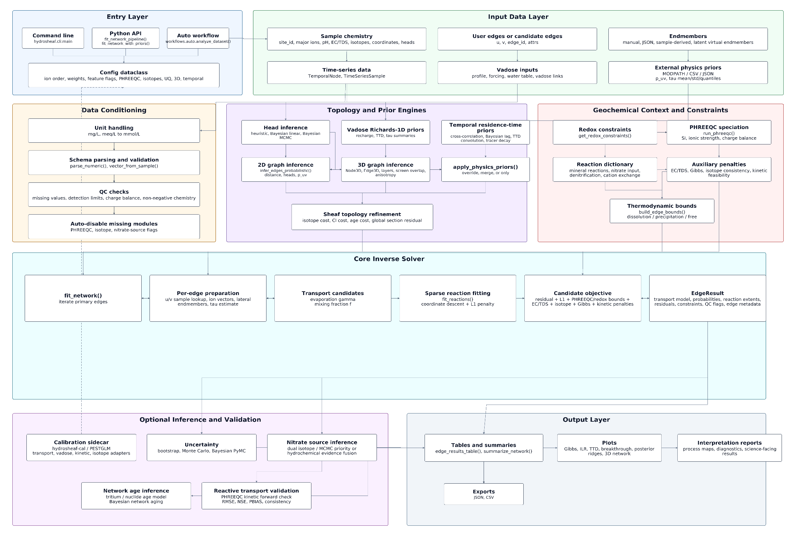
Figure 1. Hydrosheaf architecture for integrated groundwater residence-time, topology and inverse hydrogeochemical analysis.

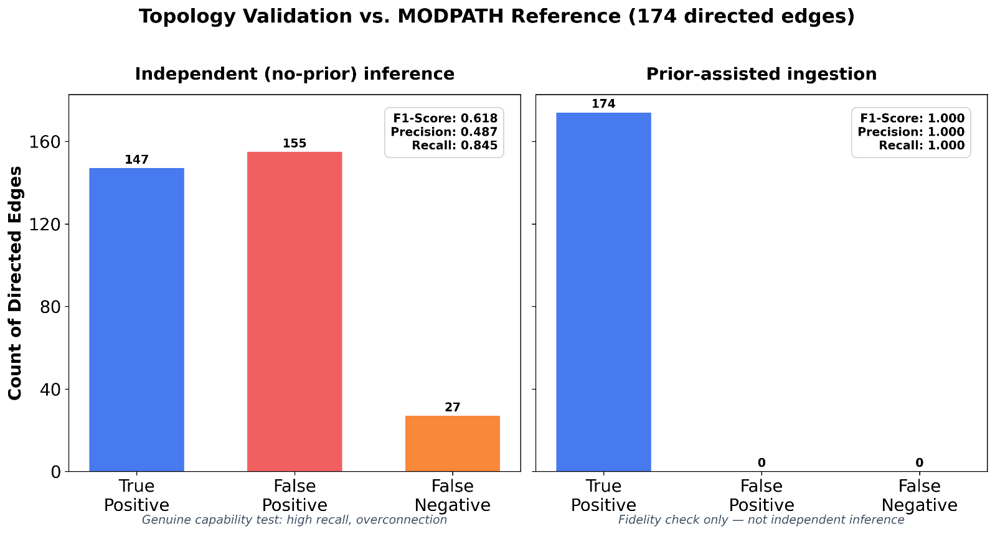
Figure 2. Topology-only comparison of Hydrosheaf-inferred directed connectivity against the MODPATH reference simulation. The prior-assisted mode tests physics-prior ingestion; the no-prior mode tests independent heuristic recovery and is the relevant capability metric.

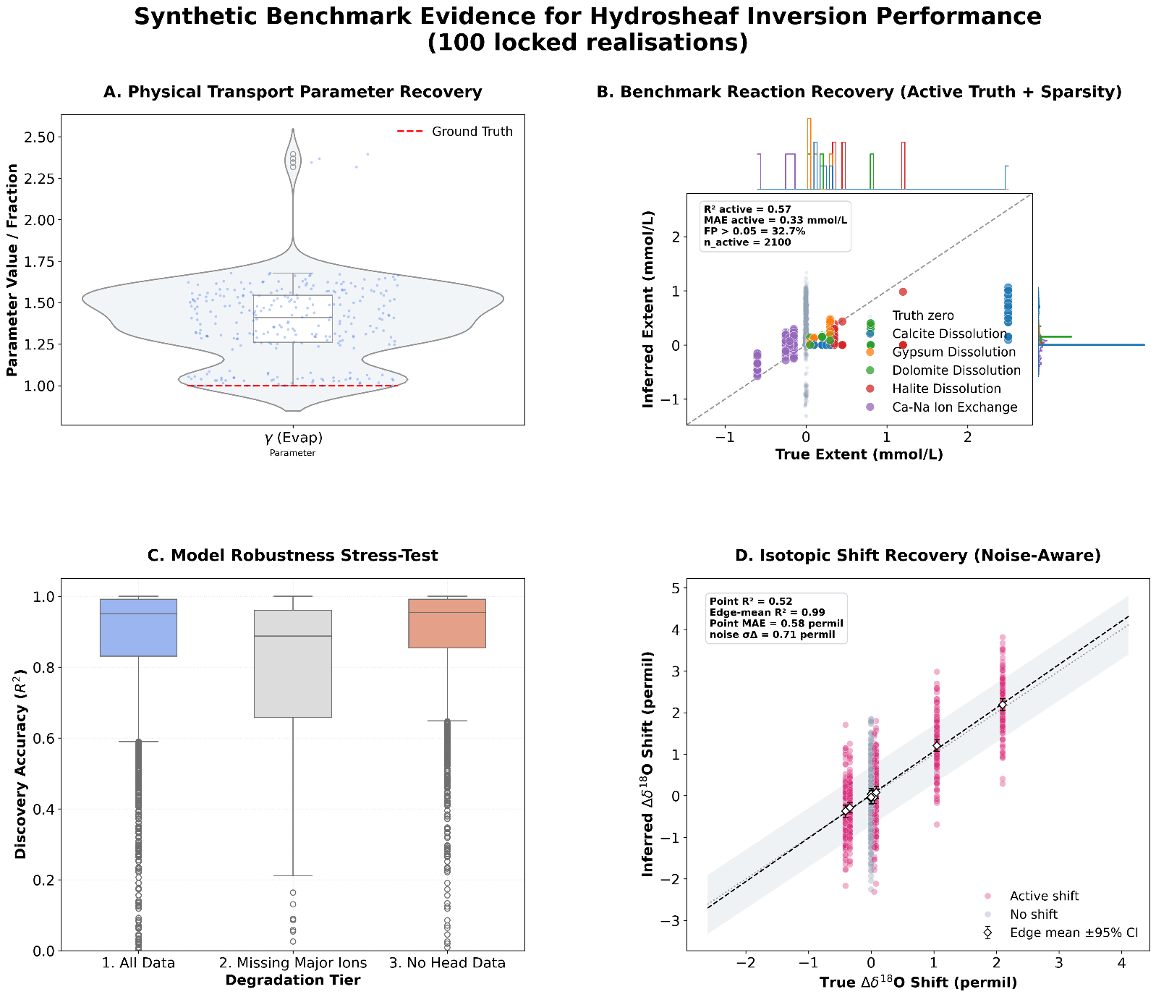
Figure 3. Synthetic benchmark evidence across 100 locked realisations. (A) physical transport-parameter recovery; (B) reaction extents for active truth rows and inactive-term sparsity, with active-row R2 = 0.57, MAE = 0.33 mmol/L and 32.7% of inactive terms exceeding 0.05 mmol/L; (C) chemistry-fit robustness under missing major ions and absent head data; and (D) noise-aware isotope recovery, with point R2 = 0.52, edge-mean R2 = 0.99, point MAE = 0.58 per mil and edge-difference noise sigma = 0.71 per mil. These are benchmark evidence, not proof of unique process recovery.

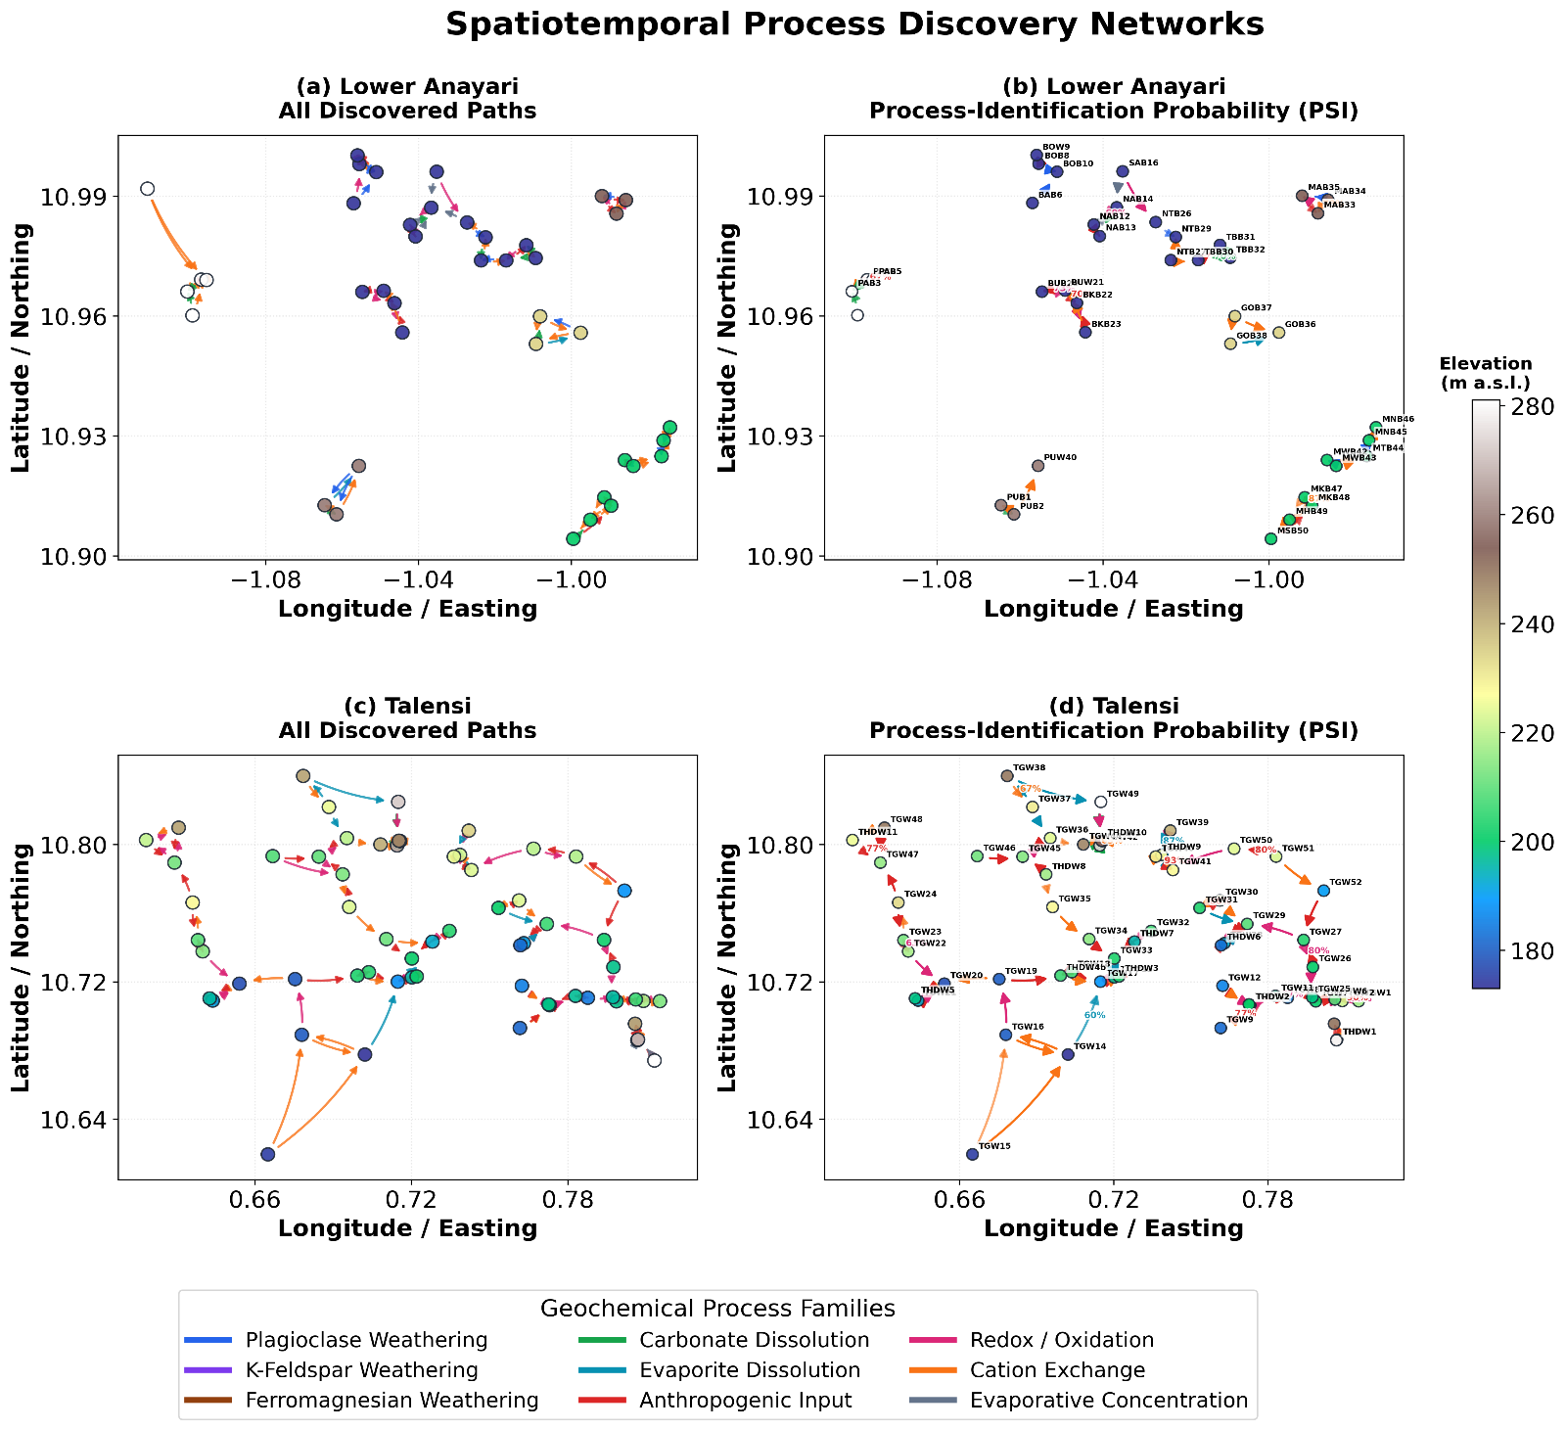
Figure 4. Data-limited process-discovery networks for Lower Anayari and Talensi. The graphs are generated from field coordinates and head proxies; edge colours denote inferred process families and edge annotations show PSI for selected links. The figure is a field-hydrochemistry demonstration without an independent process-truth graph, tracer-age validation or MODPATH field benchmark.
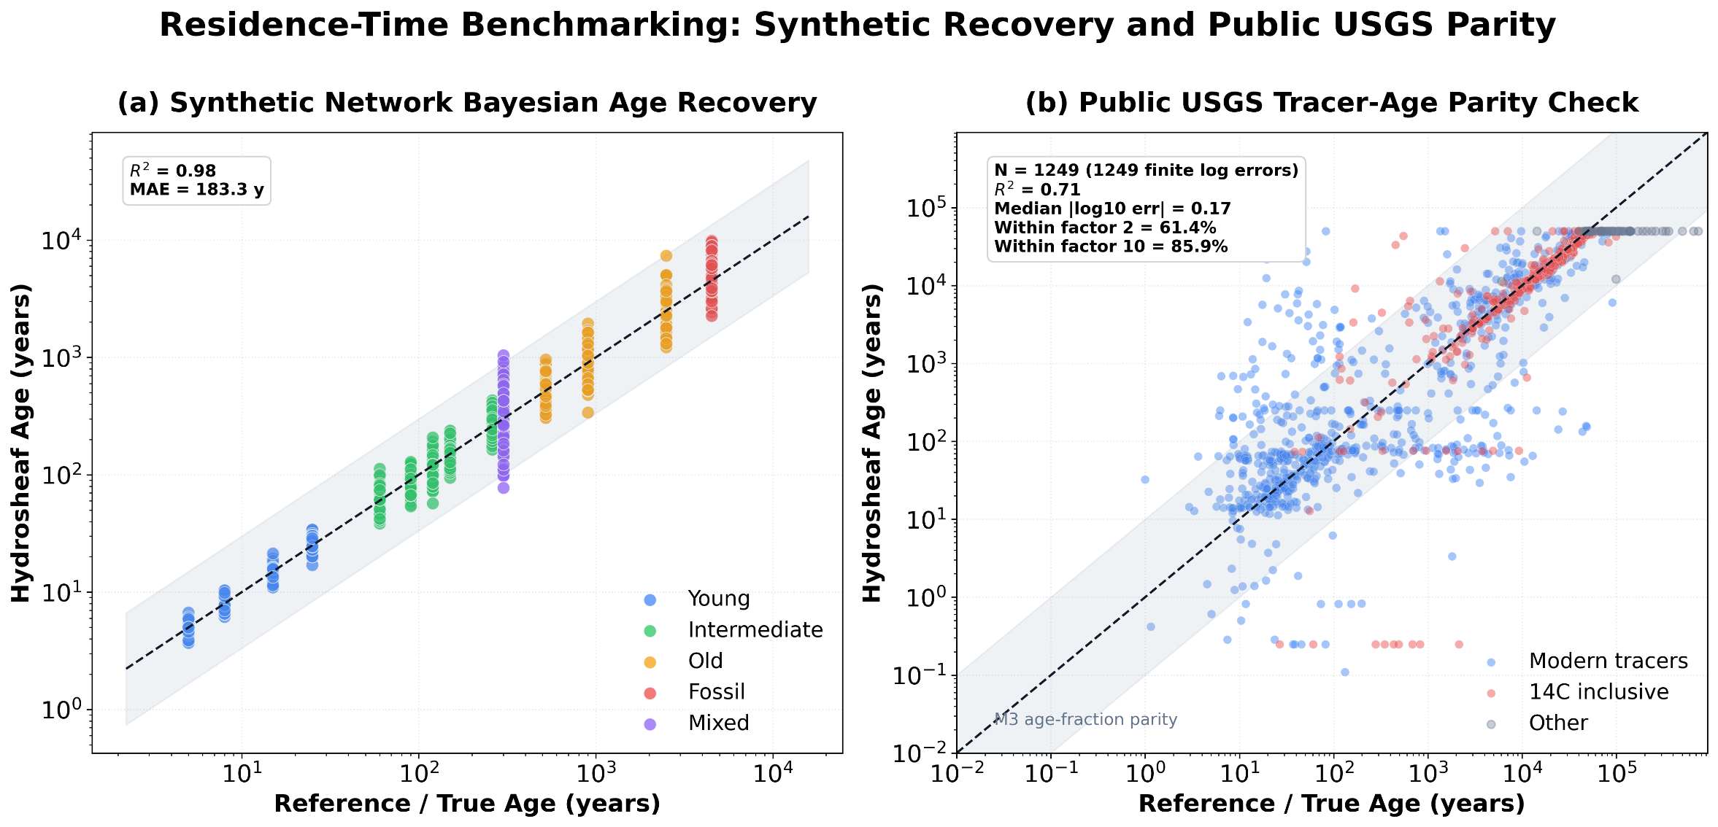
Figure 5. Residence-time benchmarking. (a) Synthetic network Bayesian recovery gives log-space R2 = 0.98 and MAE = 183.3 years. (b) The public USGS comparison is age-fraction-constrained parity to reported model outputs (1,249 finite log errors), with R2 = 0.71, median absolute log10 error = 0.17, 61.4% within a factor of two and 85.9% within a factor of ten. Public reported ages are model-derived targets, not direct true ages or evidence of full TracerLPM equivalence.

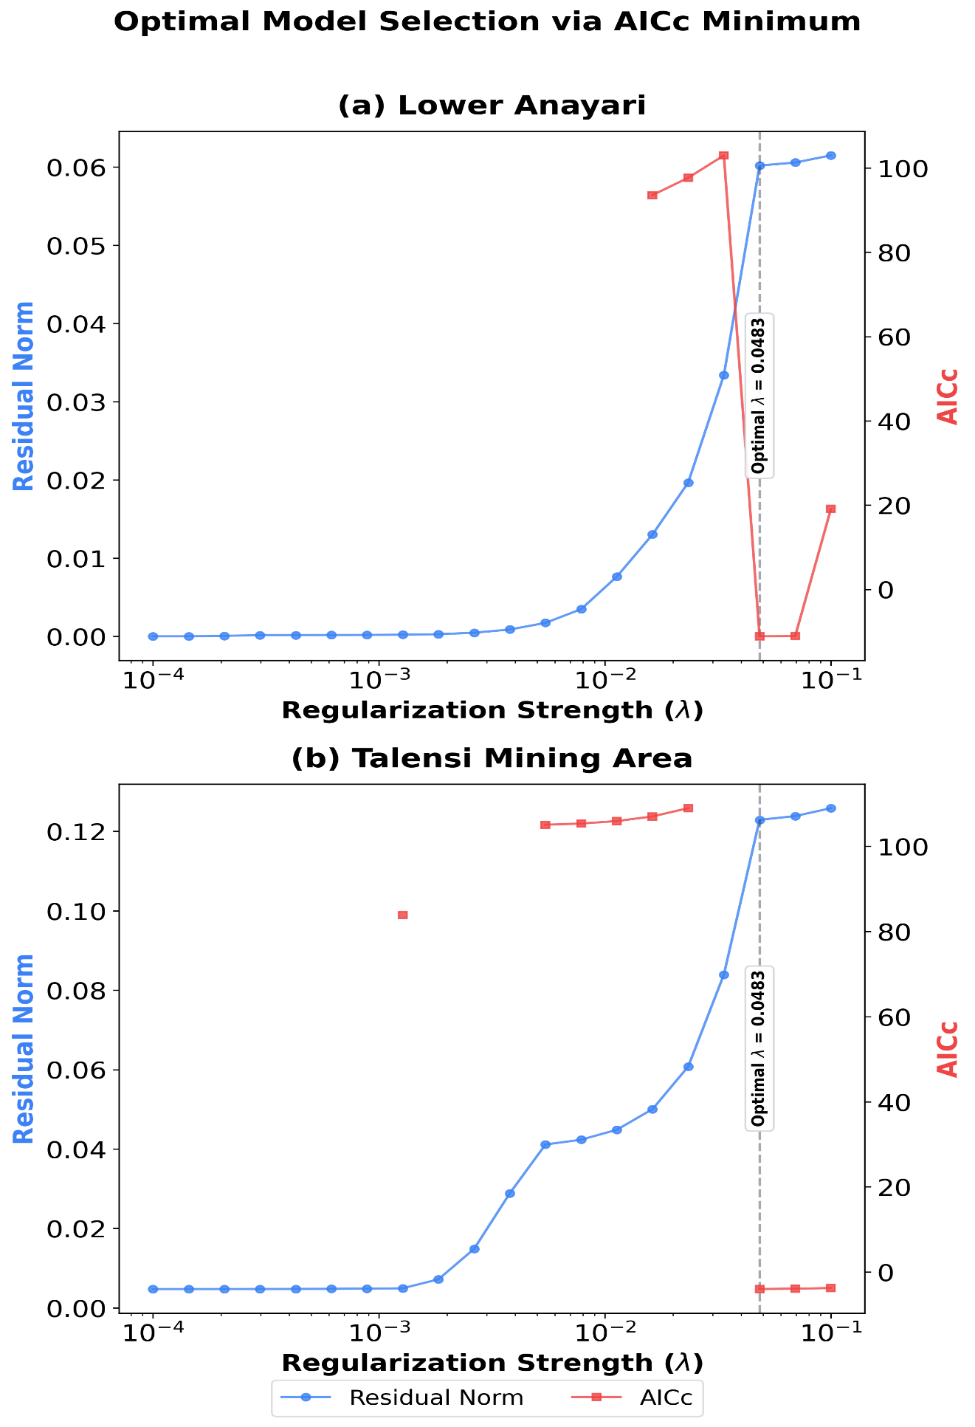
Figure 6. Site-specific AICc regularisation selection for Lower Anayari and Talensi. The minimum occurs at lambda = 0.0483 in both panels. This value is a transparent choice for the analysed datasets, not a universal optimum for other aquifers, ion panels or reaction dictionaries.

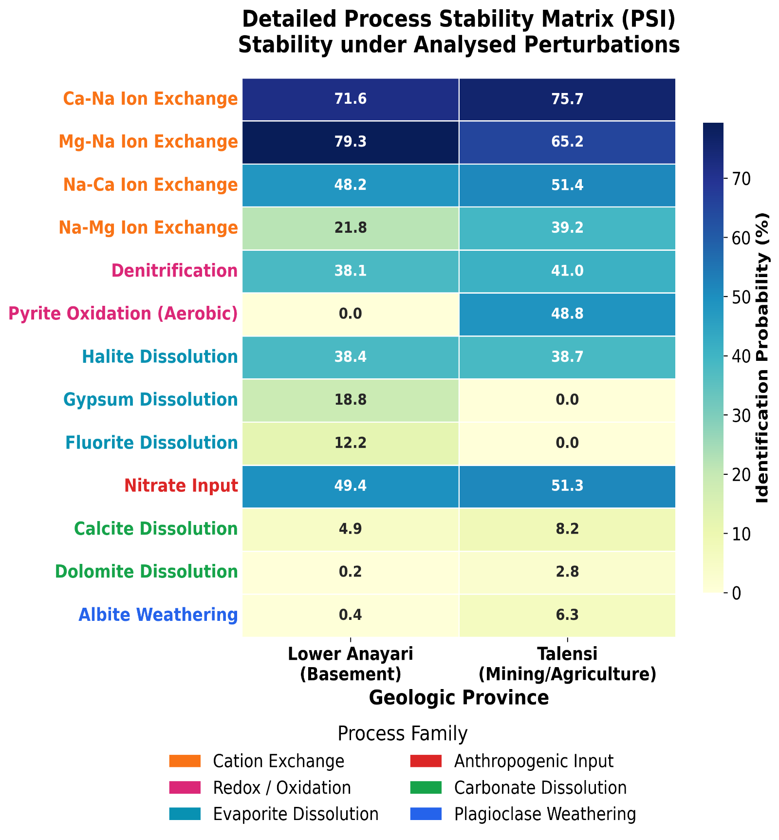
Figure 7. Detailed process-stability matrix (PSI) for Lower Anayari and Talensi. Values express identification probability under the analysed Monte Carlo perturbations. The contrasts between cation exchange, nitrate cycling, gypsum and aerobic pyrite oxidation are stability patterns requiring independent corroboration; the legacy filename should not be interpreted as a guarantee.

