Title: Conditional Value of Graph Priors in Multi-Tracer Groundwater-Age Inference: A Hydrosheaf Benchmark of Public Aquifer Datasets

Authors:
Dickson Abdul-Wahab^{a,*}, Dickson Adomakoª, Gibrilla Abass^{b}, Ebenezer Aquisman Asare^{c}, Samuel Ganyaglo^{a,d}

Affiliations:
ª Department of Nuclear Science and Applications, School of Nuclear and Allied Sciences, University of Ghana, Atomic-Kwabenya, Accra, Ghana
^{b} Department of Water Resources and Aquaculture Management, School of Sustainable Development, University of Environment and Sustainable Development, Somanya, Ghana
^{c} Nuclear Chemistry and Environmental Research Centre, National Nuclear Research Institute (NNRI), Ghana Atomic Energy Commission (GAEC), Box LG 80, Legon-Accra, Ghana
^{d} Water Resources Research Centre, National Nuclear Research Institute, GAEC, Box LG 80, Kwabenya-Accra, Ghana
*Corresponding author: Dickson Abdul-Wahab
Email: dabdul_wahab11@yahoo.com;
ORCID: https://orcid.org/0000-0001-7446-5909

Conditional Value of Graph Priors in Multi-Tracer Groundwater-Age Inference: A Hydrosheaf Benchmark of Public Aquifer Datasets

Abstract
Groundwater-age inference remains non-unique because tracer observations can be explained by alternative transit-time distributions, correction assumptions, tracer subsets, and spatial-connectivity hypotheses. We evaluated the residence-time and graph-prior component of a computational framework (Hydrosheaf) using 1,272 harmonised rows from a public USGS groundwater-age release. Published USGS lumped-parameter-model (LPM) outputs were treated as model-derived reference products, not error-free true ages. An explicit identifiability and reportability guard retained 329 strict reported-configuration fits. On that reportable subset, strict configuration emulation had median absolute log₁₀ reference discrepancy 0.0279, log₁₀ RMSE 0.2769, log₁₀ R² 0.9371, and 87.5% within a factor of two. Adding reported age fractions yielded 289 reportable fits with median discrepancy 0.0216, RMSE 0.1964, R² 0.9698, and 91.7% within a factor of two, but this is a non-independent reported-output-constrained sensitivity because the fractions and reference ages share USGS LPM provenance. In the 329-node graph-age benchmark, weak hydraulic-proxy regularisation changed RMSE by −0.00135 log₁₀ while reducing within-factor-two agreement from 87.5% to 86.9%; therefore no candidate graph met the robust-improvement rule. Wrong-direction and randomised weak controls increased RMSE by 0.1008 and 0.6550 log₁₀, respectively. Leakage-guarded tracer withholding also showed no meaningful candidate-graph gain: ³H RMSE was 20.8181 TU for the single-well baseline and 20.8181–20.8415 TU for candidate graphs; SF₆ candidate graphs increased RMSE by 0.5–3.0%; and the small ¹⁴C change was negligible. CFC graph effects were non-estimable because the 4 CFC-11 and 6 CFC-12 reportable fits formed no eligible graph edges. The framework groundwater age component is therefore supported as a controlled diagnostic and topology-falsification benchmark, not as field validation, a source of true groundwater ages, or evidence of universal graph benefit.

Keywords
Groundwater age; Hydrosheaf; transit-time distribution; TracerLPM; carbon-14;

1. Introduction
Groundwater residence time is a central descriptor of aquifer vulnerability, recharge timing, contaminant persistence, and hydrogeochemical evolution. It indicates whether sampled water is dominated by recent recharge carrying land-surface contamination signals, by older flow-system components buffered from contemporary inputs, or by mixed-age water integrating multiple recharge periods. Residence time therefore links hydrogeological structure with water-quality response because contaminant arrival, dilution, redox evolution, mineral reaction progress, and recovery after source reduction depend on the time distribution of water reaching a well (Cook & Böhlke, 2000; Jurgens et al., 2022b).
Groundwater age is not directly observed. It is inferred from environmental tracers, atmospheric input histories, correction assumptions, and transit-time distribution models. Consequently, the same sample can be explained by different apparent ages, mean ages, or age mixtures when the tracer suite is incomplete, internally discordant, or interpreted with different transit-time structures (Massoudieh et al., 2014; McCallum et al., 2014). This creates age equifinality: multiple residence-time interpretations can be consistent with the same measured concentrations. The present study is framed around that problem. Graph topology is therefore treated as an explicit, falsifiable modelling prior rather than as a confirmed representation of the true groundwater-flow network, and published USGS/TracerLPM ages are used as benchmark comparison targets rather than as error-free observations of true residence time.
Hydrosheaf is introduced here as a broad computational framework rather than as a single-purpose groundwater-age model (Abdul-Wahab et al., 2026). In its general form, Hydrosheaf represents sampling locations as graph nodes and candidate groundwater-evolution pathways as directed edges evaluated with hydraulic, spatial, conservative-tracer, isotope, residence-time, and thermodynamic evidence. The wider framework also supports transport decomposition, sparse inverse reaction fitting, PHREEQC-informed saturation-index gates, uncertainty propagation, and process-stability diagnostics. The present study deliberately evaluates only one specialised component of that framework: the residence-time and graph-prior module used to test whether physically plausible aquifer topology can constrain multi-tracer groundwater-age equifinality. Hence this study focusses on the standalone benchmark of graph age module. Although Hydrosheaf forms part of a broader research programme on graph-constrained hydrogeochemical inference, the evaluation presented here does not require prior knowledge of the companion framework papers. The necessary framework context is provided within this study: Hydrosheaf is treated as a modular computational environment in which residence-time inference, graph-prior testing, tracer-disagreement diagnosis, and hydrogeological topology auditing can be evaluated separately. This study focuses only on the residence-time and graph-prior component, and its claims are limited accordingly.
This distinction is important because the aim is not to demonstrate that Hydrosheaf universally replaces established well-wise lumped-parameter modelling workflows. Instead, the aim is to test whether graph topology can be used as a falsifiable hydrogeological prior in multi-tracer groundwater-age inference. The relevant question is therefore not whether Hydrosheaf always produces lower error than TracerLPM-style modelling, but whether it can identify when topology improves inference, when topology is neutral, and when topology should be rejected because it imposes physically implausible age structure.
Nuclear and atmospheric tracers provide complementary but imperfect age sensitivity. Tritium and tritiogenic helium-3 constrain modern recharge because the ³H bomb-pulse input and subsequent decay create a strong post-1950s signal. The ³H input history used for model forcing was derived from precipitation isotope records in the IAEA/WMO Global Network of Isotopes in Precipitation database accessed through WISER (IAEA/WMO, 2026). SF₆ and CFCs provide young-groundwater atmospheric-equivalent constraints but require careful gas correction and contamination screening. Radiocarbon extends interpretation into older groundwater, but ¹⁴C ages depend on correction models for dissolved inorganic carbon, carbonate reactions, and initial activity, while ⁴He is best treated as an old-water support constraint because accumulation rates are uncertain (Darling et al., 2012; Han & Plummer, 2016; Cartwright et al., 2017). Krypton-85 and argon-39 are noted only as future sampling options because they were not included in the present benchmark metrics.
The evaluated tracer basis is dominated by ³H, ³H/³He, SF₆, CFCs, ¹⁴C, and ⁴He. Table 1 defines ³H and ³H/³He as modern groundwater tracers, SF₆ and CFCs as atmospheric-equivalent young tracers, ¹⁴C as an old-groundwater radiocarbon constraint, and ⁴He as a radiogenic accumulation screening constraint. Figure 1 illustrates why these tracers must be interpreted jointly: ³H contains a bomb-pulse signal, SF₆ rises progressively after industrial release, and CFC-12 rises and then plateaus or declines, producing tracer-specific ambiguity. Gas tracers require careful interpretation because recharge temperature, elevation, excess air, contamination, redox effects, and unsaturated-zone thickness can affect CFC and SF₆ dating (Darling et al., 2012). Radiocarbon extends interpretation into older groundwater, but ¹⁴C ages depend on correction models for dissolved inorganic carbon, carbonate reactions, and initial activity (Han & Plummer, 2016).
Groundwater-age studies commonly rely on well-wise lumped-parameter models (LPMs) because such models are interpretable, computationally efficient, and compatible with sparse tracer datasets. TracerLPM is a recognised USGS workbook for evaluating groundwater-age distributions from environmental tracer data using simplified aquifer geometry, dispersion, and mixing assumptions (Jurgens et al., 2012). More flexible approaches also exist, including Bayesian shape-free age-distribution estimation, 3D residence-time metric mapping, and spatial interpolation of modern-recharge penetration depth (Massoudieh et al., 2014; Starn et al., 2021; Faulkner et al., 2023).
The limitation is that well-wise LPMs generally treat each well independently. They can fit a tracer suite at one location without testing whether the resulting age field is spatially coherent across neighbouring wells, depth intervals, aquifer units, or inferred recharge-to-discharge gradients. Existing spatial and Bayesian studies demonstrate that groundwater age can be mapped or inferred across space, but the specific missing element addressed here is a controlled benchmark that treats graph topology itself as a falsifiable prior and tests physically plausible, randomised, and wrongly directed graph assumptions against well-wise tracer-age baselines.
Spatial connectivity is often available indirectly through well coordinates, screen depth, aquifer labels, hydraulic proxies, or inferred recharge-to-discharge ordering, yet it is rarely formalised in well-wise tracer-age modelling. A graph representation treats wells as nodes and hypothesised hydrogeological relationships as edges. Groundwater age commonly increases with depth or along flow-system position in many regional systems, although pumping, fractures, mixing, and compartmentalisation can violate simple ordering (Jurgens et al., 2022b; Gratzer et al., 2025b). If graph edges are physically plausible, topology may impose weak consistency on age gradients, tracer coherence, or posterior uncertainty. If edges are wrong, the same regularisation can impose artificial smoothness and degrade prediction.
Graph regularisation is widely used to impose consistency over connected data structures, but its usefulness depends on whether the graph encodes meaningful geometry or physical dependence. Manifold regularisation and graph-Laplacian methods use graph structure to impose smoothness or consistency across related observations (Belkin et al., 2006). In groundwater-age interpretation, however, the graph must be hydrogeologically defensible: edge direction should reflect recharge-to-discharge or shallow-to-deep ordering where supported; edge grouping should respect aquifer or study-unit boundaries; and graph strength should remain weak enough that tracer evidence can override topology. For this reason, graph topology is treated in this study as a hypothesis tested against single-well baselines, wrong-direction controls, and randomised controls, not as a verified groundwater-flow path (Oreskes et al., 1994).
The rationale for the benchmark is that tracer equifinality and topology uncertainty must be tested together. Complex transit-time distributions can represent mixed, dispersed, or multi-modal groundwater, but increased flexibility can also overfit tracer noise. Graph regularisation can constrain age fields, but only when the graph is physically meaningful. A controlled benchmark is therefore needed to separate three effects: improvement from better mixture representation, improvement from physically meaningful topology, and degradation caused by wrong or over-strong priors.
The benchmark was designed around public groundwater-age datasets, with explicit comparison of single-well tracer-only inference, multi-tracer well-wise inference, graph-regularised inference, hydrochemical consistency checks, and tracer-removal experiments. The core test is therefore not whether graph information is generally beneficial, but when graph regularisation improves age inference, when it degrades inference, and which tracer combinations remain robust.
This study benchmarks the residence-time and graph-prior component of Hydrosheaf as a graph-regularised, multi-tracer groundwater-age inference workflow. The primary reference-age test is lower log₁₀ RMSE and median absolute log₁₀ error relative to published benchmark ages on common support, while the stronger predictive test is tracer-withholding RMSE for withheld ³H, SF₆, ¹⁴C, CFC-11, and CFC-12. Crucially, because Hydrosheaf model selection underperforms TracerLPM parity on broad samples (Section 3.2), the framework is not evaluated as a predictive replacement for TracerLPM but as a falsification and diagnostic platform. The scientific question is not whether Hydrosheaf achieves lower reference-age error overall, but whether physically plausible topology outperforms randomised and wrongly directed controls under selected tracer–topology combinations, and whether the framework identifies when age inference should be trusted or rejected. Secondary diagnostics include within-factor-2 agreement, age-class performance, graph-violation counts, and negative-control behaviour. The first hypothesis is that topological constraints can reduce tracer ambiguity only where tracer evidence and graph structure are coherent. The second hypothesis is that physically meaningful graph topology should outperform randomised or wrongly directed topology if the graph prior contains hydrogeological information rather than arbitrary smoothing.
The objectives are to compare reported-configuration LPM emulation, reported-output-constrained age-fraction sensitivity, Hydrosheaf-selected transit-time distributions, tracer and correction ablations, and graph-prior controls; quantify reference-workflow agreement only on identifiable reportable fits; test concentration prediction by target-tracer withholding; and determine whether graph topology provides defensible information beyond well-wise inference. A graph result is accepted only when RMSE improves, within-factor agreement does not deteriorate, and negative controls do not show a comparable effect.

2. Materials and Methods

2.1 Study design and benchmarking rationale
A controlled benchmarking design was used to evaluate the Hydrosheaf residence-time module as a conditional graph-prior framework for multi-tracer groundwater-age inference. The methodological aim was not to assume that graph regularisation improves age prediction, but to test when physically plausible topology preserves or improves inference and when it degrades it. Graph topology was specified before results interpretation as a testable regularising prior, not as a verified groundwater-flow path. Published USGS/TracerLPM ages were used as benchmark targets for comparative evaluation rather than as absolute ground-truth ages. Age-fraction constraints were likewise treated as reference-workflow emulation tests rather than independent validation, because the reported Anthropocene, Holocene, and Pleistocene fractions are derived from the same USGS LPM products as the benchmark reference ages; non-circular evaluation relies on tracer-withholding cross-validation (Section 2.10).
The Materials and Methods workflow was structured around public groundwater-age datasets, tracer harmonisation, transit-time distribution modelling, graph construction, benchmark scenarios, statistical evaluation, and reproducibility controls. Benchmarking was therefore performed as a sequence of controlled scenario comparisons rather than as a single Hydrosheaf-versus-baseline test. This design was necessary because groundwater residence time is inferred through tracer measurements, correction assumptions, and transit-time model structure, and different combinations can reproduce similar observations (Cook & Böhlke, 2000; Jurgens et al., 2012). Cook and Böhlke (2000) described the use of environmental tracers for determining groundwater-flow and solute-transport timescales, while TracerLPM formalised groundwater-age distribution fitting through simplified lumped-parameter models.

2.2 Public groundwater-age datasets
Three public groundwater-age data sources were used as benchmark inputs, subject to availability of tracer measurements, site metadata, reported or modelled reference ages, and hydrogeological attributes. The primary source was the USGS public-supply aquifer data release for the continental United States, 2004-2017, Version 1.1. That release contains environmental tracer data and LPM results for samples from 1,279 sites in 21 Principal Aquifers, including ³H, tritiogenic ³He, SF₆, ¹⁴C, radiogenic ⁴He, dissolved-gas model products, LPM outputs, and site metadata (Jurgens et al., 2022a). Summary details of the dataset sources, extracted variables, filtering rules, joins, and row-count trace are provided in Supplementary Table S1.
Two further public releases were assessed for restricted use. The Western Principal Aquifers release overlaps the national release and lacks the coordinate coverage required for the graph benchmark, so it was not pooled into the active matrix. The Mississippi River Valley alluvial aquifer release provides useful site and tracer context, but the reported LPM table required for like-for-like model-derived reference ages was unavailable in the archived inputs. It was therefore excluded from parity, graph-age, and replication metrics. Neither release is presented as an independent replication of the reported-configuration benchmark.
Reported USGS ages, age distributions, and age fractions were used as benchmark comparison targets, not as direct observations of true groundwater age. This distinction was retained throughout the analysis because apparent age, mean residence time, age fractions, and full transit-time distributions are model-dependent quantities. Scenarios that use reported age fractions are therefore interpreted primarily as reference-workflow emulation and mixture-structure sensitivity tests, whereas tracer-withholding experiments provide a more independent concentration-prediction test.

2.3 Tracer variables and hydrogeological attributes
The tracer suite was selected to span modern, intermediate, old, and very old groundwater domains. Tritium, ³H/³He, SF₆, and CFCs were treated as young-water or atmospheric-transient tracers, whereas ¹⁴C and ⁴He were treated as older-water constraints or diagnostic indicators. Table 1 defines ³H with a 12.32 yr half-life and a 0–60 yr target range, ³H/³He with a 0–50 yr target range, ¹⁴C with a 5,730 yr half-life and a 1,000–30,000 yr target range, ⁴He as an accumulation tracer across approximately 1,000–100,000 yr, SF₆ as a 0–50 yr atmospheric-equivalent gas tracer, and CFC-11/12/113 as 0–60 yr atmospheric-equivalent tracers. For ³H specifically, recharge-input histories were sourced from precipitation isotope records in the IAEA/WMO Global Network of Isotopes in Precipitation (GNIP) database available through WISER (IAEA/WMO, 2026).
For each sample, tracer observations were linked to available sampling year, well construction information, aquifer or study-unit identifiers, depth-related variables, dissolved-gas correction fields, and reported LPM or reference-age products where available. The tracer set was deliberately multi-domain because a single tracer class cannot defensibly resolve the full residence-time spectrum. The USGS national public-supply study likewise used multiple tracers with overlapping and complementary dating ranges; 3H, CFCs, SF6, and tritiogenic 3He were associated with Anthropocene recharge, while 14C and radiogenic 4He were associated with Holocene and Pleistocene water fractions (Jurgens et al., 2022b).

2.4 Data harmonisation and quality control
Data harmonisation was performed before modelling. Sample identifiers, sampling dates, study-unit or aquifer labels, coordinates, depth variables, tracer units, uncertainty fields, corrected tracer products, reported LPM model names, reported tracer sets, unsaturated-zone travel-time fields, total-age fields, and age-fraction fields were standardised into a common analysis table. The national USGS release was joined on SampleID across Table_1_Sites.txt, Table_2_Ages.txt, Table_3_Tracers.txt, Table_5_DissGas_ModOut.txt, and Table_7_Carbon14.txt. Duplicate SampleID rows were removed before joining; carbon-14 duplicates were resolved by preferring corrected values and PHREEQC-based correction rows where available. Non-finite values were excluded from metric calculations, while missing tracer observations were retained as missing rather than imputed.
Age classes were defined for diagnostic stratification as modern (≤50 yr), intermediate (50–1,000 yr), old (1,000–30,000 yr), and very old (>30,000 yr). These are classes of model-derived reference output, not observed groundwater-age truth. The final audit found no supported paired raw and corrected atmospheric-equivalent gas values. Consequently, no empirical gas-correction effect is estimated, Supplementary Table S4 and Supplementary Figure S1 are withdrawn, and gas correction remains a documented modelling requirement rather than a validated result of this dataset.
Carbon-14 interpretation was treated as correction-dependent because estimation of initial 14C activity and geochemical adjustment can substantially influence radiocarbon age. Reviews of 14C groundwater dating show that model choice, carbonate reactions, isotopic exchange, and geochemical mass balance assumptions can lead to wide variation in estimated 14C ages (Han & Plummer, 2016). Radiogenic 4He was treated as an old-water support constraint rather than as a stand-alone clock, because age uncertainty is strongly affected by uncertainty in the solid-to-liquid helium transfer rate; the old-water agreement, conflict, tension, single-tracer, and no-constraint categories are tabulated in Supplementary Table S3.

2.5 Transit-time distribution models
Groundwater age was represented through transit-time distributions (TTDs), denoted $g\left(τ ∣ θ\right)$, where $τ$ is residence time and $θ$ is the set of model parameters. For tracer $j$, the predicted concentration or activity was evaluated conceptually as:
$$\hat{C}j\left(t_{s},θ\right)=\int{0^{τ_{max}}I_{j}\left(t_{s}-τ\right)},\exp\left(-λ_{j}τ\right),g\left(τ ∣ θ\right),dτ,$$ | (1)
where is sampling year, is the atmospheric or initial input function, and for radioactive tracers. For stable atmospheric tracers, . For daughter-product ingrowth, as in 3H/3He, the decay term was replaced by the corresponding ingrowth form. This formulation follows the implementation in which tracer histories, LPM transit-time distributions, decay, daughter ingrowth, 14C prediction, 39Ar prediction, and atmospheric gas predictions are evaluated from the fitted TTD. In the present benchmark, the 3H input function was represented using GNIP/WISER precipitation isotope data from the station nearest each site (IAEA/WMO, 2026). Most North American WISER stations stop reporting between 1965 and 1999, whereas the benchmark samples were collected between 2004 and 2020. Linear interpolation alone would therefore assign every recharge year after a station's final observation that station's last recorded value, which for early-terminating records is a bomb-era concentration. Each station record was consequently continued past its final observation along the regional post-bomb decline curve, rescaled to join the record continuously at the splice year and converging to modern background. All reported results use this continued forcing. The full mathematical definitions of the residence-time convolution, TTD normalisation, binary mixture representation, age-fraction penalty, graph-prior penalty, and log-age metrics are provided in Supplementary Methods Sections S1–S5.
The supported LPM families included piston-flow (PFM), exponential (EM), dispersion (DM), gamma (GA), exponential-piston (EPM), partial-exponential (PEM), exponential-mixing (EMM), and binary mixture models (BMM-DM-DM and BMM-PEM-PEM). Candidate parameter grids used mean ages from 0.01 yr to the model-specific maximum age, dispersion values from 1×10⁻⁴ to 2.0, gamma shape values from 0.1 to 10, piston fractions from 0.0 to 0.95, capture fractions from 0.05 to 1.0, and binary young-fraction values constrained to 0.001-0.999 after logit transformation. The default benchmark used 90 age-grid steps, deterministic grid search, optional local refinement where enabled, and AIC/AICc/BIC ranking. These model families are consistent with standard groundwater-age interpretation in TracerLPM, which includes piston-flow, exponential mixing, exponential-piston, partial-exponential, dispersion, and binary mixing models (Jurgens et al., 2012).

2.6 Multi-tracer objective function
For each sample and scenario, supported tracer observations were fitted jointly. The basic residual objective was expressed as:
$$J_{\text{tr}}\left(θ\right)=\sum_{j=1}^{m}{w_{j}{\left[\frac{C_{j,\text{obs}}-\hat{C_{j}}\left(θ\right)}{σ_{j}}\right]}^{2}},$$ | (2)
where $C_{j,\text{obs}}$ is the observed tracer value, $\hat{C_{j}}\left(θ\right)$ is the modelled tracer value, $σ_{j}$ is the tracer uncertainty, and $w_{j}$ is the scenario-specific tracer weight. This formulation allowed multiple tracer families to contribute to a single residence-time estimate while preserving tracer-specific uncertainty and screening logic.
For ¹⁴C, the activity prediction was treated as:
$$\hat{A_{14}}\left(θ\right)=A_{0}\int_{0}^{τmax}{\exp\left(-λ_{14}τ\right)g\left(τ ∣ θ\right)dτ},$$ | (3)
where $A_{0}$ represents the initial or corrected ¹⁴C activity. For ⁴He, the diagnostic accumulation model was represented as:
$$\hat{He_{4}}\left(θ\right)=He_{4,\text{bg}}+r_{He}\overline{τ}, \overline{τ}=\int_{0}^{τ_{max}}{τg\left(τ ∣ θ\right)dτ},$$ | (4)
where $He_{4,\text{bg}}$ is background helium, $r_{He}$ is the accumulation-rate term, and $\overline{τ}$ is mean residence time. The implementation predicts ⁴He from background plus accumulation-rate-scaled mean age, while ¹⁴C is predicted by integrating radioactive decay across the TTD.

2.7 Hydrosheaf graph-prior construction
In the age-focused Hydrosheaf benchmark, graph regularisation was implemented by representing wells as nodes and hypothesised hydrogeological connections as directed edges. Each edge encoded an assumed upstream-to-downstream or shallow-to-deep ordering, not a verified flow path. The graph families tested in the benchmark were coordinate-global, study-unit coordinate, depth-constrained, hydraulic-proxy-constrained, parameter-smoothing, wrong-direction negative-control, and randomised negative-control graphs.
The graph prior was evaluated at four pre-specified strengths: none = 0.00, weak = 0.25, medium = 0.55, and strong = 0.85. For age-field regularisation, the update rule was applied for eight iterations: if a directed edge $u → v$ violated the expected age ordering, the downstream age was updated as:
$$age_{v,new}=\left(1-α\right)age_{v}+α\left(age_{u}+δ_{t}\right),$$ | (5)
where $α$ is the prior strength and $δ_{t}$ was set to zero in the reported graph benchmark. Thus, the graph prior penalised younger downstream ages but did not force equality across connected wells.
Graph-construction rules were deterministic except for the randomised negative control. The coordinate-global graph used one nearest spatial neighbour per node with no uphill movement under the elevation proxy (elevation = -depth), so a candidate was retained only where the downstream elevation proxy was strictly lower than the upstream value. The study-unit coordinate graph repeated the same nearest-neighbour rule within StudyUnit groups with at least five samples. The depth-constrained graph retained study-unit edges where downstream depth minus upstream depth was between 5 and 200 m. The hydraulic-proxy graph retained the depth-constrained subset with edge distance below 25 km. The parameter-smoothing graph used the hydraulic-proxy edge set but weighted edges by similarity of AICc-derived LPM model weights. The wrong-direction control reversed all hydraulic-proxy edges. The randomised control drew within-study-unit node pairs using seed 42 and matched the number of study-unit coordinate edges. Edge-distance and vertical-depth diagnostics for these graph families are provided in Supplementary Figure S2. This algorithm ensured that negative controls had comparable graph sizes while lacking the intended hydrogeological ordering.$elevation = -depth≤25$
Graph regularisation was therefore defined as a testable prior on residence-time coherence, not as an assumed improvement mechanism. Graph edges were built from metadata available before validation, while measured withheld-tracer concentrations were not used to construct the graph. This distinction is central because graph-Laplacian and manifold-regularisation methods can enforce smoothness across connected nodes, but smoothness is only useful when the graph encodes meaningful structure (Belkin et al., 2006).

2.8 Benchmark scenario matrix
The scenario matrix was specified to isolate the influence of tracer corrections, tracer subsets, old-water priors, age-fraction constraints, and graph priors. Scenarios were paired so that each eligible benchmark row could be compared against itself under controlled changes in correction mode, tracer set, LPM strategy, or prior structure. Outcome-based statements were excluded from the scenario definition; performance rankings were evaluated only after the a priori matrix had been run.
The active scenario matrix included reported-model parity, raw-gas and raw-¹⁴C ablations, screened young-gas correction, no-⁴He ablation, young-only and old-only tracer subsets, ¹⁴C ensemble handling, ⁴He uncertainty treatment, Hydrosheaf-selected TTDs, strict reported-configuration emulation, and reported-output-constrained age-fraction sensitivity. The hierarchical old-water prior was withdrawn because its pooled same-release priors were not independent and its archived diagnostic result was catastrophic (full-output RMSE 1.310 log₁₀ and R² 0.004). It is retained only for provenance and is not used in active tables, figures, rankings, or conclusions.
The active matrix used all 1,272 national-release rows and applied a reference-free reportability guard before any reference-age metric. Strict reported-configuration emulation produced 329 reportable fits, reported-output-constrained fraction sensitivity 289, Hydrosheaf model selection 309, screened young-gas correction 66, and reported-model parity 66. Direct mode comparisons used common support (N = 40); full-available rows are descriptive because supports differ.

2.9 Graph-prior diagnostics and negative controls
Graph-prior behaviour was evaluated by comparing each graph-regularised result with a single-sample baseline on the same node support. Candidate graphs were compared with two negative controls: wrong-direction graphs and randomised graphs. A graph-regularised result was interpreted as meaningfully improved only where RMSE was lower than the single-node baseline, within-factor agreement did not deteriorate, and randomised negative-control graphs did not show comparable improvement.
Directed age coherence was audited by checking whether downstream nodes were younger than upstream nodes beyond tolerance limits. The implementation interpreted a directed edge as upstream-to-downstream and expected the downstream node to be at least as old as the upstream node unless local recharge, mixing, contamination, pumping, or graph-direction uncertainty explained the reversal. Because some graph RMSE changes were numerically small, changes below 0.01 log₁₀ units were treated as negligible unless supported by tracer-withholding evidence and negative-control separation.

2.10 Performance metrics and statistical evaluation
Age prediction was evaluated on logarithmic age scale because groundwater ages span several orders of magnitude. For (n) valid samples, residuals were defined as:
$$e_{i}=\log_{10}\left(\hat{a}i\right)-\log{10}\left(a_{i}\right),$$ | (6)
where ($\hat{a_{i}}$) is the estimated age and ($a_{i}$) is the benchmark reference age. Median absolute log₁₀ error was computed as:
$$\text{MdA}{\text{E}}_{\text{log}}=\text{median}\left(\left|e_{i}\right|\right),$$ | (7)
and log₁₀ RMSE was computed as:
$$\text{RMSE}log=\sqrt{\frac{1}{n}\sum{i=1^{n}e_{i}^{2}}}.$$ | (8)
Practical accuracy was evaluated as within-factor agreement:
Reference-target uncertainty was handled interpretively rather than by treating published ages as error-free observations. The principal log-age metrics quantify consistency with the published reference workflow; they do not measure error relative to independently known groundwater ages. Age-fraction constraints are especially non-independent where the benchmark age and benchmark fractions come from the same USGS LPM product. Therefore, age-fraction gains are described as improved reference-workflow emulation and mixture-structure consistency. Independent predictive support is assessed separately by tracer-withholding cross-validation, and common-support comparisons are reported before full-available rankings where sample supports differ.
$$P_{f}=\frac{1}{n}\sum_{i=1}^{n}{1\left(\left|e_{i}\right|≤\log_{10}{f}\right)},$$ | (9)
with f = 2 and f = 10. Log-scale R2, age-class performance, paired ablation effects, tracer-withholding RMSE, and age-gradient violation counts were also reported. The pre-specified evaluation set included median absolute log₁₀ error, log₁₀ RMSE, log₁₀ R2, factor-of-2 and factor-of-10 accuracy, age-class error, tracer-withholding RMSE, paired ablation effects, and age-gradient violations.$R^{2}$
Tracer-withholding cross-validation tested prediction rather than agreement with model-derived ages. For every eligible row, the target was removed before model selection; the single-node fit and every graph-node age were then refitted without that target. Graph regularisation therefore received no full-fit neighbour ages containing the withheld tracer. Predictions were scored in native units only after the reference-free reportability guard. The withheld concentration was not used for fitting, graph construction, or hyperparameter tuning.

2.11 Reproducibility and software implementation
The workflow was implemented in the Hydrosheaf code base as a reproducible Python-based benchmark pipeline. The implementation used modular routines for nuclear-tracer handling, lumped-parameter model fitting, dissolved-gas correction, tracer input histories, tracer-disagreement diagnostics, graph age-coherence auditing, and network ageing.
Computational reproducibility was controlled through deterministic row selection, graph randomisation seed 42, a 90-step age grid, explicit scenario identifiers, and machine-readable manifests. The locked manifest records input and output SHA-256 hashes, parameters, reportability counts, graph-edge counts, software versions, and generated table and figure assets. Archived diagnostic scenarios are separated from active reportable outputs.

3. Results

3.1 Dataset coverage and tracer availability
The active benchmark used 1,272 harmonised rows from the national public-supply release. Reference-agreement results are restricted to identifiable reportable fits: N = 329 for strict reported-configuration emulation, N = 289 for the fraction sensitivity, and N = 309 for Hydrosheaf model selection. Tables 2–6 and Figures 2–7 use the same locked supports and distinguish reference discrepancy from target-withheld concentration prediction.
Tracer availability was uneven across age domains. Table 1 defines ³H, ³H/³He, SF₆, CFCs, ¹⁴C, and ⁴He as the benchmark tracer suite, with young-water, old-water, and very-old-water roles assigned according to tracer process scale. The benchmark did not include row-level 39Ar or 85Kr metrics; those tracers are therefore discussed only as potential future additions to fill intermediate or young-age windows.

3.2 Baseline age-model performance
On the N = 40 common support, strict reported-configuration emulation had median absolute log₁₀ reference discrepancy 0.0752, RMSE 0.3040, and 75.0% within a factor of two; the reported-output-constrained fraction sensitivity had 0.0653, 0.2854, and 75.0%, respectively. These differences describe reproduction of the published LPM workflow, not independent groundwater-age validation.
On their full reportable supports, strict reported-configuration emulation (N = 329) had median absolute log₁₀ reference discrepancy 0.0279, RMSE 0.2769, R² 0.9371, and 87.5% within a factor of two. The fraction sensitivity (N = 289) had 0.0216, 0.1964, 0.9698, and 91.7%, respectively. Hydrosheaf model selection (N = 309) had median discrepancy 0.1304, RMSE 0.6098, R² 0.7639, and 67.3% within a factor of two. Unequal supports and shared provenance preclude field-accuracy or superiority claims.

3.3 Graph topology and inferred hydrogeological connectivity
The graph-age benchmark was evaluated only on the 329 strict reportable nodes. A lower RMSE was insufficient if within-factor-two agreement deteriorated. Supplementary Figure S2 reports edge geometry; Figure 4 and Table 4 report the locked graph effects.
Weak hydraulic-proxy regularisation produced the smallest candidate RMSE change (−0.00135 log₁₀), but within-factor-two agreement fell from 0.8754 to 0.8693. It therefore failed the robust-improvement rule. Weak wrong-direction and randomised controls increased RMSE by 0.1008 and 0.6550 log₁₀, respectively. No MRVA replication metric is reported because comparable reported LPM outputs were unavailable.
Wrong-direction and randomised controls demonstrate sensitivity to imposed topology, but their degradation is not positive evidence that a candidate graph is correct. Candidate graphs were neutral or harmful under the joint decision rule, while implausible controls were more harmful.

3.4 When graph regularisation improved or degraded age inference
Leakage-guarded withholding retained 121 reportable ³H fits from 794 eligible rows and 75 reportable SF₆ fits from 262 eligible rows. For ³H, RMSE was 20.818104 TU at baseline, 20.818055 for the hydraulic graph, 20.841494 for the depth graph, and 21.566597 for the randomised control. For SF₆, RMSE was 2.843988 pptv at baseline and increased to 2.857993, 2.928528, and 2.928427 pptv. No young-tracer graph gain is supported.
For ¹⁴C, 169 reportable fits remained from 1,103 eligible rows. RMSE was 26.830072 pmC at baseline, 26.829250 under the hydraulic graph, 26.902373 under the depth graph, and 27.819135 under the randomised control. The hydraulic difference (−0.0031%) is numerically negligible.
Across reportable target-withheld tests, candidate graph effects were negligible or adverse. CFC-11 and CFC-12 retained only 4 and 6 reportable fits, respectively, with zero eligible graph edges; identical scenario RMSE values are a non-estimable graph comparison, not evidence of equivalence.

3.5 Tracer-specific diagnostic results
On the strict reportable subset, median absolute log₁₀ reference discrepancy was 0.0890 for modern (N = 76), 0.0093 for intermediate (N = 85), 0.0233 for old (N = 158), and 0.0330 for very old water (N = 10). These strata describe agreement with model-derived reference outputs and have highly unequal support; they do not demonstrate age-class field accuracy.
Young-tracer discordance is retained as an exploratory diagnostic of disagreement among available young-water proxies. It is not a causal explanation of reference discrepancy, and SF₆/CFC interpretation remains conditional on contamination, excess-air, recharge-temperature, atmospheric-history, and unsaturated-zone assumptions.
Old-water indicators were heterogeneous: 176 agreement, 3 conflict, 8 tension, 633 single-tracer, and 452 no-constraint cases. These are diagnostic classifications from available ¹⁴C and ⁴He products, not independent age validation or a basis for the withdrawn hierarchical prior.

3.6 Data-limited emulation experiments
Ablation effects were support-limited. On 65 paired reportable rows, removing ⁴He produced no change in median or mean log₁₀ discrepancy and no factor-of-two gains or losses. Several old-water scenarios likewise had near-zero paired effects on small supports. These results do not establish that a tracer is unimportant.
A direct SF₆-removal experiment was not included. The raw-gas scenario produced no reportable metrics, and the paired raw-versus-corrected atmospheric-equivalent audit had zero supported pairs. The gas-correction table and figure are withdrawn. Withheld SF₆ shows no graph gain, while CFC graph effects are non-estimable because no reportable CFC nodes are connected.
Raw-¹⁴C and old-water ensemble perturbations had small, support-limited paired effects, and graph regularisation did not meaningfully improve withheld ¹⁴C. The young-only scenario retained 65 metric rows with RMSE 0.6872 and 53.8% within a factor of two, whereas the old-only scenario produced no reportable fits. This shows limited identifiability, not a universal tracer-suite rule.

3.7 Summary of key results
Five results define the defensible claim. First, only 329 of 1,272 strict fits passed the reference-free reportability guard. Second, strict and age-fraction modes reproduced model-derived USGS outputs, but the fraction result is non-independent. Third, no candidate graph robustly improved the 329-node reference benchmark. Fourth, leakage-guarded ³H, SF₆, and ¹⁴C withholding showed no meaningful graph gain, and CFC graph comparisons were non-estimable. Fifth, the hierarchical old-water prior and unsupported gas-correction comparison were withdrawn. M3 is a controlled capability and falsification benchmark, not field validation.

4. Discussion

4.1 What network enhancement adds beyond conventional LPMs
Hydrosheaf adds explicit topology testing to conventional groundwater-age inference. Conventional LPMs remain valuable because they offer interpretable, data-efficient representations of tracer transport and age distributions. TracerLPM formalises this approach by using simplified flow and mixing models to evaluate groundwater-age distributions from environmental tracer data (Jurgens et al., 2012). However, well-wise LPMs generally do not test whether inferred ages are spatially coherent across a physically plausible aquifer network. Hydrosheaf addresses that limitation by treating node ages as a field constrained by tracer likelihoods and graph-prior hypotheses.
The network component is most defensible as a falsification and sensitivity tool. Candidate graphs did not meet the joint improvement rule, while wrong-direction and randomised controls caused larger degradation. Control failure can reject an imposed topology; it cannot confirm that a surviving candidate graph is a true flow path.
Three misreadings must be avoided. Agreement with published LPM outputs is not accuracy against true groundwater age; reported fractions and reference ages share provenance; and target-withheld tests are heavily filtered by reportability and sparse graph connectivity. The corrected tests support no meaningful graph gain and do not validate the complete Hydrosheaf framework.
This interpretation is consistent with broader modelling principles. Numerical models of natural systems cannot be fully validated because natural systems are open and incompletely observed; model agreement is only partial confirmation (Oreskes et al., 1994). Hydrosheaf therefore improves model discipline by requiring graph hypotheses to be tested against baseline, randomised, and wrong-direction alternatives.

4.2 Hydrogeological meaning of graph-constrained residence-time structure
Graph-constrained residence-time structure has hydrogeological meaning only when edge construction reflects plausible aquifer connectivity. Short-distance, depth-consistent, aquifer-constrained, or hydraulic-proxy-informed edges are more defensible than arbitrary coordinate proximity because groundwater age is commonly structured by recharge position, depth, hydraulic gradients, and mixing along flow systems. Supplementary Figure S2 shows that graph families differ in spatial-distance and vertical-gradient structure, meaning that graph priors impose different hydrogeological assumptions.
Wrong-direction controls were more harmful than the baseline, showing that the implementation responds to edge orientation. This is evidence that direction is consequential under the model, not evidence that the candidate direction represents actual groundwater flow.
Figure 6 shows no meaningful candidate-graph improvement for ³H, SF₆, or ¹⁴C after every node was refitted without the target tracer. Randomised controls were more harmful for ³H and ¹⁴C, but essentially indistinguishable from the depth graph for SF₆. Graph value is not demonstrated for target-withheld prediction.

4.3 Contribution to nuclear-isotope groundwater dating
The contribution to nuclear-isotope groundwater dating is methodological: target-tracer withholding, reference-free reportability checks, and negative controls expose unsupported topology effects. The corrected ³H benchmark retained 121 reportable fits and showed a negligible −0.0002% hydraulic-graph RMSE change and +0.112% depth-graph change.
The closest reference agreement was obtained when reported configurations or reported age fractions were used. Because those quantities reproduce the USGS LPM workflow, they establish implementation parity and sensitivity, not independent truth.

4.4 Implications for data-limited aquifers
For data-limited aquifers, the present evidence supports Hydrosheaf as a diagnostic workflow rather than a black-box age estimator. Reduced-tracer scenarios often became non-reportable or support-limited, so sampling recommendations remain hypotheses for independent field testing.
The results suggest, as a hypothesis for future field design rather than as a demonstrated rule for all aquifers, that sparse sampling should prioritise tracer complementarity. A future minimum design to test should include at least one young-water tracer, one old-water tracer or old-water indicator, dissolved-gas correction support where gas tracers are used, and hydrogeological metadata sufficient to test graph plausibility. The cost, feasibility, and value of this design need to be evaluated in actual sparse aquifer settings before it is adopted as field guidance.
This is particularly relevant to semi-arid and low-resource aquifers because recharge is spatially variable, groundwater monitoring is often sparse, and residence-time estimates may guide long-term water-supply decisions. However, the present benchmark did not include a Ghana-specific or semi-arid African validation dataset. Transfer to those settings should therefore be framed as a future application and a testable sampling-design hypothesis, not as a demonstrated result of the public-data benchmark.

4.5 Methodological contribution and modular scope within Hydrosheaf
The present benchmark clarifies the role of residence-time inference within the broader Hydrosheaf framework. Hydrosheaf is not limited to groundwater-age modelling; it is designed as a modular Python workflow for inferring directed groundwater hydrochemical evolution networks from sparse multi-tracer datasets. In the broader framework, sampling locations are represented as graph nodes, candidate groundwater-evolution pathways are represented as directed edges, and each edge may be constrained by hydraulic, spatial, conservative-tracer, isotope, residence-time, and thermodynamic evidence. The framework also supports transport decomposition, sparse inverse reaction fitting, PHREEQC-informed saturation-index screening, uncertainty propagation, and process-stability diagnostics. This modular structure situates the present study as an evaluation of the residence-time and graph-prior component, rather than as a complete validation of all Hydrosheaf capabilities.
The contribution of this benchmark is specific but important: it tests whether topology-informed residence-time inference provides defensible additional information beyond conventional well-wise tracer-age modelling. This is methodologically relevant because lumped-parameter models remain a standard approach for interpreting groundwater-age distributions from environmental tracer data, but they generally operate at the level of individual wells or receptors rather than as spatially connected age fields (Jurgens et al., 2012). TracerLPM, for example, evaluates groundwater-age distributions using LPMs based on simplified aquifer geometry, dispersion, and mixing assumptions. The present results therefore extend the conventional LPM comparison problem by asking whether physically plausible graph topology can act as a conditional prior on age coherence.
The graph-prior component is also consistent with broader graph-regularisation theory, in which graph structure is used to impose smoothness or consistency only when the graph captures meaningful geometry or dependence among observations (Belkin et al., 2006). The benchmark results refine this principle for groundwater-age interpretation: topology should not be treated as an automatic improvement mechanism, but as a conditional prior whose value depends on tracer coherence, hydrogeological plausibility, prior strength, and performance against negative controls. This interpretation is important because radioactive and atmospheric residence-time tracers provide powerful but imperfect constraints, with known limitations arising from recharge history, mixing, correction assumptions, and tracer-specific dating windows (Cartwright et al., 2017).
This modular positioning prevents M3 from being misread as whole-framework validation. M3 evaluates only residence-time fitting, reference-workflow emulation, reportability, and graph-prior diagnostics. Other Hydrosheaf modules require separate validation.

4.6 Methodological risks and interpretive boundaries
The principal risks are false connectivity, tracer contamination, non-identifiable fits, reference circularity, sparse reportable support, and transfer beyond the evaluated USGS release. Published LPM ages are model-derived targets; graph edges are hypotheses; and no Ghana-specific or semi-arid validation dataset was evaluated.

4.7 Comparison with existing tracer-age modelling approaches
Strict reported-configuration mode is an emulation test by construction. Hydrosheaf model selection has larger reference discrepancy on its own reportable subset, but unequal supports prevent a general ranking. Hydrosheaf contributes reportability, target withholding, and topology-failure tests; it does not establish true ages or displace established LPM interpretation.
Reported age fractions reduce reference discrepancy, but shared provenance prevents treating them as independent evidence. A defensible workflow harmonises inputs, establishes identifiability, separates emulation from prediction, tests target withholding, and rejects graph configurations that fail joint metric and negative-control checks.

4.8 Recommendations for future sampling and model validation
Future Hydrosheaf applications should prioritise tracer complementarity, graph validation, and uncertainty reporting. Sampling designs should combine young tracers such as ³H/³He, SF₆, CFCs, or ⁸⁵Kr with old-water constraints such as ¹⁴C and ⁴He, while recognising that ³⁹Ar may be valuable in the intermediate-age gap where available. Dissolved-gas correction metadata, recharge temperature, elevation, excess-air assumptions, and well-construction details should be collected wherever gas tracers are used.
Future validation should include independent field constraints, reference-free reportability, target-tracer withholding with every graph node refit, graph-strength sensitivity, negative controls, and frozen manifests. A graph effect should replicate on independent aquifers before it is accepted.

5. Conclusions
The principal contribution is an auditable procedure for testing and rejecting topology assumptions. On 329 reportable nodes, no candidate graph robustly improved reference agreement: the smallest RMSE change was −0.00135 log₁₀ but within-factor-two agreement worsened. Wrong-direction and randomised weak controls increased RMSE by 0.1008 and 0.6550 log₁₀.
Leakage-guarded tracer withholding found no meaningful candidate-graph gain. ³H RMSE was 20.818104 TU at baseline versus 20.818055 and 20.841494 for candidate graphs; SF₆ candidate graphs increased RMSE by 0.5–3.0%; and the smallest ¹⁴C change was −0.0031%. CFC graph comparisons were non-estimable because no eligible edges remained.
Strict reported-configuration emulation reproduced model-derived outputs closely on 329 reportable fits, and the fraction sensitivity was closer on 289 fits. These are implementation-agreement and sensitivity results only. The 943 non-reportable strict rows, unequal supports, and shared provenance preclude population-wide or true-age claims.
The practical contribution is a reproducible workflow recording when residence-time inference is reportable, when topology is harmful, and when an analysis must be withdrawn. The hierarchical old-water prior and unsupported gas-correction comparison remain only as archived failure evidence.
Hydrosheaf M3 supports a controlled public-data capability claim for residence-time emulation, identifiability screening, target withholding, and topology falsification. It does not provide field validation, confirm flow paths, demonstrate universal graph benefit, or validate the complete framework.
.

Author contributions
Dickson Abdul-Wahab: conceptualisation, methodology, software, formal analysis, visualisation, writing - original draft. Dickson Adomako: supervision, validation, hydrogeological interpretation, and writing - review and editing. Gibrilla Abass: water-resources interpretation, validation, and writing - review and editing. Ebenezer Aquisman Asare: nuclear-isotope methodology, supervision, validation, and writing - review and editing. Samuel Ganyaglo: water-resources supervision, interpretation, validation, and writing - review and editing. All authors reviewed and approved the final paper.

Declaration of competing interest
The authors declare no competing interests related to this paper.

Data and code availability
The benchmark uses public USGS data releases cited in the reference list. Tritium precipitation isotope input data were obtained from the IAEA/WMO Global Network of Isotopes in Precipitation through WISER (IAEA/WMO, 2026). The Hydrosheaf implementation used for this study is identified in the code bundle as version 0.5.0 and is organised under the public repository https://github.com/dabdul-wahab1988/Hydrosheaf. The groundwater-age benchmark workflow is located under M3/m3_age_benchmark and includes scripts for design-matrix analysis, gas-correction auditing, young-tracer diagnostics, tracer-withholding cross-validation, the real-USGS graph benchmark, table generation, and publication-figure generation. Randomised graph controls used a fixed seed of 42; ensemble sampling utilities use seed 123 where activated.

References
Abdul-Wahab, D., Asare, E. A., & Dickson, A. R. (2026). Hydrosheaf: A Graph-Sheaf Framework for Hydrogeochemical, Groundwater-Age, and Flow-Topology Inference (0.5.1). Zenodo. https://doi.org/10.5281/zenodo.20339942
Belkin, M., Niyogi, P., & Sindhwani, V. (2006). Manifold regularization: A geometric framework for learning from labeled and unlabeled examples. Journal of Machine Learning Research, 7, 2399-2434.
Cartwright, I., Cendón, D., Currell, M., & Meredith, K. (2017). A review of radioactive isotopes and other residence time tracers in understanding groundwater recharge: Possibilities, challenges, and limitations. Journal of Hydrology, 555, 797-811. https://doi.org/10.1016/j.jhydrol.2017.10.053
Cook, P. G., & Böhlke, J. K. (2000). Determining timescales for groundwater flow and solute transport. In P. G. Cook & A. L. Herczeg (Eds.), Environmental tracers in subsurface hydrology (pp. 1-30). Springer. https://doi.org/10.1007/978-1-4615-4557-6_1
Darling, W. G., Gooddy, D. C., MacDonald, A. M., & Morris, B. L. (2012). The practicalities of using CFCs and SF6 for groundwater dating and tracing. Applied Geochemistry, 27(9), 1688-1697. https://doi.org/10.1016/j.apgeochem.2012.02.005
Faulkner, K. E., & Jurgens, B. C. (2019). Data for groundwater age in the Western Principal Aquifers, 2004-2018. U.S. Geological Survey data release. https://doi.org/10.5066/P9U9ZSBN
Faulkner, K. E., Jurgens, B. C., Voss, S., Dupuy, D., & Levy, Z. (2023). Modeling the dynamic penetration depth of post-1950s water in unconfined aquifers using environmental tracers: Central Valley, California. Journal of Hydrology, 616, 128818. https://doi.org/10.1016/j.jhydrol.2022.128818
Gratzer, M. C., Solder, J. E., Knierim, K. J., & Kingsbury, J. A. (2025a). Data for groundwater age estimates for the Mississippi River Valley alluvial aquifer based on tracer data collected during 2018-20. U.S. Geological Survey data release. https://doi.org/10.5066/P14DPCXE
Gratzer, M. C., Solder, J. E., Knierim, K. J., Kingsbury, J. A., O'Reilly, A. M., & Davidson, G. R. (2025b). Groundwater age estimates for the Mississippi River Valley alluvial aquifer based on tracer data collected during 2018-20. U.S. Geological Survey Scientific Investigations Report 2024-5127. https://doi.org/10.3133/sir20245127
Han, L. F., & Plummer, L. N. (2016). A review of single-sample-based models and other approaches for radiocarbon dating of dissolved inorganic carbon in groundwater. Earth-Science Reviews, 152, 119-142. https://doi.org/10.1016/j.earscirev.2015.11.004
IAEA/WMO. (2026). Global Network of Isotopes in Precipitation. The GNIP Database. Accessible at: https://nucleus.iaea.org/wiser
International Atomic Energy Agency. (2013). Isotope methods for dating old groundwater. IAEA. https://www-pub.iaea.org/MTCD/Publications/PDF/Pub1587_web.pdf
Jurgens, B. C., Böhlke, J. K., & Eberts, S. M. (2012). TracerLPM (Version 1): An Excel workbook for interpreting groundwater age distributions from environmental tracer data (U.S. Geological Survey Techniques and Methods 4-F3). U.S. Geological Survey. https://doi.org/10.3133/tm4F3
Jurgens, B. C., Böhlke, J. K., Haase, K., Busenberg, E., Hunt, A. G., & Hansen, J. A. (2020). DGMETA (version 1): Dissolved gas modeling and environmental tracer analysis computer program (U.S. Geological Survey Techniques and Methods 4-F5). U.S. Geological Survey. https://doi.org/10.3133/tm4F5
Jurgens, B. C., Faulkner, K. E., McMahon, P. B., Hunt, A. G., Casile, G. C., Young, M. B., & Belitz, K. (2022b). Over a third of groundwater in USA public-supply aquifers is Anthropocene-age and susceptible to surface contamination. Communications Earth & Environment, 3, 153. https://doi.org/10.1038/s43247-022-00473-y
Jurgens, B. C., Musgrove, M., McAdoo, M. A., McMahon, P. B., & Faulkner, K. E. (2022a). Data for distribution of groundwater age in aquifers used for public supply in the continental United States, 2004-2017 (Version 1.1: June 2022). U.S. Geological Survey data release. https://doi.org/10.5066/P9W7T0DN
Mace, E. K., Aalseth, C. E., Day, A. R., Hoppe, E. W., Hyronimus, B. J., Korte, N., Morley, S. M., & Thonnard, N. (2017). Methods for using argon-39 to age-date groundwater using ultra-low-background proportional counting. Applied Radiation and Isotopes, 126, 9-12. https://doi.org/10.1016/j.apradiso.2016.12.028
Massoudieh, A., Visser, A., Sharifi, S., & Broers, H. P. (2014). A Bayesian modeling approach for estimation of a shape-free groundwater age distribution using multiple tracers. Applied Geochemistry, 50, 252-264. https://doi.org/10.1016/j.apgeochem.2013.10.004
McCallum, J. L., Cook, P. G., Simmons, C. T., & Werner, A. D. (2014). Bias of apparent tracer ages in heterogeneous environments. Groundwater, 52(2), 239-250. https://doi.org/10.1111/gwat.12052
Musy, S., Sültenfuss, J., Hinsby, K., Galili, N., Purtschert, R., & Aeschbach, W. (2021). In-situ sampling for krypton-85 groundwater dating. MethodsX, 8, 101341. https://doi.org/10.1016/j.mex.2021.101341
Oreskes, N., Shrader-Frechette, K., & Belitz, K. (1994). Verification, validation, and confirmation of numerical models in the earth sciences. Science, 263(5147), 641-646. https://doi.org/10.1126/science.263.5147.641
Parkhurst, D. L., & Appelo, C. A. J. (2013). Description of input and examples for PHREEQC version 3: A computer program for speciation, batch-reaction, one-dimensional transport, and inverse geochemical calculations (U.S. Geological Survey Techniques and Methods 6-A43). U.S. Geological Survey. https://doi.org/10.3133/tm6A43
Solomon, D. K., & Cook, P. G. (2000). 3H and 3He. In P. G. Cook & A. L. Herczeg (Eds.), Environmental tracers in subsurface hydrology (pp. 397-424). Springer. https://doi.org/10.1007/978-1-4615-4557-6_13
Starn, J. J., Kauffman, L. J., Carlson, C. S., Reddy, J. E., & Fienen, M. N. (2021). Three-dimensional distribution of residence time metrics in the glaciated United States using metamodels trained on general numerical models. Water Resources Research, 57(2), e2020WR027335. https://doi.org/10.1029/2020WR027335

Tables

Table 1. Nuclear and dissolved-gas tracer properties used to benchmark groundwater residence-time inference across modern, intermediate, old, and very old groundwater domains. 3H, 3H/3He, SF6 and CFCs define the young-tracer domain, whereas ¹⁴C and ⁴He provide old-water constraints or diagnostic support.
Tracer | Decay/process scale | Target range (yr) | Unit | Benchmark role
Tritium (3H) | 12.32 | 0-60 | TU | bomb-pulse young-water tracer
3H/3He | 12.32 parent | 0-50 | TU-equivalent | closed-system ingrowth apparent age
Carbon-14 (14C) | 5730 | 1000-30000 | pmC | old-groundwater radiocarbon constraint
Helium-4 (4He) | accumulation | 1000-100000 | ccSTP/g | radiogenic accumulation screening constraint
SF6 | stable | 0-50 | pptv | atmospheric-equivalent gas tracer
CFC-11/12/113 | stable | 0-60 | pptv | atmospheric-equivalent gas tracers

Table 2. Active design-matrix performance on the national release. Metrics are reported only for fits passing the reference-free identifiability guard; non-reportable rows are counted but excluded from performance claims. Published LPM outputs are model-derived reference targets, not true ages.
Scenario | Total | Reportable | Median |log₁₀| | log₁₀ RMSE | log₁₀ R² | Within ×2 | Within ×10 | Calibrated ⁴He
ablation no he4 | 1272 | 65 | 0.1310 | 0.3981 | -2.9971 | 0.6923 | 1 | 0
ablation raw c14 | 1272 | 61 | 0.1469 | 0.4190 | -3.1959 | 0.6721 | 1 | 0
ablation raw gases | 1272 | 47 | — | — | — | — | — | —
hydrosheaf selection corrected | 1272 | 309 | 0.1304 | 0.6098 | 0.7639 | 0.6731 | 0.9159 | 87
oldwater c14 ensemble | 1272 | 59 | 0.1469 | 0.4138 | -4.2436 | 0.6780 | 1 | 0
oldwater ensemble he4 uncertainty | 1272 | 59 | 0.1469 | 0.4138 | -4.2436 | 0.6780 | 1 | 0
oldwater he4 uncertainty | 1272 | 66 | 0.1361 | 0.3955 | -2.6179 | 0.6970 | 1 | 1
parity reported corrected | 1272 | 66 | 0.1361 | 0.3955 | -2.6180 | 0.6970 | 1 | 1
screened dgm gases | 1272 | 66 | 0.1361 | 0.3955 | -2.6180 | 0.6970 | 1 | 1
tracer old only | 1272 | 0 | — | — | — | — | — | —
tracer young only | 1272 | 67 | 0.1922 | 0.6872 | -0.0999 | 0.5385 | 0.9231 | 0
tracerlpm parity agefractions | 1272 | 289 | 0.0216 | 0.1964 | 0.9698 | 0.9170 | 0.9965 | 166
tracerlpm strict parity | 1272 | 329 | 0.0279 | 0.2769 | 0.9371 | 0.8754 | 0.9878 | 177

Table 3. Paired ablation and sensitivity effects on reportable common rows. Negative mean delta denotes lower reference discrepancy than the paired reported-corrected baseline; small supports and shared provenance limit causal interpretation.
Scenario | Paired N | Median Δ|log₁₀| | Mean Δ|log₁₀| | Improved fraction | Gained ×2 | Lost ×2
ablation no he4 | 65 | 0 | 0 | 0 | 0 | 0
ablation raw c14 | 61 | 0 | 0.0054 | 0.0656 | 0 | 0
hydrosheaf selection corrected | 64 | -0.0017 | -0.0446 | 0.5312 | 11 | 5
oldwater c14 ensemble | 59 | 0 | -3.48e-04 | 0.1695 | 0 | 0
oldwater ensemble he4 uncertainty | 59 | 0 | -3.48e-04 | 0.1695 | 0 | 0
oldwater he4 uncertainty | 66 | 0 | -7.87e-07 | 0.0152 | 0 | 0
screened dgm gases | 66 | 0 | 0 | 0 | 0 | 0
tracer young only | 38 | 5.44e-08 | -0.0054 | 0.4474 | 0 | 0
tracerlpm parity agefractions | 40 | 0 | -0.0120 | 0.3500 | 0 | 1
tracerlpm strict parity | 44 | 0 | 0.0023 | 0.1818 | 0 | 1

Table 4. Graph-age benchmark on the 329 strict reportable nodes. Delta RMSE is graph minus single-node log₁₀ RMSE. A candidate is not a robust improvement if practical within-factor-two agreement deteriorates. Edges are hypothesised connectivity, not verified flow paths.
Graph | Type | Strength | Nodes | Edges | RMSE single | RMSE graph | ΔRMSE | Within ×2 single | Within ×2 graph | Violations before | Violations after | Improved RMSE
coordinate global | candidate family | none | 329 | 329 | 0.2769 | 0.2769 | 0 | 0.8754 | 0.8754 | 127 | 127 | No
coordinate global | candidate family | weak | 329 | 329 | 0.2769 | 0.8541 | 0.5772 | 0.8754 | 0.6960 | 127 | 110 | No
coordinate global | candidate family | medium | 329 | 329 | 0.2769 | 0.9262 | 0.6493 | 0.8754 | 0.6687 | 127 | 109 | No
coordinate global | candidate family | strong | 329 | 329 | 0.2769 | 0.9400 | 0.6632 | 0.8754 | 0.6687 | 127 | 109 | No
study unit coordinate | candidate family | none | 329 | 319 | 0.2769 | 0.2769 | 0 | 0.8754 | 0.8754 | 123 | 123 | No
study unit coordinate | candidate family | weak | 329 | 319 | 0.2769 | 0.7528 | 0.4759 | 0.8754 | 0.7112 | 123 | 103 | No
study unit coordinate | candidate family | medium | 329 | 319 | 0.2769 | 0.8095 | 0.5326 | 0.8754 | 0.6809 | 123 | 102 | No
study unit coordinate | candidate family | strong | 329 | 319 | 0.2769 | 0.8181 | 0.5412 | 0.8754 | 0.6809 | 123 | 102 | No
depth constrained | candidate family | none | 329 | 218 | 0.2769 | 0.2769 | 0 | 0.8754 | 0.8754 | 77 | 77 | No
depth constrained | candidate family | weak | 329 | 218 | 0.2769 | 0.5540 | 0.2771 | 0.8754 | 0.7690 | 77 | 66 | No
depth constrained | candidate family | medium | 329 | 218 | 0.2769 | 0.5841 | 0.3072 | 0.8754 | 0.7508 | 77 | 65 | No
depth constrained | candidate family | strong | 329 | 218 | 0.2769 | 0.5870 | 0.3101 | 0.8754 | 0.7508 | 77 | 65 | No
hydraulic proxy constrained | candidate family | none | 329 | 30 | 0.2769 | 0.2769 | 0 | 0.8754 | 0.8754 | 12 | 12 | No
hydraulic proxy constrained | candidate family | weak | 329 | 30 | 0.2769 | 0.2755 | -0.0013 | 0.8754 | 0.8693 | 12 | 11 | Yes
hydraulic proxy constrained | candidate family | medium | 329 | 30 | 0.2769 | 0.2766 | -2.95e-04 | 0.8754 | 0.8693 | 12 | 11 | Yes
hydraulic proxy constrained | candidate family | strong | 329 | 30 | 0.2769 | 0.2766 | -2.78e-04 | 0.8754 | 0.8693 | 12 | 11 | Yes
parameter smooth aicc | candidate family | none | 329 | 30 | 0.2769 | 0.2783 | 0.0014 | 0.8754 | 0.8723 | 12 | 12 | No
parameter smooth aicc | candidate family | weak | 329 | 30 | 0.2769 | 0.2815 | 0.0046 | 0.8754 | 0.8693 | 12 | 8 | No
parameter smooth aicc | candidate family | medium | 329 | 30 | 0.2769 | 0.2844 | 0.0075 | 0.8754 | 0.8663 | 12 | 8 | No
parameter smooth aicc | candidate family | strong | 329 | 30 | 0.2769 | 0.2830 | 0.0061 | 0.8754 | 0.8693 | 12 | 8 | No
wrong direction negative control | negative control | none | 329 | 30 | 0.2769 | 0.2769 | 0 | 0.8754 | 0.8754 | 18 | 18 | No
wrong direction negative control | negative control | weak | 329 | 30 | 0.2769 | 0.3777 | 0.1008 | 0.8754 | 0.8419 | 18 | 18 | No
wrong direction negative control | negative control | medium | 329 | 30 | 0.2769 | 0.3857 | 0.1088 | 0.8754 | 0.8419 | 18 | 18 | No
wrong direction negative control | negative control | strong | 329 | 30 | 0.2769 | 0.3859 | 0.1090 | 0.8754 | 0.8419 | 18 | 18 | No
randomized negative control | negative control | none | 329 | 319 | 0.2769 | 0.2769 | 0 | 0.8754 | 0.8754 | 159 | 159 | No
randomized negative control | negative control | weak | 329 | 319 | 0.2769 | 0.9319 | 0.6550 | 0.8754 | 0.5866 | 159 | 155 | No
randomized negative control | negative control | medium | 329 | 319 | 0.2769 | 1.0080 | 0.7311 | 0.8754 | 0.5471 | 159 | 157 | No
randomized negative control | negative control | strong | 329 | 319 | 0.2769 | 1.0172 | 0.7403 | 0.8754 | 0.5441 | 159 | 159 | No

Table 5. Modelling-mode comparison on unequal full-available supports and N = 40 common support. Direct ranking is limited to common support. Reported-configuration emulation and fraction sensitivity reproduce model-derived USGS products and are not independent validation.
Support | Mode | N | Finite | Median |log₁₀| | log₁₀ RMSE | log₁₀ R² | Within ×2
Full Available | USGS reported-configuration parity emulation | 329 | 329 | 0.0279 | 0.2769 | 0.9371 | 0.8754
Full Available | Reported-output-constrained sensitivity (not independent validation) | 289 | 289 | 0.0216 | 0.1964 | 0.9698 | 0.9170
Full Available | Hydrosheaf model selection | 309 | 309 | 0.1304 | 0.6098 | 0.7639 | 0.6731
Full Available | Screened young-gas correction | 66 | 66 | 0.1361 | 0.3955 | -2.6180 | 0.6970
Full Available | Reported-model parity | 66 | 66 | 0.1361 | 0.3955 | -2.6180 | 0.6970
High-N Common Support (N=40) | USGS reported-configuration parity emulation | 40 | 40 | 0.0752 | 0.3040 | -1.0163 | 0.7500
High-N Common Support (N=40) | Reported-output-constrained sensitivity (not independent validation) | 40 | 40 | 0.0653 | 0.2854 | -0.7774 | 0.7500
High-N Common Support (N=40) | Reported-model parity | 40 | 40 | 0.0801 | 0.3079 | -1.0689 | 0.7750
Design Common Support (N=40) | USGS reported-configuration parity emulation | 40 | 40 | 0.0752 | 0.3040 | -1.0163 | 0.7500
Design Common Support (N=40) | Reported-output-constrained sensitivity (not independent validation) | 40 | 40 | 0.0653 | 0.2854 | -0.7774 | 0.7500
Design Common Support (N=40) | Hydrosheaf model selection | 40 | 40 | 0.0938 | 0.3607 | -1.8380 | 0.7750
Design Common Support (N=40) | Screened young-gas correction | 40 | 40 | 0.0801 | 0.3079 | -1.0689 | 0.7750
Design Common Support (N=40) | Reported-model parity | 40 | 40 | 0.0801 | 0.3079 | -1.0689 | 0.7750
Full Available = all reportable metric rows for a mode; Common Support = the same 40 reportable samples shared by compared modes. Full-available rows are descriptive and must not be ranked across unequal supports.

Table 6. Paired comparison of reported-configuration emulation and reported-output-constrained fraction sensitivity. Statistical differences quantify closer agreement with shared-provenance products; they do not establish independent true-age accuracy.
Test/metric | Comparison | Statistic | p value | CI lower | CI upper | Interpretation
Paired Wilcoxon signed-rank test | Reported-Configuration Emulation vs Reported-Output-Constrained Sensitivity | 5881 | 2.41e-08 | — | — | Significant difference in absolute error distributions (p < 0.05).
Paired t-test | Reported-Configuration Emulation vs Reported-Output-Constrained Sensitivity | 2.5389 | 0.0117 | — | — | Significant difference in mean absolute errors (p < 0.05).
Bootstrap Difference in MAE (strict - agefractions) | Reported-Configuration Emulation vs Reported-Output-Constrained Sensitivity | 0.0046 | — | 0.0011 | 0.0082 | Positive difference indicates age-fraction constraints reduce median absolute error (MAE).
Bootstrap Difference in RMSE (strict - agefractions) | Reported-Configuration Emulation vs Reported-Output-Constrained Sensitivity | 0.0340 | — | 0.0073 | 0.0796 | Positive difference indicates age-fraction constraints reduce RMSE.

Figures

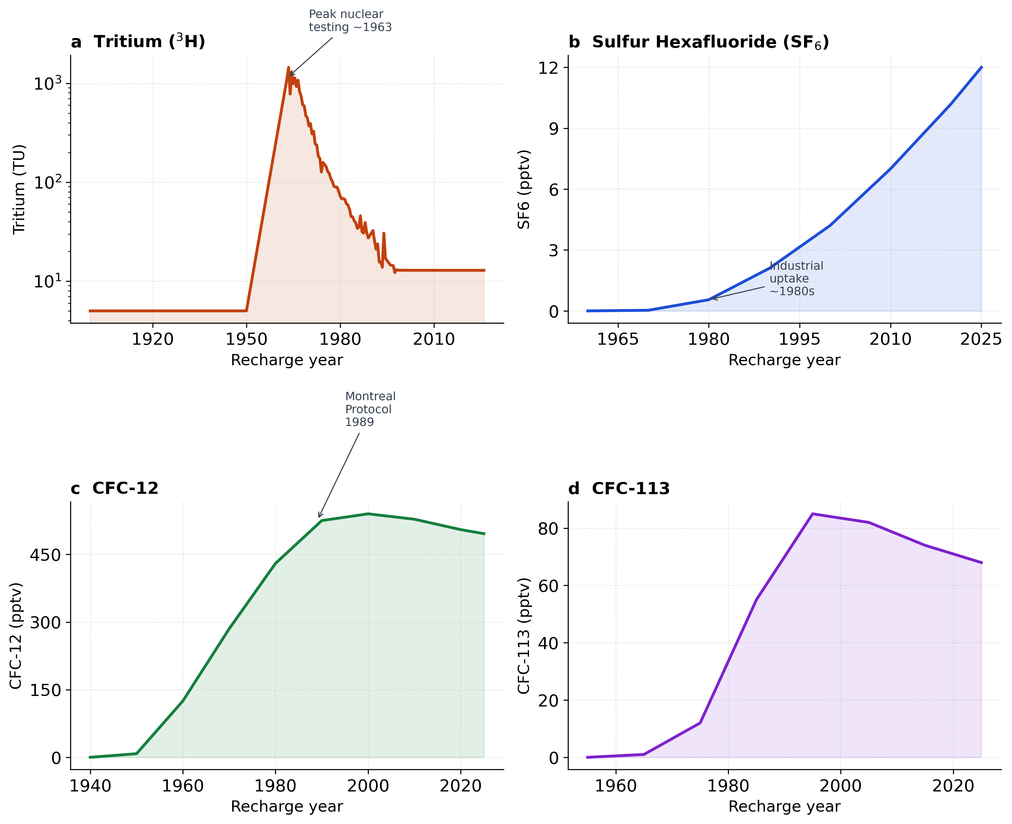
Figure 1. Atmospheric input histories of transient tracers used for young-groundwater residence-time interpretation. Panels show idealised recharge-year histories for (a) tritium (³H), (b) sulfur hexafluoride (SF₆), and (c) chlorofluorocarbon-12 (CFC-12). The figure supports the multi-tracer model design by showing that young tracers have complementary atmospheric histories and different ambiguity structures. The tritium input-history panel uses GNIP/WISER precipitation isotope records as the source for ³H forcing (IAEA/WMO, 2026).

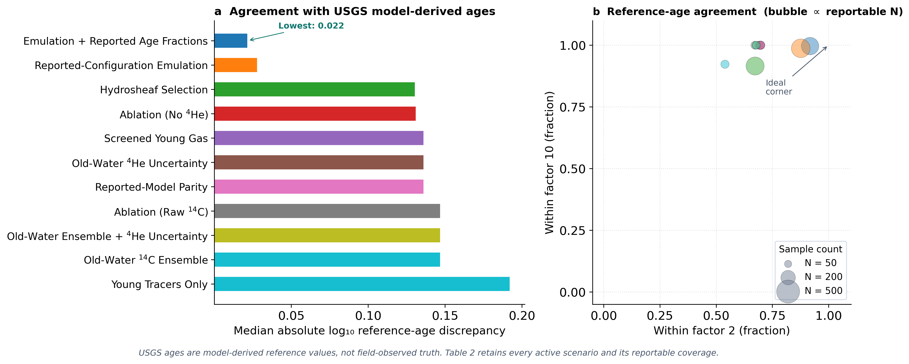
Figure 2. Active design-matrix reference agreement and reportability. Metrics use only identifiable reportable fits; archived withdrawn scenarios are excluded. Lower discrepancy does not imply field-validated true-age accuracy.

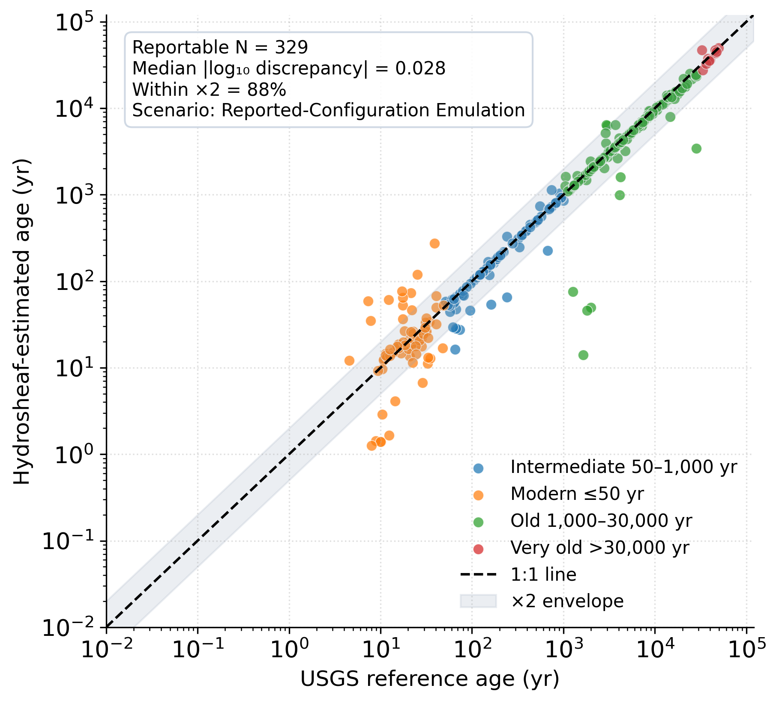

Figure 3. Strict reported-configuration emulation against model-derived USGS reference ages for the N = 329 reportable subset. This evaluates reference-workflow agreement, not independently known groundwater ages.

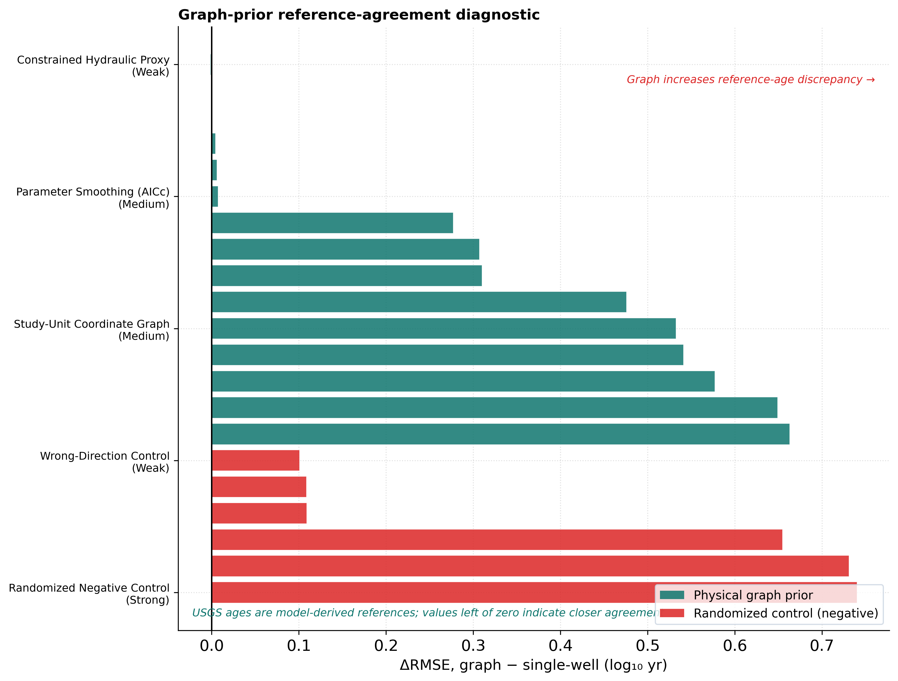
Figure 4. Graph-age effects on the N = 329 strict reportable nodes. The best candidate RMSE change is numerically small and accompanied by lower within-factor-two agreement; no candidate meets the robust-improvement rule.

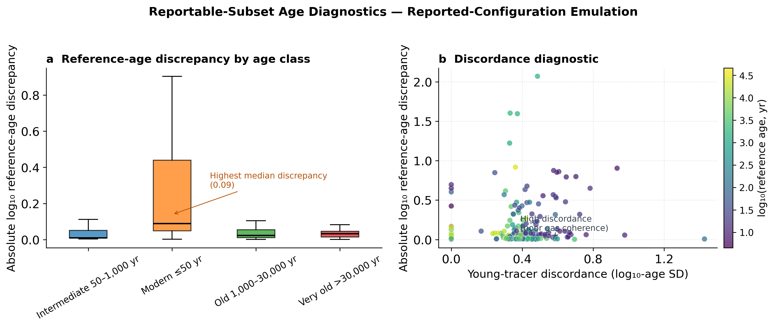
Figure 5. Age-class reference-discrepancy and young-tracer discordance diagnostics on the strict reportable subset. Age classes derive from model outputs and have unequal support.

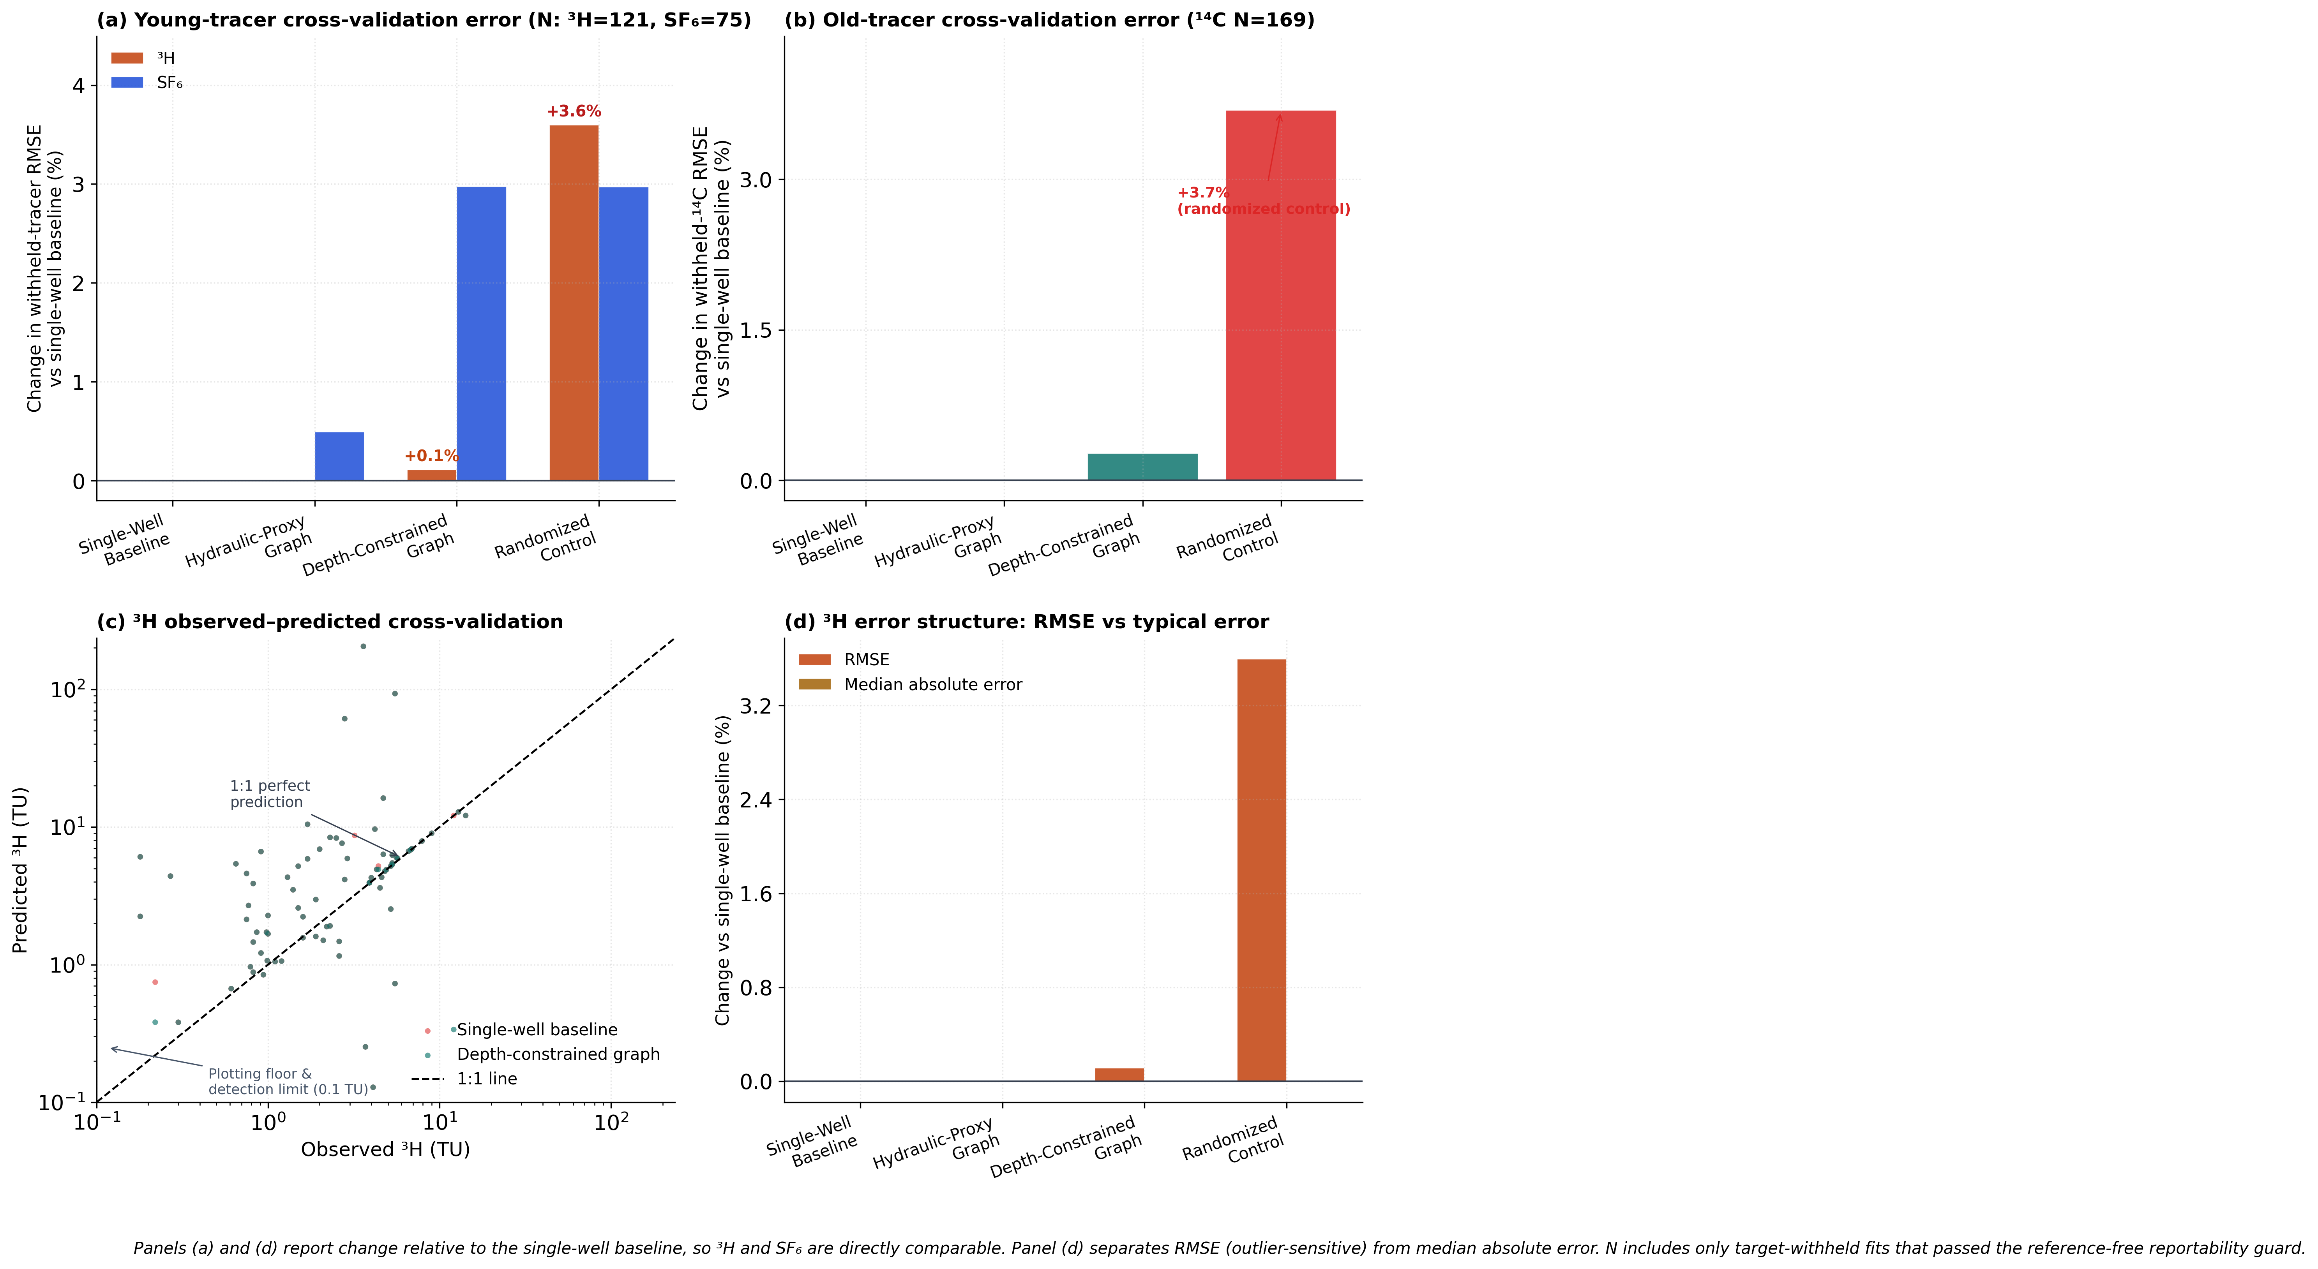
Figure 6. Leakage-guarded target-tracer withholding. Each target is removed before every single-node and graph-node refit, and only reportable fits are scored in native units. Candidate graphs show no meaningful ³H, SF₆, or ¹⁴C gain.

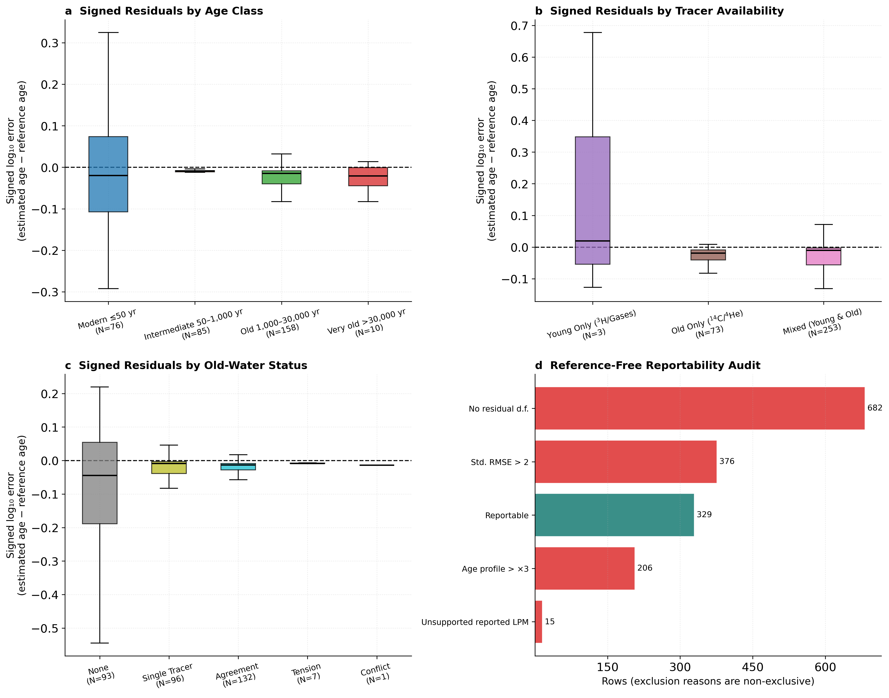
Figure 7. Signed reference-discrepancy diagnostics on the finite strict reportable plotting subset. Counts differ from Supplementary Table S3 because that table classifies old-water evidence before plotting filters.

