Title:
Conditional Value of Graph Priors in Multi-Tracer Groundwater-Age Inference: A Hydrosheaf Benchmark of Public Aquifer Datasets

Authors:
Dickson Abdul-Wahab^{a,*}, Dickson Adomakoª, Gibrilla Abass^{b}, Ebenezer Aquisman Asare^{c}, Samuel Ganyaglo^{a,d}

Affiliations:
ª Department of Nuclear Science and Applications, School of Nuclear and Allied Sciences, University of Ghana, Atomic-Kwabenya, Accra, Ghana
^{b} Department of Water Resources and Aquaculture Management, School of Sustainable Development, University of Environment and Sustainable Development, Somanya, Ghana
^{c} Nuclear Chemistry and Environmental Research Centre, National Nuclear Research Institute (NNRI), Ghana Atomic Energy Commission (GAEC), Box LG 80, Legon-Accra, Ghana
^{d} Water Resources Research Centre, National Nuclear Research Institute, GAEC, Box LG 80, Kwabenya-Accra, Ghana
*Corresponding author: Dickson Abdul-Wahab
Email: dabdul_wahab11@yahoo.com;
ORCID: https://orcid.org/0000-0001-7446-5909

Supplementary Information
S1. Residence-time convolution
For a tracer with atmospheric input history $I_{j}(t)$, decay constant $λ_{j}$, and residence-time distribution $g(τ∣θ)$, the modelled concentration at sample time $t_{s}$was:
 | $${\hat{C}}_{j}(t_{s},θ)=\int_{0}^{τ_{max}}{I_{j}}(t_{s}-τ)exp⁡(-λ_{j}τ)g(τ∣θ)dτ.$$ | (S1)
For stable atmospheric tracers such as SF₆ and CFCs, $λ_{j}=0$. For radioactive parent tracers such as ³H, ¹⁴C, ³⁹Ar, and ⁸⁵Kr, $λ_{j}=ln⁡(2)/T_{1/2,j}$. For daughter ingrowth in the ³H/³He system, the simplified ingrowth contribution was represented as:
 | $${\hat{C}}_{3He_{trit}}(t_{s},θ)=\int_{0}^{τ_{max}}{I_{3H}}(t_{s}-τ)\left[1-exp⁡(-λ_{3H}τ)\right]g(τ∣θ)dτ.$$ | (S2)

S2. Transit-time distribution normalisation
All TTDs were normalised so that:
 | $$\int_{0}^{τ_{max}}{g(τ∣θ)dτ=1.}$$ | (S3)
For binary mixture models, the TTD was expressed as:
 | $$g(τ∣θ)=f g_{1}(τ∣θ_{1})+(1-f) g_{2}(τ∣θ_{2}),0≤f≤1.$$ | (S4)
This formulation allowed young and old components to contribute simultaneously to a sampled well, consistent with the Hydrosheaf design emphasis on age-fraction constraints and multi-modal residence-time structure.
S3. Age-fraction penalty
Where age-fraction constraints were activated, the tracer residual objective was augmented by an age-fraction penalty:
 | $$J(θ)=J_{tr}(θ)+\sum_{k}{{\left[\frac{F_{k,obs}-F_{k,pred}(θ)}{σ_{F}}\right]}^{2}},$$ | (S5)
where $F_{k}$denotes a reported or target fraction for age domain $k$. In the implementation, anthropocene, holocene, and pleistocene fractions were evaluated from the TTD using fixed age cut-offs.
S4. Graph-prior penalty
For a directed edge $u→v$, the network ageing implementation expected downstream age to equal or exceed upstream age plus an expected travel-time increment. The penalty was activated only when the directed constraint was violated:
 | $$J_{G}=β\sum_{(u,v)∈E}{{min \left(0, a_{v}-a_{u}-\frac{L_{uv}}{v_{h}}\right)}^{2}},$$ | (S6)
where $a_{u}$and $a_{v}$are node ages, $L_{uv}$is edge length, $v_{h}$is inferred hydraulic velocity, and $β$is the graph-prior strength. In the Bayesian implementation, this was encoded as a potential term on negative downstream-age differences.
S5. Log-age performance metrics
The use of log-age residuals converted multiplicative age error into additive residuals:
 | $$e_{i}={log⁡}_{10}\left(\frac{{\hat{a}}_{i}}{a_{i}}\right).$$ | (S7)
For the strict reportable subset (N = 329), median absolute log₁₀ reference discrepancy was 0.0279, log₁₀ RMSE was 0.2769, and 87.5% were within a factor of two. The fraction sensitivity (N = 289) had median discrepancy 0.0216 and RMSE 0.1964. These quantify agreement with model-derived LPM outputs, not independently known true ages.
Supplementary Tables
Supplementary Table S1. Reproducibility inventory. Source-data tables, variables, filtering rules, and row-count trace used to build the common Hydrosheaf M3 benchmark table.
Source | Version / DOI | Tables or files used | Variables extracted | Main filters and joins | Row-count trace
Jurgens et al. (2022) USGS national public-supply aquifers, 2004-2017 | Version 1.1; DOI 10.5066/P9W7T0DN | Table_1_Sites.txt; Table_2_Ages.txt; Table_3_Tracers.txt; Table_5_DissGas_ModOut.txt; Table_7_Carbon14.txt | SampleID, SampleDate, StudyUnit, AqGroup, coordinates, depth, 3H, 3He_trit, SF6, CFCs, 14C, 4He, DGMETA fields, LPM model and age-fraction fields | Inner join by SampleID; duplicate SampleID rows removed; 14C rows deduplicated by corrected and PHREEQC-preferred products; rows without sample year excluded | 1,279 source sites; 1,272 harmonised rows in principal M3 benchmark
Faulkner and Jurgens (2019) Western Principal Aquifers, 2004-2018 | DOI 10.5066/P9U9ZSBN | USGS data-release groundwater-age and tracer tables | Tracer concentrations, calculated atmospheric-equivalent gases, age and metadata fields where available | Mapped to Hydrosheaf tracer schema and used for contextual parity/reproducibility checks where compatible | Source release reports 1,353 samples from 1,182 locations; compatible rows retained only when required target fields were finite
Gratzer et al. (2025) Mississippi River Valley alluvial aquifer, 2018-2020 | DOI 10.5066/P14DPCXE | Available site/tracer files; reported Table8_LPMs unavailable | Site/tracer context only; no comparable reported-LPM target | Excluded from parity, graph-age, and replication metrics | 0 rows in active performance tables

Supplementary Table S2. Age-stratified reference-workflow agreement for strict reported-configuration emulation on the reportable subset. Age classes derive from model outputs and supports are unequal.
Scenario | Reference-age class | N | Median |log₁₀| | log₁₀ RMSE | Within ×2 | Within ×10 | Median proxy coherence
tracerlpm strict parity | intermediate 50 1000 | 85 | 0.0093 | 0.1467 | 0.9059 | 1 | 0.3466
tracerlpm strict parity | modern le 50 | 76 | 0.0890 | 0.3689 | 0.6842 | 1 | 0.4764
tracerlpm strict parity | old 1000 30000 | 158 | 0.0233 | 0.2869 | 0.9430 | 0.9747 | 0.3060
tracerlpm strict parity | very old gt 30000 | 10 | 0.0330 | 0.0626 | 1 | 1 | 0.3200

Supplementary Table S3. Diagnostic ¹⁴C–⁴He agreement categories for all harmonised rows. These categories are not independent age validation and do not restore the withdrawn hierarchical prior.
Scenario | Old-water status | N | Median ¹⁴C age | Median ⁴He age | Median gap log₁₀
tracerlpm strict parity | agreement | 176 | 5514.5826 | 6971.8618 | 0.0831
tracerlpm strict parity | conflict | 3 | 1166.0764 | 10256.7277 | 1.0830
tracerlpm strict parity | none | 452 | — | — | —
tracerlpm strict parity | single tracer | 633 | 9196.3210 | 42390.9383 | —
tracerlpm strict parity | tension | 8 | 2266.2429 | 1564.9057 | 0.4010

No Supplementary Table S4 is reported: the final audit found zero supported paired raw and corrected atmospheric-equivalent gas values, so an empirical gas-correction effect could not be estimated.

Supplementary Figures

No Supplementary Figure S1 is reported because the gas-correction comparison had zero supported paired values after the final audit.

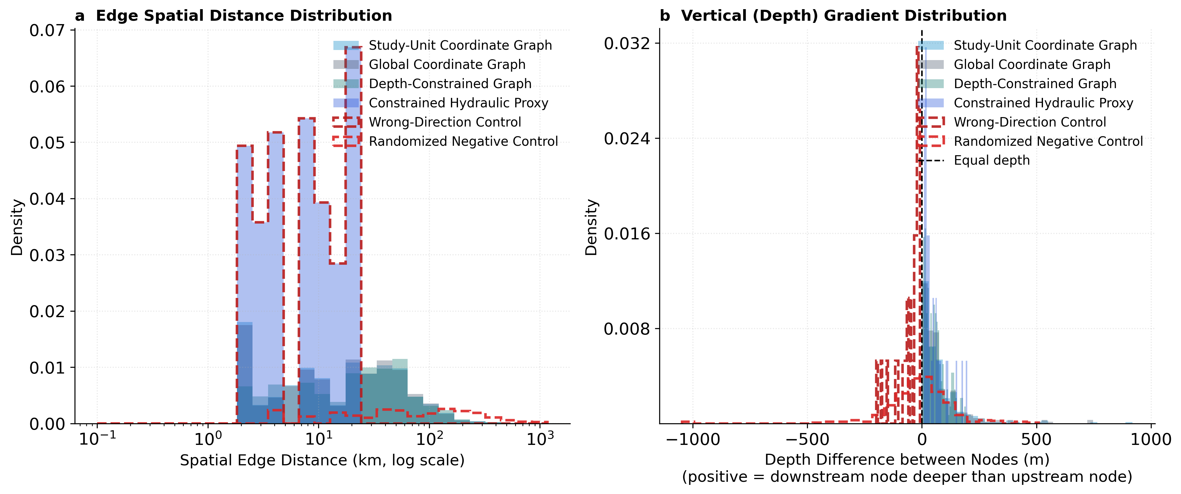
Supplementary Figure S2. Spatial-distance and vertical-difference distributions for graph edges in the N = 329 strict reportable-node benchmark. These diagnose hypothesised edge geometry, not verified flow connections.

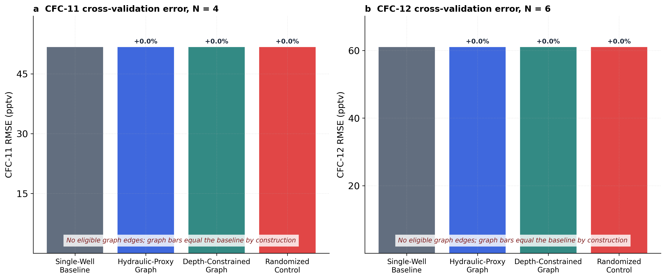
Supplementary Figure S3. CFC-11 (N = 4) and CFC-12 (N = 6) target-withheld RMSE after the reportability guard. No reportable CFC nodes formed eligible graph edges, so identical bars indicate a non-estimable graph effect, not equivalence.

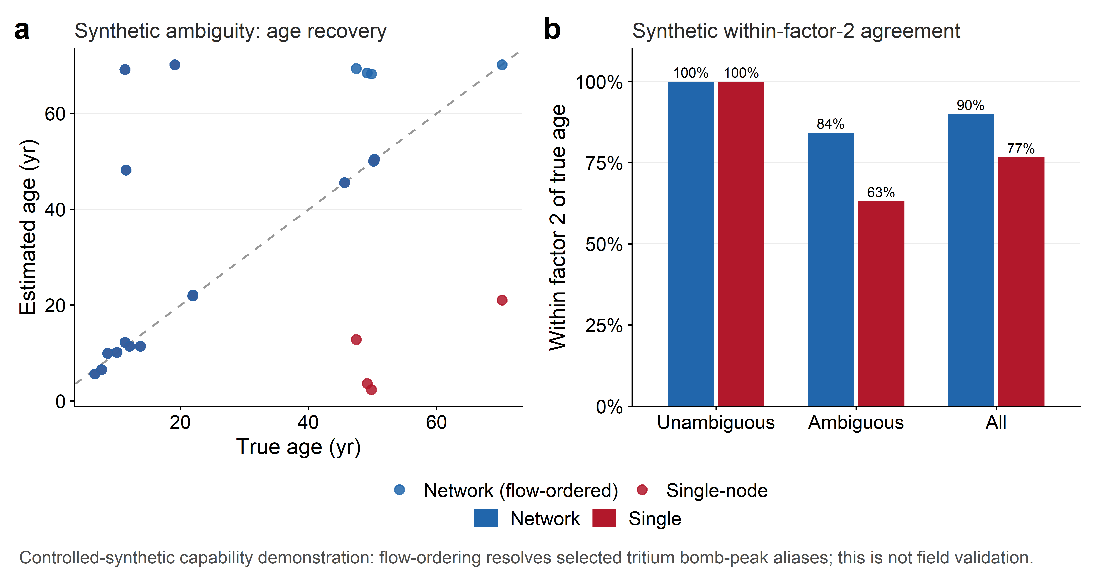
Supplementary Figure S4. Controlled-synthetic network-dating ambiguity and recovery diagnostic. This capability demonstration uses known simulated ages to test implementation behaviour; it is not field validation, does not establish accuracy for the USGS benchmark, and does not justify a general graph-improvement claim.
References
Jurgens, B., Musgrove, M., McAdoo, M. A., McMahon, P. B., & Faulkner, K. E. (2022). Data for distribution of groundwater age in aquifers used for public supply in the continental United States, 2004–2017 (Version 1.1: June 2022) [Data release]. U.S. Geological Survey. https://doi.org/10.5066/P9W7T0DN
The USGS page lists the year, title, version, DOI, and authors for this data release.
Faulkner, K. E., & Jurgens, B. (2019). Data for groundwater age in the Western Principal Aquifers, 2004–2018 [Data release]. U.S. Geological Survey. https://doi.org/10.5066/P9U9ZSBN
The USGS page lists the publication year, title, DOI, authors, and product type as a data release.
Gratzer, M. C., Solder, J. E., Knierim, K. J., & Kingsbury, J. A. (2025). Data for groundwater age estimates for the Mississippi River Valley alluvial aquifer based on tracer data collected during 2018–20 [Data release]. U.S. Geological Survey. https://doi.org/10.5066/P14DPCXE

