Competing Geochemical Drivers and Probabilistic Health Risks of Groundwater in the Semi-Arid Voltaian Sedimentary Basin, Ghana
Dickson Abdul-Wahabª, Emmanuel Daanoba Sunkari^{b,c,d*}, Celestina Akasi Yalley^{e}, Ebenezer Aquisman Asare^{f}, Cynthia Laar^{g}, Tulika Chakrabarti^{b, h}, & Abayneh Ataro Ambushe^{d}
ªDepartment of Nuclear Science and Applications, School of Nuclear and Allied Sciences, University of Ghana, Atomic-Kwabenya, Accra, Ghana
^{b}Centre of Excellence in Environmental Science and Sustainability, Sir Padampat Singhania University, Udaipur 313 601, Rajasthan, India
^{c}Mining Engineering, Faculty of Integrated and Advanced Technology, Sir Padampat Singhania University, Udaipur 313601, Rajasthan, India
^{d}Department of Chemical Sciences, Faculty of Science, University of Johannesburg, Auckland Park 2006, P.O. Box 524, Johannesburg, South Africa
^{e}Department of Geological Engineering, Faculty of Geosciences and Environmental Studies, University of Mines and Technology, P.O. Box 237, Tarkwa, Ghana
^{f}Nuclear Chemistry and Environmental Research Centre, National Nuclear Research Institute (NNRI), Ghana Atomic Energy Commission (GAEC), Box LG 80, Legon, Accra, Ghana
^{g}Water Resources Research Centre, National Nuclear Research Institute, Ghana Atomic Energy Commission, Box LG 80, Legon, Accra, Ghana
^{h}Chemistry, Faculty of Applied Sciences, Sir Padampat Singhania University, Udaipur 313601, Rajasthan, India
*Corresponding Author: emmanueldaanobasunkari@gmail.com
*ORCID: 0000-0002-0898-2286

Abstract
Groundwater in semi-arid sedimentary basins serves as a critical resource, yet its quality is often shaped by complex and competing geochemical drivers. This study evaluates groundwater quality and health risks within the Voltaian sedimentary basin of northern Ghana. An integrated compositional data analysis and uncertainty-aware framework was applied to 34 dry-season groundwater samples. Results indicate that groundwater is predominantly of the Na-HCO₃ type, governed largely by silicate weathering and forward ion exchange. A neutrosophic groundwater quality index classified most samples as excellent, though a subset proved unsuitable due to intense mineralisation. Bayesian driver profiling revealed that fluoride enrichment is inherently multicausal, driven by competing conductivity enrichment and ion-exchange suppression. Probabilistic health risk assessments identified children as the most vulnerable group, showing a 69% probability of exceeding the skeletal-dental hazard threshold under the modelled dry-season exposure scenario. However, these probabilistic estimates are constrained by the single-season nature of the sampling and represent a temporal snapshot rather than a definitive annual baseline. Ultimately, this approach successfully uncovers the competing geochemical mechanisms governing water quality, offering a transferable evaluation tool for analogous sedimentary environments.
Keywords: Compositional data analysis; Neutrosophic logic; Fluoride contamination; Irrigation suitability; Bayesian regression

Introduction
Groundwater serves as the principal source of domestic water supply across rural northern Ghana, where piped water infrastructure remains limited or unreliable and borehole water is often the sole accessible resource for everyday consumption and household sanitation ¹. In districts such as Karaga, the same groundwater resource also underpins dry-season smallholder irrigation, with local knowledge guiding well siting and seasonal water management in ways that demonstrate a dual domestic–productive dependency rather than a strictly potable function ². This dependence acquires immediate public-health significance in the context of the Voltaian sedimentary basin, where national-scale hazard modelling estimates that approximately 15% of Ghana’s land area, concentrated in the northeast, carries elevated fluoride risk, placing an estimated 920,000 people in proximity to potentially unsafe groundwater ³. Locally, empirical studies in adjacent Voltaian-setting districts confirm that hydrochemistry is heterogeneous even over short distances. In districts such as Karaga, predominantly underlain by the siliciclastic Bimbila Formation, silicate and carbonate mineral weathering act as the primary geogenic controls on major-ion and fluoride evolution (Sunkari et al., 2025, 2026). This rock-water interaction is frequently modified by forward ion exchange and semi-arid concentration effects. Furthermore, the reliance on subsistence agriculture introduces localized anthropogenic pressures, such as potential nitrate enrichment from pit latrines and agricultural runoff, which superimpose a secondary contamination signal onto the natural geogenic template ^{4–6}. Crucially, navigating this complex dependence demands a framework that does not conflate drinking-water quality, human health risk, and irrigation suitability.
Crucially, this dependence demands a framework that does not conflate drinking-water quality, human health risk, and irrigation suitability, as these are three distinct evaluative questions requiring different indicators and thresholds. Ghana-based evidence consistently demonstrates that a groundwater source acceptable for smallholder crop production may simultaneously pose a chronic fluoride exposure risk, particularly for children, who face disproportionately higher non-carcinogenic hazard owing to lower body weight and higher relative fluid intake ^{7,8}. Treating these evaluative dimensions as interchangeable can distort risk characterization. It may overstate safety in some use categories while understating risk in others. This approach can also obscure opportunities for targeted management responses, such as source substitution or protective treatment (Ganyaglo et al., 2019; Araya et al., 2022).
Conventional arithmetic groundwater quality indices represent a widely adopted screening tool yet carry systematic methodological limitations that become consequential when management decisions rely on them. Their construction typically fixes weights, thresholds, and sub-index functions without accounting for threshold ambiguity, measurement uncertainty, or variable reliability, so the final quality class can be sensitive to arbitrary design choices and can imply more certainty than the underlying data justify ^{9,10}. Monte Carlo uncertainty analysis of conventional water quality index structures demonstrates that weight uncertainty alone is large enough to alter class membership, while Bayesian model-averaging results confirm that multi-model combination materially improves reliability over any single deterministic index ^{10,11}. When threshold ambiguity and variable reliability are left unaddressed, arithmetic indices can mask which variables drive impairment, create false precision around class boundaries, and collapse structurally uncertain evidence into one overconfident score ⁹.
A second methodological problem arises in the multivariate interpretation of hydrochemical data. Groundwater chemistry is compositional: major-ion concentrations are constrained by the sum of dissolved solids and carry relative rather than absolute information. Application of Euclidean-based methods, principal component analysis, hierarchical clustering, or correlation analysis, to untransformed raw-ion data can therefore generate spurious correlations, distorted inter-sample distances, and component loadings that reflect the geometry of closure rather than genuine hydrogeochemical structure ¹². Isometric log-ratio transformation addresses closure by projecting compositions into unconstrained Euclidean space, and recent groundwater studies demonstrate that isometric log-ratio (ILR) transformation-based approaches improve discrimination of facies contrasts and polluted versus background groundwater compared with their raw-space counterparts ^{12,13}.
Deterministic hazard quotient and hazard index methods constitute a third limitation when applied as the sole characterisation of non-carcinogenic health risk. Point-estimate hazard quotient (HQ) and hazard index (HI) values conceal the variability attributable to population-level differences in body weight and ingestion rate, seasonal fluctuations in contaminant concentration, and pathway-specific exposure uncertainty. Probabilistic approaches such as Monte Carlo simulation and Bayesian hierarchical modelling explicitly propagate uncertainty into full risk distributions and exceedance probabilities. Comparisons between deterministic and probabilistic estimates consistently show that deterministic methods communicate a more certain, and sometimes misleading, risk picture than the available data support ^{14–17}. However, while probabilistic simulations excel at propagating documented parameter variability, they are not a panacea for data scarcity; they remain fundamentally constrained by the accuracy of the underlying exposure distributions. If local dietary habits, seasonal ingestion variations, or alternative exposure pathways are unmeasured, Bayesian frameworks can inadvertently generate a false sense of security by quantifying uncertainty around an inaccurate baseline.
The literature documents an established pattern of integrated groundwater assessment studies that combine hydrochemical facies diagnosis with drinking-water indexing, health-risk evaluation, and irrigation suitability assessment in a sequential pipeline ^{18–21}. However, these frameworks are typically stacked rather than structurally coupled. Process discovery is conducted in conventional hydrochemical space using Piper diagrams, raw-ion correlations, and standard multivariate methods. Downstream risk and suitability modelling then proceeds without formally importing the compositional structure identified in the preceding step. Reviews of groundwater quality assessment and groundwater pollution analytics consistently identify the absence of a single architecture linking compositional process discovery to uncertainty-aware decision modelling as an outstanding methodological gap ^{22–24}. Reviews of groundwater quality assessment and groundwater pollution analytics consistently identify the absence of a single architecture linking compositional process discovery to uncertainty-aware decision modelling as an outstanding methodological gap ^{22–24}. The practical consequence of this uncoupled approach is that downstream management decisions are often based on distorted driver profiles. For example, applying conventional regression or Euclidean indexing to raw closed-sum major ions can produce spurious correlations where a harmless ion appears as a primary pollution driver simply due to the dilution of a genuine contaminant. If this flawed compositional structure is fed blindly into a health-risk or suitability model, regulators risk misdirecting limited remediation resources toward the wrong hydrochemical target. A further fragmentation is evident within the advanced-method literature itself: ILR-based compositional data analysis, fuzzy and neutrosophic water quality indexing, Bayesian driver modelling, and probabilistic health-risk assessment have each been developed in largely separate research streams, with few studies integrating all four into one reproducible workflow ^{12,17,24,25}.
The present study addresses this gap through a dual-space compositional process framework applied to 34 groundwater samples from Karaga District, Ghana. While applying such an advanced statistical architecture to a restricted dataset presents inherent risks of overfitting, the selected methods are structurally designed to mitigate small-sample volatility. Specifically, bootstrapped neutrosophic variable importance stabilizes weight estimation across resamples, robust PCA guards against the disproportionate leverage of multivariate outliers, and the Bayesian horseshoe prior is mathematically optimized to extract sparse, informative signals even when the predictor block is large relative to the sample size. In process space, ILR-based compositional principal component analysis with parallel analysis eigenvalue retention and deterministic geochemical auditing is used to identify latent hydrochemical signatures without closure bias. In assessment space, a neutrosophic partial least squares groundwater quality index (NPLS-GWQI) with bootstrapped variable-importance-in-projection weighting is used to integrate water quality information. Bayesian horseshoe regression supports driver profiling for both NPLS-GWQI and fluoride. A hierarchical Bayesian multi-pathway risk assessment (HBMPRA) is applied to fluoride and nitrate across three demographic groups, while entropy-weighted neutrosophic irrigation suitability indexing (N-ISI) evaluates agricultural suitability. Together, these components provide an uncertainty-aware and demographically disaggregated decision layer.
To operationalize this framework, the investigation is structured around five specific objectives: (i) to assess groundwater quality using a neutrosophic PLS-based groundwater quality index (NPLS-GWQI) with bootstrapped dynamic variable-importance-in-projection weighting and aesthetic–sensory sensitivity handling, (ii) to identify latent hydrochemical signatures using ILR-PCA with parallel analysis and to interpret them against deterministic geochemical constraints, (iii) to profile the relative hydrochemical drivers of NPLS-GWQI and fluoride using Bayesian horseshoe regression on an augmented predictor block. The horseshoe prior is specifically adopted here to aggressively shrink background noise and handle high dimensionality, ensuring that driver profiling remains mathematically robust and testable despite the restricted sample size, with supplementary sparse-PLS comparator diagnostics applied for validation, (iv) to estimate deterministic and Bayesian non-carcinogenic health risk for fluoride and nitrate across three demographic groups: Adults, Children, and Teens, with uncertainty characterised through posterior distributions and exceedance probabilities, and (v) to evaluate irrigation suitability through entropy-weighted neutrosophic irrigation suitability indexing (N-ISI) derived from seven standard irrigation quality parameters.
Ultimately, this study offers an integrated and transferable framework for analogous Voltaian sedimentary groundwater settings across the region.

Study Area

Location and Settlement Pattern
Karaga District is located in the North East Region of Ghana, a predominantly rural administrative area situated in the northern part of the country. The district falls within the broader Voltaian sedimentary basin, which underlies much of northern Ghana and extends into adjacent countries ²⁶. As shown in Figure 1, the district encompasses a network of settlements distributed across a geologically heterogeneous landscape, with the sampling sites concentrated primarily within the dominant Bimbila Formation whilst also capturing communities on the Bunya belt and the southern Obosum terrain.
Settlement in Karaga District is predominantly rural and dispersed, with communities relying heavily on boreholes and shallow wells as principal sources of domestic water supply. Piped water infrastructure is limited, and the availability of treated municipal water is not consistent across the district ¹. This configuration means that the majority of residents draw directly from untreated groundwater sources for drinking, cooking, and household purposes, making the quality of that groundwater a matter of direct public-health concern. Groundwater also supports smallholder livelihoods through dry-season vegetable production, particularly where surface water availability declines sharply outside the wet season ². The dual domestic and productive role of groundwater in communities such as those sampled for this study underscores why a multi-dimensional assessment addressing potability, health risk, and irrigation suitability simultaneously is necessary.

Climate, Hydrology, and Groundwater Reliance
Karaga District experiences a semi-arid tropical climate characterised by a pronounced single wet season and an extended dry season. Rainfall is concentrated between May and October, with a marked decline in precipitation outside this window. Mean annual rainfall across northern Ghana is generally lower than in the south, and inter-annual variability is considerable ^{27,28}. The dry season, which spans approximately six months, results in the cessation of surface flow in many seasonal streams and watercourses, leaving groundwater as the only practically accessible water source for rural communities during that period.
Recharge to the Voltaian aquifer system is episodic and largely controlled by infiltration during the wet season ²⁹. The semi-arid character of the climate means that evapotranspiration rates are high relative to precipitation, which limits the proportion of rainfall that translates into effective recharge and can produce concentration effects in shallow groundwater as the dry season progresses. These concentration dynamics are particularly relevant for dissolved constituents such as fluoride, sodium, and bicarbonate, whose activity in the hydrochemical system is partly amplified by reduced dilution outside the rainy period. Groundwater is therefore not only the year-round water source in the district but also a chemically evolving resource whose quality varies with the seasonal recharge cycle and with the hydrogeological properties of the host formation ²⁶.

Geology and Hydrogeological Background
Karaga District lies entirely within the Voltaian sedimentary basin, one of the principal sedimentary sequences in West Africa and a hydrogeologically significant formation in northern Ghana. As illustrated in Figure 1, the mapped geology of the district is strongly asymmetric in its lithological distribution. The Bimbila Formation underlies most of the northern, central, western, and much of the eastern parts of the district, making it the dominant host unit for the groundwater sampled in this study. The undifferentiated Obosum Group is confined mainly to the southern to south-western margin, while the Bunya Formation occurs discontinuously, most prominently as an east-central to south-eastern belt and as smaller isolated outliers toward the north-west. Fault traces cut across this Voltaian sedimentary succession and provide structural pathways that may influence groundwater flow, mixing, and chemical evolution ²⁶.
The hydrogeological context of these formations is one of intergranular and fracture-controlled aquifer systems typical of sedimentary sequences in Sub-Saharan Africa ³⁰. Groundwater occurs in weathered and fractured zones within the sedimentary units, and the depth, yield, and chemistry of individual boreholes are influenced by the local lithological character, degree of fracturing, and proximity to fault structures. The predominantly siliciclastic composition of the Voltaian sediments promotes silicate weathering as a major driver of groundwater chemistry, and the contrast between the Bimbila Formation and the Obosum and Bunya formations introduces lithostratigraphic variability that is expected to manifest in measurable hydrochemical differences across the sampling network ²⁶. Fluoride occurrence in this setting is understood to be geogenic, deriving from weathering of fluoride-bearing minerals within the sedimentary pile, consistent with the broader pattern of fluoride enrichment documented across Voltaian and adjacent sedimentary groundwater systems in northern Ghana ^{5,26,31–33}.

Land Use and Likely Anthropogenic Pressures
Land use in Karaga District is dominated by subsistence and smallholder agriculture, with food-crop production, livestock grazing, and dry-season vegetable farming constituting the principal economic activities. Settlement activities including open defecation, improper solid-waste disposal, and the proximity of pit latrines to borehole infrastructure can introduce anthropogenic nitrogen into shallow groundwater, providing a plausible pathway for nitrate enrichment in the sampled waters. However, the absence of heavy industry, large-scale irrigation schemes, or significant point-source discharges means that industrial contamination is unlikely to be a major contributor to the observed hydrochemical character of groundwater in the district.
Anthropogenic pressure in Karaga District is therefore best understood as a secondary modifier superimposed on a geogenic hydrochemical template that is principally shaped by rock-water interaction, ion exchange, and the semi-arid climatic concentration mechanism. Localised nitrate enrichment attributable to sanitary and agricultural practices may elevate dissolved nitrogen at specific sites, but the broader hydrochemical character of the groundwater, including fluoride enrichment, bicarbonate-dominated facies, and ion exchange signatures, is predominantly geological in origin ²⁶. This framing is consistent with published findings from comparable northern Ghanaian and Voltaian settings, where geogenic processes have been identified as the primary driver of major-ion and fluoride chemistry, with anthropogenic inputs acting as a spatially variable secondary signal ^{5,7,26,34}.

Materials and Methods

Dataset, Sampling, and Measured Variables
The analytical dataset comprised 34 groundwater samples collected from active public boreholes drilled and maintained by World Vision International across Karaga District, Northern Ghana, in October 2022. The sampling network was distributed across the principal geological units of the district, as shown in Figure 1, with most sites falling within the Bimbila Formation, the dominant host unit, alongside a smaller number of sites on the Bunya and Obosum formations.
Samples were collected in 0.5 L high-density polyethylene bottles that had been thoroughly precleaned with deionized water, 10% nitric acid, and distilled water to eliminate contamination risk. Before each sample was drawn, the borehole was pumped for approximately five minutes to purge the standing column and ensure that representative formation water was collected. Groundwater was then filtered through hand-held syringes fitted with 0.45 μm cellulose acetate filter membranes to remove suspended particulates. The sealed bottles were stored in an ice chest at 4 °C and transported to the Ghana Atomic Energy Commission (GAEC) Laboratory for ion analysis.
Each sample was characterised by 12 measured hydrochemical variables: three field parameters, pH, electrical conductivity (EC), and total dissolved solids (TDS), and nine major dissolved constituents, sodium (Na⁺), potassium (K⁺), magnesium (Mg²⁺), calcium (Ca²⁺), chloride (Cl⁻), sulphate (SO₄²⁻), bicarbonate (HCO₃⁻), nitrate (NO₃⁻), and fluoride (F⁻). Temperature, pH, EC, and TDS were measured in situ using calibrated water quality probes at the time of sampling. In the laboratory, the anions Cl⁻, SO₄²⁻, F⁻, and NO₃⁻ were determined by ion chromatography using a DIONEX ICS-90 system (Dionex Corporation, California, USA). HCO₃⁻ concentrations were determined by in situ titration using a HACH® digital titrator (model 1690001; Hach Company, Loveland, Colorado, USA). The cations K⁺ and Na⁺ were measured using a flame photometer (FP910-4), while Ca²⁺ and Mg²⁺ concentrations were determined by an AA2OFS Fast Sequential atomic absorption spectrometer. Analytical accuracy and precision were verified using BCR 398 and 399 certified reference materials (CRMs), with continuous internal quality validation through repeated analyses of standards and samples, yielding a precision of ≤5% for all ions. Figure 1 provides the cartographic context for the sampling network and shows the distribution of sites relative to the mapped geological units and fault traces.

Preprocessing and Stoichiometric Conversion
Prior to multivariate analysis, relevant ionic concentrations were converted from mg/L to milliequivalents per litre (meq/L) using valence-based stoichiometric factors. Charge-balance error (CBE) was computed for each sample from the ratio of the difference between summed cationic and anionic equivalents to their total sum, expressed as a percentage. Samples with CBE values within an acceptable analytical tolerance were retained without modification.
The measured variables were partitioned into two functional blocks for downstream modelling. The compositional hydrochemical block, consisting of Ca²⁺, Mg²⁺, Na⁺, K⁺, HCO₃⁻, Cl⁻, SO₄²⁻, NO₃⁻, and F⁻, was treated as a nine-part composition subject to ILR transformation before any multivariate analysis. The field and non-compositional block, consisting of pH, EC, and TDS, was handled outside the compositional framework and used directly in water-quality indexing and as predictors in the augmented endpoint-driver models. For endpoint-driver modelling, an augmented predictor block was constructed by combining log-transformed ionic concentrations, field variables, and derived geochemical indices and proxies including the chloro-alkaline indices $CAI_{1}$ and $CAI_{2}$, the Na/Cl molar ratio, the Ca/HCO₃ ratio, the Mg/Ca ratio, a silicate weathering proxy, and a carbonate weathering proxy. Nitrate and fluoride served explicitly as health-risk endpoints throughout the assessment space.

NPLS-GWQI
Groundwater quality was assessed using a neutrosophic partial least squares groundwater quality index (NPLS-GWQI), a framework which in principle addresses key limitations of conventional arithmetic indices by incorporating threshold uncertainty, variable reliability, and ambiguity in class membership ^{9,10}. Each measured variable was first normalised against its corresponding WHO or Ghana Standards Authority (GSA) guideline value ³⁵ to produce a parameter-specific sub-index, $q_{i}$. A bipolar hazard treatment was applied to pH rather than a unidirectional upper-threshold penalty, reflecting the fact that both acidic and highly alkaline deviations from neutrality represent quality concerns. Neutrosophic membership was modelled through three independent components, truth ($T$), indeterminacy ($I$), and falsity ($F$), which capture the degree to which a sample definitively meets, ambiguously approaches, or clearly fails the adopted quality standard.
To transition from parameter-level memberships to a singular index, variable importance weights were estimated using the neutrosophic_pls (see github repo at https://github.com/dabdul-wahab1988/neutrosophic_pls) computational package ³⁶. Specifically, weights were derived via bootstrapped neutrosophic variable importance in projection (N-VIP) (see details in supplementary method S1). By recalculating weights, $w_{i}$, across repeated resamples of the neutrosophic dataset, the algorithm extracts dynamic, data-driven variable contributions rather than relying on fixed, expert-assigned weights. Details of the NPLS-GWQI formulation is presented in Supplementary methodology S1. The final NPLS-GWQI score for each sample was computed as the weighted sum of the truth components:
$${\text{NPLS-GWQI}}_{s}=Π_{s}⋅\sum_{i=1}^{p}{\hat{w_{i}}}⋅{\text{SI}}_{i,s}$$ | (1)
where, ${\text{NPLS-GWQI}}_{s}$ is the final Neutrosophic Partial Least Squares Groundwater Quality Index score for a specific groundwater sample $s$, $Π_{s}$ is the sensory–aesthetic penalty factor applied to sample $s$, $p$ is the total number of hydrochemical parameters included in the index (in this study, $p = 12$), $i$ is the index representing an individual hydrochemical parameter (e.g., pH, EC, Nitrate), $\hat{w_{i}}$ is the bootstrap-mean dynamic weight assigned to parameter $i$. These weights are derived using a PLS-based weighting scheme and stabilized via 500 bootstrap resamples to reflect the expected contribution of each parameter, ${\text{SI}}_{i,s}$ is the per-parameter sub-index for parameter $i$ in sample $s$. It is calculated by multiplying the normalized hazard ratio ($q_{i,s}$) by a neutrosophic scalar amplifier ($Ψ_{i,s}$) and a constant factor of 100. Final NPLS-GWQI scores were classified into five quality classes, Excellent, Good, Poor, Very Poor, and Unsuitable, using the standard classification thresholds adopted for neutrosophic groundwater quality indexing (Supplementary method S1.9).

Compositional Hydrochemical Discovery
Latent hydrochemical processes were identified by applying ILR transformation to the nine-part compositional block, Ca²⁺, Mg²⁺, Na⁺, K⁺, HCO₃⁻, Cl⁻, SO₄²⁻, NO₃⁻, and F⁻, before PCA. The ILR transformation maps the $D$-part simplex into unconstrained $(D-1)$-dimensional Euclidean space, eliminating the spurious correlations and distance distortions that arise when PCA is applied directly to raw closed compositions ^{12,13}. Following the sequential binary partition convention, the $k$-th ILR coordinate is:
$$z_{k}=\sqrt{\frac{k}{k+1}}ln\frac{{\left(\prod_{j=1}^{k}{x_{j}}\right)}^{1/k}}{x_{k+1}}, k=1,…,D-1$$ | (2)
where $x_{1},…,x_{D}$ are the ordered compositional parts ($D=9$ for the nine-ion block). The number of components to retain was determined objectively by parallel analysis, which compared observed eigenvalues against the 95th-percentile distribution of eigenvalues derived from repeated random permutations of the data matrix. Components were retained only when the observed eigenvalue exceeded the random threshold, providing a data-supported retention criterion rather than an arbitrary scree-plot cutoff (Figure S1).
PCA was performed in ILR space using robust projection logic to guard against the influence of multivariate outliers, which is particularly important at the relatively small sample size of 34. Component loadings were back-transformed from ILR to centred log-ratio (CLR) space following analysis, enabling geochemically interpretable loading values to be derived for each ion and each retained component. The CLR loading profiles were used to assign conservative process labels, which were subsequently refined using evidence from the deterministic geochemical constraint analysis described in section 3.5.

Deterministic Geochemical Constraints
A suite of deterministic geochemical indices was computed to constrain and corroborate the process interpretations arising from the compositional discovery step. These indices were derived from the meq/L-converted dataset and provided a classical geochemical audit of the hydrochemical system rather than a competing analytical pathway. Gibbs-domain assignment was performed using reconstructed TDS and the ratio of dominant cationic and anionic species, placing each sample within the precipitation-dominance, rock-weathering, or evaporation-concentration fields of the Gibbs diagram to characterise the overall geochemical control mechanism.
Ion-exchange behaviour was quantified through the chloro-alkaline indices $CAI_{1}$ and $CAI_{2}$, computed from the stoichiometric relationship between chloride and the sodium and potassium concentrations, with strongly negative values indicating forward cation exchange in which calcium and magnesium replace sodium on aquifer mineral surfaces, and positive values indicating reverse exchange.
The Na/Cl molar ratio was used as an indicator of halite dissolution relative to silicate weathering, with values substantially above unity indicating that sodium is derived predominantly from mineral weathering and exchange rather than from simple halite dissolution. A silicate weathering index and a carbonate weathering index were additionally computed to characterise the relative contribution of silicate and carbonate mineral dissolution to the groundwater chemistry.

Bayesian Endpoint-Driver Modelling
The relative influence of hydrochemical predictors on NPLS-GWQI and on fluoride concentration was quantified using Bayesian horseshoe regression implemented in PyMC. Let $y_{s}^{*}$ denote the standardized endpoint value for sample $s$ and $x_{s}^{*}$ the corresponding standardized predictor vector from the augmented hydrochemical block. The model was specified as
$$y_{s}^{*}∼N\left(μ_{s},σ\right), μ_{s}=α+{x_{s}^{*}}^{⊤}β$$ | (3)
with priors
$$α∼N\left(0,1\right), σ∼\text{HalfNormal}\left(1\right),$$ | (4)
$$β_{j}∣λ_{j},τ∼N\left(0,τ^{2}λ_{j}^{2}\right), λ_{j}∼\text{Half-Cauchy}\left(0,1\right), τ∼\text{Half-Cauchy}\left(0,1\right).$$ | (5)
The horseshoe prior was selected because its global-local shrinkage structure pulls weak, noise-like coefficients towards zero while allowing a small number of informative predictors to retain substantial posterior mass, which is appropriate given the size of the augmented predictor block relative to the 34-sample dataset ³⁷.
For both endpoint models, predictors were drawn from an augmented hydrochemical block comprising log-transformed major-ion concentrations, field variables (pH, EC, and TDS), linear ion-exchange and weathering proxies ($CAI_{1}$, $CAI_{2}$, Silicate Proxy, and Carbonate Proxy), and log-transformed geochemical ratios (Na/Cl, Ca/HCO₃, and Mg/Ca). For the fluoride endpoint model, fluoride itself was excluded from the major-ion predictor block.
Posterior sampling was performed with the NUTS algorithm in PyMC. Model outputs included posterior mean coefficients, 95% equal-tail credible intervals, and the probability of direction for each predictor, defined as
$$\text{pd}\left(β_{j}\right)=\max\left\{\operatorname{Pr}\left(β_{j}>0 ∣ y\right), \operatorname{Pr}\left(β_{j}<0 ∣ y\right)\right\}×100.$$ | (6)
This quantity represents the posterior probability that the coefficient has the reported sign. Normalised driver contribution percentages were computed from the absolute posterior mean coefficients, and predictors with pd > 95% were treated as directionally supported. Model fit was summarised using an in-sample pseudo-$R^{2}$ computed from posterior-mean fitted values transformed back to the original response scale. A supplementary sparse PLS model was fitted for fluoride as an external comparator, and its cross-validation and permutation statistics are reported alongside the Bayesian results.

Deterministic and Bayesian Health-Risk Assessment
Non-carcinogenic health risk was assessed for fluoride and nitrate via ingestion as the sole active exposure pathway, consistent with the absence of dermal and inhalation parameters for these contaminants in the current implementation. The assessment was conducted for three demographic groups: Adults, characterised by a reference body weight of 60 kg and an ingestion rate of 2.5 L/day; Children, characterised by a body weight of 15 kg and an ingestion rate of 1.0 L/day; and Teens, characterised by a body weight of 45 kg and an ingestion rate of 1.5 L/day. These exposure assumptions were applied consistently across both the deterministic and Bayesian components of the risk assessment (see Supplementary Method S2).
Deterministic hazard quotients (HQ) were computed for fluoride ($HQ_{F}$) and nitrate ($HQ_{NO_{3}}$) for each sample and demographic group (Supplementary Method S2.1). Organ-specific health indices were computed by aggregating the relevant HQ values across contaminants:${\text{HI}}_{\text{skeletal-dental}}$ aggregated fluoride-related dental and skeletal effects, whilst ${\text{HI}}_{\text{hemato}}$ captured the haematological burden attributable to nitrate. These methods follow established USEPA non-carcinogenic risk assessment conventions ^{14,15}.
The Bayesian health-risk component (Supplementary Method S2.2) propagated uncertainty in body weight and ingestion rate through hierarchical prior distributions (Supplementary Method S2.3) rather than using fixed point values, thereby generating posterior distributions of HI rather than single-point estimates (Supplementary Method S2.2). Posterior means, 95% credible intervals, and the exceedance probability P(HI > 1) were reported for each organ-group combination and demographic group, following approaches demonstrated in recent probabilistic groundwater risk studies ^{16,17}.

Irrigation Suitability Assessment
Irrigation suitability was evaluated using seven standard hydrochemical indices computed in meq/L space: the sodium adsorption ratio (SAR), the soluble sodium percentage (SSP), the magnesium hazard (MH), the Kelly’s ratio (KR), the permeability index (PI), the residual sodium carbonate (RSC), and the potential salinity (PS). These indices collectively characterise the sodicity hazard, permeability risk, residual alkalinity, and generalised salinity impact of groundwater on soils and crops. Details for the formulation of the Irrigation Suitability Index are reported in the Supplementary methodology S3.
Objective weights for each irrigation index were derived using the entropy-weighting method, which assigns greater weight to indices showing larger relative dispersion in the dataset, thereby avoiding the subjectivity associated with expert-assigned fixed weights ^{38,39}.
Neutrosophic irrigation suitability indexing (N-ISI) was then applied to aggregate the seven entropy-weighted indices into a composite suitability score using the same neutrosophic truth-indeterminacy-falsity architecture as outline in the Supplementary methodology S3:
$${\text{N-ISI}}_{s}=100⋅\sum_{j=1}^{m}{w_{j}η_{j,s}}$$ | (7)
where $w_{j}$ is the normalised entropy weight, $η_{j,s}$ is the per-index suitability score derived from the truth and falsity components. N-ISI classification assigned each sample to one of four irrigation suitability classes: Excellent, Good, Marginal, or Unsuitable (see Supplementary methodology S3.6).

Validation and Supplementary Diagnostics
Several supplementary diagnostic procedures were implemented to assess the robustness of the principal analytical outputs. Bootstrap stability of the absolute CLR loading magnitudes was evaluated by resampling the compositional dataset with replacement across a large number of iterations and recomputing the CLR loading structure for each replicate. For the endpoint-driver models, in-sample R² was reported for the Bayesian horseshoe regression formulations of both NPLS-GWQI and fluoride. The sparse PLS comparator for fluoride was additionally evaluated through nested cross-validation and permutation testing, with the resulting statistics reported in Section 4.5. Sensory-penalty sensitivity for the NPLS-GWQI was examined by comparing score distributions under two model configurations, with and without the TDS-based sensory penalty, and the resulting paired distributions.
Classification robustness for both NPLS-GWQI and N-ISI was additionally evaluated by Bayesian measurement-error propagation under an assumed 5% relative analytical uncertainty; details are presented in supplementary methodology S4. Each observed hydrochemical concentration was treated as a noisy observation of a latent true concentration, posterior samples of the latent concentrations were generated, and each posterior draw was propagated through the full NPLS-GWQI and N-ISI workflows. For each sample, posterior class probabilities were computed as the proportion of posterior draws assigned to each class, and the most probable class and classification confidence were defined as the class with the largest posterior probability and its associated percentage.

Results

Hydrochemical Characterisation
Descriptive statistics for all 12 measured variables are reported in Table 1. The groundwater is mildly alkaline on average but chemically heterogeneous, with strong upper-tail enrichment in EC, TDS, Na⁺, K⁺, Cl⁻, and F⁻ indicating that a minority of highly mineralised samples coexist with a larger body of more moderately chemically evolved waters. Compliance screening against WHO and GSA drinking-water guidelines is summarised in Table 2. HCO₃⁻ shows the most frequent exceedance of any measured parameter, whilst Na⁺, K⁺ and F⁻ each exceed their respective guideline values in 17.65% of samples. EC, TDS, and Cl⁻ exceed guidelines less frequently, and Mg²⁺ and SO₄²⁻ remain fully compliant across the 34 samples. Non-compliance is therefore concentrated in specific dissolved constituents, principally bicarbonate, fluoride, sodium, and potassium, rather than distributed evenly across all parameters. The hydrochemical facies structure, illustrated in Figure 2, is dominated by alkali-bicarbonate waters, particularly the Na-HCO₃ type, with smaller proportions of samples showing K-HCO₃, mixed-bicarbonate, and more chloride-influenced compositions. The normalised parameter spread relative to guideline values, shown in Figure S2, confirms that bicarbonate enrichment and episodic fluoride and sodium excursions constitute the principal departure from potability standards.

Groundwater-Quality Structure and Classification
Across the worsening quality gradient, truth membership declined and falsity rose progressively, whilst indeterminacy remained comparatively low and was most visible around class-transition boundaries rather than at the quality extremes (Figure 3a). The groundwater-quality structure is strongly right-skewed: 25 of the 34 samples were classified as excellent, 1 as good, 1 as poor, 3 as very poor, and 4 as unsuitable (Figure 3d). The four unsuitable samples form a distinct degraded subset rather than ambiguous edge cases, as reflected in their low indeterminacy values reported in Table 3.
The bootstrapped N-VIP dynamic weights assigned to the contributing variables are presented in Table 4. EC, Cl⁻, TDS, Ca²⁺, K⁺, and Na⁺ received the highest weights, demonstrating that mineralisation and salinity-related variables dominate the water-quality signal captured by the index. The VIP radar representation in Figure 3b visualises the relative weighting structure across variables. Application of the TDS-based sensory penalty shifted the score distribution upward for the higher-scoring samples whilst leaving the overall ranking architecture largely intact, as shown by the sensitivity comparison in Figure S3. This indicates that the penalty is corrective in its effect on class severity at the upper end rather than structurally transformative of the broader quality ordering. Bayesian measurement-error propagation showed that the NPLS-GWQI classification was generally stable but not uniformly so. The median posterior classification confidence was 99.83%, but 11 of the 34 samples fell below 95% confidence and 3 fell below 60%, indicating that uncertainty was concentrated in a small subset of boundary cases rather than distributed across the dataset. The posterior most-probable class distribution remained dominated by the Excellent class (25 samples), but 2 samples classified deterministically as Very Poor were reassigned to Unsuitable as their posterior most-probable class, increasing the posterior Unsuitable count from 4 to 6 (Supplementary Table S2). The lowest posterior confidence was 46.0%, confirming that classification ambiguity is confined mainly to the degraded tail of the NPLS-GWQI distribution rather than to the large body of high-quality waters.

Latent Geochemical Signatures and Deterministic Constraints
Parallel analysis of the ILR-transformed compositional data retained five components, as summarised in Table 5 and Figure S1. PC1 through PC5 each exceeded the 95th-percentile random eigenvalue threshold, whilst PC6 and subsequent components fell below it, supporting a five-process representation as a data-driven dimensionality rather than an arbitrary truncation.
The CLR loading profiles for the five retained processes, presented in Table 6 and Figure 4, resolve interpretable process families. The first process emphasises Na-Cl enrichment against depleted K. The second isolates a NO₃-Ca association against strongly negative SO₄. The third and fourth processes partition fluoride into Mg-F and K-F associations respectively, indicating that fluoride co-occurrence is governed by at least two geochemically distinguishable mechanisms. The fifth process couples Na and HCO₃ against negative Cl, marking an exchange-altered bicarbonate signature consistent with cation-exchange modification of original rock-weathering chemistry. Together, these loading structures show that mineralisation, ion exchange, and solute co-association operate simultaneously but remain distinguishable in compositional space.
The deterministic geochemical constraint diagnostics reported in Table 7 and Figure 5 corroborate these process interpretations. Thirty of the 34 samples occupy the rock-weathering field in the Gibbs framework, whilst 3 fall in the evaporation-concentration field and 1 in the precipitation-dominance field, establishing rock-water interaction as the primary geochemical regulator of the dataset. The exchange indices show predominantly negative $CAI_{1}$ and $CAI_{2}$ values across the sample set, indicating widespread forward chloro-alkaline exchange in which sodium replaces calcium and magnesium from aquifer surfaces. Na/Cl molar ratios are generally elevated above unity, confirming that observed sodium concentrations cannot be explained by halite dissolution alone and that silicate weathering and exchange are substantial sodium sources. In combination, these diagnostics support a system dominated by rock-water interaction and subsequently modified by ion exchange during hydrochemical evolution. Bootstrap stability assessment of the absolute CLR loading structure, shown in Figure S4, confirmed that the five-process architecture is reproducible at the level of dominant loading magnitudes across resamples, though some secondary ion-process pairs showed greater variability than others.

Bayesian Hydrochemical Driver Profiles and Pathway Synthesis
The Bayesian horseshoe regression results for the two endpoint models are summarised in Table 8. For NPLS-GWQI (Table 8a; Figure 6), EC was identified as the dominant driver, contributing 43.18% of the total normalised driver score with a positive directional effect, meaning that higher EC is associated with higher, that is, poorer, groundwater quality scores. The next most influential predictor was Na, with a 14.86% contribution and a negative effect, indicating that exchange-related sodium enrichment partly counterbalances the conductivity-driven rise in the quality index. K⁺ contributed 7.77% positively, the silicate proxy contributed 5.27% positively, and TDS contributed 5.06% positively. The NPLS-GWQI endpoint is therefore controlled principally by mineralisation intensity, with a secondary suite of exchange and proxy terms partly opposing the dominant salinity signal.
For the fluoride endpoint (Table 8b; Figure 7), the leading drivers were $CAI_{2}$ at 23.16% with a negative directional effect, and EC at 22.96% with a positive effect. These terms are of comparable magnitude but opposing sign, indicating that fluoride concentration is governed by competing conductivity enrichment and ion-exchange suppression rather than a single monotonic pathway. The carbonate proxy contributed 9.22% negatively, and K⁺ contributed 6.40% positively. The fluoride endpoint is therefore inherently multicausal.
Model diagnostics reported in Table 9 show that the NPLS-GWQI Bayesian model achieves a very high in-sample fit with the predictor set concentrated on EC, whilst the fluoride models are weaker and less stable, particularly under sparse PLS cross-validation, indicating that fluoride driver attribution should be interpreted with greater caution.

Deterministic and Bayesian Non-Carcinogenic Health Risk
Deterministic health-risk results are reported in Table 10 and Figure 8. The risk profile is clearly age-ordered for fluoride: children recorded the highest mean $HQ_{F}$ at 1.493, followed by adults at 0.933 and teens at 0.746. Corresponding mean $HQ_{NO_{3}}$ values were substantially lower across all demographic groups, at 0.327 for children, 0.204 for adults, and 0.163 for teens, and nitrate remained predominantly sub-threshold across the sampled waters. Fluoride distributions retained upper tails above the hazard quotient threshold of 1, especially in children, whilst nitrate did not produce comparable upper-tail exceedances in any demographic group. The deterministic skeletal-dental health index ($HI_{skeletal dental}$) was elevated in children relative to other groups, reflecting the combined effect of lower body weight and higher relative ingestion rate in that demographic. The principal deterministic burden is therefore fluoride-driven skeletal-dental risk, with children constituting the most vulnerable receptor group.
Bayesian posterior health-risk results are presented in Table 11 and Figure 9. The Bayesian results preserve the deterministic ranking whilst making exposure uncertainty explicit. Children recorded the highest posterior mean skeletal-dental health index at HI = 2.155 with P(HI > 1) = 0.6875, followed by adults at a posterior mean of 1.315 and P(HI > 1) = 0.4625, and teens at a posterior mean of 1.200 and P(HI > 1) = 0.4000. Hematological posterior means remained below unity for all groups at 0.556 for children, 0.364 for adults, and 0.316 for teens, confirming that the nitrate-related haematological burden was sub-threshold under uncertainty-aware estimation. Credible intervals are wide, reflecting the propagated exposure uncertainty, but the vulnerability ordering across demographic groups is stable across the posterior distribution, supporting the conclusion that elevated fluoride-related skeletal-dental risk in children is robust to parameter uncertainty.

Irrigation Suitability
Entropy-derived weights and the N-ISI class distribution are reported in Table 12 and Table 13. PI, PS, and KR received the greatest entropy-assigned weights, confirming that these high-dispersion, high-leverage indices dominate the composite suitability score. The seven indices, SAR, SSP, MH, KR, PI, RSC, and PS, show strong distributional dispersion across the 34 samples, with particularly large spread and prominent outliers in KR and PI (Figure 10c), indicating that a subset of samples carries disproportionately poor irrigation characteristics relative to the broader background of moderate conditions (Figure 10c).
The final N-ISI classification (Table 13; Figure 10d) is dominated by the marginal class, which encompassed 23 samples representing 67.65% of the dataset. Five samples were classified as excellent, 3 as good, and 3 as unsuitable. The scatter panels in Figure 10a and 10b, show that poorer N-ISI outcomes are concentrated in the more saline and sodic portions of the EC-SSP and EC-SAR space.
Under the same Bayesian measurement-error propagation, the N-ISI classification proved markedly more stable than the NPLS-GWQI classification. The posterior most-probable class distribution reproduced the deterministic class totals exactly (23 Marginal, 5 Excellent, 3 Good, and 3 Unsuitable), the median posterior confidence was 100%, and only 2 of the 34 samples fell below 95% confidence (Supplementary Table S3). Those 2 cases remained within the Good class as their posterior most-probable assignment, with only minor posterior spillover toward Marginal; the minimum posterior confidence was still 89.17%. These results indicate that the irrigation suitability classes are sharply separated in the present dataset and materially less sensitive to plausible analytical uncertainty than the boundary cases observed in the NPLS-GWQI classification.

Discussion

Hydrochemical Evolution in the Mapped Voltaian Setting
The dominance of rock-weathering control, established by the Gibbs-domain assignment of 30 of 34 samples to the rock-weathering field (Table 7; Figure 6), is consistent with the broader literature on sedimentary groundwater systems in northern Ghana and the Voltaian basin. Silicate and carbonate weathering, alongside reverse ion exchange, have similarly been identified as the principal controls on groundwater chemistry in the Talensi District ⁴, and fluoride enrichment in Saboba District has been linked to hydrogeochemical processes arising from rock-water interaction rather than to exogenous contamination ⁶. The present findings extend this geogenic weathering narrative into Karaga District, where the Bimbila Formation’s wide areal extent ensures that the majority of sampled waters evolve principally through dissolution of siliciclastic and associated carbonate minerals.
The five latent processes resolved by ILR-PCA, Na-Cl enrichment, NO₃-Ca association, Mg-F association, K-F association, and Na-HCO₃ exchange, map coherently onto the geological heterogeneity of the study area. The Na-HCO₃ exchange signature, expressed as the fifth latent process with positive Na and HCO₃ loadings against negative Cl, is consistent with the widely negative $CAI_{1}$ and $CAI_{2}$ values that indicate forward cation exchange in which sodium displaces calcium and magnesium from aquifer mineral surfaces. This exchange mechanism accounts for the observed sodium enrichment beyond what halite dissolution alone could explain, as confirmed by the elevated Na/Cl molar ratios documented in Table 7. Comparable exchange signatures have been reported across Voltaian and crystalline basement aquifer systems in northern Ghana and adjacent settings ^{5,26,34}.
The two fluoride-partitioning processes, Mg-F and K-F, suggest that fluoride in Karaga District groundwater is not associated with a single mineral source or a single geochemical pathway. Fluoride co-occurrence with magnesium may reflect dissolution of fluorite or fluoride-bearing silicates in the presence of magnesium-releasing minerals, whilst the K-F association may relate to potassium feldspar weathering releasing both ions simultaneously. The competing negative effect of $CAI_{2}$ and positive effect of EC in the Bayesian fluoride model (Table 8; Figure 7) reinforces the multicausal character of fluoride enrichment, showing that conductivity-driven concentration and ion-exchange suppression interact to determine the final fluoride level at any given borehole. This complexity makes Karaga District groundwater fluoride behaviour consistent with the broader national pattern described by Araya et al. (2022) and Sunkari ^{5,26}, where fluoride hazard reflects a convergence of geochemical conditions rather than a simple monotonic function of any single control.

Groundwater-Quality Structure
The strong skew of the NPLS-GWQI distribution, 25 of 34 samples classified as excellent, with only 8 samples in degraded categories (poor, very poor, or unsuitable), reflects the geogenic weathering template of the Bimbila Formation, where most boreholes tap waters that have not undergone sufficient mineralisation to exceed multiple guideline thresholds simultaneously. The dominant weighting of EC in the bootstrapped N-VIP scheme (Table 4) confirms that the groundwater quality score is primarily an expression of mineralisation intensity rather than a multi-parameter deficit distributed evenly across all variables. This finding aligns with studies in northern Ghana that document broadly acceptable groundwater chemistry at most sampled sites, punctuated by a smaller subset of highly mineralised or fluoride-enriched waters with significantly degraded quality indicators ^{7,34}.
The four samples classified as unsuitable are not ambiguous or borderline cases, as indicated by their low indeterminacy values in Table 3. This clarity of separation at the degraded end of the distribution is a particular strength of the neutrosophic framework relative to conventional hard-boundary arithmetic indices, which can misrepresent the confidence of class assignments near threshold values ^{9,10}. The bootstrapped VIP weighting further addresses the sensitivity of conventional fixed-weight indices to arbitrary design choices, producing a data-driven weight structure that reflects the actual explanatory burden of each variable within the dataset rather than an assumed contribution derived from expert opinion or literature precedent. The insensitivity of the overall quality ranking to the sensory penalty inclusion or exclusion, demonstrated by Figure S2, also indicates that the principal quality gradient in Karaga District groundwater is driven by dissolved-ion chemistry.

Interpreting the Bayesian Driver Profiles
The concentration of NPLS-GWQI driver influence on EC at 43.18% (Table 8a; Figure 6) provides a clear mechanistic link between the hydrochemical evolution identified in process space and the water-quality outcome measured in assessment space. EC integrates the total ionic mineralisation of the groundwater sample and is therefore a composite signal of the cumulative product of rock weathering, ion exchange, and any evaporative concentration that has occurred along the flow path. That a single conductivity variable captures almost half of the total driver budget confirms that the Karaga District groundwater quality gradient is fundamentally a mineralisation gradient, with the degraded waters representing the extreme tail of a geochemically evolved population rather than discretely contaminated outliers.
The suppressing role of Na in the NPLS-GWQI model, contributing 14.86% in a negative direction (Table 8a; Figure 6), is initially counterintuitive, given that Na is itself a mineralisation marker. This pattern is best understood as a consequence of the ion-exchange signature documented in the latent processes and geochemical constraints: where sodium is elevated through exchange rather than simple dissolution, its independent effect on the quality index may be partly captured by EC whilst its residual coefficient reflects the exchange substitution of less impactful ions. The Sankey pathway in Figure 6 makes this balance visible, showing that the NPLS-GWQI endpoint is the net result of a dominant mineralisation pressure moderated by a secondary suite of exchange-related and proxy-based opposing controls.
For fluoride, the near-equal opposing contributions of $CAI_{2}$ (23.16% negative) and EC (22.96% positive) reveal a system in which two coherent geochemical forces, ion-exchange context and overall mineralisation, are competing to set the final fluoride level (Table 8b; Figure 7). This balance explains why simple models relating fluoride exclusively to conductivity or exclusively to exchange indices fit the fluoride endpoint less cleanly than the NPLS-GWQI, as reflected in the weaker R² and cross-validation performance of the fluoride models reported in Table 9. The model diagnostics therefore reinforce that fluoride in this setting should not be treated as a straightforward mineralisation by-product but as the outcome of multiple interacting geochemical controls whose balance varies across the sampling network.

Public-Health Interpretation of Fluoride and Nitrate
The finding that children exhibit the highest deterministic fluoride hazard quotient (mean $HQ_{F}$ = 1.493; Table 10; Figure 8), with the mean value exceeding the unit threshold whilst adult and teen values remain sub-threshold on average, is consistent with the established pattern in northern Ghana groundwater studies. Children have consistently been identified as the most vulnerable receptor group in probabilistic fluoride risk assessments across northern Ghana, with studies in the Upper East Region ⁸ and Bongo District ⁷ both reporting non-carcinogenic risk in children at boreholes where adult exposure levels remained sub-threshold. The present findings confirm that this vulnerability gradient applies in Karaga District groundwater and is attributable to the combined effect of lower body weight and higher relative ingestion rate in children, which produce greater unit-mass fluoride exposure per unit concentration than in adults or teens.
The Bayesian results (Table 11; Figure 9) preserve this vulnerability ordering whilst revealing the degree of uncertainty surrounding the point estimates. The posterior mean skeletal-dental HI for children of 2.155 with P(HI > 1) = 0.6875 indicates that there is approximately a 69% probability that the true population-level skeletal-dental health index for children exceeds the threshold of concern under the modelled exposure scenario. For adults, P(HI > 1) = 0.4625 and for teens it is 0.4000, reflecting meaningfully lower but still non-negligible probabilities of exceedance. These Bayesian exceedance probabilities communicate risk more completely than the deterministic point estimates alone, in line with arguments made by Kaur et al.¹⁴ and Ma et al.¹⁶ for uncertainty-propagated health-risk characterisation. The contrast between the fluoride-driven skeletal-dental burden and the clearly sub-threshold haematological indices for nitrate across all groups (posterior means of 0.556, 0.364, and 0.316 for children, adults, and teens respectively) underlines that fluoride is the principal chemical health stressor in this groundwater system, with nitrate posing a lower but non-negligible concern that warrants continued monitoring particularly where sanitary pressure is suspected to elevate concentrations.

Irrigation and Groundwater-Use Implications
The predominance of the marginal N-ISI class, covering 23 of 34 samples or 67.65% of the dataset, indicates that Karaga District groundwater is not uniformly unsuitable for irrigation but presents a broad middle band of chemically constrained waters that require management caution rather than blanket prohibition. Marginal irrigation suitability in the present context reflects primarily the influence of the high-leverage PI, PS, and KR indices (Table 12), which capture permeability reduction risk, potential salinity effects, and sodium-to-calcium and magnesium balance. These constraints are consistent with the rock-weathering-dominated, bicarbonate-enriched, and selectively sodic character of the groundwater documented in the hydrochemical analysis, and they suggest that the principal irrigation concerns in Karaga District are sodicity and permeability hazard rather than simple total salinity.
The existence of 5 excellent and 3 good irrigation-quality samples within the dataset confirms that acceptable irrigation water is available within the district, and the spatial distribution of these samples relative to the geological units, as shown by the N-ISI class overlay in Figure 10, provides an initial basis for site-specific water-use planning. The 3 unsuitable samples, concentrated in the more saline and sodic portion of the EC-SSP and EC-SAR space (Figure 10a and 10b), should be excluded from irrigation without dilution or treatment. This mixed suitability profile mirrors findings from comparable northern Ghanaian settings, where groundwater has been found to support some irrigation uses whilst failing others depending on the parameter and threshold applied ^{2,34}. The entropy weighting applied through N-ISI provides a more defensible basis for composite suitability scoring than equal-weight or subjectively assigned approaches, because it ensures that the indices with greatest dispersion, and therefore greatest discriminating power, contribute proportionally more to the final classification ³⁸.

Methodological Strengths, Limitations, and Transferability
The principal methodological contribution of this study is the implementation of a dual-space framework that formally separates compositional process discovery from uncertainty-aware assessment modelling. The ILR transformation applied before PCA addresses the closure problem inherent in groundwater major-ion data, avoiding the spurious correlations and distorted loadings that can emerge when raw-space multivariate methods are applied to compositional hydrochemical datasets ^{12,13}. Parallel analysis provides a theoretically grounded component retention rule rather than relying on visual scree-plot inspection, and bootstrap stability assessment of the CLR loadings provides a resampling-based quantification of loading robustness that is rarely included in district-scale hydrochemical studies. The neutrosophic architecture for both NPLS-GWQI and N-ISI explicitly encodes classification uncertainty through truth-indeterminacy-falsity membership, and the Bayesian horseshoe regression framework in the driver models provides posterior uncertainty quantification and formal feature sparsity, addressing well-documented limitations of both deterministic WQI design and fixed-weight driver attribution ^{9,10,38}. Also, the posterior class-probability analysis was able to shows that analytical uncertainty exerts a stronger effect on degraded drinking-water class assignments than on irrigation suitability classes in the present dataset: NPLS-GWQI uncertainty is concentrated in a small number of boundary samples, whereas the N-ISI classification remains almost unchanged under the same 5% analytical-error propagation.
The principal limitations of the present study are threefold. First, the sample size of 34 is small relative to the dimensionality of the augmented predictor block, and although robust PCA, horseshoe shrinkage, and bootstrap resampling were applied to mitigate this, the statistical power for fine-grained sub-group analyses and spatial generalisation is limited. Comparison with modelling studies of similar scale in northern Ghana suggests that the core hydrochemical findings are robust, but any extrapolation to unsampled parts of the district should be treated with caution. Second, the dataset represents a single sampling campaign and does not capture temporal variability across the seasonal cycle. In a semi-arid district with pronounced dry-season concentration effects, a single-season snapshot may underestimate the range of groundwater quality conditions that residents encounter across the year. Third, the absence of trace metals, iron, lead, arsenic, cadmium, and nickel, from the dataset limits the scope of the health-risk assessment to fluoride and nitrate and precludes evaluation of trace-metal-related exposure pathways that may be relevant in some parts of the district.

Groundwater Management Implications
The findings of this study carry several practical implications for groundwater management in Karaga District and in comparable rural settings within the Voltaian sedimentary basin. These implications are organised around four priority areas: targeted borehole intervention, systematic monitoring, risk communication, and irrigation advisory use.
Borehole screening and targeted intervention are indicated where fluoride-related health risk is the dominant concern. The four samples classified as unsuitable by NPLS-GWQI and the subset of sites where deterministic $HQ_{F}$ exceeds unity or where Bayesian $P\left(HI_{skeletaldental}>1\right)$ is elevated should be prioritised for technical remediation, source substitution, or defluoridation before being used for domestic consumption. Because fluoride enrichment in Karaga District is geogenic and distributed in relation to the Bimbila Formation geology and associated geochemical processes rather than to a single point source, blanket treatment of all boreholes is unlikely to be cost-effective. The spatial structure of the NPLS-GWQI classification and the N-ISI outputs therefore provide a practical basis for tiered management, directing scarce intervention resources to the subset of sites where risk is demonstrated rather than assumed.
Monitoring and sanitary protection are especially warranted at sites where nitrate concentrations approach guideline thresholds, signalling the presence of anthropogenic nitrogen inputs from agricultural or sanitary sources. Although nitrate hazard quotients remain below unity on average across all demographic groups in the current dataset (Table 10), the single-season snapshot character of the sampling campaign means that nitrate levels at specific sites could be higher during or immediately after the wet season when flushing of surface-derived nitrogen into shallow aquifers is most active. Regular monitoring at suspected high-nitrate locations, combined with inspection of borehole sanitary protection and exclusion zones, would provide early warning of deteriorating conditions.
Risk communication to communities and local health authorities should prioritise children as the most vulnerable demographic, consistent with the Bayesian posterior finding that $P\left(HI_{skeletaldental}>1\right)=0.6875$ for children under the modelled exposure scenario (Table 11; Figure 9). This vulnerability is a function of physiological exposure differences, lower body weight and higher relative ingestion rate, rather than of unusual behavioural patterns, meaning that it applies broadly to the child population in any community served by groundwater with elevated fluoride concentrations ^{7,8}. Health communication should convey the distinction between drinking-water quality class, which may appear acceptable for the majority of adults, and the child-specific fluoride risk, which can remain elevated even when the generalised quality index is not in an alarming category.
For irrigation, the N-ISI classification provides an actionable advisory framework. The five excellent and three good samples (Table 13; Figure 10) are suitable for direct agricultural use without restriction. The 23 marginal samples should be used with agronomic caution, including crop-selection for salt-tolerant varieties, soil monitoring for sodium accumulation, and periodic leaching to prevent long-term permeability degradation. The three unsuitable samples should be excluded from irrigation unless blended with better-quality water. The EC-SSP and EC-SAR proxy plots (Figure 10a and 10b) offer field-accessible visualisation tools for district agricultural extension officers to communicate site-specific irrigation risk without requiring detailed chemical knowledge.

Conclusion
This study applied a dual-space compositional process framework to assess groundwater quality, latent hydrochemical processes, Bayesian driver profiles, health risk, and irrigation suitability in Karaga District, northern Ghana, using a dataset of 34 groundwater samples characterised by 12 measured hydrochemical variables. The findings address each of the six study objectives and advance the methodological treatment of compositional hydrochemical data in the assessment of groundwater systems within the Voltaian sedimentary basin.
Addressing the first objective, ILR-based facies characterisation established that groundwater in Karaga District is predominantly Na-HCO₃ in type, hosted primarily within the Bimbila Formation, with rock-weathering control dominating 30 of 34 samples in the Gibbs diagnostic framework. On the second objective, NPLS-GWQI classification placed 25 of 34 samples in the excellent category, with only 8 samples in degraded classes and 4 classified as unsuitable, and bootstrapped N-VIP weighting confirmed that EC and salinity-related variables dominate the water-quality signal.
The third objective yielded five latent hydrochemical processes through ILR-PCA with parallel analysis, Na-Cl enrichment, NO₃-Ca association, Mg-F association, K-F association, and Na-HCO₃ exchange, validated by deterministic geochemical constraints including Gibbs-domain assignment, chloro-alkaline exchange indices, and elevated Na/Cl ratios. On the fourth objective, Bayesian horseshoe regression identified EC as the dominant positive driver of NPLS-GWQI at 43.18%, with Na acting as the principal suppressing term at 14.86%, and revealed that the fluoride endpoint is governed by competing $CAI_{2}$ suppression and EC promotion at approximately equal magnitudes, confirming the multicausal character of fluoride enrichment in this setting.
Addressing the fifth objective, children emerged as the most vulnerable demographic in both deterministic and Bayesian health-risk assessments. Deterministic mean $HQ_{F}$ for children was 1.493, and Bayesian analysis returned a posterior mean skeletal-dental HI of 2.155 with P(HI > 1) = 0.6875, whilst nitrate-related hematological burden remained clearly sub-threshold across all demographic groups. On the sixth objective, irrigation suitability was predominantly marginal, with 23 of 34 samples in the marginal N-ISI class, PI, PS, and KR identified as the highest-weight entropy indices, and only 3 samples classified as unsuitable.
The study contributes a transferable, uncertainty-aware analytical architecture to the groundwater assessment literature for northern Ghanaian and analogous Voltaian sedimentary settings. Key limitations include the single-season sampling design, the relatively small sample size of 34, and the absence of trace-metal measurements, which together constrain temporal generalisation and health-risk scope. Future work should incorporate wet-season and dry-season paired sampling campaigns, expand the chemical panel to include trace metals, and extend the spatial coverage of the sampling network to capture the full lithostratigraphic variability of the district more completely.

Acknowledgement
The authors gratefully acknowledge World Vision International, Ghana, for granting access to relevant data, providing assistance during field activities, and making available selected historical records that supported this study.

CRediT Author Statement
Dickson Abdul-Wahab: Conceptualization, Methodology, Investigation, Writing- Original draft preparation, Validation, Visualization, Writing- Reviewing and Editing. Emmanuel Daanoba Sunkari: Conceptualization, Methodology, Investigation, Supervision, Writing- Original draft preparation, Validation, Writing- Reviewing and Editing. Celestina Akasi Yalley: Conceptualization, Methodology, Investigation, Data curation, Writing- Original draft preparation, Writing- Reviewing and Editing. Ebenezer Aquisman Asare: Software, Data curation, Writing- Original draft preparation, Visualization, Writing- Reviewing and Editing. Cynthia Laar: Supervision, Writing- Original draft preparation, Writing- Reviewing and Editing. Tulika Chakrabarti: Writing- Original draft preparation, Writing- Reviewing and Editing. Abayneh Ataro Ambushe: Writing- Reviewing and Editing.

Statements & Declarations
Ethical Approval: not applicable
Sampling Permissions: Groundwater samples were collected from active public boreholes constructed and maintained by World Vision International in the Karaga District of Northern Ghana. All boreholes sampled are publicly accessible and located outside restricted or privately owned land. As a result, no specific permissions from landowners were required for groundwater sample collection.
Consent to Participate: not applicable
Consent to Publish: not applicable
Funding: The authors declare that no funds, grants, or other support were received during the preparation of this manuscript.
Competing Interests: Emmanuel Daanoba Sunkari is an Editorial Board Member of Scientific Reports. The author declares that they were not involved in the editorial handling or decision-making process for this manuscript. Therefore, the authors have no relevant financial or non-financial interests to disclose.
Data Availability: The authors declare that the data supporting the findings of this study are available within the paper.

References
1. Abanyie, S. K., Ampadu, B., Frimpong, N. A. & Yahans Amuah, E. E. Impact of improved water supply on livelihood and health: Emphasis on Doba and Nayagnia, Ghana. Innov. Green Dev. 2, 100033 (2023).
2. Kwoyiga, L. & Stefan, C. Groundwater development for dry season irrigation in North East Ghana: The place of local knowledge. Water (Switzerland) 10, (2018).
3. Araya, D., Podgorski, J., Kumi, M., Mainoo, P. A. & Berg, M. Fluoride contamination of groundwater resources in Ghana: Country-wide hazard modeling and estimated population at risk. Water Res. 212, . [ (2022).
4. Chegbeleh, L. P., Akurugu, B. A. & Yidana, S. M. Assessment of Groundwater Quality in the Talensi District, Northern Ghana. Sci. World J. 2020, . [ (2020).
5. Sunkari, E. D. & Ambushe, A. A. Groundwater fluoride contamination, sources, hotspots, health hazards, and sustainable containment measures: A systematic review of the Ghanaian context. Groundw. Sustain. Dev. 27, . [ (2024).
6. Sunkari, E. D., Hudu, A., Fosu, S., Gyimah, E. & Oppong, O. Hydrogeochemistry, sources, enrichment mechanism and human health risk assessment of groundwater fluoride in Saboba District in the Oti sub-basin of the Volta River Basin, northern Ghana. Groundw. Sustain. Dev. 25, . [ (2024).
7. Ashong, G. W., Ababio, B. A., Kwaansa-Ansah, E. E., Koranteng, S. K. & Muktar, G. D. H. Investigation of fluoride concentrations, water quality, and non-carcinogenic health risks of borehole water in bongo district, northern Ghana. Heliyon 10, ), e27554. [ (2024).
8. Ganyaglo, S. Y. et al. Groundwater fluoride contamination and probabilistic health risk assessment in fluoride endemic areas of the Upper East Region, Ghana. Chemosphere 233, 862–872 (2019).
9. Chidiac, S., El Najjar, P., Ouaini, N., El Rayess, Y. & El Azzi, D. A comprehensive review of water quality indices (WQIs): history, models, attempts and perspectives. Rev. Environ. Sci. Biotechnol. 22, 349–395 (2023).
10. Seifi, A., Dehghani, M. & Singh, V. P. Uncertainty analysis of water quality index (WQI) for groundwater quality evaluation: Application of Monte-Carlo method for weight allocation. Ecol. Indic. 117, (2020).
11. Wang, X., Tian, Y. & Liu, C. Assessment of groundwater quality in a highly urbanized coastal city using water quality index model and bayesian model averaging. Front. Environ. Sci. 11, . [ (2023).
12. Oh, J., Kim, K. H., Kim, H. R., Park, S. & Yun, S. T. Using isometric log-ratio in compositional data analysis for developing a groundwater pollution index. Sci. Rep. 14, . [ (2024).
13. Shelton, J. L., Engle, M. A., Buccianti, A. & Blondes, M. S. The isometric log-ratio (ilr)-ion plot: A proposed alternative to the Piper diagram. J. Geochemical Explor. 190, 130–141 (2018).
14. Kaur, L., Rishi, M. S. & Siddiqui, A. U. Deterministic and probabilistic health risk assessment techniques to evaluate non-carcinogenic human health risk (NHHR) due to fluoride and nitrate in groundwater of Panipat, Haryana, India. Environ. Pollut. 259, . [ (2020).
15. Gao, Y. et al. Cumulative health risk assessment of multiple chemicals in groundwater based on deterministic and Monte Carlo models in a large semiarid basin. J. Clean. Prod. 352, (2022).
16. Ma, Z. et al. Groundwater Health Risk Assessment Based on Monte Carlo Model Sensitivity Analysis of Cr and As—A Case Study of Yinchuan City. Water (Switzerland) 14, 2419 (2022).
17. Yan, J., Chen, J. & Zhang, W. A new probabilistic assessment process for human health risk (HHR) in groundwater with extensive fluoride and nitrate optimized by non parametric estimation method. Water Res. 243, . [ (2023).
18. Yan, Y. et al. Groundwater suitability assessment for irrigation and drinking purposes by integrating spatial analysis, machine learning, water quality index, and health risk model. Environ. Sci. Pollut. Res. 31, 39155–39176 (2024).
19. Liu, L. et al. Chemical Characteristics-Based Evolution of Groundwater in Tailan River Basin, Xinjiang, China. Water (Switzerland) 15, 3917 (2023).
20. Jadoon, W. A., Zaheer, M., Tariq, A., Sajjad, R. U. & Varol, M. Assessment of hydrochemical characteristics, health risks and quality of groundwater for drinking and irrigation purposes in a mountainous region of Pakistan. Environ. Sci. Pollut. Res. 31, 43967–43986 (2024).
21. Tan, M., Gao, Z. & Jiang, B. Comprehensive Assessment of Groundwater Hydrochemistry, Driving Forces, Water Quality, and Associated Health Hazards in the Wen River Basin, Northern China. Sustain. 16, ), 10928. [ (2024).
22. Rajendran, G., Rooby, J. & Govindan, V. Influence of groundwater quality on human health and its suitability for drinking and irrigation uses: a review. Int. J. Environ. Anal. Chem. 103, 8110–8128 (2023).
23. Li, X. et al. Recent advances in groundwater pollution research using machine learning from 2000 to 2023: A bibliometric analysis. Environ. Res. 267, (2025).
24. Aware, S., Zolekar, R. & Kasar, S. Techniques and Indices for Groundwater Quality Assessment: A Comprehensive Review. Hydrospatial Anal. 1, 20 (2025).
25. An, Y., Zhang, Y. & Yan, X. An Integrated Bayesian and Machine Learning Approach Application to Identification of Groundwater Contamination Source Parameters. Water (Switzerland) 14, ), 2447. [ (2022).
26. Sunkari, E. D., Abdul-Wahab, D., Gutiérrez, M., Chakrabarti, P. & Ambushe, A. A. Geochemical and machine learning approaches to groundwater fluoride prediction in Karaga District, Northern Ghana. Sci. Rep. 16, . [ (2026).
27. Nicholson, S. E. The West African Sahel: A Review of Recent Studies on the Rainfall Regime and Its Interannual Variability. ISRN Meteorol. 2013, 1–32 (2013).
28. Owusu, K. & Waylen, P. Trends in spatio-temporal variability in annual rainfall in Ghana (1951-2000). Weather 64, 115–120 (2009).
29. Yidana, S. M., Fynn, O. F., Chegbeleh, L. P., Loh, Y. & Obeng, M. A. Analysis of recharge and groundwater flow in parts of a weathered aquifer system in Northern Ghana. J. Appl. Water Eng. Res. 2, 91–104 (2014).
30. Aliou, A. S., Dzikunoo, E. A., Yidana, S. M., Loh, Y. & Chegbeleh, L. P. Investigation of Geophysical Signatures for Successful Exploration of Groundwater in Highly Indurated Sedimentary Basins: A Look at the Nasia Basin, NE Ghana. Nat. Resour. Res. 31, 3223–3251 (2022).
31. Aryan, Y., Pon, T., Panneerselvam, B. & Dikshit, A. K. A comprehensive review of human health risks of arsenic and fluoride contamination of groundwater in the South Asia region. J. Water Health 22, 235–267 (2024).
32. Sunkari, E. D., Iddrisu, R., Turkson, J., Okyere, M. B. & Ambushe, A. A. Hydrogeochemical evaluation of groundwater evolution and quality in some Voltaian aquifers of Kintampo South District, Bono East Region, Ghana: Implications from chemometric analysis, geochemical modeling and geospatial mapping techniques. HydroResearch 8, 13–27 (2025).
33. Sunkari, E. D., Zeon, O. D., Asante-Annor, A., Nunoo, S. & Ambushe, A. A. Geochemistry, enrichment mechanisms and geomedical assessment of fluoridated groundwater in some parts of the largest semi-arid sedimentary basin in Ghana. J. Geochemical Explor. 280, . [ (2026).
34. Chegbeleh, L. P., Aklika, D. K. & Akurugu, B. A. Hydrochemical characterization and suitability assessment of groundwater quality in the saboba and chereponi districts, Ghana. Hydrology 7, 53 (2020).
35. WHO/UNICEF. Drinking-water. Newsroom (2019).
36. Asare, E. A. & Abdul-Wahab, D. Neutrosophic Partial Least Squares (N-PLS). at https://doi.org/10.5281/zenodo.18131413 (2026).
37. Piironen, J. & Vehtari, A. Sparsity information and regularization in the horseshoe and other shrinkage priors. Electron. J. Stat. 11, 5018–5051 (2017).
38. Wang, Y. et al. Evaluation of Groundwater Quality for Drinking and Irrigation Purposes Using GIS-Based IWQI, EWQI and HHR Model. Water (Switzerland) 15, 2233 (2023).
39. Gorgij, A. D. & Moayeri, M. M. Proposing a novel method for the irrigation water quality assessment, using entropy weighted method, entitled: “EIWQI”. Environ. Earth Sci. 82, (2023).

Table 1. Descriptive statistics for field parameters and major ions in the 34 sampled groundwater sources.
Parameter | Count | Mean | Std | Min | Q1 | Median | Q3 | Max
pH | 34 | 7.57 | 0.55 | 6 | 7.3175 | 7.7 | 7.9 | 8.33
EC | 34 | 1061.91 | 1632.03 | 66.6 | 678 | 744.5 | 827.0 | 9890
TDS (mg/L) | 34 | 618.09 | 829.10 | 46.62 | 369.5 | 427.0 | 552.3 | 4950
Na⁺ (mg/L) | 34 | 183.55 | 368.22 | 1.19 | 50.075 | 111.6 | 164.0 | 2144
K⁺ (mg/L) | 34 | 25.27 | 57.45 | 0.6 | 1.4 | 2.0 | 4.0 | 195
Mg²⁺ (mg/L) | 34 | 4.19 | 8.15 | 0.001 | 1.1 | 1.5 | 5.1 | 46.8
Ca²⁺ (mg/L) | 34 | 7.98 | 22.52 | 0.001 | 0.6 | 1.5 | 2.9 | 125.6
Cl⁻ (mg/L) | 34 | 168.08 | 619.53 | 0.26 | 5.34 | 16.3 | 36.3 | 3520
SO₄²⁻ (mg/L) | 34 | 4.69 | 5.40 | 0.001 | 0.425 | 4.1 | 7.6 | 26.7
HCO₃⁻ (mg/L) | 34 | 310.38 | 143.47 | 19.7 | 229.025 | 316.6 | 426.7 | 520
NO₃⁻ (mg/L) | 34 | 7.84 | 12.27 | 0.001 | 0.9075 | 3.0 | 10.4 | 55
F⁻ (mg/L) | 34 | 1.34 | 1.31 | 0.07 | 0.805 | 1.0 | 1.3 | 6.04

Table 2. Compliance of groundwater parameters with WHO and GSA guideline values, reported as exceedance counts and percentages.
Parameter | Guideline | Exceedance Count | Exceedance Percent | Mean | Max
pH | 6.5-8.5 | 2 | 5.9 | 7.6 | 8.33
EC | 1500 | 3 | 8.8 | 1061.9 | 9890
TDS (mg/L) | 1000 | 3 | 8.8 | 618.1 | 4950
Na⁺ (mg/L) | 200 | 6 | 17.6 | 183.6 | 2144
K⁺ (mg/L) | 12 | 6 | 17.6 | 25.3 | 195
Mg²⁺ (mg/L) | 50 | 0 | 0.0 | 4.2 | 46.8
Ca²⁺ (mg/L) | 75 | 1 | 2.9 | 8.0 | 125.6
Cl⁻ (mg/L) | 250 | 3 | 8.8 | 168.1 | 3520
SO₄²⁻ (mg/L) | 250 | 0 | 0.0 | 4.7 | 26.7
HCO₃⁻ (mg/L) | 300 | 19 | 55.9 | 310.4 | 520
NO₃⁻ (mg/L) | 50 | 1 | 2.9 | 7.8 | 55
F⁻ (mg/L) | 1.5 | 6 | 17.6 | 1.3 | 6.04

Table 3. Class-wise summary of NPLS-GWQI scores and neutrosophic membership components for the sampled groundwater.
Quality Class | Sample Count | Mean NPLS GWQI | Mean Indeterminacy
Excellent | 25 | 29.697 | 0.117
Good | 1 | 51.072 | 0.191
Poor | 1 | 148.109 | 0.083
Very Poor | 3 | 274.478 | 0.089
Unsuitable | 4 | 476.532 | 0.034

Table 4. Variable-importance weights for the hydrochemical inputs contributing to the NPLS-GWQI model.
Parameter | N-VIP Dynamic Weight | Rank
EC | 0.1019 | 1
Cl | 0.1012 | 2
TDS | 0.1011 | 3
Ca | 0.0996 | 4
K | 0.0956 | 5
Na | 0.0945 | 6
F | 0.0907 | 7
HCO3 | 0.0729 | 8
NO3 | 0.0714 | 9
Mg | 0.0704 | 10
SO4 | 0.0602 | 11
pH | 0.0405 | 12

Table 5. Parallel-analysis results used to determine the number of retained compositional components.
Component | Observed Eigenvalue | Random 95th Eigenvalue | Retained
PC1 | 10.05 | 2.39 | TRUE
PC2 | 6.81 | 1.86 | TRUE
PC3 | 5.11 | 1.50 | TRUE
PC4 | 2.43 | 1.24 | TRUE
PC5 | 1.31 | 1.01 | TRUE
PC6 | 0.48 | 0.81 | FALSE
PC7 | 0.33 | 0.62 | FALSE
PC8 | 0.16 | 0.48 | FALSE

Table 6. Centred log-ratio loading structure and process labels for the five retained hydrochemical components.
Process | Ca²⁺ | Mg²⁺ | Na⁺ | K⁺ | HCO₃⁻ | Cl⁻ | SO₄²⁻ | NO₃⁻ | F⁻ | Probable Process  Name
Process 1 | 0.146 | -0.096 | 0.589 | -0.555 | -0.014 | 0.456 | -0.266 | -0.159 | -0.101 | Na-Cl Enrichment  Signature
Process 2 | 0.180 | 0.176 | -0.108 | 0.166 | 0.025 | -0.036 | -0.868 | 0.362 | 0.104 | NO₃-Ca Association
Process 3 | 0.055 | 0.448 | 0.125 | 0.118 | 0.028 | -0.215 | -0.154 | -0.757 | 0.352 | Mg-F Association
Process 4 | 0.100 | -0.757 | -0.053 | 0.348 | 0.237 | 0.206 | -0.135 | -0.268 | 0.322 | K-F Association
Process 5 | -0.020 | -0.231 | 0.519 | -0.106 | 0.259 | -0.738 | 0.001 | 0.203 | 0.114 | Na-HCO₃ Exchange  Signature

Table 7. Summary of deterministic geochemical diagnostic metrics, including exchange-weathering proxies.
SampleID | Silicate  Index | Carbonate  Index | Na:Cl | $$CAI_{1}$$ | $$CAI_{2}$$ | Exchange X | Exchange Y
KAY1 | 0.96 | 0.04 | 21.27 | -20.55 | -0.91 | 3.81 | -4.06
NYI4 | 0.98 | 0.02 | 7.40 | -6.43 | -0.98 | 8.43 | -8.42
SUS3 | 0.97 | 0.03 | 10.08 | -9.15 | -0.94 | 4.27 | -4.42
GBG8 | 0.98 | 0.02 | 14.01 | -13.08 | -1.01 | 8.32 | -8.08
TOT1 | 0.99 | 0.37 | 1.07 | -0.07 | -1.15 | 1.28 | -0.57
NAN1 | 0.98 | 0.02 | 9.81 | -8.84 | -1.03 | 8.28 | -7.85
NAN4 | 0.98 | 0.03 | 9.48 | -8.53 | -0.97 | 6.38 | -6.46
MAM7 | 0.97 | 0.04 | 8.02 | -7.07 | -0.96 | 5.94 | -5.98
BIB4 | 0.97 | 0.03 | 18.97 | -18.07 | -0.96 | 6.76 | -6.89
MAM7 | 0.94 | 6.81 | 0.94 | 0.06 | 5.93 | -6.04 | 5.38
ZAZ165 | 0.93 | 0.04 | 7.12 | -581.52 | -0.53 | 0.04 | -7.59
TAT170 | 0.94 | 0.04 | 2.01 | -166.75 | -0.56 | 0.03 | -7.42
BAF195 | 0.96 | 0.03 | 2.16 | -209.17 | -0.61 | 0.03 | -7.64
NYG170 | 0.96 | 0.03 | 5.29 | -444.68 | -0.56 | 0.04 | -7.60
LAL85 | 0.85 | 0.10 | 1.62 | -68.23 | -0.54 | 0.02 | -3.45
TUT4 | 0.92 | 0.07 | 69.01 | -69.28 | -0.78 | 5.49 | -6.65
NYC5 | 0.90 | 0.10 | 26.72 | -26.39 | -0.81 | 4.40 | -5.01
SUJ7 | 0.87 | 0.12 | 19.50 | -18.86 | -0.74 | 3.61 | -4.37
ISJ2 | 0.96 | 0.05 | 5.32 | -4.38 | -0.90 | 6.18 | -6.64
DAN4 | 0.99 | 0.02 | 9.58 | -8.69 | -0.96 | 2.73 | -2.84
KPK6 | 0.96 | 0.03 | 7.63 | -6.91 | -0.48 | 0.37 | -0.71
BIB9 | 1.00 | 0.00 | 5.30 | -5.07 | -0.61 | 0.27 | -0.45
KAP2 | 0.62 | 0.66 | 1.99 | -1.04 | -0.38 | 1.04 | -0.84
GBG2 | 0.98 | 0.02 | 18.84 | -18.03 | -1.00 | 4.86 | -4.81
NAN6 | 0.75 | 0.19 | 5.53 | -4.63 | -0.45 | 3.17 | -5.75
GAG7 | 0.32 | 1.10 | 1.01 | -0.04 | -0.02 | 0.03 | 0.30
TUT9 | 0.95 | 0.05 | 11.57 | -10.66 | -0.96 | 5.91 | -5.66
NYG8 | 0.99 | 0.01 | 14.13 | -13.23 | -0.96 | 5.93 | -6.05
NYG9 | 0.16 | 0.90 | 1.33 | -2.80 | -0.12 | 0.05 | -0.36
ZOZ1 | 0.88 | 0.13 | 20.70 | -19.82 | -0.86 | 4.72 | -4.68
NYY1 | 0.96 | 0.27 | 1.07 | -0.07 | -0.38 | 1.72 | -2.88
KUK9 | 0.88 | 0.13 | 7.28 | -6.45 | -0.77 | 3.68 | -4.11
NYN97 | 0.97 | 0.03 | 4.97 | -3.99 | -0.91 | 4.70 | -5.03
SUG03 | 1.00 | 0.00 | 2.14 | -1.15 | -1.09 | 3.80 | -3.40

Table 8a. Bayesian driver summaries for NPLS-GWQI, reporting posterior direction, directional certainty, and normalised contribution share.
Predictor | Driver Score  Percent | Prob Direction  Percent | Beta Mean | Beta HDI  Lower | Beta HDI  Upper | Model  R²
EC | 43.18 | 98.00 | 0.88 | 0.01 | 1.61 | 0.98
Na | 14.86 | 90.25 | -0.30 | -0.70 | 0.04 | 0.98
K | 7.77 | 86.60 | 0.16 | -0.05 | 0.49 | 0.98
Silicate Proxy | 5.27 | 91.80 | 0.11 | -0.02 | 0.27 | 0.98
TDS | 5.06 | 63.80 | 0.10 | -0.21 | 0.82 | 0.98
$CAI_{1}$ | 4.52 | 91.95 | -0.09 | -0.23 | 0.02 | 0.98
F | 4.33 | 93.40 | 0.09 | -0.01 | 0.21 | 0.98
Na/Cl | 4.29 | 86.00 | -0.09 | -0.32 | 0.04 | 0.98
Carbonate Proxy | 3.46 | 63.80 | -0.07 | -0.52 | 0.19 | 0.98
$CAI_{2}$ | 1.87 | 60.45 | -0.04 | -0.42 | 0.23 | 0.98
Cl | 1.29 | 51.95 | -0.03 | -0.45 | 0.22 | 0.98
pH | 1.21 | 72.30 | 0.02 | -0.05 | 0.12 | 0.98
Mg | 0.86 | 62.00 | -0.02 | -0.15 | 0.08 | 0.98
Mg/Ca | 0.79 | 61.90 | -0.02 | -0.14 | 0.09 | 0.98
NO₃ | 0.59 | 63.85 | 0.01 | -0.05 | 0.09 | 0.98
SO₄ | 0.23 | 56.00 | 0.00 | -0.05 | 0.07 | 0.98
Ca | 0.20 | 50.45 | 0.00 | -0.15 | 0.19 | 0.98
HCO₃ | 0.19 | 52.10 | 0.00 | -0.11 | 0.09 | 0.98
Ca/HCO₃ | 0.00 | 51.35 | 0.00 | -0.17 | 0.17 | 0.98

Table 8b. Bayesian driver summaries for fluoride, reporting posterior direction, directional certainty, and normalised contribution share.
Predictor | Driver Score  Percent | Prob Direction  Percent | Beta Mean | Beta HDI  Lower | Beta HDI  Upper | Model  R²
CAI_2 | 23.16 | 83.85 | -0.88 | -2.80 | 0.18 | 0.69
EC | 22.96 | 81.60 | 0.87 | -0.24 | 2.92 | 0.69
Carbonate Proxy | 9.22 | 70.70 | -0.35 | -1.95 | 0.51 | 0.69
K | 6.40 | 79.75 | 0.24 | -0.13 | 1.00 | 0.69
HCO3 | 5.99 | 85.40 | -0.23 | -0.73 | 0.08 | 0.69
TDS | 5.91 | 65.85 | 0.22 | -0.47 | 1.51 | 0.69
Na_Cl | 5.76 | 84.80 | -0.22 | -0.68 | 0.10 | 0.69
Ca_HCO3 | 4.37 | 72.00 | 0.17 | -0.26 | 1.01 | 0.69
CAI_1 | 4.15 | 82.75 | -0.16 | -0.57 | 0.12 | 0.69
Na | 2.80 | 61.75 | -0.11 | -0.95 | 0.59 | 0.69
pH | 2.39 | 74.30 | 0.09 | -0.12 | 0.41 | 0.69
Cl | 2.31 | 62.00 | 0.09 | -0.44 | 0.88 | 0.69
Silicate Proxy | 2.17 | 66.80 | 0.08 | -0.24 | 0.54 | 0.69
Mg | 1.11 | 59.15 | 0.04 | -0.27 | 0.46 | 0.69
Mg_Ca | 0.79 | 57.30 | 0.03 | -0.31 | 0.43 | 0.69
SO4 | 0.33 | 54.60 | -0.01 | -0.20 | 0.14 | 0.69
Ca | 0.18 | 52.00 | -0.01 | -0.65 | 0.58 | 0.69

Table 9. Comparative diagnostics for the endpoint models, including feature sparsity and in-sample or cross-validated fit summaries.
Endpoint | Model  Type | Predictor  Block | Features  Count | Features | In Sample  _R² | CV R²  Mean | Permutation p
NPLS  GWQI | Bayesian  Horseshoe | Field +  Compositional | 1 | EC | 0.978
F | Bayesian  Horseshoe | Field +  Compositional | 0 |  | 0.693
F SPLS | Sparse PLS | Field +  Compositional | 8 | Na:Cl; K; $CAI_{1}$; pH;  Mg:Ca; Ca:HCO3;  TDS; EC | 0.288 | -3.023 | 0.619

Table 10. Deterministic hazard quotients and health-index summaries for adults, children, and teens exposed to groundwater fluoride and nitrate.
Demographic Group | Adults | Children | Teens
$HQ_{F}$ Mean | 0.933 | 1.493 | 0.746
$HQ_{F}$ P95 | 2.862 | 4.579 | 2.290
$HQ_{NO_{3}}$ Mean | 0.204 | 0.327 | 0.163
$HQ_{NO_{3}}$ P95 | 0.831 | 1.330 | 0.665
HI Skeletal Dental Mean | 0.933 | 1.493 | 0.746
HI Hemato Mean | 0.204 | 0.327 | 0.163

Table 11. Bayesian posterior summaries of non-carcinogenic health indices for adults, children, and teens.
Demographic Group | Organ System | Mean HI | CI 2.5 | CI 97.5 | P(HI>1)
Adults | skeletal dental | 1.32 | 0.10 | 4.48 | 0.46
Adults | hemato | 0.36 | 0.02 | 1.06 | 0.05
Children | skeletal dental | 2.16 | 0.23 | 7.15 | 0.69
Children | hemato | 0.56 | 0.07 | 1.75 | 0.16
Teens | skeletal dental | 1.20 | 0.07 | 4.14 | 0.40
Teens | hemato | 0.32 | 0.02 | 1.24 | 0.08

Table 12. Entropy weights of irrigation indices and
irrigation indices | Entropy weights
SAR | 0.07
SSP | 0.01
MH | 0.01
KR | 0.26
PI | 0.35
RSC | 0.03
PS | 0.27

Table 13. final class distribution for the neutrosophic irrigation suitability index (N-ISI).
Final class | Percentage | Counts
Marginal | 67.65 | 23
Excellent | 14.71 | 5
Unsuitable | 8.82 | 3
Good | 8.82 | 3

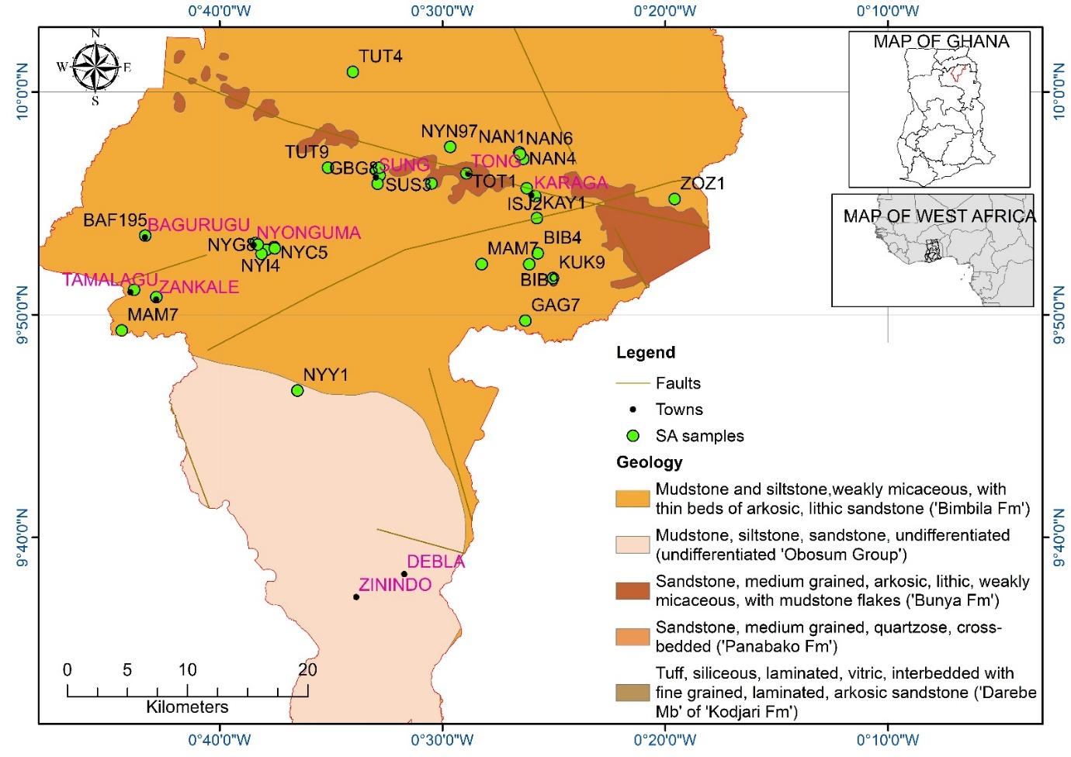
Figure 1. Geological and location map of Karaga District showing the district boundary, settlements, mapped faults, groundwater sampling sites, and the distribution of the principal mapped sedimentary units, with inset location maps of Ghana and West Africa.

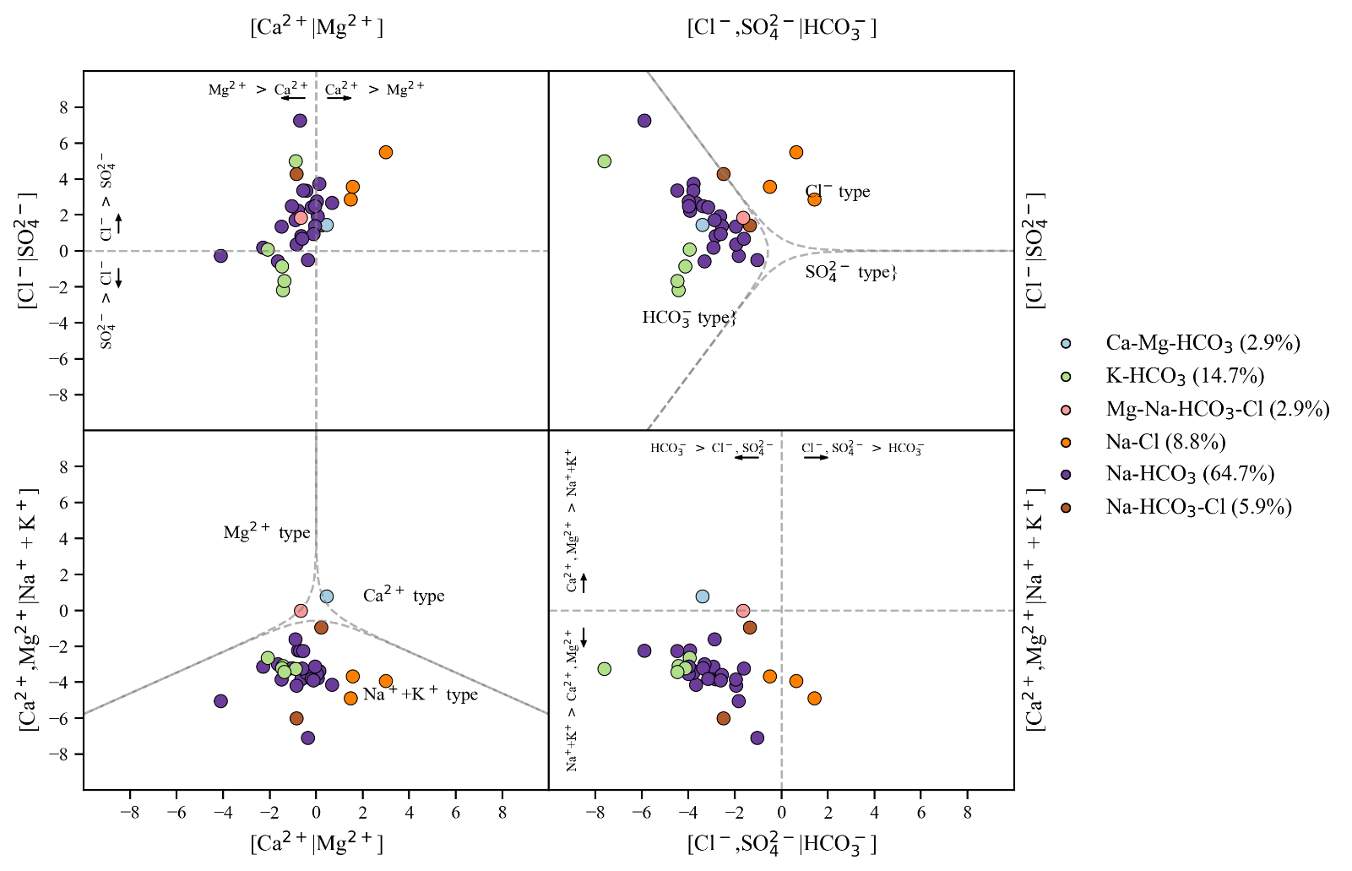
Figure 2. Multi-panel compositional hydrochemical characterisation of 34 groundwater samples, showing facies tendencies and sample separation in transformed major-ion space.

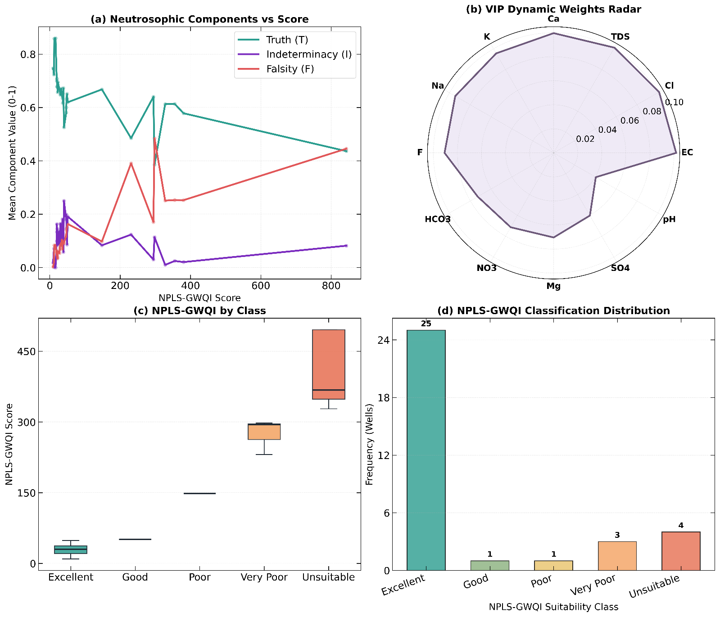
Figure 3. Structural summary of the neutrosophic PLS groundwater quality index (NPLS-GWQI), showing (a) Neutrosophic vs. score behaviour, (b) N-VIP weights (c) NPLS-GWQI by class (d) NPLS-GQWI classification distribution
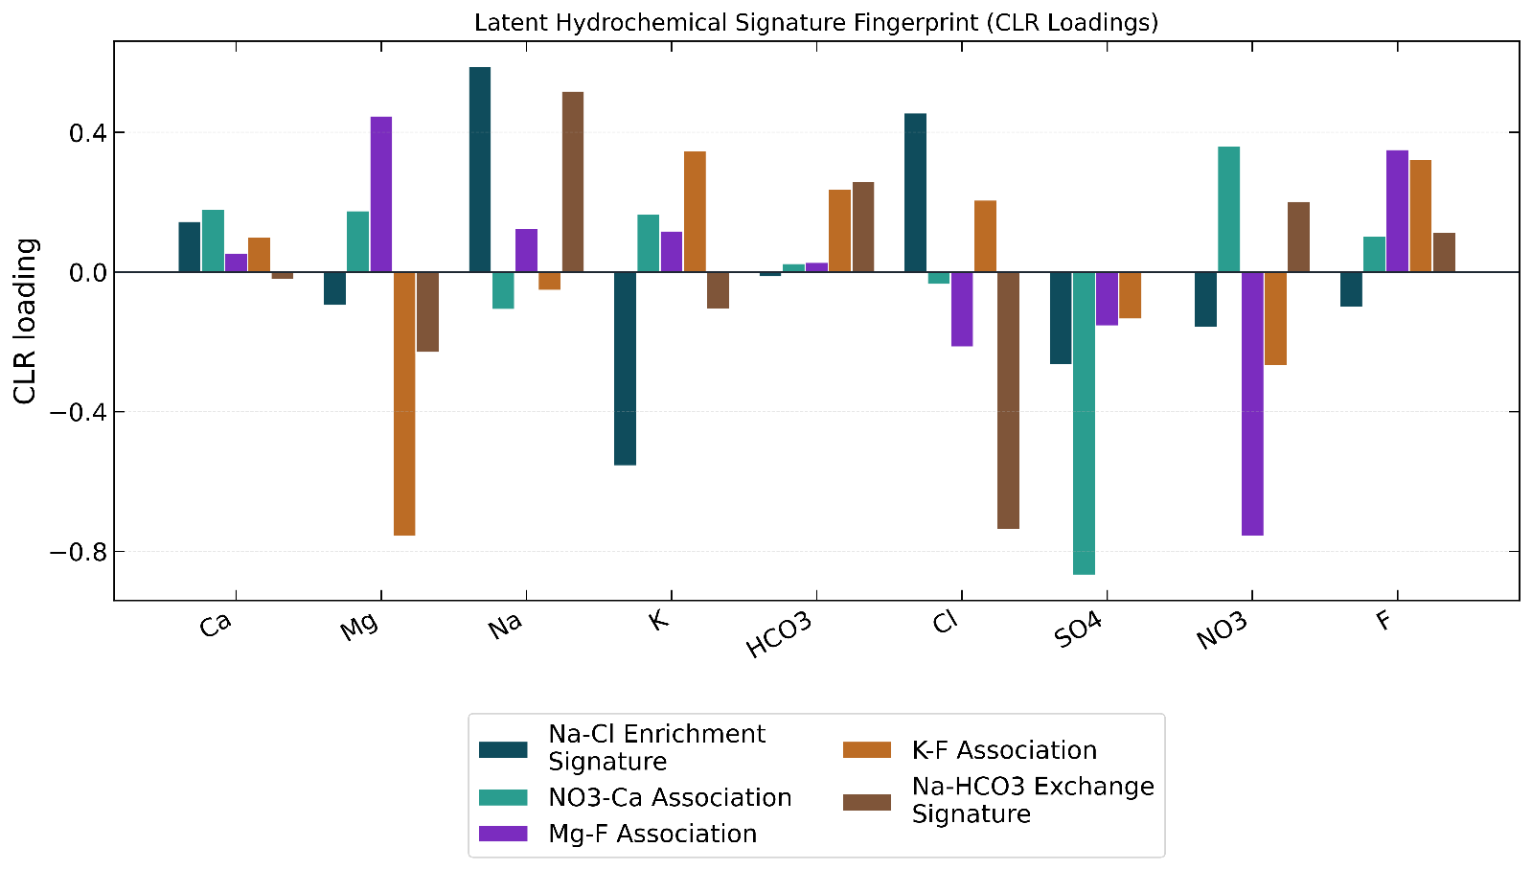
Figure 4. Absolute centred log-ratio (CLR) loading profiles for the five retained latent hydrochemical processes identified by the compositional dimensionality-reduction workflow.
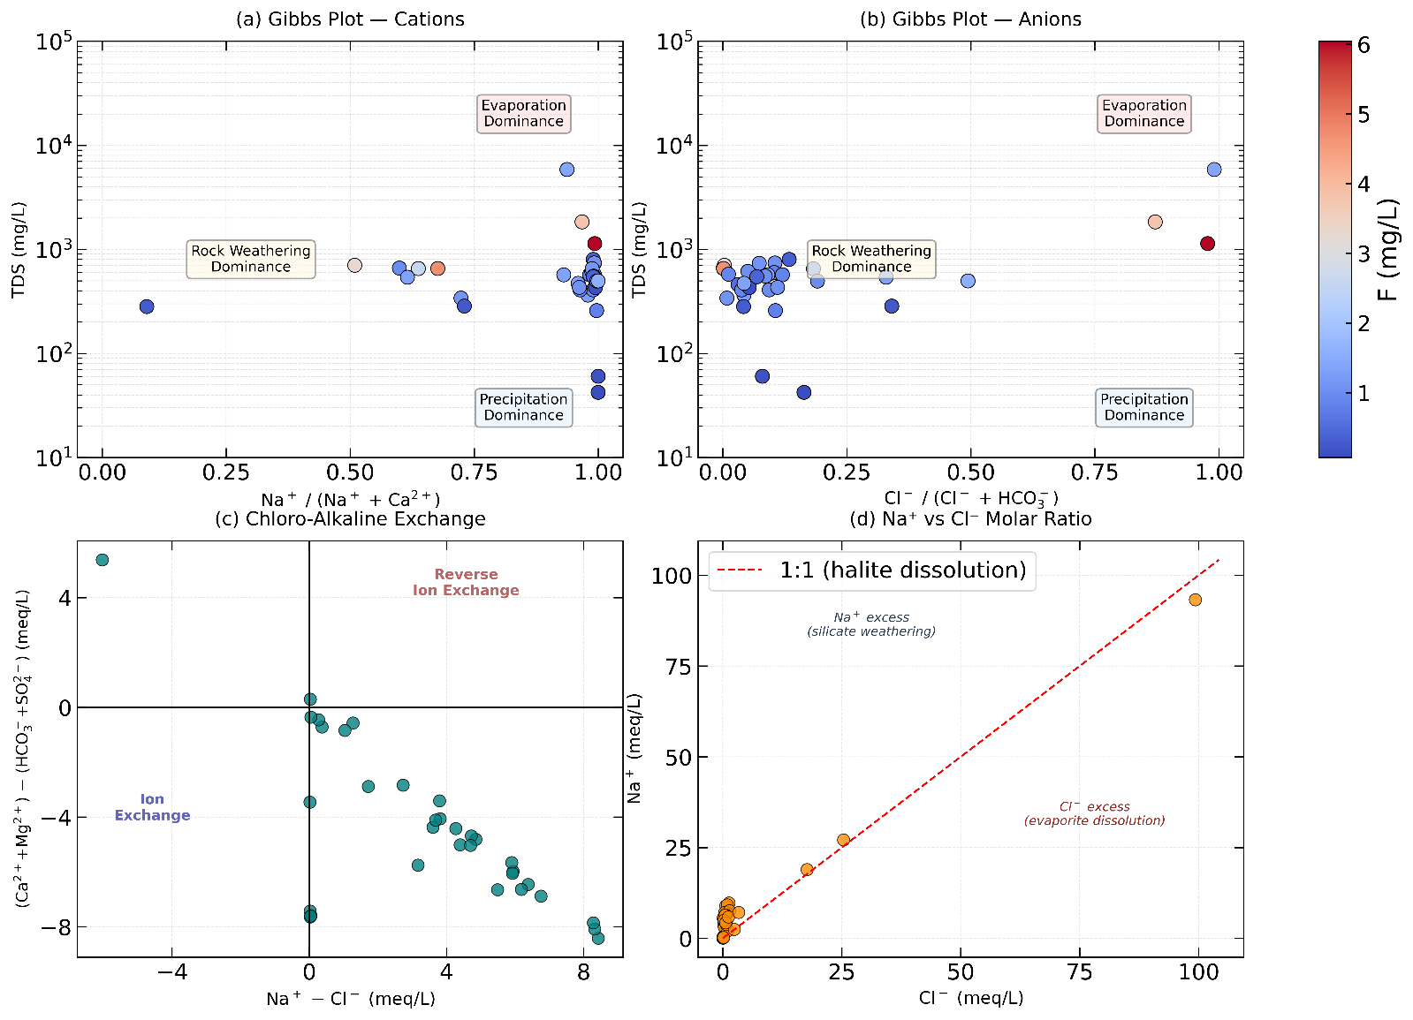
Figure 5. Deterministic geochemical constraint diagnostics showing (a) –(b) Gibbs-plot, (c) chloro-alkaline exchange behaviour, and (d) Na versus Cl molar relationships for the sampled groundwater.

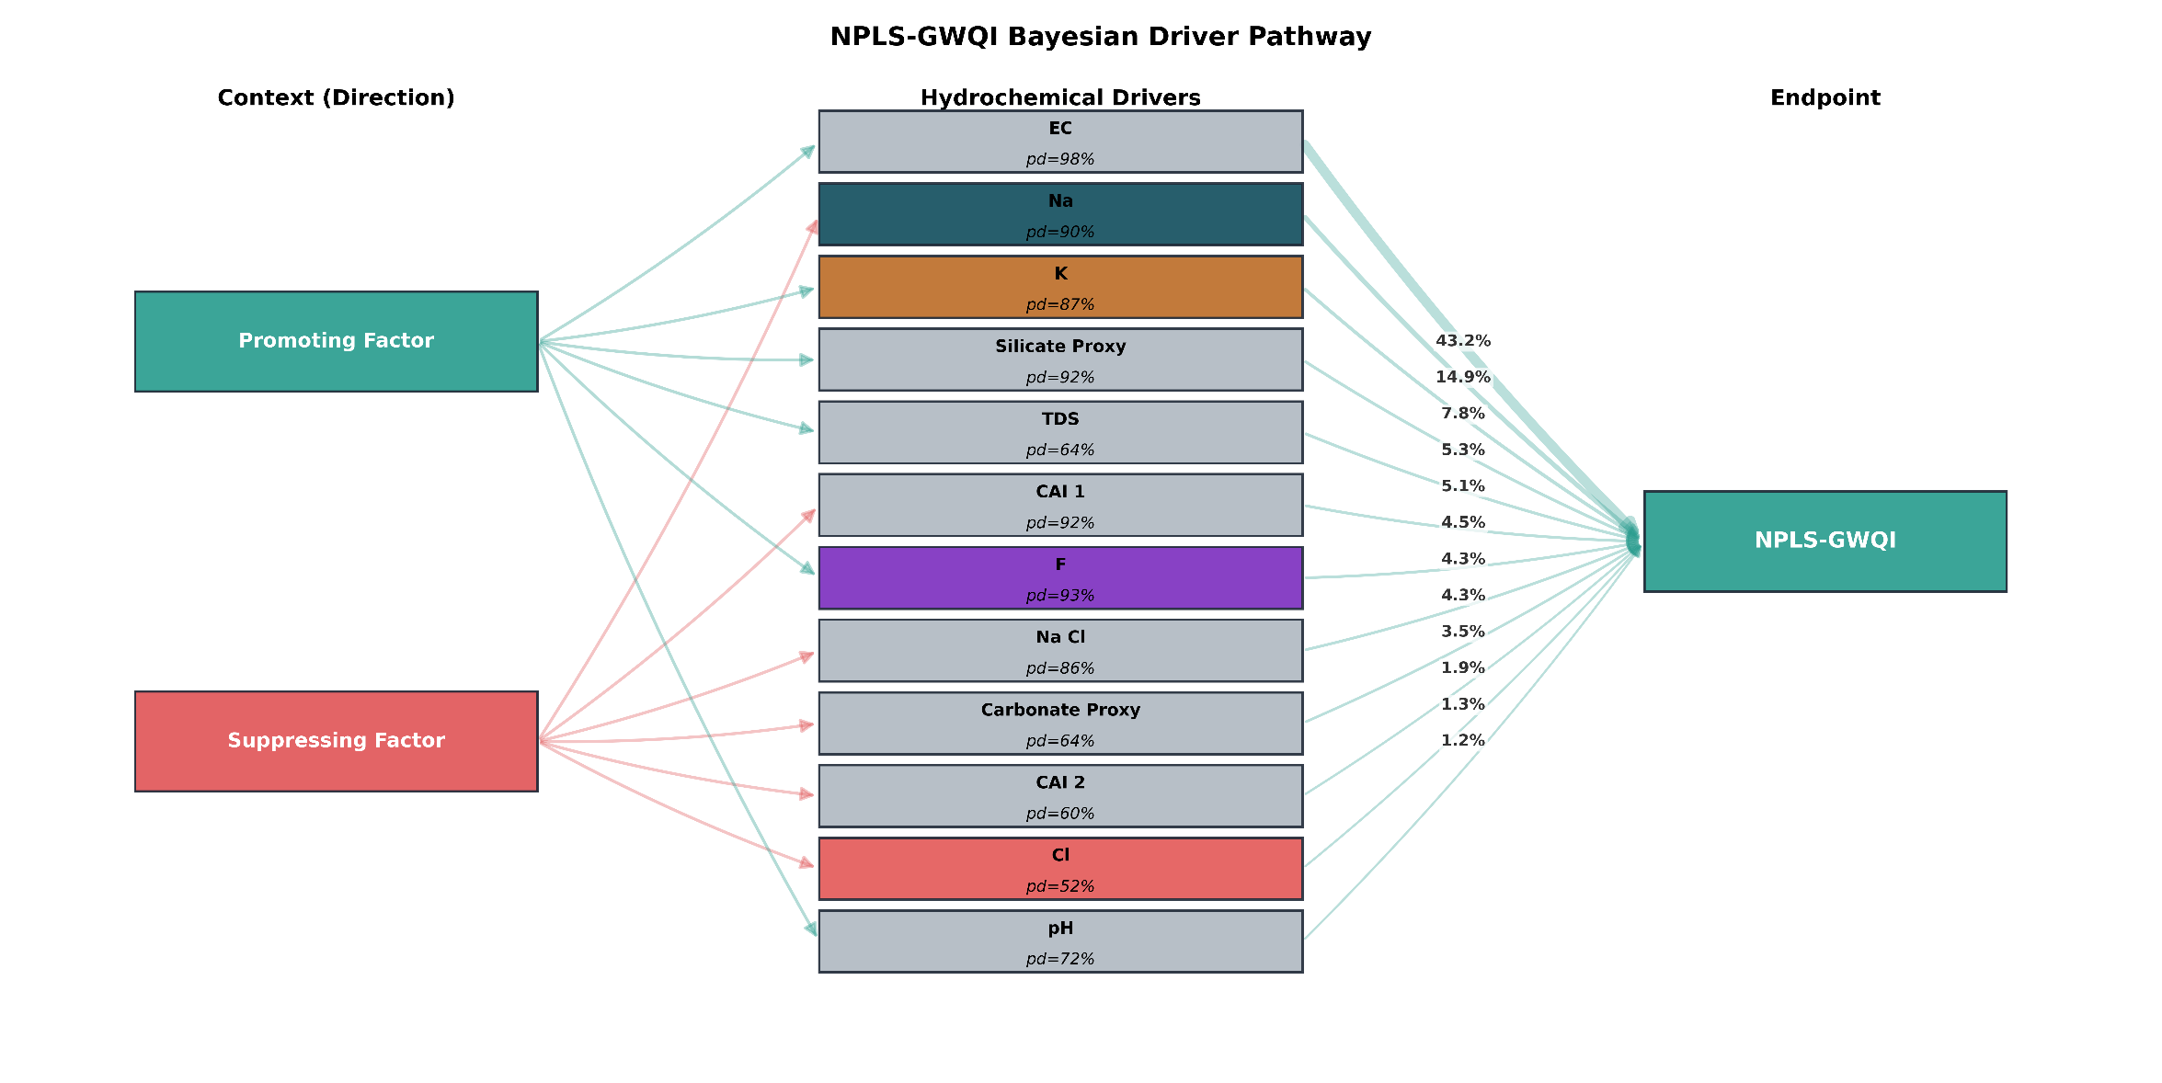
Figure 6. Sankey-style pathway summary of promoting and suppressing hydrochemical drivers of NPLS-GWQI, showing direction class, driver certainty, and relative contribution strength.

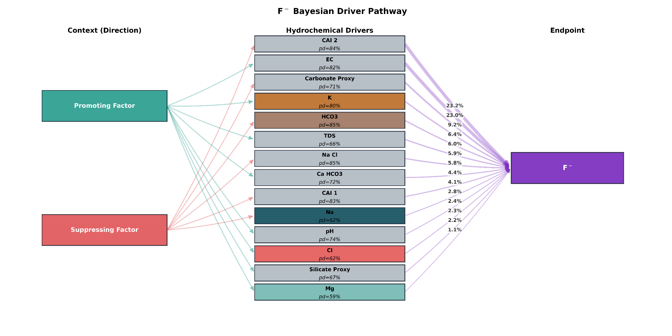
Figure 7. Sankey-style pathway summary of promoting and suppressing hydrochemical drivers of Fluoride, showing direction class, driver certainty, and relative contribution strength.

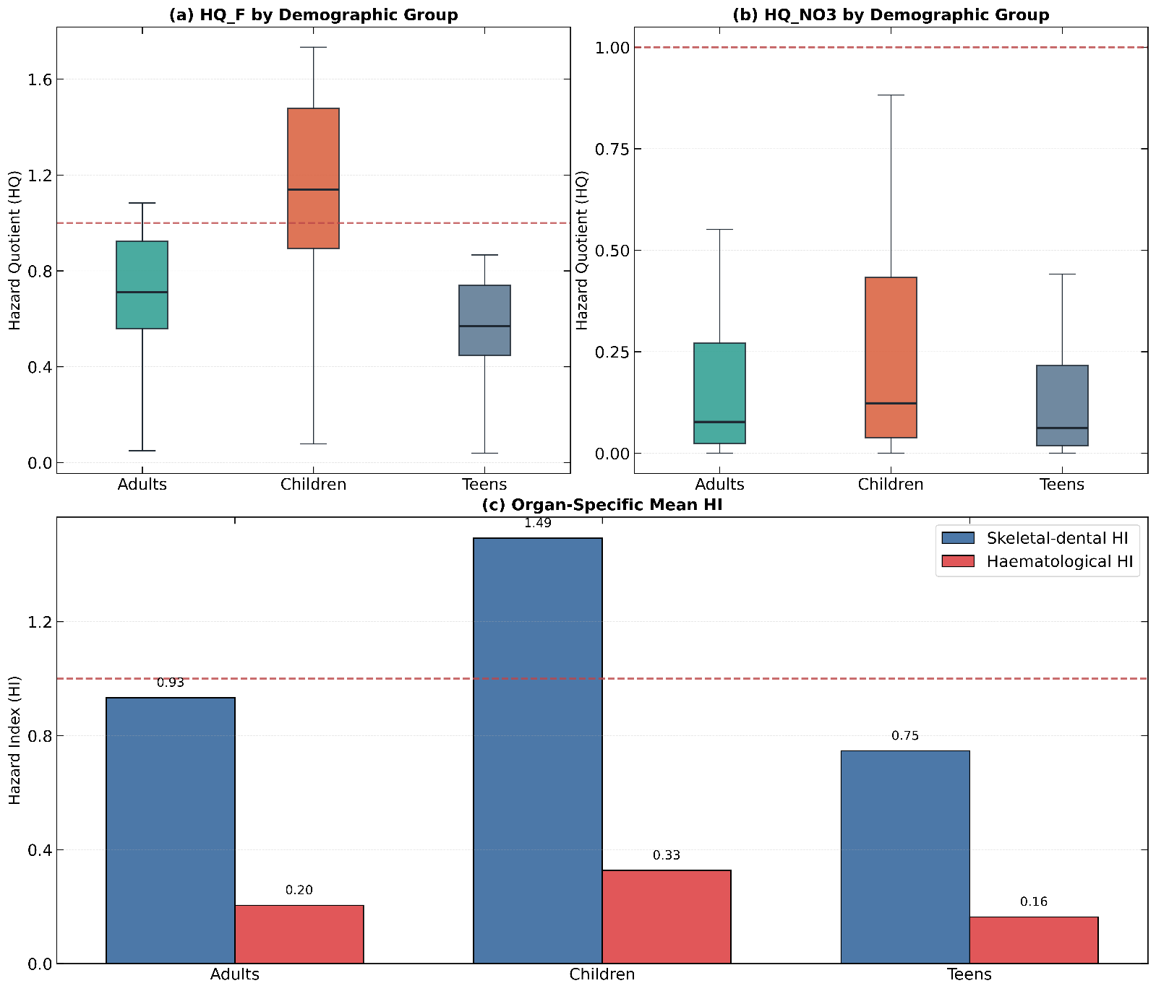
Figure 8. Deterministic non-carcinogenic risk profiles for adults, children, and teens, showing hazard quotients for (a) fluoride and (b) nitrate together with (c) mean health-index burdens by effect group.
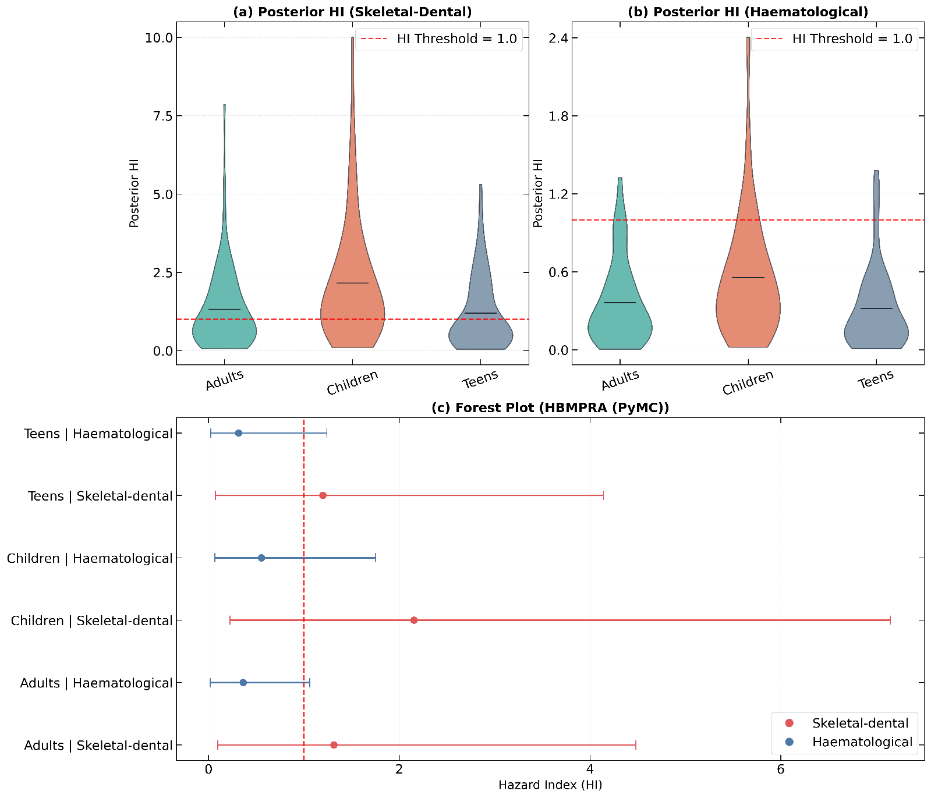
Figure 9. Posterior distributions and interval summaries for Bayesian population-level non-carcinogenic health indices across adults, children, and teens, (a) HI for Skeletal -dental risk (b) ) HI for Haematological risk. (c) Forest plot summarising the results of the HBMPRA
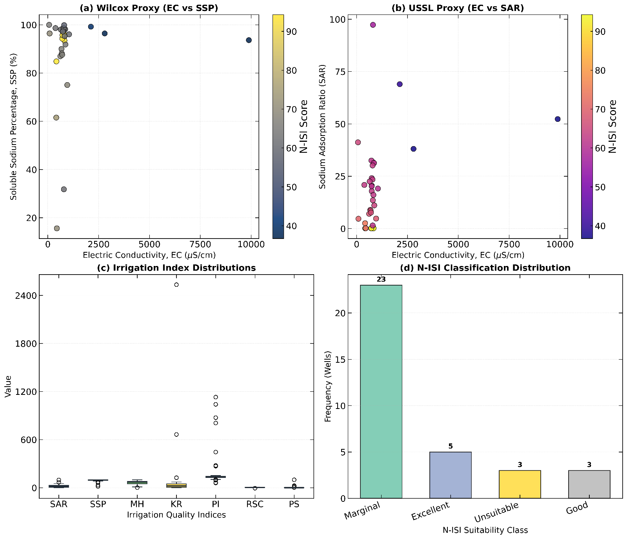
Figure 10. Irrigation suitability diagnostics showing (a) Wilcox proxy and (b) USSL proxy relationships, (c) irrigation-index distributions, and (d) final N-ISI class composition for the groundwater samples.

