Main Text Tables
Table 1. Descriptive statistics for field parameters and major ions in the 34 sampled groundwater sources.
Parameter | Count | Mean | Std | Min | Q1 | Median | Q3 | Max
pH | 34 | 7.57 | 0.55 | 6 | 7.3175 | 7.7 | 7.9 | 8.33
EC | 34 | 1061.91 | 1632.03 | 66.6 | 678 | 744.5 | 827.0 | 9890
TDS (mg/L) | 34 | 618.09 | 829.10 | 46.62 | 369.5 | 427.0 | 552.3 | 4950
Na⁺ (mg/L) | 34 | 183.55 | 368.22 | 1.19 | 50.075 | 111.6 | 164.0 | 2144
K⁺ (mg/L) | 34 | 25.27 | 57.45 | 0.6 | 1.4 | 2.0 | 4.0 | 195
Mg²⁺ (mg/L) | 34 | 4.19 | 8.15 | 0.001 | 1.1 | 1.5 | 5.1 | 46.8
Ca²⁺ (mg/L) | 34 | 7.98 | 22.52 | 0.001 | 0.6 | 1.5 | 2.9 | 125.6
Cl⁻ (mg/L) | 34 | 168.08 | 619.53 | 0.26 | 5.34 | 16.3 | 36.3 | 3520
SO₄²⁻ (mg/L) | 34 | 4.69 | 5.40 | 0.001 | 0.425 | 4.1 | 7.6 | 26.7
HCO₃⁻ (mg/L) | 34 | 310.38 | 143.47 | 19.7 | 229.025 | 316.6 | 426.7 | 520
NO₃⁻ (mg/L) | 34 | 7.84 | 12.27 | 0.001 | 0.9075 | 3.0 | 10.4 | 55
F⁻ (mg/L) | 34 | 1.34 | 1.31 | 0.07 | 0.805 | 1.0 | 1.3 | 6.04

Table 2. Compliance of groundwater parameters with WHO and GSA guideline values, reported as exceedance counts and percentages.
Parameter | Guideline | Exceedance Count | Exceedance Percent | Mean | Max
pH | 6.5-8.5 | 2 | 5.9 | 7.6 | 8.33
EC | 1500 | 3 | 8.8 | 1061.9 | 9890
TDS (mg/L) | 1000 | 3 | 8.8 | 618.1 | 4950
Na⁺ (mg/L) | 200 | 6 | 17.6 | 183.6 | 2144
K⁺ (mg/L) | 12 | 6 | 17.6 | 25.3 | 195
Mg²⁺ (mg/L) | 50 | 0 | 0.0 | 4.2 | 46.8
Ca²⁺ (mg/L) | 75 | 1 | 2.9 | 8.0 | 125.6
Cl⁻ (mg/L) | 250 | 3 | 8.8 | 168.1 | 3520
SO₄²⁻ (mg/L) | 250 | 0 | 0.0 | 4.7 | 26.7
HCO₃⁻ (mg/L) | 300 | 19 | 55.9 | 310.4 | 520
NO₃⁻ (mg/L) | 50 | 1 | 2.9 | 7.8 | 55
F⁻ (mg/L) | 1.5 | 6 | 17.6 | 1.3 | 6.04

Table 3. Classwise summary of NPLS-GWQI scores and neutrosophic membership components for the sampled groundwater.
Quality Class | Sample Count | Mean NPLS GWQI | Mean Indeterminacy
Excellent | 25 | 29.697 | 0.117
Good | 1 | 51.072 | 0.191
Poor | 1 | 148.109 | 0.083
Very Poor | 3 | 274.478 | 0.089
Unsuitable | 4 | 476.532 | 0.034

Table 4. Variable-importance weights for the hydrochemical inputs contributing to the NPLS-GWQI model.
Parameter | N-VIP Dynamic Weight | Rank
EC | 0.1019 | 1
Cl | 0.1012 | 2
TDS | 0.1011 | 3
Ca | 0.0996 | 4
K | 0.0956 | 5
Na | 0.0945 | 6
F | 0.0907 | 7
HCO3 | 0.0729 | 8
NO3 | 0.0714 | 9
Mg | 0.0704 | 10
SO4 | 0.0602 | 11
pH | 0.0405 | 12

Table 5. Parallel-analysis results used to determine the number of retained compositional components.
Component | Observed Eigenvalue | Random 95th Eigenvalue | Retained
PC1 | 10.05 | 2.39 | TRUE
PC2 | 6.81 | 1.86 | TRUE
PC3 | 5.11 | 1.50 | TRUE
PC4 | 2.43 | 1.24 | TRUE
PC5 | 1.31 | 1.01 | TRUE
PC6 | 0.48 | 0.81 | FALSE
PC7 | 0.33 | 0.62 | FALSE
PC8 | 0.16 | 0.48 | FALSE

Table 6. Centred log-ratio loading structure and process labels for the five retained hydrochemical components.
Process | Ca²⁺ | Mg²⁺ | Na⁺ | K⁺ | HCO₃⁻ | Cl⁻ | SO₄²⁻ | NO₃⁻ | F⁻ | Probable Process  Name
Process 1 | 0.146 | -0.096 | 0.589 | -0.555 | -0.014 | 0.456 | -0.266 | -0.159 | -0.101 | Na-Cl Enrichment  Signature
Process 2 | 0.180 | 0.176 | -0.108 | 0.166 | 0.025 | -0.036 | -0.868 | 0.362 | 0.104 | NO₃-Ca Association
Process 3 | 0.055 | 0.448 | 0.125 | 0.118 | 0.028 | -0.215 | -0.154 | -0.757 | 0.352 | Mg-F Association
Process 4 | 0.100 | -0.757 | -0.053 | 0.348 | 0.237 | 0.206 | -0.135 | -0.268 | 0.322 | K-F Association
Process 5 | -0.020 | -0.231 | 0.519 | -0.106 | 0.259 | -0.738 | 0.001 | 0.203 | 0.114 | Na-HCO₃ Exchange  Signature

Table 7. Summary of deterministic geochemical diagnostic metrics, including exchange-weathering proxies.
SampleID | Silicate  Index | Carbonate  Index | Na:Cl | $$CAI_{1}$$ | $$CAI_{2}$$ | Exchange X | Exchange Y
KAY1 | 0.96 | 0.04 | 21.27 | -20.55 | -0.91 | 3.81 | -4.06
NYI4 | 0.98 | 0.02 | 7.40 | -6.43 | -0.98 | 8.43 | -8.42
SUS3 | 0.97 | 0.03 | 10.08 | -9.15 | -0.94 | 4.27 | -4.42
GBG8 | 0.98 | 0.02 | 14.01 | -13.08 | -1.01 | 8.32 | -8.08
TOT1 | 0.99 | 0.37 | 1.07 | -0.07 | -1.15 | 1.28 | -0.57
NAN1 | 0.98 | 0.02 | 9.81 | -8.84 | -1.03 | 8.28 | -7.85
NAN4 | 0.98 | 0.03 | 9.48 | -8.53 | -0.97 | 6.38 | -6.46
MAM7 | 0.97 | 0.04 | 8.02 | -7.07 | -0.96 | 5.94 | -5.98
BIB4 | 0.97 | 0.03 | 18.97 | -18.07 | -0.96 | 6.76 | -6.89
MAM7 | 0.94 | 6.81 | 0.94 | 0.06 | 5.93 | -6.04 | 5.38
ZAZ165 | 0.93 | 0.04 | 7.12 | -581.52 | -0.53 | 0.04 | -7.59
TAT170 | 0.94 | 0.04 | 2.01 | -166.75 | -0.56 | 0.03 | -7.42
BAF195 | 0.96 | 0.03 | 2.16 | -209.17 | -0.61 | 0.03 | -7.64
NYG170 | 0.96 | 0.03 | 5.29 | -444.68 | -0.56 | 0.04 | -7.60
LAL85 | 0.85 | 0.10 | 1.62 | -68.23 | -0.54 | 0.02 | -3.45
TUT4 | 0.92 | 0.07 | 69.01 | -69.28 | -0.78 | 5.49 | -6.65
NYC5 | 0.90 | 0.10 | 26.72 | -26.39 | -0.81 | 4.40 | -5.01
SUJ7 | 0.87 | 0.12 | 19.50 | -18.86 | -0.74 | 3.61 | -4.37
ISJ2 | 0.96 | 0.05 | 5.32 | -4.38 | -0.90 | 6.18 | -6.64
DAN4 | 0.99 | 0.02 | 9.58 | -8.69 | -0.96 | 2.73 | -2.84
KPK6 | 0.96 | 0.03 | 7.63 | -6.91 | -0.48 | 0.37 | -0.71
BIB9 | 1.00 | 0.00 | 5.30 | -5.07 | -0.61 | 0.27 | -0.45
KAP2 | 0.62 | 0.66 | 1.99 | -1.04 | -0.38 | 1.04 | -0.84
GBG2 | 0.98 | 0.02 | 18.84 | -18.03 | -1.00 | 4.86 | -4.81
NAN6 | 0.75 | 0.19 | 5.53 | -4.63 | -0.45 | 3.17 | -5.75
GAG7 | 0.32 | 1.10 | 1.01 | -0.04 | -0.02 | 0.03 | 0.30
TUT9 | 0.95 | 0.05 | 11.57 | -10.66 | -0.96 | 5.91 | -5.66
NYG8 | 0.99 | 0.01 | 14.13 | -13.23 | -0.96 | 5.93 | -6.05
NYG9 | 0.16 | 0.90 | 1.33 | -2.80 | -0.12 | 0.05 | -0.36
ZOZ1 | 0.88 | 0.13 | 20.70 | -19.82 | -0.86 | 4.72 | -4.68
NYY1 | 0.96 | 0.27 | 1.07 | -0.07 | -0.38 | 1.72 | -2.88
KUK9 | 0.88 | 0.13 | 7.28 | -6.45 | -0.77 | 3.68 | -4.11
NYN97 | 0.97 | 0.03 | 4.97 | -3.99 | -0.91 | 4.70 | -5.03
SUG03 | 1.00 | 0.00 | 2.14 | -1.15 | -1.09 | 3.80 | -3.40

Table 8a. Bayesian driver summaries for NPLS-GWQI, reporting posterior direction, directional certainty, and normalised contribution share.
Predictor | Driver Score  Percent | Prob Direction  Percent | Beta Mean | Beta HDI  Lower | Beta HDI  Upper | Model  R²
EC | 43.18 | 98.00 | 0.88 | 0.01 | 1.61 | 0.98
Na | 14.86 | 90.25 | -0.30 | -0.70 | 0.04 | 0.98
K | 7.77 | 86.60 | 0.16 | -0.05 | 0.49 | 0.98
Silicate Proxy | 5.27 | 91.80 | 0.11 | -0.02 | 0.27 | 0.98
TDS | 5.06 | 63.80 | 0.10 | -0.21 | 0.82 | 0.98
$CAI_{1}$ | 4.52 | 91.95 | -0.09 | -0.23 | 0.02 | 0.98
F | 4.33 | 93.40 | 0.09 | -0.01 | 0.21 | 0.98
Na/Cl | 4.29 | 86.00 | -0.09 | -0.32 | 0.04 | 0.98
Carbonate Proxy | 3.46 | 63.80 | -0.07 | -0.52 | 0.19 | 0.98
$CAI_{2}$ | 1.87 | 60.45 | -0.04 | -0.42 | 0.23 | 0.98
Cl | 1.29 | 51.95 | -0.03 | -0.45 | 0.22 | 0.98
pH | 1.21 | 72.30 | 0.02 | -0.05 | 0.12 | 0.98
Mg | 0.86 | 62.00 | -0.02 | -0.15 | 0.08 | 0.98
Mg/Ca | 0.79 | 61.90 | -0.02 | -0.14 | 0.09 | 0.98
NO₃ | 0.59 | 63.85 | 0.01 | -0.05 | 0.09 | 0.98
SO₄ | 0.23 | 56.00 | 0.00 | -0.05 | 0.07 | 0.98
Ca | 0.20 | 50.45 | 0.00 | -0.15 | 0.19 | 0.98
HCO₃ | 0.19 | 52.10 | 0.00 | -0.11 | 0.09 | 0.98
Ca/HCO₃ | 0.00 | 51.35 | 0.00 | -0.17 | 0.17 | 0.98

Table 8b. Bayesian driver summaries for fluoride, reporting posterior direction, directional certainty, and normalised contribution share.
Predictor | Driver Score  Percent | Prob Direction  Percent | Beta Mean | Beta HDI  Lower | Beta HDI  Upper | Model  R²
CAI_2 | 23.16 | 83.85 | -0.88 | -2.80 | 0.18 | 0.69
EC | 22.96 | 81.60 | 0.87 | -0.24 | 2.92 | 0.69
Carbonate Proxy | 9.22 | 70.70 | -0.35 | -1.95 | 0.51 | 0.69
K | 6.40 | 79.75 | 0.24 | -0.13 | 1.00 | 0.69
HCO3 | 5.99 | 85.40 | -0.23 | -0.73 | 0.08 | 0.69
TDS | 5.91 | 65.85 | 0.22 | -0.47 | 1.51 | 0.69
Na_Cl | 5.76 | 84.80 | -0.22 | -0.68 | 0.10 | 0.69
Ca_HCO3 | 4.37 | 72.00 | 0.17 | -0.26 | 1.01 | 0.69
CAI_1 | 4.15 | 82.75 | -0.16 | -0.57 | 0.12 | 0.69
Na | 2.80 | 61.75 | -0.11 | -0.95 | 0.59 | 0.69
pH | 2.39 | 74.30 | 0.09 | -0.12 | 0.41 | 0.69
Cl | 2.31 | 62.00 | 0.09 | -0.44 | 0.88 | 0.69
Silicate Proxy | 2.17 | 66.80 | 0.08 | -0.24 | 0.54 | 0.69
Mg | 1.11 | 59.15 | 0.04 | -0.27 | 0.46 | 0.69
Mg_Ca | 0.79 | 57.30 | 0.03 | -0.31 | 0.43 | 0.69
SO4 | 0.33 | 54.60 | -0.01 | -0.20 | 0.14 | 0.69
Ca | 0.18 | 52.00 | -0.01 | -0.65 | 0.58 | 0.69

Table 9. Comparative diagnostics for the endpoint models, including feature sparsity and in-sample or cross-validated fit summaries.
Endpoint | Model  Type | Predictor  Block | Features  Count | Features | In Sample  _R² | CV R²  Mean | Permutation p
NPLS  GWQI | Bayesian  Horseshoe | Field +  Compositional | 1 | EC | 0.978
F | Bayesian  Horseshoe | Field +  Compositional | 0 |  | 0.693
F SPLS | Sparse PLS | Field +  Compositional | 8 | Na_Cl; K; CAI_1; pH;  Mg_Ca; Ca_HCO3;  TDS; EC | 0.288 | -3.023 | 0.619

Table 10. Deterministic hazard quotients and health-index summaries for adults, children, and teens exposed to groundwater fluoride and nitrate.
Demographic Group | Adults | Children | Teens
$HQ_{F}$ Mean | 0.933 | 1.493 | 0.746
$HQ_{F}$ P95 | 2.862 | 4.579 | 2.290
$HQ_{NO_{3}}$ Mean | 0.204 | 0.327 | 0.163
$HQ_{NO_{3}}$ P95 | 0.831 | 1.330 | 0.665
HI Skeletal Dental Mean | 0.933 | 1.493 | 0.746
HI Hemato Mean | 0.204 | 0.327 | 0.163

Table 11. Bayesian posterior summaries of non-carcinogenic health indices for adults, children, and teens.
Demographic Group | Organ System | Mean HI | CI 2.5 | CI 97.5 | P(HI>1)
Adults | skeletal dental | 1.32 | 0.10 | 4.48 | 0.46
Adults | hemato | 0.36 | 0.02 | 1.06 | 0.05
Children | skeletal dental | 2.16 | 0.23 | 7.15 | 0.69
Children | hemato | 0.56 | 0.07 | 1.75 | 0.16
Teens | skeletal dental | 1.20 | 0.07 | 4.14 | 0.40
Teens | hemato | 0.32 | 0.02 | 1.24 | 0.08

Table 12. Entropy weights of irrigation indices and
irrigation indices | Entropy weights
SAR | 0.07
SSP | 0.01
MH | 0.01
KR | 0.26
PI | 0.35
RSC | 0.03
PS | 0.27

Table 13. final class distribution for the neutrosophic irrigation suitability index (N-ISI).
Final class | Percentage | Counts
Marginal | 67.65 | 23
Excellent | 14.71 | 5
Unsuitable | 8.82 | 3
Good | 8.82 | 3

Main Text Figures
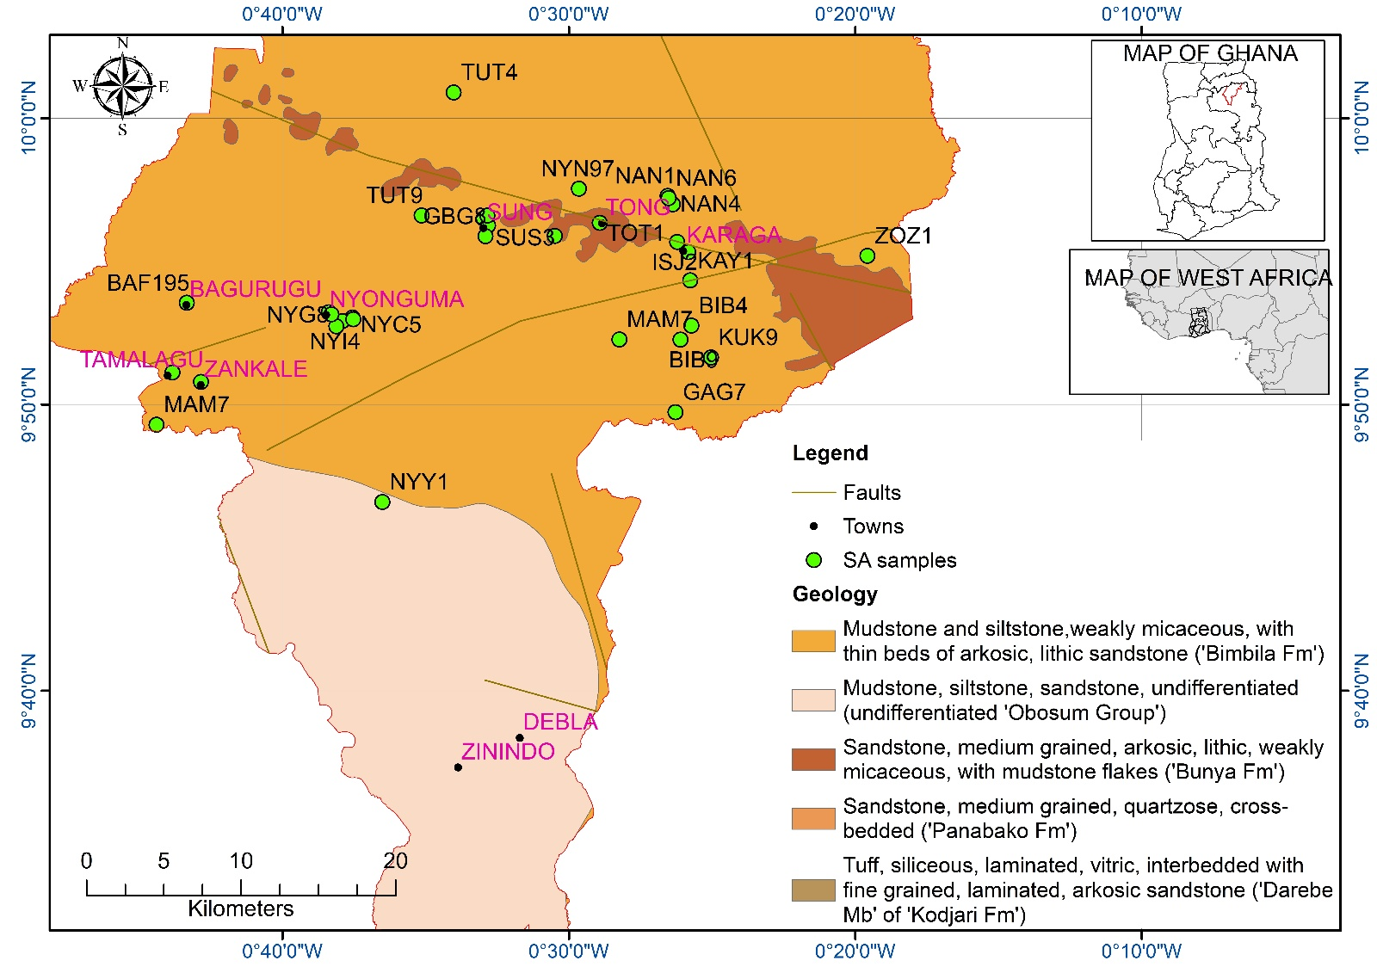
Figure 1. Geological and location map of Karaga District showing the district boundary, settlements, mapped faults, groundwater sampling sites, and the distribution of the principal mapped sedimentary units, with inset location maps of Ghana and West Africa.

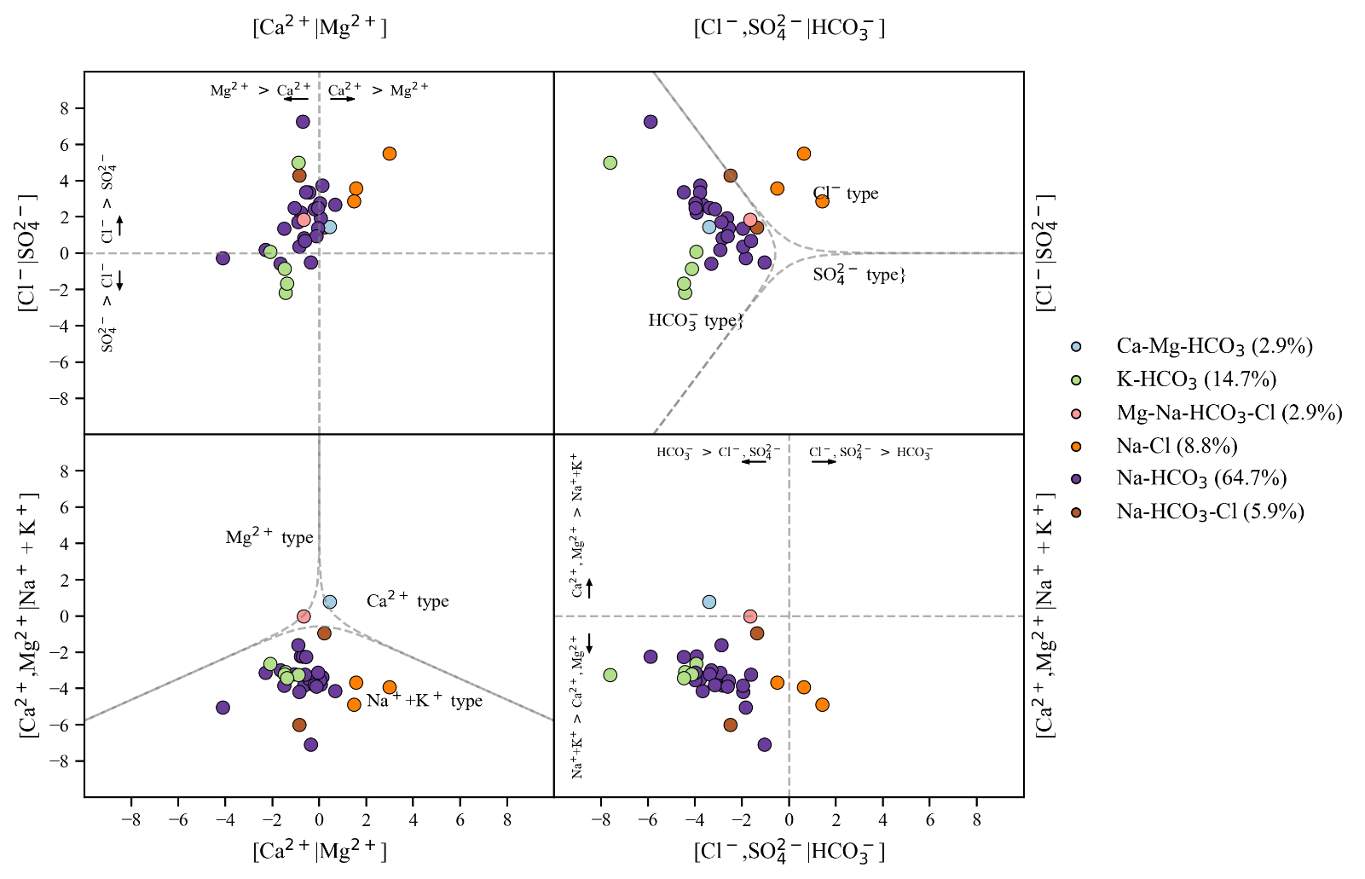
Figure 2. Multi-panel compositional hydrochemical characterisation of 34 groundwater samples, showing facies tendencies and sample separation in transformed major-ion space.

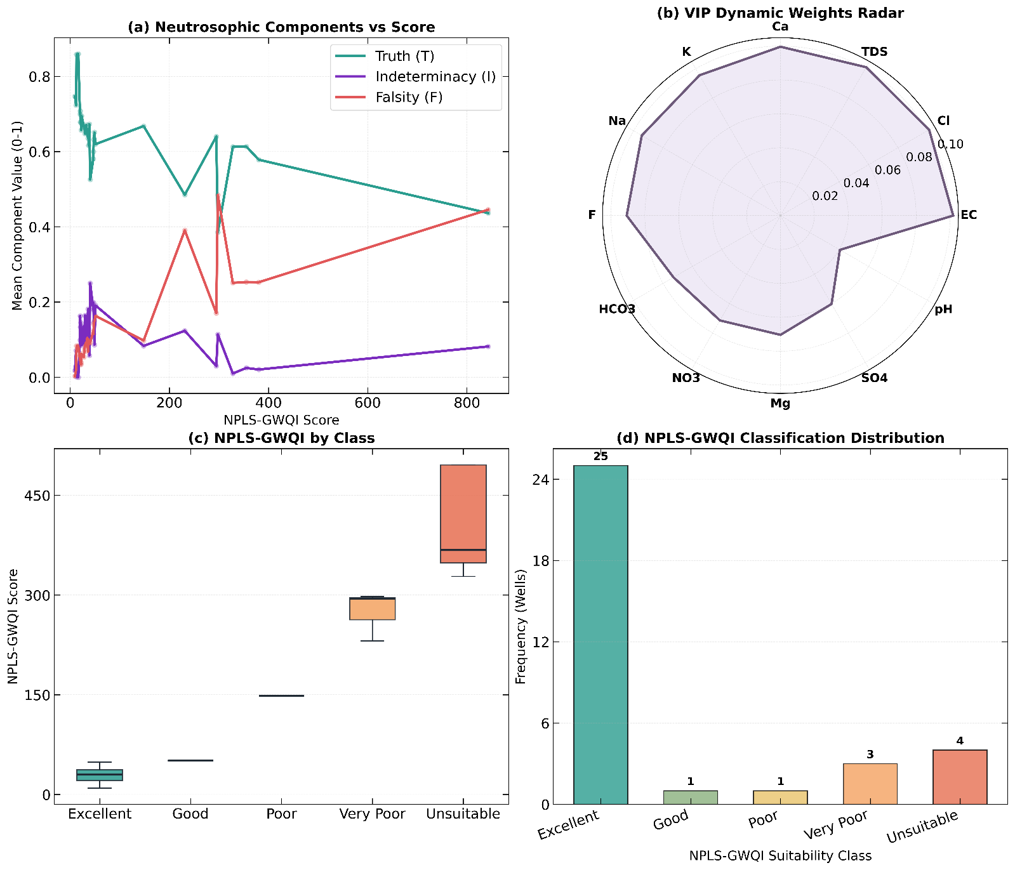
Figure 3. Structural summary of the neutrosophic PLS groundwater quality index (NPLS-GWQI), showing (a) Neutrosophic vs. score behaviour, (b) N-VIP weights (c) NPLS-GWQI by class (d) NPLS-GQWI classification distribution
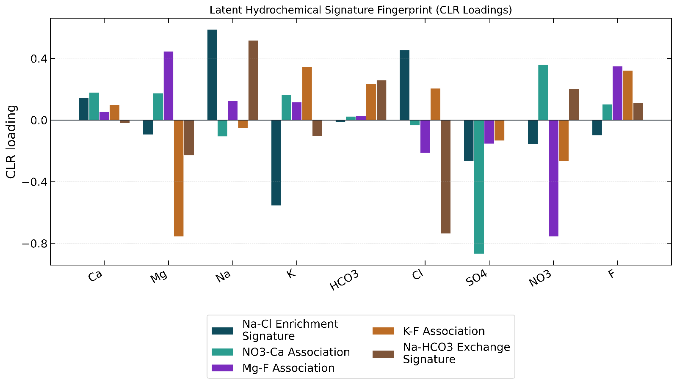
Figure 4. Absolute centred log-ratio (CLR) loading profiles for the five retained latent hydrochemical processes identified by the compositional dimensionality-reduction workflow.
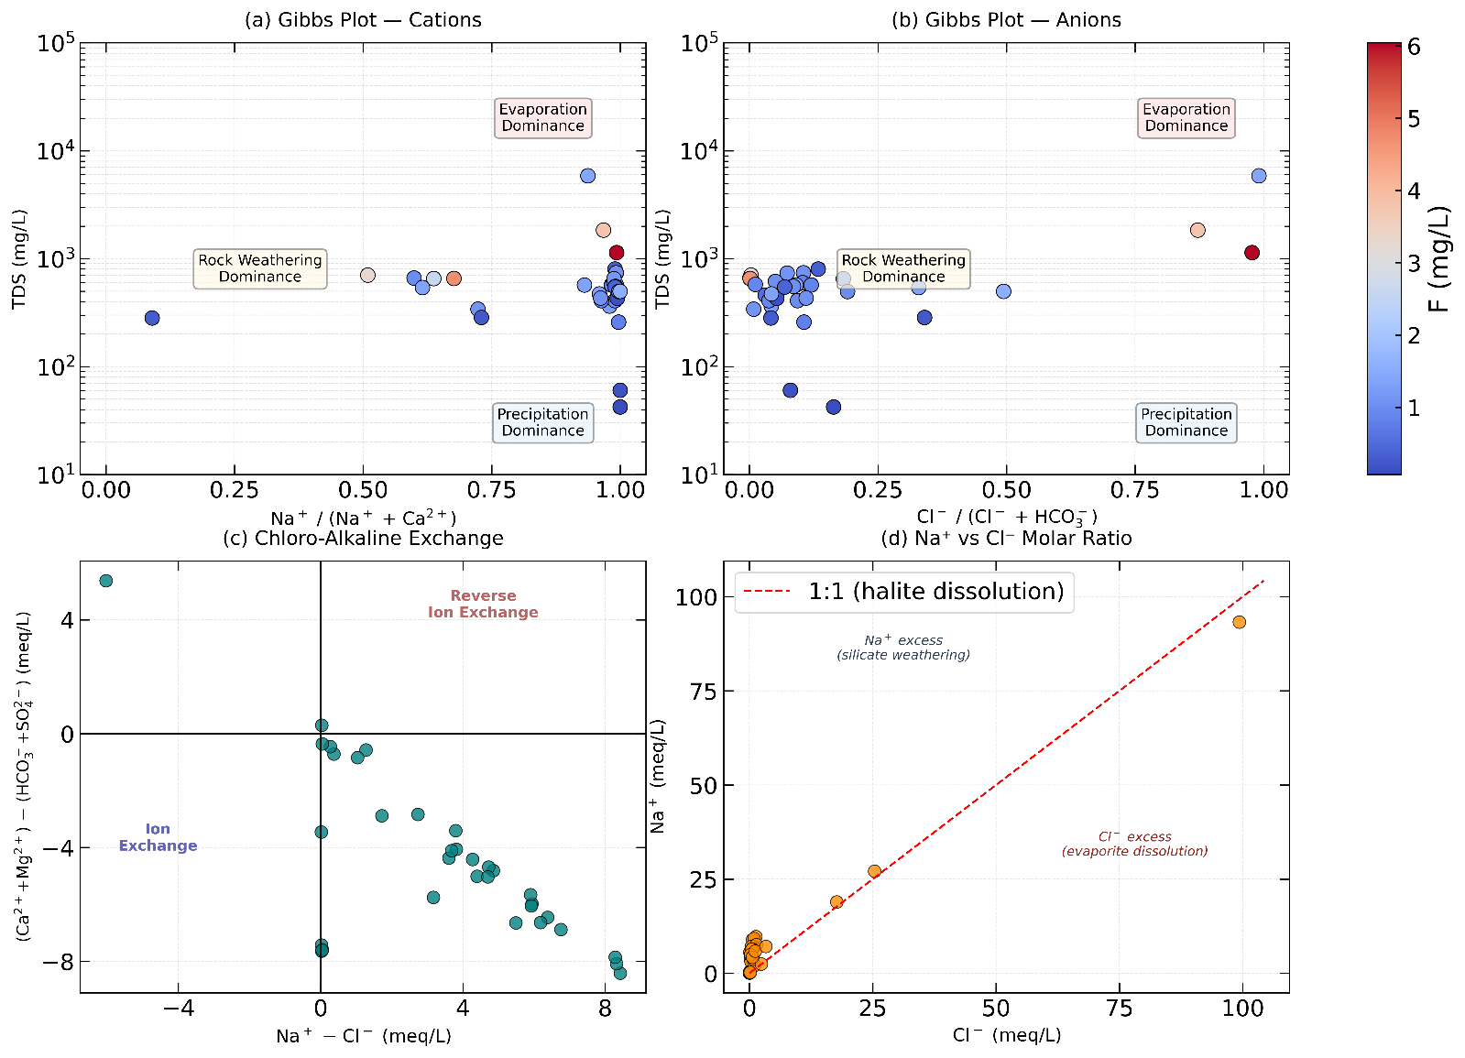
Figure 5. Deterministic geochemical constraint diagnostics showing (a) –(b) Gibbs-plot, (c) chloro-alkaline exchange behaviour, and (d) Na versus Cl molar relationships for the sampled groundwater.
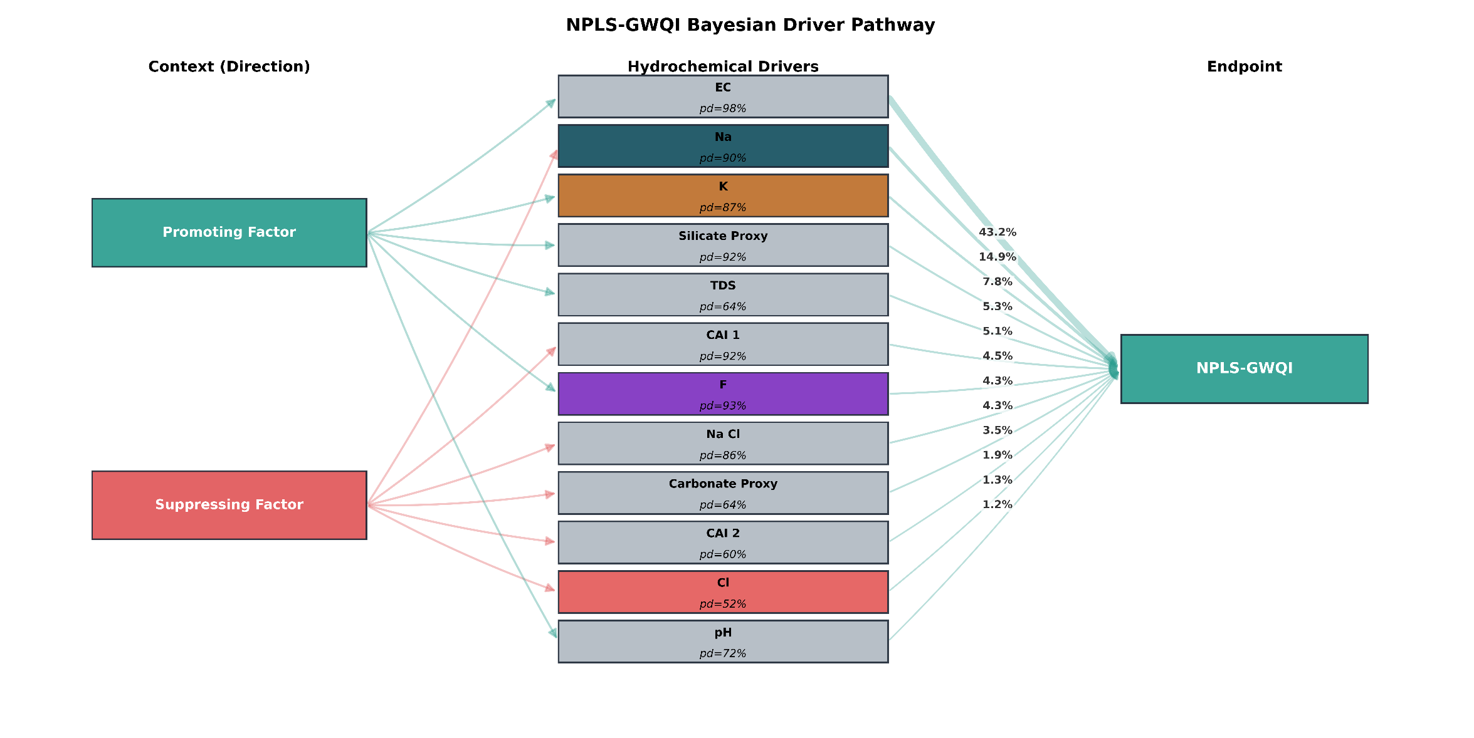
Figure 6. Sankey-style pathway summary of promoting and suppressing hydrochemical drivers of NPLS-GWQI, showing direction class, driver certainty, and relative contribution strength.

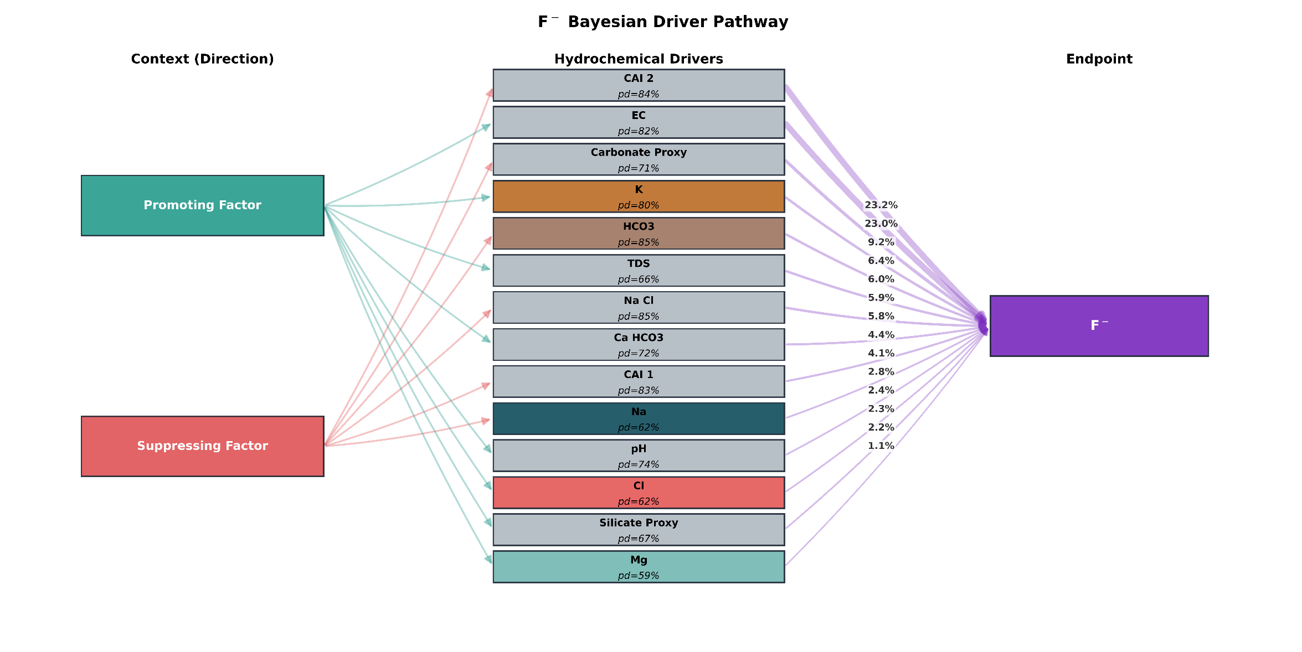
Figure 7. Sankey-style pathway summary of promoting and suppressing hydrochemical drivers of Fluoride, showing direction class, driver certainty, and relative contribution strength.

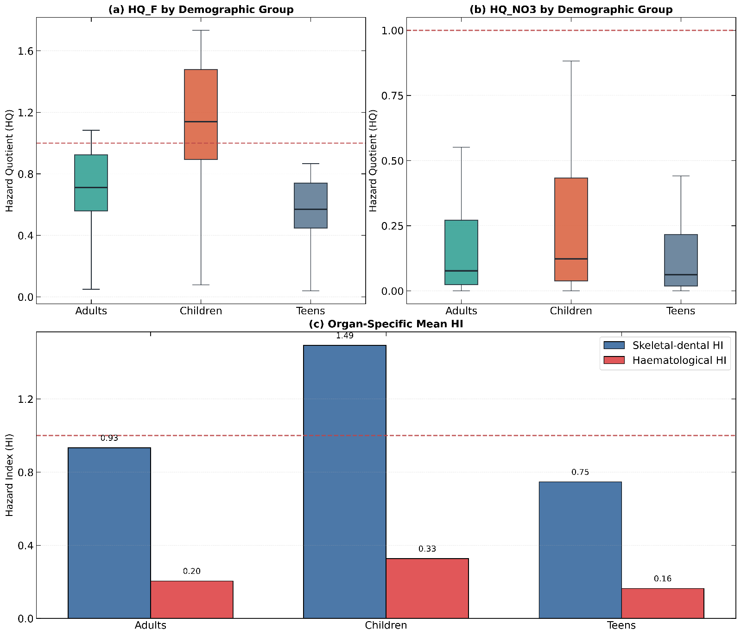
Figure 8. Deterministic non-carcinogenic risk profiles for adults, children, and teens, showing hazard quotients for (a) fluoride and (b) nitrate together with (c) mean health-index burdens by effect group.
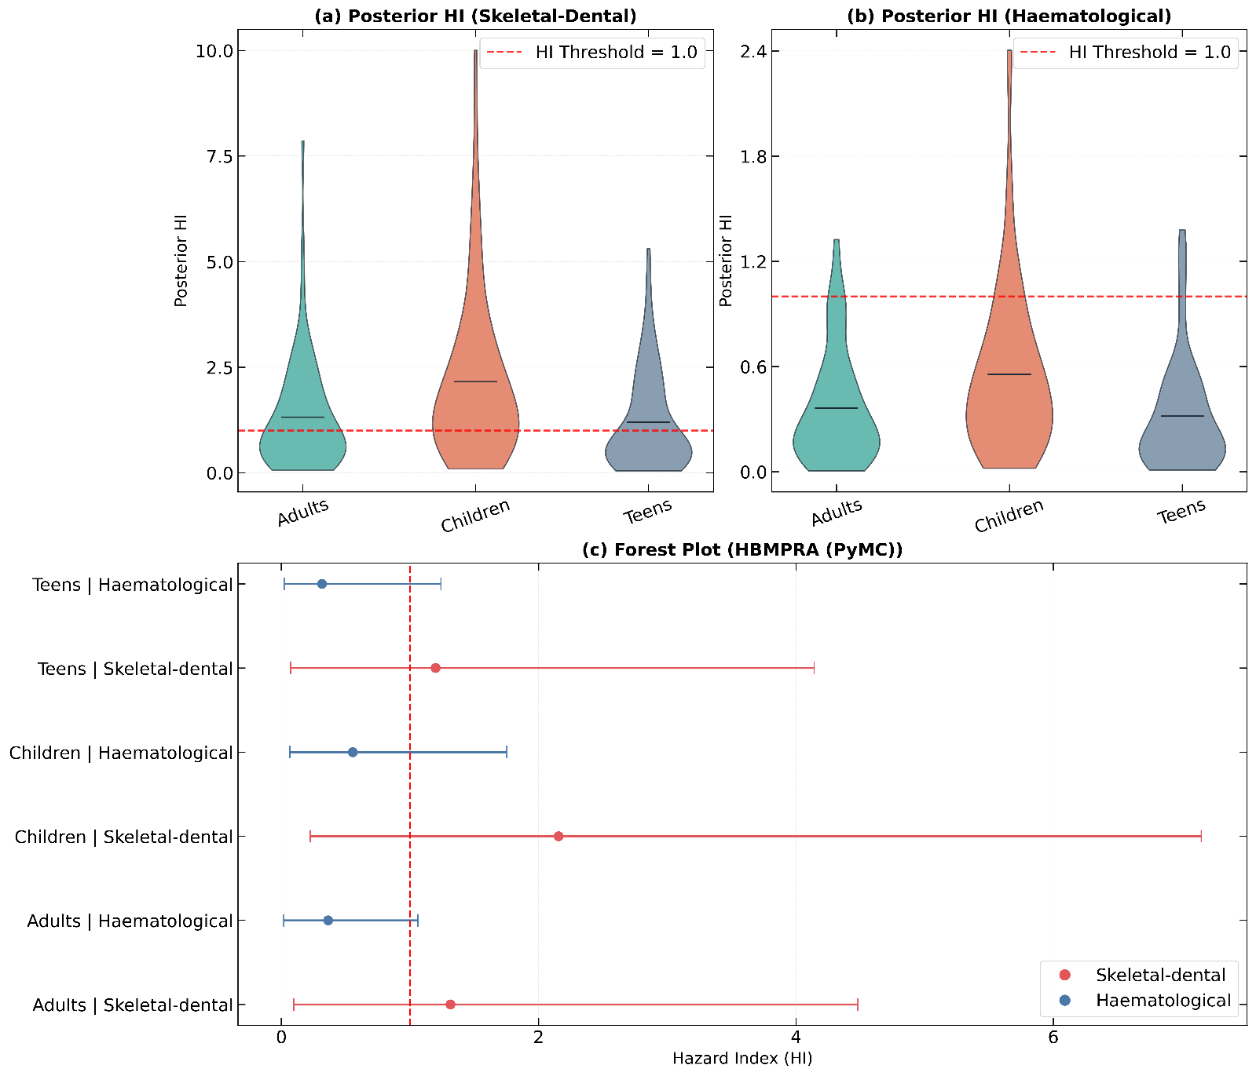
Figure 9. Posterior distributions and interval summaries for Bayesian population-level non-carcinogenic health indices across adults, children, and teens, (a) HI for Skeletal -dental risk (b) ) HI for Haematological risk. (c) Forest plot summarising the results of the HBMPRA
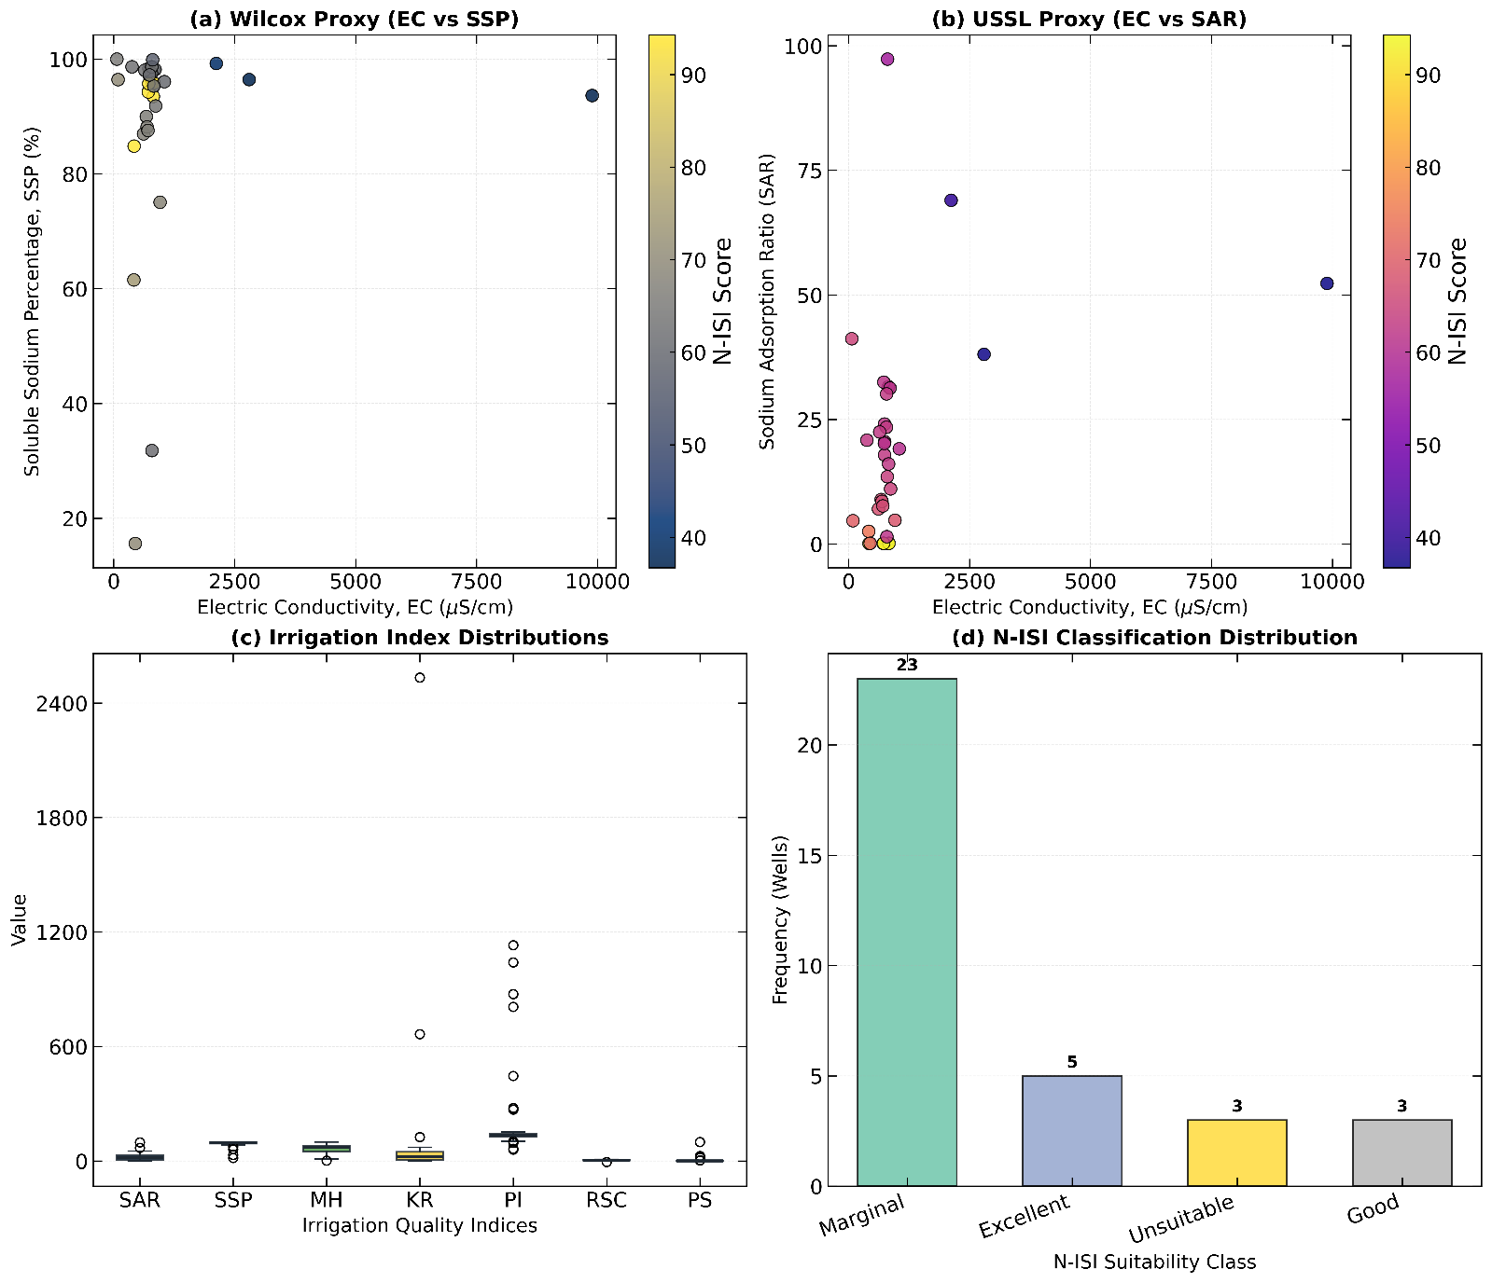
Figure 10. Irrigation suitability diagnostics showing (a) Wilcox proxy and (b) USSL proxy relationships, (c) irrigation-index distributions, and (d) final N-ISI class composition for the groundwater samples.

