2025 - 2026
Linux web & Network Services
db-k8s-stack - Repository Documentation

Inhoud
Executive Summary 6
1. Repository Overview 7
1.1. Purpose and Scope 7
1.2. Core Technologies 7
2. Repository Structure 9
3. Architecture Overview 10
3.1. High-Level Architecture 10
3.2. Kubernetes Namespaces 10
3.3. Cluster Topology 11
3.4. Port Map 11
4. Component Analysis 12
4.1. Frontend (`frontend/`) 12
4.2. API (`api/`) 14
4.3. Database (`k8s/postgres/postgres.yaml`) 18
4.4. nginx Ingress (`k8s/ingress/ingress.yaml`) 20
4.5. Cloudflare Tunnel (`k8s/cloudflared/deployment.yaml`) 22
4.6. Monitoring Stack (`k8s/monitoring/`) 23
4.7. ArgoCD (`helm/argocd-values.yaml`, `k8s/argocd/application.yaml`) 25
5. Runtime and Request Flows 27
5.1. Application Start Sequence (fresh `vagrant up`) 27
5.2. HTTP Request Flow (browser → database) 28
5.3. Name Update Flow 29
5.4. Auto Layout Refresh Flow 30
5.5. GitOps Sync Flow 31
6. Configuration and Environment Variables 32
6.1. Application Environment Variables 32
6.2. Kubernetes ConfigMap (`k8s/configmap.yaml`) 33
6.3. Kubernetes Secret (`k8s/secret.example.yaml`) 33
6.4. `.env.example` 34
6.5. Configuration Risks and Gotchas 34
7. API and Interfaces 35
7.1. REST API Reference 35
7.2. Inter-Service Communication 37
7.3. Authentication and Security 37
8. Database and Persistence 39
8.1. PostgreSQL 39
8.2. Schema 39
8.3. Read/Write Patterns 39
8.4. Persistence Model 40
9. Build, Run, Test, and Deploy 41
9.1. Building Images 41
9.2. Local Development (Docker Compose) 41
9.3. Running the Full Smoke Test 42
9.4. Deploying to Kubernetes 42
9.5. Cluster Lifecycle Commands 43
9.6. Updating the Application Name 43
10. Kubernetes and Infrastructure 44
10.1. Kubernetes Version and Installation 44
10.2. Network Architecture 44
10.3. CNI — Flannel 44
10.4. Helm Releases 45
10.5. Resource Limits Summary 45
11. Monitoring, Logging, and Operations 46
11.1. Prometheus 46
11.2. Grafana 47
11.3. Logging 48
11.4. Health Checks and Restarts 49
11.5. Common Failure Points 49
12. Key Scripts and Automation 50
12.1. `vagrant/provision-common.sh` 50
12.2. `vagrant/provision-master.sh` 50
12.3. `vagrant/provision-worker.sh` 51
12.4. `deploy-k8s.sh` 51
12.5. `vagrant/scripts/update_name.sh` 51
12.6. `package.sh` 51
13. Risks, Observations, and Improvement Opportunities 52
13.1. Confirmed Issues 52
13.2. Observations / Inferred Risks 53
13.3. Improvement Opportunities 53
14. Appendix A: Important Files 55
15. Appendix B: Commands Reference 58
15.1. Cluster Management 58
15.2. Kubernetes — Cluster Inspection 58
15.3. Kubernetes — Application Operations 58
15.4. Kubernetes — ArgoCD 59
15.5. Kubernetes — Port Forwarding 59
15.6. Build and Deploy 60
15.7. Testing API Endpoints 60
15.8. Verifying Load Balancing (PowerShell) 60
16. Appendix C: Glossary 61
17. Appendix D: Python Dependencies 63
18. Appendix E: URLs & Endpoints Reference 64
18.1. Public URLs (via Cloudflare Tunnel) 64
18.2. Local Access (Vagrant Port Forwarding) 65
18.3. NodePorts (direct on cp1: 192.168.56.10) 66
18.4. API Endpoints 66
18.5. Internal Cluster DNS 67
18.6. Prometheus Scrape Targets 67
19. Appendix F: Cloudflare Tunnel Setup 69
19.1. Prerequisites 69
19.2. Create the Tunnel 69
19.3. Add Public Hostnames (DNS entries) 70
19.4. TLS 72
19.5. Deploy the Tunnel Pod 72
19.6. Verify End-to-End 72

Executive Summary

db-k8s-stack is a production-minded three-tier web application deployed on a self-provisioned kubeadm Kubernetes cluster. The project demonstrates a complete DevOps workflow: container image authoring, Kubernetes manifest management, automated cluster provisioning with Vagrant and VirtualBox, public HTTPS exposure via a Cloudflare Tunnel, full observability with Prometheus and Grafana, and continuous GitOps deployment using ArgoCD.

The application stack consists of an Apache HTTPD frontend, a FastAPI backend, and a PostgreSQL database. It was built as a university assignment for the Thomas More Linux Web & Network Services course and is designed to achieve maximum scoring across all assignment criteria.

Key characteristics:

- Single command cluster creation: vagrant up builds a three-node kubeadm cluster from scratch
- No public IP required: Cloudflare Tunnel provides public HTTPS access
- Fully automated: provisioning scripts install the entire stack without manual steps
- GitOps: ArgoCD continuously reconciles the cluster state with the GitHub repository
- Observability: Prometheus, Grafana, kube-state-metrics, and node-exporter pre-installed

The main repository is located at: https://github.com/dabeastnet/db-k8s-stack

Repository Overview

Purpose and Scope

The repository implements a full application lifecycle for a three-tier web application in Kubernetes:

- Application layer: Frontend (Apache/HTML/JS) + API (FastAPI/Python) + Database (PostgreSQL)
- Infrastructure layer: Three-node kubeadm cluster (1 control plane + 2 workers) on VirtualBox VMs
- Networking layer: nginx ingress controller, Cloudflare Tunnel for public HTTPS
- Observability layer: Prometheus scraping four targets; Grafana with a pre-built dashboard
- GitOps layer: ArgoCD watching the k8s/ directory on GitHub

Core Technologies

Layer | Technology | Version
Frontend | Apache HTTPD | 2.4-alpine
API | FastAPI + Uvicorn | 0.111.0 / 0.23.2
API language | Python | 3.11
Database | PostgreSQL | 16-alpine
ORM | SQLAlchemy | 2.0.29
Migrations | Alembic | 1.13.1
Metrics | prometheus-client | 0.20.0
Container runtime | containerd | system
Kubernetes | kubeadm | v1.29
CNI | Flannel | latest
Ingress | ingress-nginx (Helm) | NodePort mode
GitOps | ArgoCD (Helm) | v9.x
Public TLS | Cloudflare Tunnel | cloudflared:latest
Monitoring | Prometheus | v2.51.0
Dashboards | Grafana | 10.4.0
Cluster metrics | kube-state-metrics | v2.10.0
Node metrics | node-exporter | v1.8.0
Provisioning | Vagrant + VirtualBox | 2.3+ / 7.0+
OS (VMs) | Ubuntu | 20.04 LTS (focal64)

Repository Structure

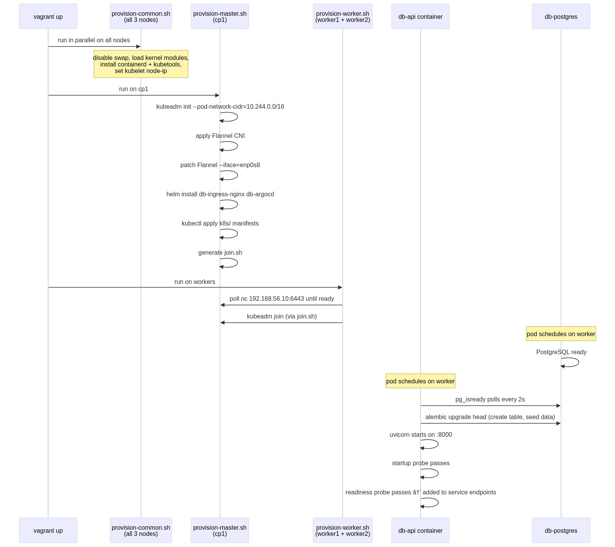

Architecture Overview

High-Level Architecture

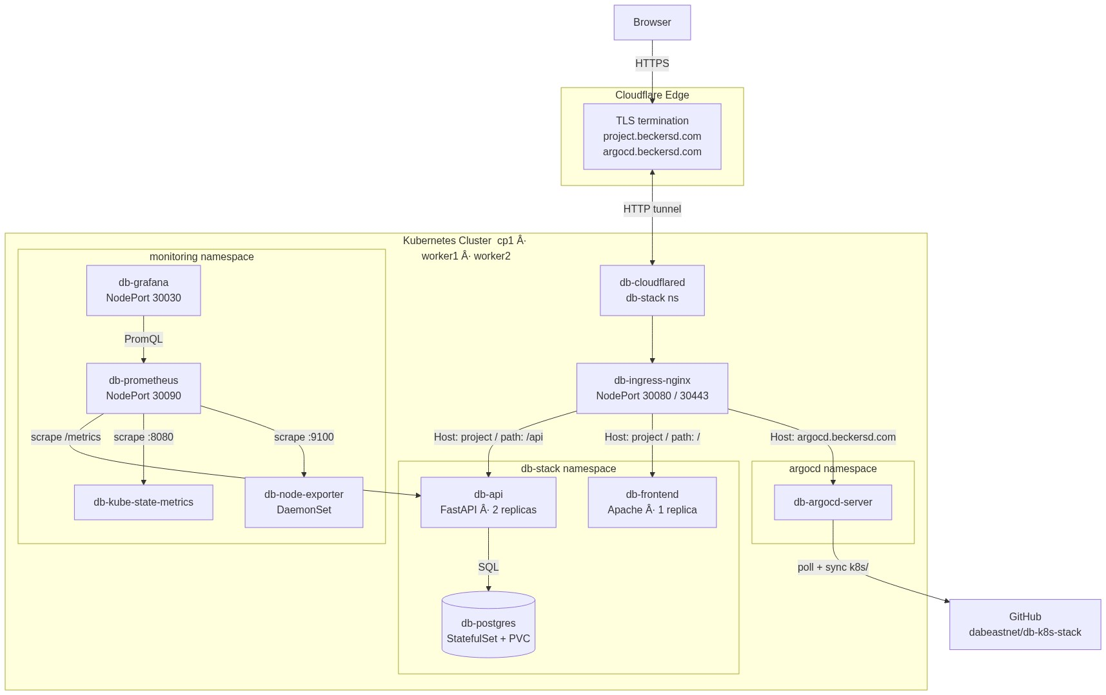

Kubernetes Namespaces

Namespace | Contents | Managed by
db-stack | frontend, API, PostgreSQL, cloudflared | deploy-k8s.sh / ArgoCD
monitoring | Prometheus, Grafana, kube-state-metrics, node-exporter | deploy-k8s.sh
ingress-nginx | nginx ingress controller | Helm (db-ingress-nginx)
argocd | ArgoCD components | Helm (db-argocd)
kube-flannel | Flannel CNI DaemonSet | kubectl apply
kube-system | Core Kubernetes components | kubeadm

Cluster Topology

VM | Role | IP | RAM | CPUs
cp1 | control-plane | 192.168.56.10 | 4096 MB | 2
worker1 | worker | 192.168.56.20 | 4096 MB | 2
worker2 | worker | 192.168.56.21 | 4096 MB | 2

All VMs run Ubuntu 20.04 LTS and share the repository directory at /vagrant.

Port Map

Host port | VM port | Protocol | Service
18080 | 30080 (cp1) | HTTP | nginx ingress → frontend + API
18443 | 30443 (cp1) | HTTPS | nginx ingress (TLS)
19090 | 30090 (cp1) | HTTP | Prometheus web UI
13000 | 30030 (cp1) | HTTP | Grafana web UI

Component Analysis

Frontend (`frontend/`)
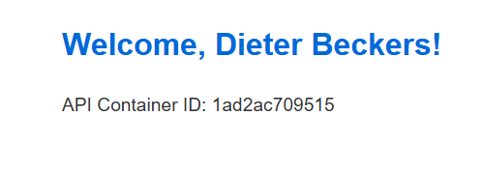
Responsibility: Serves the single-page HTML/JavaScript application that displays a greeting and container ID, both fetched live from the API.

Key files:

- frontend/src/index.html — the complete application
- frontend/apache/httpd.conf — Apache configuration
- frontend/static/version.txt — version string for the auto-reload mechanism
- frontend/Dockerfile — builds ghcr.io/dabeastnet/db-frontend:v3

Internal logic:

The page executes three async operations on load:

- fetchName() — GET /api/name → populates <span id="user">
- fetchContainerId() — GET /api/container-id → populates <span id="containerId">
- checkVersion() — GET /version.txt?_t=<timestamp> → stores current version; if it changes on subsequent polls (every 15 seconds), calls location.reload()

The cache-busting ?_t=<timestamp> query parameter prevents the browser from returning a stale cached copy of version.txt.

Apache proxy configuration:

Apache proxies all /api requests to the Kubernetes-internal DNS name:

ProxyPass "/api" "http://db-api.db-stack.svc.cluster.local:80/api"

This proxy target only resolves inside the Kubernetes cluster. In Docker Compose environments, the JavaScript fetch calls hit Apache, which tries to proxy to the K8s DNS name and fails. For local testing, API endpoints must be called directly on port 18000.

Security: Runs as UID 1001 (appuser). Port 8080 is used instead of 80 (non-root cannot bind below 1024). Directory listing is disabled (Options -Indexes).

Resource limits:

 | CPU | Memory
Requests | 50m | 64Mi
Limits | 200m | 256Mi

Published image: ghcr.io/dabeastnet/db-frontend:v3

API (`api/`)
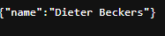
Responsibility: The sole component with direct database access. Exposes REST endpoints for the name and container ID, health/readiness probes for Kubernetes, and Prometheus metrics.

Key files:

- api/app/main.py — FastAPI app with all route handlers
- api/app/db.py — SQLAlchemy engine and session factory
- api/app/models.py — Person ORM model
- api/docker-entrypoint.sh — startup orchestration
- api/migrations/versions/001_create_person_table.py — schema migration + seed data
- api/Dockerfile — builds ghcr.io/dabeastnet/db-api:v6

API endpoints:

Method | Path | Description | Prometheus counter
GET | /api/name | Returns {"name": "<value>"} from first row of person table | db_api_requests_total{endpoint="/api/name"}
GET | /api/container-id | Returns container ID parsed from /proc/self/cgroup, plus pod_name and hostname from env | db_api_requests_total{endpoint="/api/container-id"}
GET | /healthz | Liveness probe — always returns {"status": "ok"} | —
GET | /readyz | Readiness probe — executes SELECT 1; returns 503 if DB unreachable | —
GET | /metrics | Prometheus text exposition format | —

Container ID parsing logic (main.py lines 88–102):

The endpoint reads /proc/self/cgroup and applies three regex patterns in order:

- cri-containerd-([a-f0-9]{64})\.scope — containerd in systemd cgroup v2
- containerd-:/ — generic containerd
- \b([a-f0-9]{64})\b — any 64-character hex string (Docker fallback)

Returns the first 12 characters of the matched ID.

Startup flow (docker-entrypoint.sh):

- Apply defaults for all DB_* variables
- Export PGPASSWORD=$DB_PASSWORD so pg_isready can authenticate
- Poll pg_isready -h $DB_HOST -p $DB_PORT -U $DB_USER every 2 seconds until PostgreSQL accepts connections
- Construct DATABASE_URL from individual DB_* variables if not already set
- Run alembic upgrade head — idempotent migration application
- exec "$@" — hands off to Uvicorn: uvicorn app.main:app --host 0.0.0.0 --port 8000

Database layer (db.py):

SQLAlchemy engine is created once at module import time with connection pooling:

- pool_pre_ping=True — tests connections before use, preventing stale connection errors after PostgreSQL restarts
- pool_size=5, max_overflow=10 — configurable via environment variables

Sessions are provided to route handlers via FastAPI's dependency injection (Depends(get_db)), ensuring each request gets its own session that is reliably closed after the response.

Kubernetes probes:

Probe | Endpoint | Timing | Behaviour on failure
Startup | /healthz | period=10s, failureThreshold=30 | Pod killed after 300 s
Readiness | /readyz | initialDelay=20s, period=10s | Pod removed from service endpoints
Liveness | /healthz | initialDelay=60s, period=20s | Pod restarted

The startup probe gives the API up to 300 seconds to initialise (covering the pg_isready wait and Alembic migration). Only after the startup probe passes do readiness and liveness probes begin evaluation.

Topology spread:

topologySpreadConstraints:
- maxSkew: 1
topologyKey: kubernetes.io/hostname
whenUnsatisfiable: DoNotSchedule
labelSelector:
matchLabels:
app: db-api

This guarantees exactly one API replica per worker node. DoNotSchedule prevents a third replica from being placed on a node that already has one — intentional, since the cluster has exactly two workers.

Security: Runs as UID 1001 (appuser). No root capabilities. Minimal base image (python:3.11-slim).

Resource limits:

 | CPU | Memory
Requests | 100m | 128Mi
Limits | 500m | 512Mi

Published image: ghcr.io/dabeastnet/db-api:v6

Database (`k8s/postgres/postgres.yaml`)

Responsibility: Persistent storage of the person table. Managed as a Kubernetes StatefulSet with a hostPath PersistentVolume.

Resources (all in one file):

PersistentVolume db-postgres-pv:
- capacity: 1Gi, accessModes: ReadWriteOnce
- hostPath: /mnt/postgres-data — created on every node by provision-common.sh
- storageClassName: manual — custom label used to bind to its PVC
- persistentVolumeReclaimPolicy: Retain — data is not deleted when the PVC is removed

PersistentVolumeClaim db-postgres-pvc:
- Binds to db-postgres-pv via storageClassName: manual

StatefulSet db-postgres:
- Image: postgres:16-alpine
- Port: 5432
- fsGroup: 999 (PostgreSQL default GID) allows the container to write to the volume
- POSTGRES_DB, POSTGRES_USER, POSTGRES_PASSWORD from ConfigMap/Secret
- Volume mount: /var/lib/postgresql/data ← PVC

Service db-postgres:
- ClusterIP, port 5432 → container 5432
- DNS name inside cluster: db-postgres.db-stack.svc.cluster.local
- API uses DB_HOST=db-postgres which resolves within the db-stack namespace

Schema:

The person table is created by Alembic migration 001_create_person_table:

person
id INTEGER PRIMARY KEY AUTOINCREMENT
name VARCHAR(255) NOT NULL

One row is seeded on first run: id=1, name='Dieter Beckers'. All API reads use SELECT * FROM person LIMIT 1. Name updates target WHERE id = 1.

nginx Ingress (`k8s/ingress/ingress.yaml`)

Responsibility: Routes incoming HTTP requests to the correct Kubernetes service based on Host header and URL path.

Ingress class: nginx (served by the db-ingress-nginx Helm release in the ingress-nginx namespace)

Routing rules:

Rule 1 — named host project.beckersd.com:

Path | PathType | Backend
/api | Prefix | db-api:80
/ | Prefix | db-frontend:80

Rule 2 — catch-all (no host), used for localhost:18080:

Path | PathType | Backend
/api | Prefix | db-api:80
/ | Prefix | db-frontend:80

The catch-all rule matches any Host header, making http://localhost:18080 work without configuring a custom Host header.

Annotations:

- ssl-redirect: "false" — disabled while TLS is handled by Cloudflare
- proxy-body-size: 4m — maximum request body size

TLS (commented out): The TLS block referencing cert-manager.io/cluster-issuer: letsencrypt-prod is commented out. Enabling it requires installing cert-manager and providing a real email in k8s/cert-manager/clusterissuer.yaml.

Cloudflare Tunnel (`k8s/cloudflared/deployment.yaml`)

Responsibility: Provides public HTTPS access to the cluster without requiring a public IP, open firewall ports, or a static IP address. Cloudflare terminates TLS at the edge.

How it works:

- The db-cloudflared pod maintains a persistent outbound connection to Cloudflare's global network using the provided tunnel token
- When a browser requests https://project.beckersd.com, Cloudflare routes the request through this tunnel to the pod
- The pod forwards the request to http://db-ingress-nginx-controller.ingress-nginx.svc.cluster.local (configured in the Cloudflare dashboard, not in these manifests)
- The nginx ingress routes to db-frontend or db-api based on the path

Resources:

- Secret db-cloudflared-token: stores the Cloudflare Tunnel token in stringData.token
- Deployment db-cloudflared: runs cloudflare/cloudflared:latest with tunnel --no-autoupdate run; the token is injected as the TUNNEL_TOKEN environment variable from the Secret

To update the tunnel token: edit line 9 of k8s/cloudflared/deployment.yaml, then run:

kubectl apply -f k8s/cloudflared/deployment.yaml
kubectl rollout restart deployment db-cloudflared -n db-stack

Monitoring Stack (`k8s/monitoring/`)

Responsibility: Full observability of cluster resources and application performance without requiring the Prometheus Operator.

Components:

Prometheus (prometheus.yaml):

Static scrape configuration targeting four jobs:

Job | Target | What it collects
prometheus | localhost:9090 | Self-metrics
kube-state-metrics | db-kube-state-metrics.monitoring:8080 | K8s object state
db-api | db-api.db-stack:80/metrics | Application request counters
kubernetes-nodes | All nodes via K8s SD on port 9100 | node-exporter hardware metrics

The kubernetes-nodes job uses Kubernetes service discovery to dynamically discover all nodes and relabels __address__ to <node-IP>:9100. Node names (cp1, worker1, worker2) are preserved as the node label.

Service: NodePort 30090 → http://localhost:19090

kube-state-metrics (kube-state-metrics.yaml):

Exposes Kubernetes object state as Prometheus metrics. Key metrics: kube_pod_status_phase, kube_node_status_condition, kube_pod_container_status_restarts_total.

node-exporter (node-exporter.yaml):

DaemonSet running one pod per node (including cp1 via a control-plane toleration). Uses hostNetwork: true, hostPID: true, and read-only mounts of /proc, /sys, / to read kernel-level hardware counters.

Grafana (grafana.yaml):

Pre-provisioned via three ConfigMaps:

ConfigMap | Purpose
db-grafana-datasources | Auto-registers Prometheus as default datasource
db-grafana-dashboard-provider | Configures file-based dashboard loading
db-grafana-dashboard | Pre-built "db-k8s-stack Overview" dashboard JSON

Dashboard panels: Running Pods, Ready Nodes, API Request Rate, Pod Restarts, Node CPU %, Node Memory %, API Request Rate per endpoint, Node Disk I/O.

Service: NodePort 30030 → http://localhost:13000 (admin / admin)

ArgoCD (`helm/argocd-values.yaml`, `k8s/argocd/application.yaml`)
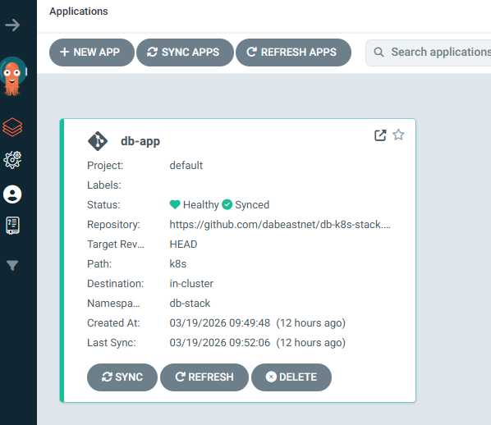
Responsibility: GitOps controller — continuously reconciles the cluster state with the k8s/ directory of the GitHub repository.
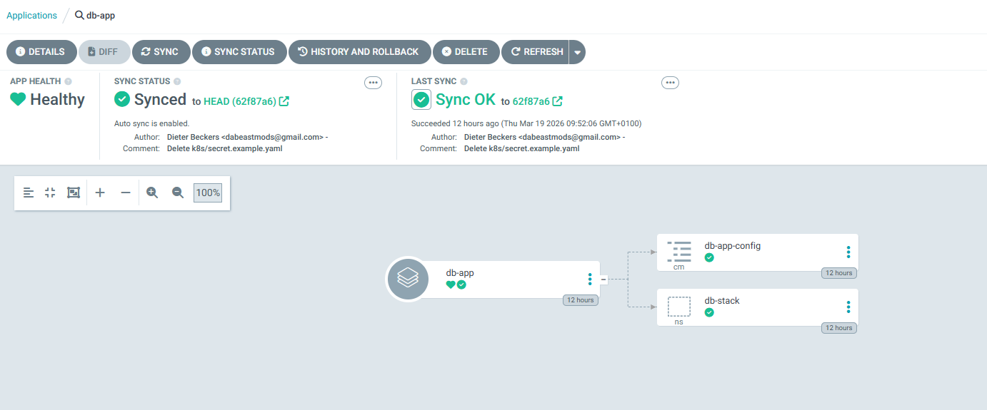
Helm release: db-argocd in namespace argocd

Key configuration decisions:

- --insecure mode: ArgoCD serves plain HTTP; TLS is terminated by Cloudflare Tunnel upstream
- global.tolerations: allows pre-install Jobs to schedule on cp1 before workers join (otherwise Helm install times out)
- server.ingress.hostname: argocd.beckersd.com: direct subdomain required because Cloudflare Universal SSL wildcard *.beckersd.com does not cover two levels deep (e.g., argocd.project.beckersd.com would not be covered)

ArgoCD Application (db-app):

source:
repoURL: https://github.com/dabeastnet/db-k8s-stack.git
targetRevision: HEAD
path: k8s
syncPolicy:
automated:
prune: true # resources deleted from Git are deleted from cluster
selfHeal: true # manual cluster changes are reverted to match Git

ArgoCD polls every ~3 minutes. Any commit to k8s/ on the main branch is automatically applied to the cluster.

Retrieving the admin password:

vagrant ssh cp1
kubectl -n argocd get secret argocd-initial-admin-secret \
-o jsonpath="{.data.password}" | base64 -d && echo

The password changes on every cluster rebuild (new secret generated by Helm).

Runtime and Request Flows

Application Start Sequence (fresh `vagrant up`)

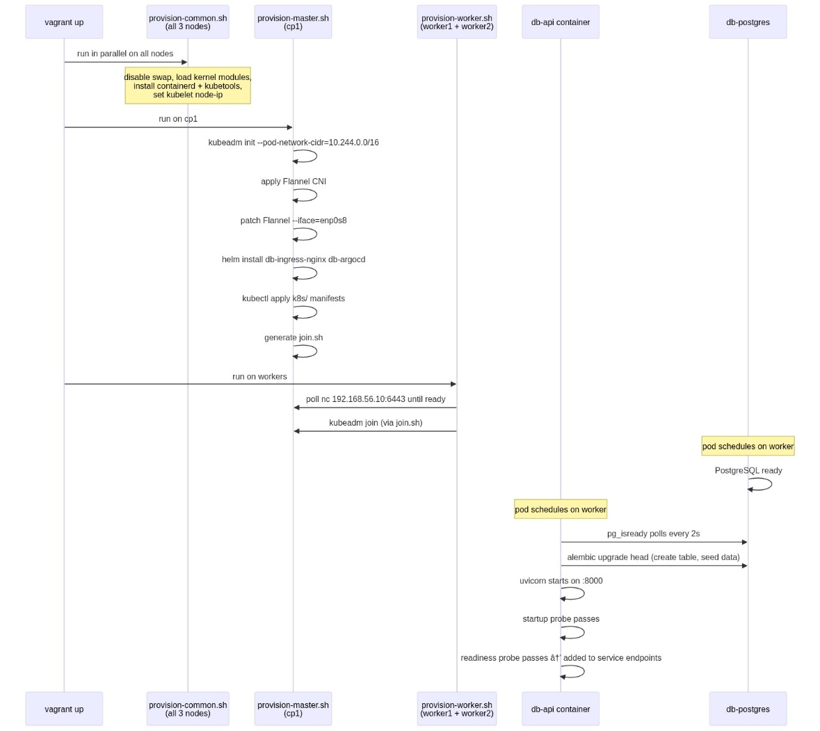

HTTP Request Flow (browser → database)

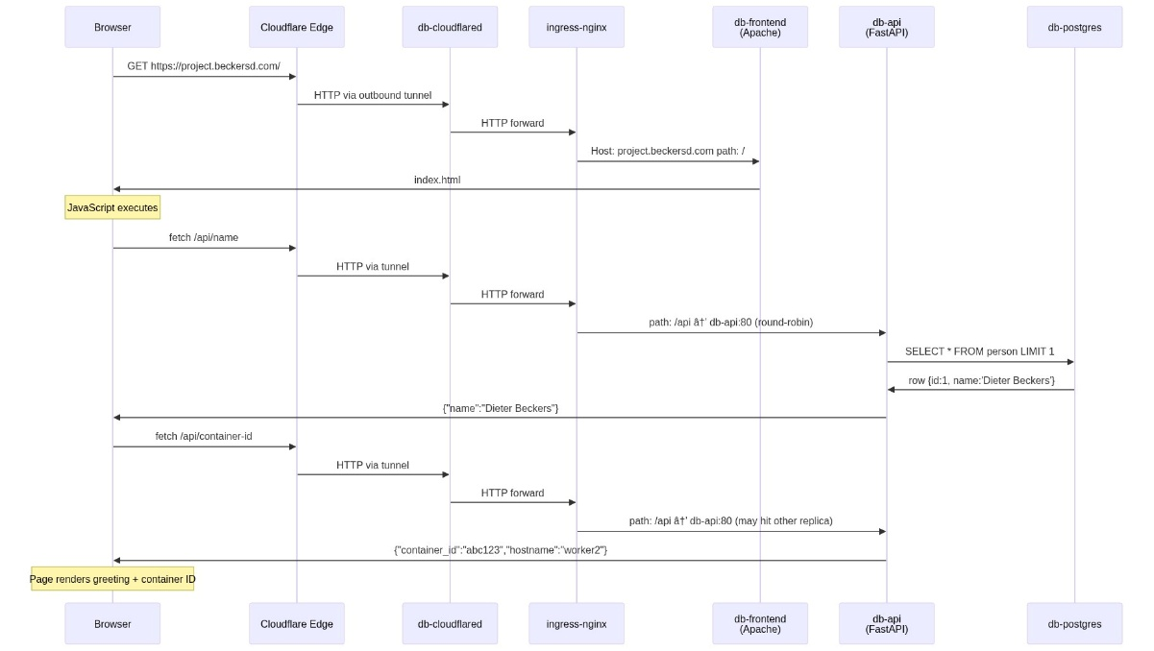

Name Update Flow

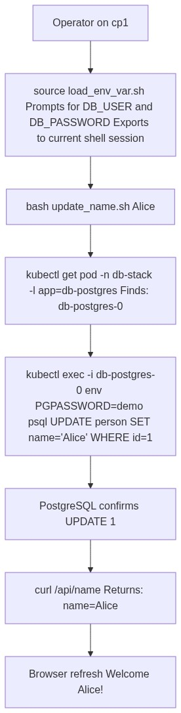

Auto Layout Refresh Flow

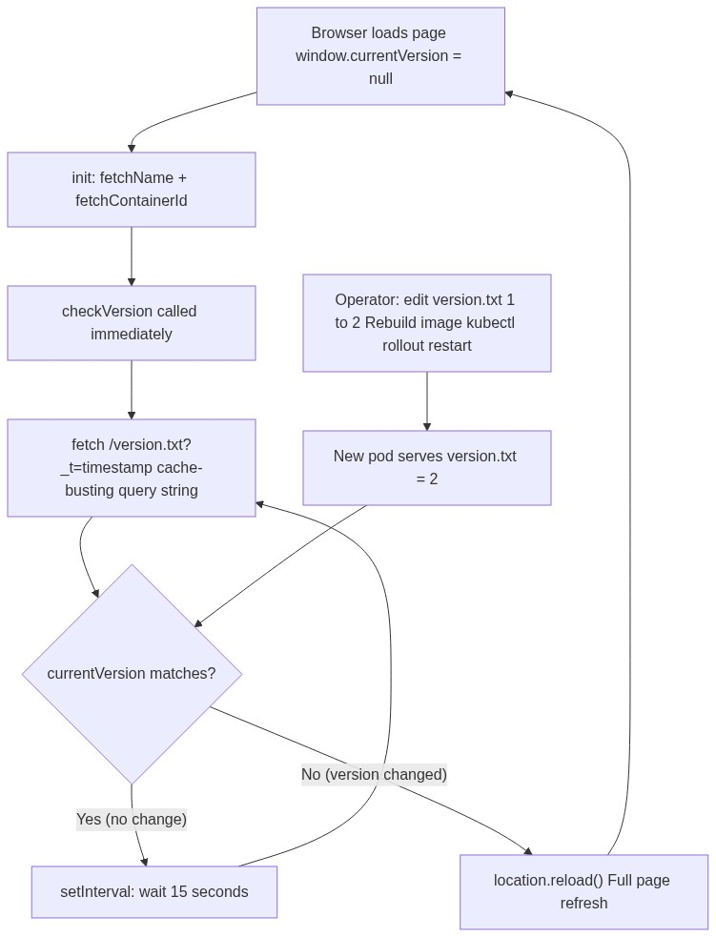

GitOps Sync Flow

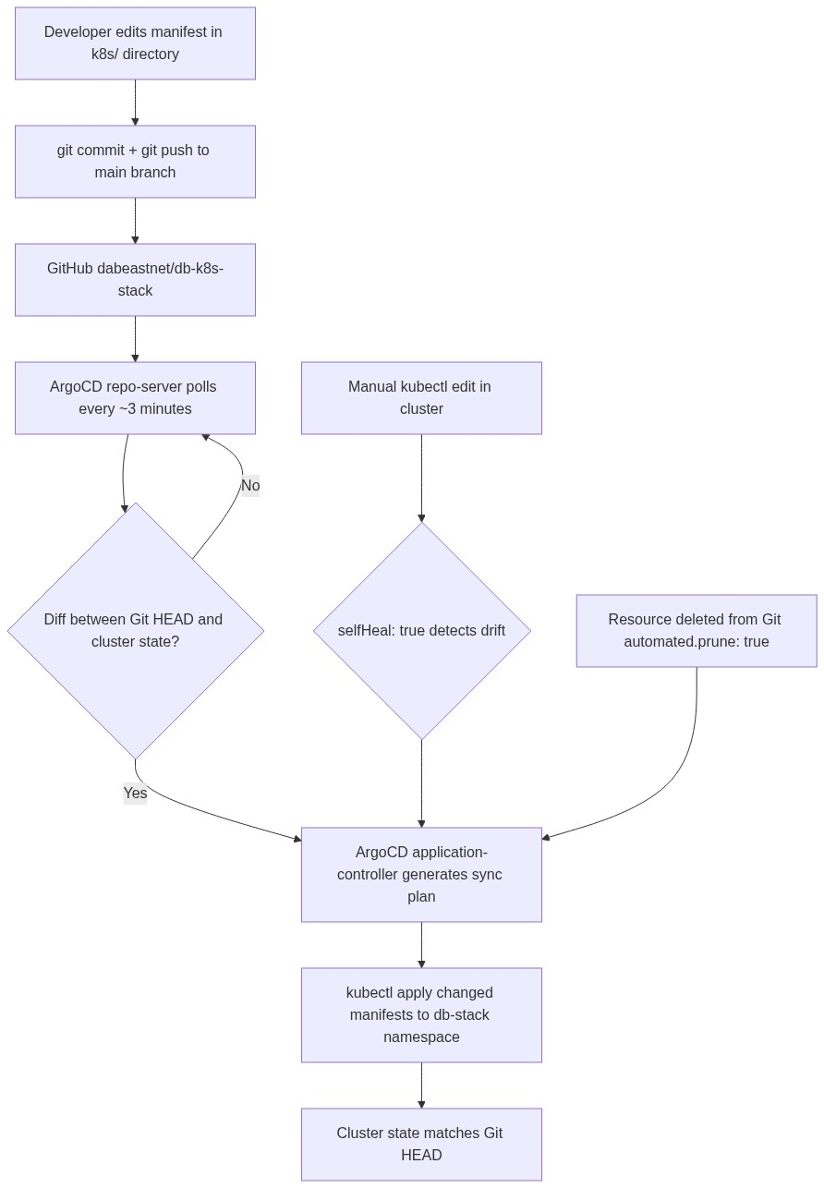

Configuration and Environment Variables

Application Environment Variables

Variable | Default | Source in K8s | Description
DB_HOST | db-postgres | ConfigMap db-app-config | PostgreSQL service hostname
DB_PORT | 5432 | ConfigMap db-app-config | PostgreSQL port
DB_NAME | demo | ConfigMap db-app-config | Database name
DB_USER | demo | Secret db-app-secret | Database username
DB_PASSWORD | demo | Secret db-app-secret | Database password
PGPASSWORD | (= DB_PASSWORD) | Secret db-app-secret | Used by pg_isready in entrypoint
DATABASE_URL | constructed | — | Full SQLAlchemy URL; auto-built if absent
DB_POOL_SIZE | 5 | — | SQLAlchemy connection pool size
DB_MAX_OVERFLOW | 10 | — | SQLAlchemy max extra connections
POD_NAME | "" | Downward API (metadata.name) | Pod name; returned by /api/container-id
HOSTNAME | "" | Downward API (spec.nodeName) | Node name; returned by /api/container-id

Kubernetes ConfigMap (`k8s/configmap.yaml`)

db-app-config holds non-sensitive database connection parameters:

Key | Value
DB_HOST | db-postgres
DB_PORT | 5432
DB_NAME | demo

Kubernetes Secret (`k8s/secret.example.yaml`)

db-app-secret holds database credentials. The example file contains development values only:

Key | Example value
DB_USER | demo
DB_PASSWORD | demo

Important: This file is a template. In provision-master.sh, the secret is only applied if db-app-secret does not already exist — allowing real credentials to be pre-created before provisioning.

`.env.example`

Template for local development. Variables:

DB_HOST=db-postgres
DB_PORT=5432
DB_NAME=demo
DB_USER=demo
DB_PASSWORD=demo
DOMAIN=example.com
EMAIL=admin@example.com
GIT_REPO_URL=https://github.com/your-user/db-k8s-stack.git
GIT_REPO_BRANCH=main

Configuration Risks and Gotchas

- Default credentials in Git: secret.example.yaml contains demo/demo. The provisioning script guards against overwriting an existing secret, but the default credentials are not suitable for production.
- Cloudflare token in Git: k8s/cloudflared/deployment.yaml currently contains the Cloudflare Tunnel token directly in the manifest. This should be managed outside of Git (e.g., via a pre-created Secret) in a production environment.
- cert-manager email placeholder: k8s/cert-manager/clusterissuer.yaml contains admin@example.com — must be replaced before installing cert-manager.
- ArgoCD initial password: The auto-generated password in argocd-initial-admin-secret should be changed after first login.
- emptyDir storage for Prometheus and Grafana: All monitoring data is lost on pod restart. Replace with PVCs for persistence in a production setup.

API and Interfaces

REST API Reference

Base URL (local): http://localhost:18080 (via ingress) or http://localhost:18000 (direct, Docker Compose only)

GET /api/name

Returns the name stored in the database.

Response:

{ "name": "Dieter Beckers" }

If the person table is empty: { "name": "Unknown" }.

GET /api/container-id

Returns the running container's identity.

Response:

{
"container_id": "abc123def456",
"pod_name": "db-api-6d9f7b5c4-xk9pq",
"hostname": "worker1"
}

container_id is derived from /proc/self/cgroup (12 characters). pod_name and hostname are injected via the Kubernetes Downward API.

GET /healthz

Liveness probe. Always returns 200.

{ "status": "ok" }

GET /readyz

Readiness probe. Executes SELECT 1 against PostgreSQL.

- 200: { "status": "ok" } — database reachable
- 503: { "detail": "Database not ready" } — database unreachable

GET /metrics

Prometheus text exposition format. Key metric:

# HELP db_api_requests_total Total API requests
# TYPE db_api_requests_total counter
db_api_requests_total{endpoint="/api/name",method="GET"} 4.0
db_api_requests_total{endpoint="/api/container-id",method="GET"} 2.0

Inter-Service Communication

Source | Target | Protocol | Address
Browser JS | /api/* | HTTP (via ingress) | Relative URL — same origin
Apache | db-api | HTTP | db-api.db-stack.svc.cluster.local:80
db-api | db-postgres | PostgreSQL | db-postgres.db-stack.svc.cluster.local:5432
Prometheus | db-api | HTTP | db-api.db-stack.svc.cluster.local:80/metrics
Prometheus | kube-state-metrics | HTTP | db-kube-state-metrics.monitoring.svc.cluster.local:8080
Prometheus | node-exporter | HTTP | Node IP:9100 (Kubernetes SD)
Grafana | Prometheus | HTTP | db-prometheus.monitoring.svc.cluster.local:9090
ArgoCD | GitHub | HTTPS | github.com/dabeastnet/db-k8s-stack.git
cloudflared | ingress-nginx | HTTP | db-ingress-nginx-controller.ingress-nginx.svc.cluster.local

Authentication and Security

- No application-level authentication on the frontend or API (read-only public application)
- Database credentials are stored in a Kubernetes Secret (base64-encoded by Kubernetes)
- Cloudflare Tunnel token stored in a Kubernetes Secret
- ArgoCD protected by initial admin password
- Grafana protected by admin/admin (should be changed)
- All pods run as non-root (UID 1001 for frontend and API; UID 999 for PostgreSQL; UID 472 for Grafana)
- Minimal base images reduce attack surface

Database and Persistence

PostgreSQL

- Image: postgres:16-alpine
- Deployment model: Kubernetes StatefulSet (db-postgres) with 1 replica
- Storage: hostPath PV at /mnt/postgres-data on the node where the pod schedules
- Service: ClusterIP db-postgres, port 5432

Schema

CREATE TABLE person (
id SERIAL PRIMARY KEY,
name VARCHAR(255) NOT NULL
);
INSERT INTO person (name) VALUES ('Dieter Beckers');

Created and seeded by Alembic migration 001_create_person_table. Alembic tracks applied migrations in the alembic_version table. Running alembic upgrade head on an already-migrated database is safe and idempotent.

Read/Write Patterns

Operation | Query | Trigger
Read name | SELECT * FROM person LIMIT 1 | Every GET /api/name request
Write name | UPDATE person SET name = :name WHERE id = 1 | update_name.sh via kubectl exec
Health check | SELECT 1 | Every GET /readyz request

Persistence Model

The hostPath PV (/mnt/postgres-data) persists across pod restarts because the directory lives on the node's filesystem. However, if the PostgreSQL pod is rescheduled to a different node, the data will not follow it. For a production setup, a distributed storage solution (e.g., Rook-Ceph, Longhorn) should be used instead.

The Retain reclaim policy ensures data is not deleted when the PVC is removed — manual cleanup of the directory is required if the PV is to be reused.

Build, Run, Test, and Deploy

Building Images

./build.sh

Builds:
- db-frontend:latest from ./frontend
- db-api:latest from ./api

To push to a registry:

export REGISTRY=ghcr.io/dabeastnet
./push.sh

Local Development (Docker Compose)

docker compose up --build

Service | Host port | Notes
db-api | 18000 | Direct API access for testing
db-frontend | 18080 | Apache frontend
db-postgres | — | Internal only

Limitation: The Apache proxy (/api → db-api.db-stack.svc.cluster.local) does not resolve outside Kubernetes. Test API endpoints directly on port 18000.

Full workflow: see LOCAL_TESTING.md.

Running the Full Smoke Test

Docker Compose:

./test-local.sh

Kubernetes:

./test-k8s.sh

Smoke tests hit all endpoints and print responses. No assertions — review output manually.

Deploying to Kubernetes

Full cluster provisioning (from scratch):

vagrant up

Apply manifests to a running cluster:

./deploy-k8s.sh

Apply individual components:

vagrant ssh cp1 -- kubectl apply -f /vagrant/k8s/api/deployment.yaml

Cluster Lifecycle Commands

vagrant up # Create and provision all VMs
vagrant halt # Stop all VMs
vagrant destroy -f # Delete all VMs
vagrant provision cp1 # Re-run provisioner on cp1
vagrant ssh cp1 # SSH into cp1
vagrant status # Check VM states

Updating the Application Name

vagrant ssh cp1
source /vagrant/vagrant/scripts/load_env_var.sh
# Enter DB_USER: demo
# Enter DB_PASSWORD: demo
bash /vagrant/vagrant/scripts/update_name.sh "Alice"

Kubernetes and Infrastructure

Kubernetes Version and Installation

Kubernetes v1.29 is installed via the official pkgs.k8s.io APT repository. The package pinning for kubelet, kubeadm, and kubectl uses apt-mark hold (commented out in the provisioner — a minor observation).

Network Architecture

All Vagrant VMs have two NICs:

Interface | Type | Address | Purpose
enp0s3 | VirtualBox NAT | 10.0.2.x (same for all VMs) | Internet access
enp0s8 | Host-only | 192.168.56.x (unique per VM) | VM-to-VM communication

Critical: Flannel auto-detects enp0s3 (the first interface), which cannot route traffic between VMs. The provisioner patches the Flannel DaemonSet with --iface=enp0s8 to force the correct interface. Without this, all cross-node pod communication (including DNS) fails silently.

Kubelet is configured with --node-ip=192.168.56.x (written to /etc/default/kubelet) to ensure each node registers with its unique private IP rather than the shared NAT address.

CNI — Flannel

- Applied from: https://raw.githubusercontent.com/flannel-io/flannel/master/Documentation/kube-flannel.yml
- Patched post-install: --iface=enp0s8 appended to DaemonSet args
- Pod CIDR: 10.244.0.0/16 (set at kubeadm init)
- Encapsulation: VXLAN over the private network

Helm Releases

Release | Chart | Namespace | Key settings
db-ingress-nginx | ingress-nginx/ingress-nginx | ingress-nginx | NodePort 30080/30443, webhooks disabled
db-argocd | argo/argo-cd | argocd | --insecure, global tolerations, ingress hostname

Resource Limits Summary

Pod | CPU request | CPU limit | Memory request | Memory limit
db-api | 100m | 500m | 128Mi | 512Mi
db-frontend | 50m | 200m | 64Mi | 256Mi
db-cloudflared | 50m | 200m | 64Mi | 128Mi

Monitoring, Logging, and Operations

Prometheus

Access: http://localhost:19090

Key queries:

Query | Description
db_api_requests_total | All API request counts by endpoint
rate(db_api_requests_total[5m]) | Request rate per second
sum(kube_pod_status_phase{namespace="db-stack",phase="Running"}) | Running pods
count(kube_node_status_condition{condition="Ready",status="true"}) | Ready nodes
100 * (1 - avg by(node)(rate(node_cpu_seconds_total{mode="idle"}[5m]))) | Node CPU %
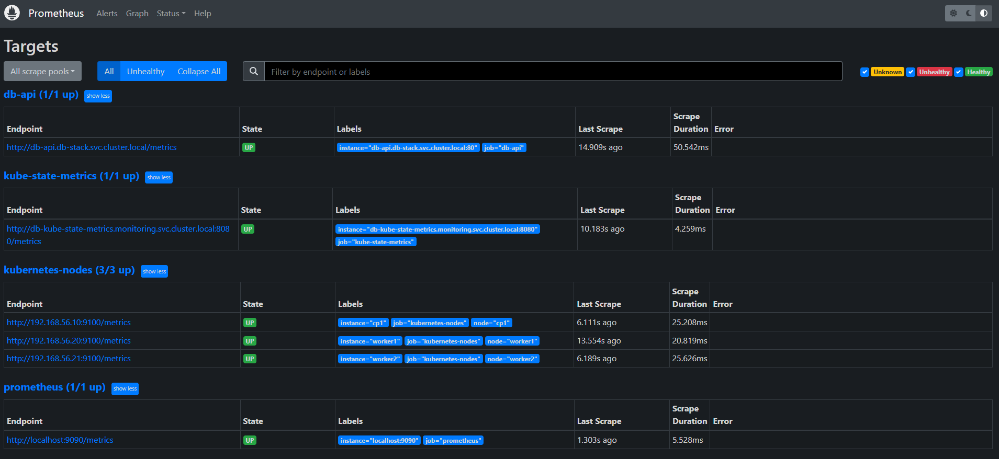

Grafana

Access: http://localhost:13000 (admin / admin)

The pre-built dashboard "db-k8s-stack Overview" shows eight panels covering pod health, node resources, API performance, and disk I/O.
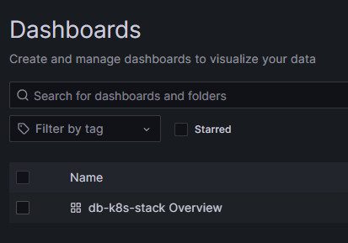
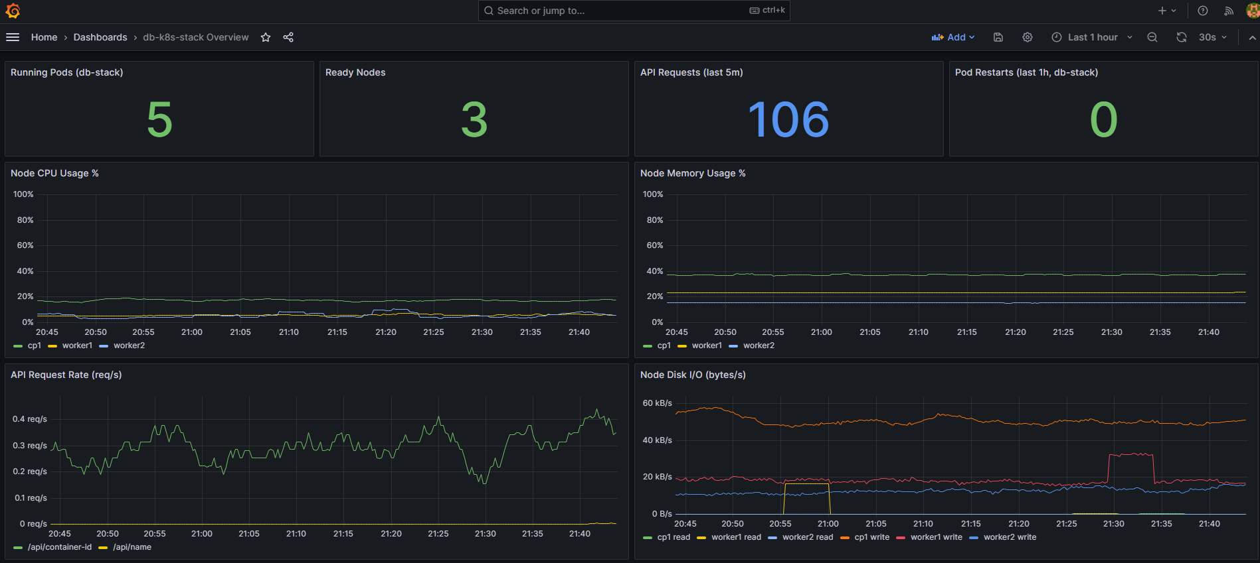

Logging

All containers log to stdout/stderr (container runtime captures these):

# API logs
kubectl logs -n db-stack -l app=db-api --tail=50

# Frontend logs
kubectl logs -n db-stack -l app=db-frontend --tail=50

# PostgreSQL logs
kubectl logs -n db-stack db-postgres-0 --tail=50

# Cloudflare tunnel
kubectl logs -n db-stack -l app=db-cloudflared --tail=20

# Prometheus
kubectl logs -n monitoring -l app=db-prometheus --tail=50

API logging format: %(asctime)s %(levelname)s [%(name)s] %(message)s at INFO level. Warnings for container ID parse failures; errors for readiness check failures.

Health Checks and Restarts

- Startup probe prevents premature liveness evaluation during the initial pg_isready wait and Alembic migration (up to 300 s grace)
- Readiness probe removes the API from the service's endpoint list when the database is unreachable — traffic automatically redirects to the healthy replica
- Liveness probe triggers a pod restart if the API becomes unresponsive; the 60-second initialDelaySeconds prevents premature restarts during startup

Common Failure Points

Symptom | Likely cause | Fix
API pods Pending | worker2 not joined | vagrant up worker2
bridge fdb show shows 10.0.2.x | Flannel on wrong NIC | Re-provision cp1
ArgoCD redirects to main site | Incorrect ingress hostname | Check ArgoCD ingress host
Cloudflare tunnel error | Invalid token or wrong origin URL | Update token; check dashboard origin URL
Workers fail to join | API server not ready when workers boot | provision-worker.sh poll loop handles this

Key Scripts and Automation

`vagrant/provision-common.sh`

Runs on every node. Responsibilities:

- Disable swap (swapoff -a, comment out in /etc/fstab)
- Install APT prerequisites
- Load overlay and br_netfilter kernel modules permanently
- Set sysctl: bridge-nf-call-iptables, ip_forward
- Install and configure containerd (SystemdCgroup = true)
- Create /mnt/postgres-data
- Add Kubernetes v1.29 APT repository
- Install kubelet, kubeadm, kubectl, cri-tools, conntrack, kubernetes-cni
- Set KUBELET_EXTRA_ARGS=--node-ip=192.168.56.x

`vagrant/provision-master.sh`

Runs on cp1 only. Responsibilities:

- kubeadm init (only if /etc/kubernetes/admin.conf does not exist)
- Set up kubeconfig for the vagrant user
- Apply Flannel; patch DaemonSet with --iface=enp0s8; wait for rollout
- Install Helm
- Install db-ingress-nginx and db-argocd Helm releases
- Wait for applications.argoproj.io CRD to be registered
- Generate join.sh
- Apply all core K8s manifests (namespace through ingress)
- Call bash /vagrant/deploy-k8s.sh

`vagrant/provision-worker.sh`

Runs on worker1 and worker2. Polls 192.168.56.10:6443 with nc until the API server is reachable, then executes bash join.sh --v=5.

`deploy-k8s.sh`

Applies all manifests in dependency order. Non-fatal blocks for cert-manager ClusterIssuers, Prometheus Operator ServiceMonitor, and ArgoCD Application (skipped gracefully if CRDs are absent). Uses SCRIPT_DIR for absolute path resolution — works when called from any directory by Vagrant provisioners.

`vagrant/scripts/update_name.sh`

- Validates that $1 (new name), DB_USER, DB_NAME, DB_PASSWORD are set
- Finds the db-postgres-0 pod by label app=db-postgres
- Executes UPDATE person SET name = :name WHERE id = 1 via kubectl exec + psql

Must be preceded by source vagrant/scripts/load_env_var.sh to set credentials interactively.

`package.sh`

Creates db-k8s-stack.zip from the repository root, excluding .git, *.pyc, __pycache__, vendor/, node_modules/, and the archive itself.

Risks, Observations, and Improvement Opportunities

Confirmed Issues

Item | File | Description
Cloudflare token in Git | k8s/cloudflared/deployment.yaml:9 | Tunnel token is committed in plaintext. Should be managed via a pre-created Secret outside the repository.
Default credentials in Git | k8s/secret.example.yaml | demo/demo credentials in the repository. Acceptable for a dev cluster; not suitable for production.
cert-manager placeholder email | k8s/cert-manager/clusterissuer.yaml:9 | admin@example.com must be replaced before cert-manager is installed.
Stale Vagrantfile comment | Vagrantfile:21 | Comment references app.example.com (old hostname) after domain was changed to project.beckersd.com.
Commented-out apt-mark hold | provision-common.sh:58 | Without package holds, future apt-get upgrade runs could update Kubernetes packages to an incompatible version.
set -euo pipefail commented out | vagrant/scripts/update_name.sh:5 | Weakened error handling; errors in sub-commands may be silently ignored.

Observations / Inferred Risks

Item | Description | Risk
imagePullPolicy: IfNotPresent | API deployment uses cached images. If the image tag is not updated after a rebuild, the new code will not be deployed. | Medium
emptyDir for Prometheus and Grafana | All metrics and user-created dashboards are lost on pod restart. | Low in dev, high in production.
Single PostgreSQL replica | No replication or standby. Pod failure = downtime until Kubernetes reschedules. | Acceptable for dev.
hostPath PV not portable | If PostgreSQL reschedules to a different node, data is lost. | Medium
ArgoCD admin@example.com | The ArgoCD Application manifest has a placeholder repo URL comment. The actual URL is correct, but the comment may mislead. | Low
No rate limiting on ingress | /api endpoints have no rate limiting configured on the ingress. | Low for this use case.
Docker Compose port mismatch in old test-local.sh defaults | Fixed (18000/18080). Original defaults were 8000/8080. | Fixed

Improvement Opportunities

- Replace hostPath PV with a distributed storage solution for PostgreSQL portability
- Move the Cloudflare tunnel token to a pre-provisioned Secret not stored in Git
- Add apt-mark hold kubelet kubeadm kubectl to lock package versions
- Enable cert-manager for in-cluster Let's Encrypt certificate management
- Add Grafana persistent storage to retain user-created dashboards
- Consider Horizontal Pod Autoscaler for the API deployment
- Add network policies to restrict pod-to-pod communication to required paths only

Appendix A: Important Files

File | Purpose
Vagrantfile | Cluster topology and port forwarding
vagrant/provision-common.sh | Node baseline: swap, kernel, containerd, kubetools
vagrant/provision-master.sh | Control plane: kubeadm init, CNI, Helm, manifests
vagrant/provision-worker.sh | Worker join with API server readiness polling
vagrant/scripts/update_name.sh | Update name in PostgreSQL via kubectl
vagrant/scripts/load_env_var.sh | Interactive credential loader for shell session
api/app/main.py | All FastAPI route handlers
api/app/db.py | SQLAlchemy engine + session factory
api/app/models.py | Person ORM model
api/docker-entrypoint.sh | DB wait + migration + server start
api/migrations/versions/001_create_person_table.py | Schema + seed data
frontend/src/index.html | Complete single-page application
frontend/apache/httpd.conf | Apache config with /api proxy
frontend/static/version.txt | Auto-reload version trigger
k8s/namespace.yaml | db-stack namespace
k8s/configmap.yaml | DB host/port/name (non-secret)
k8s/secret.example.yaml | DB user/password template
k8s/api/deployment.yaml | API: 2 replicas, topology spread, all probes
k8s/api/service.yaml | db-api ClusterIP
k8s/frontend/deployment.yaml | Frontend deployment
k8s/frontend/service.yaml | db-frontend ClusterIP
k8s/postgres/postgres.yaml | PV + PVC + StatefulSet + Service
k8s/ingress/ingress.yaml | nginx routing rules
k8s/cloudflared/deployment.yaml | Cloudflare Tunnel token + Deployment
k8s/argocd/application.yaml | ArgoCD GitOps Application
k8s/cert-manager/clusterissuer.yaml | Let's Encrypt prod + staging
k8s/monitoring/prometheus.yaml | Static scrape config + Deployment + NodePort
k8s/monitoring/grafana.yaml | Pre-provisioned dashboard
k8s/monitoring/node-exporter.yaml | Per-node hardware metrics DaemonSet
k8s/monitoring/kube-state-metrics.yaml | K8s object state metrics
helm/argocd-values.yaml | ArgoCD Helm values
deploy-k8s.sh | Apply all manifests in order
docker-compose.yml | Local development stack
.env.example | Environment variable template
VERIFICATION.md | Per-criterion verification guide
LOCAL_TESTING.md | Docker Compose testing guide

Appendix B: Commands Reference

Cluster Management

vagrant up # Create and provision full cluster
vagrant halt # Stop all VMs
vagrant destroy -f # Delete all VMs and free disk
vagrant up worker2 # Start/provision a single VM
vagrant provision cp1 # Re-run provisioner on cp1
vagrant ssh cp1 # SSH into control plane
vagrant ssh cp1 -- kubectl get nodes # Run kubectl without interactive SSH
vagrant status # Show VM states

Kubernetes — Cluster Inspection

kubectl get nodes -o wide
kubectl get pods -A
kubectl get pods -n db-stack -o wide
kubectl get pods -n monitoring
kubectl get pods -n argocd
kubectl get ingress -n db-stack
kubectl describe pod <name> -n db-stack
kubectl logs -n db-stack -l app=db-api --tail=50

Kubernetes — Application Operations

# Update name
source /vagrant/vagrant/scripts/load_env_var.sh
bash /vagrant/vagrant/scripts/update_name.sh "Alice"

# Restart a deployment
kubectl rollout restart deployment db-api -n db-stack
kubectl rollout restart deployment db-frontend -n db-stack
kubectl rollout status deployment db-api -n db-stack

# Scale the API (limited by topology spread to number of workers)
kubectl scale deployment db-api -n db-stack --replicas=2

Kubernetes — ArgoCD

# Get initial admin password
kubectl -n argocd get secret argocd-initial-admin-secret \
-o jsonpath="{.data.password}" | base64 -d && echo

# Check sync status
kubectl get application -n argocd db-app

# Force immediate sync
kubectl -n argocd patch app db-app \
-p '{"operation": {"sync": {}}}' --type merge

Kubernetes — Port Forwarding

kubectl port-forward svc/db-api -n db-stack 18000:80
kubectl port-forward svc/db-frontend -n db-stack 18080:80
kubectl port-forward svc/db-prometheus -n monitoring 9090:9090
kubectl port-forward svc/db-grafana -n monitoring 3000:3000

Build and Deploy

./build.sh # Build images locally
export REGISTRY=ghcr.io/dabeastnet
./push.sh # Push to registry
./deploy-k8s.sh # Apply all K8s manifests
./deploy-local.sh # Start Docker Compose
./test-local.sh # Smoke test Docker Compose
./test-k8s.sh # Smoke test Kubernetes
./package.sh # Create db-k8s-stack.zip

Testing API Endpoints

# Via ingress (Kubernetes)
curl -s http://localhost:18080/api/name
curl -s http://localhost:18080/api/container-id
curl -s http://localhost:18080/healthz
curl -s http://localhost:18080/readyz

# Direct (Docker Compose)
curl -s http://localhost:18000/api/name
curl -s http://localhost:18000/metrics | head -5

Verifying Load Balancing (PowerShell)

1..6 | ForEach-Object {
(curl "http://localhost:18080/api/container-id") -match '"hostname":"([^"]*)"' | Out-Null
$matches[0]
}

Appendix C: Glossary

Term | Definition
ArgoCD | GitOps continuous delivery tool for Kubernetes; watches a Git repository and applies changes automatically
Alembic | Python database migration framework, used by SQLAlchemy projects
ClusterIP | Kubernetes service type exposing a stable internal IP; not reachable from outside the cluster
CNI | Container Network Interface — plugin providing pod networking. This project uses Flannel
containerd | Industry-standard container runtime used by kubeadm clusters
DaemonSet | Kubernetes workload that runs exactly one pod on every (matching) node
Downward API | Kubernetes mechanism to expose pod/node metadata to containers as environment variables
Flannel | Simple overlay network CNI using VXLAN encapsulation
GitOps | Operational model where the desired cluster state is stored in Git; an operator reconciles the live state
hostPath PV | Kubernetes PersistentVolume backed by a directory on the node's filesystem
ingress-nginx | nginx-based Kubernetes Ingress controller; routes HTTP traffic based on Host header and path
kubeadm | Official tool for bootstrapping a Kubernetes cluster
kube-state-metrics | Exposes Kubernetes object state (pod phases, conditions) as Prometheus metrics
NodePort | Kubernetes service type exposing a port on every cluster node; used when no cloud load-balancer is available
node-exporter | Prometheus exporter for hardware and OS metrics (CPU, memory, disk, network)
PVC / PV | PersistentVolumeClaim / PersistentVolume — Kubernetes storage abstraction
Readiness probe | Kubernetes probe that determines whether a pod should receive traffic
Liveness probe | Kubernetes probe that determines whether a pod should be restarted
Startup probe | Kubernetes probe evaluated only at container startup; delays liveness/readiness evaluation
StatefulSet | Kubernetes workload for stateful applications; provides stable network identities and ordered scaling
Topology spread | Kubernetes scheduling constraint distributing pods evenly across nodes/zones
Uvicorn | ASGI server used to run FastAPI applications
VXLAN | Virtual Extensible LAN — network encapsulation protocol used by Flannel for pod-to-pod communication
Vagrant | Tool for managing reproducible VM environments

Appendix D: Python Dependencies

Package | Version | Purpose
fastapi | 0.111.0 | Web framework
uvicorn[standard] | 0.23.2 | ASGI server
SQLAlchemy | 2.0.29 | ORM and connection pooling
alembic | 1.13.1 | Database migration tool
psycopg2-binary | 2.9.9 | PostgreSQL adapter (binary distribution, no compilation needed)
python-dotenv | 1.0.1 | .env file loading for local development
prometheus-client | 0.20.0 | Prometheus metrics exposition

Appendix E: URLs & Endpoints Reference

Public URLs (via Cloudflare Tunnel)

URL | Service | Notes
https://project.beckersd.com/ | Frontend (Apache) | Serves index.html
https://project.beckersd.com/api/name | db-api | Returns {"name": "..."} from PostgreSQL
https://project.beckersd.com/api/container-id | db-api | Returns container ID, pod name, hostname
https://project.beckersd.com/healthz | db-api | Liveness probe — {"status": "ok"}
https://project.beckersd.com/readyz | db-api | Readiness probe — HTTP 200 or 503 if DB down
https://project.beckersd.com/metrics | db-api | Prometheus metrics (text/plain)
https://argocd.beckersd.com | ArgoCD UI | GitOps dashboard — login: admin / see secret

Local Access (Vagrant Port Forwarding)

Host URL | Host Port | NodePort (cp1) | Service
http://localhost:18080/ | 18080 | 30080 | nginx ingress → frontend
http://localhost:18080/api/name | 18080 | 30080 | nginx ingress → db-api
http://localhost:18080/api/container-id | 18080 | 30080 | nginx ingress → db-api
http://localhost:18080/healthz | 18080 | 30080 | nginx ingress → db-api
http://localhost:18080/readyz | 18080 | 30080 | nginx ingress → db-api
http://localhost:18080/metrics | 18080 | 30080 | nginx ingress → db-api
https://localhost:18443/ | 18443 | 30443 | nginx ingress (TLS)
http://localhost:19090/ | 19090 | 30090 | Prometheus UI
http://localhost:13000/ | 13000 | 30030 | Grafana UI — login: admin / admin

NodePorts (direct on cp1: 192.168.56.10)

URL | NodePort | Service
http://192.168.56.10:30080/ | 30080 | nginx ingress HTTP
https://192.168.56.10:30443/ | 30443 | nginx ingress HTTPS
http://192.168.56.10:30090/ | 30090 | Prometheus UI
http://192.168.56.10:30030/ | 30030 | Grafana UI

API Endpoints

All endpoints are served by FastAPI on container port 8000, exposed via the db-api ClusterIP service on port 80.

Method | Path | Description | Response
GET | /api/name | Name from PostgreSQL person table | {"name": "Dieter Beckers"}
GET | /api/container-id | Container identity | {"container_id": "abc123", "pod_name": "...", "hostname": "worker1"}
GET | /healthz | Liveness probe | {"status": "ok"} — HTTP 200
GET | /readyz | Readiness probe (checks DB) | {"status": "ok"} — HTTP 200, or HTTP 503
GET | /metrics | Prometheus metrics | text/plain — db_api_requests_total counter

Internal Cluster DNS

DNS name | Port | Service
db-api.db-stack.svc.cluster.local | 80 | API (FastAPI)
db-frontend.db-stack.svc.cluster.local | 80 | Frontend (Apache)
db-postgres.db-stack.svc.cluster.local | 5432 | PostgreSQL
db-prometheus.monitoring.svc.cluster.local | 9090 | Prometheus
db-grafana.monitoring.svc.cluster.local | 3000 | Grafana
db-kube-state-metrics.monitoring.svc.cluster.local | 8080 | kube-state-metrics
db-ingress-nginx-controller.ingress-nginx.svc.cluster.local | 80 / 443 | nginx ingress (Cloudflare tunnel target)

Prometheus Scrape Targets

Job | Target | Path | What it scrapes
prometheus | localhost:9090 | /metrics | Prometheus itself
kube-state-metrics | db-kube-state-metrics.monitoring.svc.cluster.local:8080 | /metrics | Kubernetes object state
db-api | db-api.db-stack.svc.cluster.local:80 | /metrics | Application request counters
kubernetes-nodes | Each node IP :9100 (auto-discovered) | /metrics | node-exporter: CPU, memory, disk, network

Appendix F: Cloudflare Tunnel Setup

The cluster has no public IP and no open inbound firewall ports. Instead, a cloudflared pod inside the cluster opens an outbound tunnel to Cloudflare's edge. All traffic to project.beckersd.com and argocd.beckersd.com arrives through this tunnel — no LoadBalancer or NodePort exposure to the internet is required.

Prerequisites

- A Cloudflare account with a zone (domain) managed by Cloudflare DNS.
- The domain beckersd.com already added to Cloudflare (free plan is sufficient).

Create the Tunnel

- Log in to the Cloudflare dashboard at https://one.dash.cloudflare.com.
- Navigate to Networking > Tunnels. 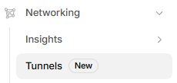
- Click Create a tunnel.

- Give the tunnel a name (e.g., ProjectTunnel) and click create tunnel. 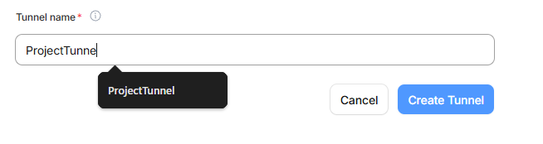
- Cloudflare generates a tunnel token. Copy it — it looks like: 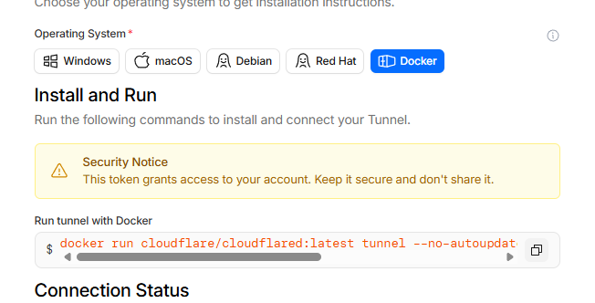

docker run cloudflare/cloudflared:latest tunnel --no-autoupdate run --token eyJhIjoiMj…pKaCJ9

- Paste the token into k8s/cloudflared/deployment.yaml under stringData.token:

stringData:
token: "eyJhIjoiMj…pKaCJ9"

Add Public Hostnames (DNS entries)

After saving the tunnel, go to the Zero Trust > Networks>Connectors>Your Tunnel>Published application routes tab and add two entries:


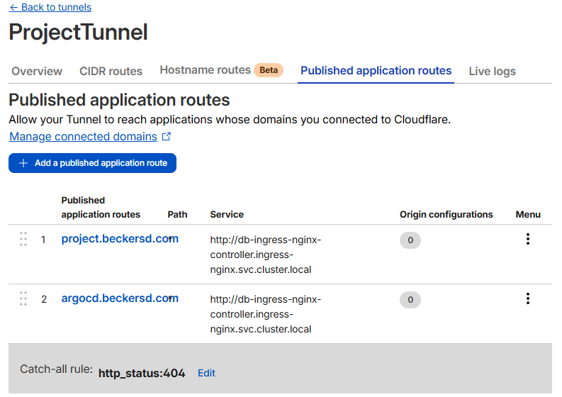
Subdomain | Domain | Type | Service
project | beckersd.com | HTTP | http://db-ingress-nginx-controller.ingress-nginx.svc.cluster.local
argocd | beckersd.com | HTTP | http://db-ingress-nginx-controller.ingress-nginx.svc.cluster.local

Note: Both entries point to the same nginx ingress NodePort (30080). The ingress controller uses the Host header to route:
- project.beckersd.com → db-frontend and /api → db-api
- argocd.beckersd.com → db-argocd-server

Cloudflare automatically creates CNAME DNS records for both hostnames pointing to <tunnel-id>.cfargotunnel.com.

TLS

Cloudflare terminates TLS at the edge for free using its Universal SSL certificate (*.beckersd.com). The tunnel carries plain HTTP between Cloudflare and the cluster — no certificate configuration is needed inside the cluster.

Important: The wildcard cert *.beckersd.com covers single-level subdomains only (e.g., project.beckersd.com). It does not cover two levels deep (e.g., project.app.beckersd.com). This is why argocd.beckersd.com is used instead of something like argocd.project.beckersd.com.

Deploy the Tunnel Pod

Once the token is set in the manifest, apply it to the cluster:

kubectl apply -f k8s/cloudflared/deployment.yaml
kubectl rollout status deployment/db-cloudflared -n db-stack

Verify the tunnel is connected in the Cloudflare dashboard — the tunnel status should show Healthy with one connector.

Verify End-to-End

curl https://project.beckersd.com/api/name
# {"name":"Dieter Beckers"}

curl https://project.beckersd.com/healthz
# {"status":"ok"}

