MIDDS Notes

# Fitting the coarse counter

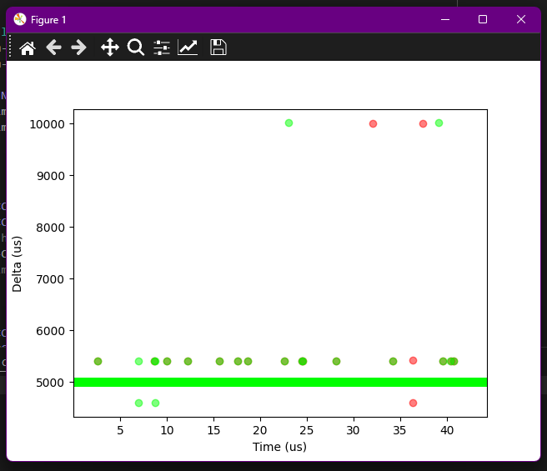

Input frequency of 100 Hz, detecting both rising and falling edges.

Using margin of < 40000.

Intermediate readings of SR register are **disabled**.

Error in X-axis label, should be seconds.

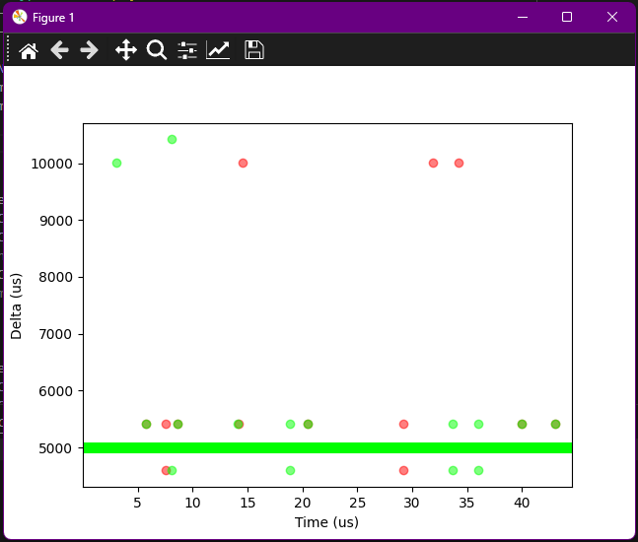

Input frequency of 100 Hz, detecting both rising and falling edges.

Using margin of < 40000.

Intermediate readings of SR register are **enabled**.

Error in X-axis label, should be seconds.

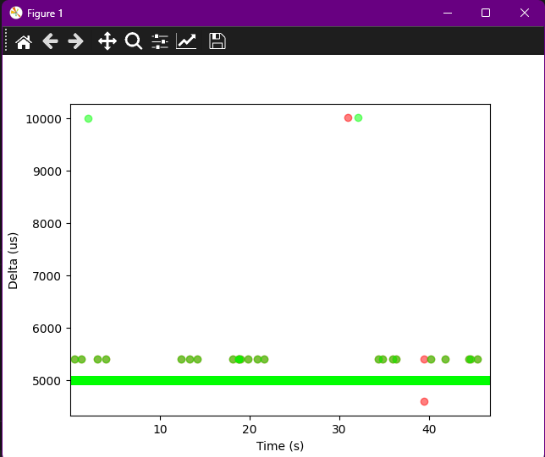

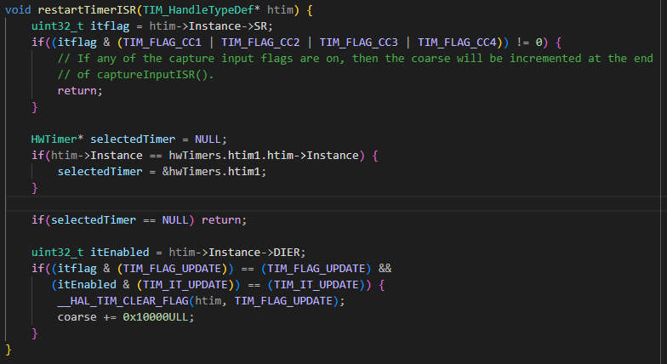

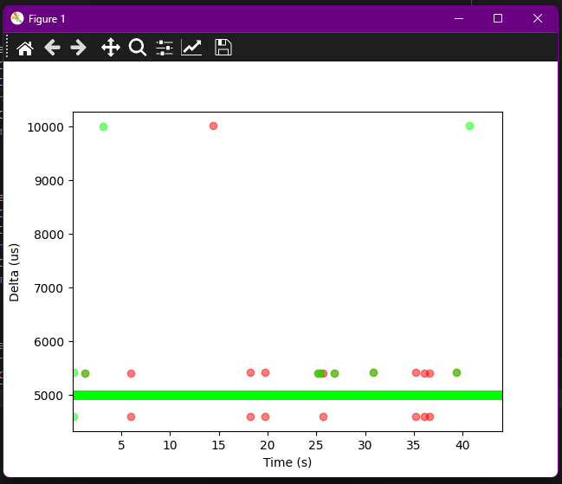

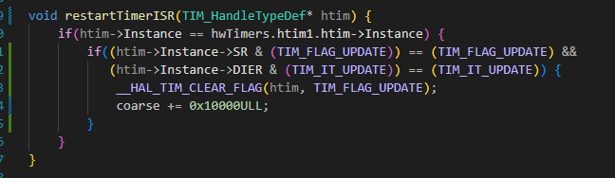

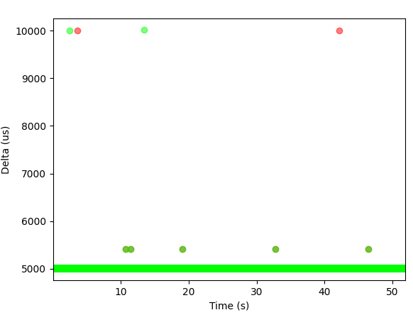

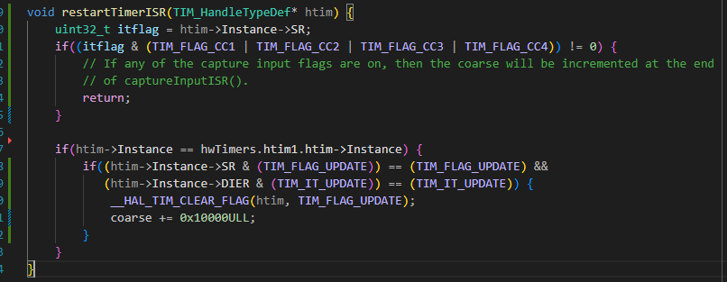

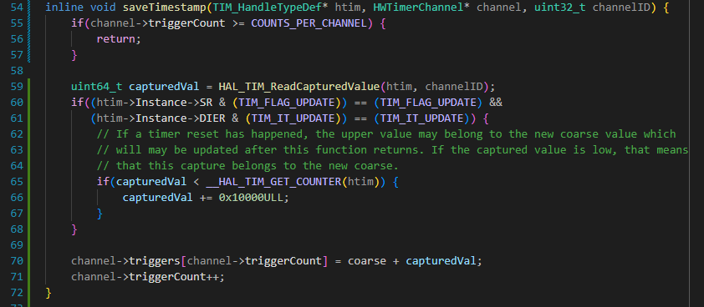

I thought that by checking if the captured value was less than the trigger count one could definitely know if the trigger happened AFTER the timer rollout. Looking good!

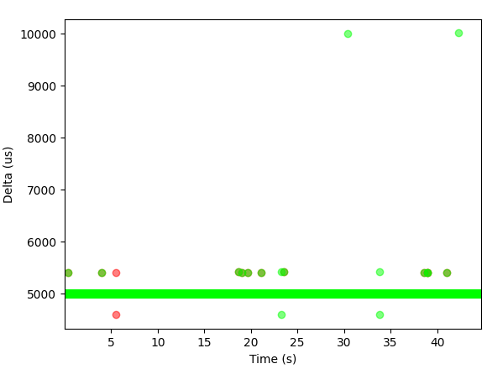 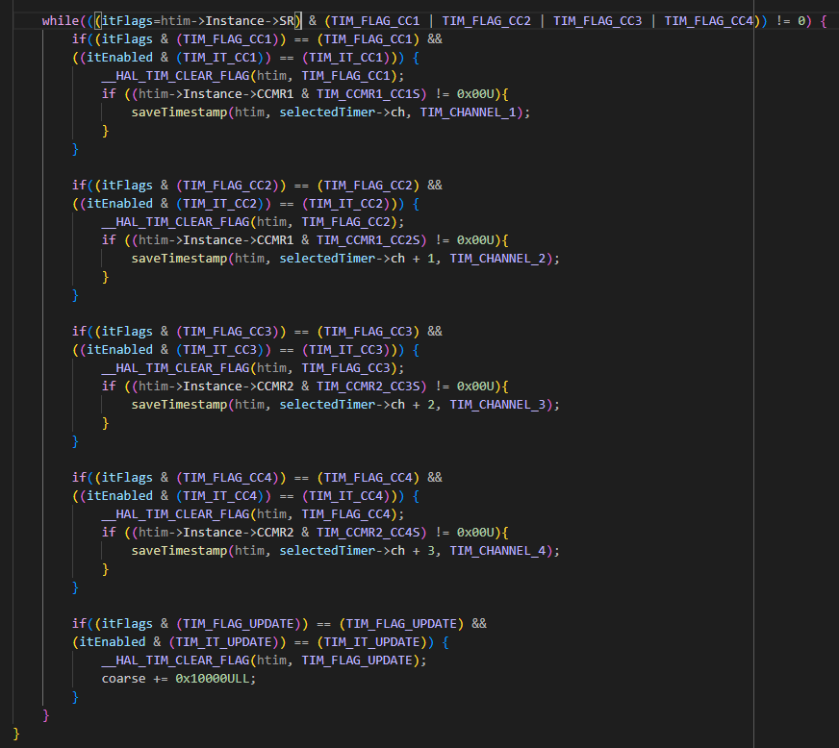

Inside captureInputISR() I thought that maybe by thoroughly making sure that no flag is set after exiting the ISR it would result in no overruns, but it doesn’t look to be making it and is instead ruining a little bit the measurements.