Stock Data Visualizer
Derek Abeln, Antonia Clay, James Lyerla, Kaden Marshall

Table of Contents
- Division of Work --------- 2
- Team Communication --------- 3
- Screenshots --------- 4
- Lessons Learned -------- 8

Division of Work
- Derek
  - Application, Coding,
- Antonia
  - Application, Sprint watch
- James
  - Application, Debug, coding
- Kaden
  - Application, Debug Scrum Master, edit project page

Team Communication
For our team communication we met on Discord before each of our sprints. We discussed our plans for the application as well as the best ways to communicate with each other. For any issues we had while coding we would typically reach out via Discord to ask any questions. This ended up being important because it was our first experience working with different batches in GitHub. There were multiple instances where comments from previous versions were not removed leading to confusion going forward. Luckily this was easily solved from having access to all team members.

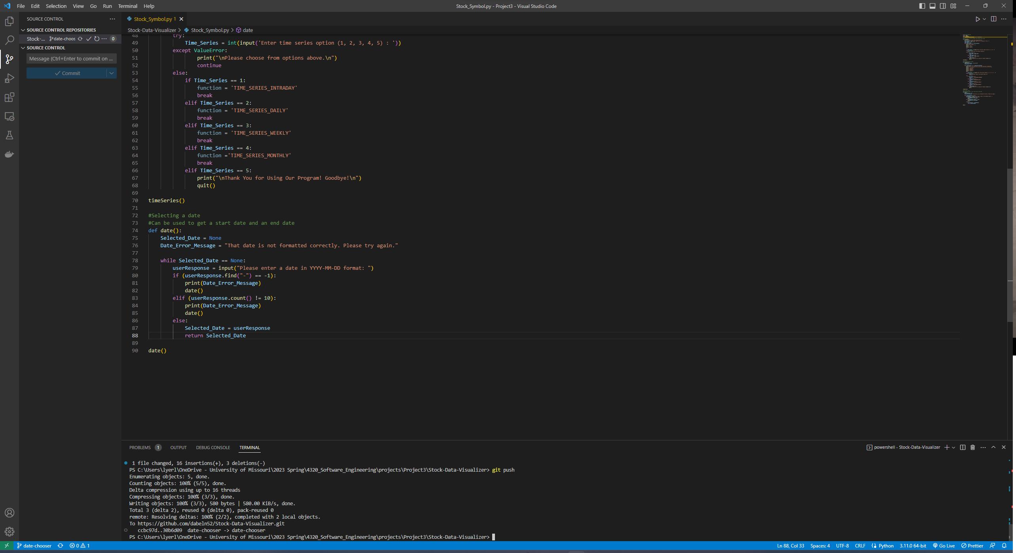
Screenshots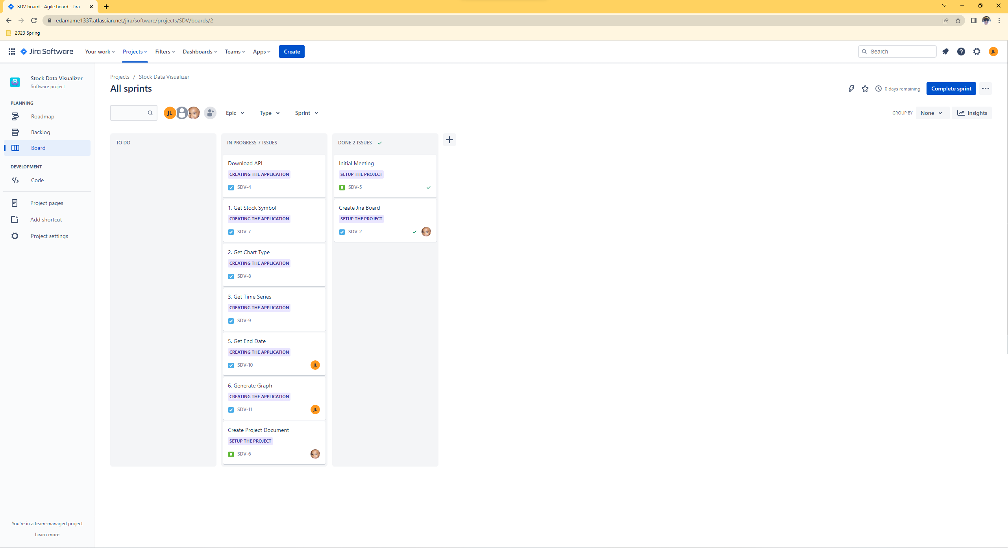
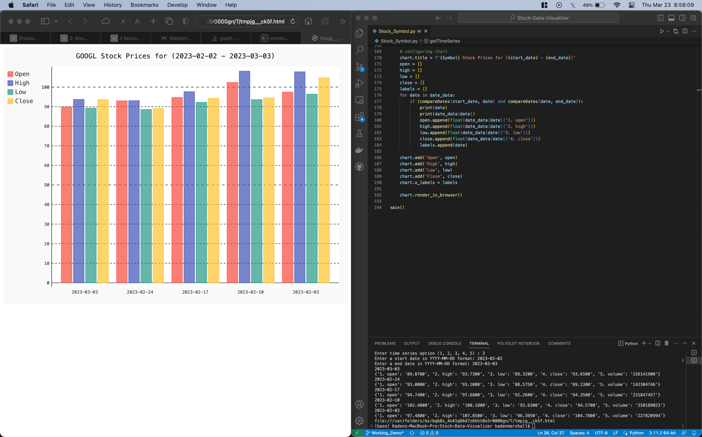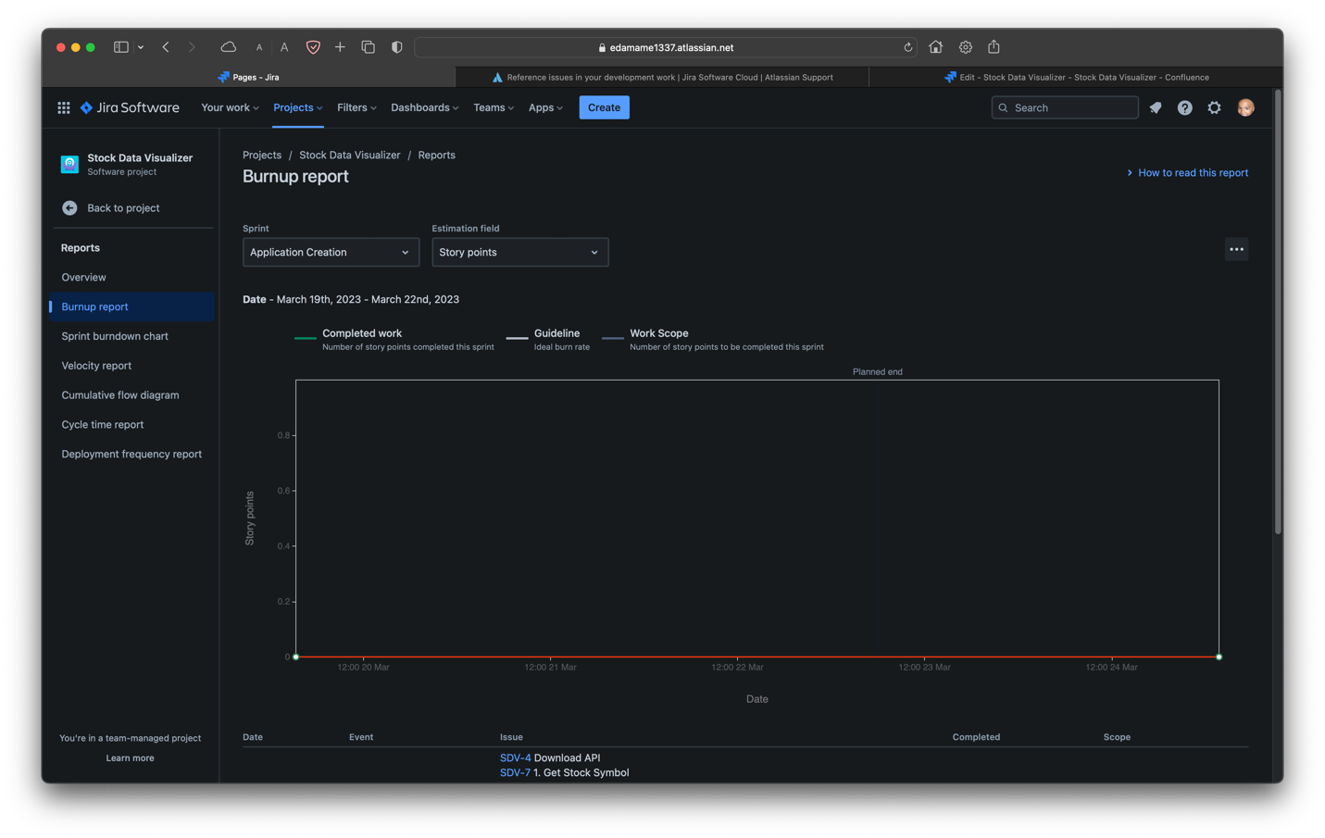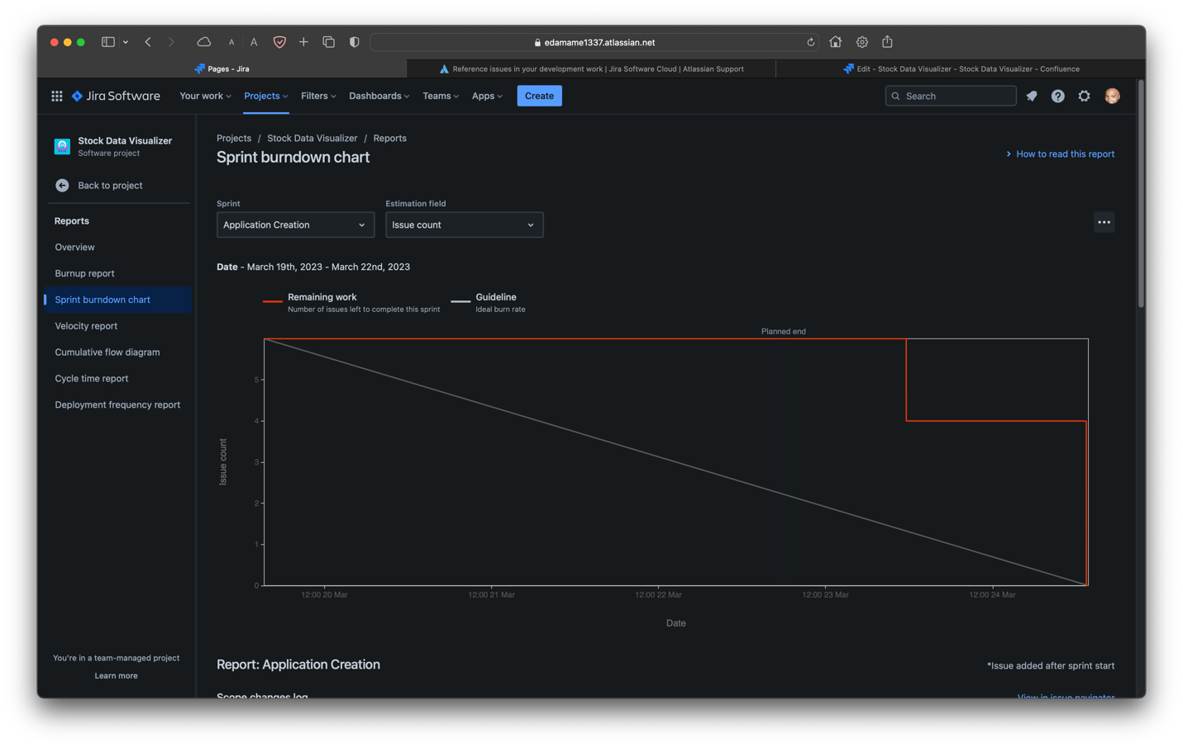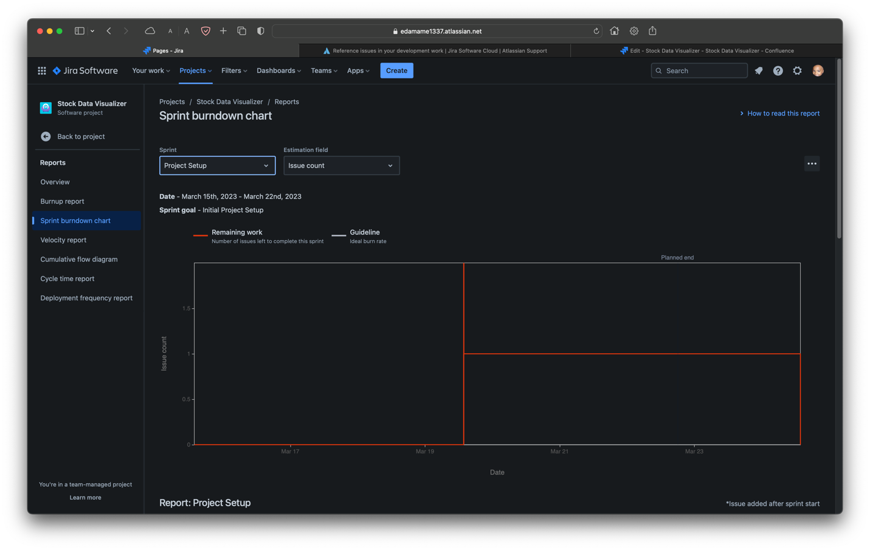

Lessons Learned
GitHub and branches are very helpful because we’re working on the same exact files. We need to work on getting started earlier still, but we are able to get things done quite well. Maybe it would be beneficial to try live coding while working on our projects. That way there is more cohesion with what is done. Setting up proper sprints is more important that we thought. It allowed us to have our own deadline which helped us get this finished quickly. I think for the next project we should be able to start earlier and finish earlier from the experience we have gained from this project.

