FULL PENETRATION TEST OF METASPLOITABLE 2
Authorized laboratory penetration-testing report
Prepared for internship/project submission
Name: Daberechi Success
Track: Networking and Cyber
Target | Metasploitable 2
Target IP | 192.168.56.101
Testing Environment | Isolated VirtualBox laboratory / Ubuntu WSL
Assessment Date | 22 September 2026

1. Assessment Objective
This report documents an authorized penetration test performed against the Metasploitable 2 training machine. The assessment covered target connectivity, network reconnaissance, service/version discovery, HTTP and SMB enumeration, FTP validation, PHP information disclosure, evidence collection, impact assessment, and remediation recommendations.

2. Scope and Method
Testing was restricted to the intentionally vulnerable Metasploitable 2 virtual machine at 192.168.56.101 in the laboratory environment. The assessment followed a practical sequence: verify connectivity, identify exposed services, enumerate selected services, validate observable weaknesses, and document evidence. No finding is presented as a successful exploit unless the supplied evidence demonstrates it.

3. Assessment Outcome
The work produced direct evidence of several security weaknesses, particularly anonymous FTP access, plaintext FTP communication, exposed PHP configuration information, and permissive SMB/IPC enumeration. The evidence also confirms a large exposed service surface.

RECONNAISSANCE AND SERVICE DISCOVERY

4. Connectivity Verification
Connectivity to the target was verified before service testing. Four ICMP requests were sent to 192.168.56.101 and all four were received, confirming reachability from the testing environment.
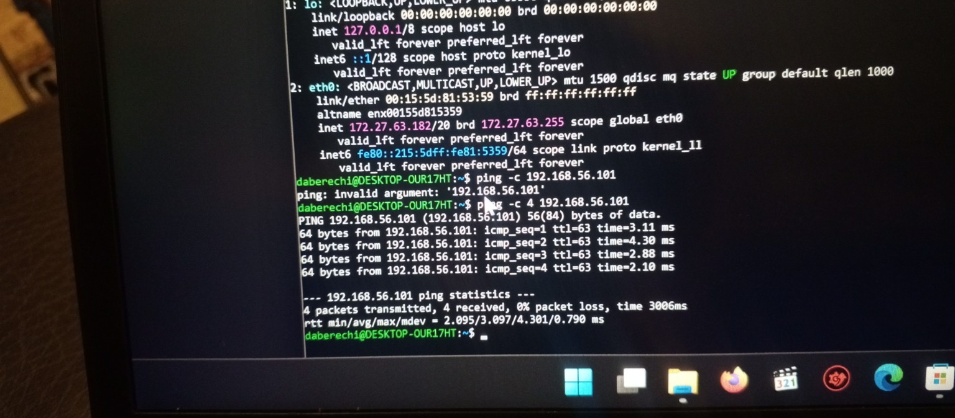
Figure 1. Connectivity evidence: 4 packets transmitted, 4 received, 0% packet loss.

5. Nmap Service Discovery
Nmap service/version detection identified multiple exposed services on the target. The observed attack surface included FTP, SSH, Telnet, SMTP, DNS, HTTP, RPC, SMB, rsh-related services, NFS, MySQL, PostgreSQL, VNC, X11, IRC, AJP, and Tomcat. The FTP service was identified as vsftpd 2.3.4.
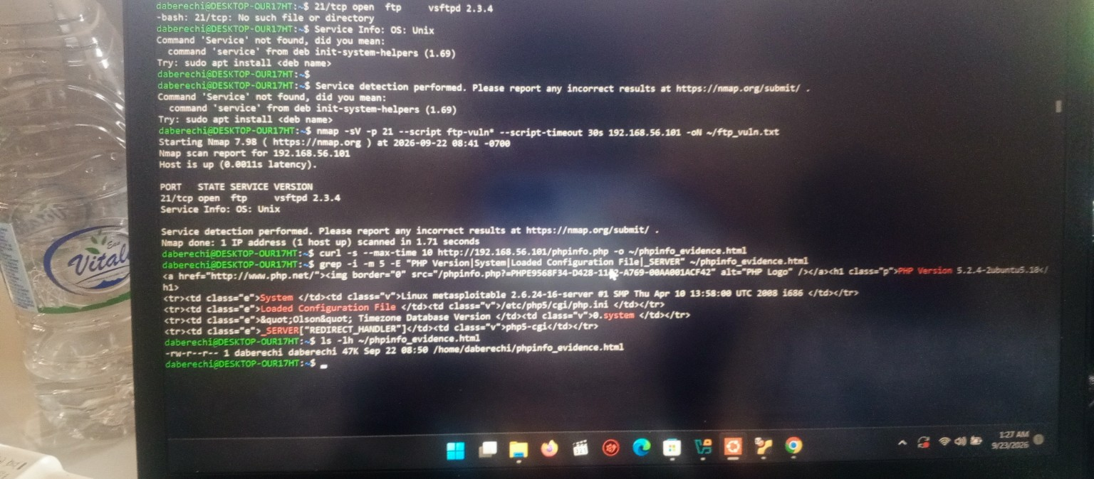
Figure 2. Nmap evidence identifying vsftpd 2.3.4 on TCP port 21.

6. Key Exposed Services
Service | Port | Observed result
FTP | 21/tcp | vsftpd 2.3.4; anonymous login allowed
SSH | 22/tcp | OpenSSH 4.7p1
Telnet | 23/tcp | Linux telnetd exposed
HTTP | 80/tcp | Apache 2.2.8; multiple discoverable paths
SMB | 139/445 | Samba 3.0.20-Debian
MySQL / PostgreSQL | 3306/5432 | Database services exposed
VNC / X11 | 5900/6000 | Remote/display-related services exposed

HTTP AND SMB ENUMERATION

7. HTTP Enumeration
The HTTP service was enumerated using Nmap's http-title and http-enum scripts. The results identified the Metasploitable 2 web page and several potentially sensitive or interesting paths, including /phpinfo.php, /phpMyAdmin/, /tikiwiki/, /test/, /doc/, /icons/, and /index/.
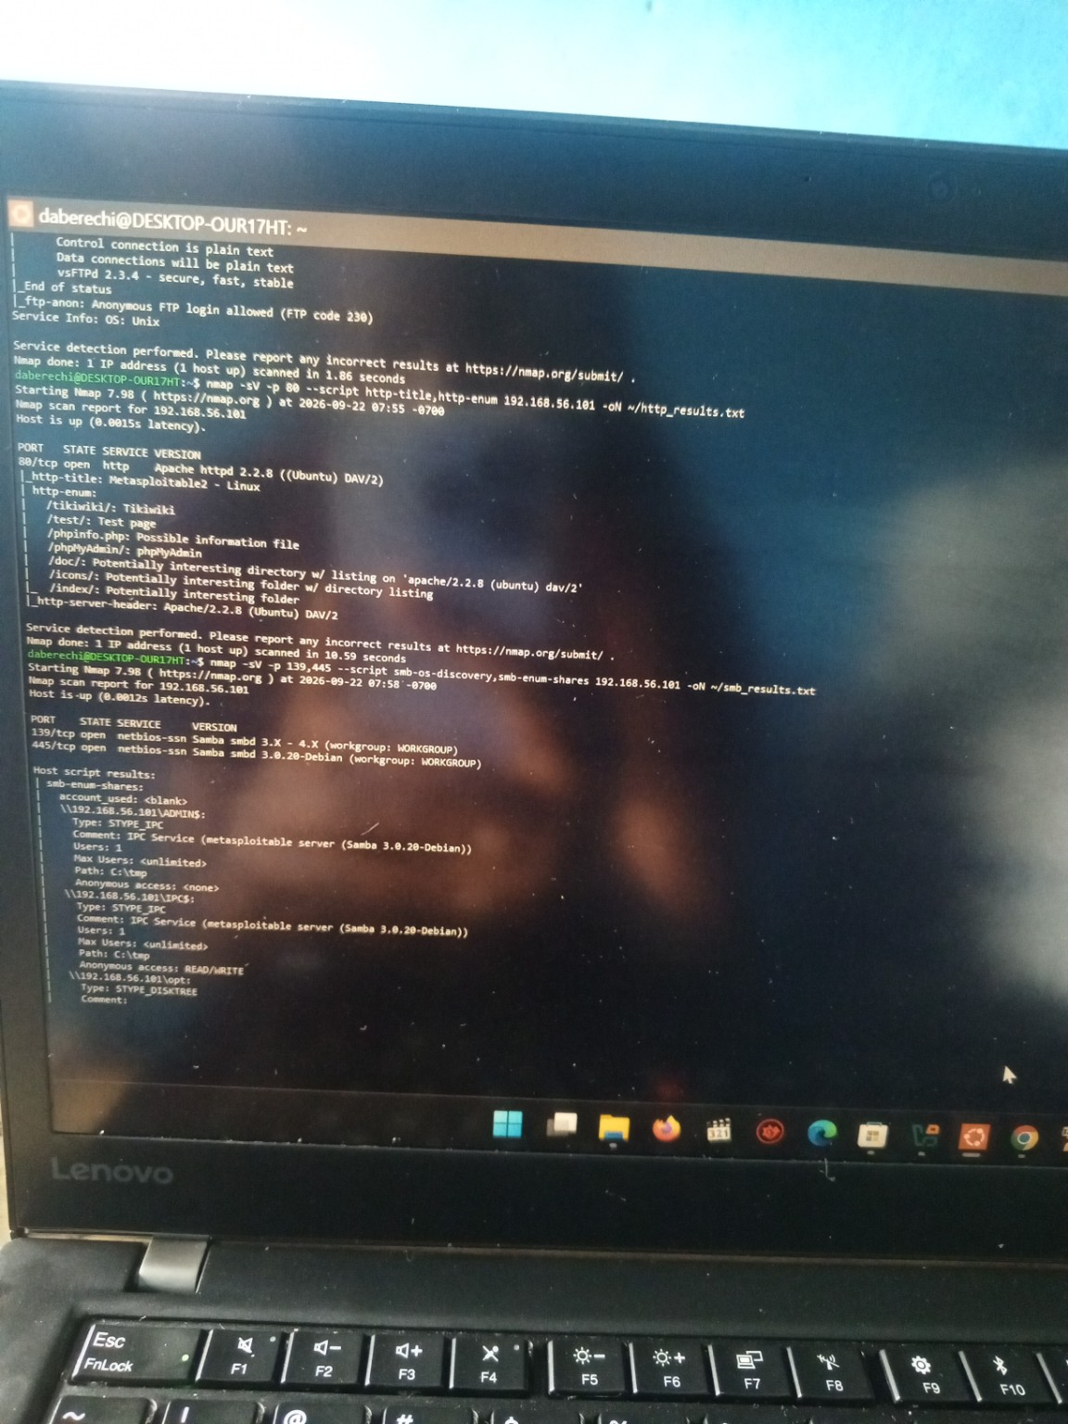
Figure 3. HTTP enumeration output showing discovered web paths, including phpinfo.php and phpMyAdmin.

8. Web Service Confirmation
The target web interface was then opened directly, confirming that the Apache service was reachable and exposing the Metasploitable 2 landing page.
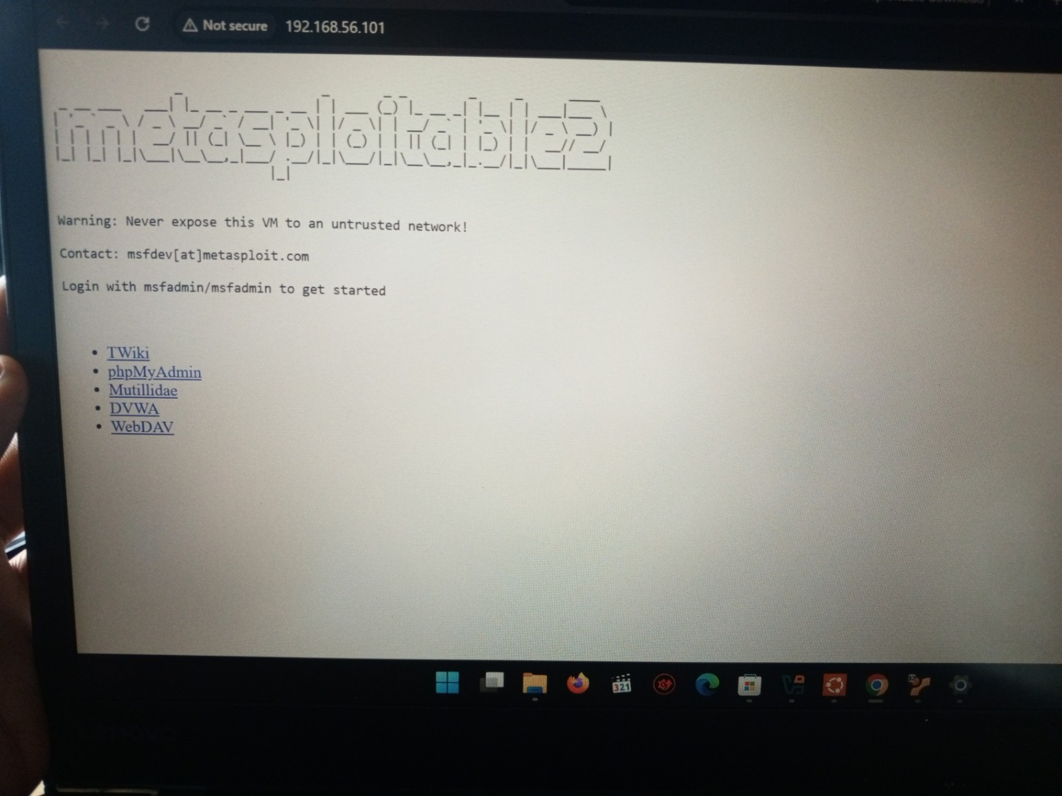
Figure 4. Metasploitable 2 web interface reached through the target IP.

9. SMB Enumeration
SMB enumeration identified Samba 3.0.20-Debian on ports 139 and 445. The enumeration output showed IPC$ with anonymous READ/WRITE access, while ADMIN$ did not permit anonymous access. This was recorded as an access-control/configuration weakness requiring review.
Figure 5. SMB enumeration showing Samba version and enumerated shares.

FTP VULNERABILITY IDENTIFICATION AND VALIDATION

10. FTP Service Validation
The FTP service was identified as vsftpd 2.3.4. Nmap's ftp-anon and ftp-syst scripts confirmed that anonymous FTP login was allowed (FTP code 230). The output also indicated that FTP control and data connections were transmitted in plain text.

Figure 6. FTP enumeration evidence showing anonymous FTP login and plaintext communication.

11. Manual Anonymous FTP Login
A manual FTP connection to 192.168.56.101 was performed using the anonymous account. The server returned '230 Login successful'. Directory listing commands were issued to determine what was exposed. The session did not demonstrate successful access to the attempted pub directory or prove file-write capability.
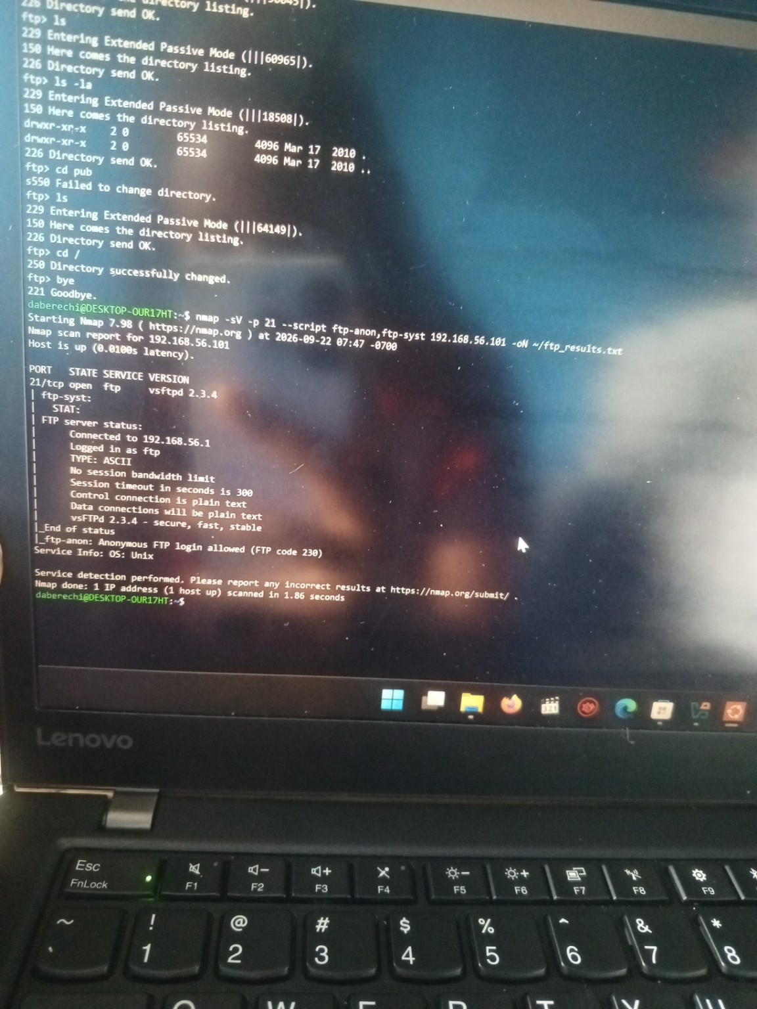
Figure 7. Manual FTP session showing successful anonymous authentication and directory enumeration.

12. Validation Summary
Test | Status | Interpretation
Anonymous FTP login | CONFIRMED | Unauthenticated/anonymous access is enabled.
Plaintext FTP | CONFIRMED | FTP communications are not protected by encryption.
vsftpd 2.3.4 exposed | CONFIRMED | Legacy service version is directly identifiable.
Sensitive file disclosure/write | NOT DEMONSTRATED | The supplied evidence does not prove it.
The report therefore treats the demonstrated FTP issues as configuration/security findings, not as proof of successful remote-code execution.

PHP INFORMATION DISCLOSURE, FINDINGS AND CONCLUSION

13. PHP Information Disclosure
The /phpinfo.php endpoint discovered during HTTP enumeration was retrieved and saved as phpinfo_evidence.html. The captured output disclosed the PHP version, operating-system information, loaded configuration file, and server variables. The evidence file was approximately 47 KB.
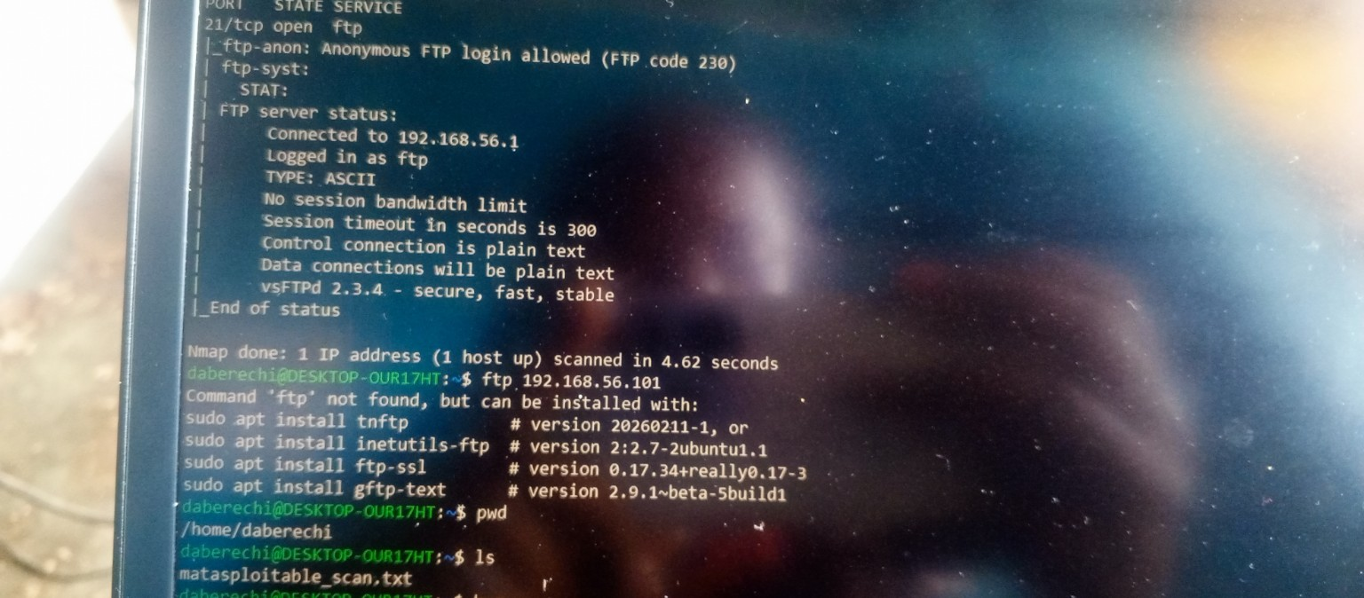
Figure 8. PHP information-disclosure evidence showing PHP version, Linux system information, and the loaded configuration file.

14. Consolidated Findings
Finding | Evidence | Impact | Recommended remediation
Anonymous FTP access | FTP code 230; manual login | Allows unauthenticated users to reach the FTP service. | Disable anonymous access unless required; enforce least privilege.
Plaintext FTP | ftp-syst output | Credentials/data may be exposed to interception. | Use SFTP/FTPS and retire legacy FTP where possible.
PHP information disclosure | phpinfo.php evidence | Reveals detailed platform/configuration information. | Remove phpinfo.php or restrict it to administrators.
SMB anonymous IPC$ access | smb-enum-shares output | May increase information and service exposure. | Disable unnecessary anonymous SMB access and review share permissions.

15. Conclusion
The authorized assessment successfully completed the reconnaissance, service discovery, HTTP and SMB enumeration, and validation of several observable security weaknesses on Metasploitable 2. The strongest directly demonstrated findings were anonymous FTP access, unencrypted FTP communications, PHP information disclosure, and permissive SMB/IPC access.
The supplied evidence does not demonstrate a completed exploit or privileged-shell takeover, so the report deliberately does not claim that those stages were achieved. This keeps the technical report consistent with the evidence collected during the laboratory exercise.

16. Evidence Index
- Figure 1 – Target connectivity verification.
- Figure 2 – FTP service/version validation.
- Figures 3–5 – HTTP enumeration, web confirmation, and SMB enumeration.
- Figures 6–7 – FTP anonymous-login and manual validation evidence.
- Figure 8 – PHP information-disclosure evidence.

