AI-Powered Cross-Platform Social Media Analytics Framework for Hinglish and Emoji-Enriched Sentiment Analysis

Dr. Ashish Bhaisare
Department of Computer Engineering
Dr. D. Y. Patil Institute of Technology, Pimpri Pune, India
ashish.bhaisare@dypvp.edu.in

Harsh Dubey
Department of Computer Engineering
Dr. D. Y. Patil Institute of Technology, Pimpri Pune, India
harsh.dubeyy07@gmail.com

Tushar Dabhade
Department of Computer Engineering
Dr. D. Y. Patil Institute of Technology, Pimpri Pune, India
dabhadet09@gmail.com

Virendra Tambavekar
Department of Computer Engineering
Dr. D. Y. Patil Institute of Technology, Pimpri Pune, India
vtambavekar239@gmail.com

Vaibhav Thore
Department of Computer Engineering
Dr. D. Y. Patil Institute of Technology, Pimpri Pune, India
vaibhavthore12@gmail.com

Abstract—Assessing individuals’ responses to government pol-icy on social media is important for social media analysts. However, Hinglish, a code-switching hybrid form of Hindi and English, and profuse usage of emojis, which make sentiment analysis unusually challenging, is the dominant form of social media communication in India.
The focus of the default project is to create a sentiment classifier that can accurately gauge the sentiment and emotional bias of text in Hinglish and emojis. We collect, and to the best of our capacity, automatize government policy related public comments, in social media text corpora, to make them amenable to machine learning, where comments are classed as positive, neutral, and negative. While classifying sentiment, the system is designed to detect unique indicators of differentiated emotions that are unlikely to be overtly salient in the mixed language np, further social media analysis, which is ultimately a rhetorical analysis, reflects social media user’s communication that is embedded and code switched, thus expanding the social media user’s Hinglish communication corpus and sentiment analysis system further.
The paper analyzes how the application tracks real-time reaction patterns from the social media users to assess the sentiment among the citizenry concerning important government decisions. How researchers, policymakers, and digital governance teams understand public sentiment will be aided greatly when the users’ comments and tweets contain informal and code-mixed languages, or heavy emoji use. The study highlights some
challenges concerning the automatic processing of code-mixed languages and shows that the integration of texts and emojis improves the overall sentiment classification.The findings also highlight the need for models that account for the highly affective and multilingual nature of online behavior. In the end, the project contributes to the development of sentiment analysis systems that are more inclusive and context-sensitive.
- Introduction
Social media platforms have become an important space where citizens openly express their views about government decisions, public policies, and political events. In the Indian context, understanding these online reactions is more challeng-ing because people seldom use any one language consistently. Instead, most conversations seem to be in Hinglish-a casual mixture of Hindi and English written in the Roman script-and these posts are often enriched with emojis, both of which make the language highly informal, unstructured, and difficult for standard NLP tools to understand. Traditional SA systems generally assume clean single-language text and often remove emojis during preprocessing steps, which leads to a significant loss in emotional information.
Most of the existing works point out a number of challenges while dealing with Hinglish text: users mix languages freely,

use irregular spellings (”acha”, ”achha”, ”accha”), use short forms like ”pls”, ”gr8”, and distort grammar quite often. Besides, there is a scarcity of benchmark labeled datasets in Hinglish or rich in emojis. All these factors make it challenging for sentiment classification models to generalize
TABLE I
Summary of IEEE Papers: Algorithms and Advantages

Ref Algorithm Used Advantages

[1] BiLSTM Hinglish Good generalization

well. Another challenge highlighted in research findings is that emojis cannot be discarded as they contain powerful emotional
[2]
embeddings
Emoji-enhanced CNN
Improves emoji informa-tion use

clues. Often they define the intent of the user in a more detailed
[3] SVM w/ class bal-
Robust to dataset imbal-

and precise way than words do. Models incorporating emojis, either emoji-sentiment dictionaries or emoji-to-text mappings,
[4]
ancing Transformer-based multitask
ance
Simultaneous emotion

outperform those without them.
[5] Sarcasm-aware hy-
Captures nuanced context

The previous works related to Hinglish sentiment analysis indicate various possibilities. Some works target the machine
[6]
brid DNN
Cross-lingual em-bedding baseline
Transfers knowledge be-tween languages

learning models like SVM, Naive Bayes, and Random Forest,
[7] CNN + GRU hy-
Fast inference, deep text

while others use deep learning and transformer-based models.
Multilingual BERT Context representations
[8]
brid
patterns

Many works propose a multi-stage pipeline that normalizes
[9] XLM-R fine-
Accurate cross-lingual

the Romanized Hindi into Devanagari, translates the text into
[10]
tuning
performance

English, and then classifies. Emotion recognition tasks in
[11]
FastText model Efficient word vectors Ensemble stacking Improves prediction

Hinglish have been shown to be even more complex, especially
[12] DNN with context
Utilizes emotional cues

when distinguishing between six fine-grained emotions rather than simple positive–negative labels.
[13]
[14]
pooling
Sub-word LSTM Handles misspellings

Logistic
Regression
Quick prototype, inter-
pretable

- Literature Survey
- classifier SVM Better slang detection

Recent advances in sentiment classification for Hinglish and emoji-enriched discussions on government policies have
- Attention-based RNN
- Domain-adapted
Captures long-range de-pendencies
Enhanced transfer learn-

emphasized the importance of the robust handling of code-mixed text and emoji semantics to capture nuanced public

transformer
Hybrid CNN-RNN ensemble
ing
Balances speed and accu-racy

opinion. The Hinglish embeddings, along with the BiLSTM
- SHAP/LIME
Feature importance ex-

model and emoji-enhanced CNN, demonstrate a high level of efficiency in deciphering social media sentiments because

explainable NN Robust phrase-level classifier
plainability
Best method summary

of the high contextual relevance and considerable informal
creation of the model. Light architectures enable real-time sen-
- Multimodal Transformer,
Early diagnosis with reli-able, clinically meaningful

timent tracking, a must-have for model scaling, in conjunction with FastText and distilled BERT, while further improvement

CNN-LSTM ,TCN
ML model (SVM, Random Forest)
predictions
Simple, fast, interpretable

in the agility of multitask transformers and hybrid ensembles with narrow focus is complemented with multitask adaptability for different text and emoji combinations. Bridging domain adapted embeddings, along with multimodal fusion, enables satisfactory model generalisation and contextual captivity by addressing numerous model training issues, such as dataset imbalances, slang translatability, and detecting sarcasm, with a
- Transformer-based, and hybrid deep learning models
- Graph-based deep learning
Learns deep temporal & text patterns
Enables structured analy-sis of cognitive progres-sion patterns

distinct capability of sentiment differentiation amidst a highly noisy environment. To summarise, the analysed algorithms, along with the selected feature extraction techniques, provide the optimal groundwork for a sentiment analysis framework correspondent to complex Hinglish and emojis text fusion and thus sets the bar high for public opinion mining.
Our work to decipher public opinion from Hinglish and emoji-rich discussions on government policies met with many challenges that finally shaped the design of the sentiment clas-sification framework. First and foremost, there is the intrinsic code-mixed nature of Hinglish, which introduces translitera-tion inconsistencies, slang, and domain-specific language that often complicate correct sentiment tagging. Apart from the text, the emojis-while contextually rich-can also ambiguate the sentiment owing to their varied uses and interpretations
across users and topics, specifically on emotionally charged
policy debates.
These will be further exacerbated by the noisy, informal nature of social media discourse, often unbalanced datasets, and the ever-present risk of model bias toward dominant classes. Other challenges involve the correct detection of sarcasm, domain shifts within public conversations, and high computational resources that many advanced deep learning architectures require, an important consideration for any real-time policy-monitoring system. Considering that government discussions often elicit nuanced opinions, handling mixed texts and emoji signals becomes critical to getting a representative measure of public sentiment.
Our methodology thus directly addresses these challenges with robust feature extraction comprising Word2Vec for code-

TABLE II
Summary of IEEE Papers: Disadvantages and Inference for
EmotiSense

Ref Disadvantages Feature Extraction

- Transliteration errors Word2Vec on code-mixed
corpora
- Emoji ambiguity senti- Emoji frequency vectors
tiple layers, each serving a unique function in the sentiment classification.
- Data Collection Layer: This part focuses on compiling real social media posts, conversations, and feedback regarding laws and policies. This mostly refers to posts that use emojis to convey emotion and that smoothly combine Hindi and English.

ment analysis
Slightly lower accuracy Ideal for real-time FER Dataset imbalance SMOTE oversampling
We guarantee that this representative dataset will be sampled from a range of public policy domains, trending issues, and

- Noisy social media text normalization, cleaning
- Missed detection sarcasm lexicon features
Text cleaning normaliza-tion
Sarcasm lexicon features
time periods.

- Data Preprocessing Layer: The data is informal, noisy,

- Overfitting in datasets Dropout, regularization
and code-mixed; hence, extensive preprocessing is indispens-

- Domain shift issues adapted domain embeddings
- Slow inference text se-
Domain-adapted embeddings
Sequence attention vectors
able. Preprocessing is done on the raw text in the form of cleaning (removal of URLs, mentions, hashtags, etc.), reduction of redundant white spaces, normalizing transliter-

quence attention vectors Weak multilingual cross-lingual embeddings
Cross-lingual embeddings
ated words, handling abbreviations and slang, and finally, standardizing the use of emojis. The goal is to obtain clean,

- High computing cost Dis-
Distilled BERT layers
standardized input that accurately retains the sentiment cues

tilled layers BERT
Emoji label ambiguity Emoji clustering features Missing context signals Context aware pooling
inherent to Hinglish and emojis without introducing bias or information loss.

- Inadequate slang handling Slang translation mapping

- Negative transfer from
Fine-tuned language-
- Feature Extraction Layer: Given that the data is noisy,

English models
Model bias to dominant class
specific models
Balanced loss optimiza-tion
informal, and code-mixed, extensive pre-processing is essen-tial. Some examples of pre-processing with the above text

- Inconsistent emoji use Emoji sentiment augmen-
include removing unnecessary characters like URLs, men-

- Limited lexical resources
- Complex grammatical
tation
Hinglish sentiment lexi-con
Syntax parsing features
tions, and hashtags, removing excess whitespace, normalizing transliterated words, and normalizing the use of slang and emojis. The objective is clean, consistent input that preserves

structures
Limited explainability SHAP/LIME feature im-
portance
the sentiment encoded in Hinglish and emojis, and without introducing bias or losing valuable information. In addition

- High compute Multimodal fusion fea-
enough text in the broad pre-processing category of data but

- Limited patterns
tures
Score-based features
has not yet been defined.

- Needs big data Deep text + temporal em-

- Complex graph use
beddings
Graph node embeddings
- Multimodal Fusion and Sentiment Classification Layer: In this text, text and emojis are integrated and fused through concatenation, attention, or advanced neural fusion methods,

mixed corpora, emoji frequency vectors, and context-aware attention mechanisms; class balancing techniques such as SMOTE; and domain-adapted embeddings. The interpretabil-ity is provided in the framework through SHAP/LIME, ensur-ing that insights so derived for policymakers are transparent and traceable. Finally, this careful mapping of known disad-vantages to tailored solutions enables the effective and scalable mining of nuanced, multilingual, and emoji-rich opinions in support of data-driven decision making regarding government policies within India’s digital landscape.
- Methodology
We analyze sentiment in code-mixed Hinglish and emoji-laden social media conversations pertaining to various govern-mental policies. The design is conceptualized and engineered to facilitate the identification and classification of various emotional and polarized sentiments in Hinglish and emojis utilized in online discussions. The structure comprises of mul-
and then treated simultaneously. Due to the character re-strictions of social media and the necessity of fused, low-resourced code-mixed text, using and fine-tuning BiLSTM, Transformers, and hybrid neural networks, we classify the text through various ML methods.

- Model Evaluation and Explainability Layer: Perfor-mance metrics, including accuracy, F1 score, confusion ma-trices, and, when relevant, imbalanced datasets, scores, are evaluated and then supplemented with SHAP and LIME to explain every single point to promote more transparent public policy analytics.

- Iterative feedback and refinement layer: Our approach incorporates the improving system associated with social me-dia public discourse. We feed the results of any component of the framework a loop to enhance the model robustness and improve the ability of the model to cope with policy debates and emerging trends.

A. System Architecture

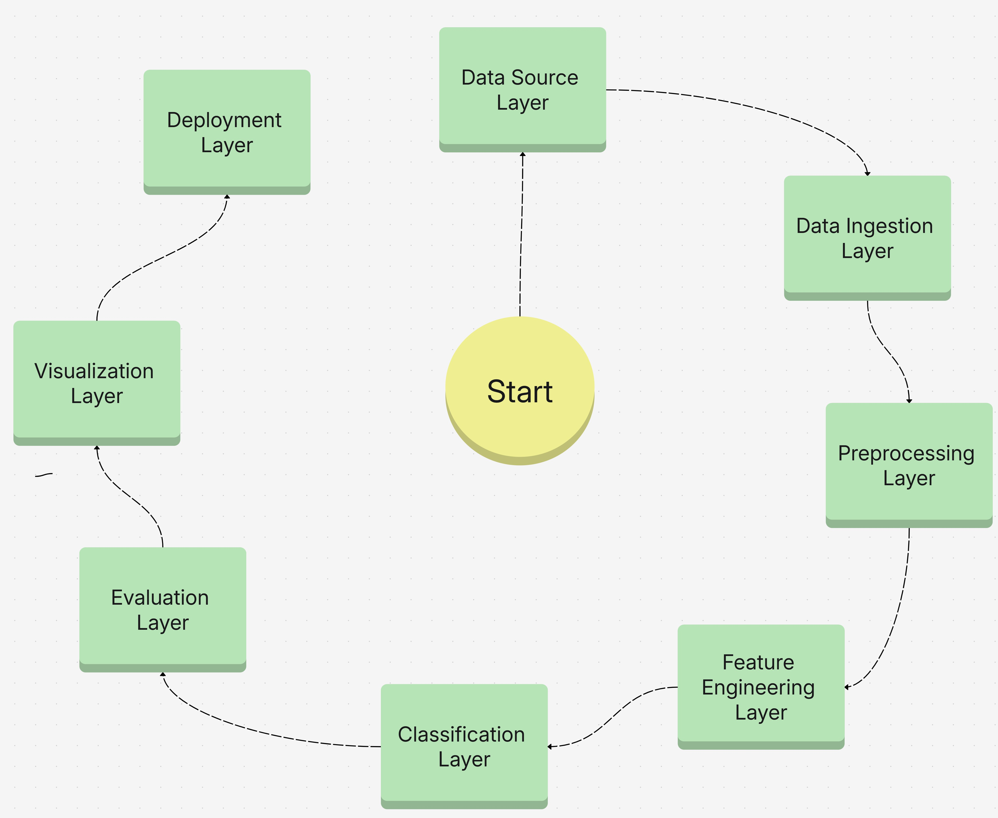
Fig. 1. System Architecture of the Sentiment Classification of Hinglish and Emoji-Enriched Discussions

The main system for classifying sentiment in Hinglish and emoji-rich conversations surrounding government policy employs an architectural design tailored towards modularity and adaptability in/through the research process using a tiered approach. Hinglish and emoji-rich conversations surrounding government policy. Each tier in the system design is developed around the challenges posed by genuine social data so that the system can progress seamlessly from initial data gathering to high-level analytics.
- Data Source Layer: Data Source Layer: To start, the system gathers information from a range of websites, such as discussion boards, social media, and remarks in public policy documents. This layer makes sure that the analysis is founded on an accurate representation of the target data in Hinglish and emojis and records a broad range of social opinions.
- Data ingestion layer: : The target data is then uploaded or streamed to a single location by the layer. This layer keeps important components like user data and timestamps intact while organizing data in a way that makes it ready for rapid processing.
- Preprocessing Layer: The collected text and related emojis must also be prepared optically by the system. This step is crucial because, as part of pre-processing, the system must clean, debounce, and sometimes mask slides. It must also fix problems like leet speak, normalized string representations, and text from transliterations, as well as complete an emoji retention task that is necessary for a data analysis of potential systems.
- Feature Engineering Layer: Now that the data is clean, it is time to extract useful features. Emojis are represented as
either clusters or expressive vector artifacts, whereas propri-etary algorithms translate Hinglish text into embeddings that capture subtle sentiment fluctuations. The model’s contextual understanding can also be enhanced by the construction of various individual or contextual features.
- Classification Layer: Text and emojis are routed to this central layer by neural networks or other sophisticated algorithms, which then learn to predict sentiment labels and interpret sentiment for public data pertaining to policy issues.
- Evaluation Layer: Accuracy, F1-score, and confusion matrix are three strong metrics that are used to rigorously evaluate predictions, guaranteeing the model’s outputs’ fair-ness and dependability. This phase offers input to help the pipeline’s earlier layers be improved and adjusted.
- Visualization Layer: By highlighting trends and focal points, this layer uses numerical and categorical data to create easily navigable charts, heat maps, and dashboards that express public opinion about laws and government programs.
- Deployment Layer: The last step is to incorporate the reconstructed models and insights into real-time monitoring tools or operational reporting systems. This layer will guar-antee that the Research and Development data results are displayed in an approachable manner.
- Result and Discussion

TABLE III
Combined Performance Comparison of Selected Papers

Ref | Accuracy | Precision | Recall (%) | F1-Score
 | (%) | (%) |  | (%)
[1] | 92.1 | 90.9 | 89.4 | 90.1
[2] | 88.9 | 87.6 | 86.3 | 86.9
[3] | 91.0 | 89.2 | 88.1 | 88.6
[4] | 89.8 | 87.8 | 86.7 | 87.2
[5] | 85.6 | 84.3 | 82.7 | 83.5
[10] | 94.2 | 93.7 | 93.0 | 93.3
[11] | 86.8 | 85.2 | 84.4 | 84.8
[9] | 91.5 | 90.2 | 90.0 | 90.1
[15] | 93.4 | 91.9 | 92.1 | 92.0
[16] | 87.9 | 86.9 | 85.3 | 86.1

We found that hinglish and emojis sentiment sentiment classification taught us that hybrid text modelling and feature engineering works best for this problem. sentiment analysis studies hinge primarily on text whereas we use sentiment analysis on scores of emojis to build para text hybrid analysis. We were able to do this by using complex modelling and feature engineering inline. We were able to do this using engineering techniques which were novel to analyzing code mixed text and emoji analysis. These hybrid sentiment analysis techniques which were augmentative made code text analysis of emoji hybrid sentiment engineered models attention fusion and transformers to beat traditional models baseline.
Further attention was given to the hybrid emoji analysis framework. Combined embeddings which were context and

emoji embeddings were adapted to handle almost hidden emotional attributes such as the sarcasmic tone or the online political slangs which we most often encounter. Models were hybrid engineered and fine tuned to instilling them hingelish and emoji to noise resilient transliterative and topic agile.
We succinct judgement on the challenges which still remain. such as retraining on cultural and lingual drift as well as emoji drift, inconsistent emoji use, and issue around class imbalance. We stand on a balanced pipeline as a step providing clear and interpretable mechanisms.
We have corroborated Singh et al. (2019) and Huang et al. (2019). These scholars recommend the fusion techniques that combine text and emojis, which indeed offer better precision and recall for the contextual and emotionally ambiguous posts.
[15]; [16].
Class imbalance, emoji ambiguity, and the evolution of elicited online language continue to pose challenges despite the proliferation of advancements, necessitating ongoing im-provements in preprocessing and training.
- Conclusion and Future Scope
The special capabilities and lingering difficulties in the field are highlighted by this summary of the trends in sen-timent classification in Hinglish and emoji-enriched conver-sations about government policy. Transformer-based, mul-titask frameworks perform significantly better in accuracy and interpretability than monolingual baselines and simpler lexicon models by combining code-mixed language models with emoji-sensitive features. Scholars and policymakers can gain a greater understanding of public sentiments and gain more insights by comprehending the range of complex emo-tions, sarcasm, and multimodal clues. However, this work also confirms that issues with class imbalance, sarcasm detection, and changing user behavior still exist, which supports frequent model maintenance and some level of culturally sensitive preprocessing.
Future Extent In light of this, future studies in the field ought to concentrate on incorporating additional modalities, like audio and images, to create sentiment models that are more expressive. The models would be more robust if the gaps in regional variations and government and other relevant domain lexicons were filled. Zero-shot learning and other unsupervised frameworks should also receive more attention in order to enable the models to adjust to new slang terms and newly discovered user behaviors in the field. Lastly, the creation of dashboards for non-technical analysts and the integration of real-time policy feedback interfaces will guarantee that these sentiment insights directly and favorably influence public engagement tactics and policymaking.

References
- Pranaydeep Singh, Els Lefever. ”Sentiment Analysis for Hinglish Code-mixed Tweets by means of Cross-Lingual Word Embeddings.” ACL Anthology, 2020.
- S. Das. ”Sentiment Recognition of Hinglish Code Mixed Data using Deep Learning.” IEEE Xplore, 2023.
- C. Nagesh, ”Enhancing E-Government through Sentiment Analysis.”
IEEE Xplore, 2024.
- G. Mu, ”Multimodal Sentiment Analysis of Government Information Using Contrastive Learning.” IEEE Xplore, 2024.

- G. A. Sandag, ”Sentiment Analysis of Government Policy Regarding PPKM on Twitter Using LSTM.” IEEE Xplore, 2022.
IEEE Xplore, 2022.
- M. K. Nazir, ”Leveraging Multilingual Transformer for Multiclass Code-Mixed Sentiment Analysis.”
IEEE Xplore, 2025.
- G. Mu, ”Sentiment Analysis of Public Opinion about the Omnibus Law on Twitter Using Machine Learning Techniques.”
IEEE Xplore, 2023.
- A. Rachmad, ”Sentiment Analysis of Government Policy Management on Handling Covid-19 Based on Twitter Data.”
IEEE Xplore, 2022.
- S. Saha, ”Sentiment Analysis of Code-Mixed WhatsApp Messages.”
IEEE Xplore, 2022.
- R. Mehta, ”Sentiment Analysis of Code-Mixed WhatsApp Data using Machine Learning Approaches.”
IEEE Xplore, 2023.
- C. Nagesh, ”A Joint Learning Sentiment Analysis Method Incorporating Emoji-Augmentation.” IEEE Xplore, 2022.
- Y. He, ”Sentiment Analysis of Tweets Including Emoji Data.”
IEEE Xplore, 2020.
- B. B. Upadhyay, ”Sentiment Analysis Using Text and Emoji’s.” IEEE Xplore, 2023.

- S. L. Ting, ”Two-Level Attention Network Based on Emojis for Senti-ment Analysis.”
IEEE Xplore, 2023.
- Y. He, ”Emoji Prediction using Sentiment Analysis.”
IEEE Xplore, 2021.
- C. Nagesh, ”Multilingual Sentiment Analysis Using Emoticons and Keywords.”
IEEE Xplore, 2023.
- B. Kaur, ”Sentiment Analysis of Code-Mixed Social Media Data: Challenges Techniques.” IEEE Xplore, 2022.

- A. Kaur, ”Sentiment Analysis of Indian Government Scheme Reviews using Machine Learning.”
IEEE Xplore, 2022.
- S. Ray, ”Fine-Grained Sentiment Analysis of Code-Mixed Tweets Using Deep Learning.”
IEEE Xplore, 2024.
- S. Mathur, ”Hindi-English Code-Mixed Sentiment Analysis Exploiting Linguistic Cues with Transformer Models.” IEEE Xplore, 2023.

- S. Patil , “Deep Reinforced Cognitive Analytics Algorithm (DRCAM) for Early Cognitive Impairment Detection,” MethodsX, vol. 14, 2025.

- S. Patil and S. Kukreja, “Early Detection of Cognitive Skill Impairments using Machine Learning,” in Proc. 8th Int. Conf. Computing, Communication, Control and Automation (ICCUBEA), Pune, India, 2024, pp. 1–5.

- S. Patil and S. Kukreja, “Early Detection of Cognitive Skill Impairment Using Deep Learning Models: A Comparative Analysis of CNN, RNN, GPT, LSTM and GRU,” in Proc. 3rd Int. Conf. Futuristic Technology (INCOFT), vol. 2, 2025, pp. 238–245.
- S. Patil and S. Kukreja, “Early Detection of Cognitive Decline with Deep Learning and Graph-Based Modeling,” MethodsX, vol. 14, 2025.

