A Project Report on

Sunrise Hotel Management



The Report Submitted To

SAURASHTRA UNIVERSITY

Submitted In Partial Fulfillment of The Requirement For The Award of The Degree

Academic Year 2024 – 2025

**BACHELORE OF COMPUTER APPLICATION**

**[SEMESTER – 5th]**

**Prepared By: -**

[ Vikram Dabhi ]

[ Ravi Chhatrodiya ]

**Int.Project Guidance:- prof.[ Sanjay Tilavat ]**

**FROM:-**

**23073 – N. P.VEKARIA EDU.&CH. TRUST SANCH. GRACE COLL. OF**

**COMM.,RAJKOT**

**DECLARATION**

I hereby declare that this project work entitled **HOTEL MANAGEMENT** is record done by me.

I also declare that the matter embodied in this project is genuine work done by me and has not been submitted whether to this University or to any other University /Institute for the Fulfilment of the requirement of any course of study.

**Place:-**

**Date:-**

**ACKNOWLEDGEMENT**

Our website, which you are using, is the result of many people’s dedication. The cumulative efforts of many minds working to get his day and night gave us the contentment of developing the software. Special thanks to Grace College for great support.

We express our gratitude to for guidance and who kept the things on track and to all other faculty members who helped us directly or indirectly. Finally yet importantly, our acknowledgement goes to all the well-wishers of our project his excellent support in all aspects.

**PREFACE**

There is a wide difference between theoretical and practical knowledge and to understand that different for the use of knowledge. Project Report is new and interesting experience for us. We say it is difficult from particular we came to know about the the oretical ideas of the matter and its dealing. Project Report helps to build sin our life.

By preparing this report, we have understood the need of practical training in the education field. It is easier to work with computerized system the manual system. It saves time , effort and space and increases the efficiency by creating

interest.

Our project is with respect to “Royal Furniture”. The Project Report contains the information regarding information

about Online Shopping.

The concerned people who were connected with our project were very keen in their work and provided us with all the useful information. The response from them was very positive and they were very informal to us.

This project is part of our fifth Semester of BCA Course Curriculum. We here by declare that it is our own work with guidance of the faculty members of our college.

**INDEX**

|  |  |  |
| --- | --- | --- |
| **Sr** **No.** | **Title** | **Page No.** |
| 1 | Title Page | I |
| 2 | Certificate | II |
| 3 | Declaration | III |
| 4 | Acknowledgment | IV |
| 5 | Preface | V |
| 6 | Index | 1 |
| 7 | Introduction | 3 |
| 8 | Project Profile | 4 |
| 9 | Requirement | 8 |
| 10 | Data Flow Diagram | 10 |
| 11 | E-R Diagram | 13 |
| 12 | Use Case Diagram | 14 |
| 13 | Flow Chart | 17 |
| 14 | Data Dictionary | 21 |
| 15 | Screen Layout | 25 |
| 16 | Conclusion | 40 |
| 17 | Bibliography | 41 |

#### Table of Contents

Contents

# **Chapter I: Introduction** ......................................................................................... **Error! Bookmark not defined.**

1.1 Introduction................................................................................................................................................ 5

1.2 Objective .................................................................................................................................................... 5

1.3 Needs of Hotel Management System ......................................................................................................... 5

1.4 Methodology Development Model ............................................................................................................. 6

1.5 Tools and Technique ................................................................................................................................... 7

1.6 Specification Requirement .......................................................................................................................... 9

1.6.1 External Interfaces .................................................................................................................................. 9

1.6.2 Software Product Features ................................................................................................................... 11

Figure: Schema Diagram ................................................................................................................................. 16

**Chapter II: Task and Activities Performed** ............................................................ **Error! Bookmark not defined.**

2.1 Advantage ................................................................................................................................................. 18

2.2 Structure of the project ................................................................................ **Error! Bookmark not defined.**

2.3 Scope and Feasibility ................................................................................................................................. 19

2.4 System Analysis ......................................................................................................................................... 19

2.5 System Design ........................................................................................................................................... 20

2.6 Implementation......................................................................................................................................... 20

2.7 Test Generation ......................................................................................................................................... 20

Screen Shot ................................................................................................. **Error! Bookmark not defined.**

#### 

#### Chapter I: Introduction

##### 1.1 Introduction

Hotel Management System is a hotel reservation site script where site users will be able to search rooms availability with an online booking reservations system. Site users can also browse hotels, view room inventory, check availability, and book reservations in real-time.

Site users enter check in date and check out date then search for availability and rates. After choosing the right room in the wanted hotel – all booking and reservation process is done on the site and an SMS is sent to confirm the booking.

Administrator Panel Account Manager

* Administrator – Administrator can manage administrator accounts and conform the rooms.
* Room Types – Administrator can define the type of rooms in the hotels, room’s prices and upload an image for each room.
* Bookings – All booking and reservations maid on the site are displayed with all booking details:

arrival date, departure date, hotel name, room type, number of passengers, price.

##### 1.2 Objective

The Main Objective of hotel organizations could be improved by integrating service-oriented operations service-oriented operations with project management principles. Such integration would instill innovation, proactive attitudes and regulated risk-taking needed to pursue ongoing improvement and proactive response to change. By managing each change as a project, embedded in smoothly running operations, hotels would extend their life span by continuously reinventing themselves. Due to which the customers can easily book the hotels rooms.

##### 1.3 Needs of Hotel Management System

This system will help administration to work easily. Because of its easy access and less time consuming administration can get the information of the Users, Rooms, Payments, etc. They do not have to search in the paper file for the log time. Members an easily handle the system.

##### 1.4 Methodology Development Model

##### 

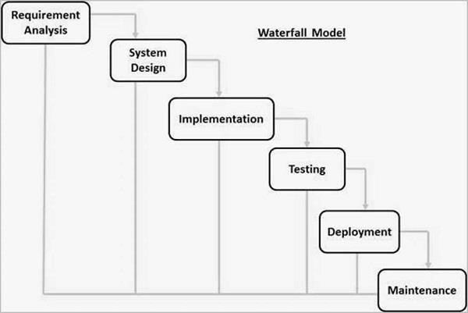

The sequential phases in Waterfall model are −

**Requirement Gathering and analysis** − All possible requirements of the system to be developed are captured in this phase and documented in a requirement specification document.

* **System Design** − The requirement specifications from first phase are studied in this phase and the system design is prepared. This system design helps in specifying hardware and system requirements and helps in defining the overall system architecture.
* **Implementation** − With inputs from the system design, the system is first developed in small programs called units, which are integrated in the next phase. Each unit is developed and tested for its functionality, which is referred to as Unit Testing.
* **Integration and Testing** − All the units developed in the implementation phase are integrated into a system after testing of each unit. Post integration the entire system is tested for any faults and failures.
* **Deployment of system** − Once the functional and non-functional testing is done; the product is deployed in the customer environment or released into the market.
* **Maintenance** − There are some issues which come up in the client environment. To fix those issues, patches are released. Also to enhance the product some better versions are released.

Maintenance is done to deliver these changes in the customer environment.

## 1.5 Tools and Technique

1. Php
2. Xampp
3. Mysql yog
4. HTML
5. Bootstrap
6. Sublime text
7. Git hub
8. Java Script
9. Css

**Php :**

**Hypertext Preprocessor** (or simply **PHP**) is a [server-side scripting langu](https://en.wikipedia.org/wiki/Server-side_scripting)age designed for [Web development, but](https://en.wikipedia.org/wiki/Web_development) also used as a [general-purpose programming language. It w](https://en.wikipedia.org/wiki/General-purpose_programming_language)as originally created by [Rasmus Lerdorf in 19](https://en.wikipedia.org/wiki/Rasmus_Lerdorf)94,[] the P](https://en.wikipedia.org/wiki/PHP#cite_note-History_of_PHP-5)HP [reference implementation is no](https://en.wikipedia.org/wiki/Reference_implementation)w produced *by* The PHP Group. PHP originally stood for Personal *Home Page*[,] but i](https://en.wikipedia.org/wiki/PHP#cite_note-History_of_PHP-5)t now stands for the [recursive acronym *PHP:*](https://en.wikipedia.org/wiki/Recursive_acronym) *Hypertext Preprocessor*.

PHP code may be embedded into [HTML code,](https://en.wikipedia.org/wiki/HTML) or it can be used in combination with various [web template systems, web](https://en.wikipedia.org/wiki/Web_template_system) content management systems, and [web frameworks. PHP](https://en.wikipedia.org/wiki/Web_framework) code is usually processed by a PHP [interpreter imple](https://en.wikipedia.org/wiki/Interpreter_(computing))mented as a [module in th](https://en.wikipedia.org/wiki/Plugin_(computing))e web server or as a [Common Gateway Interface (CGI)](https://en.wikipedia.org/wiki/Common_Gateway_Interface) executable. The web server combines the results of the interpreted and executed PHP code, which may be any type of data, including images, with the generated web page. PHP code may also be executed with [a command-line interface (CLI)](https://en.wikipedia.org/wiki/Command-line_interface) and can be used to implement [stand](https://en.wikipedia.org/wiki/Computer_software)[alone graphical applications.](https://en.wikipedia.org/wiki/Graphical_user_interface)

**Xampp :**

XAMPP is a [free and open](https://en.wikipedia.org/wiki/Free_software) [source cross-pl](https://en.wikipedia.org/wiki/Cross-platform)[atform web](https://en.wikipedia.org/wiki/Web_server) [server solution stack packa](https://en.wikipedia.org/wiki/Solution_stack)ge developed by Apache Friends, consisting mainly of the [Apache HTTP S](https://en.wikipedia.org/wiki/Apache_HTTP_Server)[erver, Ma](https://en.wikipedia.org/wiki/MariaDB)[riaDB database,](https://en.wikipedia.org/wiki/Database) [and interpreters for s](https://en.wikipedia.org/wiki/Interpreter_(computing))cripts written in the [PHP](https://en.wikipedia.org/wiki/PHP) [and](https://en.wikipedia.org/wiki/Perl) [Perl programming languages. XAMP](https://en.wikipedia.org/wiki/Programming_language)P stands for Cross-Platform (X), Apache (A), MariaDB (M), PHP (P) and Perl (P). It is a simple, lightweight Apache distribution that makes it extremely easy for developers to create a local web server for testing and deployment purposes. Everything needed to set up a web server – server application (Apache), database (MariaDB), and scripting language (PHP) – is included in an extractable file. XAMPP is also cross-platform, which means it works equally well on Linux, Mac and Windows. Since most actual web server deployments use the same components as XAMPP, it makes transitioning from a local test server to a live server extremely easy as well.

**Mysql yog :**

MySQL Workbench is a unified visual tool for database architects, developers, and DBAs. MySQL Workbench provides data modeling, SQL development, and comprehensive administration tools for server configuration, user administration, backup, and much more. MySQL Workbench is available on Windows, Linux and Mac OS X.

**HTML :**

Hypertext Markup Language (HTML) is the standard [markup language for c](https://en.wikipedia.org/wiki/Markup_language)reating [web page](https://en.wikipedia.org/wiki/Web_page)[s and web applications. Wi](https://en.wikipedia.org/wiki/Web_application)[th Cascading Style Sheets (CSS)](https://en.wikipedia.org/wiki/Cascading_Style_Sheets) and [JavaScript, it f](https://en.wikipedia.org/wiki/JavaScript)orms a triad of cornerstone technologies for the [World Wid](https://en.wikipedia.org/wiki/World_Wide_Web)[e Web.[4]](https://en.wikipedia.org/wiki/HTML#cite_note-4)

[Web browsers recei](https://en.wikipedia.org/wiki/Web_browser)ve HTML documents from a [web server or fr](https://en.wikipedia.org/wiki/Web_server)om local storage and [render the](https://en.wikipedia.org/wiki/Browser_engine) documents into multimedia web pages. HTML describes the structure of a web page [semantically and](https://en.wikipedia.org/wiki/Semantic_Web) originally included cues for the appearance of the document.

[HTML elements are t](https://en.wikipedia.org/wiki/HTML_element)he building blocks of HTML pages. With HTML constructs, [images and o](https://en.wikipedia.org/wiki/HTML_element#Images_and_objects)ther objects such as [interactive forms may b](https://en.wikipedia.org/wiki/Fieldset)e embedded into the rendered page. HTML provides a means to create [structured documents by de](https://en.wikipedia.org/wiki/Structured_document)noting structural [semantics for t](https://en.wikipedia.org/wiki/Semantics)ext such as headings, paragraphs, lists, [links,](https://en.wikipedia.org/wiki/Hyperlink) quotes and other items.

**Bootstrap :**

Bootstrap is a [free and open-source front](https://en.wikipedia.org/wiki/Free_and_open-source_software)-end framework for designing [websites](https://en.wikipedia.org/wiki/Website) [and web applications.](https://en.wikipedia.org/wiki/Web_application)

It contains [HTML-](https://en.wikipedia.org/wiki/HTML) [and CSS-based](https://en.wikipedia.org/wiki/CSS) design templates for [typography, form](https://en.wikipedia.org/wiki/Typography)s, buttons, navigation and other interface components, as well as optional [JavaScript exten](https://en.wikipedia.org/wiki/JavaScript)sions. Unlike many web frameworks, it concerns itself with [front-end development only.](https://en.wikipedia.org/wiki/Front-end_web_development)

**Java Script :**

JavaScript often abbreviated as JS, is a [high-l](https://en.wikipedia.org/wiki/High-level_programming_language)[evel, interp](https://en.wikipedia.org/wiki/Interpreted_language)[reted programming language. It i](https://en.wikipedia.org/wiki/Programming_language)s a language which is also characterized as [dyn](https://en.wikipedia.org/wiki/Dynamic_programming_language)[amic, weakly t](https://en.wikipedia.org/wiki/Weak_typing)[yped, prototype-based](https://en.wikipedia.org/wiki/Prototype-based_programming) [and multi-paradigm.](https://en.wikipedia.org/wiki/Multi-paradigm_programming_language)

Alongside [HTML](https://en.wikipedia.org/wiki/HTML) [and CSS, Java](https://en.wikipedia.org/wiki/CSS)Script is one of the three core technologies of the [World Wide Web.](https://en.wikipedia.org/wiki/World_Wide_Web)

[Java](https://en.wikipedia.org/wiki/World_Wide_Web)Script enables interactive [web pages and t](https://en.wikipedia.org/wiki/Web_page)hus is an essential part of [web applications.](https://en.wikipedia.org/wiki/Web_application)

[The](https://en.wikipedia.org/wiki/Web_application) vast majority of [websites use i](https://en.wikipedia.org/wiki/Website)t, and all major [web browsers have](https://en.wikipedia.org/wiki/Web_browser) a dedicated [JavaScript engine to](https://en.wikipedia.org/wiki/JavaScript_engine)  [ex](https://en.wikipedia.org/wiki/JavaScript_engine)ecute it

**Sublime Text :**

Sublime Text is a [propri](https://en.wikipedia.org/wiki/Proprietary_software)[etary cross-pla](https://en.wikipedia.org/wiki/Cross-platform)[tform source code editor with](https://en.wikipedia.org/wiki/Source_code_editor) [a P](https://en.wikipedia.org/wiki/Python_(programming_language))[ython application programming interface (API)](https://en.wikipedia.org/wiki/Application_programming_interface). It natively supports many [programming languages](https://en.wikipedia.org/wiki/Programming_languages) [and markup languages, and](https://en.wikipedia.org/wiki/Markup_languages) functions can be added by users with [plugins, typi](https://en.wikipedia.org/wiki/Plugins)cally community-built and maintained under [free-software licenses.](https://en.wikipedia.org/wiki/Free_software_licenses)

**Github :**

GitHub is a web-based [hosting service](https://en.wikipedia.org/wiki/Internet_hosting_service) [for version control usi](https://en.wikipedia.org/wiki/Version_control)[ng Git. It i](https://en.wikipedia.org/wiki/Git)s mostly used for [computer code. It o](https://en.wikipedia.org/wiki/Source_code)ffers all of the [distributed version contro](https://en.wikipedia.org/wiki/Distributed_version_control)[l and source code management (SCM)](https://en.wikipedia.org/wiki/Source_code_management) functionality of Git as well as adding its own features. It provides [access control and s](https://en.wikipedia.org/wiki/Access_control)everal collaboration features such as [bug tra](https://en.wikipedia.org/wiki/Bug_tracking_system)[cking, feature requ](https://en.wikipedia.org/wiki/Software_feature)[ests, task management,](https://en.wikipedia.org/wiki/Task_management) [and wikis for e](https://en.wikipedia.org/wiki/Wiki)very project.

GitHub offers plans for both private repositories and free accounts which are commonly used to host [opensource softw](https://en.wikipedia.org/wiki/Open-source)are projects.

**Css :**

Cascading Style Sheets (CSS) is a [style sheet language used](https://en.wikipedia.org/wiki/Style_sheet_language) for describing the [presentation of a](https://en.wikipedia.org/wiki/Presentation_semantics) document written in a [markup language l](https://en.wikipedia.org/wiki/Markup_language)[ike HTML. CSS](https://en.wikipedia.org/wiki/HTML) is a cornerstone technology of the [World Wide Web,](https://en.wikipedia.org/wiki/World_Wide_Web) alongside HTML and [JavaScript.](https://en.wikipedia.org/wiki/JavaScript)

CSS is designed to enable the separation of presentation and content, including [l](https://en.wikipedia.org/wiki/Page_layout)[ayout, colors,](https://en.wikipedia.org/wiki/Color) [and fonts.](https://en.wikipedia.org/wiki/Typeface) This separation can improve content [accessibility, prov](https://en.wikipedia.org/wiki/Accessibility)ide more flexibility and control in the specification of presentation characteristics, enable multiple [web pages to sh](https://en.wikipedia.org/wiki/Web_page)are formatting by specifying the relevant CSS in a separate css file, and reduce complexity and repetition in the structural content.

## 

## 1.6 Specification Requirement

### 1.6.1 External Interfaces

- This interface will be actual interface through which the user will communication with the application and perform the desired tasks.

**Admin login**

**I.D:**

**Role**: Admin wishes to login to the system

**Precondition**: Username and Password

**Success end Condition**: Main option of screen display

**Failed end Condition**: User has entered incorrect Username and Password or both

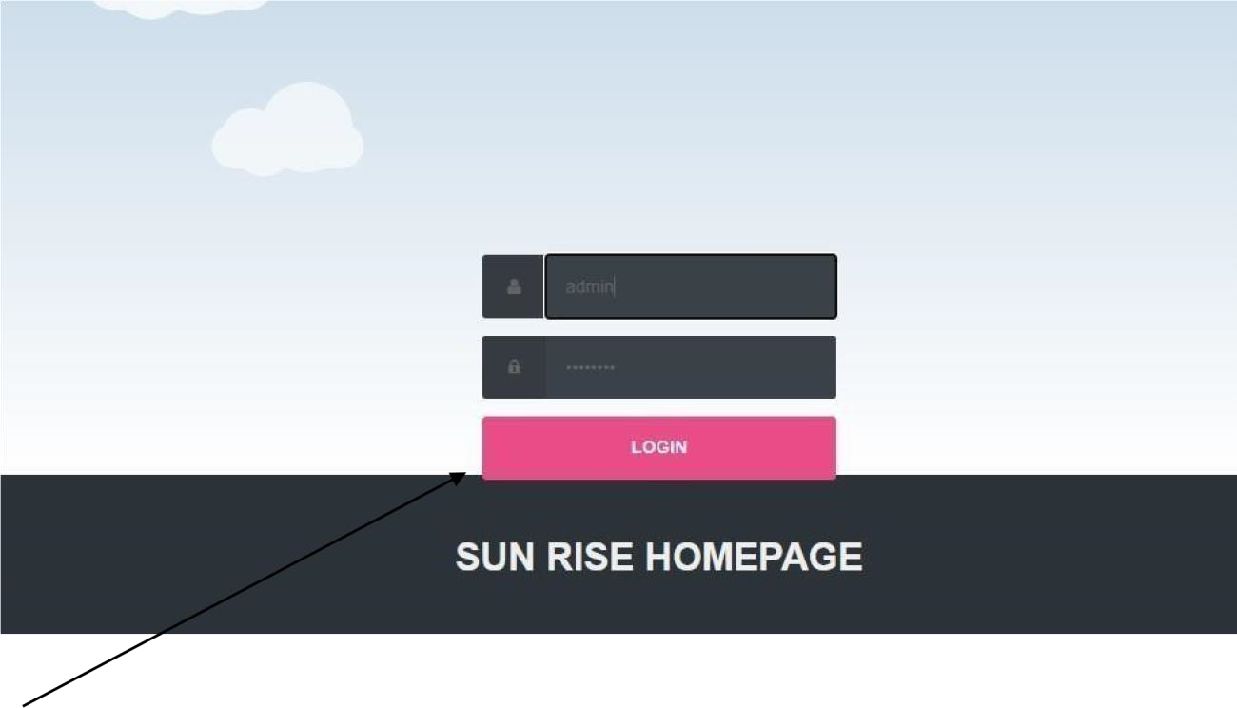

**Conform**

**ID:**

**Precondition:** Admin has successfully navigated to the search result

**Success end Condition:** Admin has successfully made the changes

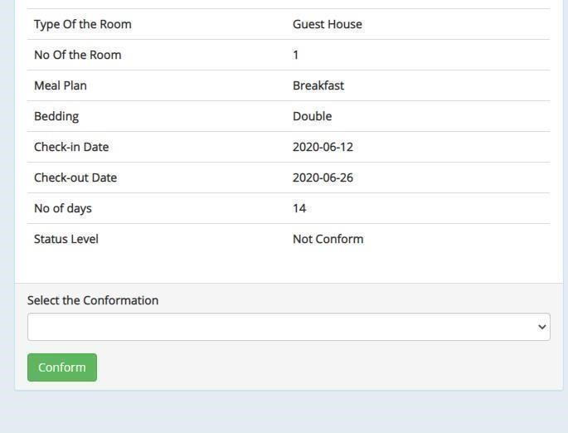

### 1.6.2 Software Product Features

Hotel Management System **:**

* Sequencing information

-Login information should be filled before the user allowed.

* Error Handling

-If user doesn’t filled up validate information then the system display error message for user and request to enter the validate information.

Performance required **:**

* Security

-System should be Protected from unauthorized access Where the validate Username

and Password are required so no other can access. Logical Database

Data Design **:**

Data Model: A database model is a type of data model that determines the logical structure of a database and fundamentally determines in which manner data can be stored, organized and manipulated.

**DFD Level :**

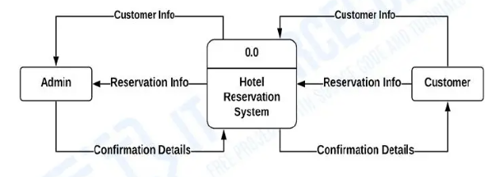

Figure: 0 - Level Data flow

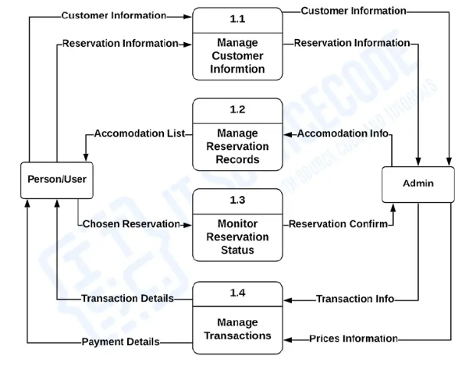Figure: 1 - Level Data flow

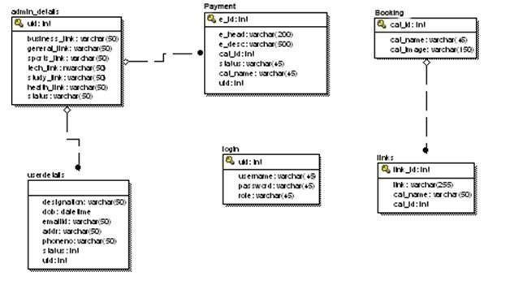

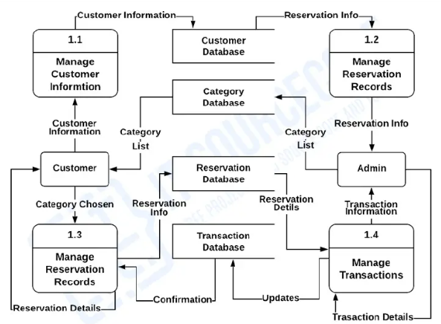

Figure: 2 - Level Data flow

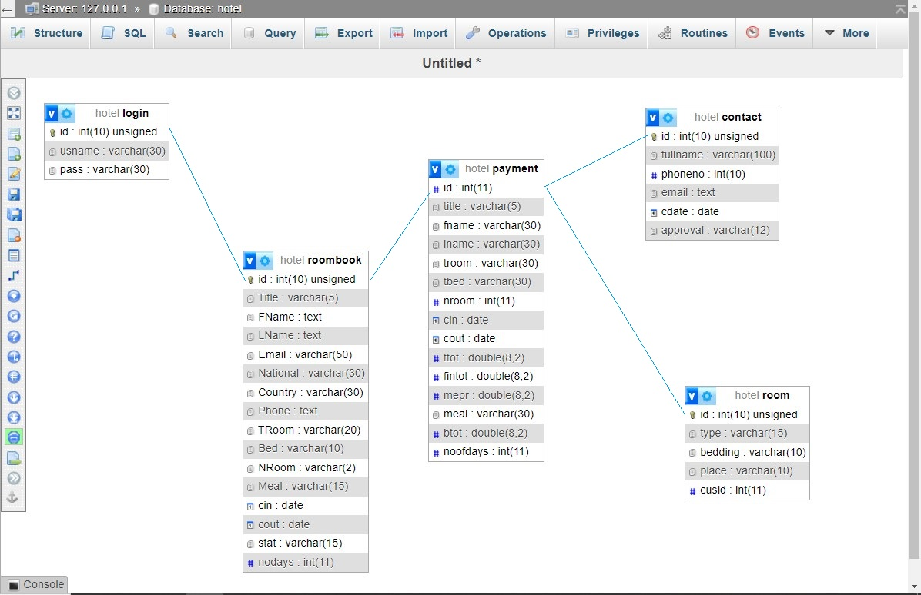

Figure: ER diagram

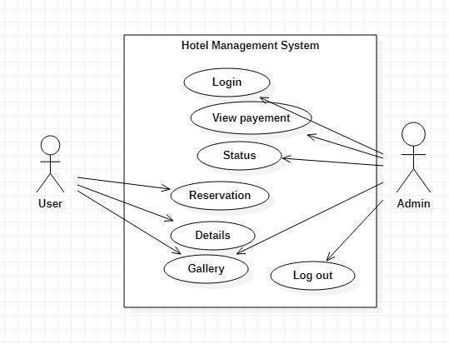



Figure: Use case Diagram

Database **:**

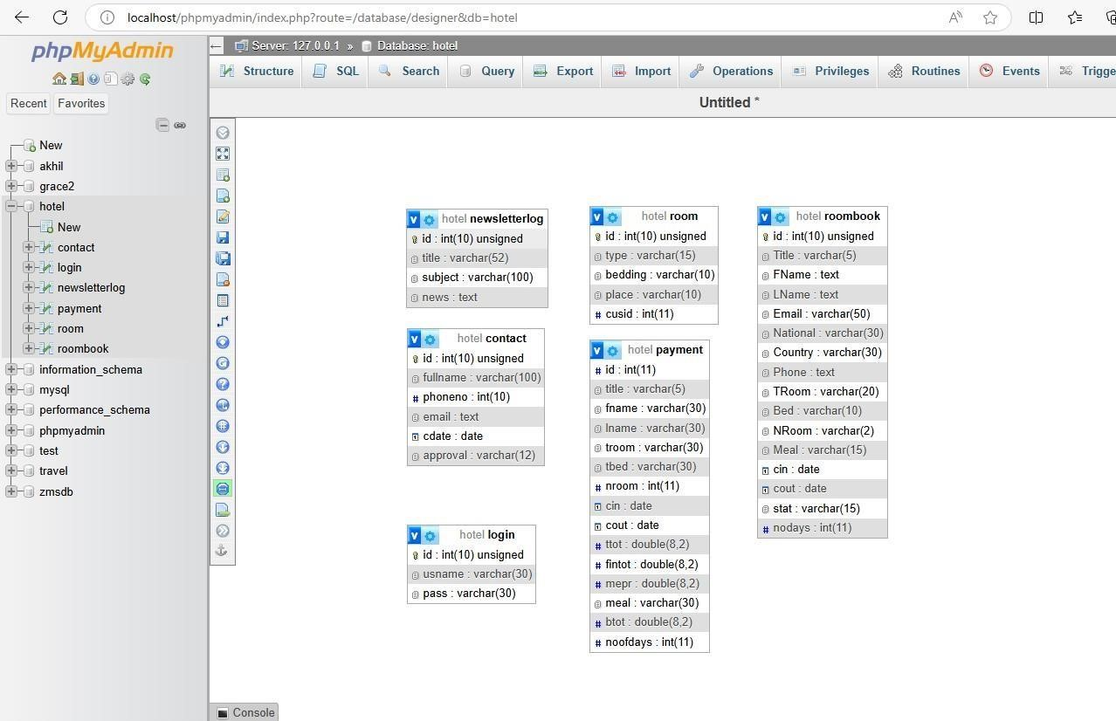

**Figure: Schema Diagram**

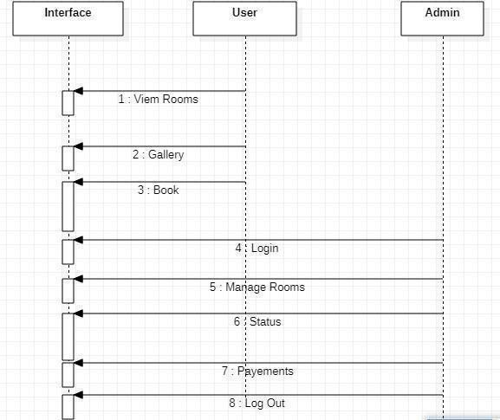

Figure: Sequence Diagram

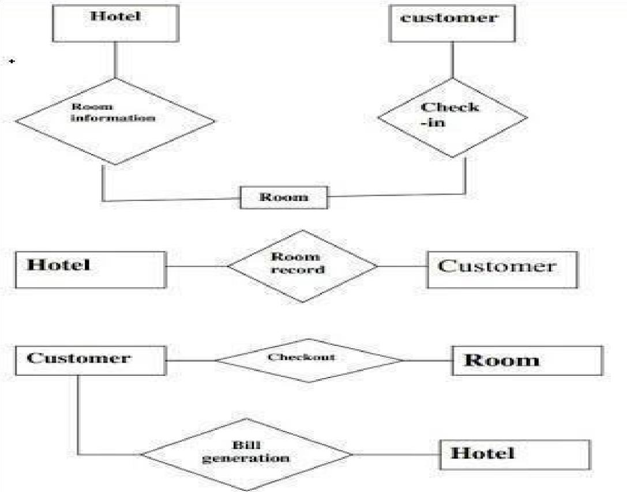

Figure: Flow Chart Diagram

#### Chapter II: Task and Activities Performed

##### 2.1 Advantage

* The advantagesof *booking* a *hotel online*add up long before your arrival. Our legendary customer service extends to the web
* One advantage of booking with the hotel directly is the use of the hotel's full cancellation policy as well as not needing a deposit in most situations.
* Read reviews and compare prices for *Online Hotel Booking*.
* simply sitting in home. Internet helps you to browse through the hotels around the world and compare the facilities and rates easily. The most important advantage of online hotel booking is convenience, you can book your room by

##### 2.2 Structure of the project

* After Administrator Login
  + Status
  + View Booking
  + View Rooms
  + View payment’s
  + News Letter
  + Logout
* Users visit
  + View rooms
  + View Gallery
  + View services
  + Book

##### 2.3 Scope and Feasibility

This activity is also known as the feasibility study.

Perform and evaluate feasibility studies like cost-benefit analysis, technical feasibility, time feasibility and operational feasibility for the project. Project Scheduling should be made using chats. Feasibility study is carried out t decide whether the proposed system is feasible for the company. It begins with a request from the user for a new system. It involves the following:

* Identify the responsible user for a new system
* Clarify the user request
* Identify deficiencies in the current system
* Establish goals and objectives for the new system
* Determine the feasibility for the new system
* Prepare a project charter that will be used to guide the remainder of the Project

##### 2.4 System Analysis

It is a process of collecting and interpreting facts, identifying the problems, and decomposition

of a system into its components.

System analysis is conducted for the purpose of studying a system or its parts in order to identify its objectives. It is a problem solving technique that improves the system and ensures that all the components of the system work efficiently to accomplish their purpose.

The objective of the system analysis activity is to develop structured system specification for the proposed system. The structured system specification should describe what the proposed system would do; independent of the technology, which will be used to implement these requirements.

The structured system specification will be used to implement these requirements.

The essential model may itself consist of multiple models, modeling different aspect of the system. The data flow diagrams may model the data and there relationships and the state transition diagram may model time dependent behavior of the system. The essential model thus consists of the following.

* Context diagram
* Leveled data flow diagrams
* Process specification for elementary bubbles
* Data dictionary for the flow and stores on the DFDs.

##### 2.5 System Design

System design involves transformation of the user implementation model into software design.

The design specification of the proposed system consists of the following:

* Database scheme
* Sequence Diagram
* Flow Chart

##### 2.6 Implementation

This activity includes programming, testing and integration of modules into a progressively more complete system. Implementation is the process of collect all the required parts and assembles them into a major product.

##### 2.7 Test Generation

This activity generates a set of test data, which can be used to test the new system before accepting

it. In the test generation phase all the parts are come which are to be tested to ensure that system does not produce any error. If there are some errors then we remove them and further it goes for accepting.

**Data Dictionary**

|  |  |  |  |
| --- | --- | --- | --- |
| **No** | **Field Name** | **Data Type** | **Attribute** |
| 1 | Id | Int(10) | Auto_increment |
| 2 | Full Name | Varchar(100) | - |
| 3 | Phone No | Int(10) | - |
| 4 | Email | Text | - |
| 5 | Cdate | Date | - |
| 6 | Approval | Varchar(12) | - |

**1.Contact**

**2.Login**

|  |  |  |  |
| --- | --- | --- | --- |
| **No** | **Field Name** | **Data Type** | **Attribute** |
| 1 | Id | Int(10) | Auto_increment |
| 2 | Usname | Varchar(30) | - |
| 3 | Pass | Varchar(30) | - |

**3.Payment**

|  |  |  |  |
| --- | --- | --- | --- |
| **No** | **Field Name** | **Data Type** | **Attribute** |
| 1 | Id | Int(11) | - |
| 2 | Title | Varchar(5) | - |
| 3 | Fname | Varchar(30) | - |
| 4 | Lname | Varchar(30) | - |
| 5 | Troom | Varchar(30) | - |
| 6 | Tbed | Varchar(30) | - |
| 7 | Nroom | Int(11) | - |
| 8 | Cin | Date | - |
| 9 | Cout | Date | - |
| 10 | Ntot | Double(8,2) | - |
| 11 | Fintot | Double(8,2) | - |
| 12 | Mepr | Double(8,2) | - |
| 13 | Meal | Varchar(30) | - |
| 14 | Btot | Double(8,2) | - |
| 15 | Noofdays | Int(11) | - |

**4.Room**

|  |  |  |  |
| --- | --- | --- | --- |
| **No** | **Field Name** | **Data Type** | **Attribute** |
| 1 | Id | Int(10) | Auto_increment |
| 2 | Type | Varchar(15) | - |
| 3 | Bedding | Varchar(10) | - |
| 4 | Place | Varchar(10) | - |
| 5 | Cusid | Int(11) | - |

**4.Room book**

|  |  |  |  |
| --- | --- | --- | --- |
| **No** | **Field Name** | **Data Type** | **Attribute** |
| 1 | Id | Int(10) | Auto_increment |
| 2 | Title | Varchar(5) | - |
| 3 | Fname | Text | - |
| 4 | Lname | Text | - |
| 5 | Email | Varchar(50) | - |
| 6 | Nation | Varchar(30) | - |
| 7 | Country | Varchar(30) | - |
| 8 | Phone | Text | - |
| 9 | Troom | Varchar(20) | - |
| 10 | Bed | Varchar(10) | - |
| 11 | Nroom | Varchar(2) | - |
| 12 | Meal | Varchar(15) | - |
| 13 | Cin | Date | - |
| 14 | Cout | Date | - |
| 15 | Stat | Varchar(15) | - |
| 16 | Nodays | Integer(11) | - |

##### Screen Layout

**Home page**

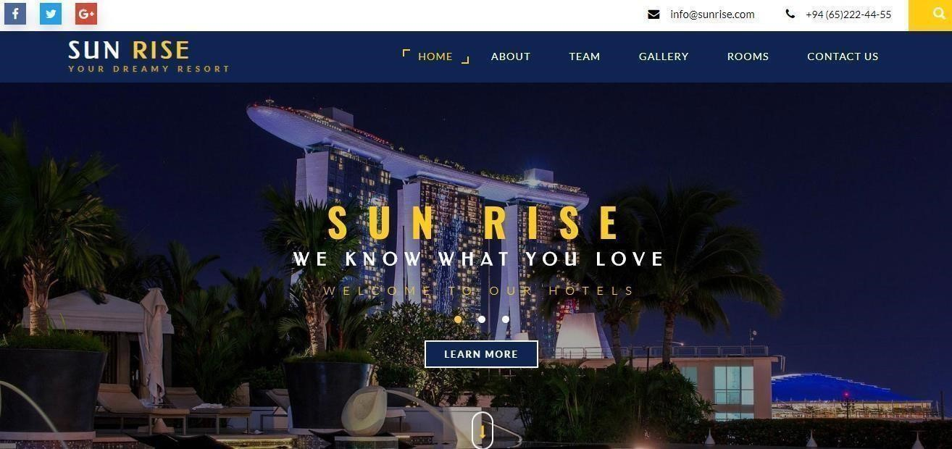

**About**

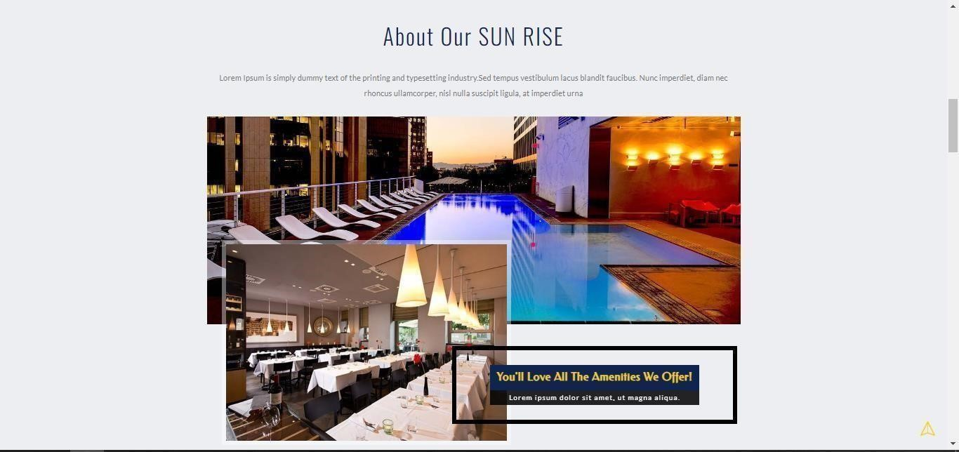

**Team**

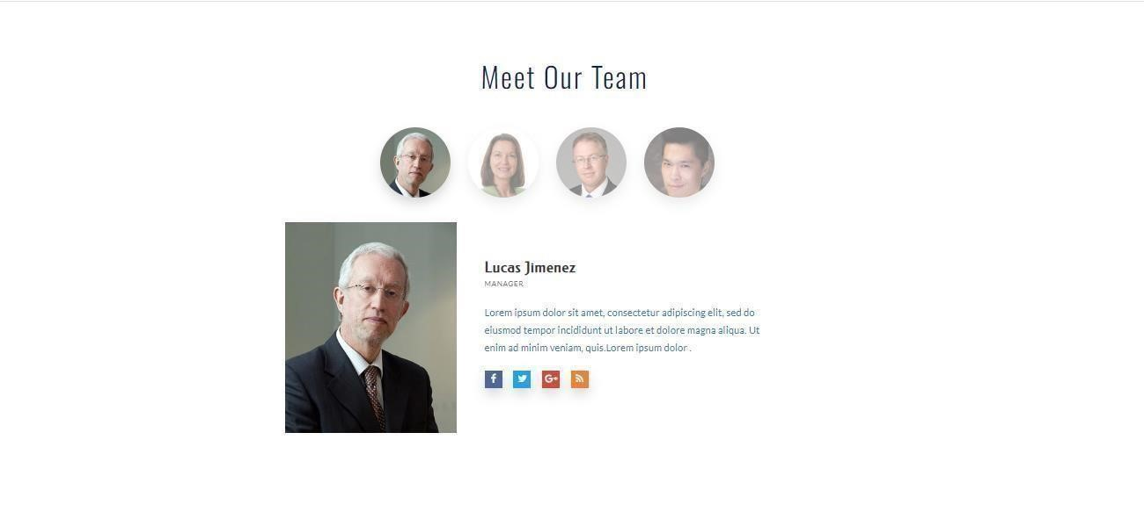

**Gallery**



**Rooms**

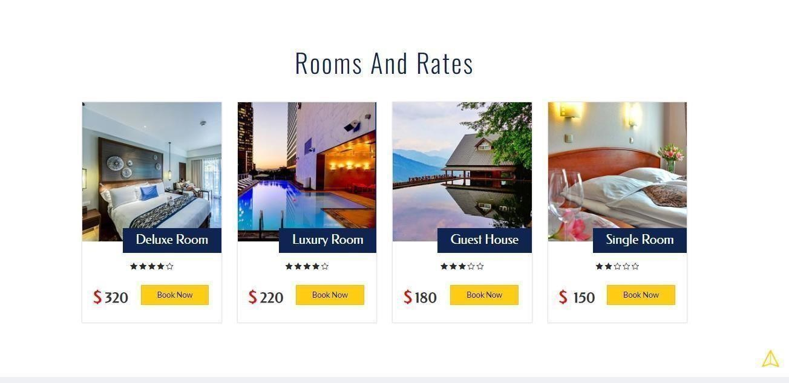

**Contact Us**

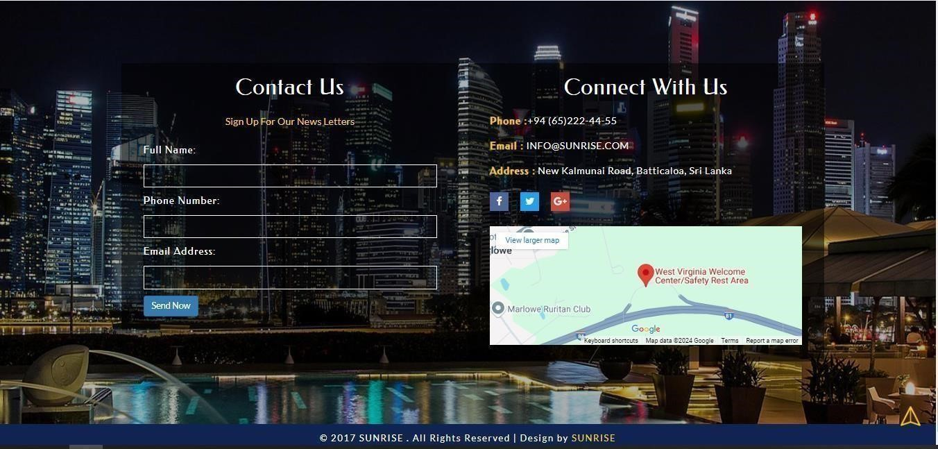

**Login page**

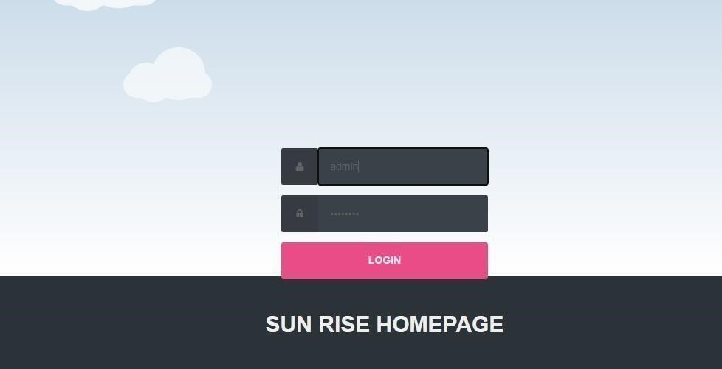

**Admin**

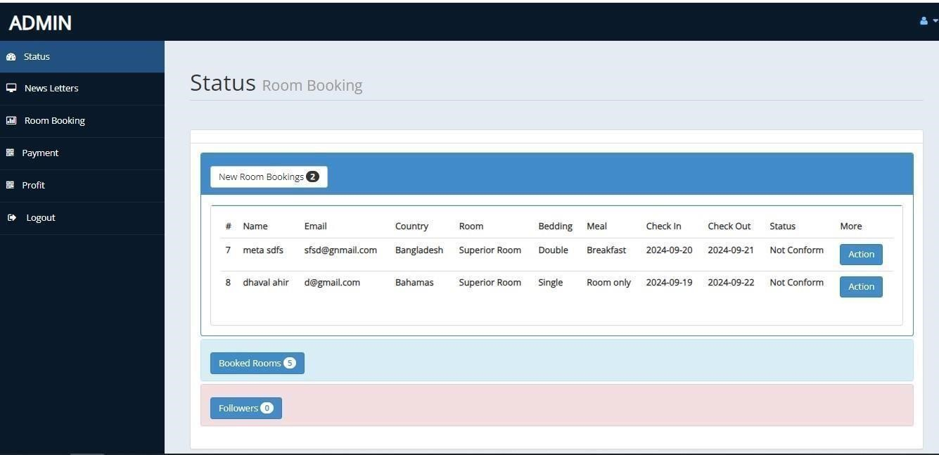

**Reservation Form**

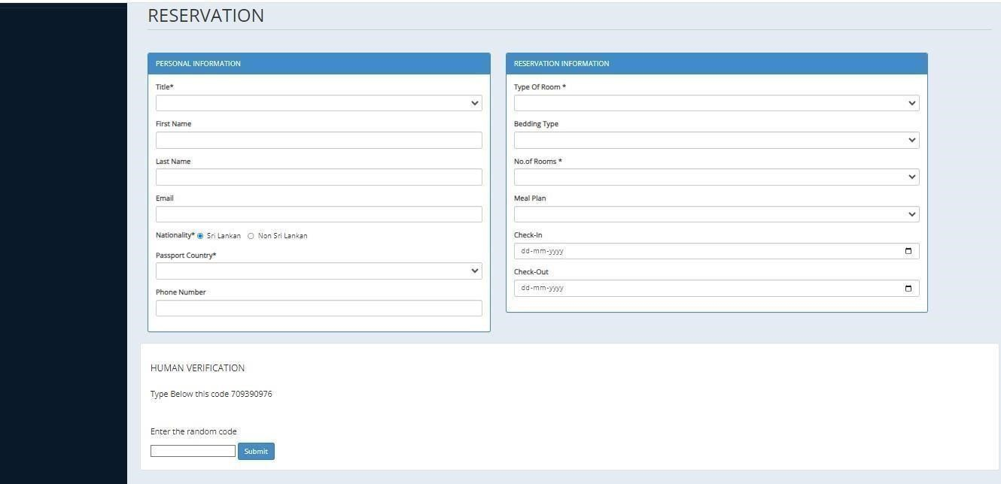

**Payment**

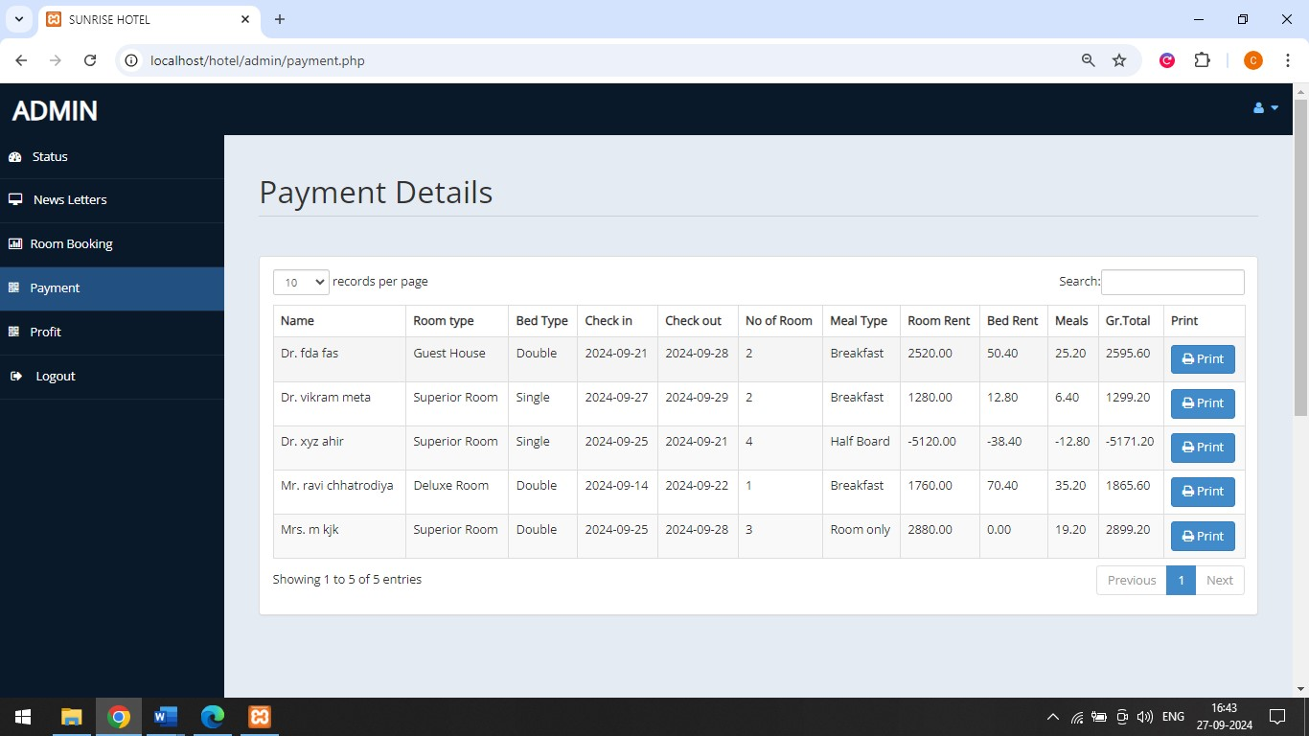

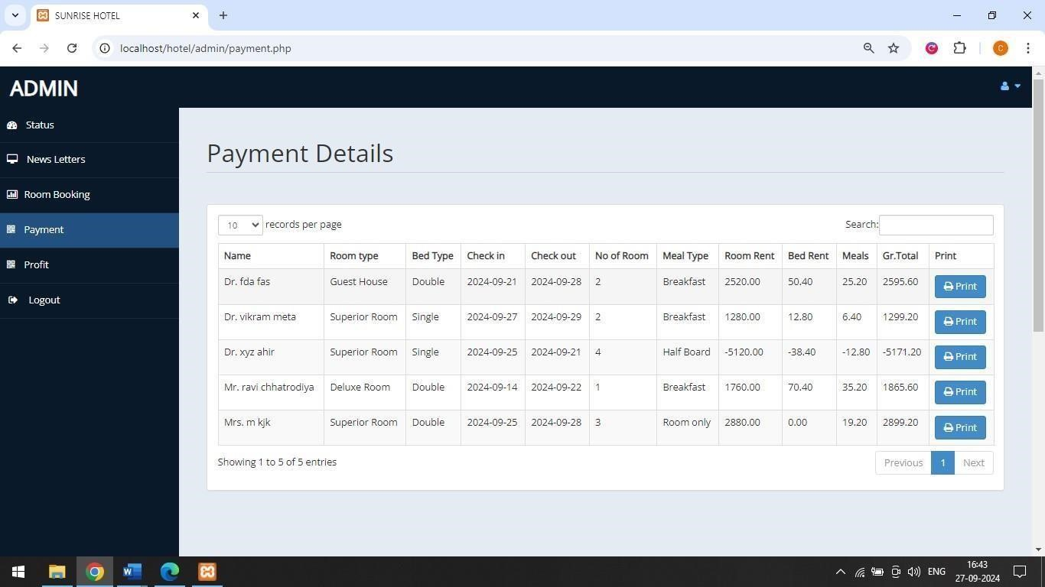

**Profit Chart**

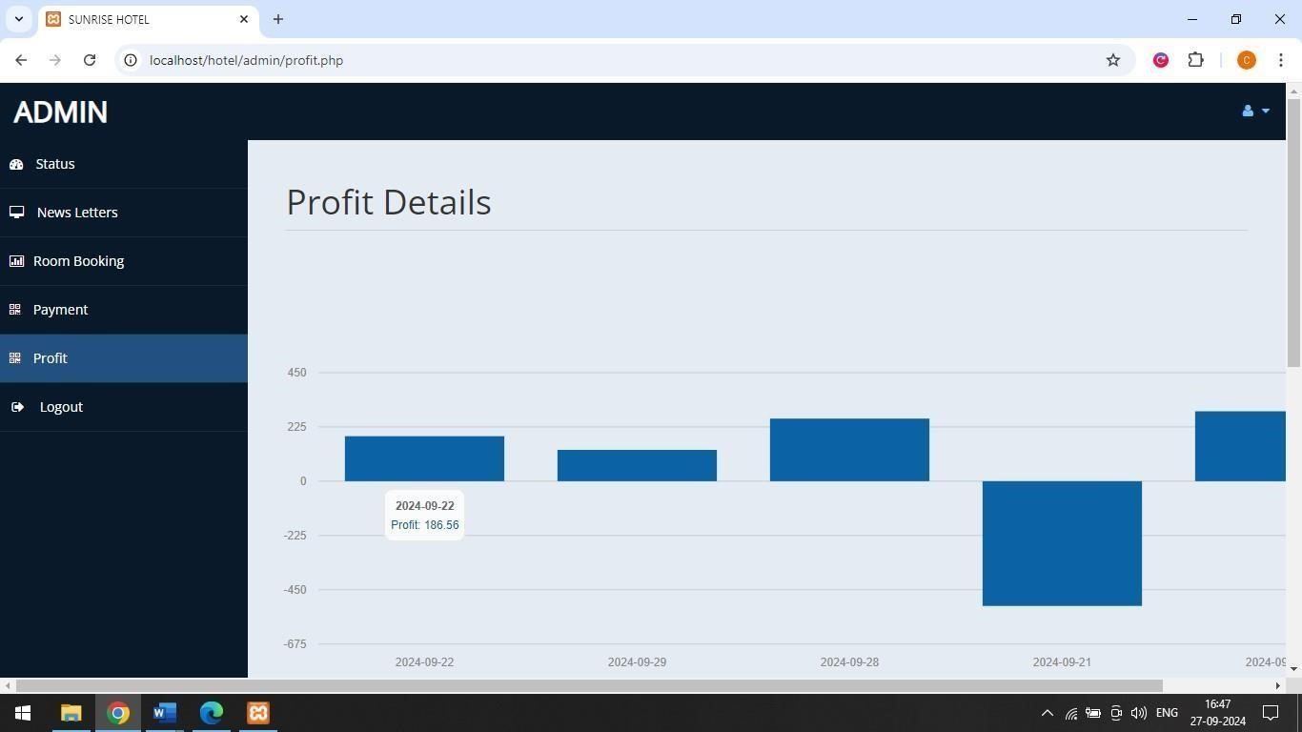

**Hotel Database**

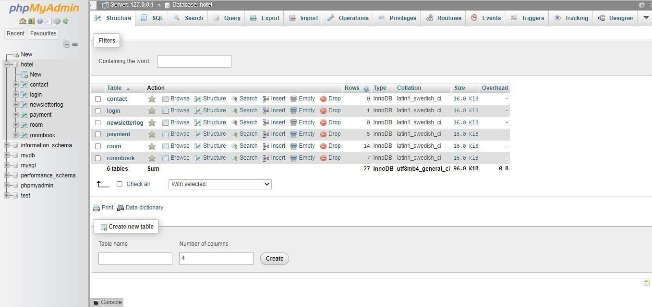

**Rooms Book**

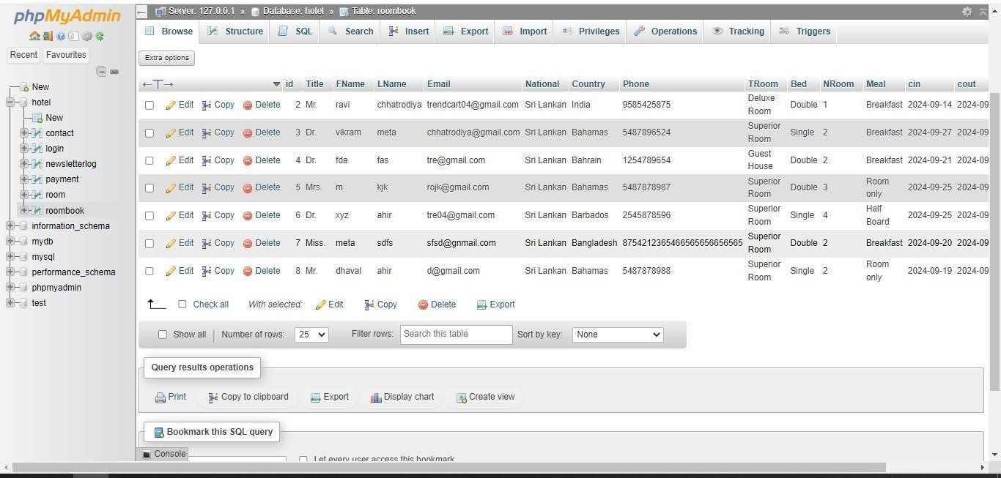

###### **TESTING LEVEL**

**LEVEL : 1**

* Testing is one of the important steps in system development. Software Testing also provides an objective, independent view of the software to allow the business to appreciate and understand the risks at implementation of the software. Test techniques include, but are not limited to, the process of executing a program or application with the intent of finding software bugs.
* Software Testing can also be stated as the process of validating and verifying that a software program/application/product:
* Meets the business and technical requirements that guided its design and development.

* Software Testing, depending on the testing method employed can be implemented at any time in the development process. However, most of the test effort occurs after the requirements have been defined and the coding process has been completed. As such, the methodology of the test is governed by the Software Development methodology adopted.

**LEVEL : 2**

* Tests are frequently grouped by where they are added in the software development process, or by the level of specificity of the test.

**Unit Testing :**

* Unit Testing refers to tests that verify the functionality of a specific section of code, usually at the function level. In an object-oriented environment, this is usually at the class level, and the minimal unit tests include the constructors and destructors.
* These types of tests are usually written by developers as they work on code (white-box style), to ensure that the specific function is working as expected. One function might have multiple tests, to catch corner cases or other branches in the code. Unit testing alone cannot verify the functionality of a piece of software, but rather is used to assure that the building blocks the software uses work independently of each other.Unit testing is also called Component Testing.

**Integration Testing :**

* Integration Testing is any type of software testing that seeks to verify the interfaces between components against a software design. Software components may be integrated in an iterative way or all together ("big bang"). Normally the former is considered a better practice since it allows interface issues to be localized more quickly and fixed.

* Integration Testing works to expose defects in the interfaces and interaction between integrated components (modules). Progressively larger groups of tested software components corresponding to elements of the architectural design are integrated and tested until the software works as a system.

**System Testing :**

* System Testing tests a completely integrated system to verify that it meets its requirements.

**Types Of Testing :**

1. **Functional Testing :**

* + It is an approach to testing where the tests are derived from the program or component specification. The system is a black box whose behavior can only be determined by studying its inputs and the related outputs.

1. **Structural Testing :**

* + Structural testing is an approach to testing where the tests are derived from knowledge of the software„s structure and implementation. This approach is sometimes called ‗white-box testing„ to distinguish from black –box testing.

**FUTURE WORK :**

* + We have done analysis of this entire system till now, and in future we will develop this system as per our analysis.
  + In future this application will became very user-friendly..
  + We will covert this web-site into online management so that any user can access our web-site anywhere through their mobiles.

**Conclusion :**

* + I have developed “Om Electronics” website in order to overcome the difficulties in managing the existing manual system. The website has been designed effectively keeping in mind, the possible future enhancement and additional functionality; it has been designed to run in an efficient way.
  + The website is designed to be very user-friendly and interactive manner so that the user cannot find any difficulty while browsing the website. Thereby the proposed website, which

is an economically, technically and operationally feasible system has overcome the deficiency

that was present in the manual system.

**REFERENCES :**

* + This project was impossible to be a success without the support and help from the experience guide; the books and mainly the internet really prove it for us the “Information Highway”.

Everything was really easy to find out on the internet.

**Wesite :**

**1. W3Schools:** Offers fundamental PHP tutorials, great for beginners.

www.w3schools.com

**2.PHPGurukul:** This website provides complete projects with source code, including hotel management systems in PHP.

* www.phpgurukul.com

**3.SourceCodester:** Provides a wide range of projects with full source code in PHP, including hotel management systems.

* www.sourcecodester.com

**4.TutorialsPoint:** Great resource for PHP tutorials and project ideas.

* www.tutorialspoint.com

**5.GitHub:** You can find many open-source hotel management PHP projects here to study and modify.

* www.github.com

