Seminar assessment
The seminar counts for 50% of the final grade in Mobile Application Development, and you need a seminar grade of at least 5 to pass.
Component | Weight in the final grade
Practical test 1 (week 7 - 12 NOV) | 15%
Practical test 2 (week 13 - 14 JAN) | 15%
Seminar activity | 20%
Seminar total | 50%
Minimum performance standard:
- at least 10 seminar attendances;
- a seminar grade of at least 5.

The Android Development Environment
The Android SDK (Software Development Kit) is the collection of libraries, tools and system images required to develop, build and test Android applications.
Navigate to More Actions -> SDK Manager
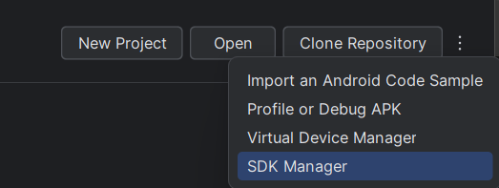
The installation path, by default C:\Users\<user>\AppData\Local\Android\Sdk
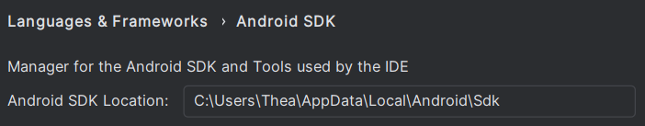
In SDK Platform we can check what SDK we have installed and the correspondent API Level.
In SDK Tools we should check to see if the following are installed:
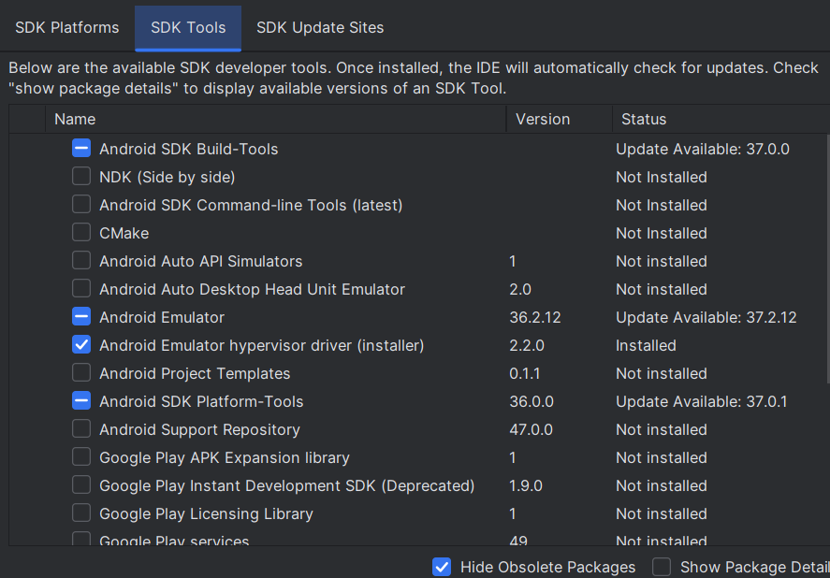
- Android SDK Build-Tools – compiles the resources, converts the Java bytecode to DEX and signs the APK.
- Android SDK Platform-Tools – contains adb (Android Debug Bridge), used to communicate with the emulator or a physical device.
- Android Emulator – runs the virtual devices (AVDs).
- Android Emulator hypervisor driver – provides hardware acceleration for the emulator on Windows.

Adding an emulator
- On the Android Studio welcome screen, click More Actions (⋮) → Virtual Device Manager.
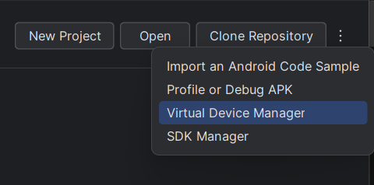
- In Device Manager, click + → Create Virtual Device.
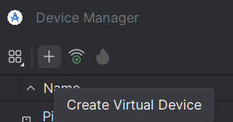
- Select a device profile (e.g. Pixel 8) and click Next.
- In the Configure virtual device window, set the following:
  - API: API 36.0 (Android 16)
  - Services: Google Play Store
  - System image: Google Play Intel x86_64 Atom System Image (the one marked with ★). Do not choose the 16 KB Page Size variant.
- Click Finish.
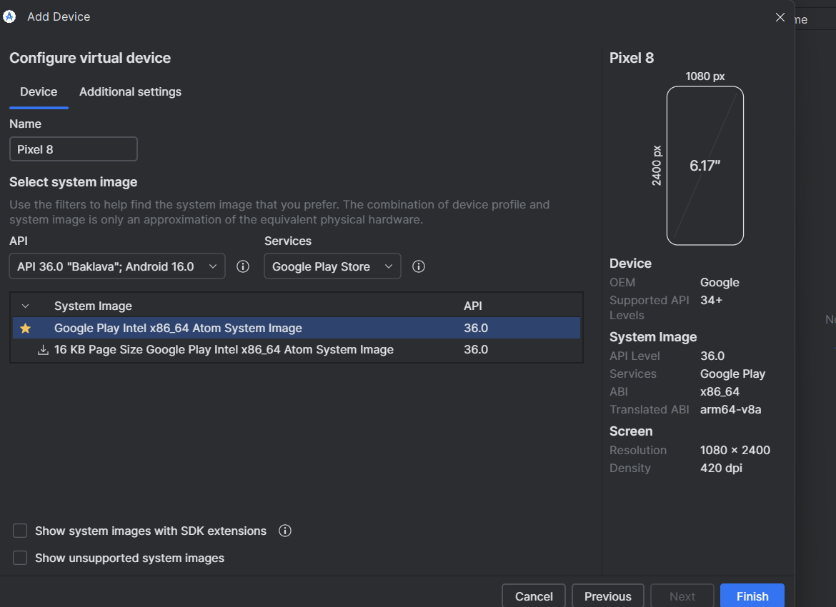
In order to use your own Android Phone instead of an emulator, please follow one of these tutorials.

Creating a project
- On the Android Studio welcome screen, click New Project.
- Select the Empty Views Activity template and click Next.
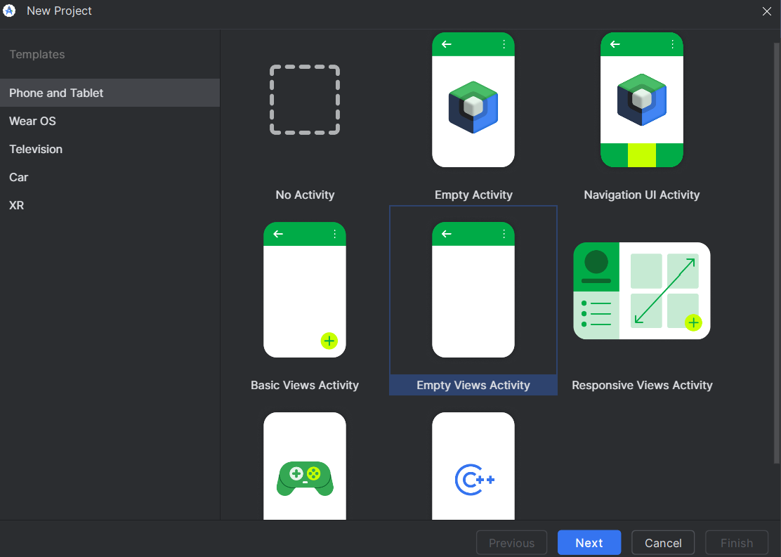
- Configure the project:
  - Name: choose a name
  - Package name: com.example.chosen_name or different package name
  - Save location: a local folder without spaces or special characters (e.g. C:\dam\lab1). Avoid OneDrive or synced folders, as they can lock files during the build.
  - Language: Java
  - Minimum SDK: for example API 28 (Android 9.0)
  - Build configuration language: Kotlin DSL (build.gradle.kts), the default option.
- Click Finish.

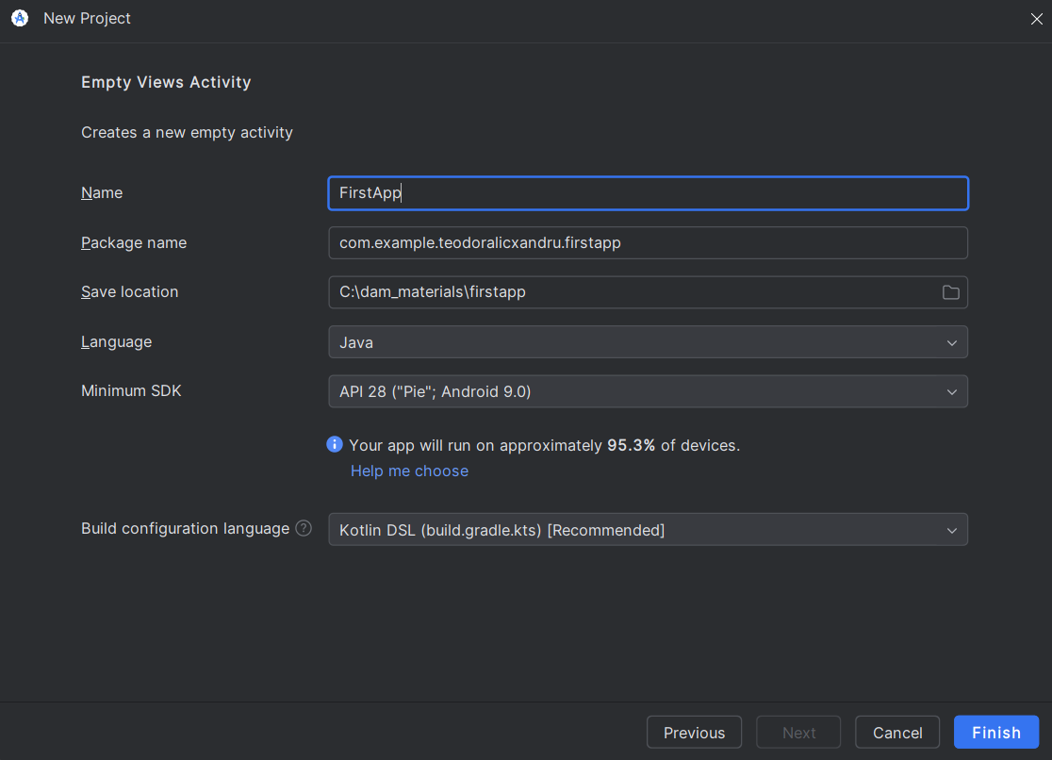

- Wait for Gradle sync to finish (progress bar at the bottom of the window). The first sync can take a few minutes, as Gradle downloads the required libraries. Until it completes, parts of the code may be highlighted in red.

Gradle
Gradle is the build system used by Android Studio. It transforms the project's source code and resources into an installable application (APK). When you press Run, Android Studio delegates the build to Gradle.
The build configuration is written in the build.gradle.kts files. The most important one is app/build.gradle.kts, which contains:
- namespace and applicationId – the app's package and unique identifier;
- compileSdk, minSdk, targetSdk – the SDK versions;
- dependencies { … } – the libraries used (e.g. appcompat, material, constraintlayout).

Building and running from the command line
1. Build the APK
.\gradlew assembleDebug
After BUILD SUCCESSFUL, the APK is located at app\build\outputs\apk\debug\app-debug.apk.
2. Check the connected devices
C:\Users\<user>\AppData\Local\Android\Sdk\platform-tools\adb devices
adb (Android Debug Bridge) is the command-line tool used to communicate with an emulator or a physical device. Replace <user> with your Windows user name. With the emulator running, the output should contain emulator-5554 device.
3. Install the APK
C:\Users\<user>\AppData\Local\Android\Sdk\platform-tools\adb install -r app\build\outputs\apk\debug\app-debug.apk
The -r option reinstalls the app over an existing version.
4. Launch the main activity
C:\Users\<user>\AppData\Local\Android\Sdk\platform-tools\adb shell am start -n com.example.lab1/.MainActivity
am (Activity Manager) starts the activity given after -n, in the format package/.ActivityName.
Notes:
- The full path to adb is needed because platform-tools is usually not in the system PATH.
- If the build fails with JAVA_HOME is not set, run this before step 1:
$env:JAVA_HOME = "C:\Program Files\Android\Android Studio\jbr"

Logcat
Logcat is the console in Android Studio (bottom panel) that displays the log messages of the device or emulator. It is the main tool for following what the app does and for finding errors.
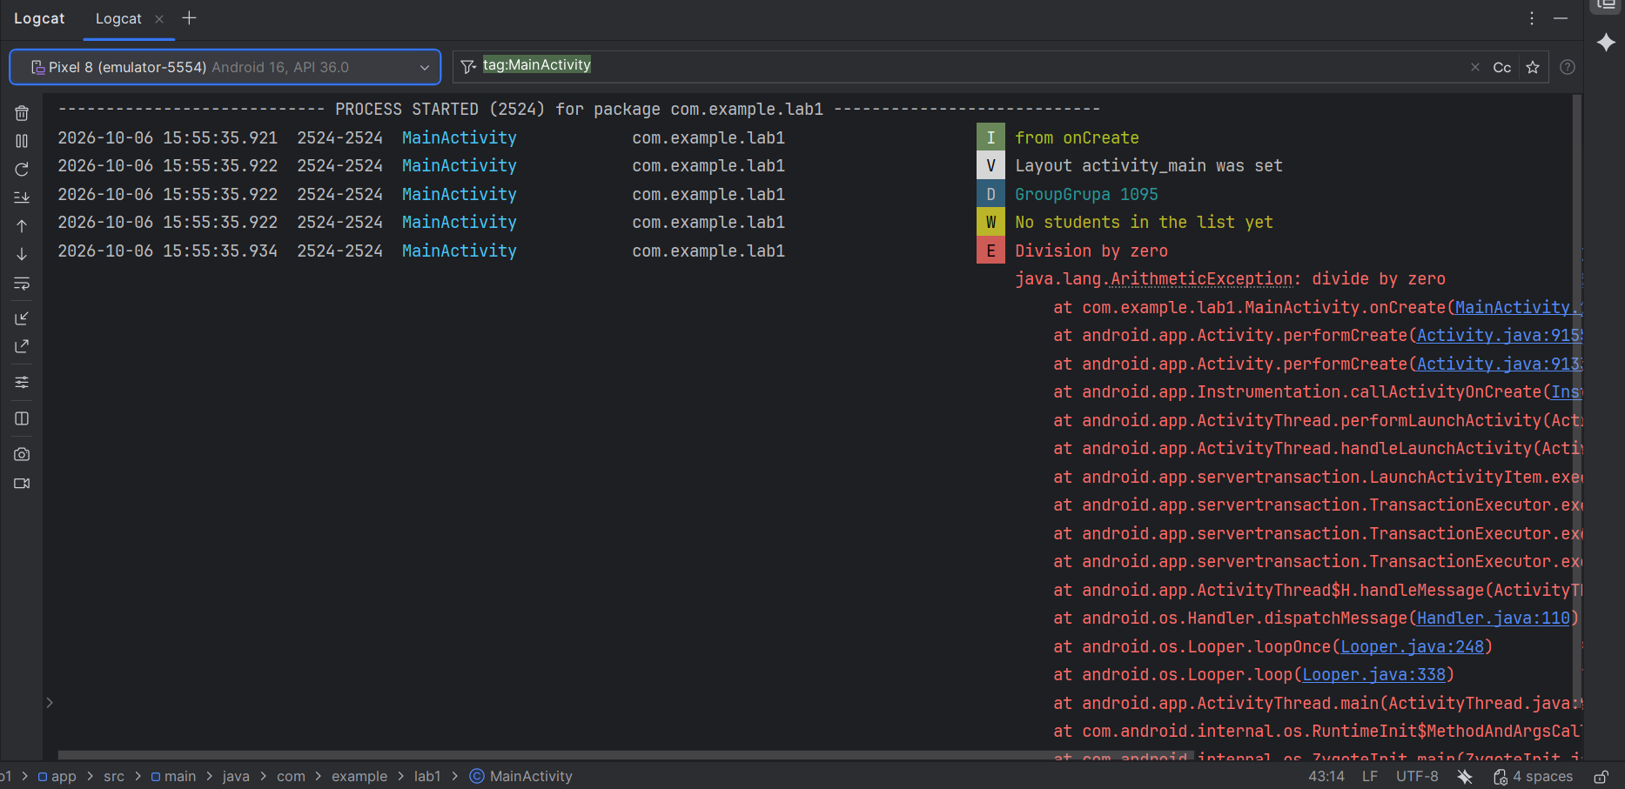

Nota Bene: The first lab source code can be found here.

