Migrating JobMatix (from MYOB-RM) to JobMatix POS
Revised 25-July-2021 for Open Source version V 6.2.6201..
Existing JobMatix+MYOB Users- JobMatix POS provides a migration path for existing JobMatix/MYOB-Retail Manager users to move away from Retail Manager and onto JobMatix POS by creating a new database, importing the basic RM database stock data and related information, and joining it with the Jobs data from their JobTracking database.
For New JobMatix users ( ie. existing MYOB-Retail Manager shops upgrading (migrating) to JobMatixPOS)- A new JobMatixPOS database is created, and the basic RM database stock data and related information are imported.
In both cases, the import/migration parameters are as follows:
- The main Retail Manager data to be imported includes all stock item definitions, stock categories (Cat1 and Cat2), stock serial numbers and serial history (ie Goods Received history, serialAudit table and Trail history). It also includes basic info on all suppliers, staff and customers, as well as some Sales Orders (quotes only).
- JobMatix will not import Departments, Sales Invoices, Payments, Credit Notes or Layby's from Retail manager. Setting up JobMatix POS will effectively start a new sales and payments history, debtors ledger and credit-note record. (Processing of outstanding debtors payment amounts and credit notes will have to be continued using Retail Manager until they have been run out.)
Currently, JobMatix Open Source Build 6201 contains the latest JobTracking and POS functionality, (although the POS system is still at Beta+ level).. Current JobMatix users can evaluate the POS system by installing the latest JobMatix application on a (preferably isolated) test system/environment, carrying out a test migration, and then a test of the POS features.
NB: A migration operation requires that the user have to hand a copy of the latest Retail Manager database (recent.mdb), and (for existing JobMatix users) a copy of the latest JobMatix backup file (.BAK)
For existing JobMatix users , the main steps in migrating are (firstly) for the system to RESTORE the JobMatix .BAK jobs backup file to what will become a newly created database with a new name (suffix "_jmpos"), and then browse to the RM recent.mdb. JobMatix will then add retail-POS table definitions to the new (_jmpos) database, and then proceed to populate the new retail POS tables by importing and converting all the related table content from the Retail Manager recent.mdb database.
For New JobMatix users ( existing MYOB-Retail Manager shops upgrading (migrating) to JobMatixPOS)- A new Jobmatix POS database will be created, and the user has the option to select to import existing RM data into the new JobMatixPOS database. NB: This point is the only chance for new JobMatixPOS databases to import the Retail Manager data..
(Important note: the primary keys (_id’s) and barcodes columns on the Retail Manager Stock, Suppliers, Staff and Customer tables are all preserved and transferred to the corresponding JobMatixPOS table columns during the import process.. This means that JobMatix Jobs records that contain references to these entities will still be valid.. In fact Jobs processing won’t be any the wiser about the migration, it will just be going through a different interface after migration. This is possible because JobMatix was designed that way from the beginning,)
Here are the steps to follow-

Step 1. (For existing JobMatix JobTracking and Retail Manager users)
Start up JobMatix and press ESC for admin when the "Press ESC for DB-Admin..." message appears.. The Startup Options form (Existing users Tab) should then be displayed (top and bottom-right of form shown)..
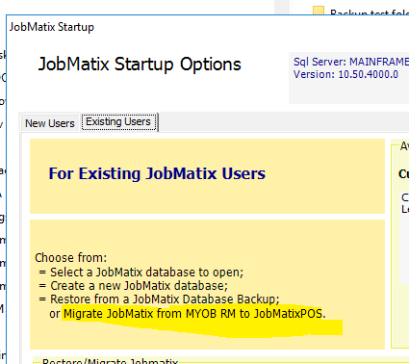
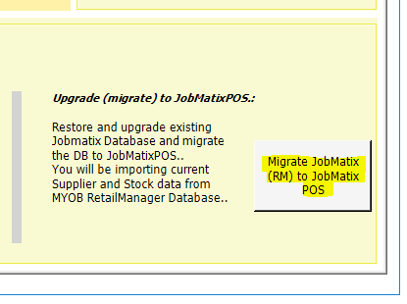
To start the migration process, click on the button "Migrate Jobmatix (RM)..." at the bottom right.. The Migration Form should then be displayed..
Step 1. (For NEW JobMatix users)
Change the Startup Options to show the New Users Tab.
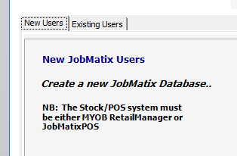
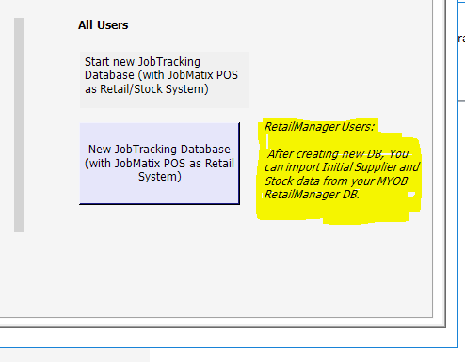
Click on the New JobTracking Database button to start the creation process. The Jobmatix Setup Screen will be displayed.
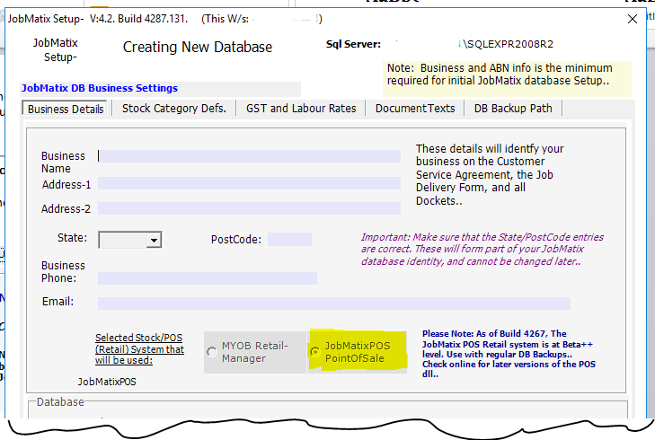
Note- After database is created, RetailManager data can be imported as the starting data for the new DB. If Create has been successful, you should see this popup..
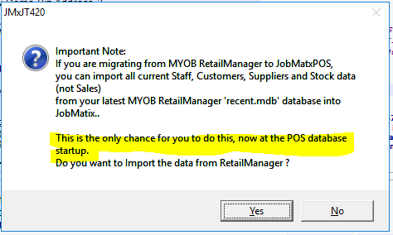
NB: This point is the only chance for new JobMatixPOS databases to import the Retail Manager data.. If YES, then go to Step 3.

Step 2. . (For existing JobMatix JobTracking and Retail Manager users)
On the Migration Form, Browse to the latest JobMatix jobs (_Jobtracking) database backup file (.BAK). This file will be restored to the SQL server to create the new combined Jobs/POS database..
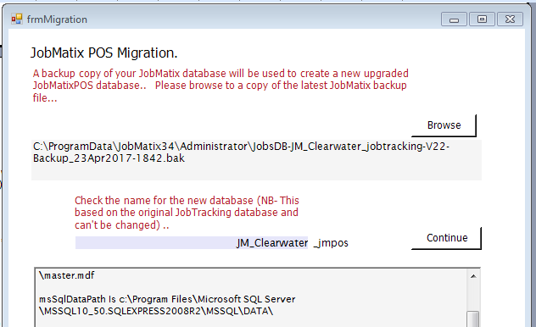
==
If this is the right Jobs database to migrate, then Press Continue.
NB: If there already exists a “_jmpos” database for this name, then the program will ask if it is to be over-written. If Yes, then the JobTracking backup file is “restored” to the SQL Server with the new name..
The program may then display a Login to Jet (Access) Database dialogue box.
Step 3.
The login screen is to choose the MYOB RetailManager database that contains the latest RetailManager Stock information for your business.
If displayed, Browse to the latest RM recent.mdb file, and press “Login” on the Login Form.
The program will then display the Import Form for the next step.
Step 4.
If no Retail Manager database has been selected yet, or if it has to be changed, then press Browse to RetailManager database, and select a recent.mdb file as in step 3. above.
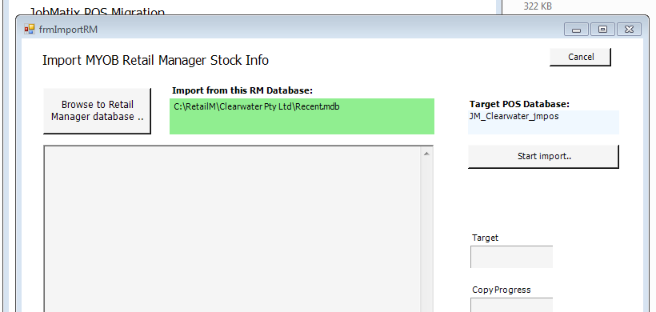
= = = =
To continue, press the Start Import button. All the relevant Retail Manager table data will be imported into the new JobMatixPOS database to join the Jobs data.
When this is completed there will be a popup “ all done.” message showing the log file name. Press OK, close the import form, make a note of the new database name, and close the Migration form.
Restart the JobMatix application.. A new tab showing the POS system as a sub-TabControl should be visible.
= = = the end = = =
Updated 27-July-2021.. = = =
Copyright © 2014, 2015, 2016, 2017..2021. grhaas@outlook.com

