1.java根据velocity生成实体类项目结构

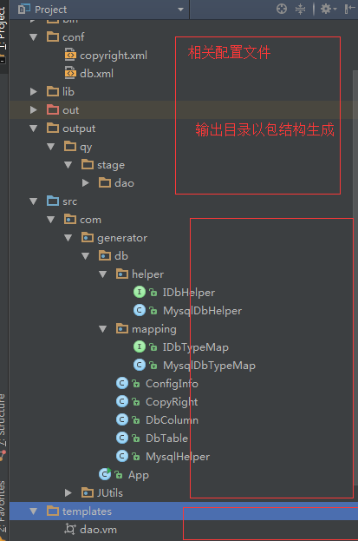

2.config介绍

copyright.xml

db.xml

<?xml version="1.0" encoding="UTF-8"?>

<databases>

<database key="mysql">

<attr name="DbType" value="mysql"/>

<attr name="Server" value="127.0.0.1"/>

<attr name="Port" value="3306"/>

<attr name="DbName" value="huanqiu"/>

<attr name="User" value="root"/>

<attr name="Passwd" value="root"/>

<attr name="Enable" value="true"/>

</database>

<database key="mssql">

<attr name="DbType" value="mssql"/>

<attr name="Server" value="127.0.0.1"/>

<attr name="Port" value="1433"/>

<attr name="DbName" value="huanqiu"/>

<attr name="User" value="root"/>

<attr name="Passwd" value="root"/>

<attr name="Enable" value="true"/>

</database>

<database key="oracle">

<attr name="DbType" value="oracle"/>

<attr name="Server" value="127.0.0.1"/>

<attr name="Port" value="3306"/>

<attr name="DbName" value="huanqiu"/>

<attr name="User" value="root"/>

<attr name="Passwd" value="root"/>

<attr name="Enable" value="true"/>

</database>

</databases>

ConfigInfo.java

package com.generator.db;  
  
*/**  
 * Created by Administrator on 2018/1/9.  
 */*public class ConfigInfo {  
 //db  
 public final static String *SCHEMA_NAME* = "huanqiu";  
 public final static Boolean *PREFIX_TABLE_ENABLE* = true;  
 public final static String *PREFIX_TABLE* = "huanqiu_";  
 public final static String *SEPARATOR_CHAR* = "_";  
  
 //生成附加信息  
 public final static String *PACKAGE_OUT_PATH* = "qy.stage";  
  
 //版权信息  
 public final static String *COPYRIGHT_REMARK* = "版权归作者本人所有";  
 public final static String *COPYRIGHT_AUTHOR* = "iceld";  
 public final static String *COPYRIGHT_VERSION* = "v1.0";  
  
 */**  
 * 类文件命名（大写开头）  
 *  
 \** ***@param*** *src  
 \** ***@return*** *\*/* public static String toUpperTitleByClass(String src) {  
 String out = "";  
 if (src != "" && src != null) {  
 if (*PREFIX_TABLE_ENABLE*) {  
 out = *toUpperTitle*(src.substring(*PREFIX_TABLE*.length(), src.length()));  
 } else {  
 out = *toUpperTitle*(src);  
 }  
 }  
  
 return out;  
 }  
  
 */**  
 * 类文件命名(小写开头)  
 *  
 \** ***@param*** *src  
 \** ***@return*** *\*/* public static String toLowerTitleByClass(String src) {  
 String out = "";  
 if (src != "" && src != null) {  
 if (*PREFIX_TABLE_ENABLE*) {  
 out = *toLowerTitle*(src.substring(*PREFIX_TABLE*.length(), src.length()));  
 } else {  
 out = *toLowerTitle*(src);  
 }  
 }  
  
 return out;  
 }  
  
 */**  
 * 类属性命名  
 *  
 \** ***@param*** *src  
 \** ***@return*** *\*/* public static String toUpperTitle(String src) {  
 String out = "";  
 if (src != "" && src != null) {  
 if (src.indexOf("_") > 0) {  
 String[] arr = src.split(*SEPARATOR_CHAR*);  
 for (String s : arr) {  
 if (s != "" && s != null) {  
 out += s.substring(0, 1).toUpperCase() + s.substring(1, s.length()).toLowerCase();  
 }  
 }  
 } else {  
 out = src.substring(0, 1).toUpperCase() + src.substring(1, src.length()).toLowerCase();  
 }  
 }  
 return out;  
 }  
  
 */**  
 * 类字段命名  
 *  
 \** ***@param*** *src  
 \** ***@return*** *\*/* public static String toLowerTitle(String src) {  
 String out = "";  
 if (src != "" && src != null) {  
 if (src.indexOf("_") > 0) {  
 String[] arr = src.split(*SEPARATOR_CHAR*);  
 for (int i = 0; i < arr.length; i++) {  
 if (arr[i] != "" && arr[i] != null) {  
 out += (i == 0 ? arr[i].substring(0, 1).toLowerCase() : arr[i].substring(0, 1).toUpperCase()) + arr[i].substring(1, arr[i].length()).toLowerCase();  
 }  
 }  
 } else {  
 out = src.toLowerCase();  
 }  
 }  
 return out;  
 }  
  
}