**ERC20 Token Assignment**

In this Project, We have created four solidity file like:-

**a)Mindpay.sol**

**b) StakingPool.sol**

**c) LiquidityPool.sol**

**d)ReservePool.sol**

all the file we will deploy on remix local because there is no enough Ether in the test network.

**1)Click on Transact button and deploy Mindpay.sol contract**

**2)After that deploy StakingPool.sol contract , then feed mindpay contract address in it at deployment time.**

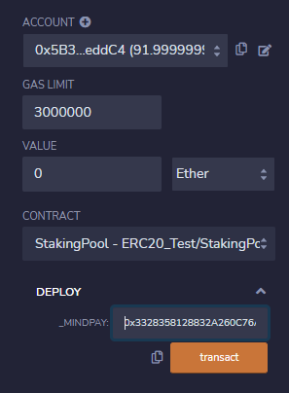

**3)After that deploy LiquidityPool.sol contract .**

**4)after that deploy ReservePool.sol ,then feed liquiditypool and staking contract address**

**5)then, we feed the reservePool contract address to LiquidityPool contract setAddress method.**

**6)then, we click on invest method of ReservePool.sol with msg.value has some ETHER greater then 1.**

**Thanks**