**GitHub questions**

* **What is GitHub?**

GitHub Inc. is a web-based hosting service for version control using Git. It is mostly used for computer code. It offers all of the distributed version control and source code management (SCM) functionality of Git as well as adding its own features. It provides access control and several collaboration features such as bug tracking, feature requests, task management, and wikis for every project.

* **When was it created?**

February 8, 2008

* **Why?**

*See „What is GitHub?“*

* **By who?**

Developed by Chris Wanstrath, PJ Hyett, Tom Preston-Werner and Scott Chacon using Ruby on Rails. On October 26, 2018 GitHub was acquired by Microsoft.

* **What similar platforms exist?**

Bitbucket by Atlassian, GitLab (OpenSource)

* **Why would you use such a platform?**

Supporting collaborative work (open source), as a backup and a method for project distribution as well as for the exploration of new projects.

*Sources:*

<https://en.wikipedia.org/wiki/GitHub>

<https://bitbucket.org/>

<https://about.gitlab.com/>

**Git tutorial**

Using Git-it (<https://github.com/jlord/git-it-electron#what-to-install>).

1. Get Git: Install Git on your computer and configure your name and email. ✅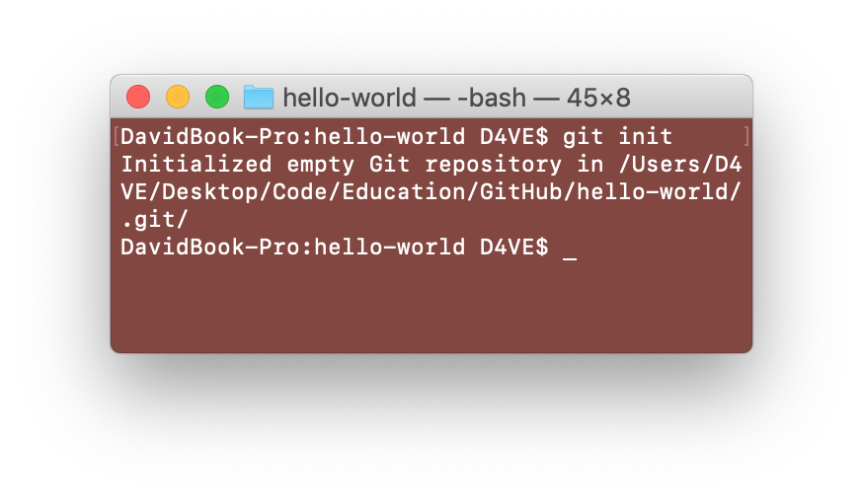

2. Repository: Create a new repository on your computer. ✅

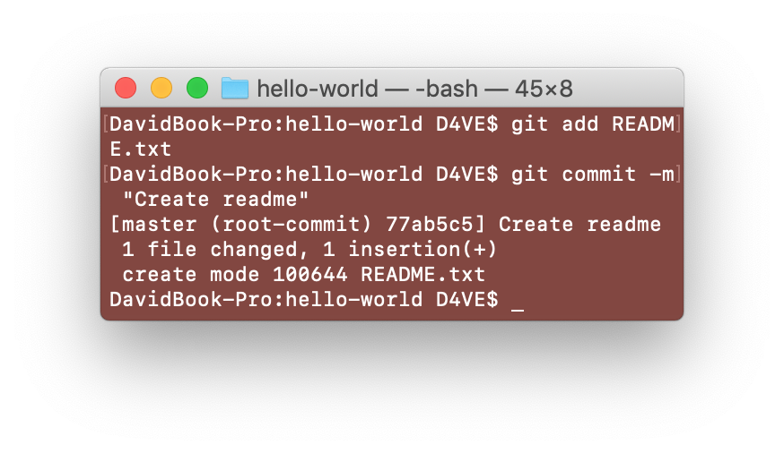

3. Commit To It: Create a file in your new repository, add something to that file and commit that change with Git. ✅

4. GitHubbin: Create a GitHub account and add your username to your Git config. ✅

5. Remote Control: Connect your local repository to a remote one and push changes to it. ✅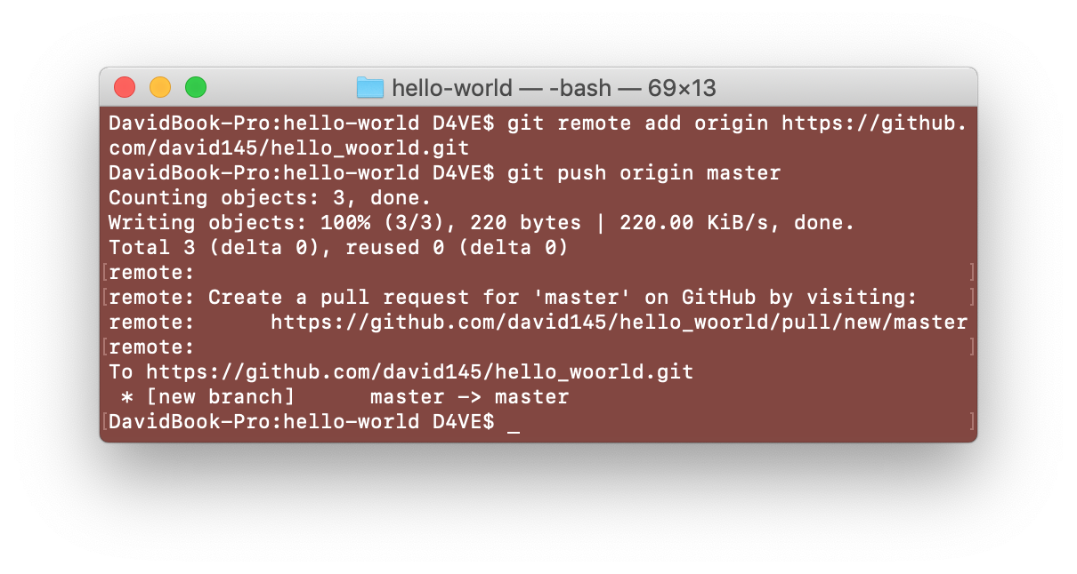

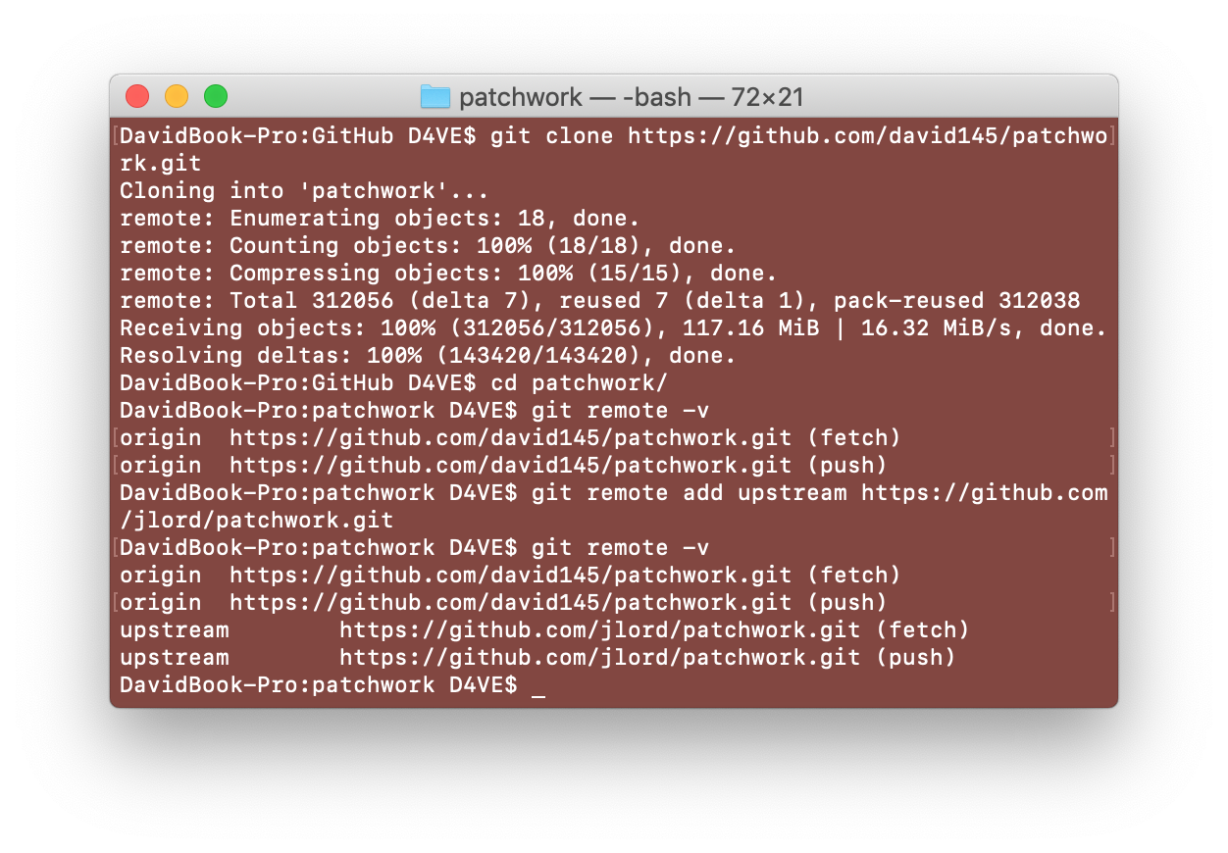

6. Forks And Clones: Fork a project from [GitHub.com](http://GitHub.com) and clone it locally. ✅

7. Branches Aren’t Just For Birds: Add a branch, locally, to your forked repository to work on your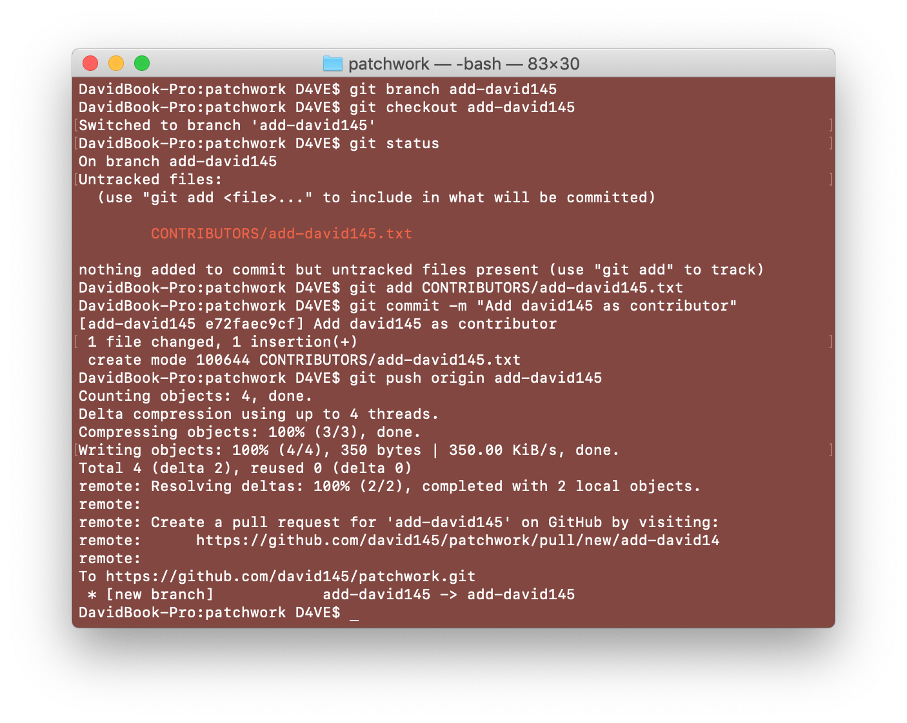 changes. ✅

8. It’s A Small World: Add a collaborator to your project. ✅

9. Pull Never Out Of Date: Keep your file up to date by pulling in changes from collaborators. ✅

10. Requesting You Pull Please: Submit a Pull Request to the original Patchwork repository. ✅

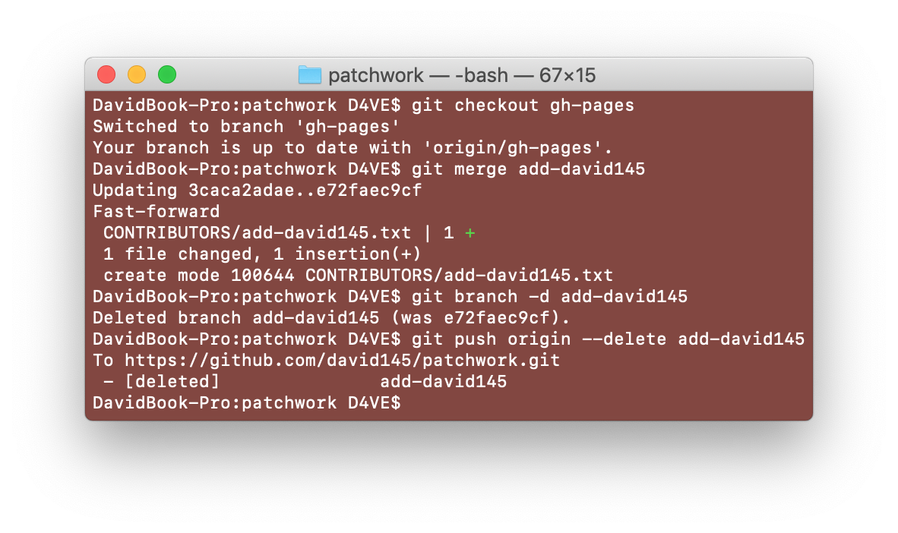

11. Merge 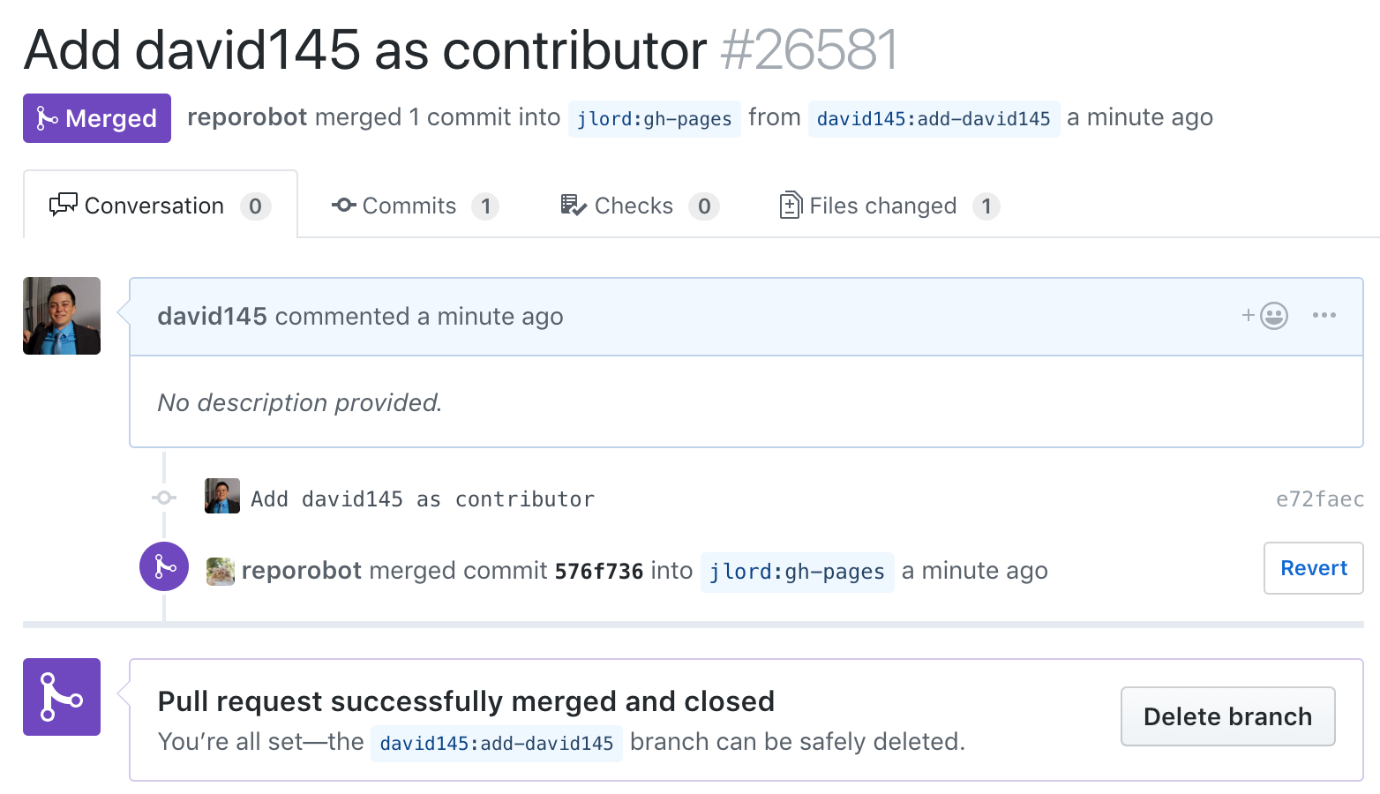Tada: Merge your branch locally, delete the branch and pull from upstream. ✅

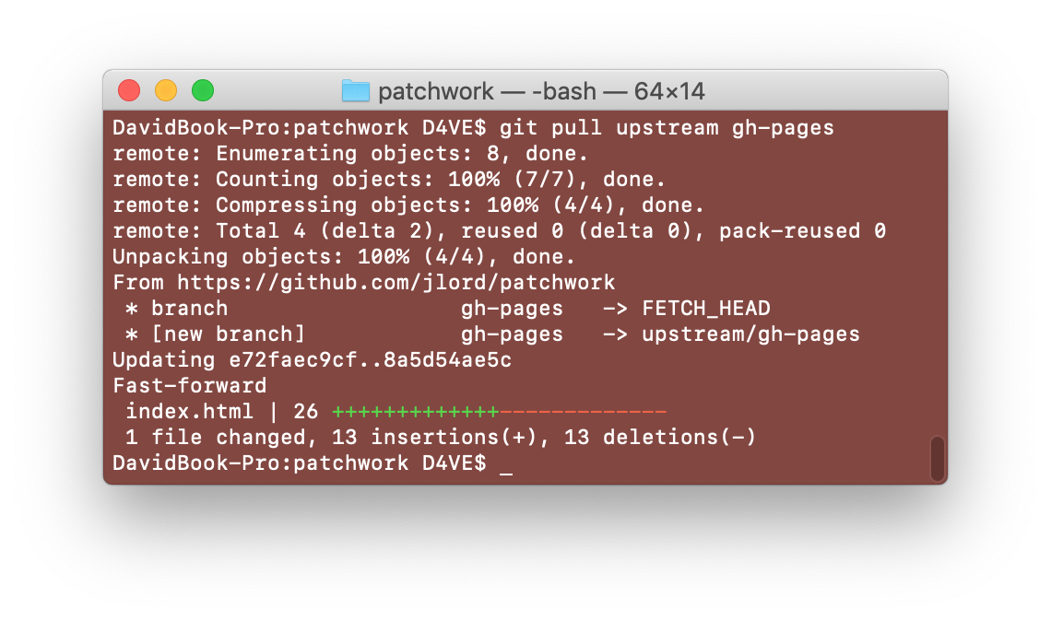

**Git terms**

* **Repository**

They're easiest to imagine as a project's folder. A repository contains all of the project files (including documentation), and stores each file's revision history.

* **Commit**

A commit, or "revision", is an individual change to a file (or set of files).

* **Push**

Pushing refers to sending your committed changes to a remote repository, such as a repository hosted on GitHub.

* **Branch**

A branch is a parallel version of a repository. It is contained within the repository, but does not affect the primary or master branch allowing you to work freely without disrupting the "live" version.

* **Fork**

A fork is a personal copy of another user's repository that lives on your account. Forks allow you to freely make changes to a project without affecting the original.

**- Merge**

Merging takes the changes from one branch (in the same repository or from a fork), and applies them into another.

* **Clone**

A clone is a copy of a repository that lives on your computer instead of on a website's server somewhere, or the act of making that copy.

**- Pull**

Pull refers to when you are fetching *in* changes *and* merging them.

**- Pull request**

Pull requests are proposed changes to a repository submitted by a user and accepted or rejected by a repository's collaborators.

*Source:*

*<https://help.github.com/articles/github-glossary/>*

**Add name to Pace’s README**

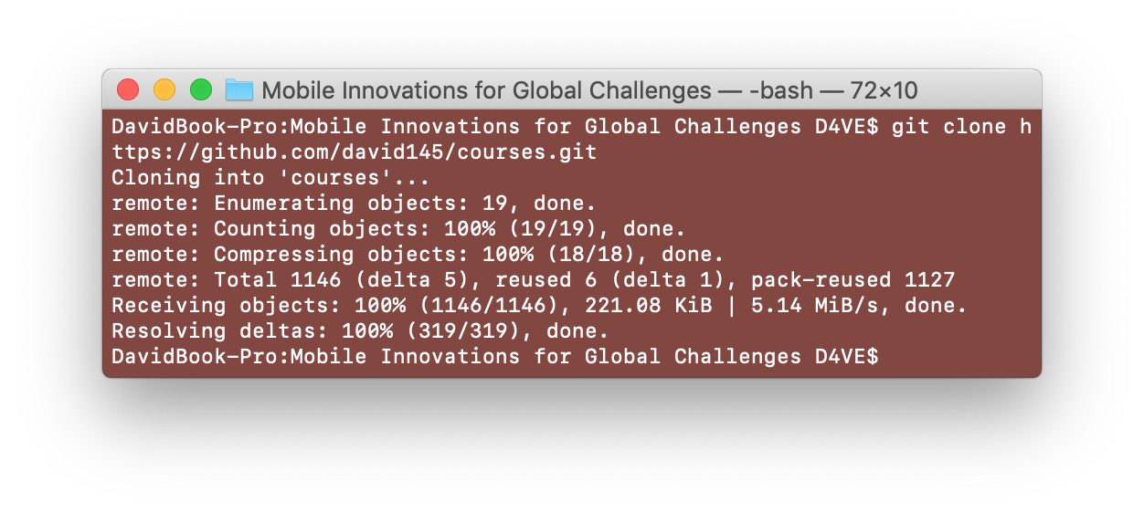

1. Fork project <https://github.com/paceuniversity/courses> and clone locally

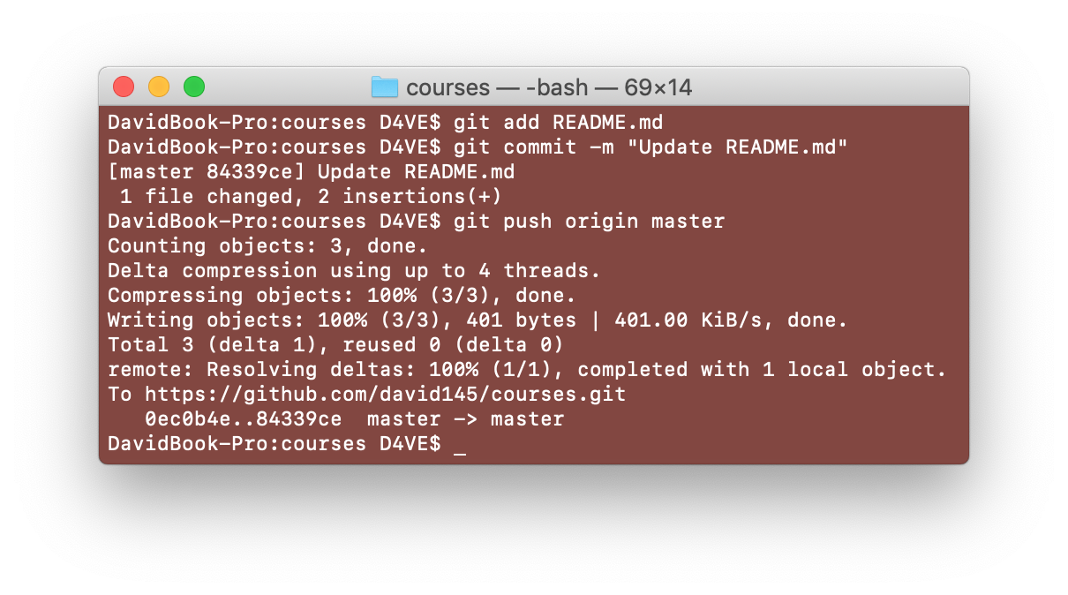

2. Make change, commit and push changes to forked repository

3. Create pull request

