Swift-L Quick install guide for the Commodore 128 flat.

Start by removing the CIA chip at U4. It’s on the left side down from the user port. Then insert the Swift-L into the socket, wifi module to the rear of the machine. The plug the cia into the socket of the Swift-L. (Notch towards the front of the machine.)

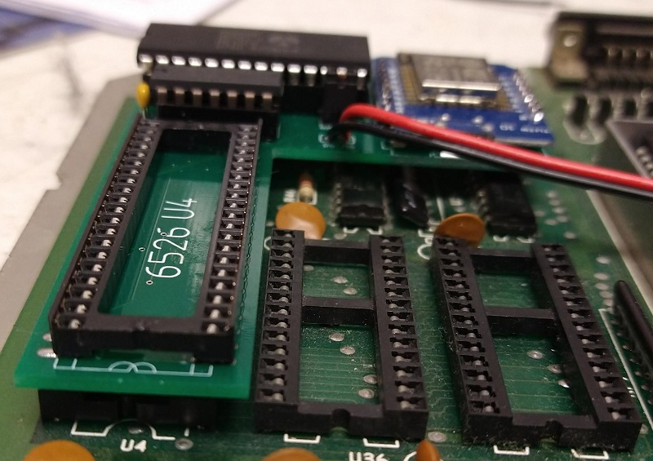

After removing the chip, insert the swift-t into the socket, wifi module to the rear of the machine.

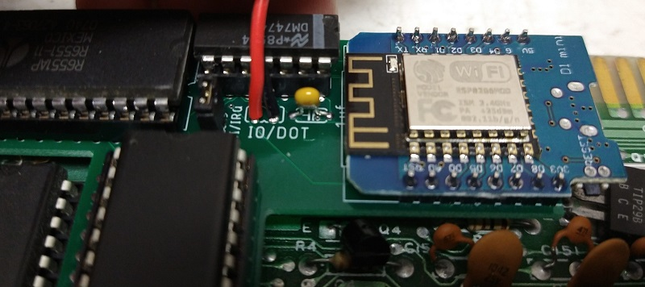

Now double check which wire is which. In the example, Red goes to the IO select pin, and black goes to DOT Clock.

Dot Clock ALWAYS goes to pin 6 on the cartridge port. This is the same on the 64 or the 128.

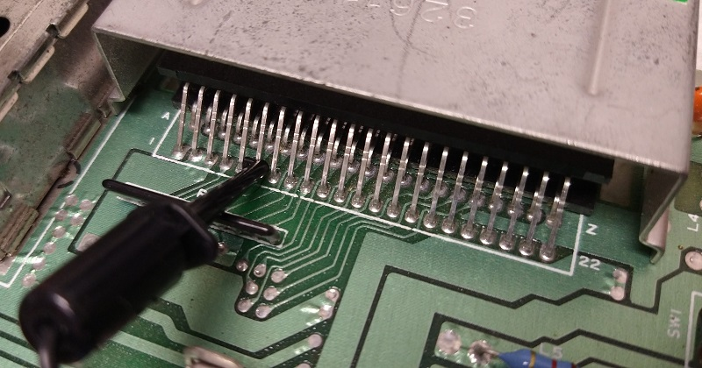

Now we need to pick a IO address for the Swiftlink Driver to use.

On the cartridge port, Pin 7 = DE00, and Pin 10=DF00

Here’s a example of DE00.

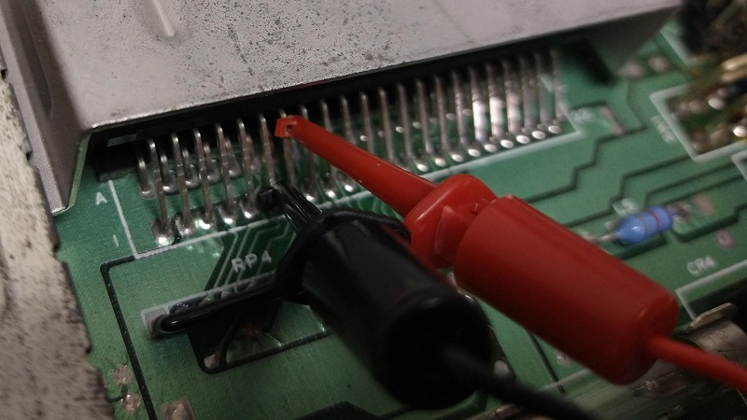

And here we have DF00.

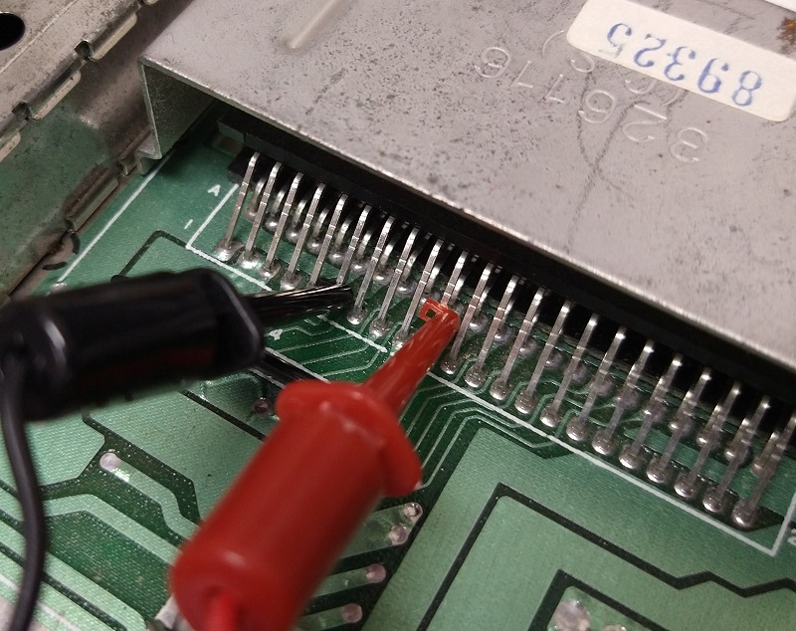

For D700 it’s located on u3, pin 12.

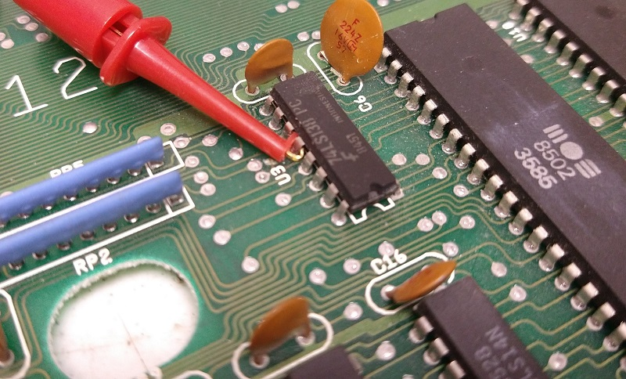

And that’s it, you are ready to load up your favorite terminal.

If you must have IRQ instead of NMI, you will need to remove the IRQ/NMI jumper from the Swift-L, and the run a lead (Not provided) to pin 21 of the other CIA chip.