Hangman User Documentation

**2012**

Andre Smink

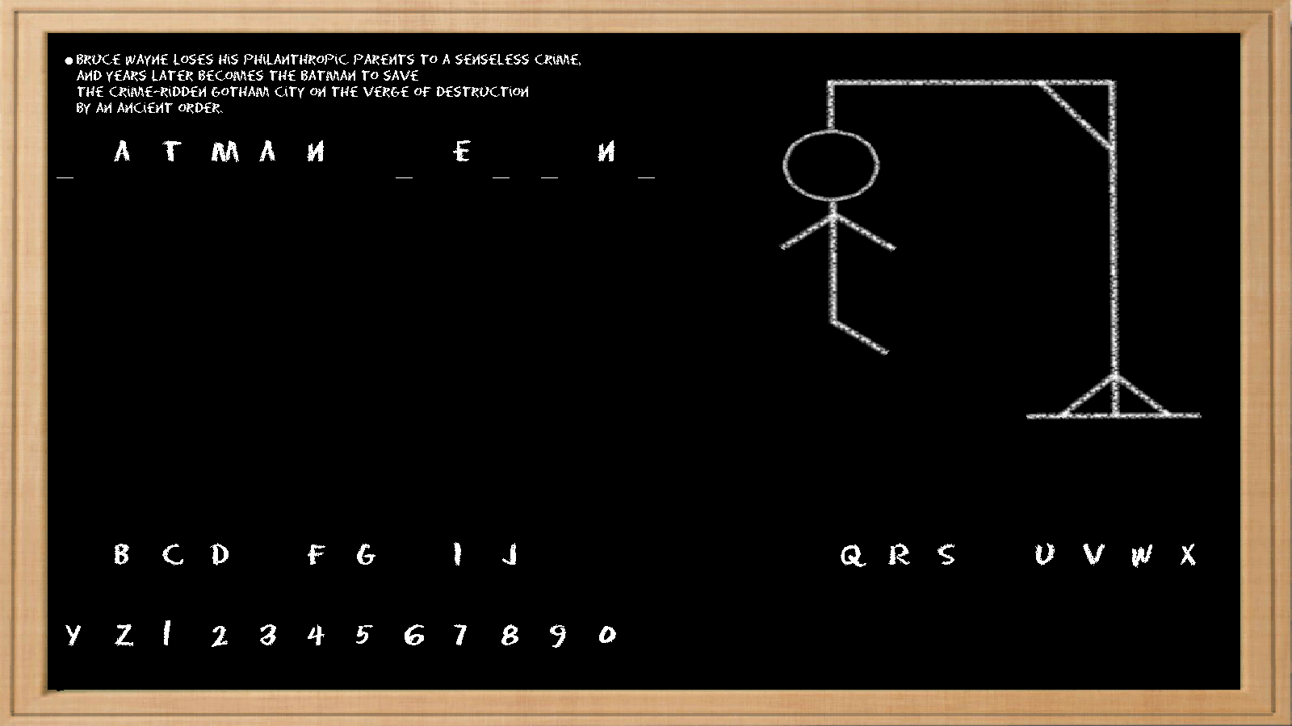

# Index

Index 2

Introduction 3

Game Overview 4

Game History 4

Game Strategy 4

System Requirements 5

Hardware requirements 5

CPU 5

RAM 5

Disk Space 5

Peripherals 5

Software requirements 5

OS 5

Additional Software 5

Restrictions 5

Setting up the game 5

Running the game 5

Operating the game 6

Bibliography 9

# Introduction

This hangman game can be played in single player and multiplayer mode.

In single player mode you can select a category from which the game should select a word you must try and guess.

In multiplayer mode you can enter any word or phrase you want and let someone else try and guess what it is.

In single player mode you have one objective. You must guess letters until you have guessed the whole word. You get 6 wrong letter guesses before the man gets hanged. The objective is to avoid hanging the man.

In multiplayer mode there are 2 objectives. One user must enter the most difficult word they can think of and the other user must try and guess what it is. The first objective is for the user that enters the word. He must try and get the man to hang. The other objective is for the user that has to guess the word. He must try and stop the man from hanging.

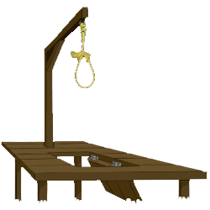

# Game Overview

The word to guess is represented by a row of dashes, giving the number of letters and category of the word. If the guessing player suggests a letter which occurs in the word, the other player writes it in all its correct positions. If the suggested letter does not occur in the word, the other player draws one element of the hangman diagram as a tally mark. The game is over when:

* The guessing player completes the word, or guesses the whole word correctly
* The other player completes the diagram:

This diagram is, in fact, designed to look like a hanging man. Although debates have arisen about the questionable taste of this picture, it is still in use today. A common alternative for teachers is to draw an apple tree with ten apples, erasing or crossing out the apples as the guesses are used up.

The exact nature of the diagram differs; some players draw the gallows before play and draw parts of the man's body (traditionally the head, then the torso, then the arms and legs one by one). Some players begin with no diagram at all, and drawing the individual elements of the gallows as part of the game, effectively giving the guessing players more chances. The amount of detail on the man can also vary, affecting the number of chances. Many players include a face on the head, either all at once or one feature at a time.

Some modifications to game play to increase difficulty level are sometimes implemented, such as limiting guesses on high-frequency consonants and vowels. Another alternative is to give the definition of the word. This can be used to facilitate the learning of a foreign language.

# Game History

"The origins of Hangman are obscure, but it seems to have arisen in Victorian times," says Tony Augarde, author of "The Oxford Guide to Word Games" (Oxford University Press). The game is mentioned in Alice Bertha Gomme's "Traditional Games" in 1894 under the name "Birds, Beasts and Fishes." The rules are simple; a player writes down the first and last letters of a word for an animal, and the other player guesses the letters in between. In other sources the game is called "Gallows", "The Game of Hangin'", or "Hanger". Hangman has featured in the 1978 Speak & Spell video game system under the name "Mystery Word" and is sometimes played today as a forum game.

# Game Strategy

In the English language, the 12 most commonly occurring letters are, in descending order: e-t-a-o-i-n-s-h-r-d-l-u. This and other letter-frequency lists are used by the guessing player to increase the odds when it is their turn to guess. On the other hand, the same lists can be used by the puzzle setter to stump their opponent by choosing a word which deliberately avoids common letters (e.g. *rhythm* or *zephyr*) or one that contains rare letters (e.g. *jazz*).

Another common strategy is to guess vowels first, as English only has five vowels (a, e, i, o and u), and almost every word has at least one.

# System Requirements

## Hardware requirements

### CPU

3.0GHz Intel Pentium 4 or better.

### RAM

1GB Memory or more.

### Disk Space

1GB Free space or more

### Peripherals

Mouse and Keyboard

## Software requirements

### OS

Platform in depended

Tested on Windows 7 32-bit Windows 7 64-bit and Windows XP 32-bit

### Additional Software

Java JRE 7

# Restrictions

Minimum screen resolution of 1200 X 700

# Setting up the game

Extract the folder with the game anywhere on your computer. Install the 2 fonts in the folder, Eraser, by double clicking it and then click the install button at the top or copy it directly into your OS font folder.

# Running the game

Run the game by simply double clicking the HangMan.jar file.

# Operating the game

The Single player button is used to launch a single player game.

The Multiplayer button is used to launch a multiplayer game.

The Exit button ends the program

The File Menu contains another Exit button

The Help Menu contains a about option that provides general details and a help option that opens the user documentation

## Menu.png

This window appears when you choose to play a single player game.

Here you select a category from which you want to guess a word.

You can also select the Random option if you want the program to select a category for you.

The BACK button will take you back to the Main Menu and the START button will start the game using a word from the selected category.

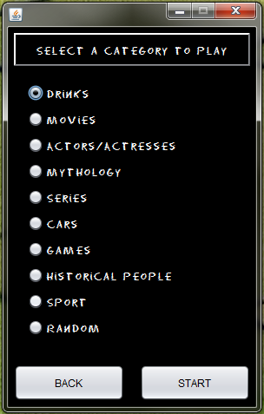

When you select the Multiplayer mode you will be presented with this window.

Here you can enter any word or phrase that you want that contains only alphanumeric characters and is no longer than 30 characters long

The BACK button will take you back to the Main Menu and the START button will start the game using the word entered.

# Multiplayer.png

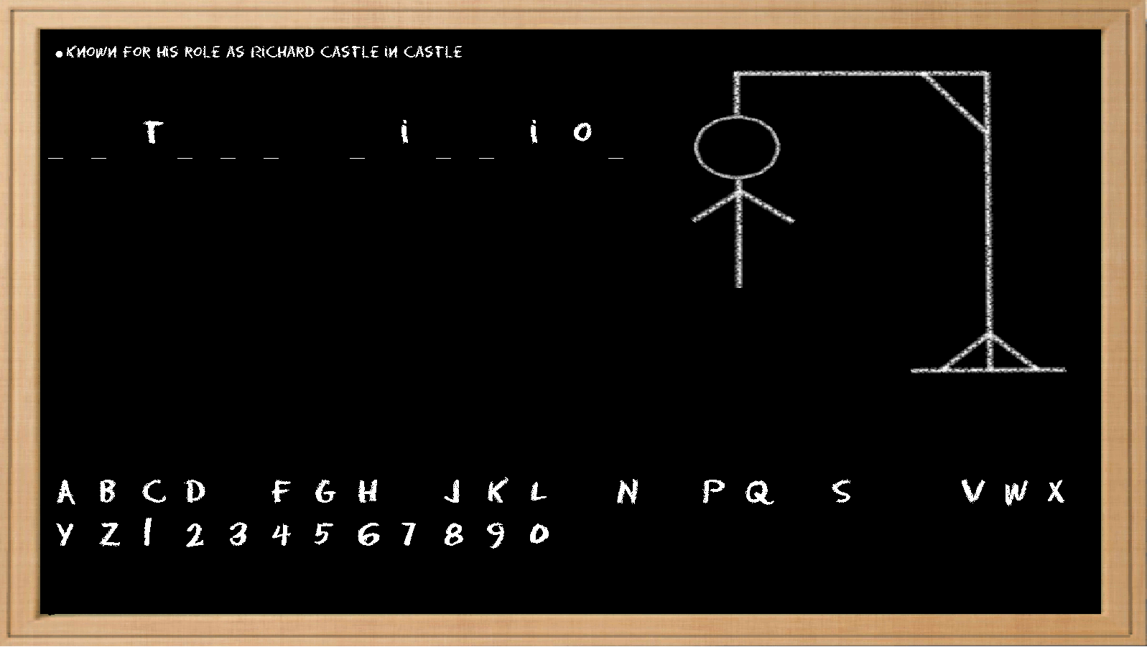

This is the main window of the game. Here you can guess letters by clicking on them or entering them by keyboard.

You can view a hint in single player mode by clicking the dot in the top left corner or by typing Ctrl + H on your keyboard.

At the middle-left of the screen is the word you have to guess with lines where missing letters are. At the middle-right is the progress of how far the man is from hanging. At the bottom is a list of all the letters you haven’t guessed yet.

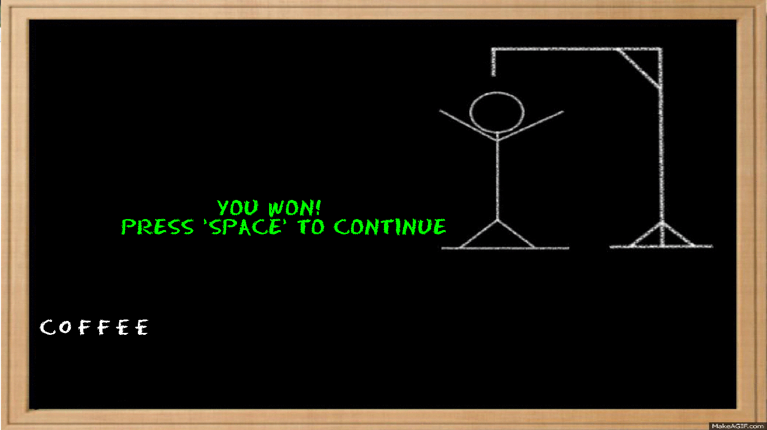

When you save the man from hanging you will see this on your screen.

The word you guessed is displayed at the bottom

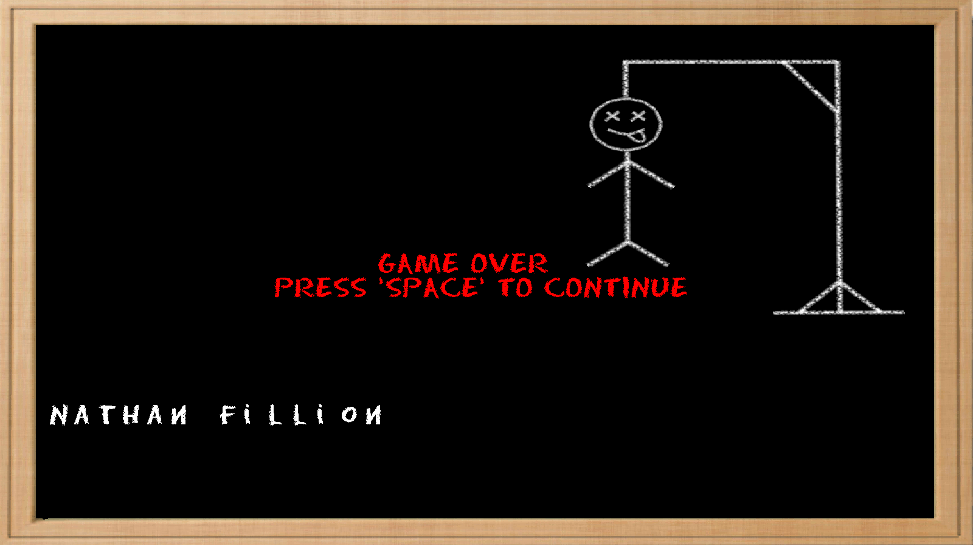

When you hang the man this is displayed on your screen.

The word you couldn’t guess is displayed at the bottom

# Bibliography

Game history, overview and strategy: <http://en.wikipedia.org/wiki/Hangman_%28game%29>

Animation of the winning hangman image: <http://makeagif.com/>

Words and hints: Mythology: <http://www.greekmythology.com/>

<http://www.godchecker.com/pantheon/egyptian-mythology.php>

<http://en.wikipedia.org/wiki/List_of_Greek_mythological_figures>

<http://gwydir.demon.co.uk/jo/roman/>

Series, movies, actors: <http://www.imdb.com/>

Historical people: <http://www.biographyonline.net/people/people-who-made-a-difference.html>