USER’S GUIDE:

**🡪           Table Of Contents:**

***Content: Page Number***

**-Overview: 2**

Introduction to W10_560 Machine and

contents of Users Guide

**-Prerequisites: 3**

Information to gather before running

W10_560 Machine Program

**-Running the Integrated W10_560 Machine Software: 3**

Guide to installation and usage of the Assembler Program

**1.) *Contents of Software* 4**

**2.) *Installation and Execution* 5**

**3.) *Process Summary*  8**

**🡪             Overview:**

The purpose of the following guide is to provide the information necessary to understand, install and properly use the W10_560 Machine software in an integrated fashion. This software combination is used to simulate the function of a W10_560 Machine, reading in an assembly language program, running this file through assembly, linked-loading, and simulation, all to produce an executable program output.

The guide that follows focuses on program usage and testing above program specification parts. It illustrates how to successfully run the three components in series. It is assumed that the user is familiar with operating the three components separately, and has the software installed. For more detail on the necessary software, consult the **Running the Program** section below.

A data flow diagram is shown below to illustrate the shell of the W10_560 Machines software.

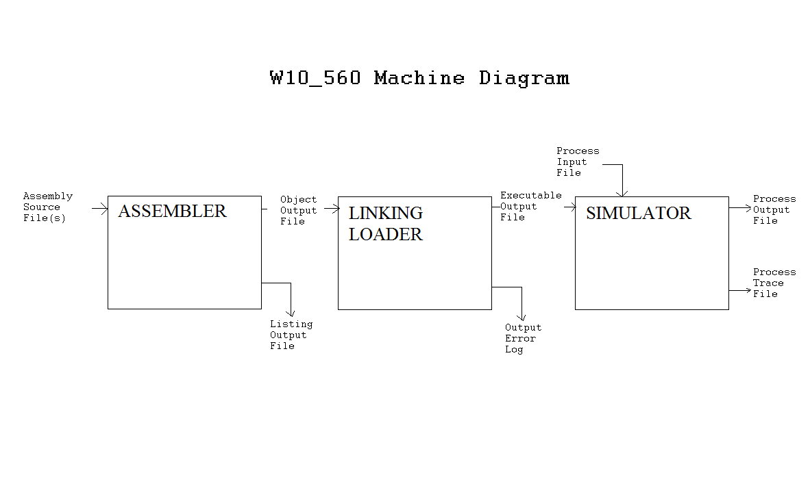

**🡪             Prerequisites:**

There is a very large amount of assumed knowledge when proceeding through this guide. This knowledge is found in the documentation of assembler, linker-loader and simulator software, (Respectively, ***c560ab03_lab2/, c560ab03_lab3/, c560ab03_lab4/).*** This includes but is not limited to:

* Knowledge of the assembler usage, documentation found in previously installed c560ab03_lab3/src/docs directory
* Knowledge of the linking loader usage, documentation found in previously installed c560ab03_lab4/src/docs directory.
* Knowledge of the simulation program, documentation found in previously installed c560ab03_lab4/src/docs directory.

Any additional required knowledge is referenced in each individual component’s User’s

Guide sections **Prerequisites.**

**🡪    Running the Integrated W10_560 Machine Software**

**Required Software:**

As mentioned above, in order to run the integrated W10_560 machine, all three components of its operation,( the assembler, the linking loader, and the simulator) must already be installed. The three program folders included are as follows:

***c560ab03_lab2/***

***c560ab03_lab3/***

***c560ab03_lab4/***

Each of these folders must contain the complete and original *src* subfolder for the following guide to accurately guide the process Integration. The guide that follows will begin assuming the installed folders are intact, locatable and running properly, as provided.

Note: For syntax examples shown below, the program is run in the UNIX environment. (Note:

Syntax will also apply for most *nix environments)

**Part A.) Installation and Compilation:**

Note: The software is written in a combination of RESOLVE/C++, and C++. It is

necessary for installation that the Resolve/C++ catalog is included in the

desired installation directory.

**1.**) Given the W10_560 machinesoftware, installation first requires **copying all of the content**

**of the following folders to a desired directory :**

***C560ab03_lab2/src/***

***C560ab03_lab3/src/***

***C560ab03_lab4/src/***

This can be done both inside and outside of the UNIX environment. Sample UNIX copies

can be seen below using the sample directory, *INTEGRATOR,* as the desired the location.

% **cp *c560ab03_lab2/src/* /****INTEGRATOR/*

% **cp *c560ab03_lab3/src/* /****INTEGRATOR/*

% **cp *c560ab03_lab4/src/* /****INTEGRATOR/*

**2.)** The next step to take before running the program is to ensure you are located in the correct

directory. If following the commands above, **change to src directory** as shown below:

***% cd /****INTEGRATOR/*

**3.)** Once you are located in the proper directory, the next step in execution is to **compile the**

**programs installed** previously. Using the Resolve/C++ rcpp-make command,(as

mentioned previously, RESOLVE/C++ components must be included, compile

assembler.cpp, linker.cpp, and simulator.cpp. A sample call is shown below.

***% rcpp-make*** *assembler.cpp, linker.cpp, simulator.cpp*

**4.)** Once all of the contents of lab2-lab3/src are located in the desired directory, and the programs have been compiled, **copy the desired *Assembly Language Source File* to the *INTEGRATOR*  folder** as shown below. We will call this source file *sourceFile*:

% **cp *sourceFile /****INTEGRATOR/*

If all files are located in the appropriate folders, the next step will be to run the program.

(Note: Remember list command ls to verify file locations.)

**Part B.) Running the Program:**

Given the separate components involved in the total simulation of the W10_560

machine, the following steps describe the commands required to run the integrated

machine software.

Note: In continuation from the previous steps of installation, **ensure that the current directory**

**is the INTEGRATOR** folder as described above.

The Assembler:

The assembler program converts assembly language code into machine language code, which will be read by the Linking Loader. The assembler will accomplish this by reading in an *Assembly Language Source File* and create an output of the *Object Output File* and *Listing Output File.* Please reference the **Prerequisites** section for in-depth information on syntax, operation notes, and other additional information for the assembler and its I/O.

**1.)** Begin first, with running the *Assembly Language Source File* with the assembler as shown below. If multiple *Assembly Language Source File(s)* exist with the intention of be linked together please run one file at a time, creating several different *Object Output Files.* Be sure to name the *Object Output Files* appropriately to avoid confusion in the next step.

***% assembler sourcefile objectoutput listingoutput***

Where: ***assembler*** 🡪assembly program

***sourcefile*** 🡪*Assembly Language Source File,*

(Copied above)

***objectoutput***  🡪*Object Output File* ,

(Will be created, or prompted to replace)

***listingoutput*** 🡪*Listing Output File* ,

(Will be created, or prompted to replace)

Note: All of the output files will be written to the ***src*** folder and if these output files already exist, you will be prompted with the following messages:

***Warning: File ‘objectOutput’ already exists, overwrite?(y/n)***

***Warning: File ‘listingOutput’ already exists, overwrite?(y/n)***

**2.)** If the program has successfully run, the following messages will appear on the command prompt.

*Begin Assembly*

*…*

*Assembler Finished*

If the message “Assembler Code Error. Please Check Listing File”. appearsplease refer the listing output file for the listed errors. To correct these errors, reference the Lab3_UsersGuide **troubleshooting** section for assistance in fix *Language Source File.* Errors must be removed before continuing.

The Linking-Loader:

The linking loader program creates a linked-machine-code file by linking several machine-coded programs together. The assembler will accomplish this by reading in the *Object Output File(s)* (created by the assembler), then outputting the *Linked Executable File* and the *Error Log File.* Please reference the **Prerequisites** section for in-depth information on syntax, operation notes, and any other additional information for the assembler and its I/O.

**1.)** To run the linker loader program linker.cpp, follow the command line syntax shown below:

***% linker linked_executable error_log obj_1,….obj_n***

Where: ***linker*** 🡪Linking Loader Program

***Linked_executable*** 🡪*Linked Executable File,*

(Will be created, or prompted to replace

***error_log*** 🡪*Error Log File* ,

(Will be created, or prompted to replace)

***obj_1…obj_n*** 🡪 *Object Output File(s)* from assembler program,

Note: All of the output files will be written to the ***src*** folder and if these output files already exist, you will be prompted with the following messages:

***Warning: File ‘linked_executable’ already exists, overwrite?(y/n)***

***Warning: File ‘error_log’ already exists, overwrite?(y/n)***

**2.)** If the program has successfully run, the following messages will appear on the command prompt.

*The footprint size is ______ words.*

*Provide an appropriate IPLA(hex)*

The Simulator:

The simulator program is the final step in running the W10_560 machine software. The simulator will read in the *Linked Executable File* (created by the linking loader), then outputting the *Linked Executable File* and the *Error Log File.* Please reference the **Prerequisites** section for in-depth information on syntax, operation notes, and any other additional information for the assembler and its I/O.

**1.)** To run the simulator program simulator.cpp, follow the command line syntax shown below:

***% simulator executable_input process_input process_output trace_output***

Where: ***simulator*** 🡪Simulator Program

***executable-input*** 🡪 *Linked Executable File,*

(Will be created, or prompted to replace

***process-input*** 🡪*Process Input File* ,

***process-output*** 🡪*Process Output File* ,

(Will be created, or prompted to replace)

***process-trace*** 🡪*Trace Output file*

(Will be created, or prompted to replace)

Note: All of the output files will be written to the ***INTEGRATION***  folder and if these output files already exist, you will be prompted with the following messages:

***Warning: File ‘process-output’ already exists, overwrite?(y/n)***

***Warning: File ‘process-trace’ already exists, overwrite?(y/n)***

**2.)** If the program has successfully run, the following messages will appear on the command prompt.

*Begin Simulation*

*…*

*Simulation Finished*

**Process Summary:**

Congratulations, you have successfully run the W10_560 Machine software. This process has taken a sample assembly language source file or related files and simulated their effects on W10_560 Machine memory. Remember this final memory printout and command summary can be found in the simulator created *Trace Output file*. For more information on how to access this file, please reference the **Prerequisites** section for reference to the Simulator users guide.

Again, the component based nature of the simulation software design allows for a greater freedom of usage. Please feel free to reference the individual programs and their appropriate documentation for more information.