General Help

What is in here?
This folder contains the files needed to run the Java Robot Controller application, as well as Source Code and accompanying project files.

Packaged Software
Java Robot Controller:
Windows OS (.EXE)
Windows Phone 7 Mango (.XAP)
Android OS (.APK)
UNIX/LINUX/Mac (.sh)

Source Code
Java Robot Controller:
Windows OS (Visual Studio 2010 Project Folder, C#)
Windows Phone 7 Mango (Visual Studio 2010 Project Folder, C#)
Android OS (Eclipse Project Folder, JAVA)
UNIX/LINUX/Mac (SHELL)
Robot Software:
RoboJDE Package Folder
Capstone.java (JAVA Source)

How does it work?
The Java Robot used the WiFLY adapter to connect to a Wireless Router called Java_Robot. If you wish to change this, be sure to change the settings on the WiFLY adapter to match your Access Point, and take note of the IP Address and Port Number.
On any of the software packages above type in the IP Address and Port number, and hit connect. You can now control your robot.

I got an error, what should I do?
Make sure you are on the same network as the WiFLY adapter, make sure you use the right address and port number, also make sure that the Robot is on and running, and that batteries are strong enough. If you experience problems with the applications make sure you have your device set to run Unsigned applications, and that a firewall is not blocking the port. You may also need to install Telnet in some clients, if using Command Based.

I am using a custom Robot, what accessories do I need on it?
The applications make use of the Display (LCD), the IR Detection in the Back of the robot, the Sonar detection in the front of the robot and two wheels.

Device Specific FAQ

Windows Application
This application is designed for the Windows Operating System from Microsoft. It was designed specifically for Windows 7, but should work in Windows Vista, with the latest Service Pack installed. You also need the .NET framework installed with the current version.

Windows Phone Application
This application is designed for the Windows Phone 7 Operating System; it must have Windows Phone 7 Mango installed. Older versions will not work! This is due to Socket limitations in earlier versions.

Android Application
This application is designed for the Android smartphone platform; it is designed for Android 2.3.3. The application may work on older versions of Android, but this is not guaranteed. Some features are not available in Android, due to limitations on Stick controls in Android versions before 3.0 and the way Android uses Sockets, which differs from past implementations that were used.

UNIX/LINUX/Mac Application (CMD)
This application is a text based (command line) version of the application to allow people using UNIX, LINUX, or Macintosh (Darwin), to control the robot from an easy to use Terminal window. Please make sure that you have Telnet installed, this should be freely available from your distribution’s repository (repo). Most versions of UBUNTU and Macintosh come preinstalled with Telnet.

Java Robot On-Board Software
The Robot uses a Java based application to await commands from a client; the commands are preprogrammed into all software packages, and are listed for convenience in command-based applications. If the robot does not move, make sure that the batteries are charged, and that the robot is Running (press START). The WiFly is designed to work with a specific Router, if you are using a different router you need to reprogram the WiFly adapter.

The next few pages have screenshots of the devices in action!

Windows OS
Directional Pad Controls:

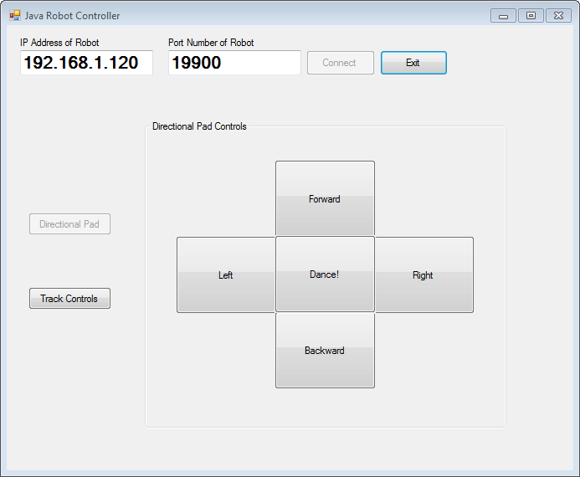

Stick Controls:

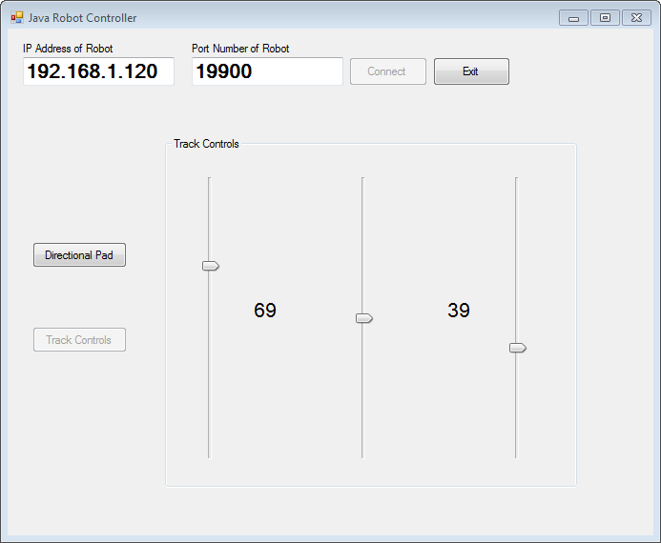

Windows Phone 7 (Mango)
Directional Pad Controls Stick Controls
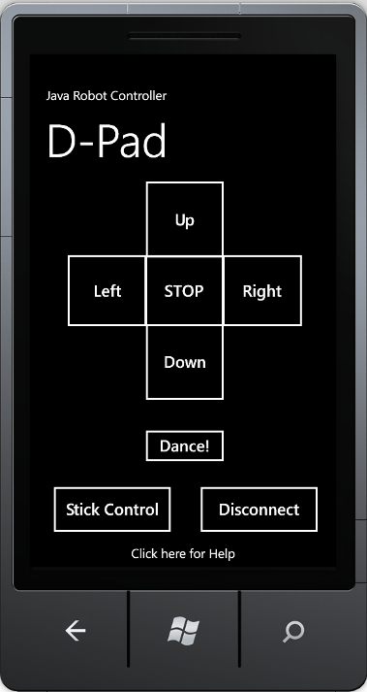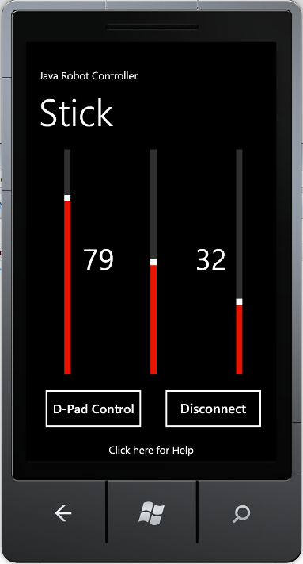

Android Application
Log in Directional Pad
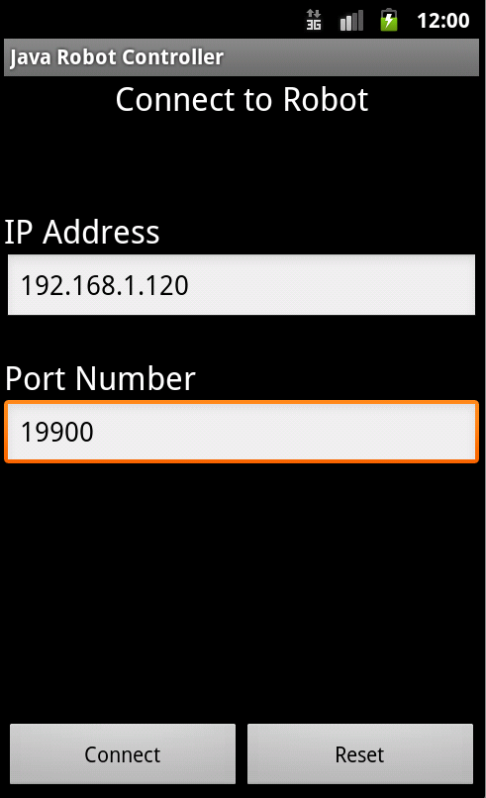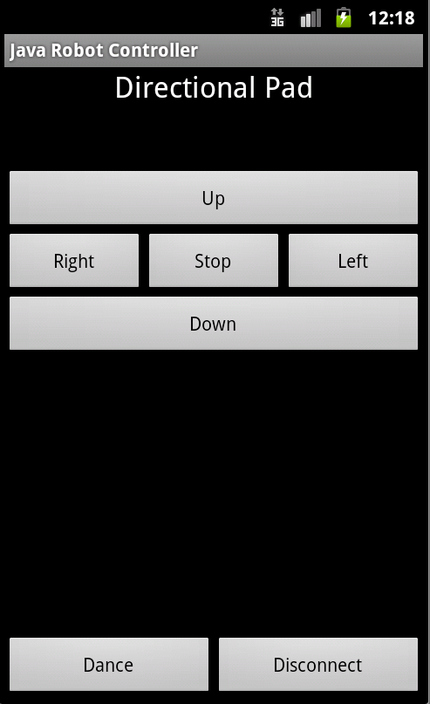

UNIX/LINUX/Mac Application

