Abstract – In the past few years utility-scale renewable energy sources such as photovoltaic solar farms and wind farms have seen rapid growth. As at a utility-scale these technologies require the utilization of large areas of land and collect energy that would otherwise be used in natural processes, they may have a noticeable impact on the climates they are situated in. This report attempts to examine if with readily available climate data there is a noticeable climate effect before and after the establishment of a wind or solar farm.

I. Introduction
Renewable energies, particularly wind farms and photovoltaic (PV) solar farms have seen immense growth in recent years. Global capacity of renewable energy installments as a whole accounted for about 750 GW of added capacity in 2025 [1].
This growth has had some noted impact on local environments. Previoius studies have discovered that large wind farms have an impact on their local atmosphere by reducing wind speed in their wakes, with this reduced speed persisting long distances during stable conditions, and introducing turbulence in their wakes [2]. As wind is a major factor in the distribution of heat and moisture impacts may affect more than the immediate region around these sites.
While much closer to the ground, photovoltaic (PV) solar panels have had a measurable impact on their local climates as well. It has been measured that while PV do absorb and reflect light that otherwise would have been absorbed into buildings keeping them cooler, that reflected light acts to heat up the surrounding environment in urban ares. With measurable daytime and nighttime temperature increases.
As utility-scale solar and wind farms are massive collections of these technologies the aforementioned effects could scale up or vary in unforeseen ways. Certain industries such as agriculture are dependent on favorable and predictable weather. As these technologies at a utility-scale are typically situated in rural regions impacts may be devastating to local communities.
Parameters such as atmospheric pressure, precipitation, humidity, temperature, and wind speed give an idea about the climate surrounding a region. As they are the most readily available and processable humidity, temperature, and wind speed will be the Key Climate Parameters (KCP) for evaluating changes in local climate.
This project will use projects and climate conditions in Texas as Texas has the highest renewable energy capacity in the United States, with a whopping 67.7 GW of generating capacity [8]. Due to it’s size, Texas also provides a diverse range of climates to examine for climate changes. This report focuses on Texas as these aspects contribue to a large array of site data from the state.
This report attempts to use publicly available climate data to investigate climate impacts by scale of counties in Texas. Comparing the differences of climate before and after the establishment of a solar or wind farm, and comparing these against a base-line of data without any of these sites nearby.

II. Data Collection and Preparation

A) Data Collection
Climate data containing the KCPs, climate data containing location and date of KCP collection, site data containing location, and site data for year of project establishment are essential for the evaluation this report is pursing.
The United States Geological Survey provides two databases regarding wind and utility-scale solar farms, the United States Wind Turbine Database [4] and the United States Large-Scale Solar Photovoltaic Database [5] respectively. Each database provides a list of projects, project county location, and date of project establishment. From these lists it was gathered that there were 282 wind farm projects and 187 solar farm project sites in Texas.
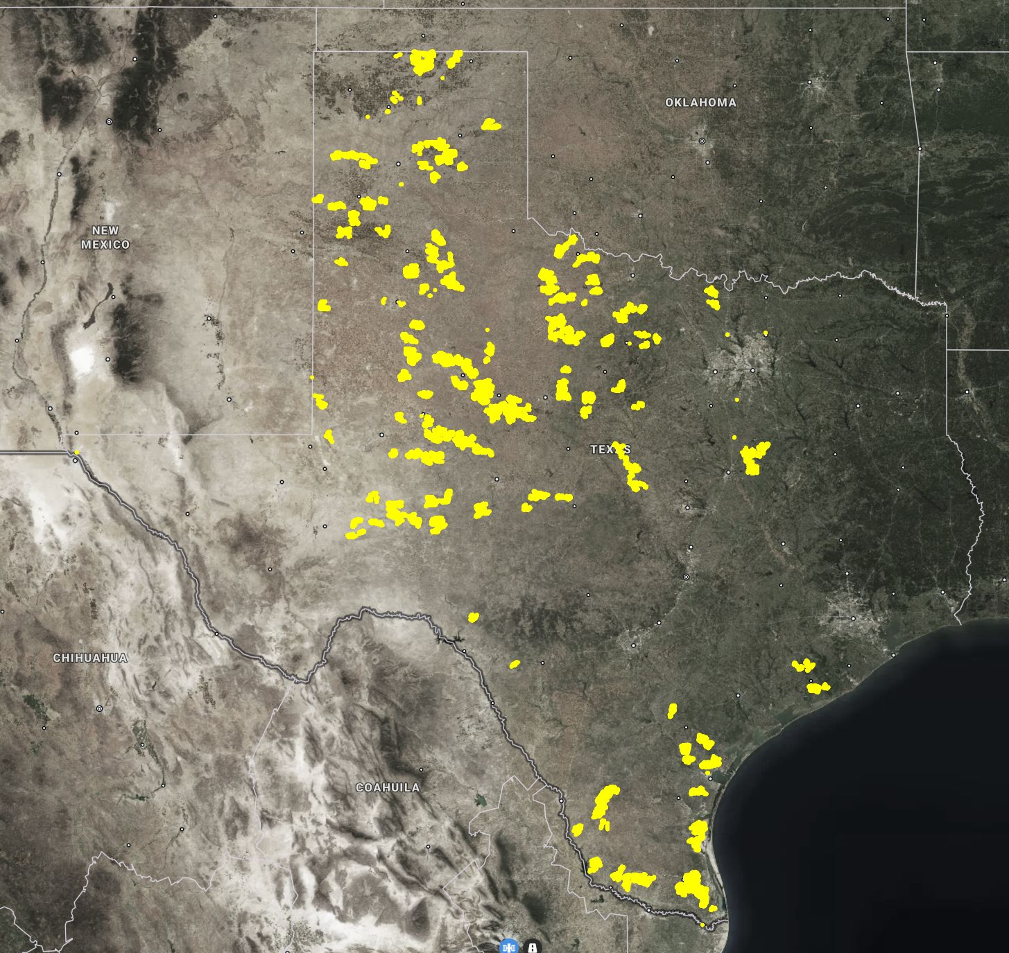Figure 1: Texas Wind Farm Sites
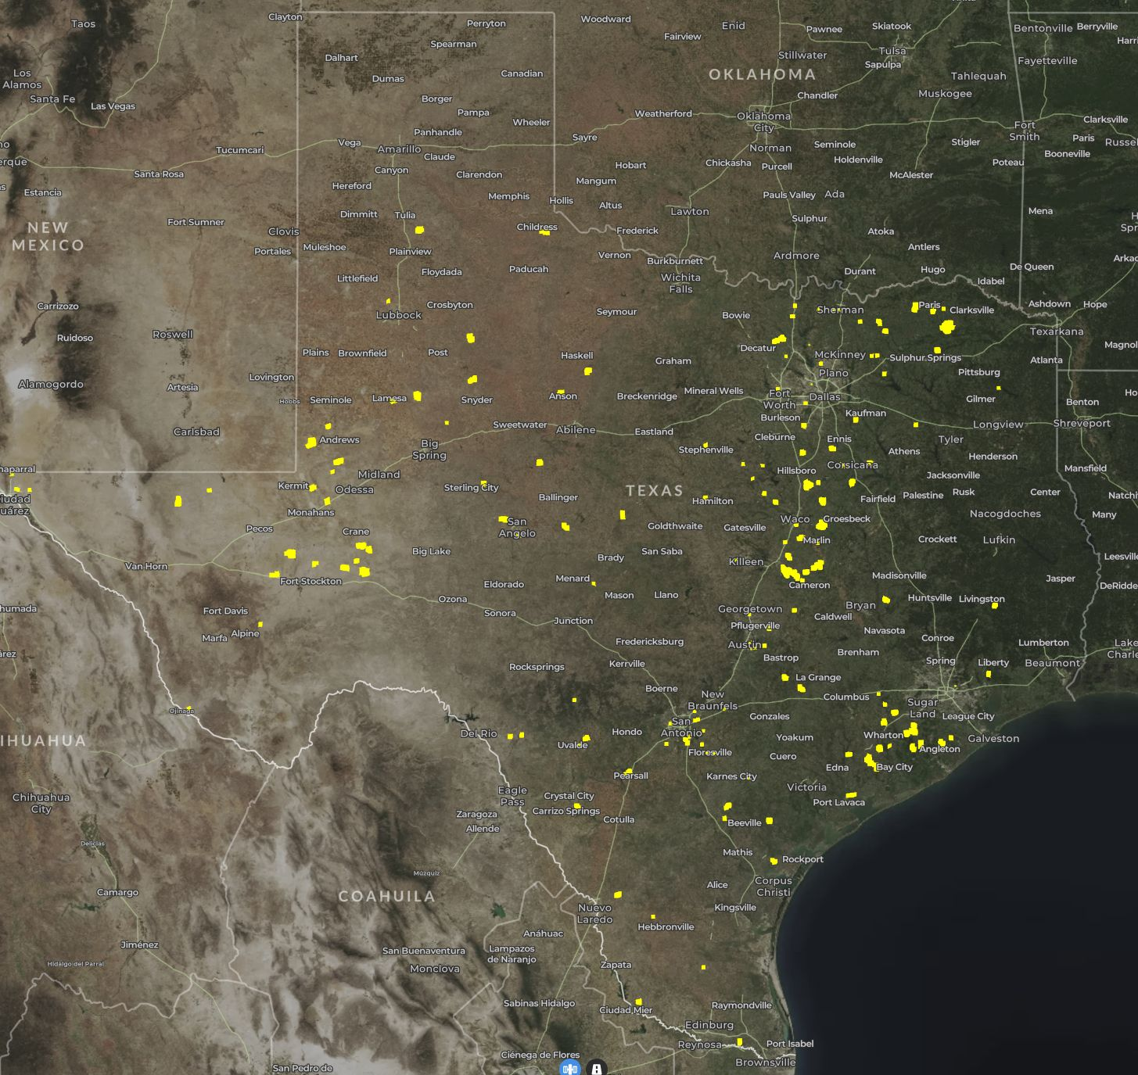Figure 2: Texas Solar Farm Sites
The National Oceanic and Atmospheric Administration’s National Centers for Environmental Information provides both historical and current lists of the monitored KCPs through it’s Local Climatological Data Version 2 (LCDv2) database. This database provides an assortment of climate data collected hourly. This data is limited, however, by both location and date range. The data available that holds the KCPs only comes from airports, this presents a problem as solar and wind farms are not typically near airports and greatly limits the granularity of the data. Furthermore, the data is also limited by date range as some datasets can reach back to 1990 while others only go as far as 2020, limiting the available range. Regardless, this project uses climate data available for each county in Texas as county location can be isolate when downloading with site data. Of the 254 counties in Texas, there are only 121 counties with data with our KCP, these sets can have a range from 1990 to 2025.
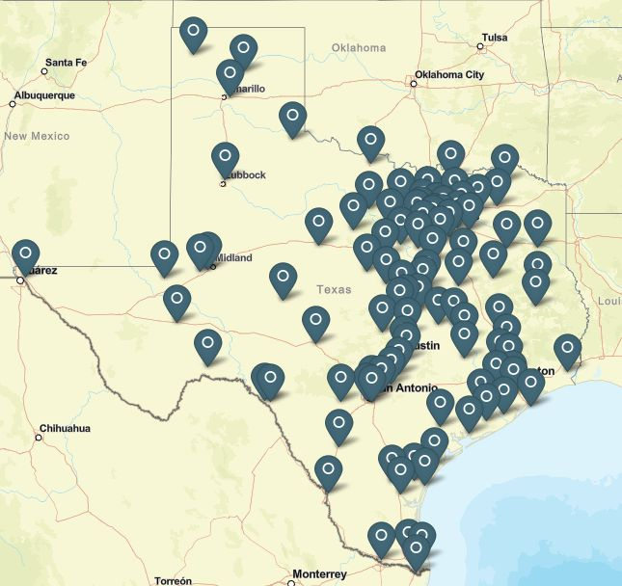Figure 3: NOAA LCDv2 Sites

B) Data Processing
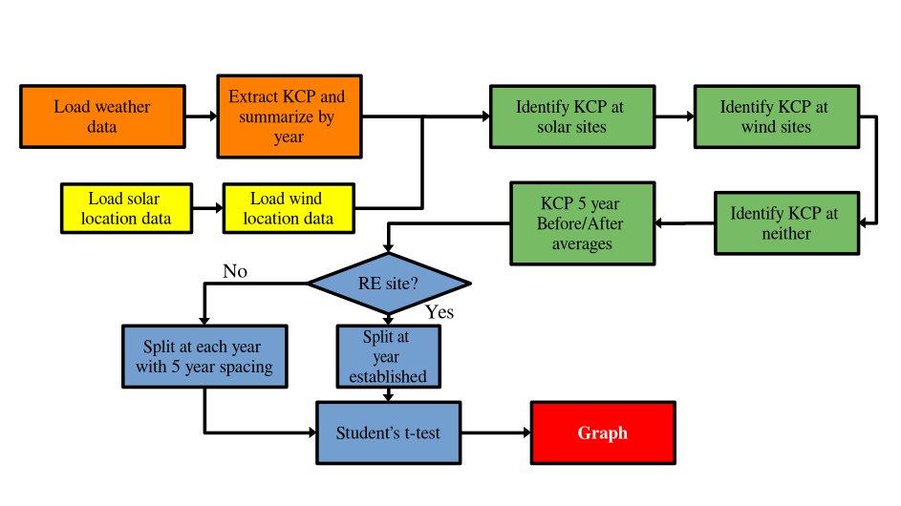Figure 4: Data Processing Flowchart
From the site data and the climate data collected this project requires a before and after comparison of the collected data. To achieve this end this projecct used the Matlab scripting software to process, analyze, and plot the data.
The site data and the climate data are loaded into a script where the KCPs are processed to attain informative values. While humidity and wind speed are simply averaged, the values for temperature are given a bit more attention as simply the average isn’t very informative. Temperature is processed by the average annual temperature, the highest and lowest annual temperature, and the average daily highs and lows. There the climate data is segmented between counties that contain solar sites, climate data for counties that contain wind sites, and climate data for counties that contain neither as the baseline control data.
As this report is attempting to measure if there is a difference before and after the establishment of a wind or solar farm, this report uses the difference of the KCP 5 year averages from before and after the establishment of a site. This method also curtails the regional variation as instead of evauating what a climate is like, it’s evaluating the change that climate has seen. Using the previously calculated annual averages, each dataset is split by either year established for the wind and solar sites, or by year avaliable for the baseline control data. Years that don’t have enough data for a full 5 years before and after are trimmed from their respective sets.
Once this data is processed and prepared for analysis there are 93 wind differences, 111 solar differences, and 852 control differences avaliable for analysis.
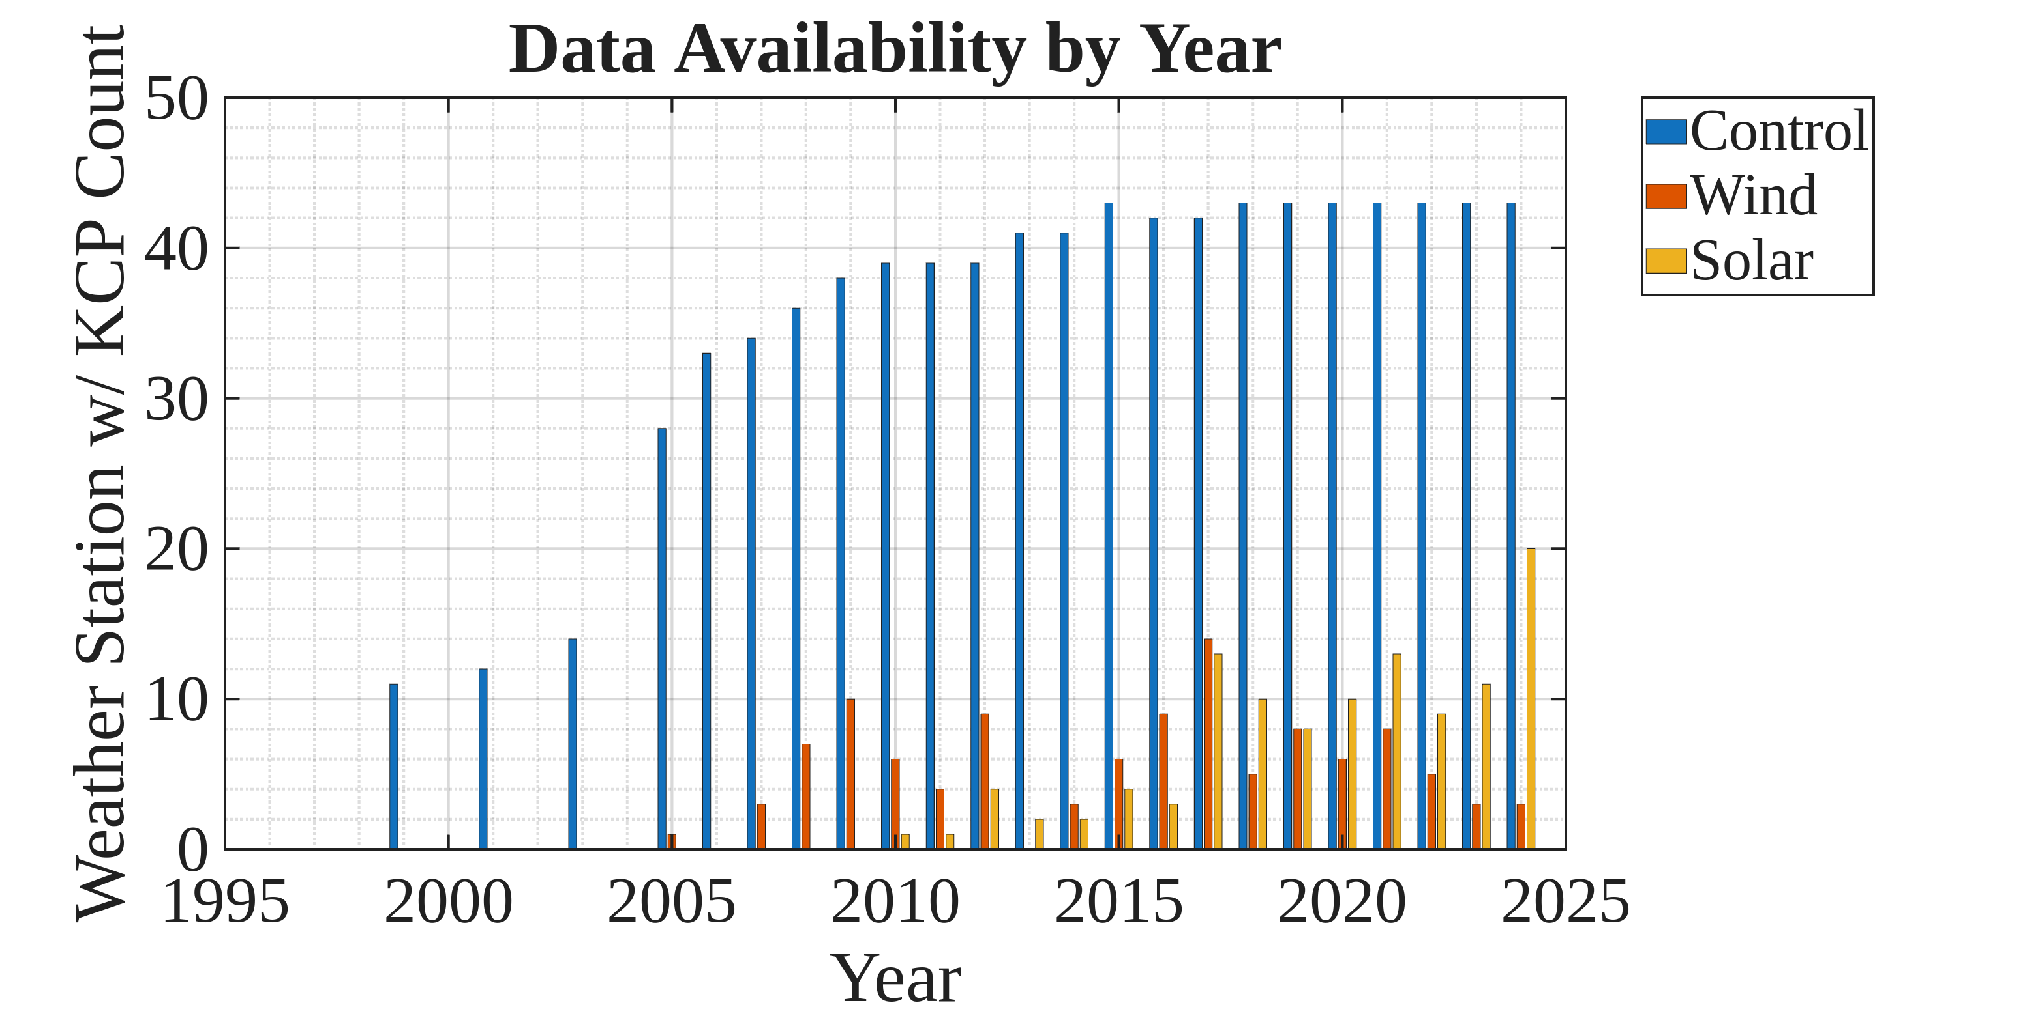Figure 5: Before & After Difference Avaliability
However, due to the variability of data collected prior to 2015 and the impossibility of collecting data more than 5 years from 2020 as the date of writing is early-July 2026, data is further trimmed to dates between 2015 and 2020. This leaves 48 wind sets, 41 solar sets, 286 control sets.

III. Data Analysis
The primary analysis of this data is testing the null hypothesis that the difference distribution of the wind and solar datasets can be likely found within a given distribution of the control data. Though there isn’t enough data to do an analysis for each year, when aggregated there is a comfortable data set for wind, solar, and control sites. As both the wind and the solar datasets have above 30 points the student’s t-test is applicable for analysis. The control dataset is pleaniful enough that it can be bootstrapped for 1000 points of data to gain a resonable distribution. See Appendix A for relevant aggregate data graphs.
The student’s t-test requries the mean value of the sample size, the variance of the sample sample size, the sample size, and the distribution mean. Here, as each data set is
Equation 1: Student's t-test Formula
Key Climate Parameter | H0 | p
Humidity Difference | Proven | 0.07
Wind Speed Difference | Proven | 0.76
Average Temperature Difference | Proven | 0.38
Average Daily Hi Temperature | Proven | 0.67
Average Daily Lo Temperature | False | 0.01
Annual Hi Temperature Difference | False | 0.24
Annual Lo Temperature Difference | Proven | 0.61
Table 1: Solar Farm t-test Results
Key Climate Parameter | H0 | p
Humidity Difference | False | 0.02
Wind Speed Difference | Proven | 0.52
Average Temperature Difference | Proven | 0.44
Average Daily Hi Temperature | Proven | 0.26
Average Daily Lo Temperature | False | 0.01
Annual Hi Temperature Difference | False | 0.01
Annual Lo Temperature Difference | Proven | 0.73
Table 2: Wind Farm t-test Results
Further making use of the Matlab scripting software, its bootstr() bootstrap function and ttext() student’s t-test function allow our generated data sets to be easily analyzed. Generating the following results.

IV. Discussion
From the provided tables and the student t-test, it could be concluded that solar and wind farms have had an impact on average daily lows and annual extreme highs, while wind farms have had an additional impact on humidity. From the equations and the data presented this may be a reasonable conclustion, however this project’s data is invalid largely due to data granualrity, data distribution bias, and the difference value being measured.
Micro climates such as those reported in [2] and [3] typically have a maximum radius of 1-2 km around the site, this project takes it’s measurements by the county which in Texas have an average radius of 27.3 km calculated from data from [7]. This means that effects that have a historical effect within a small radius are attempted to be calculated on a much grander scale. Not only that, but this method ignores edge cases where a weather station site collecting data and a renewable energy site my be right next to each other to detect such a differece, but are in separate counties so such a connection is glossed over. Not only that, but looking at figures 1 through 3 show a distinct pattern that while wind sites are typically established in the west or southeast of the state and solar sites showing a similar but more distributed trend, while the weather data is heavily concentrated towards central and southeastern Texas. This means that the potential changes observed in humidity or temperature could be regional deviations from the control’s mean instead of any actual change brough upon by the sites themselves.
In conjunction with the location sample, the difference measrued is also very flawed as when plotted out year to year, it becomes clear that the trend of before/after differences follow a yearly trend. So the data distributions may be skewed towards a trend occuring for a given year more solar or wind farms were established.
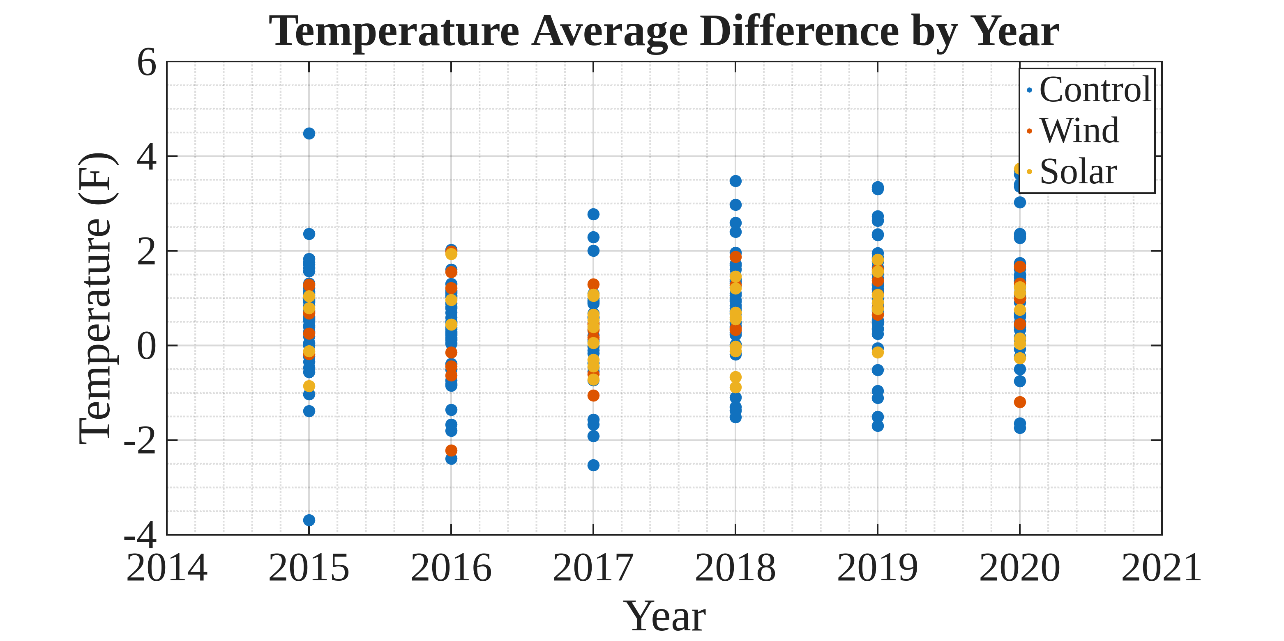Figure 6: Example Yearly Difference Trend
In summary, the results produced by this project are inconclusive due to various flaws in data analysis.
Future work would absolutely focus on collecting climate data much closer to the sites, both for sample and for control distributions. This project’s inconclusive results occur mostly from the lack of data publicly avalilable. On top of that, a before/after comparison may not be as important than simply a regional difference much like those measured in [1] and [2]. There is evidence to show that there are effects from wind and solar, however further and more focused data needs to be collected before these claims could be analyzed. Further, such data could also enable the analysis of site size to climate effects, enabling optimization models to balance the cost of site design and impact mitigation to potential generation and profit.

V. Appendix

A) Appendix A: Aggregated KCP Figures
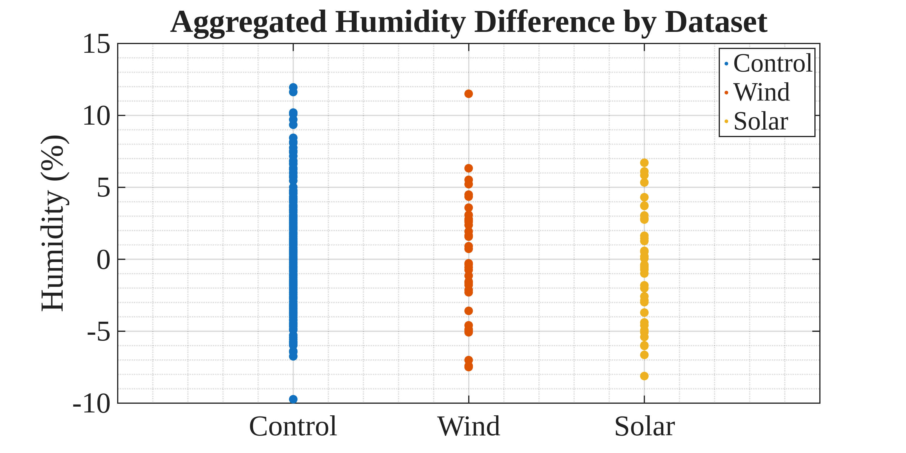Figure 7: Aggregated Humidity Data
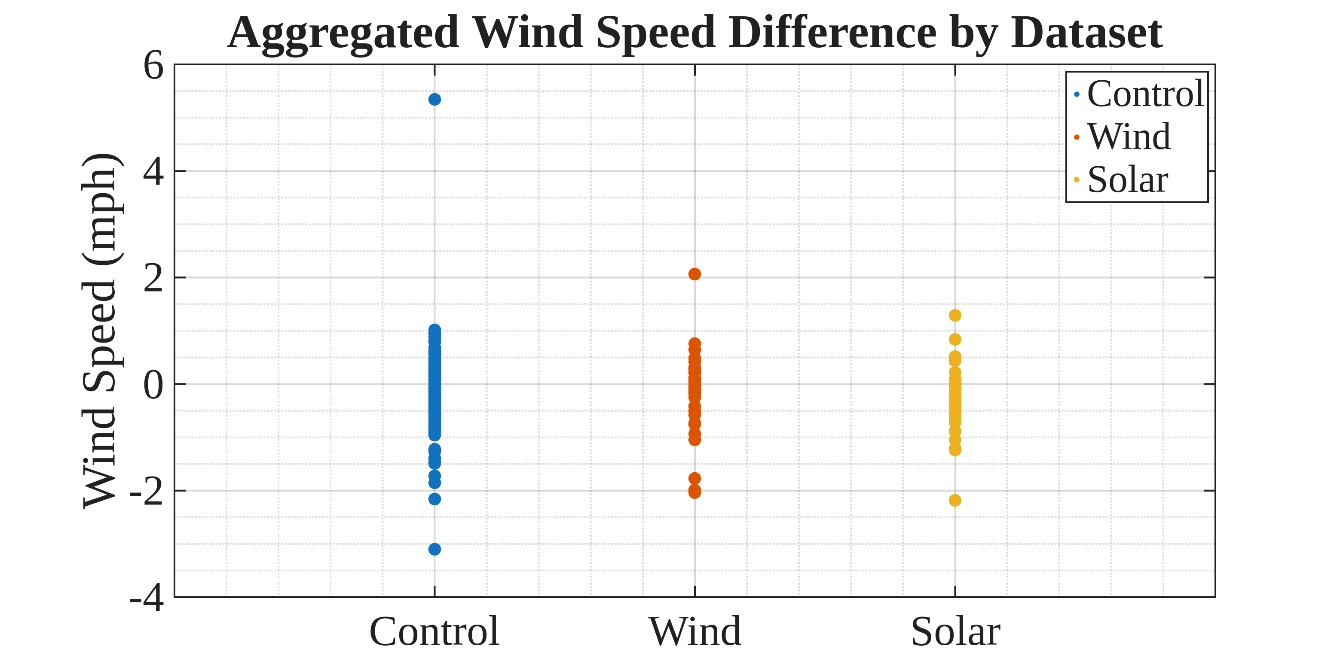Figure 8: Aggregated Wind Speed Data
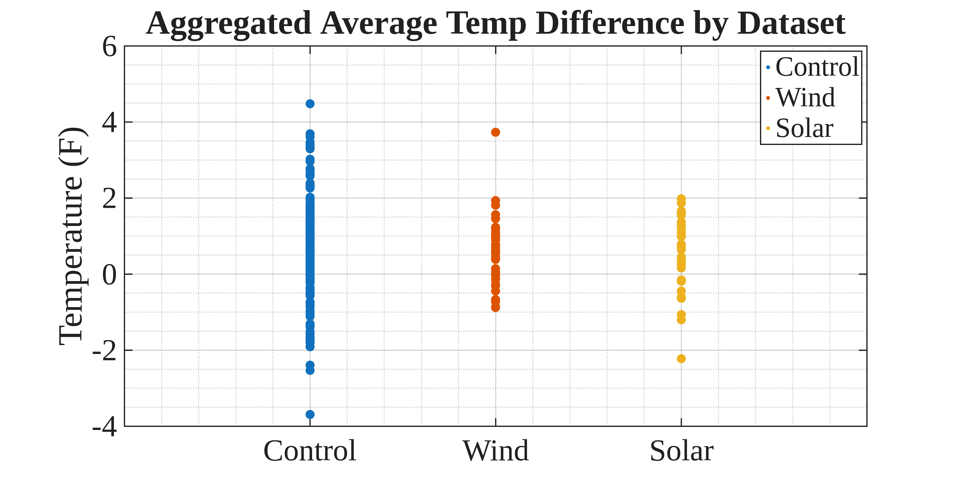Figure 9: Aggregated Average Temperature Data
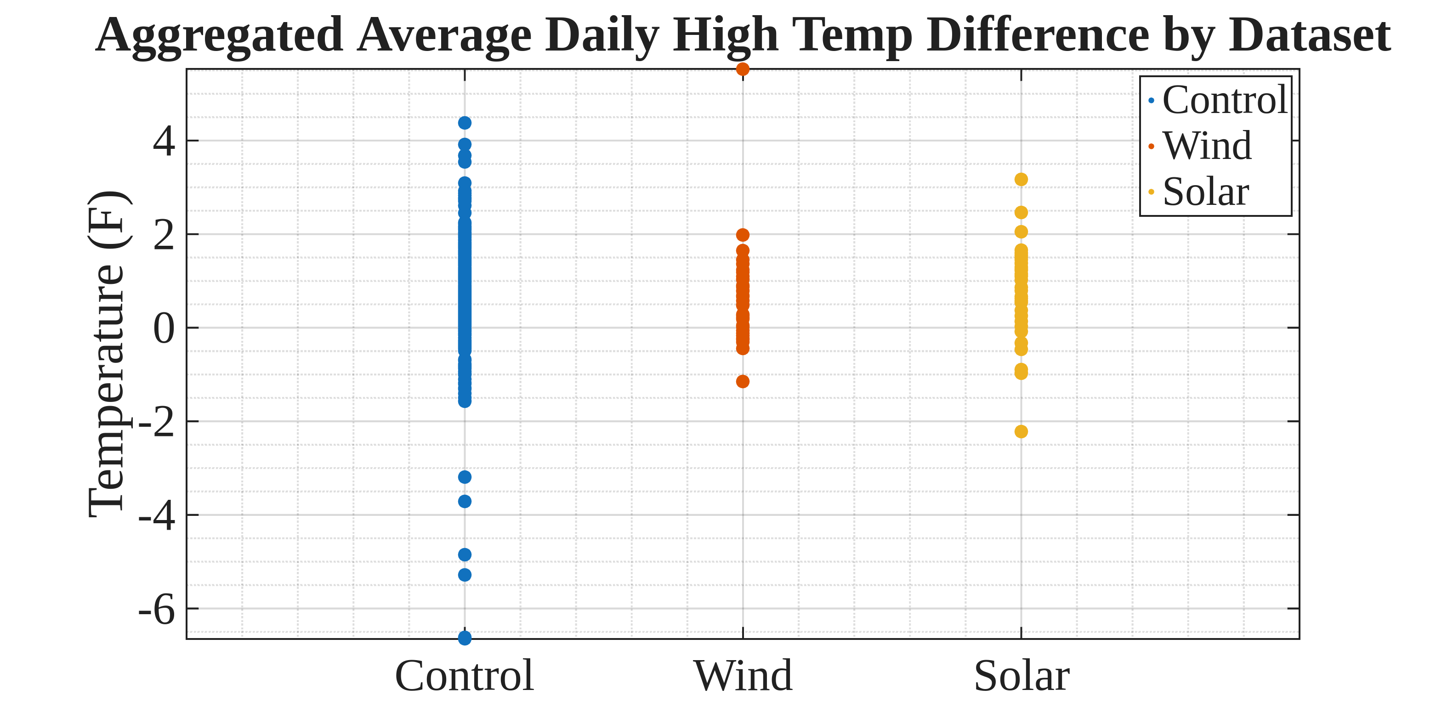Figure 10: Aggregated Average Daily High Temp Data
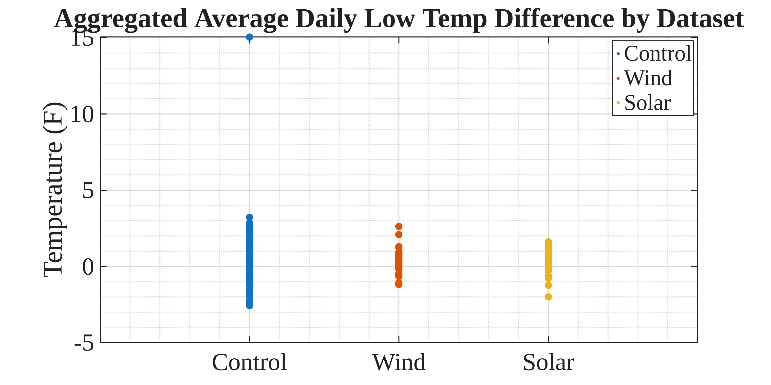Figure 11: Aggregated Average Daily Low Temp Data
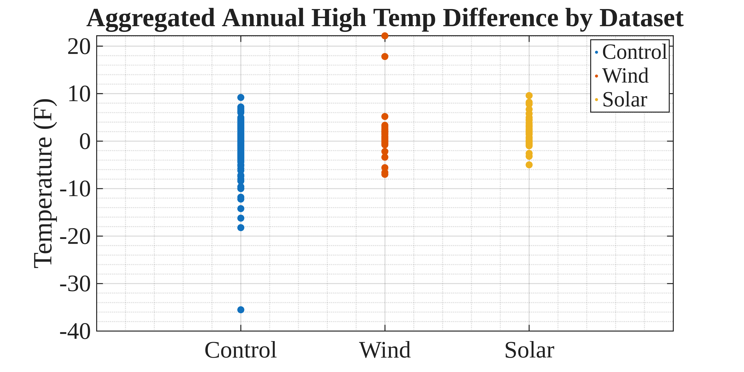Figure 12: Aggregated Yearly High Temp Data
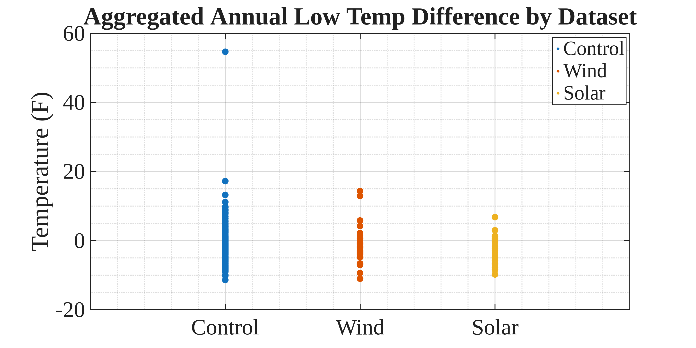Figure 13: Aggregated Yearly Low Temp Data

References
- Bahar, H., Abdelilah, Bàscones, A., Anatolitis-Pelka, V., Bockhold, M., Bojek, P., et. al, Renewables 2025, Paris, France: IEA, (2025) https://www.iea.org/reports/renewables-2025,
- Bodini, N., Lundquist, J.K. & Moriarty, P. Wind plants can impact long-term local atmospheric conditions. Sci Rep 11, 22939 (2021). https://doi.org/10.1038/s41598-021-02089-2.
- Khan, A., Anand, P., Garshasbi, S. et al. Rooftop photovoltaic solar panels warm up and cool down cities. Nat Cities 1, 780–790 (2024). https://doi.org/10.1038/s44284-024-00137-2.
- Hoen, B.D., Diffendorfer, J.E., Rand, J.T., Kramer, L.A., Garrity, C.P., and Hunt, H.E., 2018, United States Wind Turbine Database (ver. 9.0, June 2026): U.S. Geological Survey data release, https://doi.org/10.5066/F7TX3DN0.
- Fujita, K.S., Ancona, Z.H., Kramer, L.A., Straka, M., Gautreau, T.E., Garrity, C.P., Robson, D., Diffendorfer, J.E., and Hoen, B., 2023, United States Large-Scale Solar Photovoltaic Database (ver. 4.0, April 2026): U.S. Geological Survey data release, https://doi.org/10.5066/P9IA3TUS.
- Kantor, Diana; Casey, Nancy W.; Menne, Matthew J.; Buddenberg, Andrew. 2023. Local Climatological Data (LCD), Version 2. NOAA National Centers for Environmental Information. https://doi.org/10.25921/jp3d-3v19. [June 2026]
- n.d., Map of Texas Counties by Land Area. TexasCounties.net. https://www.texascounties.net/statistics/landarea.htm [June 2026]
- US EIA. Texas Analysis. (2025, August). United States - U.S. energy information administration (EIA). U.S. Energy Information Administration. https://www.eia.gov/states/TX/analysis

