Object-Oriented Programming Lecturer

**Lab 01: Environment Setup and Java Basics**

2.2.5 Write a program to calculate sum, difference, product, and quotient of 2 double numbers which are entered by users.

Notes

- To convert from String to double, you can use

double num1 = Double.parseDouble(strNum1)

- Check the divisor of the division

- Don't forget to add and commit your work using ‘git add .’ and ‘git commit -m <message>’ command

1. **Code**

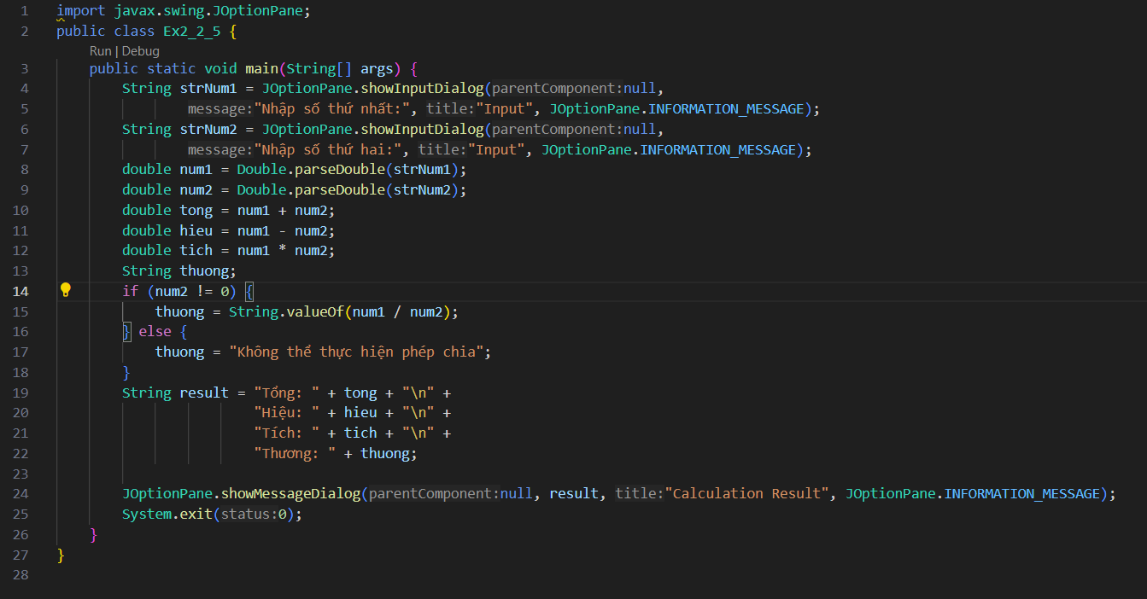

1. **Chạy chương trình**
   1. **Trường hợp số thứ hai khác 0 :**

