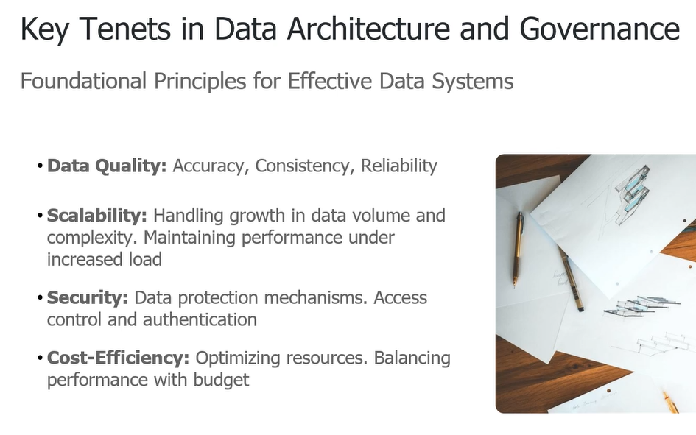

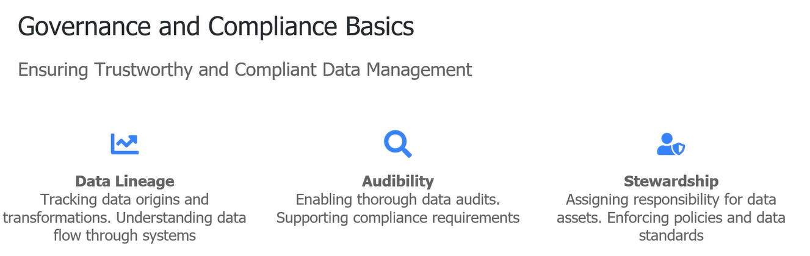

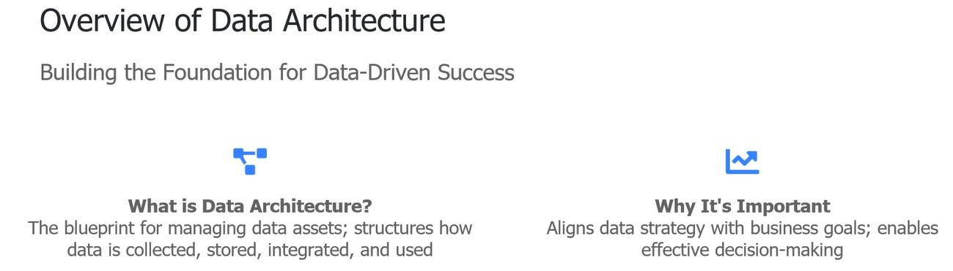

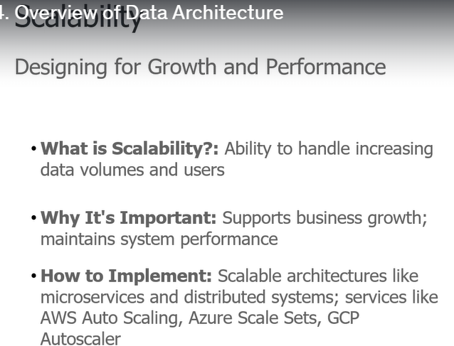

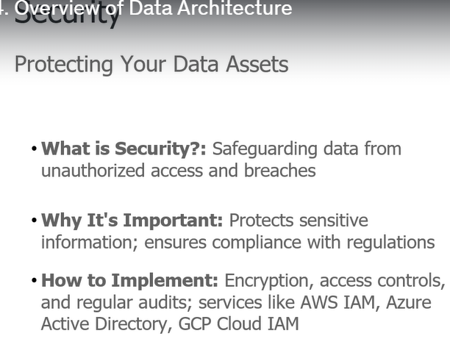

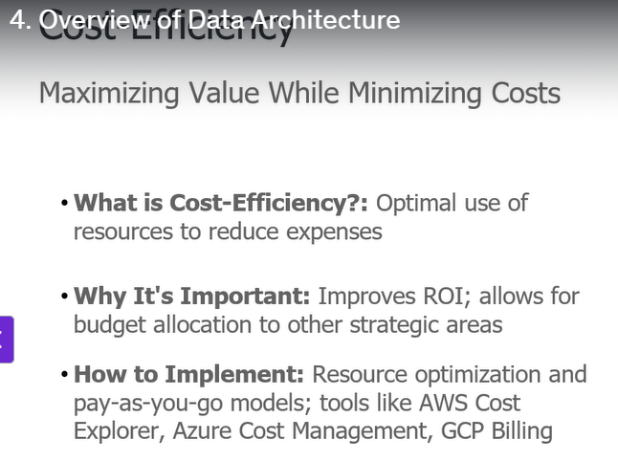

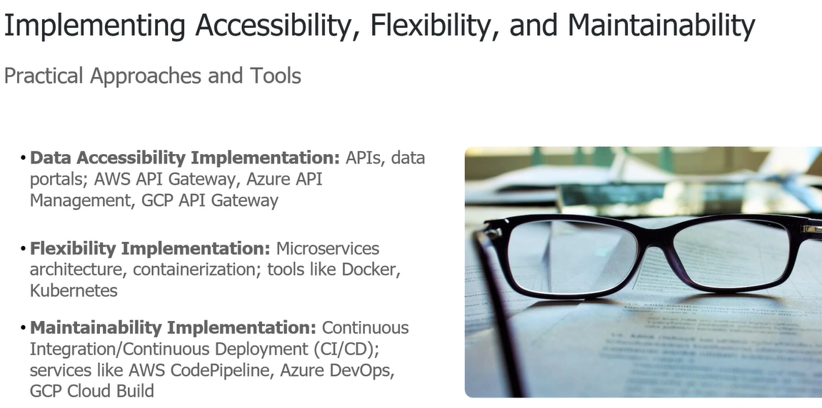

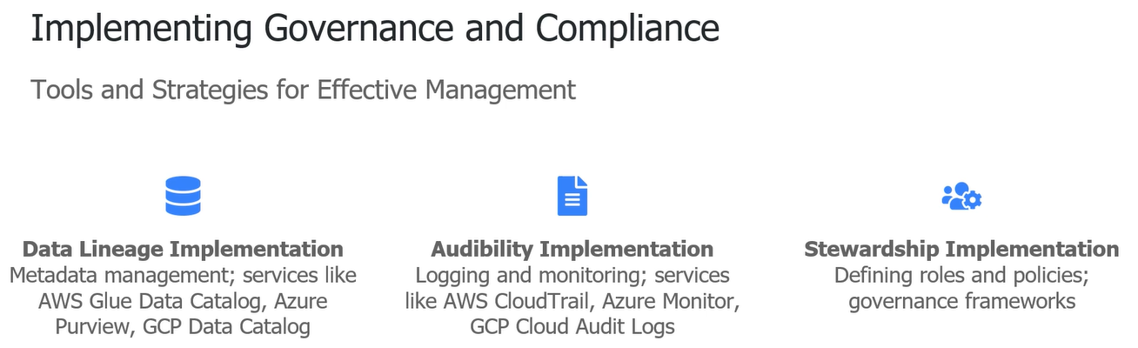

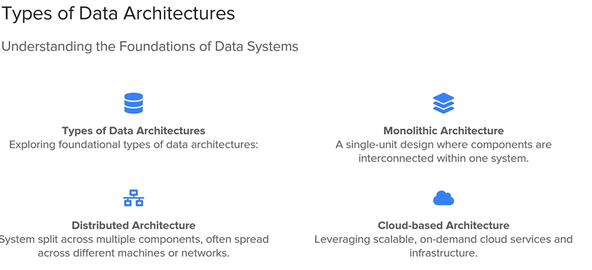

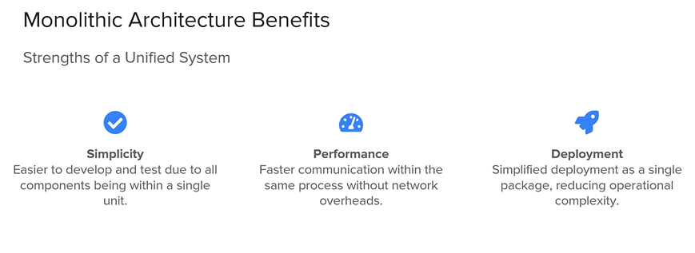

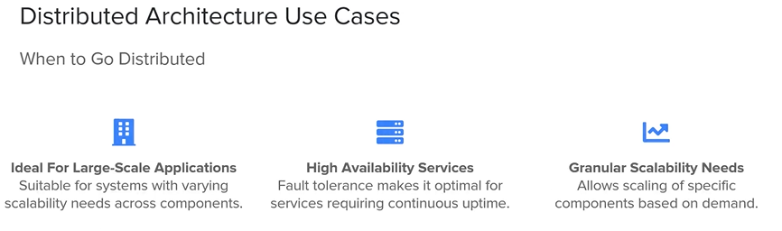

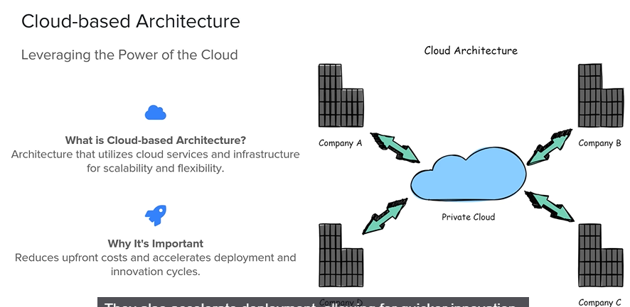

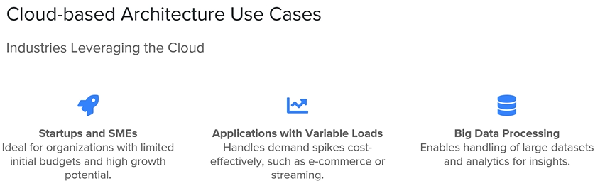

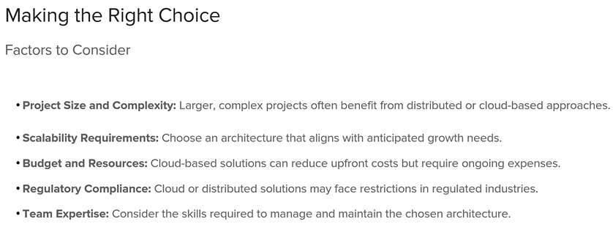

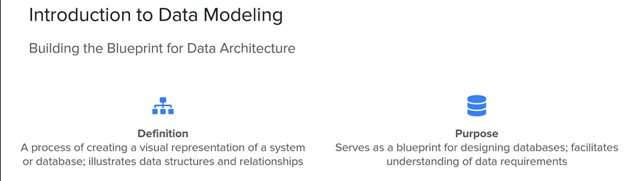

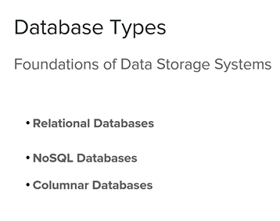

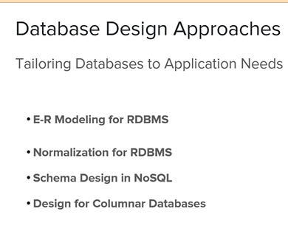

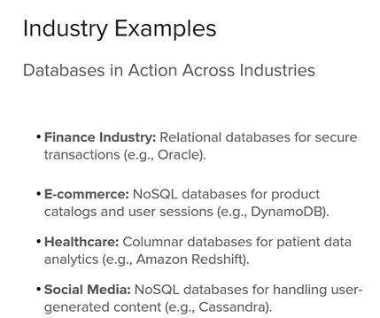

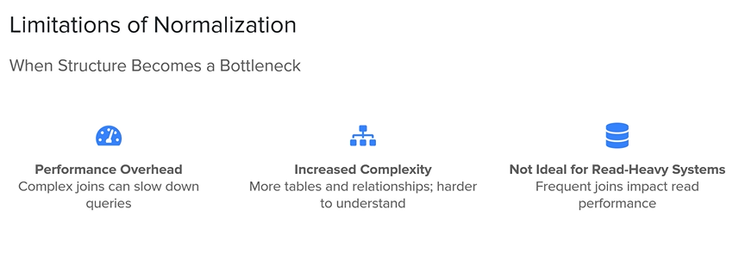

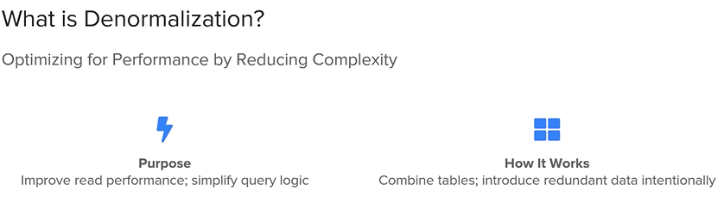

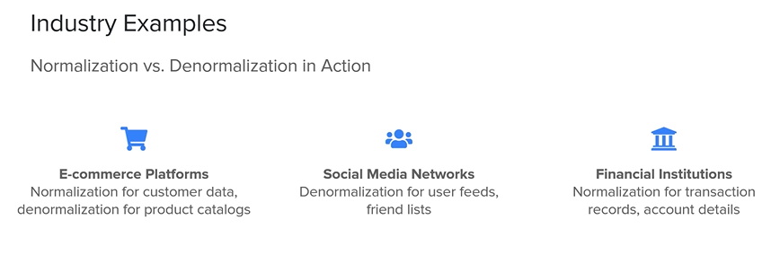

ELT VS ETL

BATCH Data processing

Real time processing

Data lakes vs data warehouse

Data mesh and data fabrics



