GENERAL DATABRICKS QUESTIONS
- What is Databricks?
  - Databricks is a cloud-based platform built on Apache Spark that provides collaborative notebooks, data engineering pipelines, ML lifecycle management, and data warehousing using Delta Lake.
Databricks Architecture: Its just platform. its just software. Databricks rely on cloud for storing and processing. So Databricks is data pane and control pane.
Data Pane: VMS+ Storage (Customer Provide account means Azure/aws etc)
Control pane : Jobs/Notebooks/Workspace/process. Cluster management
Cluster/Compute :
2 Types of cluster: Job cluster/All purpose cluster (Interactive cluster..more costly)
DBU : Data bricks unit
DBFS : Data bricks file system. Abstraction for storage . it is Blob Strogage.
- What are the advantages of using Databricks?
  - Unified analytics platform
  - Delta Lake for ACID transactions
  - Auto-scaling and managed clusters
  - Built-in ML and data science tools
  - Integration with major cloud providers (Azure, AWS, GCP)
- What is a workspace in Databricks?
  - A workspace is a collaborative environment for accessing notebooks, libraries, jobs, and data within Databricks.

🔹 DATABRICKS DATA ENGINEERING
- What is a Delta Lake?
  - Delta Lake is a storage layer that brings ACID transactions, schema enforcement, and time travel to big data workloads.
- What are the main features of Delta Lake?
  - ACID compliance
  - Time travel (using VERSION AS OF)
  - Schema evolution and enforcement
  - Support for upserts/merges
- How do you perform SCD Type 2 in Delta Lake?
  - Use MERGE INTO with conditions and maintain current/active flags or effective date ranges for history tracking.
- What is Auto Loader?
  - Auto Loader is a Databricks utility for incrementally ingesting data from cloud storage (e.g., ADLS, S3) using file metadata logs.
- How do you handle schema evolution in Auto Loader?
  - Use cloudFiles.schemaEvolutionMode = addNewColumns to auto-detect new fields.

🔹 DATABRICKS JOBS AND PIPELINES
- What is a Databricks Job?
  - A job is a way to run a notebook, script, or JAR file on a schedule or in response to events.
- What is a Delta Live Table (DLT)?
  - DLT is a framework to build reliable, automated, and declarative data pipelines on Delta Lake using SQL or Python.
- Difference between Streaming and Materialized Views in DLT?
  - STREAMING LIVE TABLE: Ingests data continuously
  - LIVE TABLE: For batch or slowly-changing datasets
- What is Medallion Architecture in Databricks?
  - A layered architecture:
    - Bronze (raw ingestion),
    - Silver (cleansed data),
    - Gold (aggregated business logic)

🔹 DATABRICKS SQL & OPTIMIZATION
- How to improve performance of Databricks SQL queries?
  - Use Delta Lake
  - Optimize with Z-Ordering and file compaction (OPTIMIZE)
  - Use caching
  - Partition pruning
- What is Z-Ordering in Databricks?
  - It co-locates related information in the same set of files to improve query performance using multi-dimensional clustering.
OPTIMIZE sales_data
ZORDER BY (customer_id);
- How does Delta Lake ensure data reliability?
  - By using Write-Ahead Logs (WALs), transaction logs, and checkpointing for ACID guarantees.

🔹 INTEGRATION & SECURITY
- How do you connect ADF with Databricks?
  - Use Databricks Notebook activity in ADF pipelines and provide a linked service to the Databricks workspace.
- How is authentication handled in Databricks?
  - Supports Azure Active Directory (AAD), personal access tokens, and OAuth for secure access.
- What is Unity Catalog?
  - Unity Catalog provides centralized governance for all data assets in Databricks using fine-grained access control at catalog, schema, and table levels.

🔹 ML & ADVANCED
- How does MLflow integrate with Databricks?
  - MLflow is natively supported for tracking experiments, model training, and deployment.
- Can Databricks support real-time streaming?
  - Yes, using Structured Streaming and Auto Loader for near real-time data pipelines.

🔹 SCENARIO-BASED QUESTIONS
- You notice multiple users are running slow queries on a SQL endpoint. What would you do?
  - Scale up the endpoint
  - Use Serverless SQL
  - Enable query caching and optimize tables
- How would you implement CDC in Databricks?
  - Using Delta Lake merge operations and record change tracking (using timestamps or watermark logic)
- How would you automate your pipelines?
  - Use Jobs, Delta Live Tables, or integrate with orchestration tools like Azure Data Factory or Airflow

bricks Data Engineer Questions
1. What is the difference between Delta Lake and traditional Parquet format?
Answer:
Delta Lake adds ACID transactions, schema enforcement, time travel, and versioning to Parquet, enabling reliable and consistent data pipelines.
2. How do you implement Slowly Changing Dimensions (SCD) Type 2 in Databricks?
Answer:
Using Delta Lake MERGE and the APPLY CHANGES INTO with LIVE TABLE in Delta Live Tables. We maintain historical versions by checking for changes and inserting new rows with updated timestamps and version numbers.
3. What are the benefits of using Delta Live Tables?
Answer:
- Declarative ETL pipelines
- Auto-managed data quality checks
- Dependency management
- Simplified CDC & SCD implementation
- Performance optimization using incremental updates

🔧 Databricks Admin Questions
1. How do you manage workspace permissions in Databricks?
Answer:
Using access control lists (ACLs) for clusters, jobs, notebooks, and DBFS. You can use Unity Catalog for centralized data governance and fine-grained access control.
2. How do you monitor and optimize cluster usage?
Answer:
- Use Ganglia metrics and Spark UI
- Enable autoscaling and spot instances
- Monitor with Databricks' built-in metrics or Azure Monitor integration
- Set cluster policies to control costs
3. What are the different types of clusters in Databricks?
Answer:
- Interactive clusters: for notebooks and ad-hoc queries
- Job clusters: auto-terminated after job completion
- SQL warehouses (endpoints): optimized for BI and SQL queries
- Serverless SQL: automatically managed by Databricks (no cluster startup lag)

🏗️ Databricks Architect Questions
1. How would you design a medallion architecture using Delta Lake?
Answer:
- Bronze Layer: Raw ingestion (e.g., streaming or batch data)
- Silver Layer: Cleansed and transformed data (e.g., joins, filters)
- Gold Layer: Aggregated business-level tables (KPIs, dashboards)
Each layer is stored in Delta format with ACID guarantees and schema enforcement.
2. How do you integrate Databricks with Azure services?
Answer:
- Azure Data Factory for orchestration
- Azure Event Hubs for real-time ingestion
- Azure Data Lake Gen2 for storage
- Azure Synapse or Power BI for consumption
- Azure Key Vault for secrets
3. How do you ensure data quality and reliability in Databricks pipelines?
Answer:
- Use Delta Live Table expectations for validations
- Implement retries and error handling
- Use checkpointing in streaming
- Monitor with alerting (Azure Monitor or Databricks jobs API)

GENERAL DATABRICKS QUESTIONS
- What is Databricks?
  - Databricks is a unified data analytics platform built on Apache Spark. It supports collaborative data engineering, ML, and analytics using notebooks, jobs, and data pipelines.
- What is a Databricks cluster?
  - A set of computation resources used to run notebooks, jobs, and applications.
- Difference between Standard and High Concurrency Clusters?
  - Standard: Good for complex ETL.
  - High Concurrency: Optimized for concurrent SQL and data science workloads.
- What is a Databricks Workspace?
  - User interface to access notebooks, jobs, libraries, and clusters.
- Explain Databricks Runtime (DBR).
  - A versioned Spark runtime optimized by Databricks. Includes Apache Spark + libraries.

🔹 DATA ENGINEER ROLE
- What is Delta Lake?
  - Open-source storage layer for ACID transactions and schema enforcement on data lakes.
- What are Delta Live Tables (DLT)?
  - Managed ETL pipelines with quality enforcement, CDC support, and declarative syntax.
- How do you implement SCD2 in Databricks?
  - Use MERGE and Delta Lake’s time travel. Delta Live Tables supports APPLY CHANGES.
- How do you optimize Delta Lake performance?
  - Use ZORDER, OPTIMIZE, and vacuum old files.
- What is the difference between MERGE INTO and INSERT OVERWRITE?
  - MERGE INTO: UPSERT logic.
  - INSERT OVERWRITE: Replaces data in target table.
- When to use Auto Loader in Databricks?
  - For streaming ingestion of files from cloud storage.
- How to manage schema drift in streaming pipelines?
  - Enable schema evolution in Auto Loader or Delta Live Tables.
- Explain CDC implementation with DLT.
  - Use APPLY CHANGES in DLT to track and apply inserts/updates/deletes.
- What are Unity Catalog benefits?
  - Centralized governance for access control, auditing, and lineage across workspaces.
- What is a medallion architecture?
  - Bronze: Raw data → Silver: Cleaned/enriched → Gold: Business level aggregations.

🔹 ADMINISTRATOR ROLE
- What is cluster autoscaling?
  - Automatically adjusts number of workers to optimize cost and performance.
- What is the use of cluster policies?
  - To enforce governance (e.g., instance types, auto termination).
- What is access mode in clusters?
  - Single User, Shared, No Isolation (Legacy).
- How to monitor job performance?
  - Use Spark UI, Ganglia metrics, and job logs.
- What is DBFS (Databricks File System)?
  - A distributed file system interface on top of object storage (e.g., S3, ADLS).
- How is access control managed in Databricks?
  - Through workspace ACLs, Unity Catalog, and cluster policies.
- What are the types of notebooks supported?
  - Python, SQL, Scala, R.
- How to secure secrets?
  - Use Databricks Secrets or integrate with Azure Key Vault.
- What is a job cluster?
  - Ephemeral cluster created for the duration of a job.
- How do you handle data exfiltration risks?
  - Use IP Access Lists, SCIM integration, and Unity Catalog row/column security.

🔹 ARCHITECT ROLE
- How do you design a real-time ingestion pipeline?
  - Use Auto Loader or Kafka → Bronze Delta → Transform to Silver → Gold tables.
- How does Unity Catalog support data governance?
  - Provides centralized cataloging, fine-grained access, and audit logs.
- What is the best storage design for large-scale ingestion?
  - Partitioned Delta tables with ZORDER on frequently queried columns.
- What is the preferred way to ingest structured batch data?
  - Use COPY INTO or Auto Loader with trigger once.
- How can Databricks integrate with Azure Data Factory?
  - Use ADF’s Databricks activity to trigger notebooks/jobs.
- What is a good monitoring strategy for pipelines?
  - Use alerts, MLflow metrics, and integration with tools like Azure Monitor.
- How do you architect multi-region or multi-workspace solutions?
  - Use Unity Catalog with external location mapping and standard naming conventions.
- How do you secure PII data in Databricks?
  - Masking, Unity Catalog, and encryption at rest and in transit.
- How do you track data lineage in Databricks?
  - Unity Catalog provides automatic lineage. Use MLflow for experiment tracking.
- How to handle schema evolution?
  - Enable mergeSchema and use schema enforcement in Delta Lake.

🔹 PRACTICAL/SCENARIO QUESTIONS
- Scenario: Queries are slow on Delta table.
- Solution: OPTIMIZE + ZORDER + Cache + Cluster tuning.
- Scenario: Need to orchestrate a multi-step ETL.
- Solution: Use Databricks Jobs with task dependencies or Azure Data Factory.
- Scenario: Business wants CDC with audit trail.
- Solution: Use Delta Lake + MERGE + _change_type column + version history.
- Scenario: Ingest high-volume IoT data.
- Solution: Streaming pipeline using Auto Loader or Kafka.
- Scenario: Cost reduction request.
- Solution: Enable auto termination, use spot instances, compact small files.
- Scenario: GDPR/Compliance audit.
- Solution: Unity Catalog + ACLs + Logging.
- Scenario: Need to load CSV with nested JSON column.
- Solution: Use from_json() and define schema explicitly.
- Scenario: Cluster fails often.
- Solution: Review driver node size, check logs, increase retry count.
- Scenario: Data team needs versioned datasets.
- Solution: Use Delta Lake with DESCRIBE HISTORY.
- Scenario: Dev, Test, Prod segregation.
- Solution: Use separate workspaces or catalogs.

Project: Customer 360 DLT Pipeline using Databricks SQL (SCD1 & SCD2)

🏗️ Medallion Architecture Overview:
java
CopyEdit
1️⃣ Bronze Layer → 2️⃣ Silver Layer → 3️⃣ Gold Layer (SCD1 and SCD2 outputs)

1️⃣ Bronze Layer – Raw Ingestion
sql
CopyEdit
CREATE OR REFRESH LIVE TABLE bronze_customers
COMMENT "Raw customer data ingested from external location"
AS
SELECT
*
FROM
cloud_files("dbfs:/mnt/raw/customers/", "csv");

2️⃣ Silver Layer – Cleaned and Filtered Data
sql
CopyEdit
CREATE OR REFRESH LIVE TABLE silver_customers
COMMENT "Cleaned customer data with required fields"
AS
SELECT
customer_id,
first_name,
last_name,
email,
address,
updated_at
FROM
LIVE.bronze_customers
WHERE
email IS NOT NULL;

3️⃣ Gold Layer – SCD Type 1 (Overwrite Current Record)
sql
CopyEdit
CREATE OR REFRESH LIVE TABLE gold_customers_scd1
COMMENT "SCD Type 1 - Keeps only current customer record"
AS
SELECT
*
FROM (
SELECT *,
ROW_NUMBER() OVER (PARTITION BY customer_id ORDER BY updated_at DESC) as rn
FROM LIVE.silver_customers
)
WHERE rn = 1;

4️⃣ Gold Layer – SCD Type 2 (Maintain History)
sql
CopyEdit
CREATE LIVE TABLE gold_customers_scd2
COMMENT "SCD Type 2 - Maintains full customer history"
TBLPROPERTIES ("quality" = "gold")
AS
MERGE INTO gold_customers_scd2 AS target
USING (
SELECT *,
current_timestamp() AS effective_date,
NULL AS expiry_date,
TRUE AS is_current
FROM LIVE.silver_customers
) AS source
ON target.customer_id = source.customer_id
AND target.is_current = TRUE
AND (
target.email <> source.email OR
target.address <> source.address
)
WHEN MATCHED THEN
UPDATE SET
target.is_current = FALSE,
target.expiry_date = current_timestamp()
WHEN NOT MATCHED THEN
INSERT *;

Gold Table – SCD Type 1 (Latest Snapshot using APPLY CHANGES INTO)
sql
CopyEdit
CREATE OR REFRESH LIVE TABLE gold_customers_scd1
COMMENT "Real-time SCD Type 1 using APPLY CHANGES INTO"
TBLPROPERTIES ("quality" = "gold")
AS
APPLY CHANGES INTO live.gold_customers_scd1
FROM stream(live.silver_customers_clean)
KEYS (customer_id)
SEQUENCE BY updated_at
COLUMNS * EXCEPT (operation)
STORED AS SCD TYPE 1;

4️⃣ Gold Table – SCD Type 2 (Historical Tracking using APPLY CHANGES INTO)
sql
CopyEdit
CREATE OR REFRESH LIVE TABLE gold_customers_scd2
COMMENT "Real-time SCD Type 2 using APPLY CHANGES INTO"
TBLPROPERTIES ("quality" = "gold")
AS
APPLY CHANGES INTO live.gold_customers_scd2
FROM stream(live.silver_customers_clean)
KEYS (customer_id)
SEQUENCE BY updated_at
COLUMNS * EXCEPT (operation)
STORED AS SCD TYPE 2;

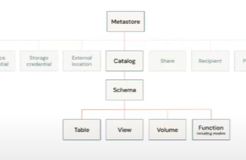

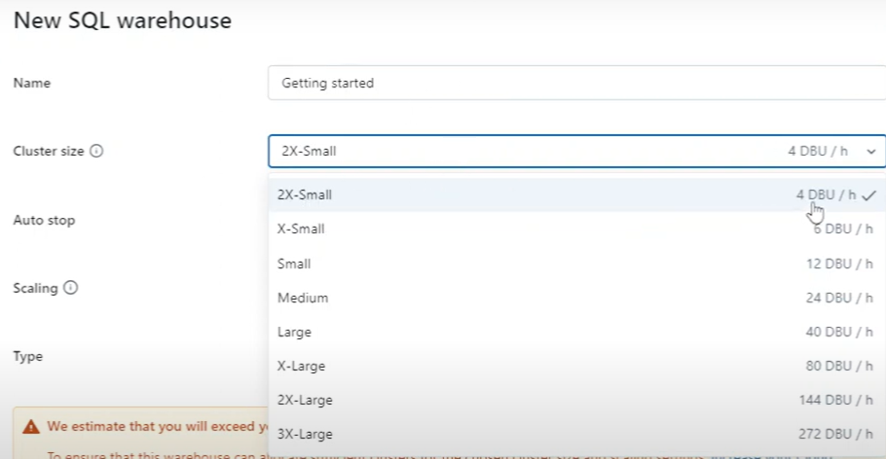

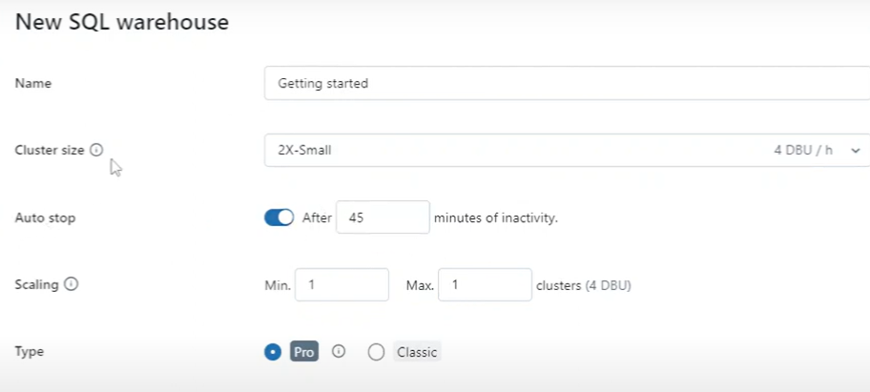

Databricks vs synapse differences:

Schema evolution refers to the ability to change the structure (schema) of a database or data file over time without breaking existing data pipelines, queries, or application
df.write.format("delta") \
.option("mergeSchema", "true") \
.mode("append") \
.save("/delta/events")

Running Parallel jobs :
Create a Databricks Workflow (Job)
- Go to Workflows → Create Job
- Add 3 tasks:
  - Task 1: orders_transform (notebook 1)
  - Task 2: customers_transform (notebook 2)
  - Task 3: products_transform (notebook 3)
- Set no dependencies among the 3 → they run in parallel

