|  |  |  |  |
| --- | --- | --- | --- |
| **Feature** | **Azure SQL Database** | **Azure SQL Managed Instance** | **SQL Server in Azure VM** |
| **Type** | PaaS (Platform as a Service) | PaaS (near full SQL Server compatibility) | IaaS (Infrastructure as a Service) |
| **Use Case** | Modern apps, SaaS, cloud-native | Migration from on-prem SQL with minimal changes | Legacy apps, full OS/SQL control |
| **Admin Overhead** | Low (Microsoft handles patching, backups) | Moderate (most managed by Microsoft) | High (you manage OS, SQL updates, backups) |
| **SQL Server Features** | Most commonly used features only | **Near 100%** compatibility with on-prem SQL Server | Full SQL Server features |
| **OS-Level Access** | ❌ No | ❌ No | ✅ Yes (full Windows/Linux control) |
| **Custom SQL Agent Jobs** | Limited (elastic jobs or automation only) | ✅ Supported | ✅ Supported |
| **Linked Servers / SSIS / CLR** | ❌ Limited or unsupported | ✅ Mostly supported | ✅ Fully supported |
| **Scaling** | Elastic pools, serverless, hyperscale | Instance-level scaling | Manual scaling |
| **High Availability** | Built-in, auto failover | Built-in, zone-redundant options | You configure it (Always On, FCI, etc.) |
| **Backups** | Automated (7-35 days retention) | Automated (7-35 days) | Manual or script-based |
| **Licensing** | Included | Included | BYOL or pay-as-you-go |

Max Storage by Service Tier in SQL Managed Instance

|  |  |  |
| --- | --- | --- |
| **Service Tier** | **Max Size per Database** | **Max Total Instance Storage** |
| **General Purpose** | **16 TB** | Up to **16 TB** |
| **Business Critical** | **16 TB** | Up to **16 TB** |

Service Tier : Business Critical/General Purpose/Next Generation

Instance : 128 Vcores

Disater Recovery : Geo Secondary Replication instance/Pirmary instance

Azure SQL DB :

|  |  |  |
| --- | --- | --- |
| **Service Tier** | **Maximum Database Size** | **Notes** |
| **General Purpose** | **4 TB** | Standard for most workloads |
| **Business Critical** | **4 TB** | Higher IOPS and availability |
| **Hyperscale** | **100 TB** (theoretical limit) | Auto-scales storage on demand |
| **Elastic Pool** | Up to **4 TB per database** | Shared resources among multiple DBs |

PostGres :

|  |  |  |
| --- | --- | --- |
| **Deployment Option** | **Max Storage** | **Notes** |
| **Single Server** (retiring by 2025) | **16 TB** | Limited flexibility and performance |
| **Flexible Server** (recommended) | **16 TB** | Most current and preferred option |
| **Hyperscale (Citus)** | **Unlimited (scales out across nodes)** | Best for multi-tenant, sharded, or high-ingest workloads |

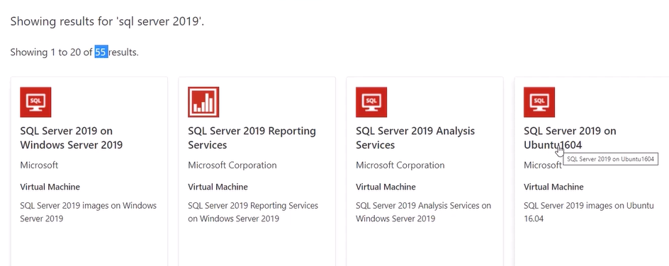

BYOL –Bring your own licence

Computer Tier : Provisioned : Computer resource pre allocation. Billed per hour

Serverless : Computer based on autosclaed. Billed per seconds based on Vcores used.

Vcores/DTU Based

<https://github.com/MicrosoftLearning/dp-300-database-administrator/blob/master/Instructions/Labs/02-provision-sql-database.md>



