**WIREGUARD + GUI + Duckdns:**

**Installation:**

1. Install Docker and Docker compose https://docs.docker.com/
2. You need sign in <https://www.duckdns.org/domains> and register a sub domain
3. Open the port in your router by default it is 51820 but you can change it
4. Create the folder “wireguard” in / inside create the docker-compose.yml
5. The Web UI will now be available on http://ServerIp:51821

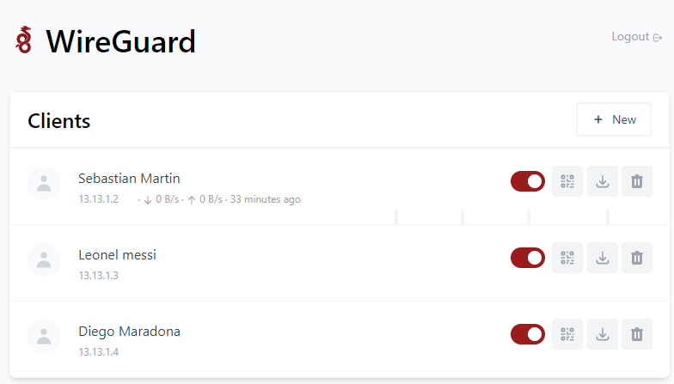

**Sources:**

* <https://github.com/WeeJeWel/wg-easy>
* <https://hub.docker.com/r/weejewel/wg-easy>

**Features:**

* All-in-one: WireGuard + Web UI + Duckdns.
* Easy installation, simple to use.
* List, create, edit, delete, enable & disable clients.
* Show a client's QR code.
* Download a client's configuration file.
* Statistics for which clients are connected.
* Tx/Rx charts for each connected client.

**Options:**

