Methods:

Site description

The study was conducted at the Fernow Experimental Forest (herein Fernow), situated in the north-central Appalachian Mountain range within Tucker County, WV, USA (39.03°N, 79.67°W). The Fernow is a mixed-mesophytic forest comprised of a variety of experimental watersheds undergoing long-term silvicultural treatments (Madarish et al., 2002). The average elevation of the Fernow is 760 m and predominantly features soils of the Calvin series. Classified as Typic Hapludalfs, Calvin series soils exhibit a well-drained, silt loam texture and moderate to high fertility (NRCS Soil Survey 2002; Adams et al., 2012). The mean annual precipitation at the Fernow is 1458 mm and the mean annual temperature is 9.3°C with a growing season that lasts from May to October (Adams et al., 2012; Young et al., 2019).
Experimental watersheds
At the Fernow, we focused on three experimental watersheds that underwent different harvesting practices: (1) one which has been managed by diameter limit harvesting (watershed 2), (2) another which has been managed by single tree selection (watershed 5), and (3) a third one which has been uncut since the early 1900s and can thus serve as our reference (watershed 4). All three watersheds, as detailed by Adams and Kochenderfer (2015), underwent initial logging and between 1907 and 1915, preceding federal ownership establishment. Since 1934, the Fernow has been designated to showcase various levels of forest management practices. For both of the managed watersheds, the first harvest occurred from 1957 to 1958, followed by subsequent treatments applied according to their respective harvesting rotations (Adams et al., 2012). The watershed that has been managed by diameter limit harvesting (approximately 15 hectares) underwent seven harvests of trees with diameters equal to or exceeding 17 inches between 1958 and 2020. Currently, the dominant trees species in this watershed are American Beech (Fagus grandifolia), Red Maple (Acer rubrum), Sugar Maple (Acer saccharum), Fraser Magnolia (Magnolia fraseri), and Sweet Birch (Betula lenta). Similarly, the watershed that has been managed by single tree selection harvesting (approximately 35 hectares) experienced eight harvests of sawlog-size trees with diameters equal to or exceeding 11 inches, on a ten-year cutting cycle between 1958 and 2013. Currently, the dominant tree species in this watershed are American Beech (Fagus grandifolia), Sweet Birch (Betula lenta), Sugar Maple (Acer saccharum), Tulip Tree (Liriodendron tulipifera), and Striped Maple (Acer pensylvanicum). Finally, the reference watershed is dominated by Sugar Maple (Acer saccharum), Red Maple (Acer rubrum), American Beech (Fagus grandifolia), Striped Maple (Acer pensylvanicum), and Northern Red Oak (Quercus rubra). This watershed, which is adjacent to the watershed managed by single tree selection harvesting, serves as a reference to the harvested watersheds due to the lack of harvest since the early 1900s as well as its similar site conditions and pre-treatment site disturbance history to the managed watersheds (Schuler et al., 2017).
Soil sampling
To measure the effects of long-term silviculture treatments on forest SOM stocks and fractions, we conducted an intensive soil sampling campaign in July of 2022. We collected samples at six previously established plots inside the diameter limit harvested watershed and the reference watershed. In the watershed managed by single tree selection harvesting, we sampled five previously established plots and a sixth plot we randomly established in 2022. We divided each of the six plots into three sub-plots where we collected three samples from three different depths: (1) organic horizon, (2) 0 to 20 cm, and (3) 20 to 40 cm. For the organic horizon, we removed the freshly fallen litter and sampled the organic horizon in a 20 cm by 20 cm area. Directly below where we sampled the organic horizon, we used a slide hammer with a 5 cm diameter by 20 cm depth core to sample mineral soils at 0 to 20 cm and 20 to 40 cm. In total, 162 soil samples were collected from a combination of three experimental watersheds, six growth plots, three subplots, and three depths.
While long-term study sites like the Fernow Experimental Forest provide a valuable opportunity to evaluate the effects of forest management over extended timescales, they also reflect evolving experimental designs. For example, In the 1970s, sub–compartments were added within WS2-DLC and WS5-STS to apply the same harvesting method at different cutting intervals. Specifically, one subplot in WS2-DLC follows a 20-year harvest rotation, while one subplot in WS5-STS follows a 10-year rotation. In our sampling, only 9 of the 54 soil samples collected per watershed came from these rotation-specific subplots. Because this small number of samples is consistent across both managed watersheds, any potential bias introduced by different harvest intervals is likely minimal and does not affect overall comparisons between these watersheds.
Soil analysis
For the analysis of soil samples, we sieved the soil to remove rocks and fine roots (roots with a diameter < 3 mm). For organic horizon samples, we used an 8 mm sieve. For mineral soils, we used a 2 mm sieve. After removing the fine roots from the soil, each root sample was washed to remove soil particles, dried at 60 °C, and weighed. For the soils, subsamples of all soils were analyzed for C and N content. All % C and % N analyses on the soil were performed at the Central Appalachian Stable Isotope Facility (CASIF) on a Carlo Erba NC2500 Elemental Analyzer in Frostburg, MD, USA.
For the 0 to 20 cm and 20 to 40 cm mineral soil samples, we calculated bulk density for one core from a randomly chosen subplot from each plot. To determine bulk density, we used a displacement method to determine the volume of rocks in the core, followed by calculating the volume of soil, excluding rocks and roots. This process involved subtracting the volume of rocks from the total volume of the soil core, yielding the volume of soil. Finally, we calculated bulk density by dividing the soil mass by the volume of soil in the core. These calculations can be expressed as follows:

To calculate the total C and N in the soil on a g per m² basis, we used the bulk density to calculate the total soil in the 0 to 20 cm or 20 to 40 cm depth. We then calculated total C (g·m⁻²) or N (g·m⁻²) by multiplying the bulk density by the % C and % N from the elemental analyzer. For the organic horizon, we first converted the mass of the organic horizon in the 20 cm by 20 cm sample to a one m² basis. Then, we multiplied the % C and % N of each sample by the mass of the organic horizon in one m².
Soil density fractionation procedure
Prior to conducting the density fractionation procedure, we pooled mineral soil samples for each plot by combining a subsample of the 0 to 20 cm or the 20 to 40 cm for each of the three subplots. It was necessary to pool the samples given time and logistical constraints of performing soil fractionations. This pooling resulted in six 0 to 20 cm samples and six 20 to 40 cm samples for each watershed. For a given sample from a plot, 5 g (± 0.5 g) of soil from each subplot was mixed together and vortexed to ensure proper homogenization of the soil sample.
To determine whether long-term management practices alter the distribution of SOM fractions, we followed a three-pool soil density fractionation protocol outlined by Lavallee et al., (2020). In short, SOM was separated into three pools based on their density, which is thought to represent the degree of organic C vulnerability (Gregorich et al., 2006). The POM fraction was separated into light and heavy POM, firstly 5.5 to 6.0 g of dry soil samples were shaken for 15 minutes in DI water at ~ 100 oscillations per minute. Next, they were centrifuged at 3600 rpm for 15 minutes and then the supernatant was filtered through a 20 µm nylon filter to catch the light POM referred to as the light fraction. The remaining light POM was then isolated by shaking the soil sample in sodium polytungstate (SPT) at a density of 1.85 g·cm⁻³ for no less than 18 hours to diffuse soil macroaggregates. Once the macroaggregates were separated samples were centrifuged at 3600 rpm for 30 minutes, allowing for the remaining light POM to float on top of the dense SPT, which was then aspirated onto a 20 µm nylon filter and thoroughly rinsed.
The remaining heavy POM, while still chemically plant-like, contains some mineral association or microbial byproducts that increase its density and may protect the SOM in soil aggregates. Therefore, the centrifuged soil pellets containing heavy fractions (1.85 g·cm⁻³ density) were thoroughly rinsed and centrifuged with DI water at least three times to remove excess SPT. The heavy POM and MAOM that remained in the soil pellet were separated by size, suspending the pellet in DI water and wet sieving through a 53 µm sieve. The material remaining on the sieve was considered the heavy POM and sand (> 1.85 g·cm⁻³ density and > 53 µm in size), while the material that passed through the sieve was considered MAOM, silt and clay fraction (< 53 µm).
All soil fractions were then air dried in a drying oven for 16 hours at 65 °C, and then weighed to determine fraction mass. We then used these masses to calculate the percentage of each soil sample that was composed of light POM, heavy POM, and MAOM by dividing the mass of a given fraction by the total soil mass fractionated. After fractionation, all three fractions from each plot were ground, wrapped, and sent to CASIF to determine % C and % N. We then calculated the total C or N in the light POM, heavy POM, or MAOM using the following equation:

Statistical analysis
We used R (version 4.4.2; R Core Team 2024) to examine the effects of different management practices on our response variables. First, we performed one-way ANOVAs using the function ‘aov’ in the stats package and included watershed (or management) as a fixed effect. Using the same package, we also performed post hoc tests (Dunnett’s test) to compare the managed watersheds to the reference watershed.
Results:
Fine Root Biomass

Forest management did not affect fine root biomass in the organic horizon and in the top 20 cm of the mineral horizon (ANOVA: F_{OH} = 2.601, p_{OH} = 0.0844; p₂₀ = n.s.; Fig. 1A, B). However, in the deeper layers of the mineral soil (20 to 40 cm depth), fine root biomass was significantly greater in the two managed watersheds when compared to the reference watershed (ANOVA: F = 3.818, p = 0.0286; Dunnett’s: p_{DL} = 0.0378, p_{ST} = 0.0360; Fig. 1C).
Soil Carbon
In the organic horizon and in the top 20 cm of the mineral soil, there was an effect of management on soil C (ANOVA: F_{OH} = 4.537, p_{OH} = 0.0154; F₂₀ = 2.531, p₂₀ = 0.0895; Fig. 2A, B). In the organic horizon, soil C was significantly lower in the watershed managed by diameter limit harvesting compared to the reference watershed (Dunnett's: p = 0.101, Fig. 2A). In the top 20 cm of the mineral soil, there was a trend of lower soil C in the watershed managed by single tree selection harvesting relative to the reference watershed (Dunnett's: p = 0.059, Fig. 2B). In the deeper layers of the mineral soil (20 to 40 cm), management did not significantly affect soil C (Fig. 2C).
Soil Nitrogen
In the organic horizon and in the top 20 cm of the mineral soil, there was an effect of management on soil N (ANOVA: F_{OH} = 4.821, p_{OH} = 0.0121; F₂₀ = 3.683, p₂₀ = 0.032; Fig. 3). In both the organic horizon and the top 20 cm of the mineral soil, soil N was greatest in the reference watershed (Fig. 3A, B). In the organic horizon, soil N was lowest in the watershed managed by diameter limit harvesting, whereas in the mineral soil (0 to 20 cm), soil N was lowest in the watershed managed by single tree selection harvesting (Fig. 3A, B). Management did not significantly affect soil N in the deeper layers of the mineral soil (20 to 40 cm) (Fig. 3C).
In both the organic horizon and in the top 20 cm of the mineral soil, forest management affected soil N (F_{OH} = 4.821, p_{OH} = 0.0121, F₂₀ = 3.683, p₂₀ = 0.032, Fig. 3). In the organic horizon, soil N in the watershed managed by diameter limit harvesting was significantly lower than in the reference watershed (Dunnett’s: p = 0.007; Fig. 3A). Soil N was also marginally lower in the watershed managed by single tree selection compared to the reference watershed (Dunnett’s: p = 0.085; Fig. 3A). In the top 20 cm of the mineral soil, soil N was only lower in the watershed managed by single tree selection compared to the reference watershed (Dunnett’s: p = 0.021; Fig. 3B). On the other hand, soil N was not affected by management in the deeper layers of the mineral horizon (20 to 40 cm depth) (Fig. 3C).
Soil C-to-N ratio
Soil C-to-N ratio was not affected by management in the organic horizon or in the top 20 cm of the mineral soil (Fig. 4A, B). Management affected soil C-to-N ratio only in the deeper layers of the mineral soil (20 to 40 cm depth) (ANOVA: F = 4.939, p = 0.0109, Fig. 4C). At this depth, soil C-to-N ratio was marginally lower in the watershed managed by single tree selection harvesting when compared to the reference watershed (Dunnett’s: p = 0.0687, Fig. 4C). However, there was no difference in soil C-to-N ratio between the watershed managed by diameter limit harvesting and the reference watershed.
Soil Carbon Across SOM Fractions
In the light POM fraction, forest management only affected C in the deeper (20 to 40 cm) layer of the mineral soil (F = 6.415, p = 0.013, Fig. 5D). Here, the watershed managed by diameter limit harvesting had the greatest C in the light POM fraction, whereas the reference watershed had the least C in the light POM fraction (Fig. 5D). In the top 20 cm of the mineral soil, management did not affect C distribution in the light POM fraction (Fig. 5A).
Distribution of C in the heavy POM and the MAOM fractions was not affected by forest management (Fig. 5B, C, E, F).
Soil N Across SOM Fractions
Similarly to the effect of forest management on soil C across different SOM fractions, management only affected N in the light POM fraction in the deeper (20 to 40 cm) layer of the mineral soil (F = 8.284, p = 0.006, Fig. 6D). The watershed managed by diameter limit harvesting had the greatest N in the light POM fraction, whereas the reference watershed had the least N in the light POM fraction (Fig. 6D).
N in the heavy POM and the MAOM fractions, as well as in the light POM fraction in the top 20 cm of the mineral soil, did not vary by forest management (Fig. 6A, B, C, E, F).
Ratio of C in MAOM-to-POM (MAOC-to-total POC)
Forest management altered the distribution of C in the MAOM (MAOC) vs. the total (heavy and light) POM (total POC) in the deeper (20 to 40 cm) layers of the mineral soil (F = 3.874, p = 0.044, Fig. 7B). At this depth, soils from the watershed managed by single tree selection harvesting had the greatest MAOC-to-total POC ratio, while soils from the watershed managed by diameter limit harvesting had the lowest MAOC-to-total POC ratio (Fig. 7B). MAOC-to-total POC ratio was not affected by management in the top 20 cm of the mineral soil (Fig. 7A).
C Value
Insert scaled C calculations here.
This result suggests that in managed systems, nitrogen is preferentially retained in mineral-associated pools at deeper depths.
Across the three watersheds, the total soil carbon content and area were scaled to estimate the potential carbon storage and its implications if all watersheds matched the carbon density of WS4. WS4 currently holds the highest total soil carbon density at 11,156 g/m² across its 387,000 m² area, resulting in approximately 4.32 billion grams of carbon stored. WS2, with a lower carbon density of 10,850 g/m² over 155,000 m², stores around 1.68 billion grams of carbon. If WS2 had the same carbon density as WS4, it could store an additional 47.43 metric tons of carbon, equivalent to 174.07 metric tons of CO₂, with a potential market value of $15,666. Similarly, WS5, with the lowest carbon density of 8,116 g/m² across 364,000 m², currently stores about 2.95 billion grams of carbon. If WS5 achieved the carbon density of WS4, it could store an additional 1,106.56 metric tons of carbon, equivalent to 4,061.08 metric tons of CO₂, with a potential value of $365,497 in carbon credits.
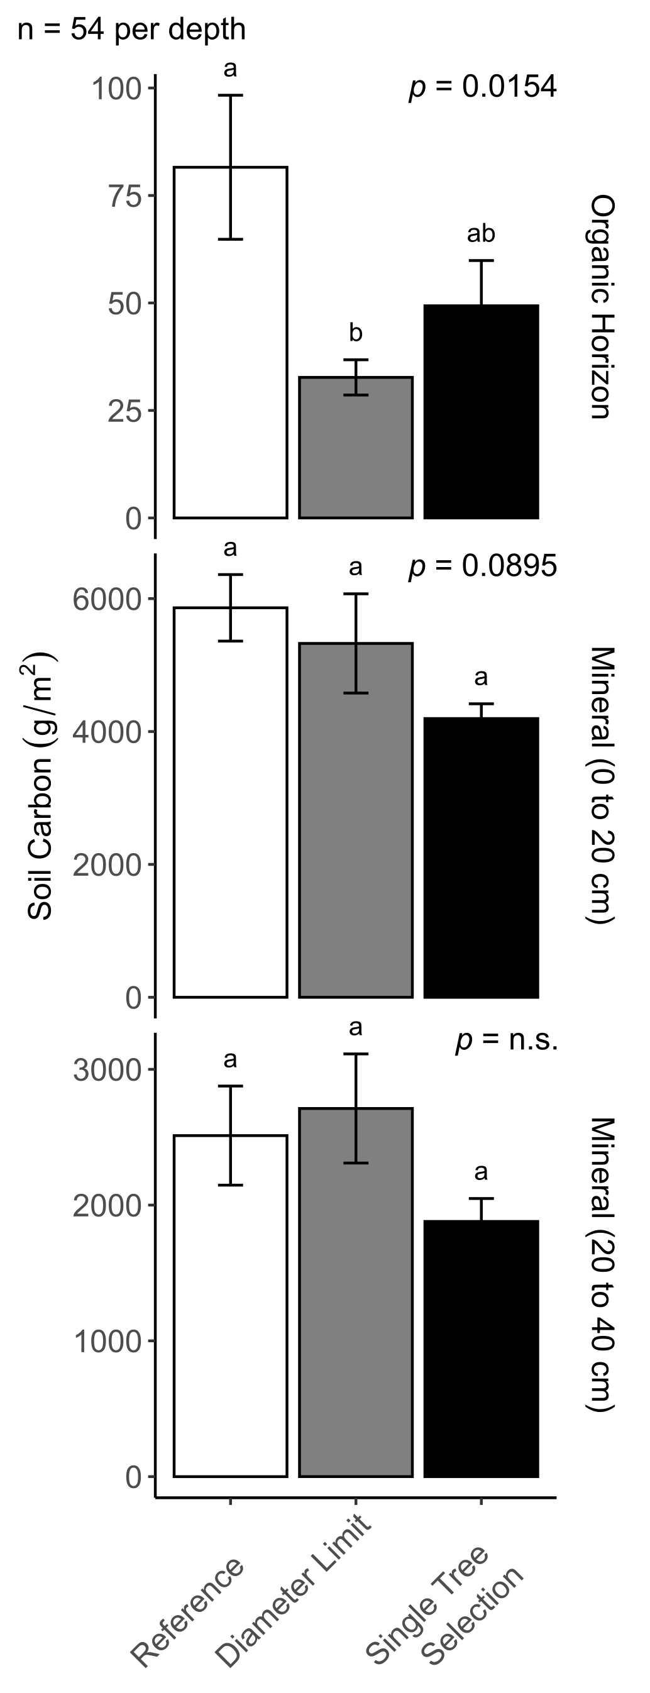
1. Particularly from the top layers of soil, carbon (C) is lost from the watersheds that underwent diameter limit harvesting (DL-WS) and single tree selection harvesting (STS-WS) when compared to the reference watershed (REF-WS)(Figure #). In the organic horizon, soil C is significantly lower in the DL-WS compared to the REF-WS (Dunnett's, p = 0.009), and marginally lower in the STS-WS compared to the REF-WS (Dunnett's, p = 0.101)(Figure #A). In the top 20 cm of the mineral horizon, soil C is also marginally lower in the STS-WS when compared to the REF-WS (Dunnett's, p = 0.059)(Figure #B). However, at this depth interval, soil C in the DL-WS is no longer different from the REF-WS. Deeper in the mineral horizon (20 to 40 cm depth), any differences between harvested watersheds and the REF-WS in terms of soil C disappear (Figure #C).

soilC.aov <- aov(soil_C_gm2 ~ watershed, dc)
summary(soilC.aov) #F=1.389, p=0.252

soilC.dun <- glht(soilC.aov, linfct=mcp(watershed="Dunnett"))
summary(soilC.dun) #DL: 0.953, ST: 0.211

#Total C: ns, dunnett for tot c: ns

soilC.OH.dun <- glht(soilC.OH.aov, linfct=mcp(watershed="Dunnett"))
summary(soilC.OH.dun) #DL: 0.00884, ST: 0.10103

soilC.20.dun <- glht(soilC.20.aov, linfct=mcp(watershed="Dunnett"))
summary(soilC.20.dun) #DL: 0.7020, ST: 0.0588* the only change

soilC.40.dun <- glht(soilC.40.aov, linfct=mcp(watershed="Dunnett"))
summary(soilC.40.dun) #DL: 0.875, ST: 0.301
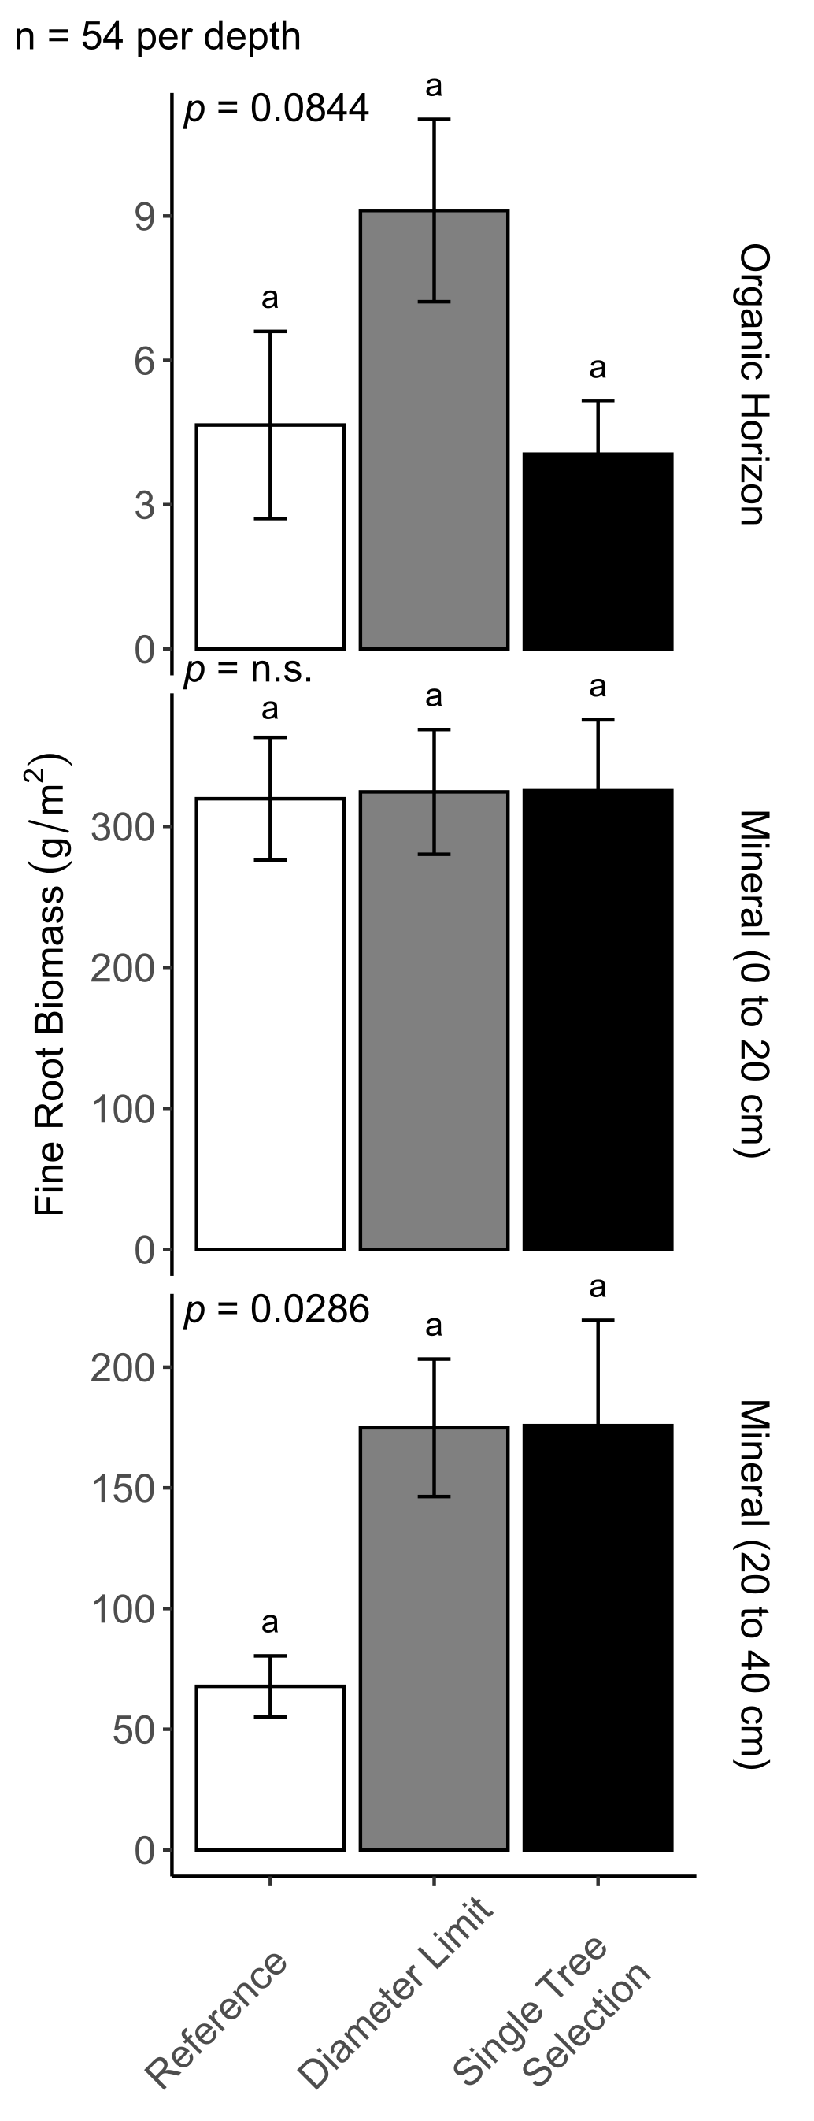
2. Fine root biomass did not differ between the harvested watersheds and the REF-WS in the organic horizon and in the top 20 cm of the mineral horizon (Figure #A-B). However, in the deeper layers of the mineral soil (20 to 40 cm depth), fine root biomass was significantly greater in the two harvested watersheds when compared to the REF-WS (ANOVA p = 0.0286, Dunnett’s, Figure #C).

roots.OH.dun <- glht(roots.OH.aov, linfct=mcp(watershed="Dunnett"))
summary(roots.OH.dun) #DL: 0.124, ST: 0.955

roots.20.dun <- glht(roots.20.aov, linfct=mcp(watershed="Dunnett"))
summary(roots.20.dun) #DL: 0.996, ST: 0.994

roots.40.dun <- glht(roots.40.aov, linfct=mcp(watershed="Dunnett"))
summary(roots.40.dun) #DL: 0.0378, ST: 0.0360 * the only change
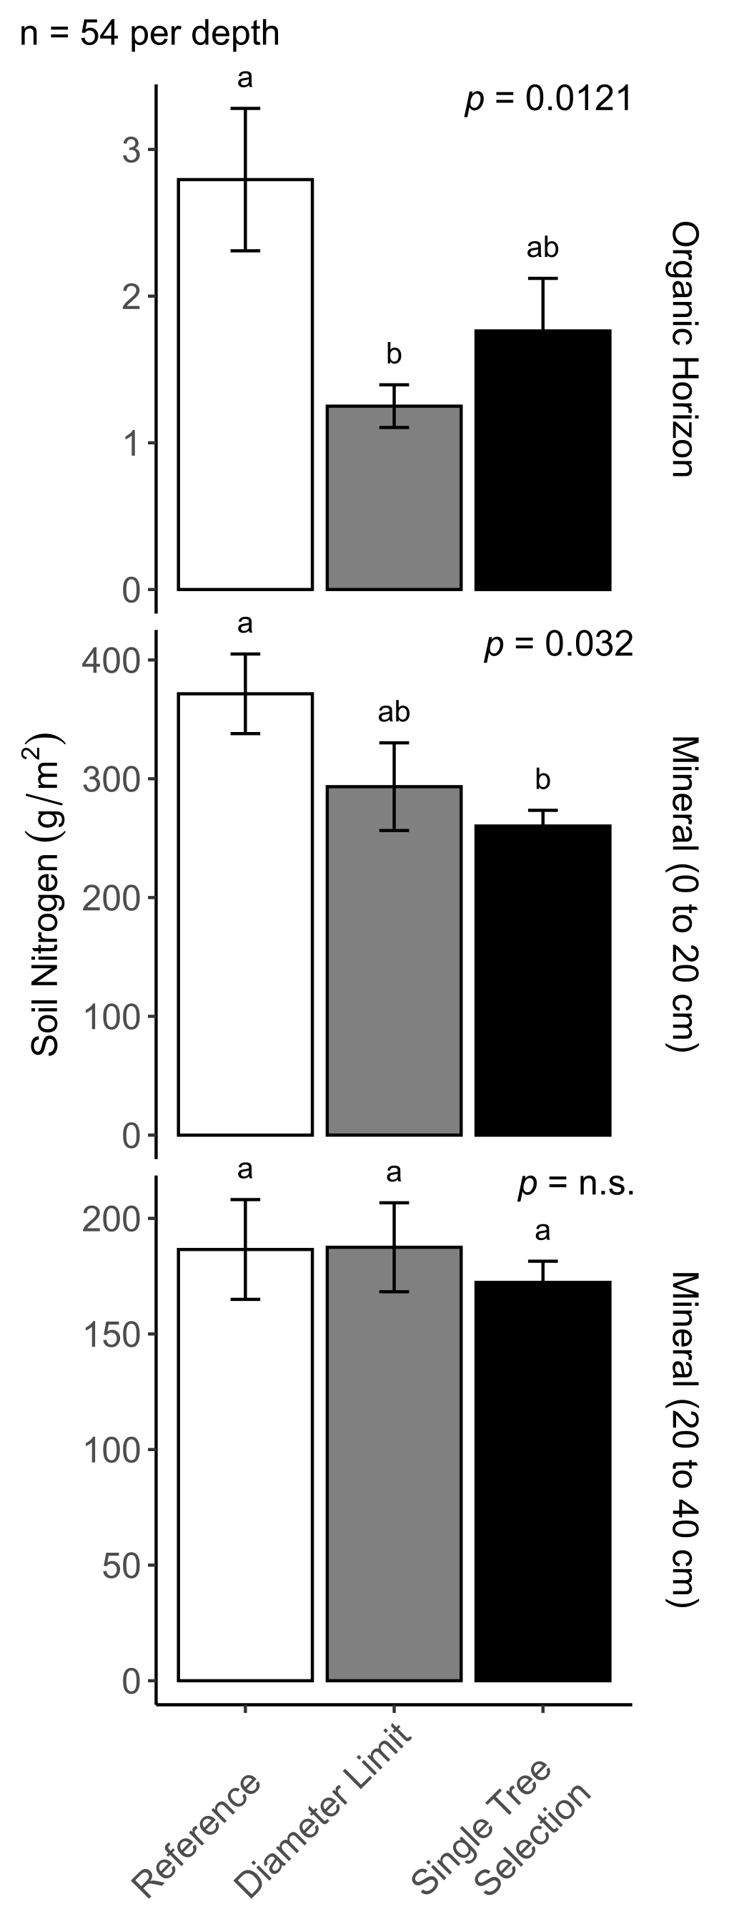
3. Similarly to soil C, harvesting treatment mainly affected soil N in the top layers of the soil, in the organic horizon (ANOVA, p = 0.012) and in the top 20 cm of the mineral soil (ANOVA, p = 0.032) (Figure #). In the organic horizon, soil N in the DL-WS was significantly lower than in the REF-WS (Dunnett’s, p = 0.007, Figure #A). Soil N was also marginally lower in the STS-WS compared to the REF-WS (Dunnett’s, p = 0.085, Figure #A). In the top 20 cm of the mineral soil, soil N was only lower in the STS-WS (Dunnett’s, p = 0.021, Figure #B). On the other hand, soil N was not affected by harvesting treatment in the deeper layers of the mineral horizon (20 to 40 cm depth) (Figure #C).

soilN.OH.dun <- glht(soilN.OH.aov, linfct=mcp(watershed="Dunnett"))
summary(soilN.OH.dun) #DL: 0.00698, ST: 0.08490

soilN.20.dun <- glht(soilN.20.aov, linfct=mcp(watershed="Dunnett"))
summary(soilN.20.dun) #DL: 0.1231, ST: 0.0205

soilN.40.dun <- glht(soilN.40.aov, linfct=mcp(watershed="Dunnett"))
summary(soilN.40.dun) #DL: 0.999, ST: 0.790

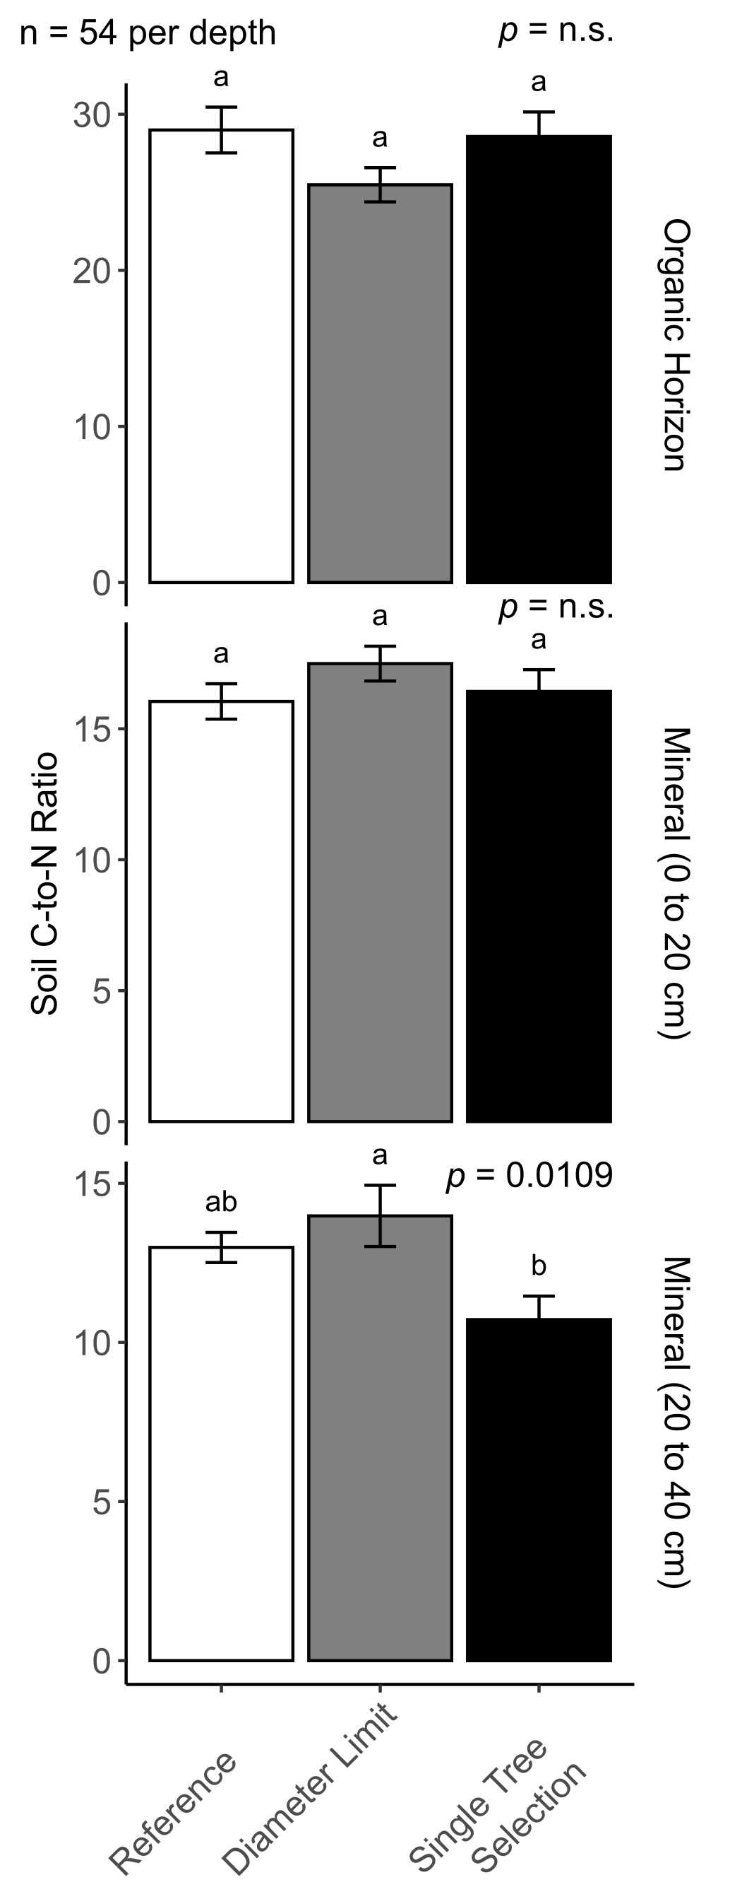
4. Harvesting treatment only affected soil C-to-N (CN) ratio in the deeper layers of the mineral horizon (20 to 40 cm depth) (ANOVA, p = 0.011, Figure #C). Soil CN was marginally lower in the STS-WS compared to the REF-WS (Dunnett’s, p = 0.069, Figure #C). However, there was no difference in soil CN between the DL-WS and the REF-WS (Figure #C).

soilCN.OH.dun <- glht(soilCN.OH.aov, linfct=mcp(watershed="Dunnett"))
summary(soilCN.OH.dun) #DL: 0.142, ST: 0.968

soilCN.20.dun <- glht(soilCN.20.aov, linfct=mcp(watershed="Dunnett"))
summary(soilCN.20.dun) #DL: 0.281, ST: 0.905

soilCN.40.dun <- glht(soilCN.40.aov, linfct=mcp(watershed="Dunnett"))
summary(soilCN.40.dun) #DL: 0.5514, ST: 0.0687

5. Looking at C and N distribution across various mineral soil fractions, we only observed a significant effect of harvesting treatment on the light fraction of the deeper mineral layer.

- finalize figures
- draft results
- go through methods
- pick thesis sentences for the discussion
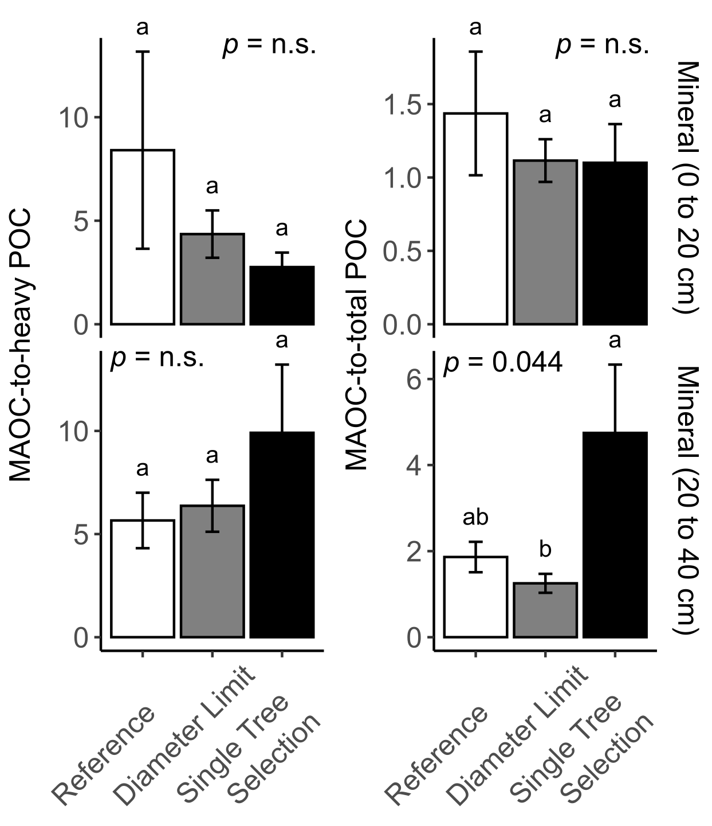
6. Looking at the distribution of C between the mineral associated and the particulate (both light and heavy fractions) organic matter fractions, we found that the ratio of the C in the mineral associated organic matter (MAOC) to the C in the particulate organic matter (total POC = light + heavy fraction) was only different in the deeper layers of the mineral soil (20 to 40 cm depth) (ANOVA, p = 0.044, Figure #B). Here, the ratio of MAOC-to-total POC was greater in the STS-WS compared to the REF-WS (Dunnett’s, p = 0.0859, Figure #B).

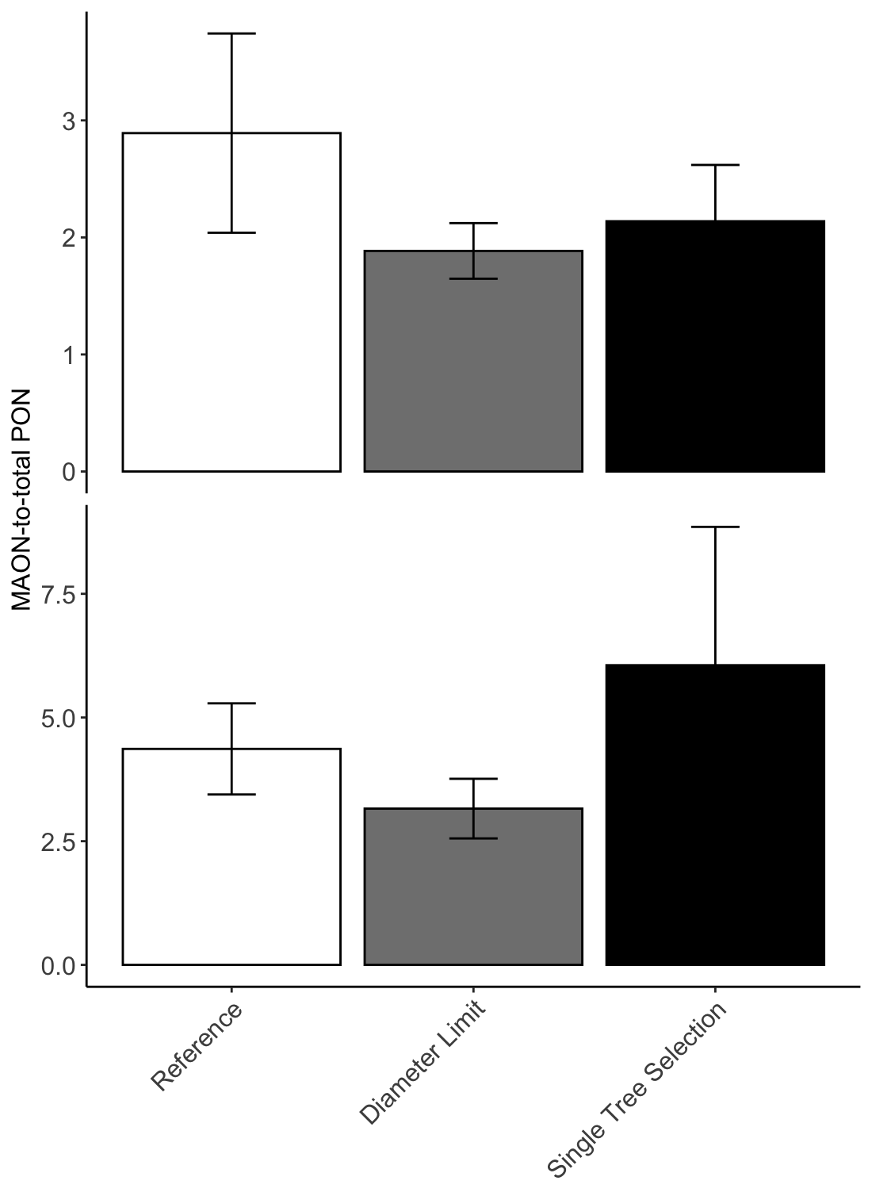
MAON:PON graph

- stats: n.s. (both 0 to 20 and 20 to 40)
- dunnett’s: n.s.

Dunnett's on Frac C and Frac N figures

Harvest (these types) effects on N stocks -> search the literature to see if anyone’s seen a similar effect

